Developing Innovation & Creativity for Business Advantage
Tesla
VLADIMIR KOSTADINOV (1815823)
2023
Executive Summary

The report was focused on Tesla’s innovation opportunity which was represented by the electric cars. The report started with an overview of the innovation opportunity, which showed that Tesla has been inspired by the concern of the negative impact of petrol and diesel cars over the environment when deciding to start manufacturing electric cars. Furthermore, it has also been identified that Tesla uses Incremental Innovation, which means that the company has looked to improve an already existing market which was the car manufacturing. At the same time, the creative thinking process at Tesla is represented by First Principles Thinking model, which focuses on finding solution to complicated issues. It has also been discovered the fact that Tesla uses the Open Innovation, as it is always inspired by external factors such as environmental. The main barrier faced by Tesla is the lack of infrastructure, but it has been able to overcome that with the help of the governments. Moreover, Elon Musk is an innovative person himself, and he passed this onto Tesla which embrace this culture.

Table of Contents
1.0 Introduction 2
2.0 Main Findings 2
2.1. Overview of the Innovation Opportunity 2
2.2 Types of Innovation 3
2.3 The Creative Thinking Process at Tesla 4
2.4. Innovation Models 4
2.4.1. Open and Closed Innovation 5
2.4.2. The Innovation Process 6
2.4.3. 4P’s of Innovation 6
2.5. Assessment of the Effectiveness 7
2.5.1. Barriers & Risks 7
2.6. Leadership & Management 7
3.0 Conclusion 7
References 7

Introduction

The creativity and the innovation are often seen as similar in people’s minds (Cropley, Kaufman and Cropley, 2011). However, even if both terms relate to ideas, they are, in fact, very different (Cropley, Kaufman and Cropley, 2011). Creativity is the process of coming up with ideas which are new and useful (Kaufman and Baer, 2012), while the innovation represents the actual application of the ideas generated through creativity (Joshi, 2013).
The business world is one of the most competitive markets, and it is considered that creativity is simply not enough to gain competitive advantage. (Kaufman and Baer, 2012) Because of this, business must always be innovative, so that they can secure their place on the market and have the desired competitive advantage (Kaufman and Baer, 2012). Given this, the businesses’ priority and the majority of the investments go into innovation (Kaufman and Baer, 2012). Moreover, there are rankings to show which company is the most innovative.
One of the companies that are part of the BCG’s Top 50 Most Innovative Companies in 2021 is Tesla, which, in this top, it is positioned on the 5th place, after it has managed to advance 6 places in one year (Ang, 2021).
Tesla is a Transport and Energy company which was founded by Martin Eberhard and Marc Tarpenning in 2003, the name of the company being inspired by Nikola Tesla, a well-known inventor and electrical engineer (Tesla, 2013). A year later, in 2004, Elon Musk joined the company as the largest shareholder and by 2008 he becomes the CEO of Tesla (Tesla, 2013).

2.0 Main Findings

Tesla’s main innovation has been the electric cars (Helmers and Marx, 2012). These are the cars that do not run on petrol or diesel, as they are fully powered by an electric motor (Helmers and Marx, 2012). Tesla’s electric cars are innovative because they are environmentally friendly, as well as very efficient. A plus in consumer’s eyes is that Tesla cars are very elegant and modern, giving a luxury feeling. To ensure that people are able to make long-distance travel, Tesla also has successfully developed supercharging stations, where the cars could be charges very fast when compared with electric cars and charging stations from other manufacturers (Vynakov, Savolova and Skrynnyk, 2019). Apart from the electric cars, Tesla has also innovated through solar roofing and autonomous vehicles (Tesla, 2013). The autonomous vehicles are considered to be the greatest innovation of Tesla from the past few years, as this technology allows the car to drive itself, being the most advanced technology of its kind (Ajitha and Nagra, 2021).
This chapter will further look into evaluating innovation models (The Innovation matrix, Open and Closed Innovation, The Innovation Process, 4P’s of Innovation and Field Force Analysis) and applying them to Tesla’s case. The purpose of the evaluation is to evaluate whether or not Tesla’s innovation offers the company a competitive advantage.

2.1. Overview of the Innovation Opportunity

Sustainability became a very important aspect in the recent years. Studies have been made on the environmental consequences of the petrol or diesel cars (Ithnin et al., 2014). These studies (Ithnin et al., 2014) revealed that the atmosphere was and continues to suffer from the emission that come from diesel and petrol cars, where the engines have emissions that destroys the ground-level ozone which then affects the vegetation and have negative effects for public health. Given this major sustainability problem, car manufacturers have started to look at alternative ways to decrease the pollution and the negative effects of normal cars (Ithnin et al., 2014). Therefore, the attention has been shifted towards electric cars.
Tesla was not the company that invented the electric cars. However, Tesla is the only manufacturer that exclusively creates electric cars, and it the manufacturer that has managed to perfect the technology behind electric cars, which innovated the entire market and the customer experience (Liu and Meng, 2017). For example, Tesla has implemented in each of its cars a feature known as Autopilot, which is a driver assistance program that can steer the wheel, accelerate, and brake (Liu and Meng, 2017). At the same time, Tesla brought this program on a higher level by actually allowing the Autopilot to drive from the point A to point B without the driver doing anything (Liu and Meng, 2017). Tesla is still working on this innovation, but the plan is to make the car drive itself in the next few years, without a driver being even present in the car while driving (Tesla, 2012). Even more than that, Tesla’s car can be very affordable as well as very expensive, depending on the customers’ budget (Liu and Meng, 2017). Tesla’s electric cars are currently considered to be the best electric cars on the market, title that has been gained because of their sustainability and driving experience (Ang, 2021).

2.2 Types of Innovation

All the types of innovation are being integrated in one helpful tool which is the Innovation Matrix. This tool allows companies to understand how to best plan their innovation implementation based on the characteristics of each type of innovation (Kyffin and Gardien, 2009). The Innovation Matrix shows four types of Innovation:
- Architectural Innovation – this type of innovation requires a significant time allocation because it is built over years. However, when this innovation is finally introduced to the world, it tends to have long-lasting effects and to become an example for other innovations or companies (Kyffin and Gardien, 2009).
- Incremental Innovation – this type of innovation refers to the re-branding or the re-inventing an already existing product. This innovation helps companies to always have products in trend or relevant, or even to keep their place on the market. (Kyffin and Gardien, 2009)
- Radical Innovation – this type of innovation applied when companies are coming up with a new product or service that never existed before. This innovation usually transforms an existing market by introducing new products or services (Kyffin and Gardien, 2009).
- Disruptive Innovation – this is the type of innovation that creates an entirely new market with the introduction of the innovative product or service (Kyffin and Gardien, 2009).
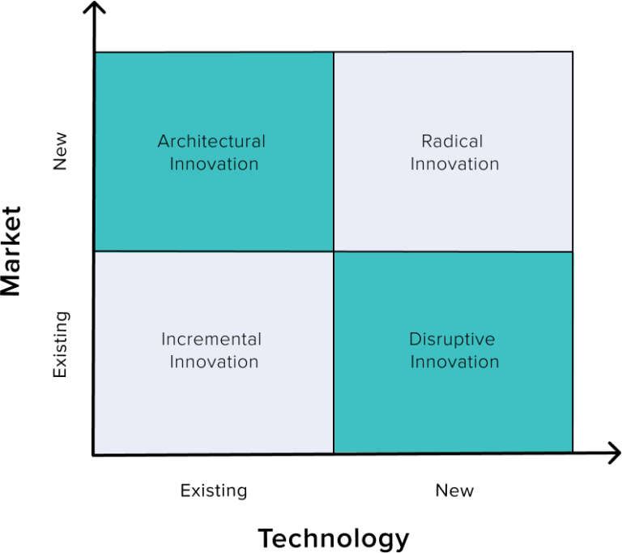
The Innovation Matrix shows companies how to correctly implement their innovation based on the exact type of innovation that they have (Kyffin and Gardien, 2009). Still, this tool alone cannot ensure the success of the innovation, because companies that are using this must do proper research in identifying what is the best type of innovation that suits the company and its values (Kyffin and Gardien, 2009). If companies are not paying attention and chose a disadvantageous type of Innovation, then the innovation is most likely to fail.
Tesla’s innovation classifies as Incremental Innovation, because, according to the definition of Incremental Innovation, this means that a company has innovated a product that was already existent. Given the fact that Tesla did not invent the electric cars, but Tesla only made electrical better and highly functioning (Liu and Meng, 2017), this means that Tesla used Incremental Innovation.

2.3 The Creative Thinking Process at Tesla

The Creative Thinking process represents the process through which companies are coming up with new ideas (Mumford and McIntosh, 2017). Most common ‘new ideas’ happen because there is a problem that must be solved, and the old ways are not working anymore, or the circumstances are different (Mumford and McIntosh, 2017). This was also Tesla’s case. Tesla identified market problems where the electric cars from that time were not efficient, and the sustainability was not a point of interest for other manufacturers (Furr and Dyer, 2020). Tesla’s CEO Elon Musk has been very transparent about the creative thinking process that happens at Tesla, saying that the company uses a model called ‘First Principles Thinking’ (Furr and Dyer, 2020). The First Principles Thinking model is a model used to solve extremely complex problems by splitting the problems into smaller problems and then finding solutions to each of them until a final solution is reached (Wang and Gloor, 2018). By applying this creative thinking model, Tesla had to solve one concerning issue, which was represented by the sustainable cars, while also thinking on how to make it user-friendly and accessible to a larger public in order to make a difference in the environment.

2.4. Innovation Models

The Innovation Models are models used to help companies identify the best way to identify innovation opportunities and to apply all the necessary steps in order to become innovative. There are three main Innovation models:
- Open and Closed Innovation
- The Innovation Process
- The 4P’s of Innovation

2.4.1. Open and Closed Innovation

Open and Closed Innovation identifies innovation opportunities within two main places:
- Inside the company – This is known as Closed Innovation because the source of innovative ideas is inside the company (Leminen, Turunen and Westerlund, 2015). The ideas could come from different departments specialised in research and innovation, or even from employee feedback (Leminen, Turunen and Westerlund, 2015). This source of innovation is mostly used within companies that are using Disruptive Innovation, but it is suitable for the other types of Innovation as well (Leminen, Turunen and Westerlund, 2015).
- Outside the company – This is known as Open Innovation because the source of the innovative ideas is found outside the company (Leminen, Turunen and Westerlund, 2015). This means that the idea can come from customers that offer feedback for the services, public criticism, or complaints (Leminen, Turunen and Westerlund, 2015). This source of innovation is mainly used by companies that that are using the Incremental Innovation, since companies are using to constantly upgrade their products or services to be consistent with the changes that are happening in the market (Leminen, Turunen and Westerlund, 2015). At the same time, this source of innovation can also be impacted by external factors such as legal, environmental, and so on.

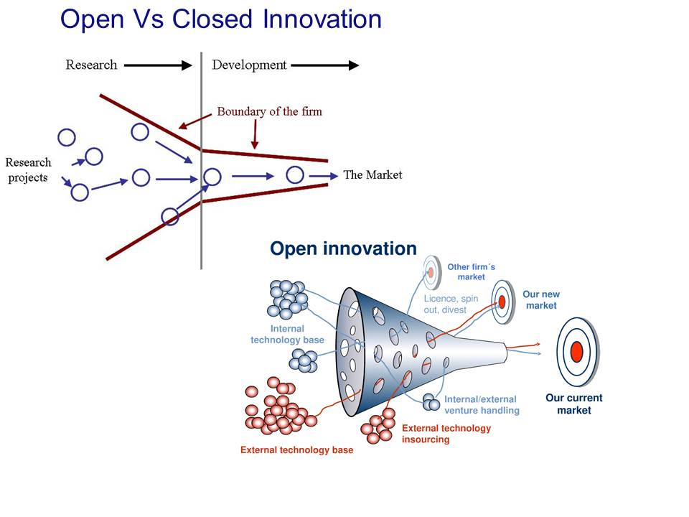

When innovating the car manufacturer market, Tesla mainly looked at the external factor which is represented by the sustainability, therefore Tesla used the open innovation (Bruijl, 2017). The company looked to solve the back-then sustainability issues and by using the company’s process of creative thinking, they have managed to upgrade the existing electric cars, make them more sustainable, as well as affordable so that more people can chose a Tesla electric car rather than a petrol or diesel car (Bruijl, 2017).

2.4.2. The Innovation Process

The Innovation Process refers to all the steps taken by a company in order to implement an innovative idea (LaFrance, 2018). The Innovation Process is not a model that is generally applicable to every company, but this model is usually created by every company that wants to innovate (LaFrance, 2018). However, there are a few general steps that must be taken by every company that prepared to come up with an innovative product or service. These are, according to Lefrance in 2018:
- Identify the innovation opportunity – this means that the creative thinking process must create a useful and innovative idea that can be applied and reach success.
- Gather all the resources – this means that the company that has identifies the innovation opportunity must also make a list with all the resources needed. These resources can be money, people, or time.
- Make an implementation plan – planning is very important to ensure that the idea can be implemented, and all the risks and threats must be taken into consideration.
- Ensure that the innovation suits the brand – the new idea must stand being the brand’s image and culture, and to express what the brand represents.
Studies made on innovation process (Dooley and O’Sullivan, 2013) have shown that, by not taken into consideration the general four advice when implementing innovation, companies often fail to reach the desired outcome.
Even from the beginning of Tesla, the main focus was the sustainability. However, being a start-up, Tesla did not have the budget to be affordable as well from the beginning (Mangram, 2012). Therefore, Tesla’s innovation process has been to create a luxury electric sports car which will generate enough revenue to allow the company to build affordable cars that are sustainable as well (Mangram, 2012). It is fair to say that Tesla succeeded at implement this innovation process as they have achieved all the goals.

2.4.3. 4P’s of Innovation

The 4P’s of Innovation shows that a company can be innovative by looking at four main aspects (Akgun et al., 2017):
- Product – the innovative product or service
- Process – represents the innovation process.
- Position – target market
- Paradigm – make the product or service be beneficial for the company.
At Tesla, the product innovation is represented by the electric cars that the company has created and perfected along the years. Along the most popular Tesla’s features are the electric motor, the charging capacity, as well as the automatic system (Tesla, 2013).
Tesla’s process innovation involves open innovation. Furthermore, Tesla has developed long-lasting partnerships with companies that are helping Tesla, such as Toyota or Panasonic (Tesla, 2019). These partnerships have allowed Tesla to continue on an innovation path.
Tesla’s paradigm innovation focuses on customer experience and care for the environment. Tesla aims to help the environment by providing accessible, affordable, and sustainable transport solution directly to the customers (Tesla, 2021).
Tesla’s position innovation means that the company has been able to revolutionise the existing car manufacturer market, as well as reaching various groups of customers in order to promote sustainability is a fashionable way (Financial Times, 2020).

2.5. Assessment of the Effectiveness

The Force Field Analysis is a tool used to assess the effectiveness of the innovation (Bozak, 2003). The tool is looking to identify the aid and the barriers of implementing the innovation. Companies can use it to evaluate whether implementing the innovation might be a good idea or not, based on the number or barriers that the company identified, as well as the number of aids that can help the company get through the barriers (Bozak, 2003).

2.5.1. Barriers & Risks

The main barrier that Tesla faced when introducing the electric vehicles was the fact that there is little to no infrastructure for it (Stringham, Miller and Clark, 2015). The charging stations were not very popular, and they have an increased cost. Therefore, even if the car itself might be affordable and more sustainable, the charging itself and the infrastructure required can make customers avoid buying Tesla (Stringham, Miller and Clark, 2015). However, because Tesla’s vision is to build a more sustainable future, government all over the world are offering help to the customers that will purchase an electric car from Tesla (Stringham, Miller and Clark, 2015). They will pay lower taxes, and their electricity consumption will have a better price (Stringham, Miller and Clark, 2015).

2.6. Leadership & Management
The leadership in general is a decisive factor when it comes to innovation within a company. In Tesla’s case, Elon Musk, the CEO, is a known for being innovation oriented (Rimmer, 2018). He is focused on solving existing sustainability problems while offering a very high level of comfort to Tesla customer through the electric cars (Rimmer, 2018). Because Elon Musk is constantly looking at ways to improve existing products, he is considered to be a transformational leader (Rimmer, 2018).

3.0 Conclusion
In conclusion, Tesla’s electric cars have innovated the existing market of car manufactures through the Incremental Innovation used by the company. Tesla has made a name for herself by being one of the most innovative companies in the world, because the company did not stop at only product, but it constantly tried to improve and do better. At the same time, Tesla has successfully applied all the Innovation Models and has discovered its barriers, but it has successfully overcome any obstacle.
Tesla’s place in the top most innovative companies is well deserved, as the company thrives in innovation and has created a culture of finding solutions to difficult problems.

References

Ajitha, P.V. and Nagra, A. (2021). An Overview of Artificial Intelligence in Automobile Industry – a Case Study on Tesla Cars. Solid State Technology, 62(1), pp.503–512.
Akgun, A.E., Keskin, H., Ayar, H. and Etlioglu, T. (2017). Why Companies Go Positive Marketing innovations: a New Theoretical Prototype for 4Ps of Innovation. Pressacademia, 6(2), pp.70–77. doi:https://doi.org/10.17261/pressacademia.2017.496.
Ang, C. (2021). Ranked: the Most Innovative Companies in 2021. [online] Visual Capitalist. Available at: https://visualcapitalist.com/ranked-the-most-innovative-companies-in-2021/ [Accessed 14 Mar. 2023].
Bozak, M.G. (2003). Using Lewin’s Force Field Analysis in Implementing a Nursing Information System. CIN: Computers, Informatics, Nursing, 21(2), pp.80–85. doi:https://doi.org/10.1097/00024665-200303000-00008.
Bruijl, G.H.Th. (2017). Tesla Motors, Inc.: Driving Digital Transformation and the Digital Ecosystem. SSRN Electronic Journal. doi:https://doi.org/10.2139/ssrn.3053142.
Cropley, D.H., Kaufman, J.C. and Cropley, A.J. (2011). Measuring Creativity for Innovation Management. Journal of Technology Management & Innovation, 6(3), pp.13–30. doi:https://doi.org/10.4067/s0718-27242011000300002.
Dooley, L. and O’Sullivan, D. (2013). Structuring Innovation: a Conceptual Model and Implementation Methodology. Enterprise and Innovation Management Studies, 2(3), pp.177–194. doi:https://doi.org/10.1080/14632440110101246.
Financial Times (2020). Tesla’s rise has sparked an electric revolution. [online] Available at: https://www.ft.com/content/2cb13384-3dd7-11ea-a01a-bae547046735.
Furr, N. and Dyer, J. (2020). Lessons from Tesla’s Approach to Innovation. [online] Harvard Business Review. Available at: https://hbr.org/2020/02/lessons-from-teslas-approach-to-innovation.
Helmers, E. and Marx, P. (2012). Electric cars: Technical Characteristics and Environmental Impacts. Environmental Sciences Europe, 24(1). doi:https://doi.org/10.1186/2190-4715-24-14.
Ithnin, A.M., Noge, H., Kadir, H.A. and Jazair, W. (2014). An Overview of Utilizing water-in-diesel Emulsion Fuel in Diesel Engine and Its Potential Research Study. Journal of the Energy Institute, 87(4), pp.273–188. doi:https://doi.org/10.1016/j.joei.2014.04.002.
Joshi, M. (2013). Understanding Innovation. SSRN Electronic Journal. doi:https://doi.org/10.2139/ssrn.2261050.
Kaufman, J.C. and Baer, J. (2012). Beyond New and Appropriate: Who Decides What Is Creative? Creativity Research Journal, 24(1), pp.83–91. doi:https://doi.org/10.1080/10400419.2012.649237.
Kyffin, S. and Gardien, P. (2009). Navigating the Innovation Matrix: an Approach to Design-led Innovation. International Journal of Design, 3(1), pp.57–68.
LaFrance, D.B. (2018). Innovating Innovation. Journal - American Water Works Association, 110(8), pp.10–10. doi:https://doi.org/10.1002/awwa.1132.
Leminen, S., Turunen, T. and Westerlund, M. (2015). The Grey Areas between Open and Closed in Innovation Networks. Technology Innovation Management Review, 5(12), pp.6–18. doi:https://doi.org/10.22215/timreview/948.
Liu, J. and Meng, Z. (2017). Innovation Model Analysis of New Energy Vehicles: Taking Toyota, Tesla and BYD as an Example. Procedia Engineering, [online] 174(1), pp.965–972. doi:https://doi.org/10.1016/j.proeng.2017.01.248.
Mangram, M.E. (2012). The Globalization of Tesla Motors: a Strategic Marketing Plan Analysis. Journal of Strategic Marketing, [online] 20(4), pp.289–312. doi:https://doi.org/10.1080/0965254x.2012.657224.
Mumford, M.D. and McIntosh, T. (2017). Creative Thinking Processes: the past and the Future. The Journal of Creative Behavior, 51(4), pp.317–322. doi:https://doi.org/10.1002/jocb.197.
Rimmer, M. (2018). Intellectual Property and Clean Energy: the Paris Agreement and Climate Justice. Singapore: Springer Singapore.
Stringham, E.P., Miller, J.K. and Clark, J.R. (2015). Overcoming Barriers to Entry in an Established Industry: Tesla Motors. California Management Review, [online] 57(4), pp.85–103. doi:https://doi.org/10.1525/cmr.2015.57.4.85.
Tesla (2013). The Mission of Tesla. [online] Tesla.com. Available at: https://www.tesla.com/blog/mission-tesla.
Tesla (2019). Charging Partners | Tesla. [online] Tesla.com. Available at: https://www.tesla.com/charging-partners.
Tesla (2021). Impact | Environment. [online] Tesla. Available at: https://www.tesla.com/impact/environment.
Vynakov, O.F., Savolova, E.V. and Skrynnyk, A.I. (2019). Modern Electric Cars of Tesla Motors Company. Automation of Technological and Business Processes, [online] 8(2). doi:https://doi.org/10.15673/atbp.v8i2.162.
Wang, X. and Gloor, P.A. (2018). Wuity as Higher Cognition Combining Intuitive and Deliberate Judgments for Creativity: Analyzing Elon Musk’s Way to Innovate. Collaborative Innovation Networks, pp.165–182. doi:https://doi.org/10.1007/978-3-319-74295-3_14.
NursingAnswers.net. (2018). Atkins and Murphy Model of Reflection. [online] Available at: https://nursinganswers.net/reflective-guides/atkins-and-murphy.php.

