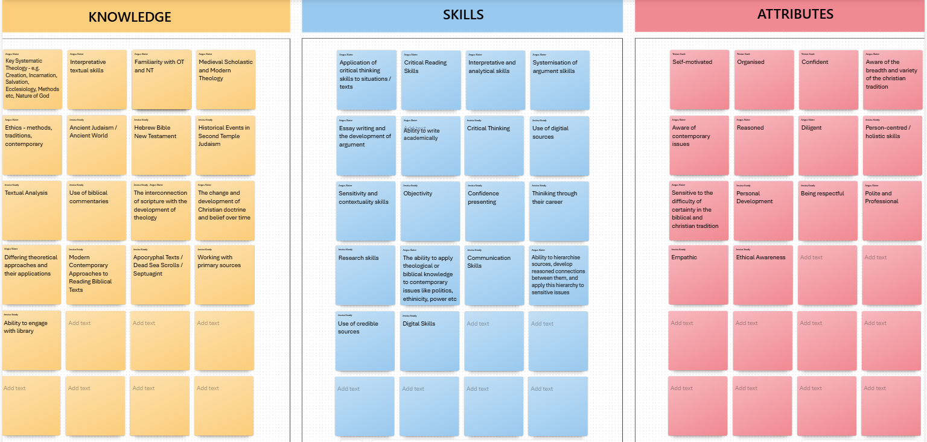

📘 KNOWLEDGE
(Yellow Notes)
- Key Systematic Theology - e.g. Creation, Incarnation, Salvation, Ecclesiology, Methods etc, Nature of God
- Interpretative methods/ skills
- Familiarity with OT and NT
- Medieval Scholastic and Modern Theology
- Ethics – methods, branches, contemporary issues
- Ancient Judaism / Ancient World
- Hebrew Bible / New Testament
- Historical Events in Second Temple Judaism
- Textual Analysis
- Use of biblical commentaries
- The interconnection of various socio-political themes and the development of ideas inside/outside the text
- The change and development of ideas/knowledge inside/outside the texts
- Different Theoretical Approaches; their application
- Modern Contemporary Scholarship; Approaches, Readings
- Old Testament Texts / Dead Sea Scrolls / Septuagint
- Working with primary sources
- Ability to engage with secondary scholarship

📘 SKILLS
(Blue Notes)
- Application of skills to lived experience
- Critical Reading Skills
- Interpretative and analytical skills
- Systematisation of argument skills
- Essay writing and academic skills development
- Ability to write academically
- Critical Thinking
- Use of digital sources
- Sensitivity and contextuality skills
- Objectivity
- Confidence in presenting
- Thinking through their career
- Research skills
- The ability to recognise how people present arguments, biases, perspectives
- Communication Skills
- Ability to research independently and work with a heavy reading load
- Use of credible sources
- Digital Skills

📘 ATTRIBUTES
(Pink Notes)
- Self-motivated
- Organised
- Confident
- Aware of the socio-political, cultural and religious context
- Aware of contemporary issues
- Reasoned
- Diligent
- Person-centred / holistic skills
- Sensitive to the cultural/ historical background of biblical text
- Personal Development
- Being respectful
- Pride and Professional
- Empathic
- Ethical Awareness

