Design and Development of a Portable Vehicle Carbon Monoxide Detection and Monitoring System

ACDA 5025 - Engineering and Project Management

Nathan McCartney

2515292
Table of Contents
1 Abstract 4
2 Introduction 5
2.1 Background 5
2.2 Problem Statement 5
2.3 Literature Review 6
3 Aim 7
4 Objectives 7
5 Proposed Design 8
5.1 System Overview 8
5.2 Sensor Selection Justification 8
5.3 Microcontroller Selection 8
5.4 Battery System Design 9
5.5 Battery Management System (BMS) 9
5.6 USB-C Charging 9
5.7 Block Diagram 10
5.8 Program Flow Diagram 10
5.9 System Operation 11
6 Technical Specification 12
6.1 System Performance Requirements 12
7 Risk Assessment 13
7.1 Risk Management Matrix 13
7.2 Risk Matrix Before Mitigation 13
7.3 Risk Matrix After Mitigation 14
7.4 Risk Review 14
8 Cost Benefit Analysis 15
8.1 Estimated Costs/Benefits 15
8.2 Net Benefit 16
8.3 Benefit Cost Ratio 16
8.4 Benefits 16
8.5 Operational Benefits 16
8.6 Financial Benefits 16
8.7 Commercial Viability 17
9 Ethical Considerations 18
9.1 User Safety 18
9.2 Reliability 18
9.3 Privacy 18
9.4 Accessibility 18
9.5 Engineering Responsibility 18
9.6 False Positives and False Negatives 18
9.7 Relevant Standards 18
9.8 Quality Management Strategy 19
10 Project Planning 20
10.1 Work Breakdown Structure (WBS) 20
10.2 Gantt Chart 22
10.3 Network Diagram 23
10.4 Critical Path 23
10.5 Project Deliverables 24
10.6 Project Milestones 24
11 Environmental Impact 25
11.1 Positive Impacts 25
11.2 Negative Impacts 25
11.3 Sustainability Considerations 25
11.4 Mitigation Measures 25
11.5 Design Limitations 25
12 Conclusion 26
13 References 27
14 Appendix 29
14.1 Equality and Diversity Briefing Certificate 29
14.2 Prevent Duty Certificate 30

Abstract
Carbon monoxide (CO) is a colourless, odourless, and highly toxic gas produced during the incomplete combustion of hydrocarbon fuels [1]. Vehicle exhaust system faults such as corrosion, damaged pipework, defective seals, and poor maintenance can allow carbon monoxide to enter both the engine compartment and passenger cabin, creating a serious health hazard. Exposure to elevated CO concentrations may result in headaches, dizziness, impaired judgement, unconsciousness, and in severe cases death [2].
This project proposes the design and development of a Portable Vehicle Carbon Monoxide Detection and Monitoring System capable of continuously monitoring carbon monoxide concentrations in both the vehicle cabin and engine bay. The system will utilise electrochemical CO sensors connected to a microcontroller based control unit that provides real time concentration monitoring, visual status indication, and audible alarms when dangerous conditions are detected.
Unlike permanently installed detection systems, the proposed design is battery powered and incorporates a rechargeable lithium-ion battery with USB-C charging capability. This allows the unit to be easily transferred between vehicles and recharged using vehicle USB ports, power banks, laptop USB ports, or domestic USB chargers.
The project combines principles from electronics engineering, embedded systems design, portable power systems, automotive safety, risk management, and project planning. The proposed device aims to improve vehicle occupant safety and potential vehicle damage through early leak detection and preventative maintenance support while remaining affordable, portable, and suitable for commercial and private vehicle applications.

Introduction

Background
Carbon monoxide poisoning remains one of the leading causes of accidental toxic gas exposure worldwide [3]. Although modern vehicles are designed with sealed exhaust systems and improved emissions controls, failures can still occur due to ageing components, corrosion, vibration, impact damage, and poor maintenance practices [4].
Vehicle occupants are often unaware of exhaust leaks because carbon monoxide cannot be detected by human senses. Even low concentrations can accumulate over time, particularly when vehicles are stationary, operating in confined spaces, or experiencing recirculation of exhaust gases into the cabin.
Modern vehicles contain numerous electronic safety systems designed to protect occupants from external and internal hazards. However, dedicated carbon monoxide monitoring systems are rarely incorporated into standard vehicle designs despite the potential risks associated with exhaust system failures [5].
The development of low-cost electrochemical gas sensors, rechargeable battery technology, and embedded control systems now makes continuous portable vehicle carbon monoxide monitoring both technically feasible and economically viable.

Problem Statement
Current vehicle maintenance practices rely primarily on periodic inspections and driver awareness to identify exhaust system leaks. Small leaks often go unnoticed until significant damage has occurred, or occupants begin to experience symptoms of carbon monoxide exposure.
There is therefore a requirement for a reliable system capable of:
- Continuously monitoring carbon monoxide levels.
- Detecting leaks before dangerous concentrations are reached.
- Alerting drivers immediately when hazardous conditions exist.
- Supporting preventative maintenance activities.
- Reducing the risk of vehicle related carbon monoxide poisoning.
- Operating independently of vehicle wiring systems.
- Being easily transferable between multiple vehicles.
This project seeks to address this problem through the development of a dedicated portable carbon monoxide detection and monitoring system.

Literature Review
Carbon monoxide has a strong affinity for haemoglobin and reduces the body's ability to transport oxygen throughout the body. Long term or high concentration exposure may lead to serious injury or death. Vehicle related carbon monoxide incidents continue to occur despite significant advancements in vehicle safety technologies [6].
Several gas sensing technologies are available, including semiconductor, infrared, and electrochemical sensors. Semiconductor sensors provide low cost monitoring but can be affected by temperature and humidity. Infrared sensors offer high measurement accuracy but require more complex and expensive circuitry. Electrochemical sensors provide a balance between accuracy, reliability, low power consumption, and affordability, making them suitable for portable safety devices [7].
The introduction of compact microcontrollers and rechargeable lithium-ion batteries has enabled sophisticated portable monitoring systems. Existing carbon monoxide detectors are largely designed for fixed installation, whereas the proposed design offers a portable dual-sensor solution that can be transferred between multiple vehicles without permanent modification.
These technologies provide opportunities to develop transferable safety devices capable of operating in vehicles, motorhomes, caravans, construction equipment, and commercial fleets without permanent installation.
Existing carbon monoxide detectors are primarily intended for domestic, marine, or recreational vehicle applications and are commonly designed for fixed installation. While these systems provide effective occupant protection, they offer limited portability. The proposed design addresses this limitation through a rechargeable dual sensor architecture that can be transferred between vehicles without permanent modification, improving flexibility and cost effectiveness.

Aim
To design, develop, and evaluate a portable carbon monoxide detection and monitoring system capable of identifying exhaust gas leaks in multiple vehicle types through continuous monitoring of carbon monoxide concentrations within both the vehicle cabin and engine bay.

Objectives
The project objectives are:
- Design a portable monitoring, display, and control unit.
- Integrate a carbon monoxide detector onboard the portable controller/display.
- Install a secondary detector within the engine bay.
- Provide real time CO concentration measurements.
- Generate audible and visual alarms at predefined thresholds.
- Log alarm events for maintenance purposes.
- Design a rechargeable battery powered system with USB-C charging capability.
- Achieve a minimum operating duration of 12 hours between charges.
- Provide battery level monitoring and low battery warnings.
- Design for operation under automotive environmental conditions.
- Construct and test a working prototype.
- Complete all project activities within the planned schedule and budget.

Proposed Design

System Overview
The Portable Vehicle Carbon Monoxide Detection and Monitoring System consists of four major subsystems:
- Portable Controller/Display Unit with Integrated Cabin Sensor
- Engine Bay Sensor Module
- Rechargeable Battery System
- USB-C Charging Interface
The control unit can be placed temporarily on a vehicle dashboard, attached using removable mounting methods, and transferred easily between vehicles.

Sensor Selection Justification
Electrochemical carbon monoxide sensors have been selected due to their high sensitivity, reliability, low power consumption, and excellent selectivity for carbon monoxide [8]. The sensors generate a current proportional to the concentration of carbon monoxide present in the atmosphere. As microcontrollers work with inputs between 0 V and 5 V, a sensor with built in conversion to volts and amplification will be used.
Compared with semiconductor sensors, electrochemical sensors provide superior accuracy and reduced susceptibility to environmental variation while maintaining low power consumption suitable for battery powered operation [8].

Microcontroller Selection
A PIC16F877A microcontroller will be used as the primary processing platform for the system. The PIC16F877A will act as the central control unit, providing reliable monitoring, control, and alarm management functions.
The controller will be responsible for:
- Acquiring and processing data from all connected sensors through its analogue and digital input channels.
- Monitoring sensor readings against predefined alarm thresholds and generating alarm conditions when required.
- Driving the local display to provide real time system status and alarm indications.
- Monitoring battery voltage and power supply status to detect low battery conditions.
- Storing alarm events and system status information in non volatile memory, where applicable.
- Performing self diagnostic routines to detect sensor faults, wiring issues, and system malfunctions.
- Managing the operation of audible and visual alarm outputs.
- Coordinating communication between system components and external interfaces, if required.
The PIC16F877A has been selected due to its proven reliability, low power consumption, integrated analogue-to-digital conversion capability, and sufficient input/output resources to support the required monitoring and control functions [9]. Its widespread industrial use and well established development environment make it a suitable and cost effective solution for this application.

Battery System Design
The device will utilise a rechargeable lithium-ion battery pack with a capacity of approximately 5000mAh. This is expected to provide between 12 and 24 hours of operation depending on alarm activity, display brightness, and monitoring frequency.

Battery Management System (BMS)
The system will include a dedicated Battery Management System to provide:
- Overcharge protection.
- Over discharge protection.
- Short circuit protection.
- Battery health monitoring.
- Temperature protection.
Users will be able to view battery percentage and charging status on the display.

USB-C Charging
Charging will be achieved through a standard USB-C connection. This allows charging from:
- Vehicle USB ports.
- USB adapters.
- Power banks.
- Computers.
- Domestic USB chargers.

Block Diagram
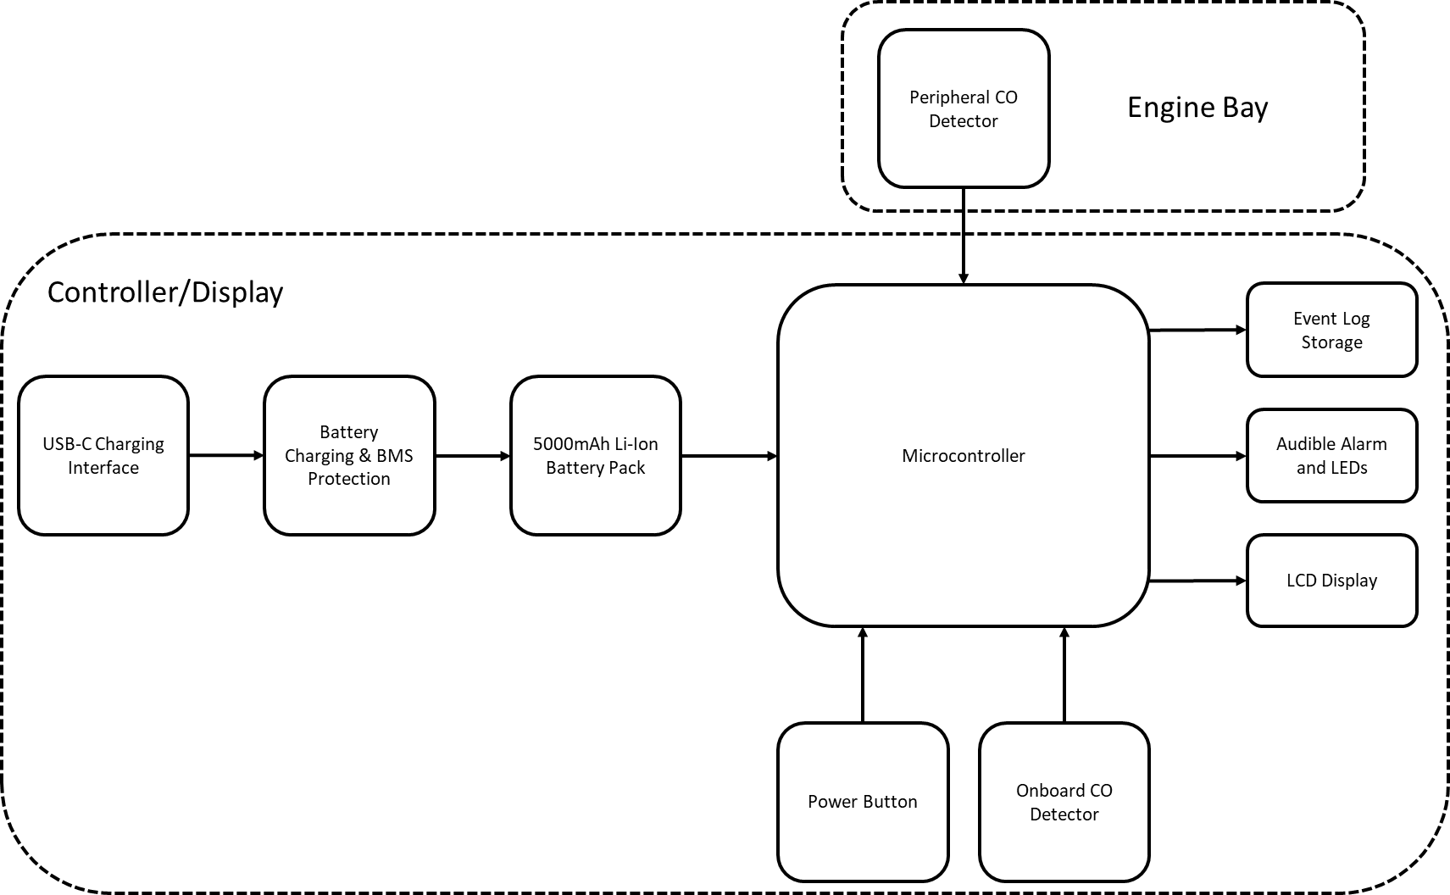
Figure 1 - Proposed Design Block Diagram

Program Flow Diagram
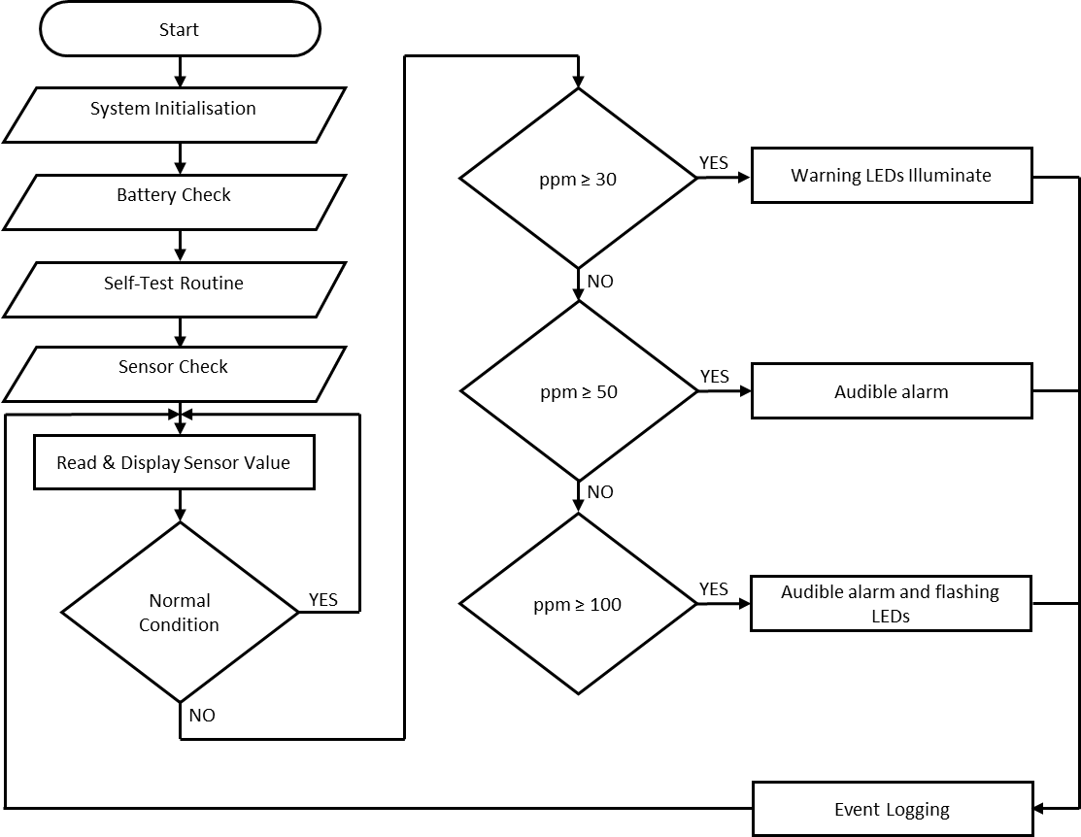
Figure 2 - Program Flow Chart

System Operation
The device continuously monitors carbon monoxide levels from both sensors and updates readings on the display. The ranges are in line with recommended levels from BS EN 50291-1 [10] and BS EN 50291-2 [11]. Although these standards state allowable timescales at certain exposure levels, this project will disregard these. Audible and visual alarms will be provided instantaneously due to the enclosed nature of the vehicle, and the potential of operating vehicles under the influence of carbon monoxide exposure, as shown Table 1.
Table 1 - CO Alarm Thresholds
CO Level | Response
0–30 ppm | Normal monitoring
≥30 ppm | Warning LED
≥50 ppm | Audible alarm
≥100 ppm | Critical alarm and flashing LED display

Technical Specification
Table 2 outlines the technical specifications for the project.
Table 2 - Technical Specification
Parameter | Specification
Battery Type | Lithium-Ion Rechargeable
Battery Capacity | 5000mAh
Operating Time | 12–24 Hours
Charging Method | USB-C
Charge Voltage | 5V DC
Sensor Type | Electrochemical CO Sensors
Detection Range | 0–1000 ppm
Accuracy | ±5%
Display | 2.4-inch LCD/OLED
Alarm Output | >85 dB
Response Time | <30 Seconds
Operating Temperature | -20°C to +70°C
Enclosure Rating | IP54 Minimum

System Performance Requirements
The system shall:
- Operate continuously for at least 12 hours between charges.
- Detect 0–1000 ppm CO concentrations.
- Maintain accuracy within ±5%.
- Display battery status.
- Provide low battery warnings.
- Operate reliably in automotive environments.

Risk Assessment

Risk Management Matrix
Project risks have been assessed using the Risk Management Matrix in Table 3, adapted from ISO 31000:2018 [12].
Table 3 - Risk Management Matrix
Risk Matrix |  | Consequence
 |  | Insignificant | Minor | Moderate | Major | Severe
Likelihood | Almost Certain | Medium | High | Very High | Very High | Very High
Likelihood | Likely | Medium | High | High | Very High | Very High
Likelihood | Possible | Low | Medium | High | High | Very High
Likelihood | Unlikely | Low | Low | Medium | Medium | High
Likelihood | Rare | Low | Low | Low | Low | Medium

Risk Matrix Before Mitigation
Table 4 assess the project risks before any mitigation measures are applied.
Table 4 - Risk Assessment Before Mitigation
Risk | Likelihood | Consequence | Risk
Sensor Failure | Unlikely | Severe | High
Calibration Error | Unlikely | Major | Medium
Software Fault | Unlikely | Major | Medium
Battery Failure | Possible | Severe | Very High
Charging Circuit Failure | Possible | Severe | Very High
Electrical Interference | Rare | Major | Low
Budget Overrun | Possible | Major | High
Schedule Delay | Possible | Major | High

Risk Matrix After Mitigation
Table 5 assess the project risks after mitigation measures are applied.
Table 5 - Risk Assessment After Mitigation
Risk | Mitigation | Likelihood | Consequence | Risk
Sensor Failure | Proven sensors | Rare | Severe | Medium
Calibration Error | Calibration procedure | Rare | Major | Low
Software Fault | Validation testing | Rare | Major | Low
Battery Failure | Certified battery | Rare | Severe | Medium
Charging Circuit Failure | BMS protection | Rare | Severe | Medium
Electrical Interference | EMC filtering | Rare | Major | Low
Budget Overrun | Cost monitoring | Unlikely | Major | Medium
Schedule Delay | Weekly reviews | Unlikely | Major | Medium

Risk Review
Using the Risk Management Matrix in Table 3, the risks to the project ranged from low to very high, as seen in Table 4. Mitigations were then explored and the project risks reassessed. Table 5 shows the new risk rating, with mitigations implemented, are all low or medium.
These are acceptable levels of risk for this project.

Cost Benefit Analysis

Estimated Costs/Benefits
Table 6 - Estimated Recurring Costs
Item | Quantity | Model | Supplier | Unit Cost (£) | Total Cost (£)
Carbon Monoxide Sensor Module | 2 | Winsen ZE07-CO | RS/Farnell | 25 | 50
Microcontroller | 1 | PIC16F877A | Mouser/Farnell | 12 | 12
TFT Display | 1 | 2.4" SPI TFT LCD | Mouser | 18 | 18
Li-Ion Battery | 1 | 5000mAh 3.7V Pack | RS Components | 20 | 20
USB-C Charging Module | 1 | TP4056 USB-C | RS/Amazon | 5 | 5
Battery Protection Module | 1 | DW01A/FS8205A BMS | RS Components | 3 | 3
Voltage Regulator | 1 | LM2596 Buck Converter | RS Components | 4 | 4
Piezo Buzzer | 1 | 5V Active Buzzer | RS Components | 4 | 4
High Brightness LEDs | 3 | Red/Amber/Green LEDs | RS Components | 0.50 | 1.50
Push Buttons | 1 | Panel Mount | RS Components | 1 | 1
PCB Manufacture | 1 | Prototype PCB | JLCPCB | 15 | 15
Enclosure | 1 | Hammond 1554 Series | RS Components | 18 | 18
Automotive Cable | 2m | 4-Core Screened Cable | RS Components | 4 | 8
Automotive Connector | 1 | IP67 Connector Set | RS Components | 8 | 8
Fuse & Holder | 1 | 1A Mini Fuse | RS Components | 2 | 2
Total |  |  |  |  | 169.50
Table 7 - Estimated Non-recurring Costs
Activity | Hours | Rate (£/hr) | Cost (£)
Research & Requirements | 40 | 15 | 600
Circuit Design | 80 | 15 | 1200
Embedded Software Design | 80 | 15 | 1200
Testing & Validation | 40 | 15 | 600
Total |  |  | 3600

Net Benefit
Using the values derived from Table 6, and given an approximate unit retail price of £250, the net benefit of each unit is £80.50, as shown from Equation 1 [13]. A total non-recurring cost of £3600 was calculated in Table 7. This means the project will be profitable after the sale of 45 units.
$$\text{Net Benefit}=\text{Total Benefit}\text{s - }\text{Total Costs}$$
$$\text{Net Benefit}=\text{£250 - £169.50}$$
$$\text{Net Benefit}=\text{£80.50}$$
Equation 1 - Net Benefit

Benefit Cost Ratio
Again, using the values derived from Table 6, and given a unit retail price of £250, the benefit cost ratio of each unit 1.47, as shown from Equation 2 [13]. With a value higher than 1, this makes the project viable for profit.
$$\text{Benefit Cost}\text{ Ratio (BCR)}=\frac{\text{Total Benefits}}{\text{Total Costs}}$$
$$\text{Benefit Cost Ratio (BCR)}=\frac{\text{£250}}{\text{£169.50}}$$
$$\text{Benefit Cost Ratio (BCR)}=\text{1.47}$$
Equation 2 - Benefit Cost Ratio

Benefits
- Early leak detection.
- Reduced risk of poisoning.
- Improved occupant protection.
- Reduced risk of vehicle damage

Operational Benefits
- Portable deployment.
- No vehicle modifications. Use existing cable routes to engine bay.
- Multi-vehicle compatibility.
- Supports preventative maintenance.

Financial Benefits
- Reduced maintenance costs.
- Reduced vehicle downtime.
- Potential reduction in insurance costs.

Commercial Viability
A portable system provides significantly greater flexibility than permanently installed alternatives because one unit can be transferred between multiple vehicles. This increases potential market demand among commercial fleet operators and private users.

Ethical Considerations

User Safety
The system must never create false safe conditions. Accurate detection is critical for protecting occupants. Therefore, sensor selection is critical to achieve this.

Reliability
The device must undergo extensive validation and calibration to ensure dependable performance.

Privacy
No personal information is collected or transmitted.

Accessibility
The design includes:
- Audible warnings.
- Visual warnings.
- Simple controls.
- Easy to read display.

Engineering Responsibility
Engineers have an ethical responsibility to ensure safety critical products perform reliably under all anticipated operating conditions.

False Positives and False Negatives
False alarms may cause inconvenience, but false negatives could result in failure to detect a dangerous condition. Testing and calibration are therefore essential.

Relevant Standards
- BS EN 50291-1 – Carbon monoxide alarm requirements for domestic
premises.
- BS EN 50291-2 – Carbon monoxide alarms for recreational vehicles and
similar environments.
- ISO 26262 – Functional safety of electrical/electronic automotive systems.
- ISO 16750 – Environmental testing for automotive electrical and electronic
equipment.
- IEC 62133-2 – Safety requirements for lithium-ion batteries.
- IEC 60529 – IP ratings
- IEC 62368-1 – General safety of electronic equipment.
- ISO 9001 – Quality management systems.
- ISO 31000 – Risk management principles

Quality Management Strategy
Quality assurance will be maintained through:
- Design reviews.
- Prototype inspections.
- Calibration verification.
- Functional testing.
- Battery endurance testing.
- Requirement’s validation.
- Continuous improvement using the Plan–Do–Check–Act (PDCA) methodology [14].

Project Planning

Work Breakdown Structure (WBS)
Level 1
- Research (1 week)
- Requirements Definition (1 week)
- Hardware Design (2 weeks)
- Software Development (2 weeks)
- Prototype Construction (3 weeks)
- Testing (1 week)
- Documentation (2 weeks)
Level 2 & 3
- Research (1 week – 5 working days)
  - Literature review (2 days)
  - Sensor comparison (1 day)
  - Battery technology review (2 days)

- Requirements Definition (1 week – 5 working days)
  - Functional requirements (1 day)
  - Component requirements (1 day)
  - Alarm thresholds (1 day)
  - Battery requirements (2 days)

- Hardware Design (2 weeks – 10 working days)
  - Circuit design (2 days)
  - Charging system design (3 days)
  - PCB development (3 days)
  - Enclosure design (2 days)

- Software Development (2 weeks – 10 working days)
  - Sensor algorithms (3 days)
  - Alarm logic (4 days)
  - Battery monitoring software (3 days)

- Prototype Construction (3 weeks – 15 working days)
  - Procurement (4 days)
  - Assembly (8 days)
  - System integration (3 days)

- Testing (1 week – 5 working days)
  - Functional testing (2 days)
  - Battery life testing (2 days)
  - Calibration testing (1 day)
7. Documentation (1.2 weeks – 6 working days)
7.1 Technical report (4 days)
7.2.User guide (4 days)
  - Final submission (2 days)

8. Contingency Time (0.6 weeks – 3 working days)

Gantt Chart
Figure 3 - Project Gantt Chart

Network Diagram
Figure 4 is the proposed network diagram for the project.


Figure 4 - Network Diagram

The tasks, activities and timescales for the network diagram are detailed in Table 8.
Table 8 – Activity Table
Task | Activity | Preceding Activity | Activity Time
1. Research | A | None | 5
2. Requirement Definition | B | A | 5
3. Hardware Design | C | A,B | 10
4. Software Development | D | A,B | 2
5. Prototype Construction | E | A,B,D | 10
6. Testing | F | A,B,C,D,E | 15
7. Documentation | G | A,B,C,D,E,F | 5
8. Contingency | H | A,B,C,D,E,F,G | 6

Critical Path
The critical path is defined as the longest chain of dependant tasks [15]. Using the network diagram in Figure 4, the longest chain of dependable tasks can be seen as A,B,D,E,F,G,H. With the given timescales, in days, of 5,5,2,10,15,5,6, the total time scale expected for the project is 48 days, excluding weekends. With weekends included, the total number of days will be 65. This gives 3 days contingency, and 2 weekend days, if a 10 week (70 day) project time is allowed for.

Project Deliverables
Table 9 – Project Deliverables
Deliverable | Week
Requirements Specification | 2
PCB Design | 4
Embedded Software | 5
Functional Prototype | 8
Tested Prototype | 9
Final Report | 10

Project Milestones
Table 10 - Project Milestones
Milestone | Week
Project Approval | 1
Requirements Complete | 2
Hardware Design Complete | 4
Software Complete | 5
Prototype Operational | 8
Testing Complete | 9
Final Submission | 10

Environmental Impact

Positive Impacts
- Encourages rapid repair of exhaust leaks.
- Reduces vehicle emissions before catalytic conversion.
- Improves fuel efficiency.
- Supports preventative maintenance.

Negative Impacts
- Battery production impacts.
- Electronic waste generation.
- Manufacturing emissions.

Sustainability Considerations
The design promotes sustainability through:
- Rechargeable battery technology.
- USB-C universal charging.
- Replaceable engine bay sensor.
- Modular construction.
- Recyclable enclosure materials.

Mitigation Measures
- Use recyclable materials where possible.
- Design for repairability.
- Encourage proper battery recycling.
- Minimise power consumption.

Design Limitations
Limitations include variable sensor positioning, periodic calibration requirements, inability to identify the exact leak location, and dependence on battery availability. Consequently, alarm activation would require further inspection to determine the root cause of any detected fault.

Conclusion
This proposal has outlined the development of a Portable Vehicle Carbon Monoxide Detection and Monitoring System designed to improve vehicle and operator safety by providing early warning of carbon monoxide leaks. The proposed design incorporates dual electrochemical carbon monoxide sensors, a rechargeable lithium-ion battery, USB-C charging functionality, and a microcontroller-based monitoring and alarm system capable of providing continuous detection and warning of hazardous conditions through audible and visual indications.
The review of the technical requirements, project risks, environmental impacts, ethical considerations, and commercial factors suggests that the proposed project is both feasible and achievable within the planned budget and timescale. The use of project management techniques, including risk assessment, cost-benefit analysis, work breakdown structures, Gantt charts, and critical path analysis, has helped establish a structured approach for planning and managing the project.
Although additional design work, testing, and validation would be necessary to confirm the final performance of the system, the proposed concept provides a practical solution to help reduce the dangers associated with vehicle related carbon monoxide exposure. Its portable nature, rechargeable operation, and ability to be used across multiple vehicles increase its potential value for both private owners and commercial fleet operators. Overall, the project offers a realistic and commercially viable engineering solution that supports improved safety, preventative maintenance, and responsible engineering practice.

References
[1] | S. Manahan, Environmental Chemistry, 10th ed., Boca Raton, FL, USA: Taylor & Francis Group, 2017.
[2] | L. K. Wang, N. C. Pereira and Y.-T. Hung, Air Pollution Control Engineering, Totowa, NJ, USA: Humana Press, 2004.
[3] | D. G. Penney, Carbon Monoxide Poisoning, Boca Raton, FL, USA: Taylor & Francis Group, 2008.
[4] | K. B. Schnelle and C. A. Brown, Air Pollution Control Technology Handbook, Boca Raton, FL, USA: CRC Press, 2002.
[5] | L. Cope, “Do Cars Have Carbon Monoxide Detectors?,” Engineering Fix, December 29, 2025. [Online]. Available: https://engineerfix.com/do-cars-have-carbon-monoxide-detectors/. [Accessed July 12, 2026].
[6] | UK Health Security Agency, “Carbon Monoxide: general information,” GOV.UK, May 24, 2022. [Online]. Available: https://www.gov.uk/government/publications/carbon-monoxide-properties-incident-management-and-toxicology/carbon-monoxide-general-information. [Accessed July 12, 2026].
[7] | F.-G. Banica, Chemical Sensors and Biosensors, Chichest, West Sussex, UK: Wiley, 2012.
[8] | J. Baranwal, B. Barse, G. Gatto, G. Broncova and A. Kumar, “Electrochemical Sensors and Their Applications: A Review,” Chemosensors, vol. 10, no. 9, p. 363, 2022. [Online]. Available: https://www.mdpi.com/2227-9040/10/9/363. [Accessed 12th July, 2026].
[9] | Microchip Technology Inc., “PIC16F87XA Data Sheet: 28/40/44-Pin Enhanced Flash Microcontrollers,” 2003. [Online]. Available: https://ww1.microchip.com/downloads/aemDocuments/documents/MCU08/ProductDocuments/DataSheets/39582C.pdf. [Accessed 12th July, 2026].
[10] | British Standards Institution, “BS EN 50291-1:2018 Electrical apparatus for the detection of carbon monoxide in domestic premises – Part 1: Test methods and performance requirements,” British Standards Institution (BSI), London, UK, 2018.
[11] | British Standards Institution, “BS EN 50291-2:2019 Electrical apparatus for the detection of carbon monoxide in domestic premises – Electrical apparatus for continuous operation in a fixed installation in recreational vehicles and similar premises including recreational craft.,” British Standards Institution (BSI), London, UK, 2019.
[12] | International Organization for Standardization, “ISO 31000:2018 Risk Management — Guidelines,” International Organization for Standardization (ISO), Geneva, Switzerland, 2018.
[13] | R. J. Brent, Applied Cost Benefit Analysis, Cheltenham, UK: Edward Elgar Publihing Limited, 2006.
[14] | J. S. Oakland, Total Quality Management and Operarional Excellence, New York, NY, USA: Routledge, 2014.
[15] | D. Lock, The Essentials of Project Management, 4th ed., New York, NY, USA: Routledge, 2014.

Appendix

Equality and Diversity Briefing Certificate


Prevent Duty Certificate


