Bethan Ames

Between the lines: What is the impact of crochet in the 21st century?

Surface Pattern Design

P146510
5511 Words

Julia Lockheart

Contents

- List of Illustrations……………………………………………Page 3
- Introduction……………………………………………………Page 4-5
- Chapter 1………………………………………………………Page 6-12
- Chapter 2………………………………………………………Page 13-18
- Chapter 3………………………………………………………Page 19-24
- Conclusion……………………………………………………..Page 25-26
- Bibliography……………………………………………………Page 27-30

List of Illustrations

- Figure: Crochet Timeline. (Allfreecrochet.com, 2017)
- Figure 2: Wide-edged crochet, (Grantham Collection, 2007)
- Figure 3: Crochet Hooks, (Hobbycraft.co.uk, 2017)
- Figure 4: Abortion Animation, (Liveaction.org, 2017)
- Figure 5: Hannah Hill Embroidery, (Cutcloth.co.uk, 2017)
- Figure 6: Bad Girls, (Wendyhuhn.com, 2017)
- Figure 7: Pussyhat Project, (Drive.google.com, 2017)
- Figure 8: Casting Off My Womb, (casey-jenkins.com, 2013)
- Figure 9: Internal Scroll, (caroleeschneemann.com, 1975)
- Figure 10: Of a different yarn, (Youtube.com, 2017)
- Figure 11: Unlikely Dwellers of the Urban, (kllylmrck.com, 2017)

Introduction

Crochet will be the focus of this dissertation, its history, its links with feminism and the impact on craft and society that it has had so far in the 21st century. The four main key words for this dissertation are:
- Lines
- Crochet
- The crochet hook
- Feminism
These words will feature within the entirety of the dissertation, being the main ideas for the writing. The word lines refer to Tim Ingold’s (2016) book ‘Lines’ in which he outlines his history and theory of lines. This will feature heavily in the first chapter and then dispersed into the rest of the dissertation where necessary. Crochet and the crochet hook are the main basis for this investigation and will be the main theory throughout. Finally, feminism seemed an appropriate key word as it will feature through all the dissertation as crochet is a task that has primarily been associated with women throughout history and feminism is a word that can already be associated with crochet.
Chapter 1 will firstly be focussing on Ingold’s theory of lines. There it will discuss a general outline of the idea of lines and then onto the holes in his theory where textiles and needlework has not been investigated, something that this first chapter will do. By pulling apart Ingold’s idea of lines and relating it to needlework and the textile world, I will build a knowledge about how crocheted lines can be viewed both literally and in an abstract sense giving the reader a new perspective on how handmade cloth can be perceived. This chapter will then lead on to the history of crochet. This feels like an important subject to cover. If we are going to assess the impacts of crochet in today’s society, it is an essential process to review where crochet has come from, and how it has been perceived throughout history till the modern day. This history will also show links to Ingold’s theories in order to maintain the abstract thinking throughout the entirety of the dissertation.
Chapter 2 will look at feminism and its links to textiles and the craft world. In this chapter there will be a discussion about how textiles and needle work has been used in artwork to create a message of feminism and will be supported by textile artists such as Hannah Hill and Wendy Huhn. It feels necessary to look at feminism when linked to textile art as it has a big place in the 21st century and will form an introduction to chapter 3 that will look at specifically crochet and needlework artists.
Chapter 3 will focus more on 21st century artists that have used crochet and other forms of needlework in their practice and how their work is challenging the stereotypical norms of crochet. Firstly, looking at Casey Jenkins and her feminist style knitting and then Kelly Limerick and her ‘Kawaii’ inspired crochet work. There will be a discussion on the artists’ work including the messages that they are trying to convey and how their practice fits into the 21st century art and craft world.

Chapter 1

The word ‘line’ can be viewed in a variety of ways: a family line, the line of a pen, line of thought, or even a wrinkle on a face; the list goes on. When thinking about lines as a designer the focus of the list narrows with the context of drawing, cutting, stitching and the endless line of threads in textiles. In his book, Lines (2016), Ingold states that “the threading, twisting and knotting of fibres were among the most ancient of human arts” (2016:43) and although not first used for textiles but for building fencing and enclosures, it eventually led to the creation of woven cloth. Ingold looks at the nature of textiles through this idea of lines by questioning the readers’ view on what a line is from the very beginning, opening the possibilities for what a line is and where it can be found. Lines surround us in daily life, both physically and figuratively, therefore seem an important concept to explore further. When looking at lines in the context of crochet, the yarn can be seen as the line which then goes through a process of weaving, looping and knotting which in turn creates new lines in the cloth that it is producing. Ingold associates the construction of lines with the ability to weave threads together and this is the primary task in crochet.
The theories contained within Lines are interesting and link to a lot of contextual themes. It feels as though Ingold has exhausted every area and idea of where a line could be found apart from that of needlework in textiles. He has touched upon the idea of lines in textiles, however this mainly focused on the theory of the reductive and the additive, which needlework like crochet and knitting cannot fit into. The reductive and additive refers to Ingold’s idea of traces left on surfaces, embroidery is a form of needlework that does fit into this theory as the threads that are being embroidered are added on top of another fabric, acting as the additive in the task. On the one hand, this would suggest that crochet and knitting as a process that creates fabric, doesn’t fit into Ingold’s Theory on the additive and reductive as it doesn’t involve the adding or taking away of anything just the creation of new material. On the other hand, it could be seen to fit into the theory if we view acts such as crochet from a larger perspective, seeing the act of crochet as adding lines to the surface of the world, not in the literal sense like Richard Long’s (Long, 1991) work, where he walked in nature leaving lines and his mark, but more in the figurative sense; where before the act there was nothing and after the act is completed there is cloth.
It is appropriate to link to the historical lineage of crochet to pave a pathway from the past to the present, this will allow us to analyse how crochet has changed through time and where it may lead to in the future. It is also important to look at the link between crochet and Tim Ingold’s work on lines, as his work doesn’t focus on textiles very much and would be interesting to see how they could be incorporated into his theories.
Crochet has evolved over a long time; however, it is unclear when and where its origin was. Crochet is believed to originally stem from an old style of embroidery known as ‘tambouring’ during the 1700’s, this comprised of a piece of cloth stretched out over a frame and a thread that is then pulled through the cloth and looped around its own stitches to create a pattern. This relates closely to traditional embroidery that we know today, which uses a very similar technique that produces the same results. Tambouring later evolved, and the fabric that was once worked into with stitch was left behind and the technique of crochet began to emerge later in the 1800’s, this new technique was named “Crochet in the air” (Marks, 1997). Crochet has no specific place of origin, it has been found throughout history in a plethora of places such as: China, South America, and Arabia. A specific country to note however, is Ireland as crochet played a significant role in the revival of the country after the large ‘potato famine’. Irish crochet was evolved through a time where poverty was high and could be produced to sell overseas to the wealthier (Marks, 1997; allfreecrochet.com, 2017). From this crochet took on an important role in Irish communities, it became something that would be taught in schools and both men and women of all ages and children would take part in to produce the crochet, a concept with feels slightly unfamiliar as such tasks were historically taken on by only women. (Marks, 1997; allfreecrochet.com, 2017). This rich history shows how crochet has gained influences from a wide range of places, being executed slightly different in every different place its used, and because of its unclear origin it cannot be placed solely in the hands of one culture making it a craft that is no ones, but could also be seen as everyone’s.
During the 1900’s, crochet took on its biggest transformation and leapt from just decorative ‘lace’ style pieces on clothing to a much wider range of items. Whole garments were made from crocheting and the 60’s brought the “crochet ‘boom’” (Wiatr, 2017) where crocheted homeware and clothing became even more popular.
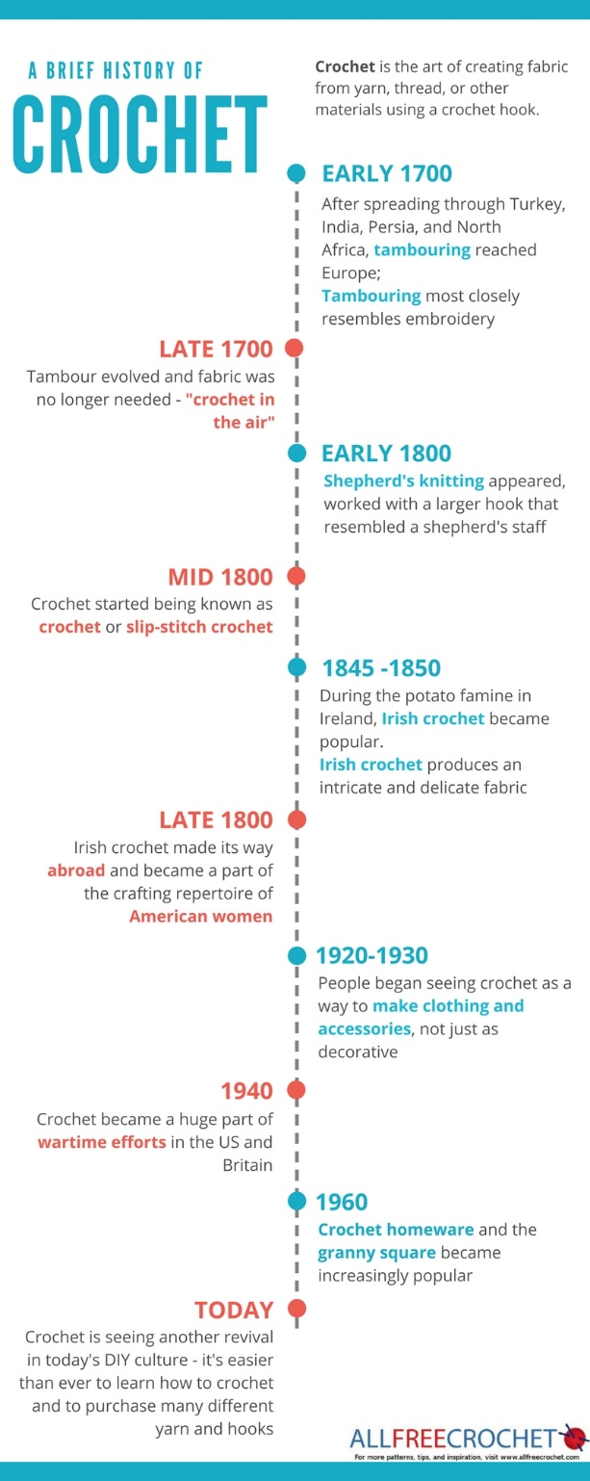
After a long decline in crochet since its height in the 60’s, crochet has slowly made its way back, now seen heavily in the fashion industry bringing a stereotypical ‘bohemian’ style. However, crochet has begun to work its way further into the art world influencing work and being used as a tool to convey a message of feminism and women in the modern day. Figure 1 attached below, (Allfreecrochet.com, 2017) shows a clear timeline of how crochet has evolved through history to the modern day. It is interesting to see the history of crochet laid out in this way, presented as sections of information sprouting off of a straight line, this creates a strong juxtaposition with the way that crochet is actually produced where the line of yarn is manipulated so that it twists, curves and knots around itself to produce new cloth.
By looking at the history of crochet we can begin to see the impact it has had on society throughout its life. Beginning as decoration and evolving through time into large fashion statements, crochet is something that seems everlasting and ever evolving, it has not only created cloth for the individual but also for the masses such as the Irish during the potato famine.
The crochet hook can be looked at as a separate entity to crochet as a whole as it has its own history and therefore can be viewed as an object alone as it can hold stories of its own. In its most basic form the hook can be seen simply as a line that is at first straight and then bend at one end. When looking at the hook in this way we can view crochet as an act, to be a single bent line manipulating another straight line into twists and knots, meandering the yarn around itself to form a new type of line. When looking at a crochet hook physically, todays crochet hooks are typically made from plastic, aluminium, steel and sometimes wood, although they have been known to be made from a variety of different materials throughout the years. Before the hook, people would simply use their fingers to crochet, however when hooks became the tool to use, many were made from various materials such as bamboo, metal wire fashioned into a hook, animal horns and in some cases bones (Marks, 1997), this made crochet a task that people of all backgrounds could take part in. A single crochet hook can hold a lot of history on its own, just like the cloth that it produces, the hook itself can be passed down a line, generation to generation; which can hold a lot of feelings and memories. Usually being passed from mother to daughter, the crochet hook can hold feelings of nostalgia but also holds the memory of a craft that has been taken on primarily by women throughout history, therefore it could be seen as a strong tool for feminism.
Figure 1: Crochet Timeline. (Allfreecrochet.com, 2017)
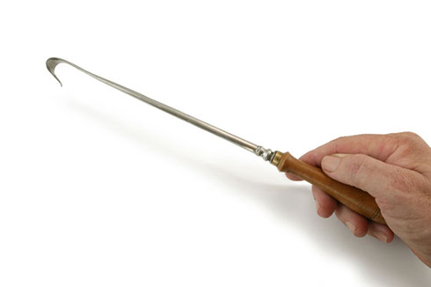
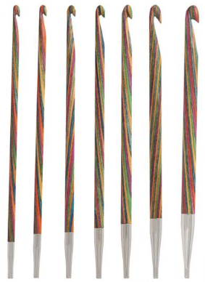
Throughout history, there has also been links with the crochet hook to more dark topics for example abortion. Although unproven, it has been stated that the crochet hook like many other objects of similar style such as an untwisted coat hanger (Marty, 2015; Valenti, 2015); were used as a tool during abortions before such things were legal. Shown below are two images, figure 2 shows a tool that has been used during abortions which is actually named “Wide-edged crochet” (Grantham Collection, 2007), the other Image: figure 3 shows a variety of crochet hooks. When viewed together the reason a crochet hook was used for such an act is clear as the tools are nearly identical, both are comprised of a long line with a hooked edge, although the hook on the end of the abortion tool is slightly wider and sharper there is no argument against why a crochet hook was used in these circumstances.
Figure 2: Wide-edged crochet, (Grantham Collection, 2007)
Figure 3: Crochet Hooks, (Hobbycraft.co.uk, 2017)
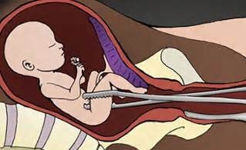
When compared also to the female anatomy the reasoning behind the use of a crochet hook for illegal abortions seems obvious. The tool, similar to the one being used in the image below would fit easily into a woman’s vagina (Marty, 2015; Valenti, 2015). Another theory as to why a crochet hook may have been used is because much like the wire coat hanger, the crochet hook was a tool that would be found in most households and an object that wouldn’t be viewed as suspicious to own.
Figure 4: Abortion Animation, (Liveaction.org, 2017)
The theory that the gives crochet hooks hook may have been involved in this much darker history gives the crochet hook a lot more depth and allows it to be separated from crochet as an act, being something that is used primarily to create new things but that has also been used to destroy others. This would also support the theory that crochet is becoming a strong tool for feminism and feminist art, it could be seen as women taking a tool that has once symbolised the oppression of their gender and using it to take control of their own life and future. The idea of inside and outside can be linked with this part of the crochet hooks history, the act of pulling something from inside to outside, in this reference its pulling the unborn child from inside out.

Chapter 2

From looking at the history of crochet we have learnt just that, the history. We have discussed its origin, where it’s been through time and how it has evolved; however, what we are yet to discuss in depth are its links with feminism. Needlework and cloth making is an act that has always been associated with women and femininity and is a task that has always been expected of them “The cultural meaning of being a woman” (Barker, 2004) when placed in context, this quote is true in the sense of men in society viewing women in a way in which they associate crochet and other forms of textile work to be a woman’s right, her job or her role in life.
Art has been seen through history as a man’s craft, this is supported by the plethora of male artists through time. However, textiles and needle work has been viewed as a woman’s job, this suggests that there is a hierarchy of the sexes in the art and craft world (Parker, Pollock, 1981:50), this can be seen by the artwork produced by men being viewed as a strong craft that is highly regarded; whereas textile and needle work being viewed as a woman’s role in society. “The sex of the artist matters” (Parker, Pollock, 1981:50), this is an interesting statement made by Rozsika Parker and Griselda Pollock in their book ‘Old Mistresses’ and the theory they seem to be producing here is that the sex of the artist changes the way that the viewer sees the art. When linked with the hierarchy of the sexes in the art world this statement has a stronger purpose, why should the sex of a person affect the way that artwork is viewed and why should a craft that can be taken on by both sexes be associated with only one and enforced as a role, however there are some exceptions to this typical hierarchy for example, William Morris who was part of both the art and the textile world. Currently in the 21st century textiles are still seen as a feminine task although it is now viewed less as a woman’s role in society unless chosen as a career.
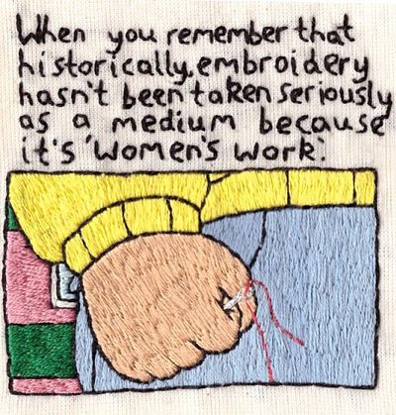
From this strong female past with the textile world, textiles and the crafts that encompass it such as needlework like crochet have begun to become part of a new feminist movement, where the crafts have been used to produce feminist protest artwork. An example of this new era of feminist artwork is the young embroidery artist Hannah Hill (Cut Cloth, 2017), who in 2016 released an image of an embroidery piece she produced. Figure 5 below shows the embroidery piece that she made, with the words “When you remember that historically, embroidery hasn’t
Figure 5: Hannah Hill Embroidery, (Cutcloth.co.uk, 2017)
been taken seriously as a medium because its ‘women’s work’.” This is a good example of how craft and needlework in the 21st century are being used to challenge the way that women are seen in society as both a gender and in relation to textiles and craft. By using an image that at the time was universally known on social media, Hill produced a piece of textile artwork that invokes feminist thoughts and brings to light how a textile craft like embroidery has always been viewed as ‘women’s work’.
Another artist who has used textiles to create feminist style artwork is Wendy Huhn. Coming from a slightly different perspective to Hill’s work, Huhn is less obvious with her feminist style and creates a wide range of artwork with a very eclectic style:
“The stories I tell through my work reflect the way I view the world, often a brash voice in a room of hushed tones. My sometimes controversial work arises more from conviction than contrariness. How one might interpret my work is, of course, unquestionably personal.” (Huhn, 2016)

Huhn’s outlook on her artwork is fascinating as she is allowing the viewer to see the work in which ever way it pleases them, she doesn’t force any ideas through her work allowing the pieces to speak for themselves. Huhn’s small embroidery pieces are particularly engaging as although there is no indication that links them directly with feminism, small details hint at hidden meanings that can be thought about in more depth. Figure 6 below shows one of her embroidered artworks which features young girls playing around in a woodland with different objects including a gun.
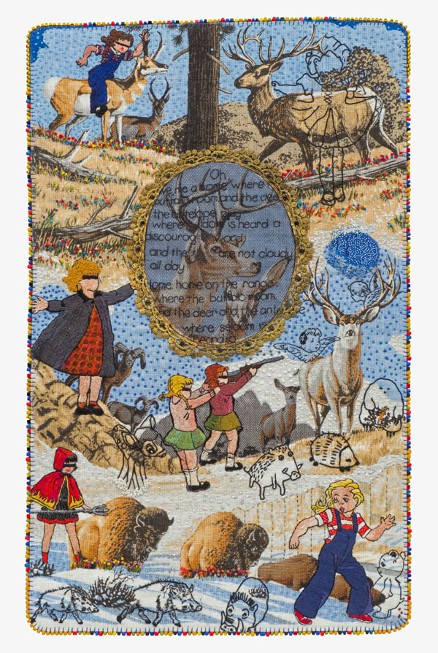
Figure 6: Bad Girls, (Wendyhuhn.com, 2017)
Titled ‘Bad Girls’ the name suggests that that the children are doing something that they shouldn’t be, giving a sense of mischief to the piece. Guns are a weapon that throughout history have been seen as a man’s object, this gives the feeling that the girls in the embroidered piece are rebelling or acting against the norm of what a woman should be.
Hill and Huhn are a good representation of feminism being portrayed through needlework and textiles. Another example of needlework that has been linked with feminism was the recent feminist movement in America known as the ‘Pussyhat’. Figure 7 below shows a photograph of the Pussyhat and instructions on how to crochet one yourself (Pussyhat Project, 2017). The Pussyhat
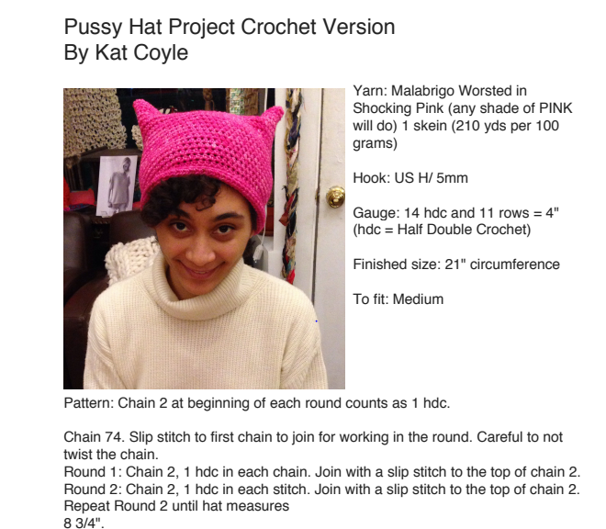
Figure 7: Pussyhat Project, (Drive.google.com, 2017)

Project was created as a symbol for women’s rights and has recently become part of the #MeToo campaign which supports people that have “experienced assault, harassment or abuse” (Zweiman, 2017). The hat has been part of many woman’s right’s marches, the most recent in protest of Donald Trumps presidency and is worn not only by women but also men who support the movement (Young, 2017; Walker, 2017). The Pussyhat is a strong example of how crochet and other forms of needlework can be used not only as a tool for feminism but also in a political context “For feminist theory, the development of a language that fully or adequately represents women has seemed necessary to foster the political visibility of women” (Butler, 1990). To create a new wave of feminism, crochet and other forms of needlework could therefore become the language that represents women on their feminist stance in politics.
These kinds of feminist needleworks suggest that there is a new era of craft upon us in the 21st century, one that will include view points from a wide range of people, spanning over different generations and genders. After being a tool for the oppression of women for such a long time, textiles and needlework are making their way back, becoming the opposite of oppression and rising up as a tool for feminism.

Chapter 3

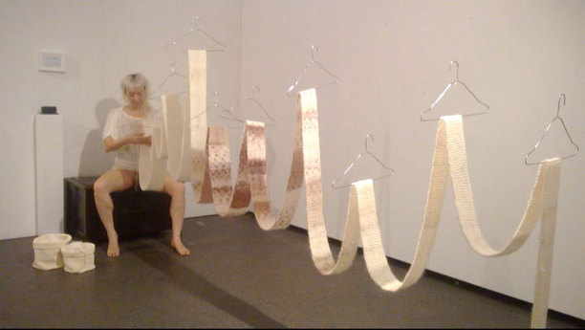
Craftivist. This is what Casey Jenkins calls herself. Working mainly through knit, her work challenges people’s views on feminism, female identity and the female genitalia. ‘Casting off my womb’, possibly her most well-known performance artwork featured Jenkins herself knitting with yarn that had been placed inside of her vagina for a 28-day period, which included working through a period of menstruation (Driscoll, 2014; Winter, 2013). Although Jenkins did not in fact use crochet in this performance piece, knitting could be seen as a close relative of crochet and the feminist themes she works on seem to work on challenging the way that society sees women, knit and the craft world. The message that Jenkins is trying to convey in her performance piece is that the female genitalia is something natural and normal; something that people shouldn’t be afraid of confronting in life. “If you take a good, hard look at the vulva, you realise it’s just a bit of body. There’s nothing shocking or scary, nothing that is gonna run out and eat you up” (Jenkins, 2013). By using yarn that unravels slowly from inside her vagina to make a long knitted piece, she is associating something that many people find taboo with something that everyone can relate to one way or another, “By linking the vulva to something that people find warm and fuzzy and benign” (Jenkins, 2013). Knitting, like crochet and the crochet hook can invoke a lot of warm feelings and memories of home and family; by using knitting in her work, this is how Jenkins is attempting to reverse the stereotypes placed on the female body.
Figure 8: Casting Off My Womb, (casey-jenkins.com, 2013)
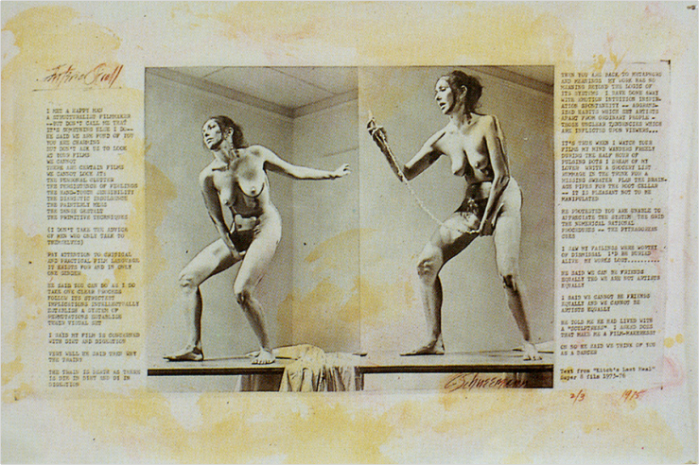
Figure 8 above shows a shot of Jenkins during her performance for her piece ‘Casting off my womb’. The way that Jenkins has positioned the knitted piece on wire hangers at different heights is interesting to look at as highlights different parts of the cloth, areas that appear very clean are raised higher than those that have been tainted from the period of time where Jenkins worked through her menstruation. It’s unclear if this is something that she has done intentionally, although it has a nice effect on the look of the cloth she has produced; disrupting the cleanliness and the idea of how new cloth is always viewed as clean and untouched. Jenkins’ performance could also link to an idea of the inside and the outside much like the crochet hook. Similar to Carolee Schneemann’s performance piece ‘Internal Scroll’ (caroleeschneemann.com,2017), where the she stood naked and pulled a scroll from her vagina which she then read from. Figure 9 shown below, shows Schneemann during her performance piece pulling the scroll from the inside out which is mirrored in Jenkins ‘Casting off my womb’ performance as she pulls yarn from within her, birthing out a line of cloth and forcing the viewer to see her complete this act, thus taking something from the inside and pulling it out. By completing her performance piece in person and partially nude “To be nude is to be seen naked by others and yet not recognised for oneself” (Berger, 1972:54), the viewer is able to see the action of yarn being pulled from inside and then knitted outside, this challenges the way that a vagina in its basic form is viewed. Usually seen as a part of the body that is linked with sexual pleasure and reproduction, Jenkins has used the vagina to create something different that cannot be produced by the body and is allowing the viewer to see her do this with her genitals exposed. The way that Jenkins has draped the cloth through the wire hangers is also very intriguing to look at, instead of letting the cloth fall into a straight line on the floor, Jenkins has disrupted the area around her by hanging it up, forcing the viewer to look at it and view it from all angles. By hanging the cloth on the wire hangers Jenkins has given the material movement and a softness that wouldn’t have been there if it was simply hung in a straight line or laid across the floor. The wave of fabric could also be viewed like the line of a woman’s period of menstruation, something that Jenkins has included in her performance.
Figure 9: Internal Scroll, (caroleeschneemann.com, 1975)
Jenkins’ work is a good example of one way that crochet and craftism is seen in today’s society. When being used in this way crochet and other forms of needlework take on a new life, leaving behind stereotypes of old doyleys and blankets that someone’s grandmother knitted all them years ago and taking on a new role in 21st century feminism and the art world. The “Warm and fuzzy” (Jenkins, 2013) feelings towards crochet and knit are still there but are coupled with a harsher reality of the female body and women’s rights, cushioning the harder topics with something that people instantly find comforting.
Another artist who has challenged the way that crochet is seen in the 21st century is Kelly Limerick (2017). A self-proclaimed ‘crochet artist’, after being taught to crochet as a child by her mother, Limerick has taken crochet to a whole new level incorporating it into the way that she lives. With a strong individual style heavily influenced by Japanese kawaii, Limerick has used her knowledge in primarily crochet and occasionally in other forms of needlework to create her own designs without the use of well-known patterns for a variety of objects ranging from items as small as phone cases up to large fine art crochet installations. Limerick has also taken part of a new crochet fad known as ‘yarn bombing’ (The Telegraph, 2009) similar to many other craft artists such as Robyn Love (Hung, Magliaro, 2007:102) who take to the streets, creating bursts of colour and yarn across the city where they reside making unconventional and mundane places pop with colour and life and transforming urbanised areas into creative spaces. Limerick’s unusual take on such a traditional craft is very fresh and brings a new perspective to the way that crochet is seen in society, transitioning it from a craft that many find old fashioned and outdated into something exciting and vibrant that everyone can have a piece of.
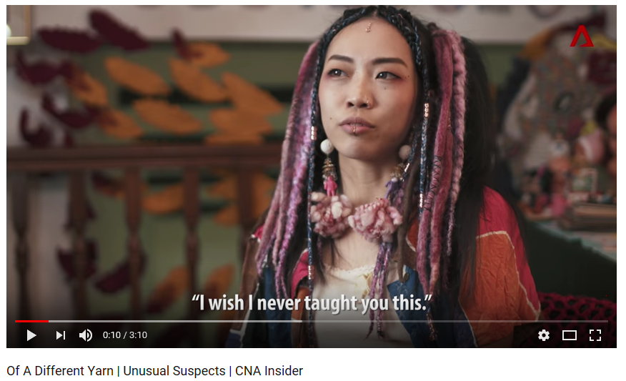
Although Limerick was taught to crochet as a child by her mother, the support of her family isn’t something that she has been given throughout her adventures with crochet. Art and crafts in the past and still to this day have not always been seen as a strong career choice due to an instability in profit and job choices, this is where Limerick has a difference in opinions to her family, “I wish I never taught you this” (Limerick, 2017) a statement made by Limerick’s own mother and stated by Limerick in an interview with CNA Insider shown in figure 10 below. It feels sad to think that
Figure 10: Of a different yarn, (Youtube.com, 2017)

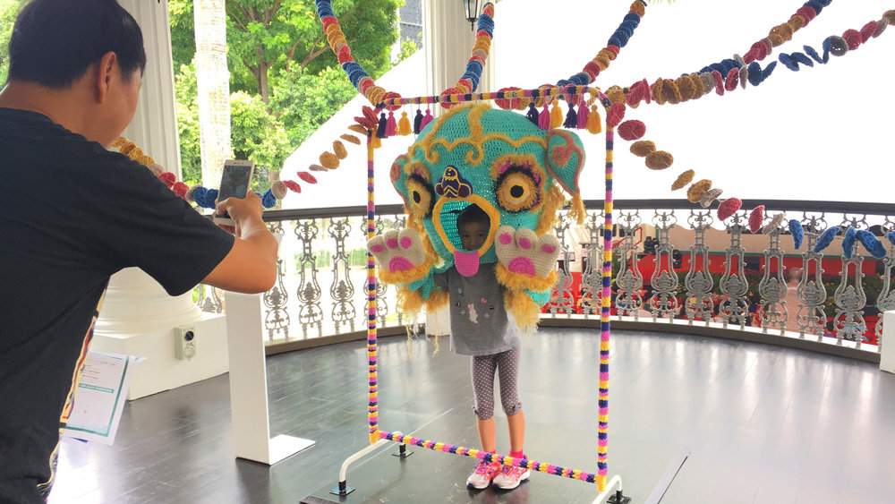
there is a lack of support in Limerick’s family for her undoubtedly successful career in the art and craft world, particularly coming from her mother. As discussed in the previous chapter, crochet is a craft that has been primarily passed down through a line of generations from mother to daughter and in Limerick’s case it is no different. Although the assumption that crochet and arts and crafts in general are an unstable career choice, the world appears to be moving in a direction where the art, crafts and needlework like crochet are beginning to have a strong role in both fashion and art culture, this is something that is represented well by Kelly Limerick and the artwork that she is producing, taking on large collaborations with big international companies such as: Louis Vuitton and Teva, Limerick has also taken on many collaborations with other artists, exhibiting in a variety of venues (2017).
Figure 11: Unlikely Dwellers of the Urban, (kllylmrck.com, 2017)
Figure 11 above shows one of Limerick’s crochet pieces from her recent exhibition ‘Unlikely Dwellers of the Urban’ which was held at the “Indian Heritage Centre, Malay Heritage Centre and Sun Yat Sen Nanyang Memorial Hall” (Limerick, 2017) the exhibition featured workshops as well as a wide range of crochet art works which were both interactive and not. The interactive pieces like the one featured above feel like a thing that should be discussed as Limerick is inviting the viewer to not just look but to explore and involve themselves in the artwork she has produced, making the viewer part of the exhibition too. Her bold colours and fresh take on what crochet can be are inspiring and show that there are no limits to where crochet can be taken to.

Conclusion

The start of this essay began with Tim Ingold’s theory on lines, a review of the history of crochet and a link between both topics. Ingold’s work on lines and its relationship with textiles allowed me to set the groundwork for the type of writing that would be encountered later in the essay, opening the mind of the reader so that it could be read in both a literal sense and a more abstract way. By looking at Ingold’s work on lines and linking it to crochet and other forms of needlework I was able to examine a theory that Ingold has yet to look at in depth and explore new ideas on crochet and its relationship with lines. By looking at the history I was able to evaluate how crochet has changed through time. Its unknown origin gives crochet a slightly mysterious quality and through time it has become an integral from of cloth making. Its relationship with class in society was fascinating as there is no definitive group of people that crochet was linked to, being a craft that could be done by both the poor and the wealthy. Its links with the Irish potato famine also show its impact with the economy as it pulled a society out of poverty.
Moving onto the second chapter, the focus was on feminism linked with textiles. Feminism was an important topic to look at as it has become a more populist movement in the 21st century and has been involved a lot with the art and textile world. By looking at artists like Hannah Hill and Wendy Huhn we were able to see the type of feminist style work that is being produced now in the 21st century and the impact that the feminist movement is having. Hill’s embroidery work in particular shows how social media can be used to publicise both embroidery as a craft and feminism, bringing artwork that many may have not seen to a pubic platform where it can be shared freely over the globe. The Pussyhat also felt like an important topic to review as it stands for women’s rights and has been a symbol for feminism since its creation in 2017. This kind of work is suggesting that there is a new wave of feminism in the 21st century that is including craft and needlework, using them as a tool for a feminist political movement.
The third chapter focused solely on artists that have used crochet and needlework in their practice. Casey Jenkins like the artists in chapter 2, worked towards a feminist outcome and challenged people to view women’s genitalia in a different way from the norm, through the use of knitting. Jenkins work is representative of the new wave of feminist art and fits in well with 21st century feminism. Kelly Limerick’s work on the other hand has no political agenda, instead her work challenges stereotypical crochet by using a modern style, bold colours and unusual influences.
Between the lines: What is the role of crochet in the 21st century? That was the question in focus when I began this essay. From evaluating the history, considering the feminist movement and discussing different textile artists I can see how crochet has evolved through time and has become a strong craft in the 21st century. Crochet has taken on a new role in the art world and is Beginning to place itself into society from its use in political stances and through the medium of art. The future of crochet is still unknown however, from its current status in today’s society I predict that it will be solidified further as a tool for protest and will be considered more in a fine art context.

Bibliography

Books:
Barker, C. (2004) The SAGE dictionary of cultural studies. London: SAGE Publications Ltd
Berger, J. (1972) Ways of Seeing. London: Penguin Books Ltd
Butler, J. (1990) Gender Trouble. New York: Routledge
Hung, S. and Magliaro, J. [eds] (2007) By Hand: The Use of Craft in Contemporary Art. New York: Princeton Architectural Press
Ingold, T. (2016) Lines. New York: Routledge
Long, R. (1991) Walking in Circles. London: Thames & Hudson
Parker, R. and Pollock, G. (1981) Old mistresses – women, art and ideology. London: Pandora

Websites:
Cut Cloth. (N.D) Accessed from https://www.cutcloth.co.uk/artists [Accessed on 10th December, 2017]
Driscoll, B. (2014) ‘Vaginal knitting’ is the latest feminist performance art - but does it open discussion or close it? Accessed from http://www.huffingtonpost.co.uk/2013/12/03/vaginal-knitting-casting-off-my-womb_n_4378006.html [Accessed on 26th November, 2017]
Hill, H. (N.D) Accessed from https://www.instagram.com/hanecdote/?hl=en [Accessed on 10th December, 2017]
Huhn, W. (2016) Accessed from http://www.wendyhuhn.com/about/ [Accessed on 10th December, 2017]
Limerick, K. (N.D) Accessed from http://www.kllylmrck.com/collab/#/unlikely-dwellers-of-the-urban/ [Accessed on 5th December, 2017]
Long, R. (N.D) Accessed from http://www.richardlong.org/ [Accessed on 3rd December, 2017]
Love, R. (N.D) Accessed from http://www.robynlove.com/ [Accessed on 7th December, 2017]
Marks, R. (1997) History of Crochet. Accessed from http://www.crochet.org/?page=CrochetHistory [Accessed on 21st November, 2017]
Marty, R. (2015) The coat hanger abortion is back, and this time, women can be jailed for it. Accessed from http://www.cosmopolitan.com/politics/news/a50831/the-coat-hanger-abortion-is-back-and-this-time-women-can-be-jailed-for-it/ [Accessed on 5th December, 2017]
Schneemann, C. (N.D) Accessed from http://www.caroleeschneemann.com/works.html [Accessed on 4th December,2017]
The Telegraph. (2009) Knitters turn to graffiti artists with ‘Yarn bombing’. Accessed from http://www.telegraph.co.uk/news/uknews/4305406/Knitters-turn-to-graffiti-artists-with-yarnbombing.html [Accessed on 7th December, 2017]
Valenti, J. (2015) Abortion by wire coat hanger is not a thing of the past in America. Accessed from https://www.theguardian.com/commentisfree/2015/dec/15/wire-coat-hanger-abortion-stories-united-states [Accessed on 5th December, 2017]
Walker, R. (2017) Accessed from https://www.newyorker.com/culture/culture-desk/the-d-i-y-revolutionaries-of-the-pussyhat-project [Accessed on 11th December, 2017]
Wiatr, J. (2017) The History of Crochet: From Tambour through Irish Crochet. Accessed from https://www.allfreecrochet.com/Basics/The-History-of-Crochet [Accessed on 20th November, 2017]
Winter, K. (2013) She didn’t learn that at WI: ‘vaginal knitter’ spends 28 days making scarf from wool stored inside her. Accessed from http://www.dailymail.co.uk/femail/article-2518107/Vaginal-knitter-artist-Casey-Jenkins-makes-scarf-wool-stored-inside-vagina.html [Accessed on 26th November, 2017]
Young, S. (2017) Accessed from http://www.independent.co.uk/life-style/fashion/pussyhat-project-donald-trump-protest-sign-symbol-defiance-womens-march-washington-dc-president-a7531256.html [Accessed on 11th December, 2017]
Zweiman, J. (2017) Accessed from https://www.pussyhatproject.com/blog/ [Accessed on 11th December, 2017]

videos:
Yanling, Z. [Producer] (2017) Accessed from https://www.youtube.com/watch?v=qlEPf2SnsvY [Featuring Kelly Limerick] [Accessed on 27th November, 2017]

images:
Figure 1: Crochet Timeline. Accessed from https://irepo.primecp.com/2017/07/338801/Timeline-History-of-Crochet_MASTER_ID-2329304.jpg?v=2329304 [Accessed on 29th November, 2017]
Figure 2: Abortion Tool. Accessed from http://www.abortioninstruments.com/new_index.html#instruments [Accessed on 7th December, 2017]
Figure 3: Crochet Hooks. Accessed from http://www.hobbycraft.co.uk/knitpro-symfonie-tunisian-crochet-hook-set/607100-1000 [Accessed on 7th December, 2017]
Figure 4: Abortion Animation. Accessed from https://www.liveaction.org/news/wp-content/uploads/2016/03/Abortion-Procedures-DE-Levatino-forceps-NAF-672x372.jpg [Accessed on 7th December, 2017]
Figure 5: Hannah Hill Embroidery. Accessed from https://www.cutcloth.co.uk/artists [Accessed on 10th December, 2017]
Figure 6: Bad Girls. Accessed from http://www.wendyhuhn.com/project/bad-girls/ [Accessed on 10th December, 2017]
Figure 7: Pussyhat Project. Accessed from https://drive.google.com/file/d/0BwBjtQGbV7gEd0FOaVVpM3M0MzVXQ2tMQmg0UDhtNktKSVVr/view [Accessed on 11th December, 2017]
Figure 8: Casting off my womb. Accessed from http://casey-jenkins.com/works#popmake-7287 [Accessed on 29th November, 2017]
Figure 9: Internal Scroll. Accessed from http://www.caroleeschneemann.com/works.html [Accessed on 7th December, 2017]
Figure 10: Of a Different Yarn. Accessed from https://www.youtube.com/watch?v=qlEPf2SnsvY [Accessed on 27th November, 2017]
Figure 11: Unlikely Dwellers of the Urban. Accessed from http://www.kllylmrck.com/collab/#/unlikely-dwellers-of-the-urban/ [Accessed on 5th December, 2017]

