

ACCA4017

Programming in C

By
Rebecca Ryall
1705433



Table of Contents
Table of figures 2
Summary 3
Exercise 1 3
The test used to check the code and findings 4
Exercise 2 5
The tests used as well as their findings for exercise two 6
References 7
Appendances 8
Appendix 1 8
Images of code being tested for exercise one 8
Appendix 2 13
Images of code being tested for exercise two 13
Appendix 3 16
The completed code for exercise 1 16
Appendix 4 17
The competed code exercise 2 17

Table of figures
Figure 1 first test 8
Figure 2 first test results 8
Figure 3 second test 9
Figure 4 second test results 9
Figure 5 third test 10
Figure 6 third test results 10
Figure 7 forth test 11
Figure 8 test for limitations 11
Figure 9 test for limitations 12
Figure 10 locations entered 13
Figure 11 result of first test 13
Figure 12 results of second test 14
Figure 13 player one’s test 14
Figure 14 player two's test 15

Summary
In this report it discusses the strengths and weaknesses that was over come to create and complete the game in exercise 1 and exercise 2. The objective of the Game created in exercise 1 was a two-player game, where player one is asked to enter 7 numbers and then they are taken stored and hidden. Then player two is given the first number out of the seven numbers entered by player one and then asked if the second number is higher or lower than the first one. Player two must enter either higher or lower, the game will continue until either player two has guessed all seven numbers correctly or if player two has guessed one of the numbers wrong. If player two has guessed all the numbers correctly then player two wins but if player two guesses one wrong the game ends and player one wins.
When it come to the game in exercise 2, the game was set out differently but with some similarities these being that the game was a two-player game and would also ask player one to enter some numbers. And those numbers to then be stored to be used later on in the game, and then for player two to also guess these numbers but that is where the similarities ended. The difference being the numbers enter by player one was used as plot points to place three treasure on a 8x8 grid. Player two would then try and guess the location of these treasure by entering the coordinates, player one needed to enter the x and y coordinates for each treasure. Player two starts the game with three lives and if they fail to type in the coordinates of a treasure it would display an ‘N’ on the grid and they would lose one life, if they find a treasure it would display a ‘X’ on the grid.

Exercise 1
When it come to the exercise one assignment, the program that was needed as a whole was tricky to implement all at once. So to make it easier to tackle the big problems were broken down in to small problems and then organised, in order being the easiest at the top and the more difficult at the bottom. Then using this list each section of the program was tackled a bit at a time, plan was to go through the list top to bottom and to take each problem and solve them one at a time, one of the first problems was to have the code ask the user to enter seven numbers.
To do this, all that was needed was a cout to display the text asking player one to enter seven numbers. Then to be able to allow the user to enter the numbers, a getline(cin, ) was needed to be setup using a string and converted into an int to allow the user to input numbers. Instead of typing the request seven times it was much simpler to place the getline in a FOR loop[1], which would loop the code until the player had entered all seven numbers. Then a simple problem to fix was having the code not display the seven number to player two, to do this needed to input system("CLS")[2] which would clear the screen to not show the numbers to second player. Then the second problem that needed to be solved was getting the program to take the numbers, that were entered and store them so they could be reused again. The best way to have the program store the numbers together was to put them in to an array.
The third easier problem to complete which was having the program then display the first number out of the seven numbers entered by player one, to get the program to show this number all that was needed was to call up the first number in the array where all seven numbers that had been entered had been stored and have it display on the screen using a cout.
The next problem seemed easy at the start which was having the code prompt the second player to enter is the second number either higher or lower than the first number. The easy part was having the program display the text asking the user to enter higher or lower using a cout, then getting the user to input the answer seem simple enough by using a getline and keeping the variable as a string. But then that was where the problem got more difficult once the user had entered their decision. the code needed to compare the numbers enter by player one, firstly starting with comparing the first number and the second number to workout which number was higher. So it could then workout if player two was right or wrong, but there was also an issue because by using a string the player could input anything be it words or numbers.
To try and fix the problem of the user typing anything in to the answer the best way was to limit what the user could enter, instead of having them be able to enter any word or number the getline would use a string and then change it in to a char so then the user could only enter words with the letter begin with ‘h’ or ‘l’ in lower case, through these parameters the user was still allow to type higher and lower. However the player was still able to type any word as long as it started with a lower case ‘l’ or a lowercase ‘h’, this problem was not able to be fix unless the user was only limited to enter one letter. Which was not done, and the code continued to allow the user to type higher or lower.
When it came to the more difficult tasks like being able to check if player two is right or wrong after each decision player two entered, the program needed to check through the answer entered by player one and compare each number with each other, by sorting them.
To get the program to check if numbers were higher or lower the program would look through player one’s entered numbers and compare the first number with the second number to do this it would test to see if the first number was greater than the second number, if yes, the first answer would be higher. The program would do the same test with the second number and the third and so on forth until all the numbers had been compared. The simplest way to test if the first number was more than the second number was to use an IF statement[3] checking if player enter ‘l’. An the ELSE was used if they had used ‘h’, then inside the first IF statement there was a second one. checking if the user had entered an incorrect lower and the ELSE statement was for the correct lower entered. And within the ELSE statement to check if the user had entered ‘h’, would have the same check using an IF statement if the answer was incorrect higher and ELSE if the answer was correct higher.

The test used to check the code and findings
The tests used to check the code was running correctly was as follows, the first test was to play the game to enter all seven numbers for player one and to have the code display the array with the numbers in on screen. This was done check to see if the code was taking the numbers entered and storing them correctly, this is shown in figure 2.
The second test was to enter all seven numbers for player one starting with one ascending to seven, then to code would display the first number in the array to player two, the number was one. Then players two enter high as answers for all 6 numbers, the code took all 6 correct answers and displayed player two has won, this is shown in figure 4.
The third test was to enter numbers as player one starting with seven and descending to one, and then to enter player two’s answers as all lower for all 6 numbers. The game took all 6 answers as they were correct and displayed on screen player two won, this is shown in figure 6.
For the forth test enter numbers for player one starting with one and ascending to seven, but this time enter the answer for player two as lower. As this was an incorrect answer the game ended, and the code displayed player one wins, this is shown in figure 7.

The next tests were to check the perimeters of the code more than if the code worked, the first test was to see if the user could enter A letter in player ones turn. The answer was yes but with only the first number to be entered, if the user attempted to enter a second letter it would then tell the user “incorrect the number has already been entered” the code would Reloop and get the user to enter again the result of the test are shown in figure 8.
To fix this user the code would need to use ascii to limit the input to only numbers this was not done due to lack of knowledge of how to get the code work as needed, also due to time constraints.
The fifth test was to see if the game would allow player two to enter numbers or other words other than higher or lower, the code was a lot more resilient then player one the game would not allow and numbers or other word in unless they started with an lower case “l” or “h” as shown on figure 9.

Exercise 2
When it came to exercise 2 the way the game was meant to work was to have the program ask player one to enter the locations, of where they would like to hide the three treasures, using an x and y coordinates on a 8 x 8 grid. The program needed to store the location of each treasure so they could be used later in the game. Player two then had their turn, the player was shown the 8x8 grid and then had to guess the location of the treasures that player two had entered. Player two was given three lives, so the player only had a limited number of attempts to find all three treasures. If player two enter coordinates that was not the location of the treasure then they would lose a life, if player two used all three lives and failed to find all three treasures, then player one would win but if player two is successful in finding all three treasures then they win the game.
The best way to create the code was to break it down in to smaller problems and to take each part one at a time going from easiest to most difficult, the easiest problem was having the code display text asking the user to enter x and y coordinates. To do this a cout was used to display the text on screen asking the user to enter the x coordinates and to then ask again for the y coordinates. The code then needed to take the numbers enter and store them.
To set this up first thing that was needed was the use of a function, instead of using a cout in the main to display the text it was better to bring the string of text in to the function. By doing this the function could be called up each time the game needed a player to input numbers. Within this function it would display the text already brought in and allow the user to enter a number. To limit the user from enter numbers larger than the 8 x8 grid, the cout and number input were all placed in an while loop, to continually loop until the user enter a number within the grid. It would then return the entered number to the main to be stored in the array.
Within the main of the code it was set out in a way that the table grid function would be called up to display the table to player one, so the player could see where there coordinates where being placed. The text that was used to ask player one to take their turn was" player 1 please enter where you would like to hide your treasures now:". The code then went into a FOR loop to loop the code three times to take the coordinates for the three treasures and store them. The code within that FOR loop asked the user for the treasure location and also displayed a count so the user could see which treasure they where entering and how many was left to enter, then the code would clear the screen by using system("CLS")[2] which would clear the screen of player ones enter locations.
Once the screen was cleared the code would then display player two’s text "player Two it’s your turn to find the three treasures". It would then enter a WHILE loop that would continue to loop unless player two had run out of lives and if treasure had been found. Once in the WHILE loop it would ask the player two to enter their x and y coordinates, after the player had entered there coordinates it would enter in to a FOR loop to loop three times checking it the coordinates give by player two matched any of the three given by player one. To check if there were any matched coordinates it would go in to two If statements, the first IF statement was used to checking the X coordinates for a match to the stored X treasures coordinates. if yes it would then go in to the second IF statement which is within the first IF statement, the second statement would check the Y coordinates to see if they match the stored numbers. The X and Y coordinates need to match the numbers already stored,
If the coordinates entered by player two was a match to player ones then the code would display an “X” in that location but if they did not match then the game would display an “N” in that location it would continue loop until one of the argument in the WHILE loop[4] where met. When one of the WHILE loops argument was met it would then go in to an IF statement checking if all three treasures had been found if yes if would display "GAME OVER player two wins congratulations" if no then would go in to the ELSE statement which would display "GAME OVER player one wins congratulations".

The tests used as well as their findings for exercise two
The first test done on exercise 2, was to have player two win the game to do this the treasures where hidden in these locations 1,1 and 6,6 and finely 4,4 show in figure 9. then playing as player two entered these locations, each time a correct location was entered the game displayed an “X” on the grid to show treasure had been found. After all located treasures had been entered the game then displayed at the end that "GAME OVER player two wins congratulations”. Giving out the result as planned as shown in figure 11.
The second test was to have player one win the game, using the same locations as in the first test as shown in figure 9. But this time entering different locations to where the treasure had been, this time the game displayed an “N” in the location that had been entered after three incorrect locations entered the game displayed “GAME OVER player one wins congratulations” As shown in figure 12.
The third test was to check if the game allowed the users to enter numbers bigger or smaller then the grid size, testing both player one’s number entered and player twos. The result are as follows player one’s code would not let you enter any numbers higher or lower then the grid size shown in figure 13. And the same result for player two not allowing any numbers other then the grid size shown in figure 14.

References
[1] S. R. Davis, ‘C++ FOR DUMmIES 5TH EDITION’.
[2] ‘How To Performing Clear Screen (CLS) in a Console Application’. [Online]. Available: https://support.microsoft.com/en-us/help/99261/how-to-performing-clear-screen-cls-in-a-console-application. [Accessed: 05-Apr-2019].
[3] A. Koenig and B. E. Moo, ‘Accelerated C++ Practical Programming by Example Addison-Wesley, 2000 ISBN 0-201-70353-X Pages 336 Second Printing’.
[4] S. Books Online LLC, Algorithms in a Nutshell. 2009.

Appendances

Appendix 1

Images of code being tested for exercise one
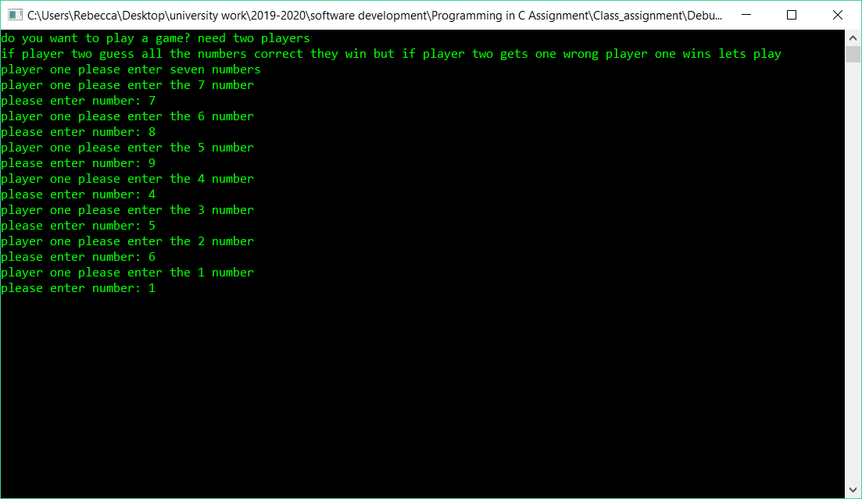
Figure 1 first test
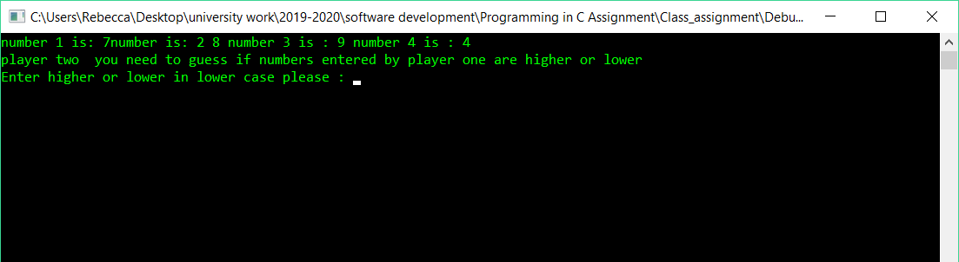
Figure 2 first test results
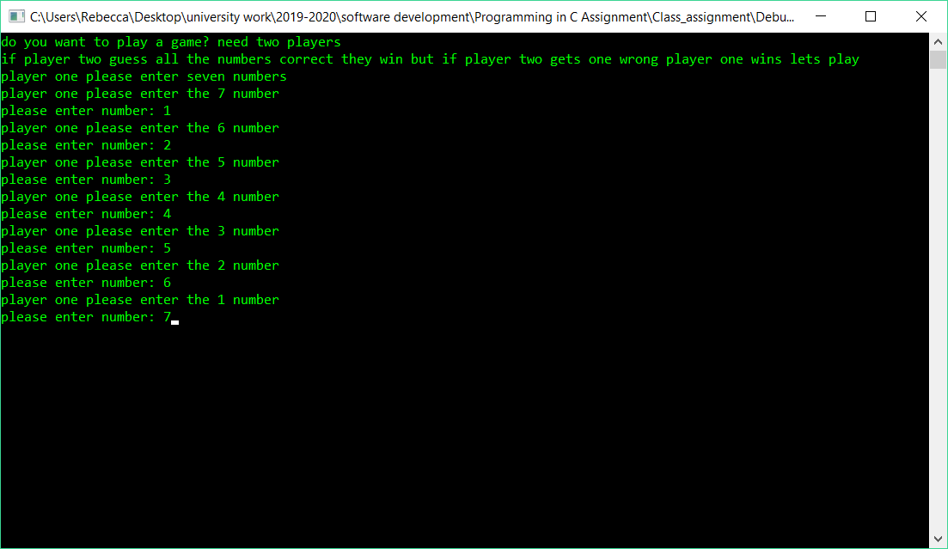
Figure 3 second test
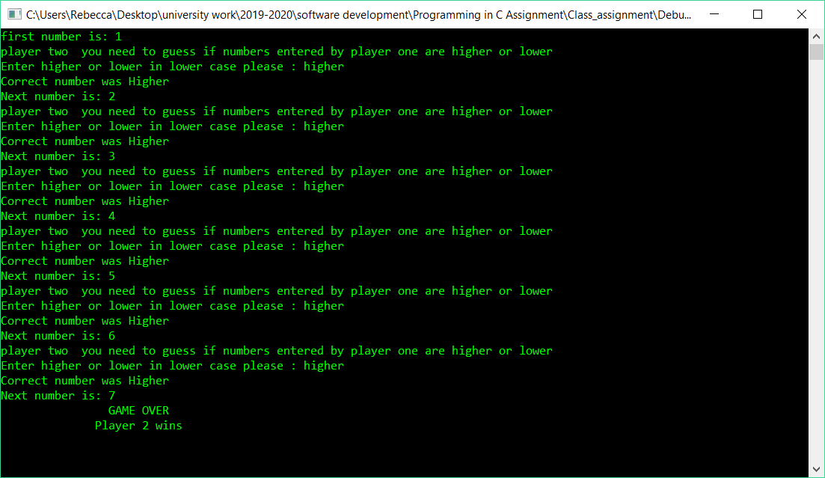
Figure 4 second test results
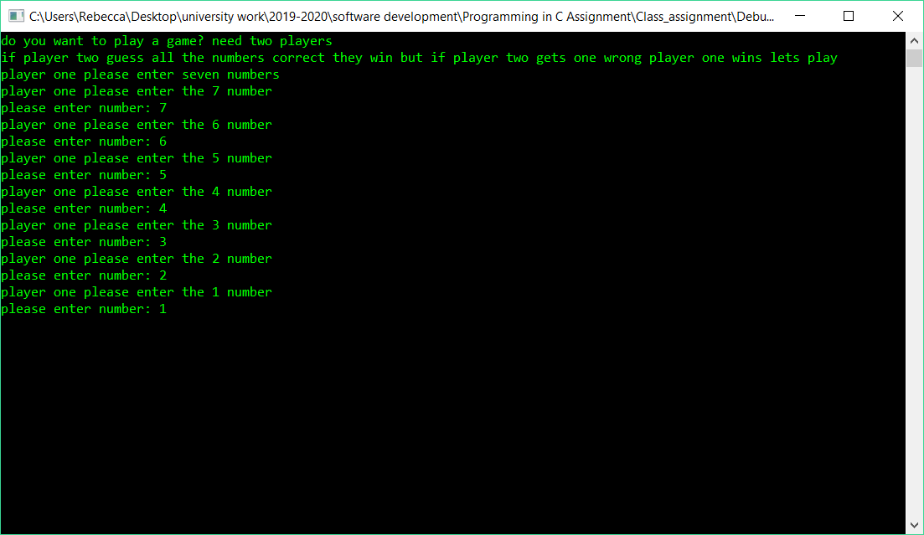
Figure 5 third test
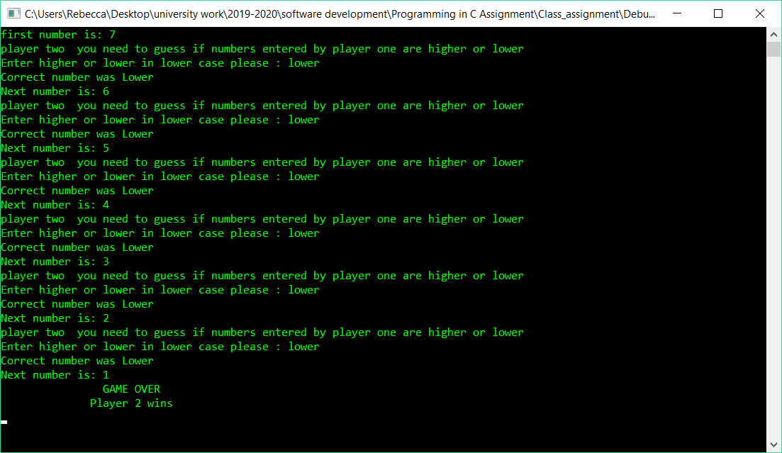
Figure 6 third test results
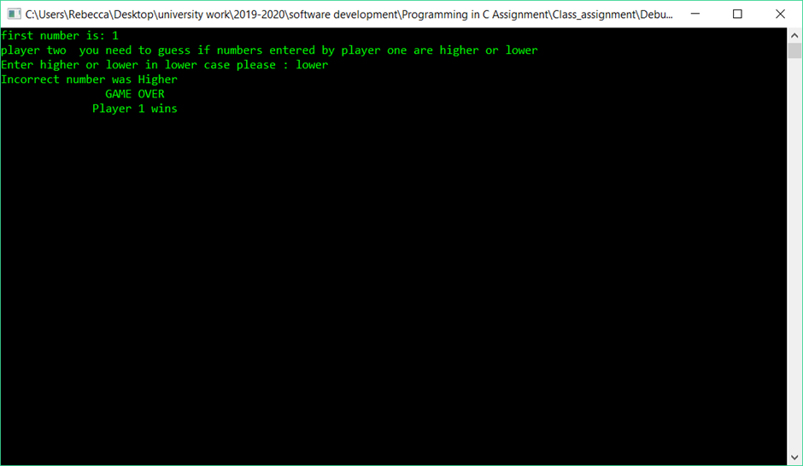
Figure 7 forth test
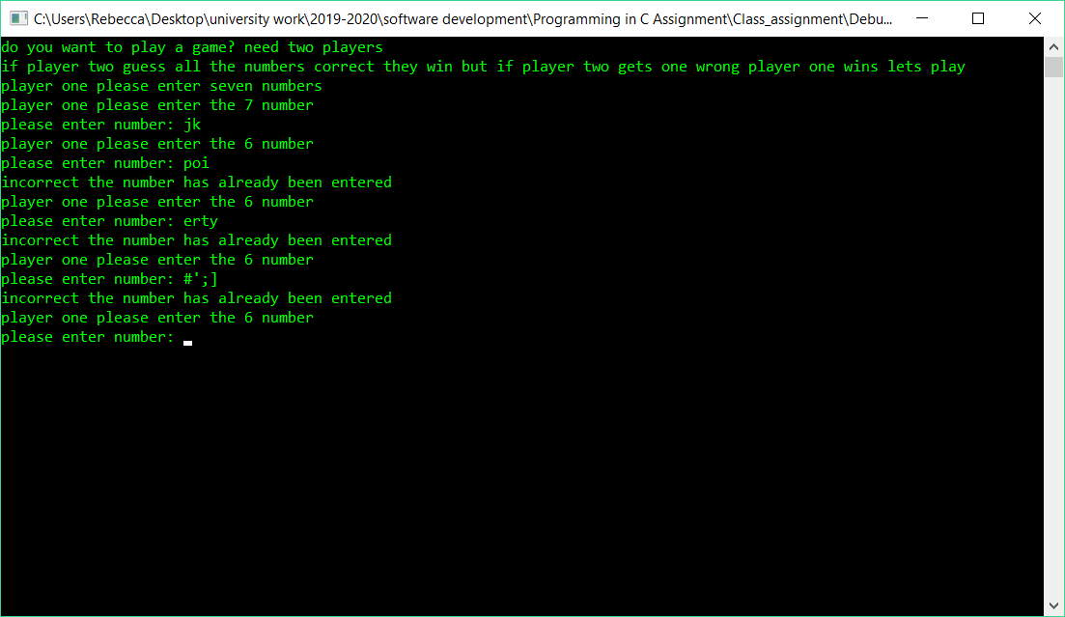
Figure 8 test for limitations
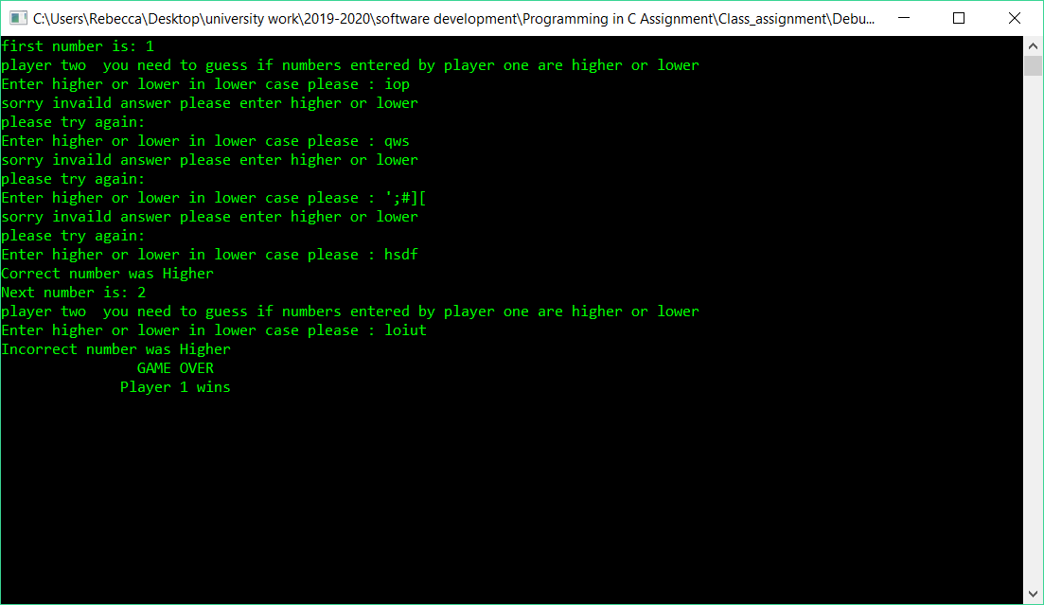
Figure 9 test for limitations

Appendix 2

Images of code being tested for exercise two
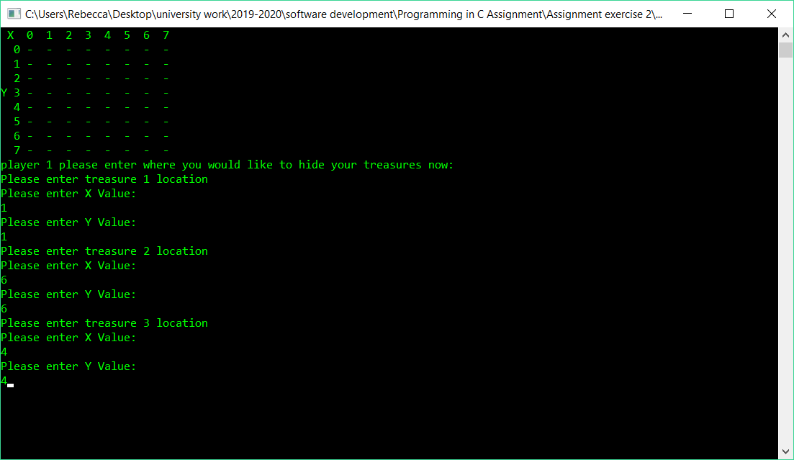
Figure 10 locations entered
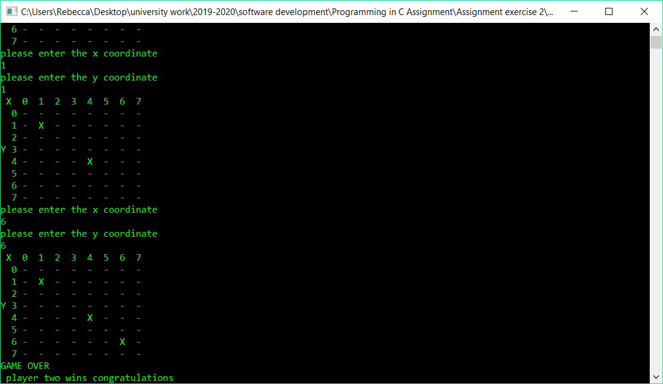
Figure 11 result of first test

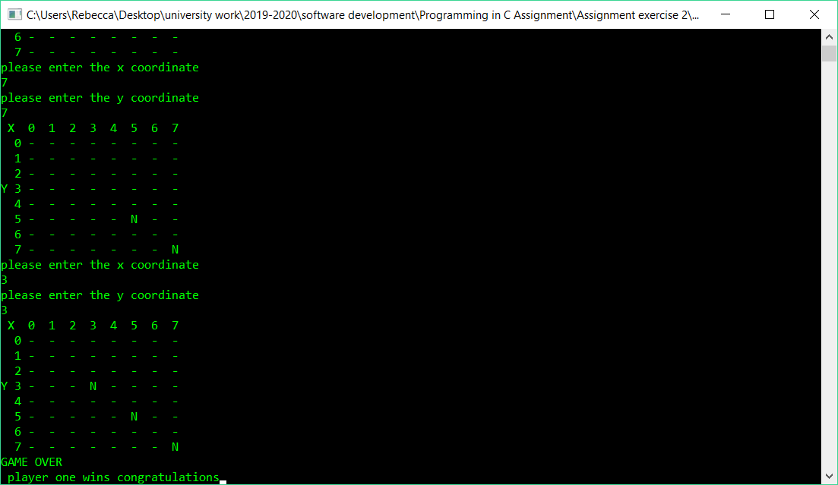
Figure 12 results of second test
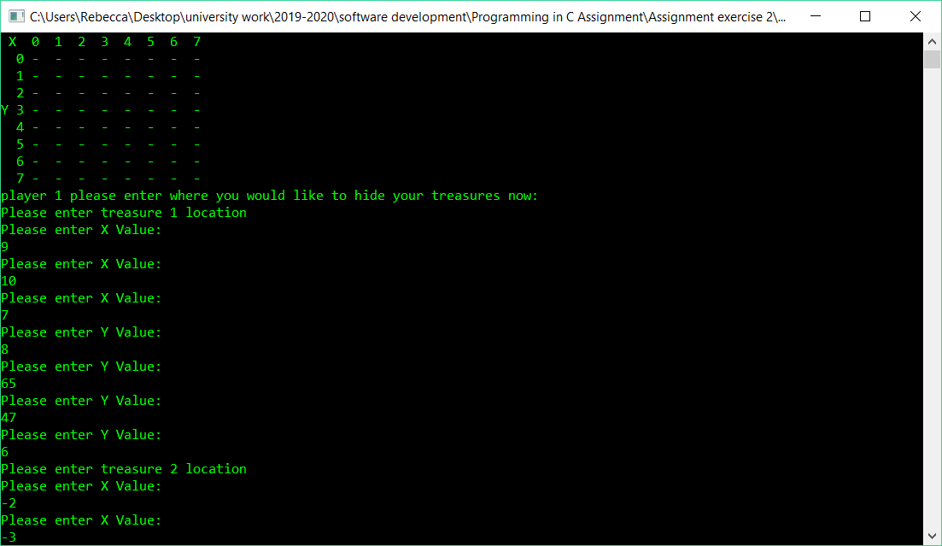
Figure 13 player one’s test
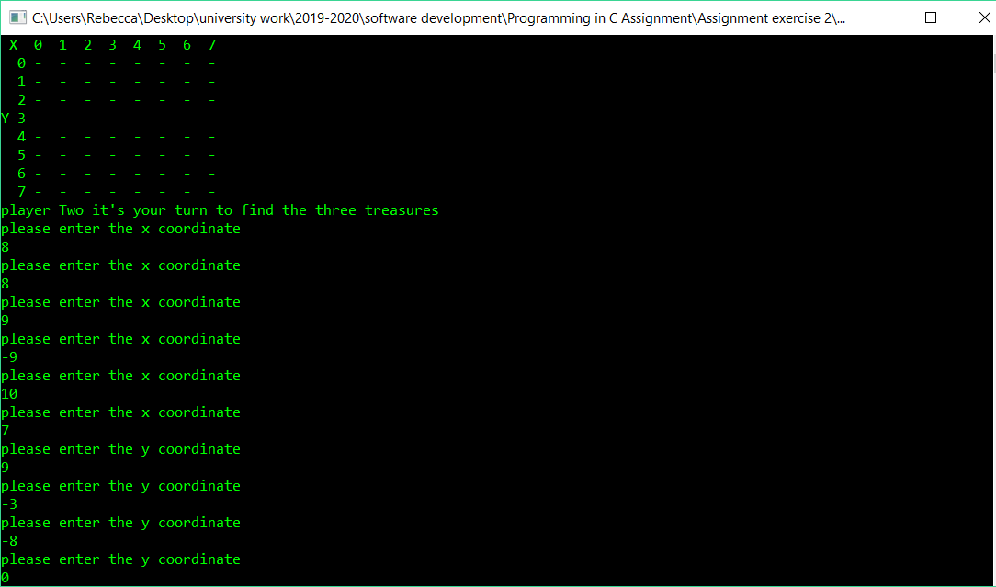
Figure 14 player two's test

Appendix 3

The completed code for exercise 1

#include<string>
#include<sstream>
#include<iostream>

using namespace std;

int numberEntered(string message);
void enterNumbers(int myarray[]);
char playTwoenters(string text);

int main(int argc, char*argv[])
{
int numbers[7];
char player2Choice;
int x, i = 0;
bool lose = false;

enterNumbers(numbers);

system("CLS");//clear screen

//for (i = 0; i < 40; i++)
//{
//cout << endl;
//}

cout << "first number is: " << numbers[0] << endl;

//cout <<"number 1 is: " << numbers[0] << "number is: 2 "<<numbers[1]<<" number 3 is : "<< numbers[2] <<" number 4 is : " << numbers[3] << endl; //test code
//cout << player2Choice << endl; //test code

for (i = 1; i < 7; i++)
{
player2Choice = playTwoenters("Enter higher or lower in lower case please ");

if (player2Choice == 'l') //if they entered lower, they go into top if
{
//cout << " top IF" << endl;

if (numbers[i - 1] < numbers[i])
{
//Incorrect
cout << "Incorrect number was Higher" << endl;
i = 7;
lose = true;
}
else
{
// correct
cout << "Correct number was Lower" << endl;
cout << "Next number is: " << numbers[i] << endl;
}
}
else // if they entered higer in here (bottom if)
{
//cout << " bottom IF" << endl;
if (numbers[i - 1] > numbers[i])
{
//incorrect
cout << "Incorrect number was Lower" << endl;
i = 7;
lose = true;
}
else
{
//correct
cout << "Correct number was Higher" << endl;
cout << "Next number is: " << numbers[i] << endl;
}
// numbers[current-1] with numbers[current]

}
}

cout <<" "<< "GAME OVER" << endl;
if (lose == true)
{
cout <<" "<< "Player 1 wins" << endl;
}
else
{
cout << " "<< "Player 2 wins" << endl;
}

cin.get();
return 0;
}
int numberEntered(string message)
{
int number;
string input;
stringstream stream;

cout << message;
getline(cin, input);

stream.str(input);
stream >> number;
stream.clear();

return number;
}
void enterNumbers(int myarray[])
{
int i, j = 7, k, temp;
bool match = false;

cout << "do you want to play a game? need two players"<< endl;
cout << "if player two guess all the numbers correct they win but if player two gets one wrong player one wins lets play" << endl;
cout << "player one please enter seven numbers" << endl;

for (i = 0; i < 7; i++)
{
cout << "player one please enter the " << j << " number" << endl;
j = j - 1;
temp = numberEntered("please enter number: ");

for (k = 0; k < 7; k++)
{
if (myarray[k] == temp)
{
cout << "incorrect the number has already been entered" << endl;
match = true;
i--;
j = j + 1;

}
}
if (match == false)
{
myarray[i] = temp;
}

}

}
char playTwoenters(string text)
{
string input;
char highOrLow;
stringstream stream;

cout << "player two you need to guess if numbers entered by player one are higher or lower" << endl;
cout << text << ": ";
getline(cin, input);
stream.str(input);
stream >> highOrLow;
stream.clear();

//if one of them match it skips while loop, if they match they equal 0
while ((highOrLow != 'h') && (highOrLow != 'l'))
{
cout << "sorry invaild answer please enter higher or lower"<< endl;
cout<<"please try again:" << endl;
cout << text << ": ";
getline(cin, input);
stream.str(input);
stream >> highOrLow;
stream.clear();

}

return highOrLow;
}

Appendix 4

The competed code exercise 2

#include<iostream>
#include<sstream>
#include<string>

using namespace std;

int playerInput(string textdisplay);
void setuparray(char myarray[64]);
void table(char myarray[64]);

int main(int argc, char argv[])
{
int treasures[3][2];
char myarray[64];
int i, j=1,x,y,lives=3,treasureFound=0;
bool found = false;

setuparray(myarray);
table(myarray);
cout << "player 1 please enter where you would like to hide your treasures now:" << endl;

for (i = 0; i < 3; i++)
{
cout << "Please enter treasure " << j << " location" << endl;
treasures[i][0] = playerInput("Please enter X Value: ");
treasures[i][1] = playerInput("Please enter Y Value: ");
j++;
}

system("CLS");// clear screen

table(myarray);
cout << "player Two it's your turn to find the three treasures" << endl;

while ((lives > 0) && (treasureFound <=2))// to loop the game til either find all treauses or run out of lives
{
x = playerInput("please enter the x coordinate");
y = playerInput("please enter the y coordinate");

for (i = 0; i < 3; i++)
{

if (treasures[i][0] == x)// to check the x stored numbers
{
if (treasures[i][1] == y)// to check the y stored numbers
{
treasureFound++;
found = true;

myarray[x + (y * 8)] = 'X';

}
}

}

if (found == false)
{
myarray[x + (y * 8)] = 'N';
lives--;
}

found = false;
table(myarray);

}

if (treasureFound == 3)// used to check if player two has won
{
cout << "GAME OVER" << endl;
cout << " player two wins congratulations";
}

else// if player two hadnt won then player one must of won
{
cout << "GAME OVER" << endl;
cout << " player one wins congratulations";
}

cin.get();//pauses the code

return 0;
}

int playerInput(string textdisplay)
{
int num = -1;
string input;
stringstream stream;

while (num < 0 || num > 7)
{
cout << textdisplay << endl;
getline(cin, input);
stream.str(input);
stream >> num;
stream.clear();
}

return num;
}

void setuparray(char myarray[64])
{
int i;

for (i = 0; i < 64; i++)
{
myarray[i] = '-';
}
}

void table(char myarray[64])// 8x8 grid funtion
{
cout << " X 0 1 2 3 4 5 6 7"<< endl;

cout << " 0 " << myarray[0] <<" " << myarray[1] <<" " << myarray[2] <<" " << myarray[3] <<" " << myarray[4] <<" " << myarray[5] <<" " << myarray[6] << " "<<myarray[7] << endl;
cout << " 1 " << myarray[8] << " " << myarray[9] << " " << myarray[10] << " " << myarray[11] << " " << myarray[12] << " " << myarray[13] << " " << myarray[14] << " " << myarray[15] << endl;
cout << " 2 " << myarray[16] << " " << myarray[17] << " " << myarray[18] << " " << myarray[19] << " " << myarray[20] << " " << myarray[21] << " " << myarray[22] << " " << myarray[23] << endl;
cout << "Y 3 " << myarray[24] << " " << myarray[25] << " " << myarray[26] << " " << myarray[27] << " " << myarray[28] << " " << myarray[29] << " " << myarray[30] << " " << myarray[31] << endl;
cout << " 4 " << myarray[32] << " " << myarray[33] << " " << myarray[34] << " " << myarray[35] << " " << myarray[36] << " " << myarray[37] << " " << myarray[38] << " " << myarray[39] << endl;
cout << " 5 " << myarray[40] << " " << myarray[41] << " " << myarray[42] << " " << myarray[43] << " " << myarray[44] << " " << myarray[45] << " " << myarray[46] << " " << myarray[47] << endl;
cout << " 6 " << myarray[48] << " " << myarray[49] << " " << myarray[50] << " " << myarray[51] << " " << myarray[52] << " " << myarray[53] << " " << myarray[54] << " " << myarray[55] << endl;
cout << " 7 " << myarray[56] << " " << myarray[57] << " " << myarray[58] << " " << myarray[59] << " " << myarray[60] << " " << myarray[61] << " " << myarray[62] << " " << myarray[63] << endl;

}

