LEVEL 5 ASSESSMENT SPECIFICATION

Student name: | Anraqeisya binti Saharuddin | Student ID number: | 2436779
Video Presentation Link: | https://canva.link/egfuxif2drhlju4 (Canva link)  https://youtu.be/ZyyhOncorl8 (Youtube link)
Programme: | IUMW Business Administration (Dual Award)
Module: | Changemakers: Applying a Research Mindset
Module code: | IUBA5010 | Contribution to Overall Module Assessment (%): | 100%
Lecturer: | Emma Roberts | Internal Verifier: | Vic Saunders
Assignment Title: | E-Portfolio Evidence of Learning | Word count (or equivalent): | 4,000 words or equivalent
Submission deadline: | Friday 11th Sep 2026 23:55 British Summer Time BST | Return date of provisional marks & written feedback: | 15th October 2026
Submission method: | All written assessments, where practical and possible, must be submitted via Turnitin unless otherwise instructed by the Lecturer. (Please DO NOT put this assessment specification into Turnitin or it will match many similarities with other students’ submissions.)  Alternative submission method (if applicable):  Late submission of the assessment will result in a late penalty mark:  Work which is submitted up to 1 week late will be capped at 40% for the first attempt and will be awarded a mark of 0% for re-assessment. Late submission penalties may be lifted only if there is an approved extenuating circumstances claim.  Work submitted more than 1 week late will be considered as a non-submission and will not be marked. The work may be considered as a submission for reassessment if offered by an Examining Board or if there is an approved extenuating circumstances claim.
Academic honesty / referencing: | Academic honesty is required. In the main body of your submission you must give credit to authors on whose research and ideas your work is based. Append to your submission a reference list that indicates the books, articles, etc. that you have used, cited or quoted in order to complete this assessment.
Module Learning Outcomes (from module syllabus)
- Demonstrate knowledge and critical understanding of a research mindset, recognising the values and the contribution that research makes to addressing the problems of the contemporary world.
- Apply a research mindset within a work-based or academic context to develop a novel research proposal.

Table of Contents
1.0 Task 1 3
1.1 Introduction of D’cabin 3
1.2 Problems faced by D’cabin 3
2.0 Task 2: Academic Literature and Generative AI 4
3.0 Task 3: Research Question and Research Approach 6
4.0 Task 4: Research Proposal 7
5.0 Gibbs Reflective Cycle 9
6.0 References 12

Task 1

1.1 Introduction of D’cabin
D’cabin was established in Wisma Rampai located in Taman Sri Rampai. It’s a small café that offers customers a variety menus options, but its main dish and specialty is the pasta that comes with different flavours which includes Korean spicy and Tomato “Marinara” and the usual Bolognese and Carbonara, with a multiple choice of protein can be added to the dish. The café also offers mac and cheese, snacks like cheesy wedges, nuggets and usual soft drinks and minerals. Moreover, all the dishes are personally prepared and cooked by the owner without any second helper to handle the pasta which maintains the pasta taste and quality of the pasta, as she’s the only person managing to prepare the foods.

1.2 Problems faced by D’cabin
During the interview with the owner, Alyssa Sofea, she had listed out and highlighted her main concerns and the issues that her business is currently experiencing such as strong competition, limited dine-in space, limited parking space and most customers complained that it’s difficult to find the cafe when they first visited D’cabin. Since the café is located in a building, Wisma Rampai, there are a lot of services offered in the same area including clinics, office, as well as restaurants. The area is often congested and packed making it’s difficult to find parking and took drivers to circle the block for about two to three rounds in the area to find a parking space.
Addition to that, despite offering diverse types of menus, customers will still have alternatives to go for a different café nearby, since in the same area that D’cabin operates, there are other competitors who provides similar types of dishes. Other than people pointed out that the café isn’t immediately visible when they reached the area, the food riders also complained the same thing and not just that, the capacity for the customers to dine-in is limited where the café can only be occupied with few tables since the café space are very small. So, it’s only possible for the customers to order for takeaway since the space availability to dine-in is limited.

2.0 Task 2: Academic Literature and Generative AI
In this part, I ‘m utilizing ChatGPT to explore and understand deeply the problems faced by D’cabin including strong competition, limited parking space, limited dine-in space, competitors offered similar menus and cafe aren't directly visible to the customers. So, in order to understand better of the issues faced by the business, I used multiple prompts to ask ChatGPT.
The first prompt I used to ask ChatGPT “I am doing research on challenges faced by small businesses in Malaysia and my focus is on D'cabin Cafe located in Wisma Rampai. The challenges faced by the business is limited parking space. So based on existing academic literature, explain how these challenges can affect customer experience, business operations and performance of D'cabin.”
ChatGPT suggested that:
Parking is part of the customer's accessibility and arrival experience. A customer may be interested in visiting D'cabin, but if parking is difficult or unavailable, the inconvenience occurs before the customer even enters the café. A Malaysian study on dining satisfaction found that having a parking area close to the restaurant was one of the factors influencing customer satisfaction during the arrival stage of the dining experience (Ismail, 2012).
The second prompt used is “Based on peer-reviewed academic literature, how can a cafe that aren't directly visible to the customers affect overall of customers choice and business performance?”
ChatGPT suggested that:
Poor visibility can make it more difficult for potential customers to notice or locate the café, increasing the likelihood that they choose a more visible and accessible alternative. Hidayat and Zuliarni (2014) found that visibility is an important location factor for small restaurants and that business location has a significant positive effect on sales volume.
In order for the business to attract and retained its customers, they have created a TikTok account to promote the business as well as a video guidance on how can their first time customers reach their shop.
Lastly, the third prompt I used is “By using some of the theoretical concept explain how can limited dine in space and competitor offering similar menus can create challenges to the small businesses.”
ChatGPT suggested that:
Limited seating represents a capacity constraint, as the café may be unable to accommodate many customers during peak periods, resulting in longer waiting times and potentially lower customer satisfaction (Hwang, 2008). At the same time, competitors offering similar menus increase the need for competitive differentiation, as customers have more alternatives when choosing where to dine. Research in Malaysia found that competition in a saturated restaurant market creates a need for menu innovation, while customers tend to compare restaurants based on factors such as price and other selection criteria when offerings are similar (Mifli et al., 2017; Chua et al., 2020).
To address on the issue of limited dine-in space, D’cabin had also include take-away as an option for the customers to try their foods and they also provide varieties of menus that customers can choose from, which not limiting the choice to only pastas as the dish.
The best AI output generated is on the limited parking space and café visibility as it defined and discussed in depth of the problems faced by D’cabin and the output generated also relates to the research findings that I found when analysing the challenges that the business is currently experiencing. To add that, based on the academic research findings that can be used in identifying the problems in detailed, provide more evidence that supports the issues faced by D’cabin.

3.0 Task 3: Research Question and Research Approach
The prompt I used to ask ChatGPT is “Based on the problems situation faced by D’cabin like strong competition, limited space of parking and dine-in areas, competitors sell similar menus and poor visibility of the cafes suggest a few suitable research questions referring to the problems I had listed out.”
ChatGPT output on the suggested research questions:

- How does perceived crowding influence customer satisfaction in a small café?
- To what extent does menu uniqueness contribute to the competitive advantage of a small café?
- How do location accessibility, café visibility, and product differentiation influence customers’ intention to visit a small café?

The prompt used to ask ChatGPT on suggested research approaches “Suggest the most suitable research approach method that can be conducted to analyse how do location accessibility, café visibility, and product differentiation influence customers’ intention to visit a small café. Then propose a relevant research, technique used to collect data for small scale research.”

AI suggested to conduct a quantitative research approach using a questionnaire survey. This is the most suitable method since the research question is asking about the influence or relationship between three factors and customers' intention to visit, which can be measured using numerical data. The recommended research design is using a cross-sectional survey design where the data is collected once during a specific period, rather than following respondents for months. The main data collection technique that ChatGPT recommend is a structured questionnaire which is distributed either through customers directly or through Google Forms survey. The recommended sampling technique is the convenience sampling involving respondents that are the potential customers of cafés in the area, rather than only existing customers.

Among the three suggested research questions I chose “How do location accessibility, café visibility, and product differentiation influence customers’ intention to visit a small café?” since it’s more relevant to the business issue and the research question covers the overall and actual problems. The research question is focused on identifying and discussing on the factors affecting customer’s choice and how it plays a role in customer’s preferences when visiting small business cafes. The most applicable research approach is by using quantitative approach by conducting structured questionnaire through Google Form that can be send out to the customers and less time is taken. AI also suggested to conduct a semi-structured interview with the café owner to understand business perspective, while the questionnaire data are based on customer’s perspective.

4.0 Task 4: Research Proposal
D’cabin is a small business selected for this research study that operates in Wisma Rampai, offering multiple choice of menus from main dishes like pastas to the sides. Despite thriving even as a small business, the business is still struggles with the competition from competitors who offers similar menus, limited number of tables for the customers to dine-in, limited parking spaces and poor café visibility. So, to understand D’cabin situation better, the research question is focused on how location accessibility, café visibility and product differentiation influence customer’s intention do to visit a small café.
The café visibility terms in the research question can be varieties such as location or digital visibility. Location visibility is important for a business since it influences customer’s choice to visit a café, so when selecting the most suitable location for the store, it should be one of the most crucial decisions needs to be made by the business owner (Bishop’s Move, 2024). It plays a key role in impacting business goals and shaping from the customer’s traffic flow to the operational costs. The importance of choosing the right location for the store will not only determine how the spot looks good from far, but also, how it aligns with the concept, target audiences and long-term goals of the business (Brewspace, 2026). Moving on, digital or online visibility is where a website or a store can easily be found in online platforms like Instagram, TikTok, or even digital navigation like Waze and Google Maps when the audience searched for the brand name. The higher factors like online reviews, search engine ranking and online presence, the more business gain audiences which results in wider business digital footprint (Seo, 2024). Furthermore, it’s crucial for a business to be visible to the customers since it determines customer’s preference when visiting a café. To ensure that the café can be access and visible to the target market, the business should use a big and clear prints of the sign so even from far customers acknowledge that is the café they are going to (Euan’s Guide, 2019). This will not only improve the café accessibility but also enhances customer’s satisfaction and business may gain loyal customers.
Additionally, the factors that influenced customer’s intention on visiting a café is due to multiple different reasons which also known as the big four restaurant attributes consists of café’s surrounding, price, food, quality and taste which plays a role in affecting customer’s satisfaction and preferences (Zanetta et al., 2024). The reason why D’cabin is selected for this case study is to analyse and study on how small businesses like D’cabin are affected by the challenges posed by their surroundings which may affect the business operations and overall performances. Since the observation done on the café the highlighted key issues of the problem experienced by the business is poor visibility, accessibility and strong competitions.
The research question was narrowed down to how location accessibility, café visibility and product differentiation influence customer’s intention, so that it’s more focused and relevant to the café’s situation and understand better of the customer’s perspectives. The situation highlights that they experienced complaints on the café visibility, issues on insufficient parking space and small dine-in spaces. The research design can be implemented in this study is by conducting questionnaire using quantitative cross-sectional research, which will be send out to the potential customers of D’cabin. The questionnaire interview can be conducted through Google Form where data collected using cross-sectional research, will be gathered at once and immediate to understand their experience and feedback (Bryman et al., n.d.). To add that, semi-structured interview with the owner can also be done to support all the findings from the data gathered and for a stronger result of the case study.
There are multiple ways to increase validity and reliability of the findings such as by applying semi-structured interview with prepared clear questions to ask the café owner which will reduce misleading and false information. All questions prepared for the questionnaire survey will solely be based on the research objectives and the question asked will not be involving other than the study purposes. During the interview, with the owner’s consent, interviewer may ask for detailed information involving the reviews and opinions from the customer allowing the research findings to be supported with valid information. When conducting the interview and creating the survey questions, the first question will be asked is the participant consents to answer the question and the participation will be voluntary. The data of the participants who participate in the questionnaire should be remained anonymous where they don’t have to include their names on the survey. To add that, all the information gained through the survey and interview will be kept confidential and ensure that the data will not be shared or used for any other purposes except for only the research matters. Also, to ask consent from the owner to take pictures of the café surroundings, not just to respect the owner’s right but to keep and remain her privacy to be protected.

5.0 Gibbs Reflective Cycle
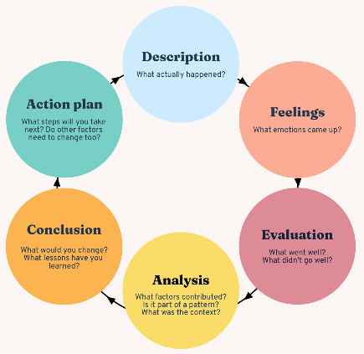
5.1 Diagram of Gibbs Reflective Cycle
- Description
The assignment description was to select a small business in Malaysia and what types of challenges they faced. So, I selected D’cabin as the business I want to study on not just because I had known the owner but also, I’m one of her regular customers who always bought from her store. There were a total of six parts needs to be discussed in this assignment which consists of task 1 where in this stage after selecting a business to study on I need to find the challenges that concerned the business then proceed on writing the company’s description and issue that the business faced. While in task 2 and task 3, it required me to use Artificial Intelligence (AI) and I chose ChatGPT to help me on understanding the problem faced by D’cabin more clearer and then AI were also used to generate research question for this case study. The research question is narrowed down to focus only on the problem that actually pose bigger threats and impact towards D’cabin. I have done an observation of the café to understand better of the flow operations and what are the actual challenges they are facing. I’m putting an absolute commitment towards this assignment so that I’ll be able to understand what are the factors that keep these small businesses in Malaysia thrives and what are the small and big threats that can affect their business.

- Feelings
When I first started the assignment, I was totally lost and unsure on what type of challenges that I should focus on. I was also worried that the research question was too broad and even the number of challenges faced by D’cabin remained unclear but the one I had included and choose to discussed in the study had already drained me out. Since, there were different kind of aspects I need to do research on and multiple of sources I need to visit and fact check the information generated by ChatGPT. It’s not that AI is not reliable but I know that I shouldn’t 100% rely only on AI to complete this assignment since it also requires academic journal sources to support the findings regarding the business issue discussed in the research proposal. Other than that, I was uncertain whether to choose quantitative or qualitative as my research approach but after I learn the actual meaning and how to apply the method then only, I know which to apply for the research.
- Evaluation
So, the overall evaluation of the assignment I think it went pretty good despite at first, I was doubting everything that I typed in, but now I feel that everything has compiled together. All academic journals used in the research studies has provided a lot of supports to my findings and AI generated outputs. Doing this research, I am able to see more detailed on what type of struggles that these small businesses may face and how it affects their performance. Instead of asking AI to generate what kind of problems that these businesses may face, I was able to find myself what type of issues that D’cabin faced when operating in a busy area like Wisma Rampai. With the support of academic literatures, it helps me to understand the problem more detailed and detect what kind of factors that actually influence the customer’s intention when visiting a small café like D’cabin. However, there were too many problems to focused on at first and I’m facing difficulty to narrow down the suggested research questions and to find the most suitable one for the research proposal.
- Analysis
After conducting a detailed research to gain better understanding on the problems, I realised that all the several problems listed out can’t be analysed at the same time. Based on the listed issues, step that should be taken is to narrow down all the possible issue and come up with a clear research problem as well s research question to investigate the main problem that affect businesses. Not just that, academic literature provides me better understanding for example D’cabin receives complaints regarding the limited parking, it doesn’t only affect the business but also affect the overall process from location accessibility affecting customer’s experience and thus influencing customer’s intention. Based on the research question, I need to find a suitable research method not just because it’s easier to be conducted but whether it matches the question type or not, like to understand the audience perspective by using structured questionnaire which will be created and sent to the customers.
- Conclusion
In conclusion, if I were to receive similar assignment in the future or conduct another research proposal, I would size down the research problem I had listed earlier. I would also read the task description thoroughly to ensure that I hadn’t missed out any important parts that should be included in the proposal. Before focusing so much on the literature I would spend myself in outlining several numbers of research questions then choose the most relevant to the problem discussed. This will provide a smoother research process, as I had only one main problem to focus on and conduct a research, which then provides a clearer purpose to provide solutions to the challenges. Before deciding what type of research method will be implemented, I would observed numbers of customer that visit the store to decide the estimated total of respondents available to proceed with the survey. During the earlier observation of D’cabin, I would have asked for permissions earlier so that the survey and interview can be conducted without delay and able to collect faster response. Most importantly, I would have differentiate and acknowledge both of the business perspectives and customers point of view when I first started to conduct the research.
- Action plan
For upcoming research proposal or any assignment that requires me to conduct research, first I would do is to define the research problems and analyse the target market of the business before deciding types of research methods that will be used in the research. Other than that, I would check beforehand on the academic sources that will be used to support the findings of the research whether they are relevant and legit to be applied. Also, I would only create questionnaire questions based on the focused research objectives.

References
- Ali, M. A., Ting, D. H., Salim, L., & Ahmad-Ur-Rehman, M. (2021). Influence of servicescape on behavioural intentions through mediation and moderation effects: A study on Malaysia’s full-service restaurants. Cogent Business & Management, 8(1). https://doi.org/10.1080/23311975.2021.1924923
- Ismail, S. (2012). Customer satisfaction of dining experience in Malaysian malay restaurants. https://eprints.bournemouth.ac.uk/20751/
- Yen, B. T., Mulley, C., Burke, M., & Tseng, W. (2020). Parking and restaurant business: Differences in business perceptions and customer travel behaviour in Brisbane, Queensland, Australia. Land Use Policy, 92, 103818. https://doi.org/10.1016/j.landusepol.2019.01.021
- Brewspace. (2026, June 9). A comprehensive guide to choosing the perfect location for your specialty coffee shop. Brewspace Blog. https://www.getbrewspace.com/blog/a-comprehensive-guide-to-choosing-the-perfect-location-for-your-specialty-coffee-shop/
- Bishop’s Move. (2024, September 23). Why is location important for a business. https://www.bishopsmove.com/blog/the-importance-of-business-location/
- Seo, V. (2024, September 12). The importance of online visibility: a digital age imperative. Visual Marketing - Digital Marketing Agency. https://www.visualmarketing.com.au/the-importance-of-online-visibility-a-digital-age-imperative/
- Euan’s Guide. (2019, July 19). Top tips for making your café accessible. https://www.euansguide.com/news/top-tips-for-making-your-cafe-accessible
- Zanetta, L. D. A., Xavier, M. C., Hakim, M. P., Stedefeldt, E., Zanin, L. M., Medeiros, C. O., & da Cunha, D. T. (2024). How does the consumer choose a restaurant? An overview of the determinants of consumer satisfaction. Food Research International, 186, 114369. https://doi.org/10.1016/j.foodres.2024.114369
- Bryman, A., Lewis-Beck, M. S & Liao, T. F. (n.d.). Cross-sectional design. The SAGE encyclopedia of social science research methods (Vol. 3, pp. 230-230). SAGE Publications, Inc., https://doi.org/10.4135/9781412950589.n204
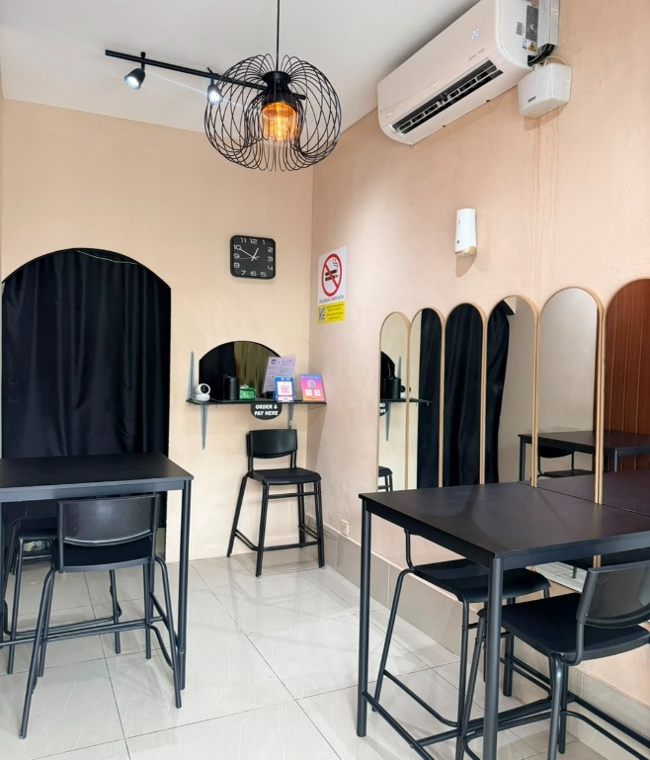
Appendices
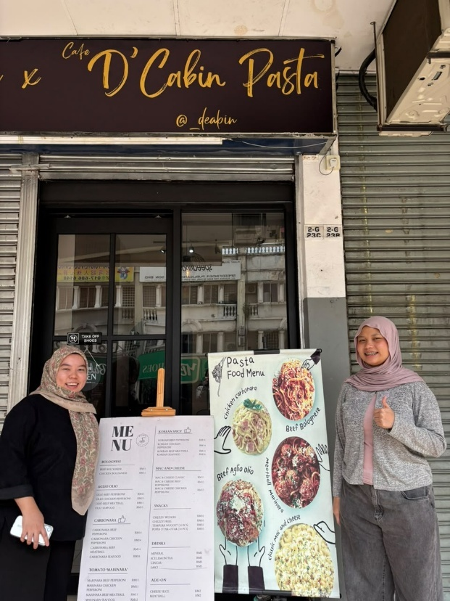

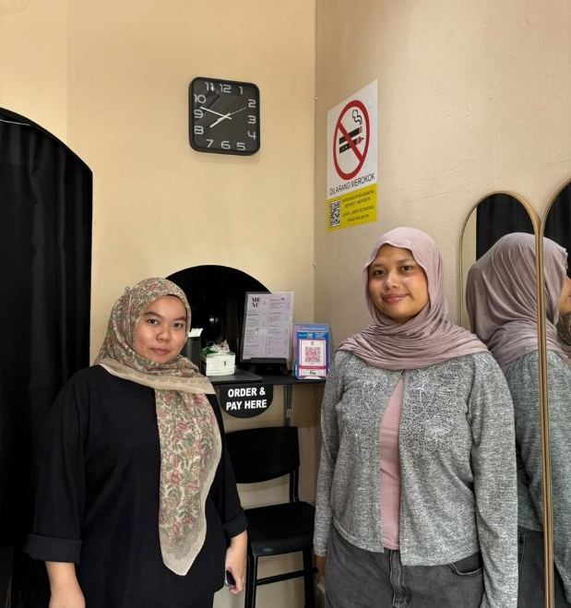
Dine-in space at PD’cabin Café Outside of D’cabin Café

Payment area at D’cabin

