Analysis and Critique of Security Frameworks and Models
Xue Yan
The University of Wales Trinity Saint David
- Abstract
This paper analyses and criticizes three well-known security frameworks and models, namely, Information Technology Infrastructure Library (ITIL), International Organization for Standardization (ISO 27000) and Control Objectives for Information and Related Technology (COBIT). Besides, combining with the real-world scenario of Caribbean Coffee, I design and analyse my own security model methods.
- Content
- Introduction
- Information Technology Infrastructure Library (ITIL)
- Introduction
- ITIL core process
- The commercial value of ITIL
- International Organization for Standardization (ISO 27000)
- Introduction
- Main Content Analysis of ISO27001
- ISO27001 Review Process
- Control Objectives for Information and Related Technology (COBIT)
- introduction
- The history of COBIT
- Technical resources of COBIT
- advantages of COBIT
- Comparison and discussion
- COBIT VS. ITIL vs. ISO 27000
- Why are new standards and regulations emerging?
- Analysis of Case Scenario
- introduction
- design of data security framework
- Detailed process of the security model
- Reference
- Introduction
The progress of Internet technology has changed people's way of life. Technology has brought unprecedented changes to the 21st century that would have been unthinkable just a few decades ago. However, the widespread use of the Internet has also created some problems. For example, attacks from criminal groups or individuals, personal information leakage and other problems often occur. In other words, as computer networks make personal information more accessible, individuals and businesses are increasingly concerned about the confidentiality and privacy of information [1].
Stuart E. Madnick et al. [2] provide an overview of the evolution and status quo of data security and summarize several well-known network security frameworks. Next, I analyze three well-known security frameworks and models.
- Information Technology Infrastructure Library (ITIL)
4.1 introduction
Traditional operation and maintenance methods can no longer meet the needs of information product operation and maintenance management, so people put forward the research of automatic operation and maintenance method based on ITIL. The ITIL architecture framework consists of six parts: business management, IT service management planning and implementation, service management, ICT infrastructure management, application management and security management.
The ITIL system framework provides enterprises with a standard, rigorous and objective service specification, which is widely used around the world. ITIL assists enterprises to carry out management work in the development, planning and operation of management and service system [3], takes process as the basic guidance, takes service quality and customer satisfaction as the core content, and takes improving the quality and utilization value of IT resources as the main purpose.

4.2 ITIL core process
4.2.1 Service Desk
- The concept of Service Desk
The service desk plays a very important role in service support by handling a large number of customer requests without having to contact a particular technician. For customers, service desk is the only way they can contact the IT department so that they can get help from relevant people. The service desk is not only responsible for handling incidents, problems and customer inquiries, but also provides an interface for maintenance contracts, customer change requests and other activities.
- The structure of the service desk
According to specific requirements, there are a variety of service desk structures to choose from. The common service desk structures are as follows: The first type of service desk is Distributed Service Desk which is a traditional service desk model in which each part creates its own help desk to support its own business operations. Besides, Centralized service desk is a physical service center that handles all service requests centrally. This service structure provides a single point of contact for all users and has the advantages of reducing the overall operation cost of the service desk and improving the efficiency of resource utilization. Lastly, Virtual service desk is not limited by time and place. After receiving the customer's request, we can arrange the corresponding experts or engineers to deal with the service according to the actual situation.
- The main work of the Service Desk
The service desk is a simple service management function that responds to daily operational activities such as responding to user calls, publishing user information, customer needs management and customer relationship management, liaising with suppliers, daily operations management and infrastructure monitoring.
4.2.2 Accident Management
Accident refers to the behavior that may lead to the interruption of business or the deterioration of service quality during use. When multiple accidents need to be dealt with at the same time, the priority of accident handling must be determined according to the impact of the accident, the urgency of the business and other factors. The goal of event management is to get IT systems back to normal as quickly as possible with as little impact on the customer and user business as possible. However, accident management is not responsible for finding the underlying causes of accidents, but rather for speed.
4.2.3 Problem Management
Rather than accident management emphasizing the speed of recovery, problem management emphasizes finding the root cause of an accident so that appropriate solutions can be developed or preventive measures can be taken to prevent the accident from happening again
4.2.4 Configuration Management
Configuration information about the infrastructure provided by Configuration management can support other service management processes, such as transaction managers and problem managers that need to use the information provided by configuration management processes to investigate and analyze accidents and problems.
4.2.5 Change Management
Change management refers to the interruption for the shortest possible time to complete the infrastructure and services of any aspect of change, change management's goal is to make sure the change using standard methods and steps in the process of implementation, to implement the change as soon as possible, to bring to business interruption caused by the change of the business impact to a minimum.
The following figure 1 shows the running process of ITIL:
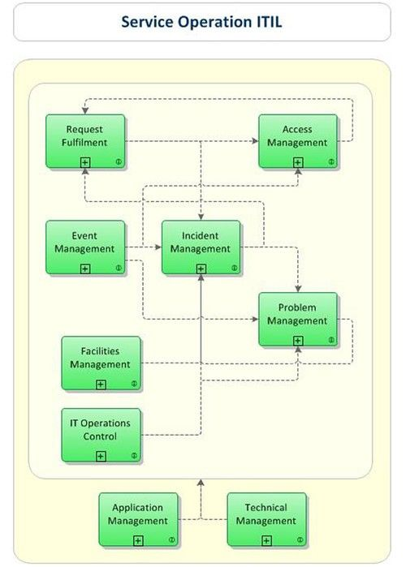
Figure 1: detailed process of ITIL

4.3 The commercial value of ITIL
ITIL is designed to address and correct these potential pitfalls by providing a guiding framework that preserves a reasonable portion of an organization's existing IT management approach, while adding the necessary and necessary technologies. In addition, the security model facilitates communication and coordination between the various IT functions. In the various process management of ITIL, it is possible to interact directly with various business departments to realize the redesign of business functions and processes, reduce costs, shorten turnaround time and improve customer satisfaction.
- ISO 27000
5.1 introduction
ISO 27000 refers to International Organization for Standardization. ISO27000 standard is the most widely used information security management system guidance standard in the world and the criterion of establishing information security management system (ISMS). It provides for the establishment, implementation and maintenance of information security management system requirements. The standard identifies the risk assessment criteria to be followed by the implementing agency, using a plan-do-check-act approach to establish, implement, operate, monitor and review [5]. Such a standardization process helps protect an organization's information assets in terms of confidentiality, integrity, and availability. The table 1 shows the documents in ISO27000 series.
Standard document number | content
ISO27000 | ISMS related terms and definitions
ISO27001 | Information security management system requirements
ISO27002 | Information security management System best practices
ISO27003 | Guidelines for the Implementation of information Security Management System
ISO27004 | Information security management measurement
ISO27005 | Information security risk assessment
ISO27006 | Entity requirements for conducting ISMS auditing and certification
ISO27007 | Information Security Management System Audit Guidelines
ISO/IEC TR 27008 | ISMS Control Implementation auditor's Guide
ISO/IEC27010 | Enterprise internal communication information security management
ISO/IEC27011 | Information security management Guide for telecom enterprises based on ISO27002
Table 1: the documents in ISO27000 series

5.2 Main Content Analysis of ISO27001
ISO27001 is the general standard of the ISO27000 series. An organization may establish its own information security management system (ISMS) in accordance with ISO27001 and obtain certification.
Chapters 1 through 3 of ISO27001 define the specification and usage of standard writing. From chapter 4 to Chapter 10, it formally introduces the construction requirements of enterprise information security management security management system. This paper elaborates on the establishment, operation, review and perfection of the information security management system, and provides instructive suggestions for the whole life cycle of ISMS. Different from the 2005 version, the latest version of THE ISO2001 standard (2013 version) does not emphasize the establishment of information security management system according to the PDCA cycle, but adopts other ways to continuously improve the process. At the same time, the new version puts more emphasis on organizational structure.
5.3 ISO27001 Review Process
Enterprises applying for ISO27001 certification usually need the following process:
- Information security management system planning and preparation
- Preparation of information security system documents
- Operation of information security management system
- Review and evaluate the information security management system
The review process usually consists of two main parts: one is the review of documents. In accordance with ISO20071, the evaluator should establish appropriate information in the course of establishing and maintaining ISMS. For example, an information security manual containing enterprise information security and an assessment report containing the results of an enterprise risk assessment. The second is the on-site audit, that is, the actual observation of the enterprise's existing facilities and equipment assets management situation, and the important process of the site to raise questions, such as: check whether the assets are marked, whether the machine room has limited access to security measures.
- COBIT
6.1 introduction
COBIT refers to Control Objectives for Information and Related Technology. COBIT is the current international standard for information systems auditing [7], which was published by the Information Systems Auditing and Control Association (ISACA) in 1996. This is an internationally recognized and authoritative security and information technology management standard, which has been updated to COBIT2019. It provides a bridge between business risk, control, and technical issues to meet multiple requirements. This standard system has been used by important organizations and enterprises in more than 100 countries to guide these organizations to effectively use information resources and effectively manage information-related risks.

6.2 The history of COBIT
There have been five major versions of COBIT:
- 1996: Release of the first edition
- 1998: The second edition was launched with a "Management guide"
- 2000: The third edition was released and made available online in 2003
- 2005.12: Release 4 was first released, and in May 2007, revised COBIT4.1 was released
- 2012.6: COBIT5 was released, which consolidates and integrates COBIT4.1, Val IT2.0, and RISK IT frameworks, while absorbing some content from BMIS and ITAF.

6.3 Technical resources of COBIT
- Data: Refers to objects in the broadest sense, including structured and unstructured charts and sounds.
- Application Systems: The sum of human and computer programs.
- Technology: Includes hardware, operating system, database management system, multimedia and so on.
- Facilities: All resources used to store and support information systems.
- People: Contains the human skills and productivity needed to plan, organize, acquire, transmit, support and monitor information systems and services

6.4 advantages of COBIT
COBIT is a useful tool that is easy to understand and implement.IT helps build a solid bridge between management, IT, and audit, and provides a common language for communication. COBIT makes IT management simple and quantitative. For those without extensive IT knowledge, the model is an INTERNATIONALLY used IT management and problem solution that is typically applicable to a variety of businesses, including current situations and possible guidelines for future use.
- Comparison and discussion
7.1 COBIT VS. ITIL vs. ISO 27000
- COBIT builds on many existing architectures and summarizes what businesses should focus on, not how they need to do it. It does not include specific implementation guidelines and steps, but rather a control framework. COBIT provides a strategic, tactical, and operational level approach to IT auditing. Its target audience is information systems auditors, enterprise senior managers, and senior IT managers , such as Chief Information Officer(CIOs).
- ITIL lists the best goals, activities, inputs, outputs, and relationships between each process for each service management process, but does not explicitly define the governance architecture.IT focuses on methods and implementation processes, so its vision is narrower than COBIT, focusing on the tactical and operational aspects of IT. Its target audience is IT and service managers.
- ISO2000 series standards almost involve every aspect of information security, and ensure the advancement and integrity of information security management. It protects an organization's information assets from three information security features: confidentiality, integrity, and availability. Compared with the previous two frameworks, ISO2000 is extensive, but not in-depth, and its main purpose is to achieve a certain high quality and practical reference.

7.2 Why are new standards and regulations emerging?
With the gradual advancement of the information age, the system established by enterprises must be standardized, must conform to the scientific management principles of enterprises and the code of conduct of enterprises, which are likely to be updated and iterated according to the new laws. Without the standard system, there is no implementation process of the standard system. The system developed by the enterprise should have four basic principles of operability, systematisms, legality and equality, and must be updated with different levels of the enterprise and different aspects involved. Standards and norms need to be updated and iterated, so as to develop better.
- Analysis of Case Scenario
8.1 introduction
Caribbean Coffee is an organized, large-scale marketing company. Because of the importance of network security, it is necessary to adopt a stable and practical network security framework. Based on the three network security frameworks I analyzed before, I designed a comprehensive network security model that meets the requirements.

8.2 design of data security framework
As for Carib Coffee, its main business is selling coffee. Therefore, under the condition of ensuring its sales chain is not interrupted, it finds its pressure from the following aspects：
- Personal devices can access and occupy company network resources
- Personal data of employees and customers
- Company's independent intellectual property rights
These resources are mainly focused on cloud services, and if the cloud service crashes, it will cause the collapse of the entire sales network. Therefore, I refer to ISO27001 and adopt the security framework of PDCA+ISMS. At the same time, ITIL mechanism is adopted in the operation and maintenance process. That security model can effectively improve the initiative of enterprise information security management and make the work of the department transparent.

8.3 Detailed process of the security model
- Carib Coffee puts forward the demands and expectations of safe operation of the company
- Plan: Develop a plan that matches the above expectations. In order to ensure the normal use of cloud services, all possible causes of damage or collapse are formulated as security rules, and the corresponding specifications and means to resist attacks are listed in detail.
- Do: During the operation of the system, all specifications are strictly implemented to ensure that all behaviors are within the scope of the specifications.
- Check: After the implementation of the safety system for a period of time, the safety system is not suitable or does not conform to the relevant provisions of the situation to make corresponding evaluation, form a document to the superior feedback.
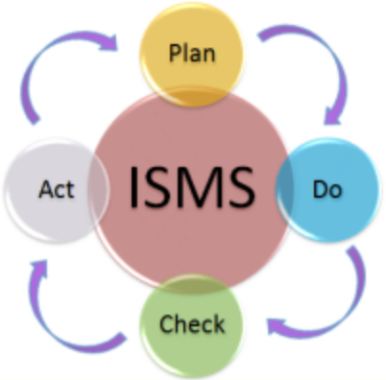
- Act: According to the results of the evaluation feedback, the management and technical level will make corresponding strategic decisions, further optimize the specifications and schemes, and start planning again. It goes round and round, forming a spiral closed loop.
Figure 2：data security framework figure
- In the operation and maintenance process, ITIL mechanism is used for internal and external maintenance respectively. Internally, it carries out operation and maintenance management for employee information, and the external part is for the management of non-employee information. Service Desk and Configuration Library are used in this step. The basic configuration of the service desk includes: providing capacity management, service level management to ensure availability and continuity, and security management. The Configuration Library is responsible for providing standards and guidelines.
- In IT audit, the strategic and tactical approach provided by COBIT security model is adopted. It is an international IT management and problem-solving solution for information systems auditors and enterprise IT senior managers. In my security framework, COBIT provides an efficient approach to IT auditing and fits well with the combination of ITIL and ISO27001 mentioned above.
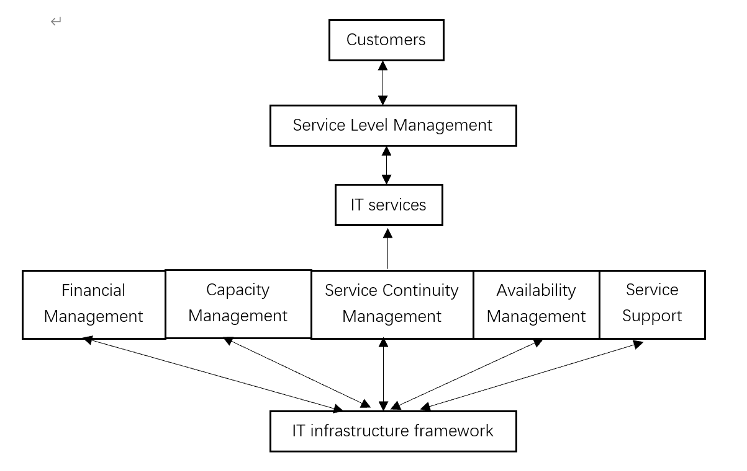
The following figure 3 shows the service flow diagram provided by the security framework
Figure 3: the service flow diagram

8.4 Additional details about the security framework
- Basic security services architecture
- Physical security: real-time monitoring and regular maintenance of the environment and equipment in the machine room.
- Architecture security: resource allocation for network planning, LAN and extranet partition, and improve host and terminal security.\
- Data security: complete data life cycle management system, data leak protection mechanism, data encryption policy, data archiving manual and requirements, disaster backup and records.
- Access security: for employees and customers, internal and external network division is consistent, reduce access pressure. And the employee to enter the internal network to achieve identity verification, access time, place, IP record at any time. There needs to be a complete identity lifecycle management.
- Operation and maintenance safety management
First of all, the security of operation maintenance is very important. Secondly, the emergency encountered in the operation and maintenance process is recorded and managed, and the performance assessment of relevant personnel, to improve the enthusiasm of operation and maintenance safety management. Finally, outsourcing services should be selected appropriately to reduce human resources and material expenditures that enterprises are not good at.
- Safety and risk management
First of all, security governance needs to formulate security policies and governance framework to form a response system. Second, in terms of risk management, all hazards or pressures encountered should be classified and contingency strategies should be developed. It must be noted that all policies and regulations must comply with local laws and regulations
- Reference
[1] U. S. Patent, “United States Patent : 3871965 United States Patent : 3871965,” Yeast, vol. 2, no. 12, pp. 4–6, 2010.
[2] S. E. Madnick, R. Y. Wang, Y. W. Lee, and H. Zhu, “Overview and framework for Data and information quality research,” J. Data Inf. Qual., vol. 1, no. 1, pp. 1–22, 2009, doi: 10.1145/1515693.1516680.
[3] S. D. Galup, R. Dattero, J. J. Quan, and S. Conger, “An overview of IT service management,” Commun. ACM, vol. 52, no. 5, pp. 124–127, 2009, doi: 10.1145/1506409.1506439.
[4] D. McPhee, “Information Technology Infrastructure Library (ITIL®),” Encycl. Inf. Assur., no. May 2007, pp. 1578–1587, 2010, doi: 10.1081/e-eia-120046727.
[5] A. Gillies, “Improving the quality of information security management systems with ISO27000,” TQM J., vol. 23, no. 4, pp. 367–376, 2011, doi: 10.1108/17542731111139455.
[6] I. Meriah and L. B. A. Rabai, “Comparative study of ontologies based iso 27000 series security standards,” Procedia Comput. Sci., vol. 160, pp. 85–92, 2019, doi: 10.1016/j.procs.2019.09.447.
[7] G. Ridley, J. Young, and P. Carroll, “COBIT and its utilization: A framework from the literature,” Proc. Hawaii Int. Conf. Syst. Sci., vol. 37, no. C, pp. 3655–3662, 2004, doi: 10.1109/hicss.2004.1265566.

