Student Name: Jessica Isaac
Student Number: 2204034

Course: BA (Hons) Graphic Design

Module: Research in Practice – ADAD5004
Lecturer: Donna Williams

Word Count: 2599

Three Keywords:

Dissociation
Visual
Euphoria

Dissociation, Visual, and Euphoria

A short overview of this academic research is to explore my three chosen key words that reflect my interests within my own practice which I will support through images and three key thinkers and artists. This research will help me attempt to make a connection with my three key words of dissociation, visual, and euphoria to form a question for my independent project in level 6. I will explore these key words further with my chosen visual artists, which include, Edvard Munch (Dissociation), Barnett Newman (Visual), and Salvador Dali (Euphoria). These will be further supported by my three chosen theorists, which include Pierre Janet (Dissociation), Man Ray (Visual), and Haig Khatchadourian (Euphoria).

Dissociation

Dissociation is “a mental process where a person disconnects from their thoughts, feelings, memories or sense of identity” (Better Health, 2023), to put this explanation into context, this is where the person experiences an out of body experience, like they are in a hypnotic state. This is supported through my research into the journal titled The dissociation theory of Pierre Jane’, Pierre Janet was one of the first psychoanalysts to conduct scientific research around dissociation, and he describes it as “a process whereby certain mental functions … that operate in a more automatic way outside the sphere of conscious awareness…” (Janet, 1989, p. 1).

Dissociation is a common response to psychological trauma, serving as a mechanism for the mind to create a ‘dissociative environment’ for self-preservation. This raises the question of how dissociation intersects with graphic design in the art industry. Through personal experience this condition created a passionate interest in how we can visually communicate and create awareness for the conditions. Graphic design plays a crucial role in informing important information, as evidenced by a blog post discussing an exhibition titled, Learning Not To Be Afraid of Yourself by Catherine Gazy, a student at the University of Hertfordshire. The exhibition aimed to tackle the stigma surrounding dissociative identity disorder (DID) by “immersing visitors in the experience” (World Brand Design Society, 2024), highlighting the potential for graphic design to drive social change.
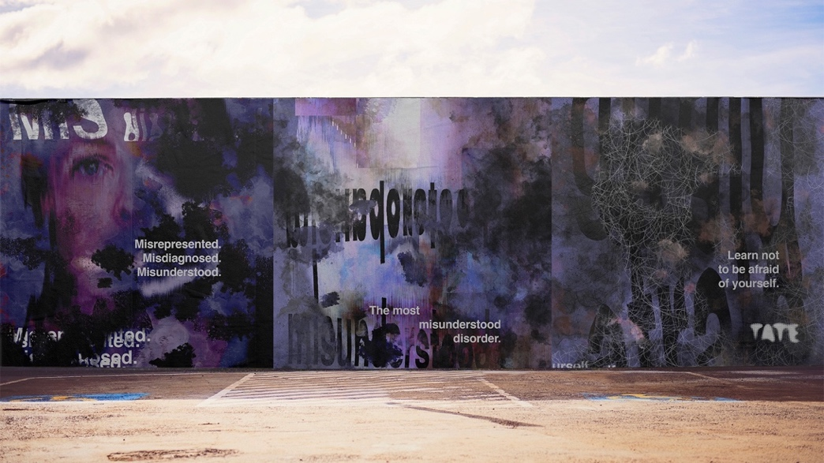
Due to dissociation being a mental health issue, graphic design can be used in the health industry to inform and help patients, figure 1, Gazy (2024) used branding and a campaign as an angle to convey information, and to encourage members of the public who have been diagnosed, not to be afraid of themselves, which is the name of the campaign itself. It is an interesting concept that the context of the campaign of figure 1 is to inform the public and for individuals experiencing a dissociative disorder, to “not to be afraid” which is an emotion, that is associated with a disorder that can impact someone from “feeling separate from their emotions” (Art Therapy Resources, Unknown). In my opinion, I believe that Gazy’s (2024) exhibition is a good thing because it is visually communicating to gain the attention and understanding of members of the public. I am excited that a student is visually informing the stigma surrounding DID because it is a complex subject of a disorder, and it is difficult to showcase in a way to gain an emotional response of an unemotional disorder.
Fig 1. Learning Not To Be Afraid of Yourself, Catherine Gazy, 2024

In my personal experience, it can also be considered that even though an individual can disconnect themselves from their emotions, it could argue that they could also experience feeling emotions more intensely but have difficulty expressing them. A couple of questions were generated in whether dissociation can be linked to expressionism in the art industry.
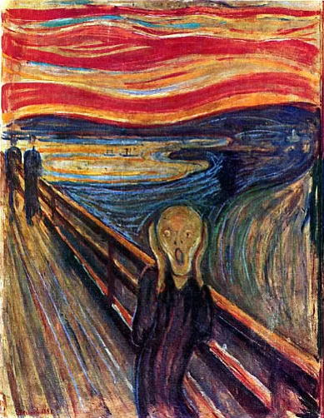
Expressionism is “an art style which… emphasises emotion over realism,” (Rob Hooks, 2019), which means in context that the art form appeals to emotions where in my opinion, it is an emotional response from individuals who are experiencing the artists’ emotional triggers. This has been supported by research within Mind (2023) which describes it as “dissociation is a way the mind copes with a traumatic event” (Mind, 2023). In my opinion, this is where the mind is altering reality, an unnatural dream, to create a haven for self-preservation.
Fig 2. The Scream, Edvard Munch, 1893

But what can be considered unnaturalness? Unnaturalness is “strange and often frightening, because it is different from what you normally expect”, (Collins English Dictionary, 2007), this can be supported by The Scream, figure 2, by Edvard Munch (1893). This can be described in context of the art industry as diverting from the societal norms where Munch (1893) expresses emotion through distorted paintings, where natural forms are changed to represent a hypnotic state of illusion. Munch (1893) perceives the word distortion as the “inner world” (Sciam, 2024), which in context suggests that an “inner world” is inside of the mind, a dream like state, which indirectly supports Janet’s (1989) scientific research on dissociation. The use of dissociation is portrayed through the sight of an individual, which is explained by a psychologist, A Synnot, who describes it as “eyes are the window of the soul” (Synnott, 2022). As a way for Munch (1893) to express emotion in his artwork, he uses portraiture which is a way that is often considered that the use of portraiture is a way for individuals to analyse an image using body language.

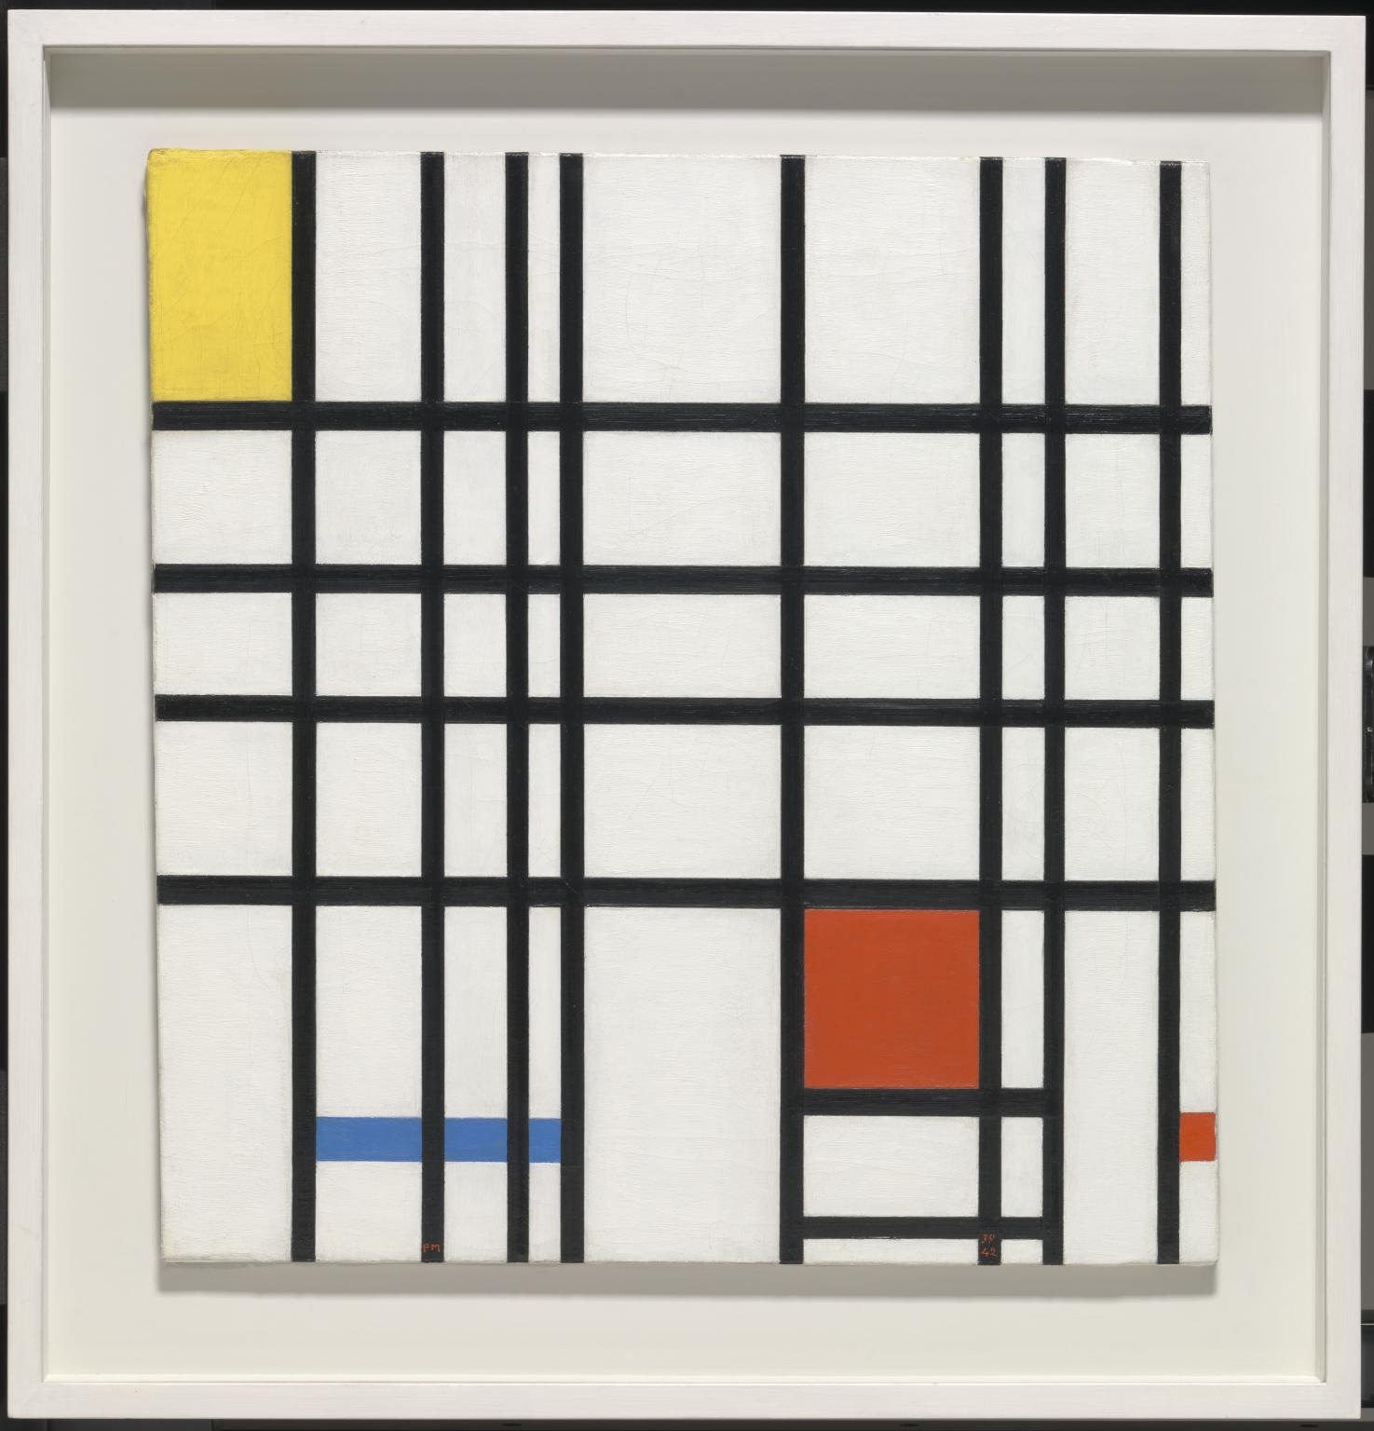
Expressive art does not have to include portraiture to convey emotion. Non portraiture occurs when there is no visual representation of a facial expression or person, in other words, abstract or conceptual art. Conceptual art is the idea is the most important point of the art piece. An abstract artist is when an artist uses a form that is the most suitable for the idea that they are trying to make. Piet Mondrian is an abstract expressionist, in figure 3, the context of Mondrian’s (1937-42) composition is based off the emotions of colour and shape. (Fig 3) supports Janet’s (1989) of how dissociation can be an organised, where the body conducts an automatic movement, instead of being fluid.
Fig 3. Composition with Yellow, Blue and Red, Piet Mondrian, 1937 - 42

The combination of expressive art through exhibition, painting and conceptual art associates to each other by immersing people into the experience of art. It creates a world to experience art on a different level, where the artist is allowing entry into the alternate reality they created for you. Thus, it connects to dissociation on how an individual experiencing DID creates an alternate reality for self-preservation.

Visual

Visual “relates to sight or things that are observable.” (Collins English Dictionary, 2007). This definition emphasises the importance of perception and aesthetic appeal. The term ‘visual’ is broad and applicable across various disciplines. In the realm of design, it encompasses “the ability to interpret and understand visual information through the sense of sight” (Visual Design Foundation, 2016).

Visual information is an important factor in graphic design, and this can be interpreted in different ways of what it is viewed as, and this can be through form, typography, colour, composition. This is supported by Man Ray, who was an American visual artist who produced paintings and photographs, ‘Review: Artists and their art with Keith Dewhurst’, that “as a result of looking at something that has no quality or meaning.” (Ray, 1972), it suggests that it doesn’t matter if elements have no meaning behind it, when it is combined, it can take its own shape.

It has generated a question of how can art reshape itself to create a feeling?

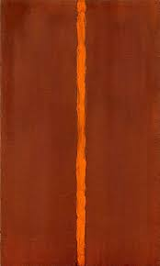
This has now introduced a sub word of ‘composition’, it has been described as a “way in which all its elements work together to produce an overall effect” (The National Gallery, 2024). In the context of graphic design, it suggests that by combining all elements, it can create an overall feeling, in which even though visual is described as an object you see, it can also generate emotions. Composition artwork can also be recognised as minimalism, where it is the artists intentions to reduce elements, so the focus is the object itself.

However, by the artists reducing elements, it can make the art piece more structured and in ways a lack of effort by a simple approach. It can be argued that the art movement ‘minimalism’ can be a balance of structure and freedom, and by working in a simple form, it can be a way for individuals to interpret and assign their own definitions to what they see, that artwork isn’t just an object, but a story of emotions. “Stop thinking about artworks as objects and start thinking about them as triggers for experiences.” (Brian Eno, Unknown). This is an interesting viewpoint by Eno, and I agree with this because I believe that this suggests that artwork is a leap created for the individual to understand an emotion.
Fig 4. Onement I, Barnett Newman, 1948
Brian Eno’s theory can be supported by Barnett Newman, an artist who focuses on abstract expressionism. His first art piece titled ‘Onement I’, is a signature mark for abstract work or ‘minimalism’, where it shows that a visual constructive piece can be created with experiments and feelings. This means that Newman didn’t plan this work, he just felt his visual thoughts, and where it would take him. The work is an expression of revelation, a barrier between the individual looking at it, and the emotion behind it, which is how Newman describes his work as “my compositions are forms of thought, and expressions of being alive and individual.” (MoMa, 2017), which supports Eno’s (Unknown) theory of how an individual can experience the art’s emotion.

The combination of ideology through composition, minimalism, and abstract expressionism is how limited shapes creates a story by integrating white and black space. This allows the individual to create a conscious emotional response that is reflected in sight, to compose the design into their own train of thought.

Euphoria

Euphoria is an “intense reaction of powerful happiness and excitement”. (Collins English Dictionary, 2007). This definition in the art industry emphasises the heaviness of the emotional response from the individual when viewing the artwork. There are many emotional components relating to Euphoria, these can vary from pleasure to substance abuse euphoric moods. In the territory of design, it forms an interesting connection with individuals, that it emits “powerfully elicited emotions in audiences”. (Edwards, 2023). This can appear with both positive and negative emotions.

A euphoric sense of emotion is important in the design environment, it is when the activity of design reveals its story to the audience. This is supported by Haig Khatchadourian, a Professor of Psychology, describes it as “a spontaneous overflow of powerful feelings” (Khatchadourian, 1965, p. 335), where it is the subconsciousness of the artist visually coming to life within the work that the individual viewing it, embraces and understands the emotions.

In my personal experience with euphoria, it can be considered that it is an addictive emotion for the mind. It can be a good emotion, where an individual can experience sexual pleasure, and immense joy, but, on the other hand, it can cause intense jealousy where it can alter their reality and viewpoint. Euphoria is intensely linked to transgender, where trans individuals experience distress about their assigned gender . A question was generated on whether euphoria can be experienced in surrealism in the art industry and how gender euphoria can be virtually demonstrated.

Surrealism is a “rational vision of life that aligns itself with dreams”. (Tate Modern, 2023), which means in context that the art form combines the conscious and subconscious mind to create an alternate reality.
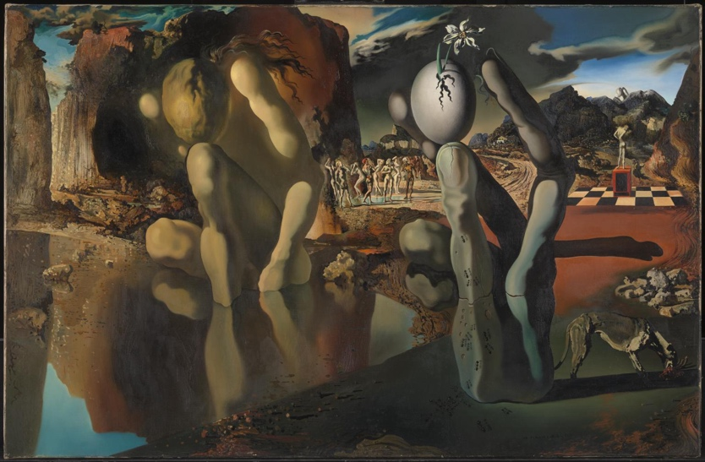
A subconscious state of euphoric art can be supported by artist Salavdor Dali, a visual artist known for painting, graphic design and photography, where the major subjects of his work were “dreams, subconscious, and sexuality” (Tate Modern, 2024), that in figure 5, it supports the concepts of desirable dreams. This can be described as a trigger of anxiety, disgust, as well as desire with Dali (1937) expressing the emotion of the hallucination of Narcissus’ transformation.
Fig 5. Metamorphosis of Narcissus, Salvador Dali, 1937

The work is an expression of hallucinations due to the use of double imagery, which will allow the viewer embracing the emotions of the artwork to experience the delusion side of the painting, where it merges into one reality of the representation of Dali’s understanding of the myth. In context, this is placing the mind of the individual who understands the overflow of the emotions emitting from the piece as well as the designer, which supports Khatchadourian’s theory.

Euphoric art doesn’t just have to be unrealistic; it can be genuine. Genuine euphoric art occurs when it is based off a non-fictional experience, it can be considered realism. In my opinion, it can be contradicting that surrealism and realism can have the same answer, it is surrealism that questions the observation. I find that having a real experience in a surrealist piece can evoke more emotions than a realism art piece, you are understanding a more human approach, and how the subconsciousness can affect your sight.
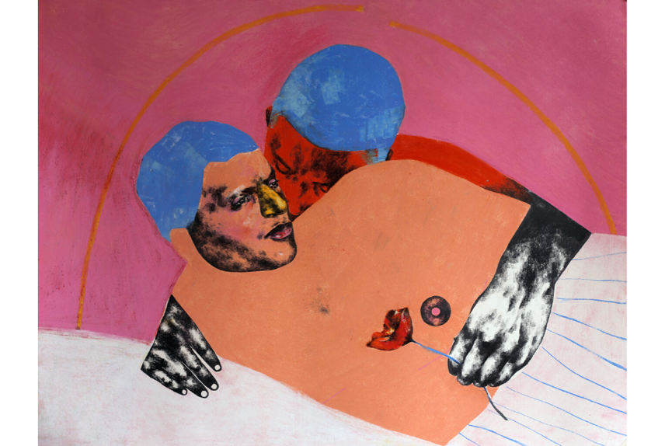
Graphic design is an important factor when communication a complex visual experience, as evidenced in an online exhibition titled Gender Euphoria: Contemporary Art Beyond the Binary by Pace Taylor, a non-binary graduate of the University of Oregon. The exhibition aimed to inform viewers “the challenges that these queer individuals are faced with” (Taylor, 2020), this in context is informing the viewer on a realistic experience by using a surrealistic art approach. His work Memory Fails; A Flower is a contemporary surrealistic approach to a complex subject.
Fig 6. Memory Fails; A Flower, Pace Taylor, 2020

The combination of surrealism, pleasure and contemporary is how they are indirectly enabling audiences to communicate over its subjectiveness to the art industry. This allows the audiences to explore beauty in the unexpectedness of non-obvious art works. In my opinion, this makes art unique in the sense of finding beauty in unusual pieces where it can make you question your values and beliefs. In my personal experience, erotic art is beautiful art, but it can be a subjective art form that is returning due to the destruction from religious believer on what they consider ‘appropriate’ for audiences.

Conclusion
To conclude my findings, it has allowed me to deepen my understanding and gain further knowledge of each keyword, and the sub genres. It has allowed me to decipher how each key word as connections with each other while maintaining their independent differences.

The connections between each keyword are how they are all linked to the emotions of audiences and the artists. I made sure to set it out where the first word is how emotions can appear in distorted work, to how visually you can see the emotions, to how an individual can embrace the emotions from the artwork and their own interpretations. It has allowed me to separate their differences which is the art movements that they are linked to, and how they can be linked to design with their differences.

Overall, this has enabled me to go down multiple pathways where I can take my research further towards multiple sub words, such as surrealism, erotic art, expressionism, abstract, collage, and subconsciousness. I could go down routes of typography, collage, poster design, and the use of contemporary art and distortion.

Based on the research that I have conducted above; I would like to focus on surrealistic art in many aspects of design with the use of graphic design elements. My proposed question for my third-year independent project is: How can expressive surrealistic art be used in graphic design?

Bibliography

Art Therapy Resources (Unknown) Case Study: Art Therapy for a Client with Dissociation Issues. Available at: https://arttherapyresources.com.au/dissociation/ (Accessed: 21st April 2024).

Better Health (2015) Dissociation and dissociative disorders. Available at: https://www.betterhealth.vic.gov.au/health/conditionsandtreatments/dissociation-and-dissociative-disorders# (Accessed: 21st April 2024).

Collins English Dictionary. (2007). Euphoria. [Online]. Available at: https://www.collinsdictionary.com/dictionary/english/euphoria (Accessed: 23rd April 2024).

Collins English Dictionary. (2007). Unnaturalness. [Online]. Available at: https://www.collinsdictionary.com/dictionary/english/unnatural (Accessed: 23rd April 2024).

Collins English Dictionary. (2007). Visual. [Online]. Available at: https://www.collinsdictionary.com/dictionary/english/visual (Accessed: 22nd April 2024).

Edwards, A. (2023). ‘Art and Emotion – How Artists Convey Feeling Through Brushstrokes’, Angela Edwards [Blog]. Available at: https://www.angelaedwards.co.uk/art-and-emotion-how-artists-convey-feeling-through-brushstrokes/ (Accessed: 24th April 2024).

Eno, B. (Unknown). ‘The Power of Minimalism in Art’, Brian Parker Visual Artist [Blog]. Available at: https://www.brianparkerartist.co.uk/the-power-of-minimalism-in-art/ (Accessed: 23rd April 2024)

Hooks, R. (2019) ‘Expressionism in graphic design’, 99 Designs [Blog]. Unknown. Available at: https://99designs.com/blog/design-history-movements/expressionism-in-design/ (Accessed: 21st April 2024)

Interaction Design Foundation. (2016). ‘What is Visual Perception?’, Interaction Design Foundation. [Online]. Available at: https://www.interaction-design.org/literature/topics/visual-perception (Accessed: 22nd April 2024).
Janet, P. (1989) ‘The Dissociation Theory of Pierre Janet’, Journal of Traumatic Stress, 2 (4), pp. 397-412). Available at: https://www.researchgate.net/publication/226524345_The_dissociation_theory_of_Pierre_Janet (Accessed: 21st April 2024).

Khatchadourian, H. (1965). ‘The Expression Theory of Art: A Critical Evaluation’, The Journal of Aesthetics and Art Criticism, 23 (3), 335-352). Available at: https://doi.org/10.2307/428180 (Accessed: 24th April, 2024).

Mind (2023) Dissociation and Dissociative Disorders. Available at: https://www.mind.org.uk/information-support/types-of-mental-health-problems/dissociation-and-dissociative-disorders/about-dissociation/ (Accessed: 22nd April 2024).

Ray, M. (1972). Man Ray Interview with Keith Dewhurst. [Video]. Available at: https://www.youtube.com/watch?v=aEaldosICdI (Accessed: 22nd April 2024).

Sciam, M. (2024) ‘Mondrian’s Expressionism: 1907 – 1911,’ An Explanation of Mondrian’s oeuvre by Michael Sciam. Available at: https://www.piet-mondrian.eu/introduction/an-overview/mondrian-expressionism-1907-1911/ (Accessed: 22nd April 2024).

Synnott, A. (2022) ‘How the Eyes Express Emotions and Bodily States’, Psychology Today, (July), p.p 1-2. Available at: https://www.psychologytoday.com/gb/blog/rethinking-men/202207/how-the-eyes-express-emotions-and-bodily-states (Accessed: 22nd April 2024).

Tate Modern. (2023) Art Term: Surrealism. Available at: https://www.tate.org.uk/art/art-terms/s/surrealism#:~:text=Surrealism%20aims%20to%20revolutionise%20human,the%20disregarded%20and%20the%20unconventional. (Accessed: 24th April 2024).

Tate Modern. (2024) Salvador Dali: 1904-1989. Available at: https://www.tate.org.uk/art/artists/salvador-dali-971 (Accessed: 24th April 2024).

Taylor, P. (2020) ‘Gender Euphoria: Contemporary Art Beyond the Binary’, Five Oaks Museum, July 9th 2020. Available at: https://fiveoaksmuseum.org/exhibit/gender-euphoria/ (Accessed: 24th April 2024).

The Museum of Modern Art. (2017) Barnett Newman: 1905-1970. Available at: https://www.moma.org/artists/4285 (Accessed: 23rd April 2024).

The National Gallery. (2024) Composition. Available at: https://www.nationalgallery.org.uk/paintings/glossary/composition#:~:text=Composition%20is%20the%20term%20given,to%20produce%20an%20overall%20effect (Accessed: 22nd April 2024).

Wolfe, S. (Unknown). ‘Art Movement: Expressionism – Expressionist Artists, Art and Overview’, Artland, Unknown dates. Available at: https://magazine.artland.com/art-movement-expressionism/ (Accessed: 22nd April 2024).

World Brand Design Society. (2024) Dissociative Identity Disorder Exhibition Branding. Available at: https://worldbranddesign.com/dissociative-identity-disorder-exhibition-branding/ (Accessed: 21st April 2024).

List of Figures

Figure 1: Learning Not To Be Afraid of Yourrself, Catherine Gazy, 2024. Available at: https://worldbranddesign.com/dissociative-identity-disorder-exhibition-branding/ (Accessed: 21st April 2024).

Figure 2: The Scream, Edward Munch, 1893. Available at: https://www.piet-mondrian.eu/introduction/an-overview/mondrian-expressionism-1907-1911/ (Accessed: 22nd April 2024).

Figure 3: Composition with Yellow, Blue, and Red, Piet Mondrian, 1937-1942. Available at: https://www.piet-mondrian.eu/introduction/an-overview/mondrian-expressionism-1907-1911/ (Accessed: 22nd April 2024).

Figure 4: Onement I, Barnett Newman, 1948. Available at: https://www.moma.org/collection/works/79601 (Accessed: 23rd April 2024).

Figure 5: Metamorphosis of Narcissus, Salvador Dali, 1937. Available at: https://www.tate.org.uk/art/artworks/dali-metamorphosis-of-narcissus-t02343 (Accessed: 24th April 2024).

Figure 6. Memory Fails; A Flower, Pace Taylor, 2020. Available at: https://fiveoaksmuseum.org/gender-euphoria-pace-taylor/ (Accessed: 24th April 2024).

