Franz Kline And De Kooning: Methodology.
With this project I want to go into detail deterring two forms of art in the Abstract expression scene, because although they are all encompassing of one movement of paintings many of those classed in it did not view themselves as such and I do so intrinsically agree, for example Franz kline’s work was described as a more of a blank statement with no emotional resemblance, they just are as taken from here in a quote I found. -
“But whereas those painters made work that was deeply rooted in underlying meaning, Kline made work that only referenced itself. The brush strokes he created were, as he explained, “unrelated to any entity but that of their own existence.” -
What attracted these artists to the abstract expressionist movement was to perhaps look at the climate in which the movement was in, the extreme war between the west and the east butting heads towards one another, people were in a state of paranoia and were worried, terrified even, the development of why I think abstract expressionism came about was from the development of freedom, the ability to not worry about the climate around them, even so much as much the climate we are now even, it was a form of freedom and allowing yourself to be controversial and free, as taken from a quote here –
“It is ironic but not contradictory that in a society…in which political repression weighed as heavily as it did in the United States, abstract expressionism was for many the expression of freedom: the freedom to creative controversial works of art, the freedom symbolized by action painting, by the unbridled expressionism of artists completely without fetters”

What is Abstract Expressionism?
The existence, and movement started in 1940 post war American environment, in the city of New York although the phrase ‘expressionism’ was coined in a earlier time period of the art world with the European German expressionism in the magazine ‘der strum’.
Abstract expressionism spans across 1940 in Europe and 1950 in America with the influence of the non- thinking, and the exploration of mythology and psychology, gravitating towards the intellectual thinkers like Carl Jung and Jean Paul Sartre, as taken from a quote here –
“The Abstract Expressionists were deeply influenced by the idea of exploring the unconscious which reigned in Surrealism, and by the ideas of Swiss psychologist Carl Jung and his exploration of myths and archetypes. They also gravitated towards existentialist philosophers like Jean-Paul Sartre”-
Here, the origin of the American version with the art movement will be focused on. The first major American Expressionist artist is the world - renowned artist Jackson Pollock. Pollock realised that the influence of making the painting and not developing the subject from thought and more about the influence and making as well as movement, as taken from here in this statement.
“J.P.: …The modern artist is living in a mechanical age and we have a mechanical means of representing objects in nature… is working and expressing an inner world…expressing the energy, the motion, and other inner form”. – Taken from a tape by William Wright in the summer of 1950 for presentation on the Sag Harbor radio station but was never used.

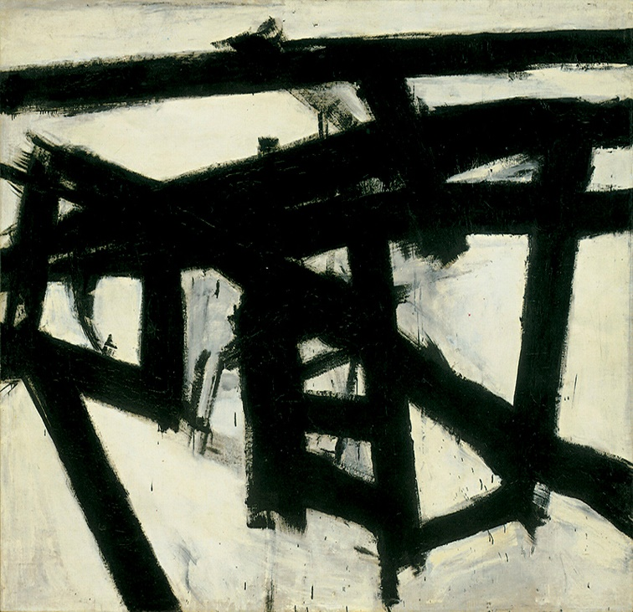
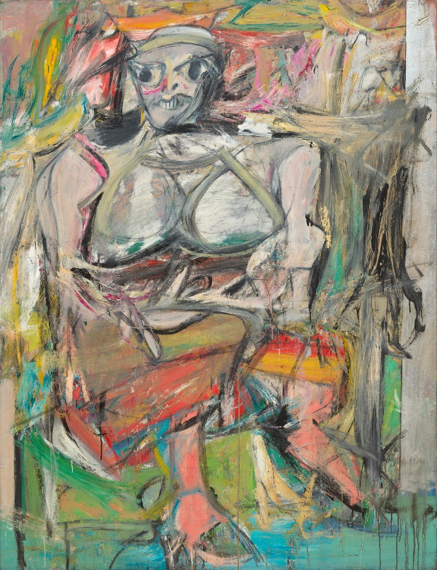
(William de kooning, Woman I, 1950-52, canvas)
(Franz Kline, Mahoning, 1956, Canvas)

The two pieces of work specifically of both artists work I will be discussing is Franz Klines Mahoning 1956 painting and de koonings Woman I analogy painting made in 1952.
Each of which being, Franz Klines work being more of a embodiment of making the image with spontaneous gestures and limitations of the canvas, and the absolute minimalism and “its ragged brushwork and slashes of pigment. De Kooning’s work on the other hand was being described as a sort of colourful horror of sorts, quite frightening but felt that it had intense vitality and liked the quality of the colour.

Franz Kline’s most prolific works comes from his era of black and white works in the nineteen fifties to the mid nineteen sixties. Most of these works consist of weighty, massive canvases on a gleaming white canvas, violated with this huge barking looming black marks being dragged on to the canvas.
The thing that compels me about Kline’s work is the brush work, the making of marks on the canvas, it is completely void of human structure, how he makes these was from de Kooning’s suggestion that he use a projector to upscale a sketch as taken from here from an article I found on the methodical process.
“It is widely believed that Kline's most recognizable style derived from a suggestion made to him by his friend and creative influence, Willem De kooning. Elaine, the wife of Willem de Kooning remembered the time where in late 1940s, de Kooning advised the artistically frustrated Kline to project a sketch onto the wall of his studio, using a Bell-Opticon projector. Kline described the projection as follows: A four by five inch black drawing of a rocking chair...loomed in gigantic black strokes which eradicated any image, the strokes expanding as entities in themselves, unrelated to any entity but that of their own existence."- (ArtWizard 24.02.2020)
Another artistic motive Franz Kline has, is the blunt black and white colour palette he uses in his work, the huge majority of the work is of a monochromatic palette, consisting of mainly black and white paint, the theory behind this was that franz thought of the black and white as a positive and negative space as taken from this quote “He explained how his monochrome palette was meant to depict negative and positive space by saying, "I paint the white as well as the black, and the white is just as important.” – (ArtWizard 24.02.2020)

The next piece of work I’m going to write about is of William de Kooning’s woman series, one of the most controversial circumstances in the abstract expressionist movement due to it’s method of subjectivity, any midst of a subject or model in the painting in abstract expressionism is a rule you don’t break according to the people in that time, which de Kooning did do, touching on the bases of a more surrealist approach than one of abstract expressionism, and that it was perceived as a negative connotation of the subject, thinking the perception of the subjects were of a form aggression and violence.
“Fans of de Kooning’s abstract paintings from the 1940s were devastated by the inclusion of a recognizable figure in his work. Critics also derided what they perceived as an aggressive and violent depiction of women, saying it was degrading.” - (https://mymodernmet.com/willem-de-kooning/)
In contrast to Kline’s work, De Kooning’s colour palette is one of an extreme variety, in the woman series the use of colour being used is one of a more brash use, the use of extreme greens, bright reds and white’s been clashed together like a flashbang of collaboration, it’s absolutely not a monochromatic piece similar to Kline’s at all.

Argument
The reasoning for writing about these two artists, was to show difference in a specific movement, to show that all methodology isn’t the same despite them being in the same bracket as one another. Kline’s work compared to de Kooning in terms of methodology are completely different and not at all similar, Kline’s work was of a more gestural action painter and the works of De Kooning’s womans paintings were more in a familiarity of taking a essence of an image and making it into something else, there more thought to the painting at hand.

Bibliography
“It is widely believed that Kline's most recognizable style derived from a suggestion made to him by his friend and creative influence, Willem De kooning. Elaine, the wife of Willem de Kooning remembered the time where in late 1940s, de Kooning advised the artistically frustrated Kline to project a sketch onto the wall of his studio, using a Bell-Opticon projector. Kline described the projection as follows: A four by five inch black drawing of a rocking chair...loomed in gigantic black strokes which eradicated any image, the strokes expanding as entities in themselves, unrelated to any entity but that of their own existence."- (ArtWizard 24.02.2020)
(https://artwizard.eu/black-and-white-with-franz-kline-ar-59)

“J.P.: …The modern artist is living in a mechanical age and we have a mechanical means of representing objects in nature… is working and expressing an inner world…expressing the energy, the motion, and other inner form”. – Taken from a tape by William Wright in the summer of 1950 for presentation on the Sag Harbor radio station but was never used.
(http://homepages.neiu.edu/~wbsieger/Art201/201Read/201-Pollock.pdf)

“It is ironic but not contradictory that in a society…in which political repression weighed as heavily as it did in the United States, abstract expressionism was for many the expression of freedom: the freedom to creative controversial works of art, the freedom symbolized by action painting, by the unbridled expressionism of artists completely without fetters”
(https://www.moma.org/learn/moma_learning/themes/abstract-expressionism/#:~:text=Abstract%20Expressionism%20emerged%20in%20a,benefits%20of%20unprecedented%20economic%20growth.)

“But whereas those painters made work that was deeply rooted in underlying meaning, Kline made work that only referenced itself. The brush strokes he created were, as he explained, “unrelated to any entity but that of their own existence.” – https://www.ideelart.com/magazine/franz-kline

Although the term "abstract expressionism" was first applied to American art in 1946 by the art critic Robert Coates, it had been first used in Germany in 1919 in the magazine Der Sturm, regarding German Expressionism. - https://en.wikipedia.org/wiki/Abstract_expressionism

“The Abstract Expressionists were deeply influenced by the idea of exploring the unconscious which reigned in Surrealism, and by the ideas of Swiss psychologist Carl Jung and his exploration of myths and archetypes. They also gravitated towards existentialist philosophers like Jean-Paul Sartre”- https://magazine.artland.com/abstract-expressionism/

“spontaneous gestures”
“its ragged brushwork and slashes of pigment” - https://whitney.org/collection/works/1997

