
KGF cONSTRUCTION
Sameeran Raveenthiran

Student No: 2114454
Web and Database Concepts
Computing Data and Information Systems

Table of Contents
Introduction 2
Requirements 2
Implementation 4
Validation 10
Evaluation 12
References 13

Introduction
Construction Management System is a web-based application for dealing with the entire everyday occasion related activities for an association. There are numerous modules on this site.
The construction division gives the data anytime as per the necessities that should be satisfied. This site saves information irregularities and lessens desk work. Work: Manager: Create clients Assign cards to individuals Member: Create branch Create project Create merchant Create things Create buy request Create directions Create installment demand for seller.

Requirements
This website is primarily used to maintain relevant production records. This website offers features that allow members to create construction projects, partners, suppliers, items and more. They can also modify the record created. This website is quick and easy to find and minimizes labor and time. This project will make your website interactive. This website is for the construction company. The users of this website are the company and the management of the company. The targeted users are the customers that want to take services from the company. The main aim is that the customers can visit the website and then they can do the research on the company. They can know that how much the company is capable for the construction. They can know about the machinery that used by the company and they can also know about the multiple tools that company uses for the construction processes. The customers can also see about the previous projects of the company that the how the company accomplish those projects and how the projects look like. The customers can also see the team and the management of the company, and they also know that how much the team is capable for doing the project. The customers can also know about the biography of these team members and experience of these members of the company. The customers can also see about the success and accomplishments of these members. So, the customer can know that which team takes their project, and the project of the customers is in good hands. So, the customer feels safe to knowing that the project is in good hands. In short, the customer can know and get all the information that is important for him from this website. The customer can also know the team in the About Us page and the customer can also contact the company through getting the information from the Contact page. The company will also talk about their selves on the website that What kind of services are providing by the company and What kind of offers are made by the companies for their customers. The company briefly tells the customers about themselves. The management and the users of the company can post the daily posts on the website that user can visit the website and they can see about the new accomplishments of the company. The company can post anything about their success about their running projects and much more.
In the technologies, we used HTML and CSS only for the development of the website. HTML (Hypertext Markup Language) is for the scripting language and to make the web page documents and the CSS (Cascading Style Sheet) is for the style sheets in the website.
HTML also known as Hypertext markup language is the default language for documents to be designed and shown in a web browser. This can be aided by technologies including CSS and scripting languages like JavaScript.
The web browser gets HTML documents from a local storage or a web server, and this renders the document into many multimedia web pages. HTML structures the web page semantically and originally included cues for the appearance of the document.
HTML elements are basically building blocks of HTML pages. HTML configurations enable the embedding of images and various objects such as interactive forms in the rendered page. With the use of HTML, it offers a path to create structured documents by using text structural semantics. For example, paragraphs, headings, lists, quotations, links, and other many other elements. HTML elements can be found by tags written with chevrons. Tags like <img /> and <input /> input content straight to the page. Other tags, like <p>, provide information relating to the body of the document, and it can consist of other tags such as child elements. Browsers doesn’t show the HTML tags, but instead can be used to interpret the content of the page.
CSS is created to allow the presentation and content, colors, fonts, and layout to be separated. This separation increases the accessibility of the content and offer more control and flexibility in the specification of presentation characteristics. It also enables many web pages to share the formatting by stating the relevant CSS in a separate .css file, which aids the website by decreasing the repetition and complexity of structural content and allow the .css file to be cached which increases the page load speed within the pages that shares the files and its formatting.
Separating the formatting and content can also make it possible to display the same markup page in different styles for several rendering methods. CSS also has alternative formatting rules when accessing content from mobile devices.
Cascading letters come from a specific precedent scheme to determine which style rule applies when multiple rules match a particular element. This plan is a predictable waterfall priority.
JavaScript is a programming language which is also the core technologies of the World Wide Web (WWW), just lie HTML and CSS. All of the biggest website consists of a dedicated JavaScript engine so the cod on user’s device can be executed
JavaScript is known for its high level and just-in-time compiled language that adapts to the ECMAScript standard. This consists of prototype-based object-orientation, first class functions, and dynamic typing. This is a multi-paradigm which encourages both functional and mandatory event driven programming models. This consists of API (known as application programming interfaces) which works dates, standard data structures, text, regular expressions, and DOM (known as document object model).
The ECMAScript doesn’t consist of input or output, such as storage, networking, or graphics. A web browser or other OS system offer JavaScript APIs for input or output.
For the code editor I used Notepad++. Notepad++ known as a text and source code editor for Microsoft Windows. This program supports tabbed editing, which enables you to work with various open files in a single window.
Implementation
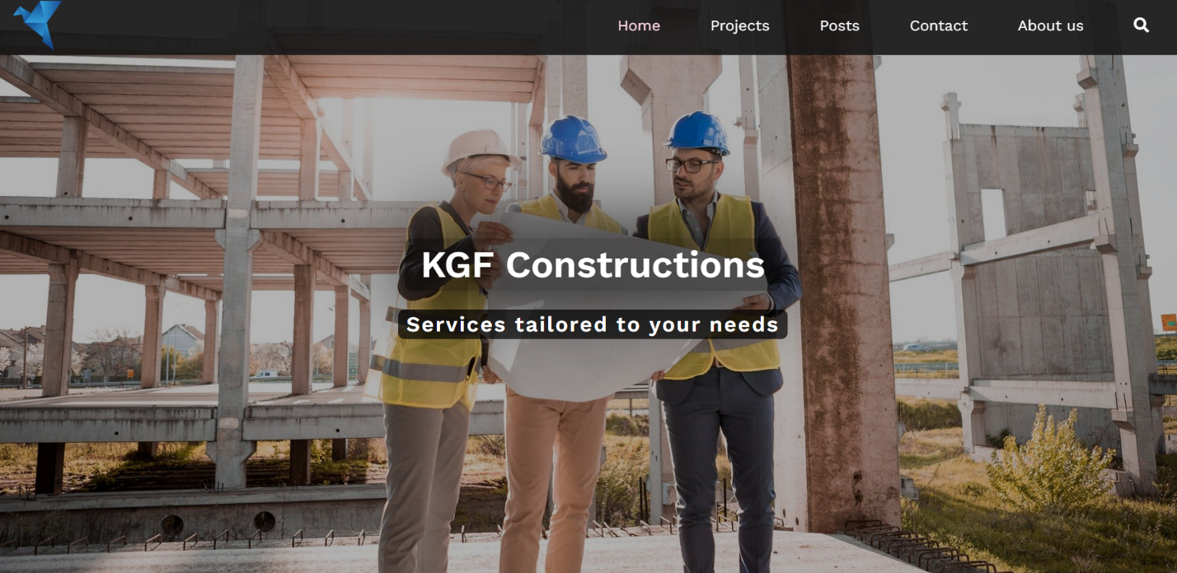
This is the home page of the website that appears on the start. This has a screen that has an image of the construction engineers that is good for the home page and on the upside for the Navigation bar there is a logo on the top left corner and then a home page button and the Projects button and the Posts button and the Contact button and also the About Us page and at last there is a search icon for the searching purposes. Customers can click on any button to go on that specific page to see the details of that page.
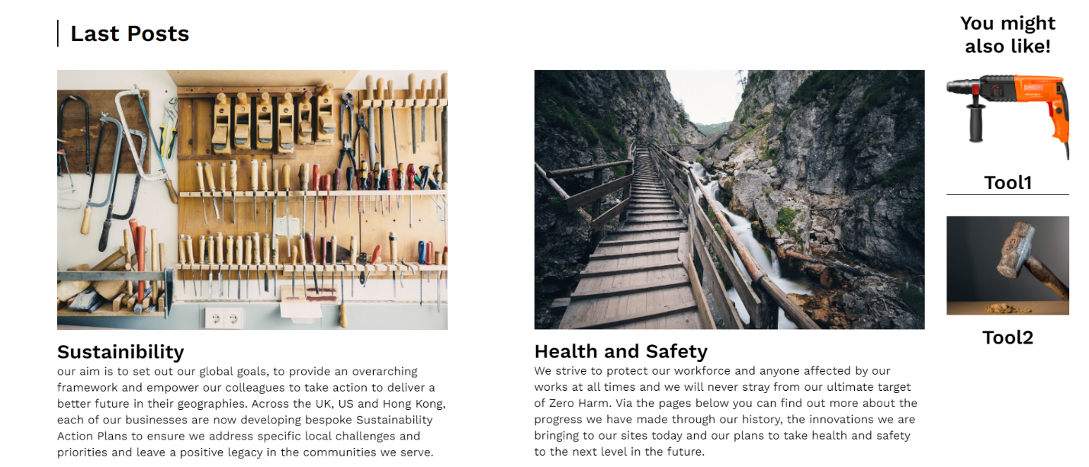
This is the “Posts” section here users can Posts all the posts and the customers can see all the old and new posts that is uploaded by the company. Customer can see all the information and can also see about the tools of the company.

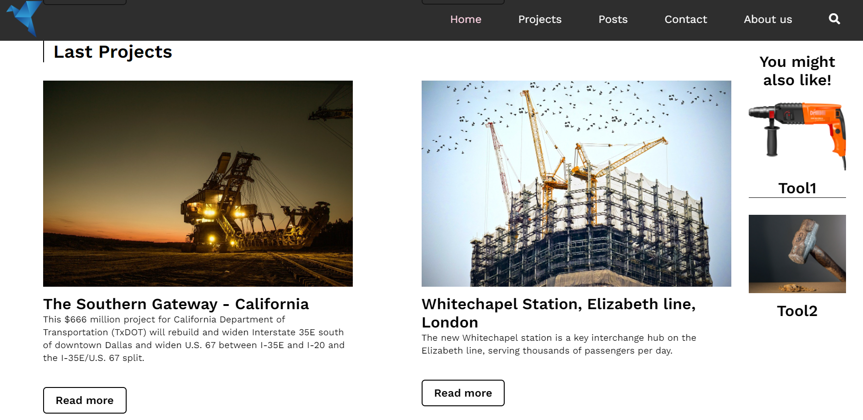
Here customers can see the projects developed by the company that how the company makes these projects. Customers can see all the provided information by the company about the project on this website. Customer can know about the information about the project. This is also the details of the project. As we can see that there are multiple projects here and user can know about the details of the multiple projects. At last, there is also some links that can take customer to their willing page. This helps the customer and this is for the easiness of the customer. For example, if a customer wants to go back to the “Home” page then he does not need to scroll up the page to go back to that page. The customer can just click on these links to go to their desired page and there are also some details about the website developer.
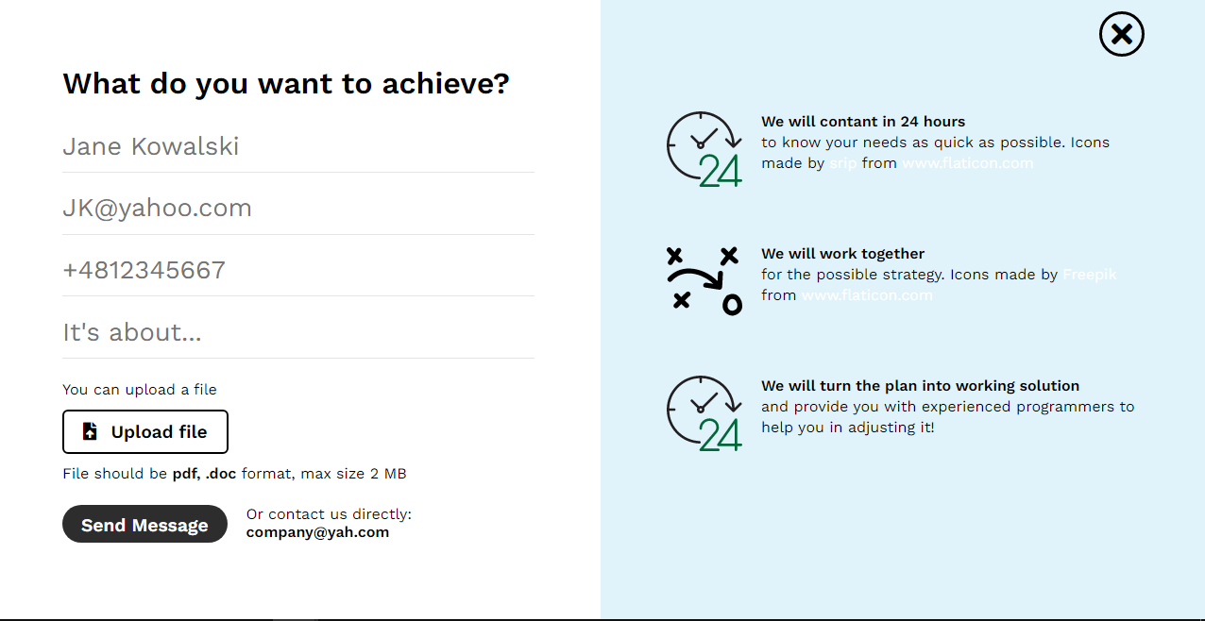
This is the Contact page. It appears after user clicking on the Contact button. Here is all the details about the company and the customer can contact to the company by seeing all the information from here.
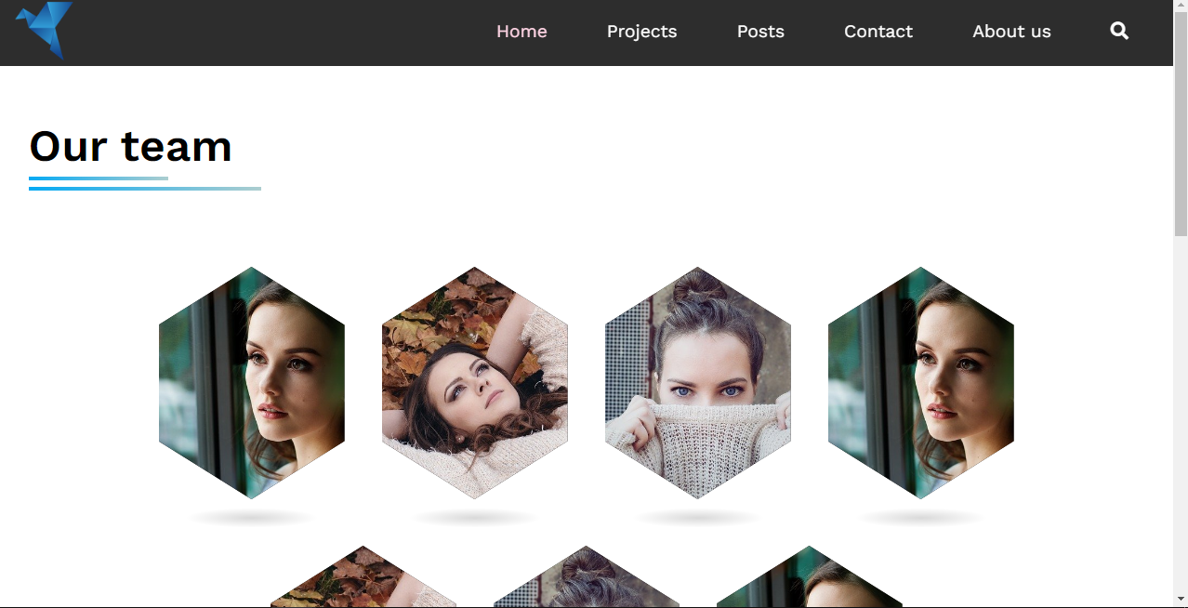
This page will appear after clicking the About Us button. This will tell the customer about the team and about the employees of the company and how much they are capable for doing the projects. After clicking on any image the customer can see all the details about that member and he can find all the details about him/her.
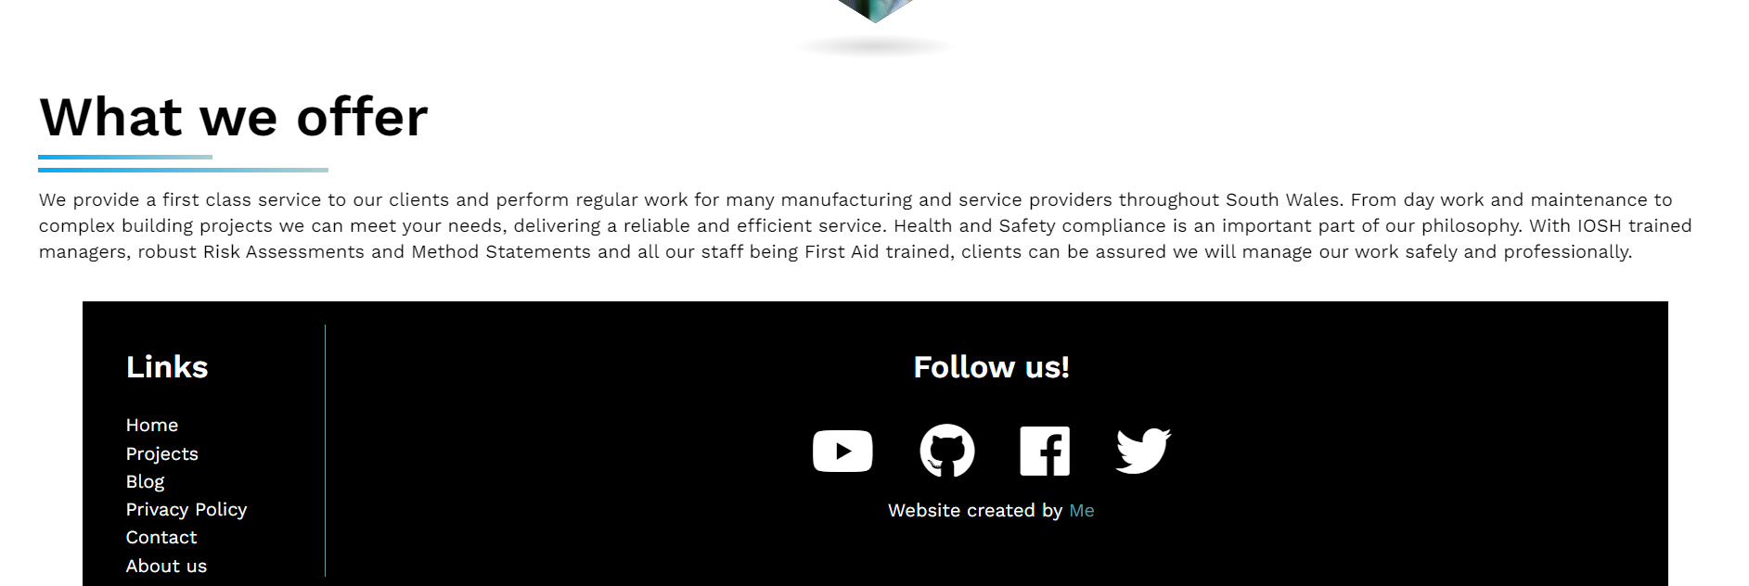
This page is to tell the customer what the company will offer to the customer. Then they can easily know about the offers of the company to the clients.


Our website is also responsive. As we can see whenever we changes the size of the window then the size of the screen of the website will also change and the menu bar will change into the button.
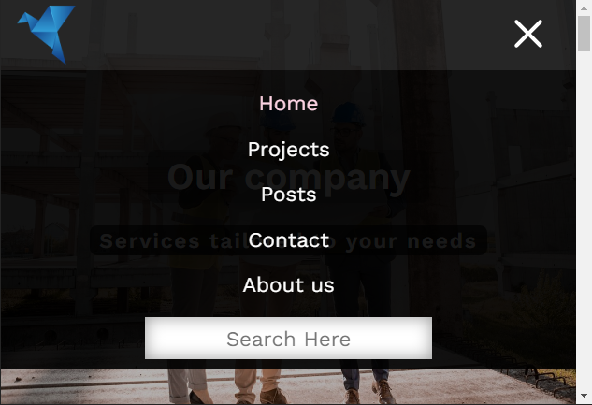
This will appear after clicking the 3 lines menu button.

Validation
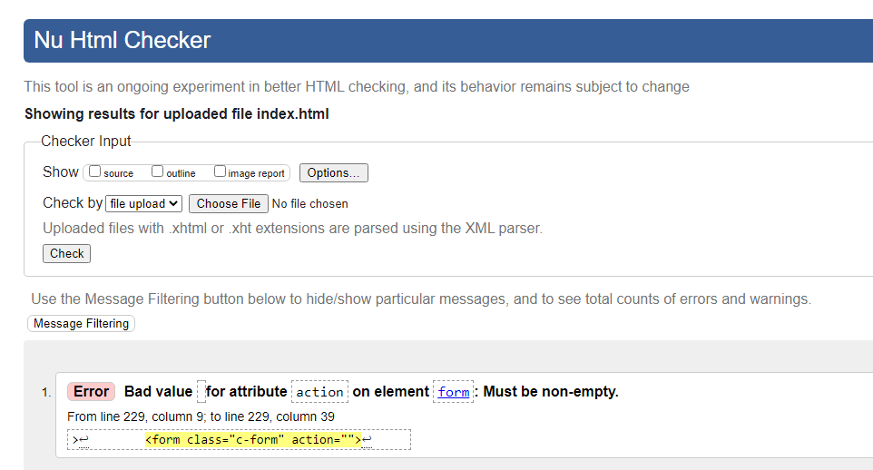
During validation these errors occurs in the index.html file. This is just an extra line that will not use in the HTML file.

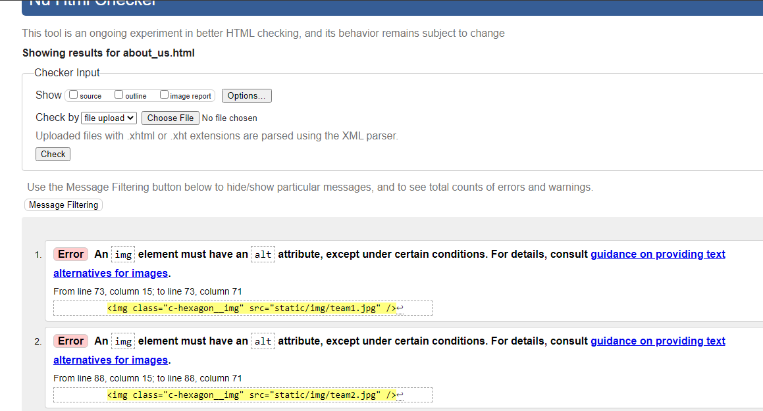
These are some errors in the about_us.html file. These are just for the img attribute that must be alt attribute.

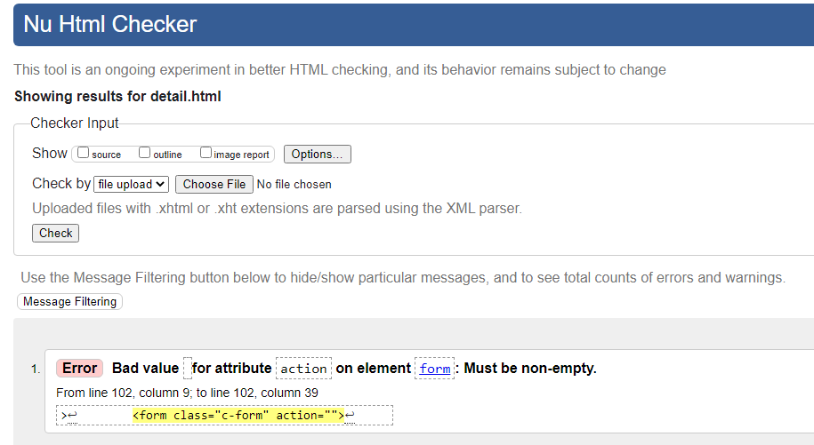
This is the error in the detail.html file. This error is due to that the action is empty.

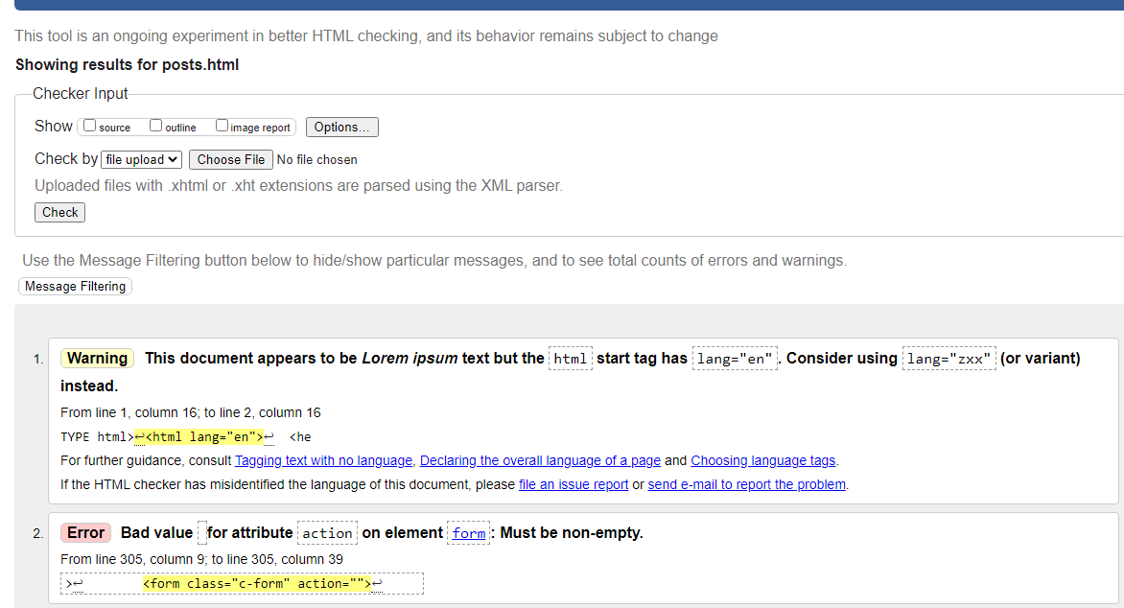
These errors occurred in the posts.html file. In this first error is for the html language and the second error is also for the empty action.

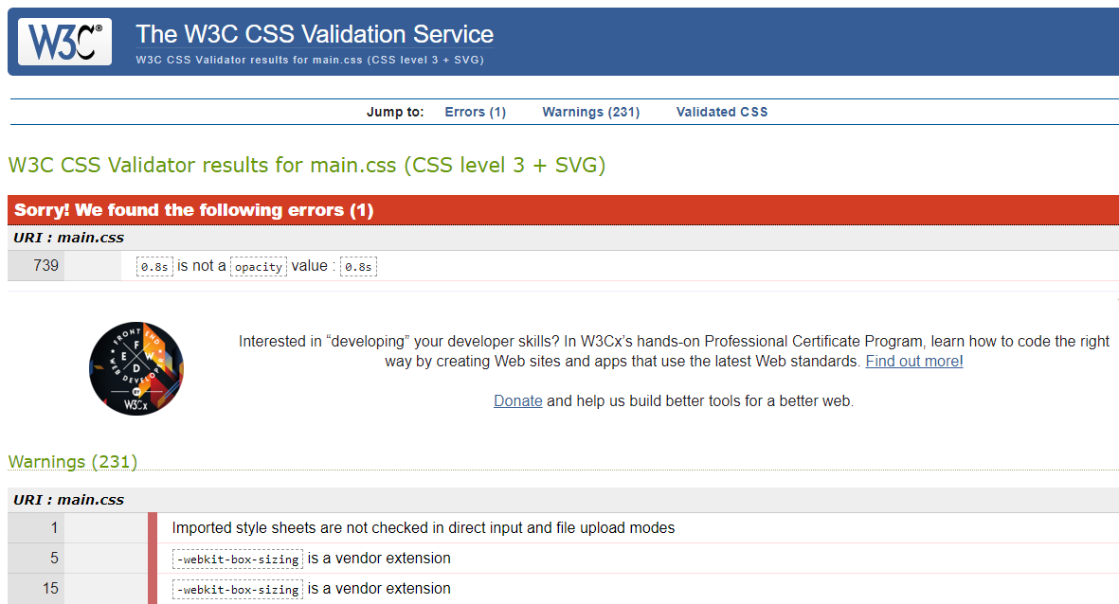
These are the errors appeared in the CSS file. These are just about importation and extension errors.

Evaluation
In the case of websites and software applications, usability has been defined as the ease at which an average person can use the software or website to achieve specific goals. Usability is comprised of learnability, memorability, efficiency, satisfaction and errors. Web accessibility means that websites, tools, and technologies are designed and developed so that people with disabilities can use them. More specifically, people can: perceive, understand, navigate, and interact with the Web. contribute to the Web. Our website is good in these two terms.
Search engine optimization is the process of improving the quality and quantity of website traffic to a website or a web page from search engines. SEO targets unpaid traffic rather than direct traffic or paid traffic. This will be happened in our website after deployment.

References
- Barrie, Donald S. and Boyd C. Paulson, Jr., Professional Construction Management, McGraw-Hill Book Company, 2nd Ed., 1984.
- Halpin, Daniel W. and Ronald W. Woodhead, Construction Management, John Wiley and Sons, 1980.
- Hodgetts, R.M., Management: Theory, Process and Practice, W.B. Saunders Co., Philadelphia, PA, 1979.
- Kerzner, H. Project Management: A Systems Approach to Planning, Scheduling and Controlling. 2nd. Ed., Van Nostrand Reinhold, New York, 1984.
- Levitt, R.E., R.D. Logcher and N.H. Quaddumi, "Impact of Owner-Engineer Risk Sharing on Design Conservatism," ASCE Journal of Professional Issues in Engineering, Vol. 110, 1984, pp. 157-167.
- Moolin, F.P., Jr., and F.A. McCoy: "Managing the Alaska Pipeline Project," Civil Engineering, November 1981, pp. 51-54.
- Murray, L., E. Gallardo, S. Aggarwal and R. Waywitka, "Marketing Construction Management Services," ASCE Journal of Construction Division, Vol. 107, 1981, pp. 665-677.
- Project Management Institute, A Guide to the Project Management Body of Knowledge, Newtown Square, Pennsylvania, 2000.

