Programme: MSc Public Health and Social Care in Practice

Module: Social Epidemiology and Public Health Development

Module code: LCHS7000

Assignment Title: Component 2 Analytical Report

Student ID:2436452
Student Name: Melvita Da Silva

Lecturer’s Name: Dr. Hamdi Hussain
Contents
Task 1: Social Epidemiological Analysis 5
1. Introduction 5
2. Contextual background and underlying factor 6
2.1. Disease and Illness Rates 6
2.2. Social Concerns 8
3. National response to reduce health and inequalities 11
3.1. Equality act 2010 11
3.2. NHS initiatives 12
3.3. Community health campaigns 12
4. Organisations that support ethnic minority groups 13
4.1. Race equality foundation 13
4.2. Runnymede Trust 13
4.3. Mind (for Ethnic Minorities) 14
5. Conclusion 14
6. Recommendations 15
7. References (Task 1) 16
Task 2: Epidemiological Analytical Report 18
8. Introduction 18
9. Epidemiological Process 19
9.1. Identification of high risk groups 19
9.2. Assessment of disease burden 21
10. Determinants and risk factors 22
11. Public health measures/interventions 23
12. Evaluation of approach (3Ps-prevention, promotion, protection) 24
13. Strengths and weaknesses of epidemiological approach 27
14. Recommendations 27
15. Conclusion 27
16. References (Task 2) 28

Task 1: Social Epidemiological Analysis
Title: Ethnicity and Health Inequalities in the UK

1. Introduction
Due to structural, social, and cultural factors, ethnic health disparities in the UK continue to be a significant public health concern. According to national data, compared to White British populations, minority ethnic groups have greater incidence of infectious diseases, chronic illnesses, and mental health problems. Language challenges, deprivation, discrimination, and unequal access to timely care are all strongly associated with these discrepancies. Finding service gaps and developing successful solutions require an understanding of these underlying issues. Acknowledging the varied experiences of ethnic groups contributes to ensuring that policies appropriately represent the needs of the community. Health systems can more effectively deploy resources and create focused prevention by looking at these important factors. These factors are described in this section together with organisational and governmental initiatives to promote more equitable health outcomes.
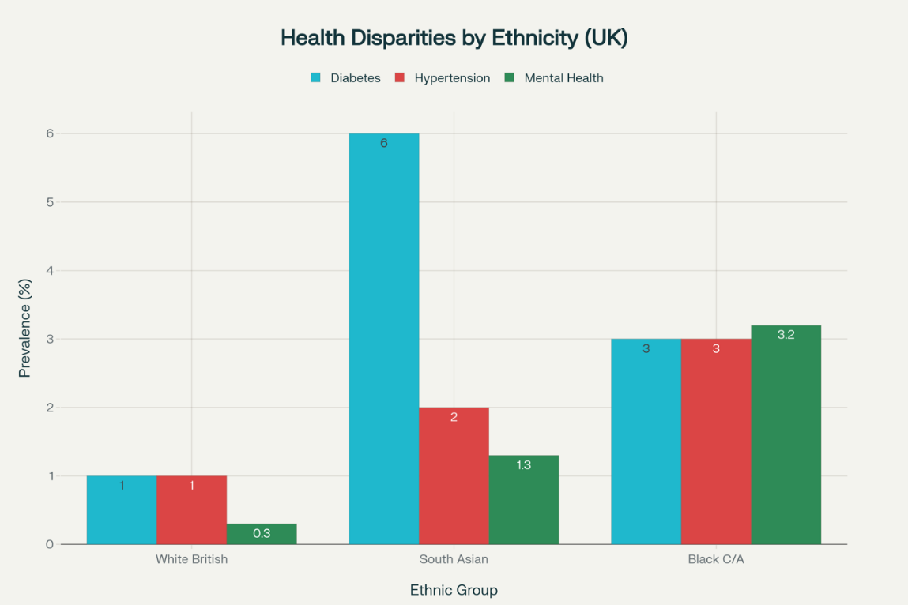 Source: ethnicity health outcomes infographic UK (2025)

2. Contextual background and underlying factor

Disease and Illness Rates

Infectious disease admissions
Admission rates for infectious disorders, particularly tuberculosis (TB), demonstrate strong ethnic differences. Individuals from various minority ethnic backgrounds have disproportionately high TB-related hospital admissions, according to the King's Fund Report on Ethnic Health Inequalities. Type 2 emergency hospital admissions for tuberculosis are 29 times higher in Asian Other groups, 29 times higher in Indian ethnic groups, and 15 times higher in Black African groups than in White British people.
These disparities reflect broader structural and social determinants of health, such as housing quality, socioeconomic status, access to preventative healthcare, and historical discrepancies in public health outreach. Such disparities indicate a persistent public health challenge and highlight the need for culturally informed prevention strategies and improved early detection within affected communities.

Chronic Conditions
Chronic diseases exhibit comparable patterns of disparity. According to data from Health Inequalities, England, Black and South Asian groups have a much higher prevalence of cardiovascular disease (CVD). These communities are also more likely to develop type 2 diabetes, with greater rates found in South Asian, Black Caribbean, and Black African populations.
Furthermore, these chronic illnesses tend to manifest earlier in life in these groups, often with higher levels of comorbidity. These findings point to long-term disparities in lifestyle factors, genetic predispositions, environmental impacts, and differential access to early screening and management services. Collectively, these variables contribute to lower long-term health outcomes and higher healthcare use among certain ethnic groups.

Inequalities in Mental Health
Mental health outcomes also show significant differences. According to The King's Fund (2023), ethnic minority men had a much greater prevalence of psychotic disorders: 3.2% among Black men and 1.3% among Asian men, against 0.3% among White men.
In addition to higher incidence rates, ethnic minority groups frequently experience increased stigma, cultural misunderstanding, and systemic impediments to mental health care. These obstacles contribute to underdiagnosis, misdiagnosis, and decreased involvement with mental health care. Delayed action can exacerbate long-term results, prolonging the cycle of inequity and undermining trust in health-care institutions.

  - Social Concerns

Social Exclusion and Discrimination
Health outcomes are significantly influenced by social variables. According to the results of the NHS England 2025 survey, 49% of Black respondents and 38% of Asian respondents believed that primary care professionals treated them differently due to their ethnicity.Such encounters with prejudice and social marginalisation have a detrimental effect on people's propensity to seek medical attention, lower their level of confidence in medical services, and cause treatment to be postponed. Repeated unfavourable experiences can eventually deter people from seeking preventative care, worsening already-existing health inequities and reducing minority ethnic populations' ability to effectively engage in healthcare
(raceequalityfoundation(2025).
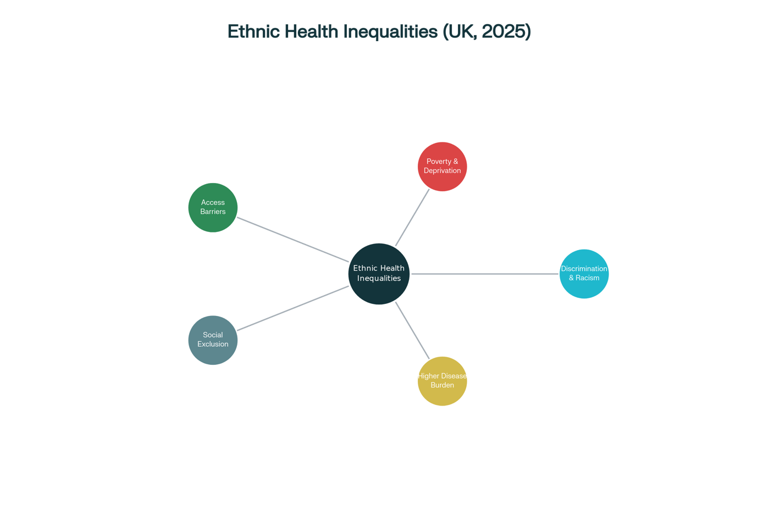

Source: Key Underlying Factors in Ethnic Health Inequalities (UK, 2025)

Poverty and deprivation.
The King's Fund has often noted that a large number of ethnic minority families live in locations with significant levels of deprivation (2025). Poorer health outcomes, such as higher rates of chronic illness, less access to high-quality treatment, and a shorter life expectancy overall, are closely associated with living in impoverished communities.
Numerous facets of daily living are impacted by socioeconomic hardship, such as housing circumstances, food quality, and timely access to medical care. Opportunities for healthy living, including buying wholesome food or getting regular exercise, are frequently limited by a lack of funds. Overcrowding and inadequate housing make people more susceptible to chronic illnesses and infectious infections.

Language and cultural barriers.
The absence of culturally responsive communication and language barriers continue to be major barriers to fair access to healthcare. The Race Equality Foundation claims that poor English proficiency can impair engagement with preventative care, make it more difficult to interpret medical information, and decrease awareness of available options.
People may experience miscommunication, misreading of symptoms, or concern about accessing the healthcare system when healthcare information is not presented in accessible ways or does not match cultural norms. Due to these obstacles, health issues are often discovered at a later stage, which has a negative impact on outcomes.
Furthermore, a lack of cultural competence in healthcare settings can erode confidence and deter some members of the minority population from seeking assistance, so exacerbating already-existing disparities in the use of health services.

National response to reduce health and inequalities

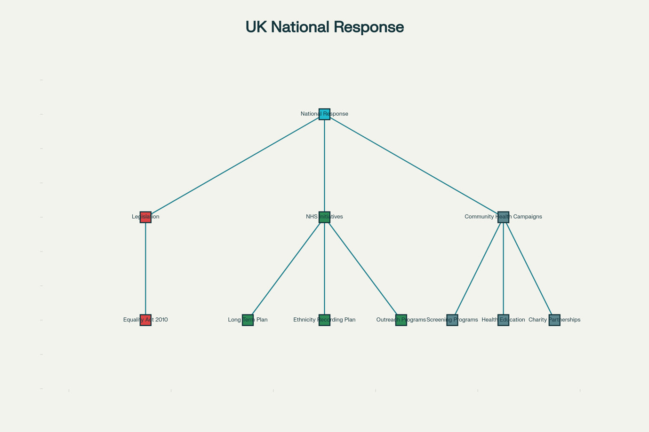
Source: NHS England (2025)

Equality act 2010
The legal basis for correcting racial and ethnic imbalances in public services, including the NHS, is provided by the Equality Act 2010. This law guarantees that people from all backgrounds are entitled to fair treatment and equitable access to services by outlawing discrimination based on ethnicity. In order for services to be responsive to the various requirements of the populace, public entities are also required by law to make reasonable modifications.
In the context of healthcare, this entails reducing obstacles pertaining to cultural needs, communication, and service accessibility in order to provide more inclusive care pathways for ethnic minority populations.

NHS initiatives
The goal of recent NHS initiatives is to directly address enduring health disparities. The NHS Long Term Plan places a strong emphasis on prevention, early diagnosis, and fair access as means of reducing health outcomes gaps among ethnic minority communities.
Furthermore, better ethnicity data recording and monitoring are mandated under new laws that were implemented in 2025. The NHS's capacity to spot gaps, monitor trends, and carry out treatments that cater to the unique needs of various groups is improved by higher-quality demographic data. These actions encourage a more methodical and responsible approach to addressing inequality at the local and national levels.

Community health campaigns
In order to increase participation and encourage early prevention among minority groups, community-based health activities are essential. In South Asian and Black communities, outreach initiatives for type 2 diabetes and tuberculosis (TB) have raised awareness of risk factors, promoted screening, and supported early intervention.
By working closely with communities, these culturally sensitive programs help close knowledge gaps, lessen stigma, and foster trust. These programs promote better health practices and more equal health outcomes by addressing cultural stereotypes and making information easily accessible.

Organisations that support ethnic minority groups

Race equality foundation
Enhancing ethnic minority groups' access to health and social services is a major contribution of the Race Equality Foundation. The organisation offers proof of the structural disparities that influence health outcomes through research, policy analysis, and activism.
Their suggestions revolve on doable, community-based fixes like focused outreach initiatives, yearly health examinations, and enhanced cultural competence education for medical personnel. These initiatives seek to improve early illness detection, build community and service trust, and guarantee culturally responsive care. The Foundation helps create more inclusive and equitable health and social care systems by advocating for evidence-based reforms.

Runnymede Trust
A prominent think tank on racial equality, the Runnymede Trust is committed to addressing systemic racism in society. The organisation gathers data on racial inequities, carries out independent research, and attempts to influence national policy.
In addition to advocating for legislative and policy changes to address the underlying causes of racial inequality, its initiatives include drawing attention to disparities in public services, health, and education. The Trust contributes significantly to the development of a more equal policy environment by working with stakeholders and increasing public awareness.

Mind (for Ethnic Minorities)
Mind seeks to increase access to high-quality mental health care through its engagement with ethnic minority groups. The organization's main goals are to lessen stigma, raise awareness of mental health issues, and promote culturally relevant treatments that take into account the varied experiences of minority groups.
Additionally, Mind strives to remove structural obstacles that lead to ethnic minority communities' underdiagnosis and disengagement from mental health treatment. Mind promotes more inclusive mental health care and improved results for marginalised communities by providing individualised assistance and advocating for changes in service delivery.

Conclusion
Ethnic health inequalities are driven by interconnected challenges including socioeconomic disadvantage, cultural barriers, and differential treatment within healthcare settings. While national policies and NHS initiatives have strengthened efforts toward fairer access, sustained progress requires culturally responsive services and meaningful community engagement. Organisations such as the Race Equality Foundation, Runnymede Trust, and Mind play a vital role in addressing systemic barriers. Continued improvements in communication, prevention, and data monitoring are essential for long-term change. Strengthening collaboration between communities and healthcare providers can further reduce mistrust and enhance early intervention. Addressing these inequalities demands ongoing commitment across public, clinical, and community sectors. With sustained action, the UK can move closer to achieving equitable health outcomes for all ethnic groups.

Recommendations
- Increase targeted prevention and screening interventions
- Enhance cultural competence and bias awareness training for NHS staff
- Collect and use high-quality ethnicity data
- Engage community code, designing services style to their needs

References (Task 1)

- Aldridge, R.W., et al. (2020) ‘Excess Covid-19 mortality patterns by ethnicity in England’, Journal of Epidemiology.
- BMJ (2022). ‘Action on patient safety can reduce health inequalities’. BMJ, 376, p. 2230.
- Gaia, S., et al. (2023) ‘Ethnic minorities, income inequalities and the COVID-19 pandemic’, Journal of Public Health, 45(9), pp. 1101–1112.
- Gov.uk (2025) ‘Health inequalities in health protection report 2025’. Available at: https://www.gov.uk/ (Accessed: 16 November 2025)
- IFS (2022) ‘Race and ethnicity in the UK’. Institute for Fiscal Studies. Available at: https://www.ifs.org.uk/ (Accessed: 16 November 2025).
- King’s Fund (2023) ‘The health of people from ethnic minority groups in England’. Available at: https://www.kingsfund.org.uk/ (Accessed: 16 November 2025).
- Lampard Inquiry (2023) ‘Racial disparities in mental health: Literature and evidence review’. Available at: https://www.lampardinquiry.org.uk/ (Accessed: 16 November 2025).
- NHS England (2025) ‘Ethnicity Recording Improvement Plan’. Available at: https://www.england.nhs.uk/ (Accessed: 16 November 2025).
- NHS Race & Health Observatory (2022) ‘Ethnic Inequalities in Healthcare: A Rapid Evidence Review’. Available at: https://www.nhsrho.org/ (Accessed: 16 November 2025).
- ONS (2024) ‘Health inequalities by built-up area and ethnic group, England’. Available at: https://www.ons.gov.uk/ (Accessed: 16 November 2025).
- Race Equality Foundation (2023) ‘Racism is the root cause of ethnic inequalities in health’. Available at: https://raceequalityfoundation.org.uk/ (Accessed: 16 November 2025).
- Salway, S., et al. (2016) ‘Obstacles to race equality in the English NHS’, BMC Health Services Research, 16, pp. 70–85.
- UCL Institute of Health Equity (2024) ‘Structural Racism, Ethnicity and Health Inequalities in London’. Available at: https://www.instituteofhealthequity.org/ (Accessed: 16 November 2025).
- Williams, D.R., et al. (2003) ‘Discrimination and health: A review of research’. Annual Review of Sociology, 29, pp. 77–98.

Task 2: Epidemiological Analytical Report
Title: Epidemiological Assessment and Intervention for Cardiovascular Disease in Older Adults in UK

Introduction
Cardiovascular disease (CVD), which includes heart failure, ischaemic heart disease, and valvular disease, is the major cause of morbidity and mortality among older persons worldwide and in the UK (NHS England, 2025). High illness burden, frequent hospital admissions, polypharmacy, and social isolation all contribute to considerable NHS healthcare expenses, as well as a high risk of decreased independence and quality of life. Variations in deprivation, multimorbidity, and unequal access to timely diagnosis and treatment all have an impact on CVD in London. Epidemiological data from primary care, hospital records, and national surveillance systems show significant differences in disease detection, outcomes, and service usage between boroughs. These patterns emphasise the importance of a targeted public health approach, particularly for adults aged 65 and over, to address unmet needs and rising service demand.
Statistics: in the UK about 45% of that and people age 65+ are due to CVD (British Heart Foundation,2023).worldwide: 18 million annual CVD deaths (WHO,2023).
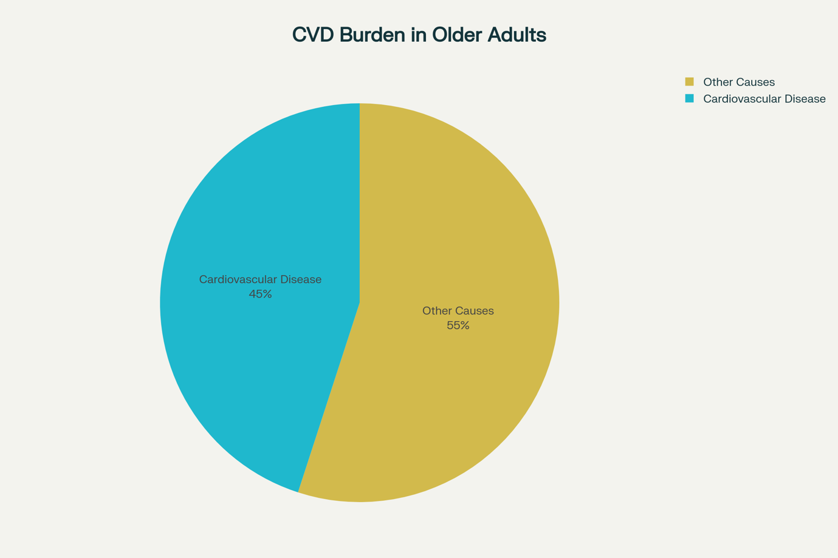
Source: British Heart Foundation (2023)

Epidemiological Process
  - Identification of high risk groups
The target audience consists of London-based individuals aged 65 and up. Primary care data and electronic health records will be utilised to identify newly diagnosed instances of cardiovascular disease (CVD), as well as common comorbidities such as hypertension and diabetes. Hospital Episode Statistics (HES) will offer data on hospital admission patterns, acute care use, and outcomes for various illnesses. Local service data will supplement national statistics by emphasising area-specific needs, differences in illness burden, and service usage across London boroughs. This integrated approach will help to assess the true prevalence of CVD and associated comorbidities in older persons, including those who may be underdiagnosed in primary care. It will also allow a clearer understanding of the impact of multimorbidity on future healthcare use. Analysing these statistics together will help identify high-risk populations and locations with higher service demand. Finally, this will help with planning, resource allocation, and targeted treatments to enhance cardiovascular outcomes in London's older population.
Risk Stratification : segment by age band X deprivation, multi mobility, ethnicity.

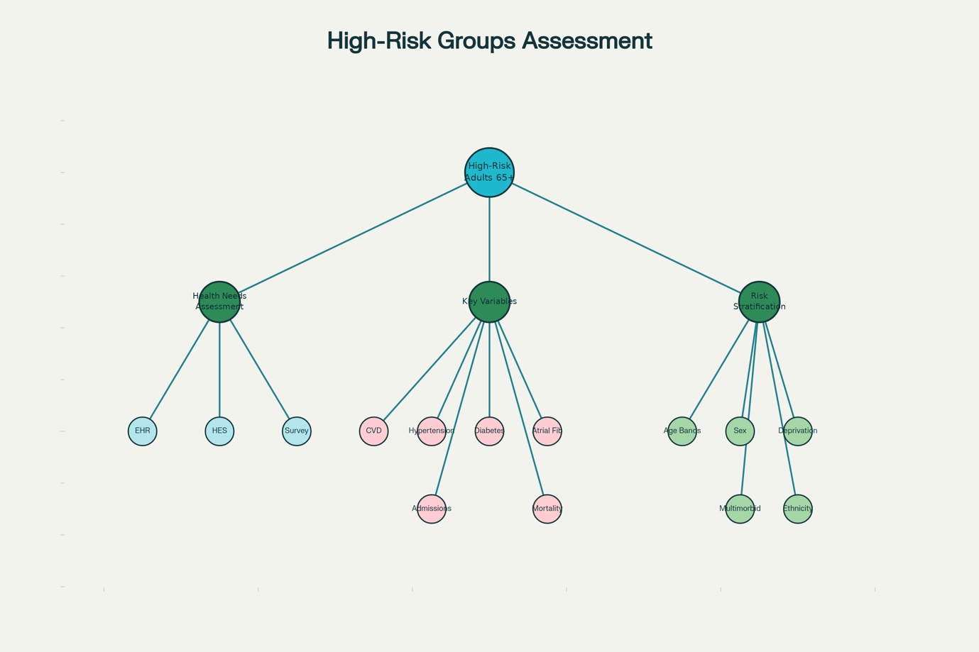
source: Electronic Health Records (HER)

  - Assessment of disease burden
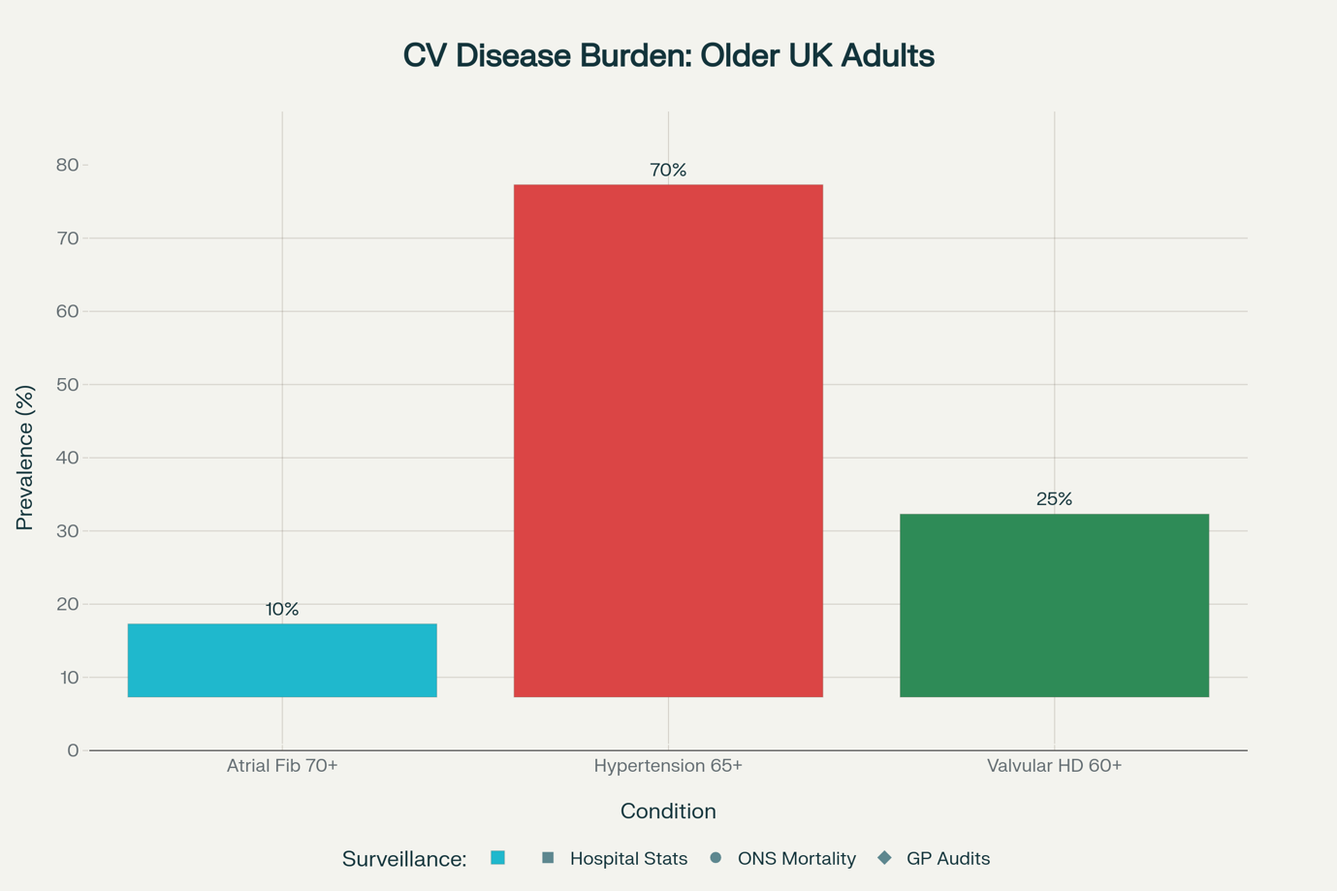
Source: British Heart Foundation (2023)
Incident/prevalence: Local and national information can be combined to demonstrate significant trends in cardiovascular disease among older persons. For example, national data show that the incidence of atrial fibrillation (AF) in persons over 70 is around 10%, although hypertension affects roughly 70% of this age group. The British Heart Foundation (2023) estimates that approximately 14% of asymptomatic elderly persons have valvular heart disease. When paired with local data sources, these national statistics help to illustrate differences in detection, diagnosis, and service demand among London boroughs. This collaborative method enables the identification of locations with a higher prevalence of undiagnosed or uncontrolled cardiovascular diseases. It also contributes to a better understanding of how multimorbidity affects healthcare use in older adults. Finally, combining local and national information improves planning and targeting of preventative and treatment measures for those 65 and older.
Surveillance systems: Weekly hospital, statistical reports, ONS mortality registers, GP records audits.

Determinants and risk factors
Non-modifiable variables include ageing, genetic vulnerability, and male sex, all of which have an inherent influence on an individual's baseline risk and cannot be changed through behavioural or pharmacological intervention. These factors contribute to underlying vulnerability in specific population groups and help explain differences in disease occurrence across age and gender categories.
Modifiable determinants refer to a broader variety of social, behavioural, and clinical variables that can be addressed through preventive and early intervention. These include socioeconomic adversity, which frequently limits access to services that promote healthy living; hypertension, a significant clinical risk factor; insufficient physical exercise; obesity; smoking; and bad food habits. Furthermore, systemic concerns including underdiagnosis, delayed symptom recognition, and impediments to timely and effective healthcare enhance risk and contribute to poor outcomes. These controllable factors point to areas where public health policies and healthcare system changes can dramatically reduce illness burden (BHF, 2023; NHS Digital, 2024).
Social influences are also becoming more widely understood. Isolation and deprivation can reduce social support and access to healthy environments, whereas digital exclusion can prevent people from obtaining information or using online health services. Low health literacy can impair comprehension of symptoms, risk factors, and accessible interventions, resulting in delayed care and poorer health management. These changeable and socioeconomic variables together emphasise the significance of focused public health interventions and equitable healthcare access (BHF, 2023; NHS Digital, 2024).

Public health measures/interventions
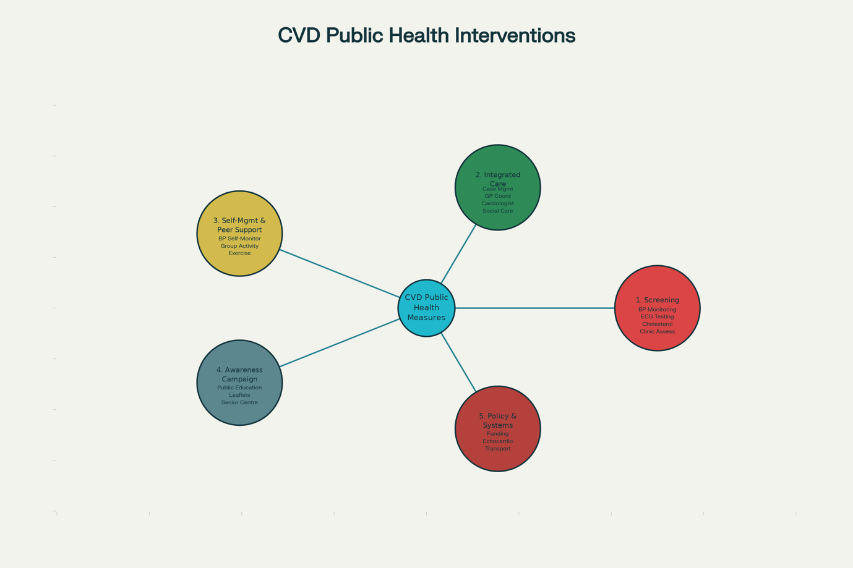
Source: Public Health England (2024)
Screening in community clinics, like a blood pressure, ECG cholesterol, focus outreach in deprive areas.
Giving integrated care to patients in case manager, coordinate GP, cardiology, and social care.
Self management, Peer support: training for BP monitoring P groups, physical activities, diet.
Awareness campaigns: “Know your heart age”, senior Centre events, leaflets, social media.
Policy/systems: funding for older adult echocardiography transport vouchers, integrated local registry.

Evaluation of approach (3Ps-prevention, promotion, protection)
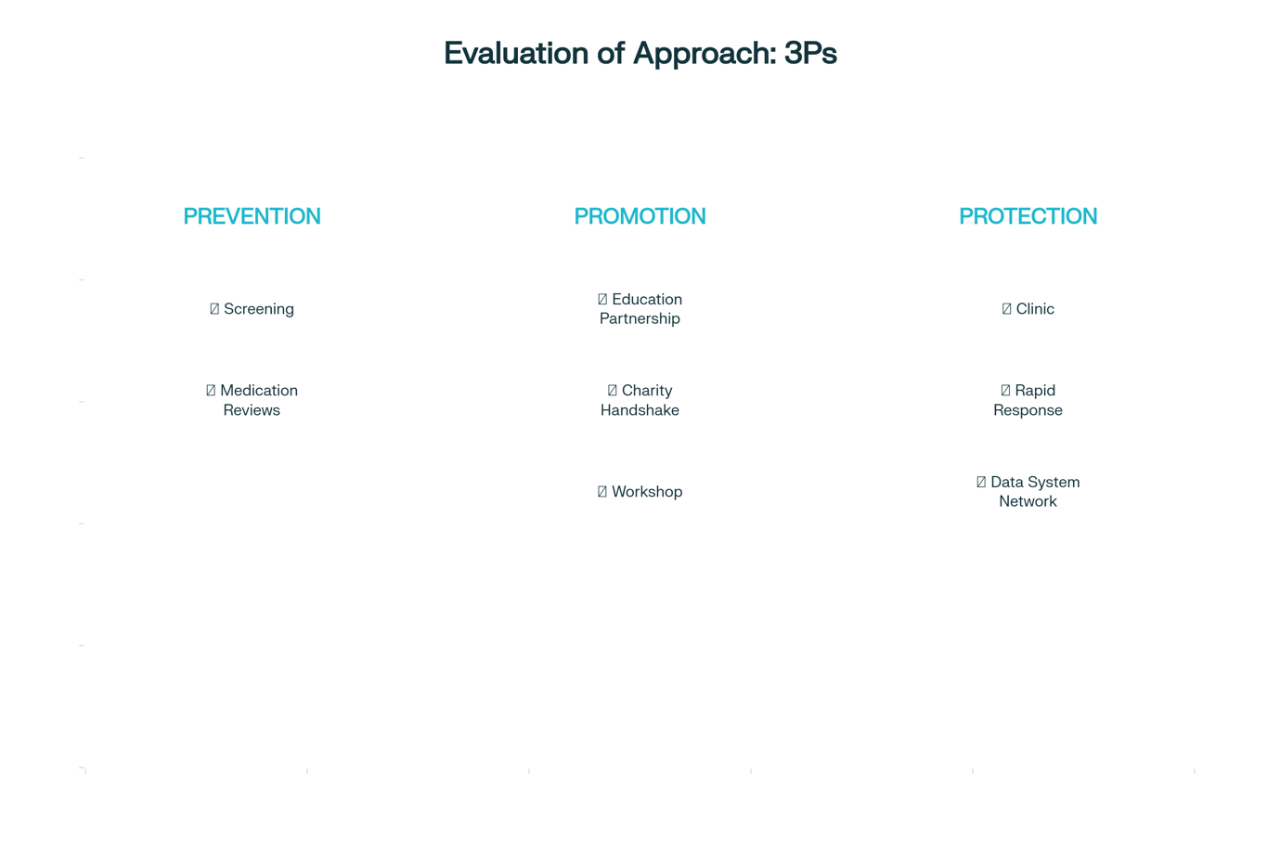
Source: Public Health England (2024)
PREVENTION
- Screening
Screening initiatives seek to identify persons who are at risk or in the early stages of disease before symptoms emerge. Screening promotes early intervention and lowers long-term problems by focussing on high-risk populations such as those with hypertension, obesity, low physical activity, or restricted healthcare access.

- Medication Reviews
Regular medication reviews assist to verify that people are receiving the right treatments, taking their drugs safely, and managing any side effects. This is especially crucial for older persons and patients with numerous illnesses, since it helps to prevent deterioration and promotes efficient long-term disease management.

PROMOTION
- Educational Partnership
Collaborative education programs involving schools, community organisations, and healthcare providers promote awareness of lifestyle risk factors like poor diet, smoking, low health literacy, and physical inactivity. These collaborations encourage healthy behaviours and enable communities to make informed decisions.
- Charity handshake.
Working with charity improves support networks for vulnerable groups, such as those enduring isolation, deprivation, or digital exclusion. To increase engagement, charities can help conduct outreach activities, community events, and culturally relevant health information.
- Workshop
Interactive workshops provide practical skills such as healthy living, symptom recognition, and navigating healthcare resources. They contribute to bridging knowledge gaps, particularly among populations with low health literacy, and encouraging behaviour change through accessible, community-based education.

PROTECTION
- Clinic
Clinic-based services provide prompt assessments, follow-up, and professional support for persons at high risk. These clinics can address unmet requirements due to late diagnosis, access constraints, or underdiagnosis by offering structured care and ongoing monitoring.
- Rapid Response
Rapid reaction teams improve the system's ability to handle acute symptoms or unexpected deterioration. They assist prevent complications and limit emergency admissions by acting fast, especially in people who have recognised risk factors like hypertension or chronic disease.
- Data System Network
A linked data system improves communication across services, allowing for early detection of high-risk people and tracking trends in diagnosis and treatment. Improved data sharing minimises fragmentation, promotes equal access, and improves public health planning and resource allocation.

Strengths and weaknesses of epidemiological approach
Strengths: use current real world data ( HES,HER,ONS), covers both medical and social determinants integrated team approach. Multisource surveillance improve identification.
Weakness/limitations: Data gaps under recording exclusion of House, born ruler, older adults, Digital exclusion, possible by us in self reported data.

Recommendations
- Enhance primary care screening in deprived areas
- Expand transportation support for isolated less mobile older adults.
- Continuous data monitoring, and evolution, adaptive intervention design.
- Collaborate with Local authority, NHS age UK,BHF, commissioning groups.

Conclusion
Cardiovascular disease in older individuals is a significant public health issue, with serious physical, social, and economic ramifications. Coordinated, data-driven, and community-focused initiatives are critical for lowering disease burdens, improving health outcomes, and addressing disparities. Ongoing evaluation, system integration, and strong cross-sector partnerships will be critical for maintaining gains and promoting healthier ageing across the population. Strengthening early detection channels and increasing access to preventative treatment can help to reduce unnecessary hospital admissions. Continued investment in public health infrastructure will contribute to equitable and long-term improvements in cardiovascular health for older persons.

References (Task 2)

- Age UK (2025) ‘Later Life in the United Kingdom’. Available at: https://www.ageuk.org.uk/ (Accessed: 17 November 2025).
- Arcaya, M., et al. (2015) ‘Inequalities in health: definitions, concepts, and theories’. Annual Review of Public Health, 36, pp. 77–99.
- Bellavia, A. (2025) ‘Statistical Methods for Environmental Mixtures: A Primer in Environmental Epidemiology’. Springer.
- Berman, P., Bossert, T., Croke, K., Keidar, S. and Yakob, B. (2025) ‘Effective Pandemic Response Linking Evidence, Intervention, Politics, Organization, and Governance’. World Scientific Series in Global Health Economics and Public Policy.
- BMJ (2022) ‘Action on patient safety can reduce health inequalities’. BMJ, 376, p. 2230.
- British Heart Foundation (2023) ‘UK cardiovascular disease factsheet’. Available at: https://www.bhf.org.uk/ (Accessed: 17 November 2025).
- Braveman, P. (2006) ‘Health inequities and health equity’. Bulletin of the World Health Organization, 84(4), pp. 1–2.
- Cambridge University Press (2021) ‘Comparing socio-economic inequalities in healthy ageing’. Available at: https://www.cambridge.org/
- Department of Health and Social Care (2024) ‘Loneliness and Social Isolation in Older Adults’. London: DHSC.
- Harvard T.H. Chan School of Public Health (2025) ‘The State of Cardiovascular Disease in G20+ Countries’. Available at: https://www.hsph.harvard.edu/
- Institute for Fiscal Studies (2022) ‘Health inequality and economic disparities by race, ethnicity, and income’. IFS. Available at: https://www.ifs.org.uk/
- King’s Fund (2023) ‘The Health of People from Ethnic Minority Groups in England’. Available at: https://www.kingsfund.org.uk/
- Lampard Inquiry (2023) ‘Racial disparities in mental health: Literature and evidence review’. Available at: https://www.lampardinquiry.org.uk/
- Lu, W. et al. (2021) ‘Comparing socio-economic inequalities in healthy ageing’. International Journal of Epidemiology, 50(4), pp. 950–963.
- National Institute for Health and Care Excellence (NICE) (2022) ‘Cardiovascular disease prevention in older adults’. NICE. Available at: https://www.nice.org.uk/
- NHS Digital (2024) ‘Hospital Episode Statistics’. Available at: https://digital.nhs.uk/data-and-information/publications/
- NHS England (2025) ‘Core20PLUS5: Tackling Inequalities in CVD’. Available at: https://www.england.nhs.uk/
- NHS England (2025) ‘Integrated Care Systems and CVD Prevention’. Available at: https://www.england.nhs.uk/
- NHS Race & Health Observatory (2022) ‘Ethnic Inequalities in Healthcare: A Rapid Evidence Review’. Available at: https://www.nhsrho.org/
- Nutritionsource Harvard University (2025) ‘Preventing Heart Disease’. Harvard. Available at: https://www.nutritionsource.hsph.harvard.edu/
- Office for National Statistics (2024) ‘Mortality and morbidity statistics: older adults’. Available at: https://www.ons.gov.uk/
- Office for National Statistics (2025) ‘Loneliness and poverty in older adults’. Available at: https://www.ons.gov.uk/
- PLOS Medicine (2019) ‘Population-based Cohort Study of Multimorbidity in UK’. PLOS Medicine, 16(12), e1003059.
- Public Health England (2023) ‘CVD Prevention Toolkit’. PHE. Available at: https://www.gov.uk/
- Public Health England (2024) ‘Model Approaches to Public Health Intervention Evaluation’. PHE.
- Race Equality Foundation (2023) ‘Racism is the root cause of ethnic inequalities in health’. Available at: https://raceequalityfoundation.org.uk/
- Salway, S., et al. (2016) ‘Obstacles to race equality in the English NHS’. BMC Health Services Research, 16, pp. 70–85.
- The Lancet (2024) ‘Ultra-processed foods and cardiovascular disease’. The Lancet, 404(10223), pp. 451–459.
- World Health Organization (2023) ‘Global Burden of Cardiovascular Diseases’. Available at: https://www.who.int/

