
PROGRAMME: MASTER OF BUSINESS ADMINISTRATION
MODULE: FINANCIAL MANAGEMENT
MODULE CODE: LCMB7002
ASSIGNMENT TITLE: ASSESSMENT COMPONENT: FINANCIAL PERFORMANCE AND MANAGEMENT
ASSESSMENT: INDIVIDUAL REPORT - HILTON WORLDWIDE
LECTURER NAME: SHENGFENG MEI AND PATRICK YEBOAH
STUDENT NAME: SAFINAZ AZIZMAHMED SUFI
STUDENT ID:2539210

Executive Summary
This report incorporates a detailed analysis of financial performance of Hilton Worldwide Holdings Inc. from 2021–2025 considering financial statements and ratio analysis. In addition to this, the findings examine an increase in the revenue is also driven from higher management fees, cost reimbursement revenues, highlighting continued expansion of asset-light business model and global travel demand of the company. The study has reflected that Hilton has maintained a solid profitability apart from increased interest expenses and impairment losses. The report also recommended strengthening working capital management, adopting financial restructuring through debt refinancing, selective divestitures and strategic partnerships. This also includes integrating ESG principles and international financial considerations to support sustainable long-term growth and shareholder value. Based on the critical reflection, I was able to outline the benefits and limitations of using AI tools which I implemented in this assignment.

Table of Contents
Introduction 5
1. Financial Health Check 5
1.1 Analysis of the financial statement of the company 5
1.2 Performing a comprehensive ratio analysis 10
1.3 Identification of trends, strengths, and potential threats 13
1.4 Comparison of liquidity ratios with industry benchmarks 17
2. Working Capital Management Analysis 18
2.1 Assessing the cash operating cycle 18
2.2 Recommendation of approaches to improve liquidity through working capital reforms 19
2.3 Comparison of short-term and long-term financing options 20
3. Strategic Financial Restructuring Plan 20
3.1 Recommendation of financial restructuring options 20
3.2 Evaluation of the impact on shareholder value, operational flexibility, and debt structure 21
3.3 International and ethical considerations 22
4. Investment Appraisal and Capital Budgeting 23
4.1 Investment appraisal analysis 23
4.2 Recommendation for project selection and justification 31
4.3 Justification suggesting assumption of maximum £100 million investment using capital rationing 32
5. Critical Reflection on AI Usage 33
5.1 Tool Disclosure 33
5.2 Critical Evaluation of AI Output 33
5.3 Contribution Analysis 33
5.4 Ethical & Professional Reflection 34
Conclusion 35
References 36
Appendices 39
Appendix 1: Ratio calculation 39
Appendix 2: Investment Appraisal 41

Introduction
As the Chief Financial Officer of Hilton Worldwide, the main task is to analyse the past five years of financial performance of the company. Additionally, critical analysis of several investments in the future is also going to examine. The analysis includes financial evaluation, working capital management, corporate restructuring, and investment appraisal for the critical discussion on financial viability of the company.

1. Financial Health Check

1.1 Analysis of the financial statement of the company
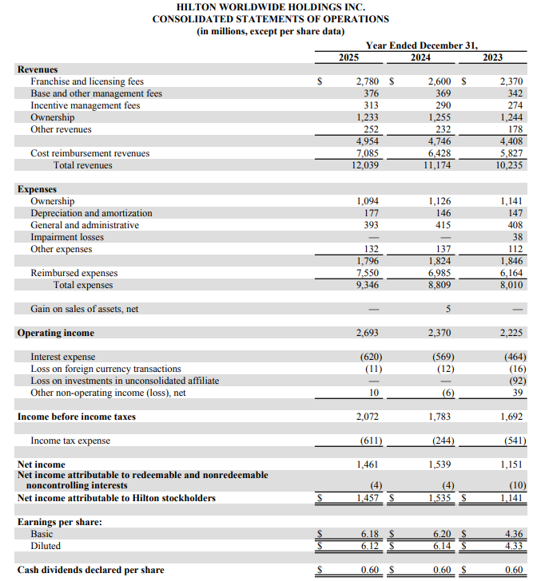
Figure 1: Income statement of Hilton 2025-2023
(Source: Hilton, 2025)
Hilton Worldwide Holdings Inc. exhibits a strong revenue development between 2023and 2025. The total revenue generated by Hilton has increased from $10.24 billion in 2023 to $12.04 billion in 2025, exhibiting effective management and franchise fees and licensing fees from strategic partners (Hilton, 2025). Figure 1 showcases an improvement in operating income from $2.23 billion in 2023 to $2.69 billion in 2025, apart from higher interest expenses, leveraging an adequate operational adequacy and cost management. However, a slight reduction is observed in net income from $1.54 billion in 2024 to $1.46 billion in 2025, revealing an increase in income tax expenses and interest costs. Income tax in 2023 was around $541 million, leading to $1,151 million net income, whereas income tax in 2024 was $244 million, reflecting a higher net income (Hilton, 2024). This shows that Hilton is maintaining a strong profitability, stable earnings per share, and adequate shareholder returns through dividend payments.
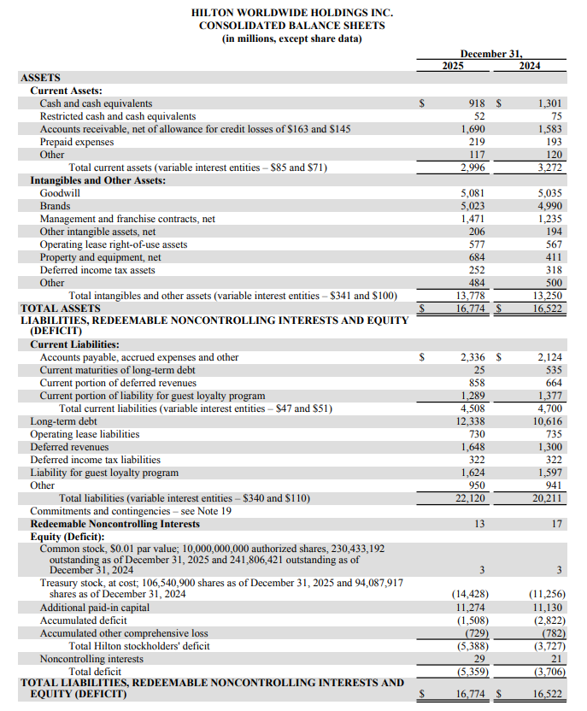
Figure 2: Balance sheet of Hilton 2025-2024
(Source: Hilton, 2025)
Figure 2 describes an increase in total assets of Hilton Worldwide from $16.52 billion in 2024 to $16.77 billion in 2025, leveraged through growing brands, management contracts, and continued investment in expansion. In addition to this, the reduction in cash and cash equivalents from $1.30 billion in 2024 to $918 million in 2025 showcase lower liquidity position (Hilton, 2025). Total liabilities have been increased to $22.12 billion in 2025 due to higher long-term debt and deferred revenues. Hilton has reported a larger shareholder deficit of $5.39 billion in 2025, resulting due to treasury stock repurchases apart from improved accumulated deficit.
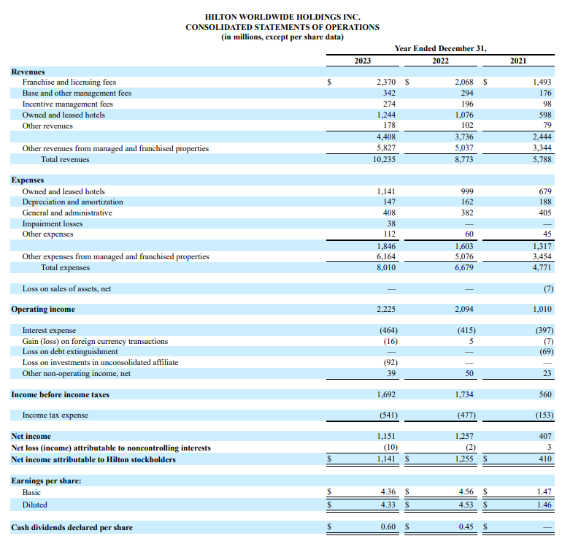
Figure 3: Income statement of Hilton 2023-2021
(Source: Hilton, 2023)
Hilton Worldwide recorded a strong financial improvement between 2021 and 2023. This includes an increase in total revenue from $5.79 billion to $10.24 billion, driven from rebound in global travel, and an improvement in franchised properties. In addition to this, operating income of Hilton has been doubled from $1.01 billion in 2021 to $2.23 billion in 2023, leveraging better operational efficiency (Hilton, 2023). Figure 3 shows that the company’s net income is attributable to stockholders, increasing from $410 million in 2021 to $1.14 billion in 2023. Earnings per share is strengthened effectively, including an increase in dividends demonstrating better financial stability.
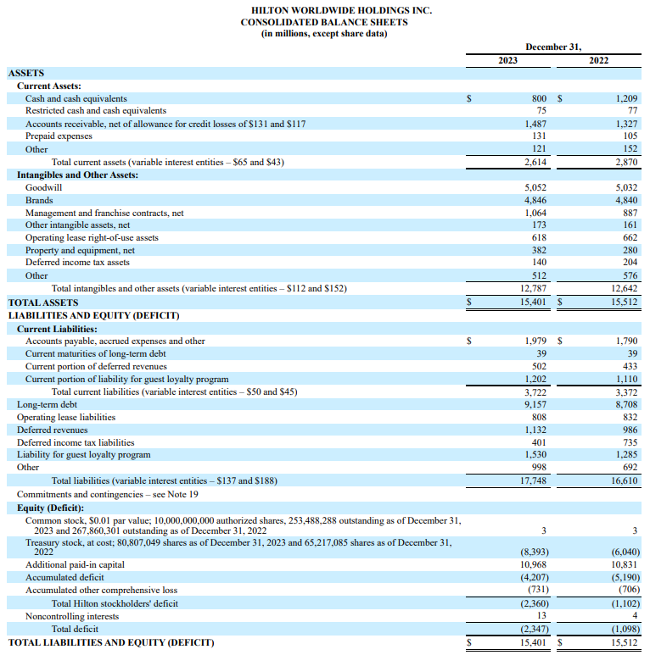
Figure 4: Balance sheet of Hilton 2023-2022
(Source: Hilton, 2023)
Total assets of Hilton Worldwide have been reduced slightly from $15.51 billion in 2022 to $15.40 billion in 2023, exhibiting lower cash balances apart from increased goodwill and franchise contracts. Current assets of Hilton are reduced reflecting tighter liquidity, whereas total liabilities have increased to $17.75 billion, driven by higher long-term debt and guest loyalty liabilities (Hilton, 2023). The figure 4 reflects that the shareholder deficit of the company has widened to $2.36 billion, highlighting leveraged capital structure and shareholder return strategy of the business.
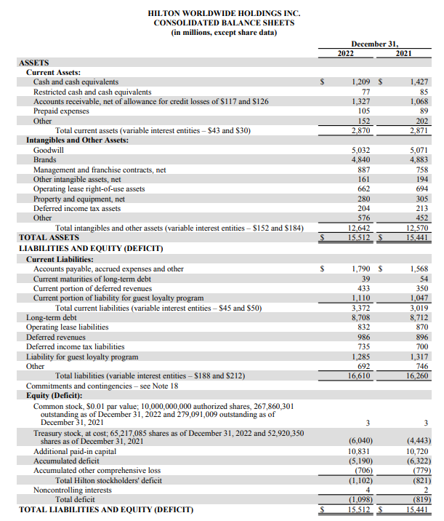
Figure 5: Balance sheet of Hilton 2022-2021
(Source: Hilton, 2022)
Hilton Worldwide Holdings Inc. has reported total assets of $15.44 billion in 2021, supported by substantial goodwill and brand assets. Additionally, total liabilities were $16.26 billion in 2021, exceeding assets and resulting in shareholder’s deficit value of $819 million (Hilton, 2022). Apart from the recovering operations after the pandemic, the company has remained highly leveraged with significant long-term debt and loyalty-program obligations.

1.2 Performing a comprehensive ratio analysis
“Financial ratios of Hilton Worldwide from 2021-2025 (in $m)
Profitability Ratios
Net Profit Margin | 2025 | 2024 | 2023 | 2022 | 2021
Net Income | 1,461 | 1,539 | 1,151 | 1,257 | 407
Revenue | 12,039 | 11,174 | 10,235 | 8,773 | 5,788
Formula: (Net Income / Revenue) * 100 | 12.14% | 13.77% | 11.25% | 14.33% | 7.03%
Return on Assets | 2025 | 2024 | 2023 | 2022 | 2021
Net Profit | 1,461 | 1,539 | 1,151 | 1,257 | 407
Average Total Assets | 16,648 | 15,962 | 15,457 | 15,477 | 16,098
Formula: (Net Income / Average Total Assets) * 100 | 8.78% | 9.64% | 7.45% | 8.12% | 2.53%
Liquidity Ratios
Current Ratio | 2025 | 2024 | 2023 | 2022 | 2021
Current Assets | 2,996 | 3,272 | 2,614 | 2,870 | 2,871
Current Liabilities | 4,508 | 4,700 | 3,722 | 3,372 | 3,019
Formula: Current Assets / Current Liabilities | 0.66 | 0.70 | 0.70 | 0.85 | 0.95
Quick Ratio | 2025 | 2024 | 2023 | 2022 | 2021
Current Assets - Inventories | 2,996 | 3,272 | 2,614 | 2,870 | 2,871
Current Liabilities | 4,508 | 4,700 | 3,722 | 3,372 | 3,019
Formula: (Current Assets - Inventory) / Current Liabilities | 0.66 | 0.70 | 0.70 | 0.85 | 0.95
Efficiency Ratios
Total Asset Turnover | 2025 | 2024 | 2023 | 2022 | 2021
Total Revenue | 12,039 | 11,174 | 10,235 | 8,773 | 5,788
Average Total Assets | 16,648 | 15,962 | 15,457 | 15,477 | 16,098
Formula: Total Revenue / Average Total Assets | 0.72 | 0.70 | 0.66 | 0.57 | 0.36
Accounts Receivables Turnover | 2025 | 2024 | 2023 | 2022 | 2021
Total Revenue | 12,039 | 11,174 | 10,235 | 8,773 | 5,788
Average Accounts Receivables | 1,637 | 1,535 | 1,407 | 1,198 | 920
Formula: Total Revenue / Average Accounts Receivables | 7.36 | 7.28 | 7.27 | 7.33 | 6.29
Gearing Ratios
Debt-to-Equity Ratio | 2025 | 2024 | 2023 | 2022 | 2021
Total Debt | 12,363 | 11,151 | 9,196 | 8,747 | 8,766
Total Equity | -5,388 | -3,727 | -2,360 | -1,102 | -821
Formula: Total Debt / Total Equity | -2.29 | -2.99 | -3.90 | -7.94 | -10.68
Interest Coverage Ratio | 2025 | 2024 | 2023 | 2022 | 2021
EBIT | 2,693 | 2,370 | 2,225 | 2,094 | 1,010
Interest Expenses | 620 | 569 | 464 | 415 | 397
Formula: EBIT / Interest Expenses | 4.34 | 4.17 | 4.80 | 5.05 | 2.54
Investment Ratios
Price-to-Earnings Ratio | 2025 | 2024 | 2023 | 2022 | 2021
Market Share Price | 292.98 | 246.52 | 182.09 | 126.36 | 155.99
Earnings Per Share | 6.18 | 6.20 | 4.36 | 4.56 | 1.47
Formula: Market Share Price / EPS | 47.41 | 39.76 | 41.76 | 27.71 | 106.12
Dividend Payout Ratio | 2025 | 2024 | 2023 | 2022 | 2021
Dividend Per Share | 0.60 | 0.60 | 0.60 | 0.45 | 0.00
EPS | 6.18 | 6.20 | 4.36 | 4.56 | 1.47
Formula: (Dividend Per Share / EPS) * 100 | 0.10 | 0.10 | 0.14 | 0.10 | 0.00
Cash Flow Ratios
Operating cash flow ratio | 2025 | 2024 | 2023 | 2022 | 2021
Operating Cash Flow | 2,129 | 2,013 | 1,946 | 1,681 | 109
Current Liabilities | 4,508 | 4,700 | 3,722 | 3,372 | 3,019
Formula: Operating Cash Flow / Current Liabilities | 0.47 | 0.43 | 0.52 | 0.50 | 0.04
Cash Flow to Debt Ratio | 2025 | 2024 | 2023 | 2022 | 2021
Operating Cash Flow | 2,129 | 2,013 | 1,946 | 1,681 | 109
Total Debt | 12,363 | 11,151 | 9,196 | 8,747 | 8,766
Formula: Operating Cash Flow / Total Debt | 0.17 | 0.18 | 0.21 | 0.19 | 0.01”
Table 1: Financial ratios of Hilton Worldwide
(Source: Excel)

1.3 Identification of trends, strengths, and potential threats
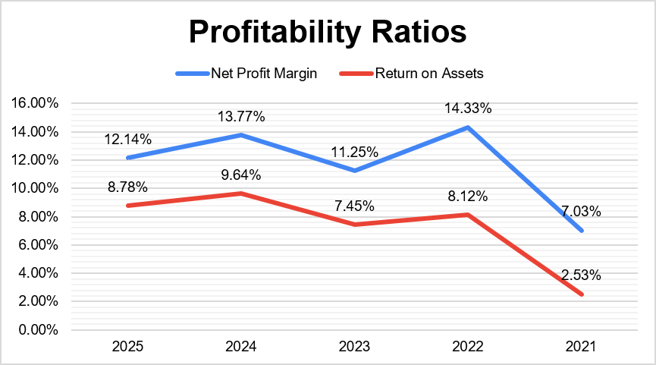
Figure 6: Profitability ratios
(Source: Excel)
The profitability metrics of Hilton Worldwide remained strong over 2021 to 2025. The net profit margin is significantly improved from 7.03% in 2021 to 12.14% in 2025, despite a decline from 2024. As stated by Nagy (2025), profitability indicators are used for analysing financial performance, affecting firm’s ability to finance future investment and repay debts. Figure 6 shows that the return on assets have been increased from 2.53% in 2021 to 8.78% in 2025, revealing its strength of effective operational adequacy, and stronger earnings generation.
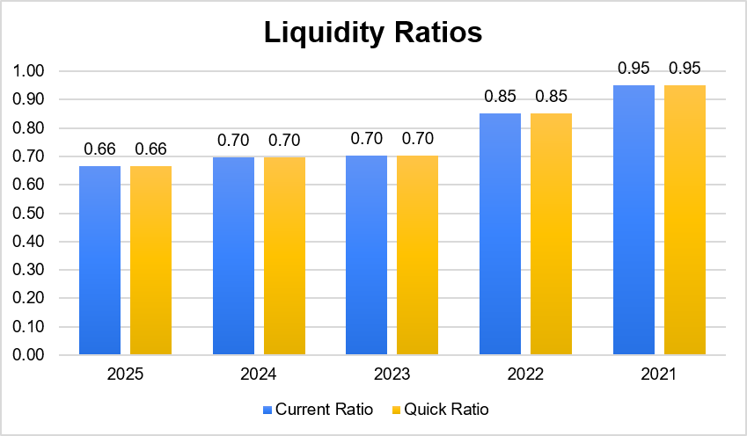
Figure 7: Liquidity ratios
(Source: Excel)
Liquidity position of Hilton weakened as the current and quick ratios both reduced from 0.95 in 2021 to 0.66 in 2025, remaining below the ideal benchmark. As mentioned by Gunawan (2023), a liquidity ratio below one means a company cannot cover its short-term liabilities, leading to bankruptcy. Table 1 shows this trend to highlight tighter short-term liquidity and an increase in operating cash flows dependency.
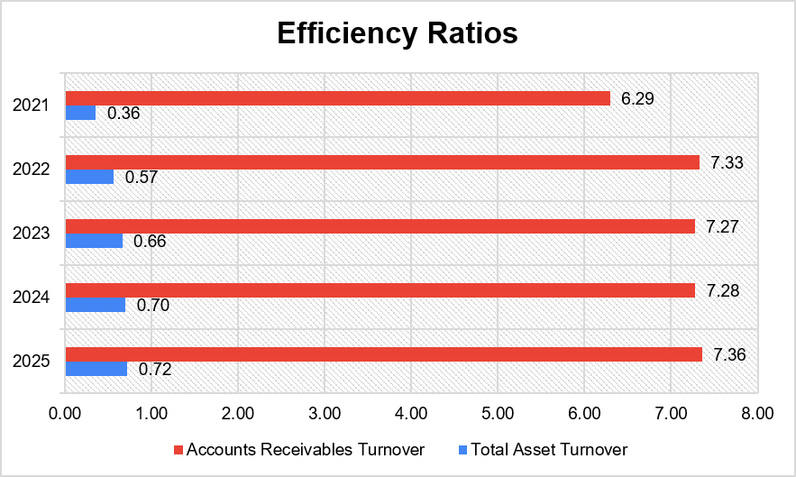
Figure 8: Efficiency ratios
(Source: Excel)
Operational efficiency is improved, including an increase in total asset turnover from 0.36 in 2021 to 0.72 in 2025. Additionally, Binsaddig et al. (2023) stated that accounts receivable turnover evaluates the time taken by a company to collect an organisational receivable. An increase in accounts receivable turnover from 6.29 in 2021 to 7.36 in 2024 shows efficient receivable collection.
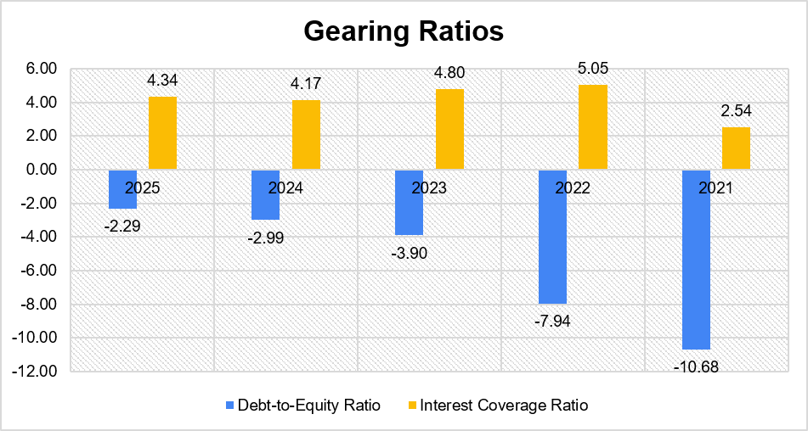
Figure 9: Gearing ratios
(Source: Excel)
Hilton remained highly leveraged, including an improved debt-to-equity ratio from -10.68 in 2021 to -2.29 in 2025, as the equity deficit narrowed. A long-term debt ratio is a company’s financing deficit, where stakeholders avoid investing in less profitable projects (Susilawati et al. 2022). Interest coverage ratio is increased from 2.54 in 2021 to 4.34 in 2025, strengthening debt-servicing capacity.
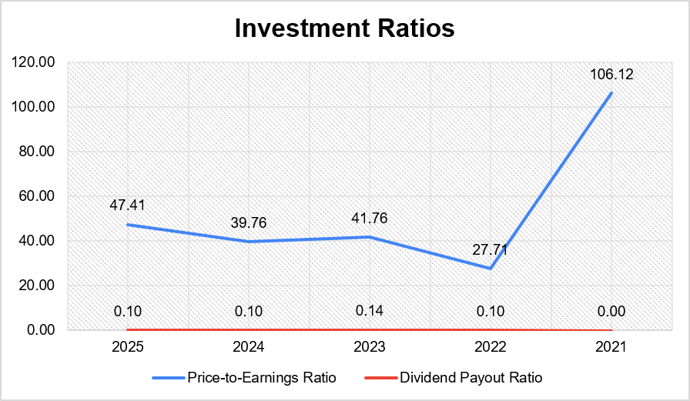
Figure 10: Investment ratios
(Source: Excel)
Investment performance shows strength as the P/E ratio is reduced from 106.12 in 2021 to 47.41 in 2025, exhibiting improved earnings. According to Ali et al. (2022) price-to-earnings ratios help in making right investment decisions for a company. The dividend payout ratio remained stable at around 10-14% after 2022, to balance shareholder returns and earnings retention.
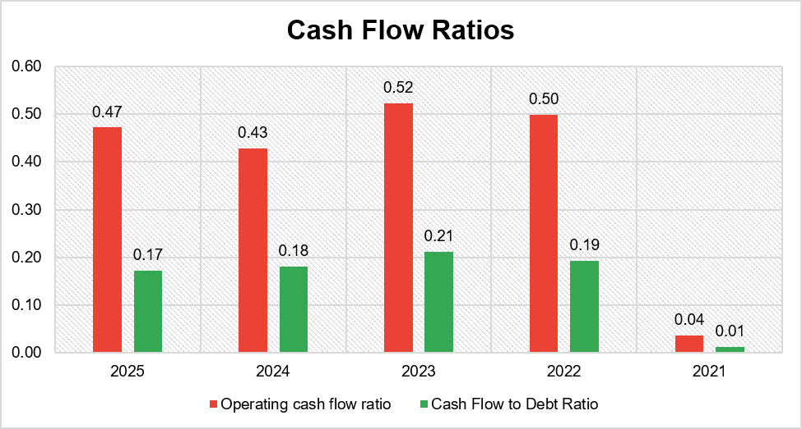
Figure 11: Cash Flow ratios
(Source: Excel)
Figure shows that the cash flow performance has improved effectively, including operating cash flow increased from 0.04 in 2021 to 0.47 in 2025. Adequate operating practices within Hilton are subjected to establish effective brand standards (Hilton, 2025). An increase in cash flow to debt ratio from 0.01 to 0.17 shows stronger liquidity.

1.4 Comparison of liquidity ratios with industry benchmarks
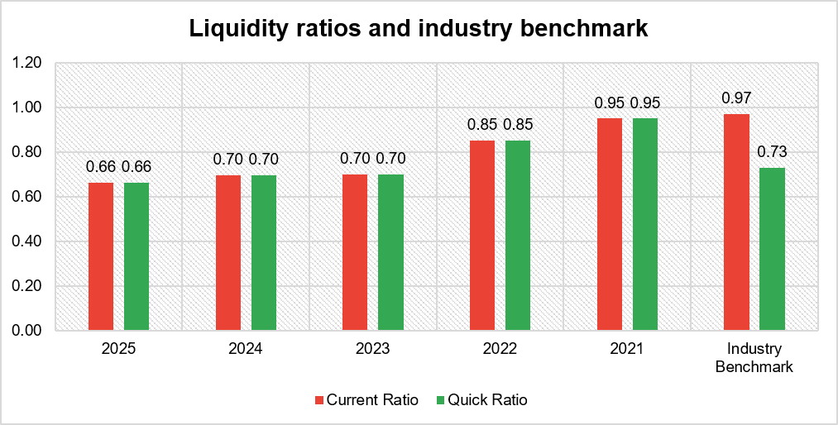
Figure 12: Liquidity ratios and industry benchmark
(Source: Excel)
Figure 12 shows the comparison of the industry benchmark of hospitality with the liquidity position of Hilton, reflecting a weak approach. The current and quick ratios of Hilton are reduced from 0.95 in 2021 to 0.66 in 2025. The current and quick ratio benchmarks of the hospitality sector are 0.97 and 0.73, respectively (Investing, 2025). This indicates comparatively lower short-term liquidity and greater reliance on operating cash flows than other industry peers.

2. Working Capital Management Analysis

2.1 Assessing the cash operating cycle
Working capital management has been efficient for the maintenance of liquidity and efficient finance for daily operations within Hilton Worldwide. For instance, Hilton generates revenue from franchise, licensing, and management fees rather than extensive hotel ownership (Hilton, 2025). This has resulted in a different cash operating cycle compared with traditional hotel operations. Cash conversion cycle or operating cycle is a WCM efficient measurable tool for businesses to facilitate the measurement of the time lag between the procurement of raw materials and collection of expenses (Asman et al. 2022). Hilton has no inventory management as most hotels have been franchised or managed rather than owned. The formula used for cash operating cycle is:
“Cash Operating Cycle = Inventory Days + Receivable Days - Payable Days”
Inventory days have no impact on its cash cycle, where the accounts receivable turnover of the company remained stable at around 7.27 - 7.36 times during 2023 and 0225, reflecting an average collection period of 50 days. Moreover, this effective receivable management and consistent collection from franchises, business partners, and corporate clients improves business revenue. The receivable collection of the company is efficient, whereas liquidity ratios show pressure on the short-term cash resources. The decline in the current and quick ratios from 0.95 in 2021 to 0.66 in 2025 highlights an excess of current liabilities compared to current assets. Moreover, the operating cash flow of Hilton is significantly increased from $109 million in 2021 to $2,129 million in 2025, exhibiting a support to operational commitments despite weak liquidity (Hilton, 2025). The cash operating cycle of Hilton remains adequate due to asset-light business model and stability in receivable collections. Thus, the reduction in liquidity position of the company requires adequate optimisation of cash management to strengthen financial flexibility.

2.2 Recommendation of approaches to improve liquidity through working capital reforms
A significant improvement in the liquidity position of Hilton requires an optimisation of cash collection, delay in supplier payments, and shrink excess inventory. These approaches can help the company to free up trapped cash, along with a significant improvement in daily operations and reduce reliance on short-term debt. As mentioned by Bessonova et al. (2024), accounts receivable has been associated with a key role in financial activities of firms, which is a vital component of working capital. An acceleration in accounts receivables through enhanced digital invoicing system and automated payment reminders can improve the liquidity position of the company. The reduction in the average collection period can increase cash flows and improve liquidity without additional borrowings. Additionally, Hilton can focus on the optimisation of supplier payment terms through negotiating extended credit periods and maintaining strong relationships. An extension in payable periods with agreed contractual terms can improve cash availability and reduce pressure on working capital of the company.
Hilton can streamline its inventory management for the reduction in cash tied up on the shelves or in warehouses. The concept of Just-in-Time ordering can help the company to reduce unrequired inventory costs, and cut holding prices. As stated by Llacer Trotti et al. (2025), Just-in-Time behaviour includes overpriced, arbitrage-driven, and overshooting trade for the identification of optimal liquidity position. This can help the company to run turnover analysis for the identification and liquidate slow-moving items at a discount. Hilton can also focus on continuing limiting unwanted capital expenditure through the prioritisation of asset-light approach, to emphasise franchising and management contracts instead of owning hotels. This practice can lower capital requirements, improve free cash flow, and support higher returns on invested capital.

2.3 Comparison of short-term and long-term financing options
Hilton can focus on financing its business operations through the inclusion of short-term and long-term financing sources, where each option offers various advantages and limitations. As stated by Gandhi and Nasit (2022), short-term financing options include trade credit, cash credit, bank overdraft, and working capital loan. These sources have been adequate for providing immediate access to funds to meet seasonal cash requirements. Short-term financing sources used for daily operations, seasonal gaps, or emergencies, where the money must be paid back.
On the other hand, long-term options involve securing capital for an extended period to support sustainable growth. Long-term financing options include bank loans, bonds, equity financing, and leasing arrangements (Legal Vision, 2025). This provides stable funding for hotel acquisition, strategic expansion, and technology investment to allow repayments over an extended period. Equity financing strengthens the capital base without the creation of mandatory repayment obligations, yet dilutes existing shareholder ownerships. The financial position of Hilton considers long-term financing for supporting strategic growth as the company operates with significant leverage. A stable equity financing option can help the company to lower refinancing risks and provide greater certainty for budgeting decisions. Short-term financing can be reserved for managing temporary fluctuations in working capital.

3. Strategic Financial Restructuring Plan

3.1 Recommendation of financial restructuring options
Financial restructuring reshapes the finances or operations of the company to enhance values and brand reputation. The options of financial restructuring can be beneficial for Hilton to offer unique strategic benefits, such as lowering debt, maximising asset values, and providing cash to expand market share. According to Tomar and Chauhan (2025), financial restructuring includes divestitures to unlock cash, mergers for achieving scale, and equity injections to strengthen the balance sheet. Hilton can focus on divestiture, which means selling off specific hotel properties or under-performing business units to raise cash.
Merger and acquisition can be an efficient option for Hilton to combine with another company for creating a large business scale. As mentioned by Tomar and Chauhan (2025), merging eliminates overlapping costs for building new businesses from scratch, as well as acquisition helps in achieving economies of scale and entering new markets. Injecting equity can be effective for Hilton to bring fresh money from investors in the exchange of partial ownership of the company. Hilton can refinance a portion of its long-term debt through the replacement of higher-interest borrowings with low-cost financing. Thus, these restructuring options can be adequate for the company to improve its liquidity position, strengthen financial stability, and lower financing costs to support sustainable international expansion.

3.2 Evaluation of the impact on shareholder value, operational flexibility, and debt structure
Corporate restructuring reshapes the finance and operations of the company for boosting business performance. This strategy has been expected to develop long-term valuation for shareholders of Hilton through improved profit margins, financial stability, and operational adequacy. Divesting non-core owned properties can release capital for debt reduction and strategic investment to improve free cash flow and return on assets. According to Siddiqa (2023), financial restructuring shapes a firm's shareholder value and debt structure for helping the business adapt and thrive to manage financial distress. Divestiture unlocks shareholder values through the elimination of conglomerate discounts and generates cash windfall for investors. Limited equity injection can dilute existing shareholdings in the short-term, yet strengthen the company’s capital structure through reducing shareholder’s deficit. This provides a cash cushion to protect daily operations from sudden market downturns and ensure freedom to spend on innovation for business growth.
Debt financing can also decrease interest expenses and improve the interest coverage ratio to enhance an ability of Hilton to meet future financial obligations. A merger can create long-term valuation for the company through synergies, yet high purchase prices destroy values. As highlighted by Tomar and Chauhan (2025), mergers and acquisitions increase operational reach, economies of scale, and market share. In the short-term, it can reduce operational flexibility due to employee turnover and complication in cultural integration. Strategic partnerships and mergers can increase market presence and avoid substantial capital commitment for greater operational flexibility. Thus, these initiatives can balance growth and financial discipline for Hilton to respond to changing market conditions and support shareholder wealth maximisation.

3.3 International and ethical considerations
Hilton can focus on the incorporation of international financial and ethical consideration into the restructuring strategy as a global hospitality company. Hilton can consider an adoption of tax-efficient financing structures to ensure full compliance with international tax regulations to lower legal and reputational challenges. For instance, the Bankruptcy Code initiates circumstances under creditors for a single asset real estate debtor obtaining relief from automatic stay (US Courts, 2025). Hilton earns revenues in numerous foreign currencies, and adequate currency risk management through natural hedging and financial derivatives to lower the influence of exchange rate fluctuations on profitability.
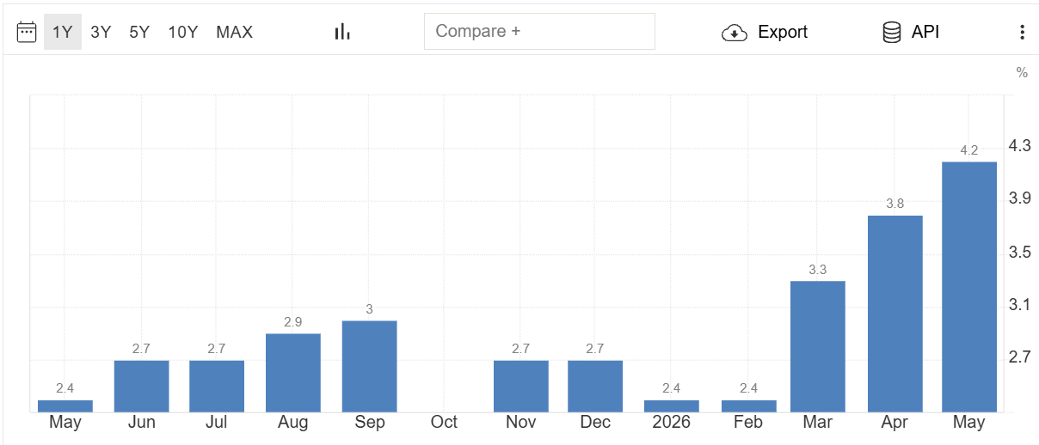
Figure 13: Inflation rate of US
(Source: Trading Economics, 2026)
Inflationary pressure and a rise in interest rates can be considered when refinancing debt to ensure sustainable financing decisions during changing economic conditions. For instance, the inflation rate of the US has increased from 2.4% in 2025 to 4.2% in 2026 (Trading Economics, 2026). Hilton can focus on an integration of environmental, social, and governance principles into its financial strategy through investing in energy-efficient hotels and a reduction in carbon emissions. Transparency in corporate governance and ethical stakeholder engagement can strengthen investor confidence and reinforce the global brand reputation of the company. Therefore, ESG-focused practices support sustainable development and align financial performance with corporate responsibility objectives.

4. Investment Appraisal and Capital Budgeting

4.1 Investment appraisal analysis
Project A: PBP, ARR and NPV
“Project A
Year | Cash Flow (in million) | Discount Factor @ 8% | Present Value (in million) | Cumulative Cash Inflow (in million) | Yearly Depreciation (in million) | Average annual profit (in million)
0 | -£ 50.00 | 1.0000 | -£ 50.00 | -£ 50.00
1 | £ 10.00 | 0.9259 | £ 9.26 | -£ 40.00 | £ 10.00 | £ -
2 | £ 12.00 | 0.8573 | £ 10.29 | -£ 28.00 | £ 10.00 | £ 2.00
3 | £ 14.00 | 0.7938 | £ 11.11 | -£ 14.00 | £ 10.00 | £ 4.00
4 | £ 10.00 | 0.7350 | £ 7.35 | -£ 4.00 | £ 10.00 | £ -
5 | £ 8.00 | 0.6806 | £ 5.44 | £ 4.00 | £ 10.00 | -£ 2.00
Total Present Value |  |  | £ 43.46
Net Present Value (NPV) |  | -£ 6.54
Payback Period (PBP) |  | 4 years and 6 months | 4.5
Total Annual Accounting Profit |  |  |  |  |  | £ 4.00
Average Annual Profit |  |  |  |  |  | £ 0.80
Average Investment |  |  |  |  |  | £ 25.00
Accounting Rate of Return (ARR) |  | 3.20%”
Table 1: Investment appraisal calculation of project A
(Source: Self-created)
Project A: PI and IRR
“Project A
Year | Cash Flow (in million) | Discount Factor @ 8% | Present Value (in million) | Cumulative Cash Inflow (in million) | Yearly Depreciation (in million) | Average annual profit (in million)
0 | -£ 50.00 | 1.0000 | -£ 50.00 | -£ 50.00
1 | £ 10.00 | 0.9259 | £ 9.26 | -£ 40.00 | £ 10.00 | £ -
2 | £ 12.00 | 0.8573 | £ 10.29 | -£ 28.00 | £ 10.00 | £ 2.00
3 | £ 14.00 | 0.7938 | £ 11.11 | -£ 14.00 | £ 10.00 | £ 4.00
4 | £ 10.00 | 0.7350 | £ 7.35 | -£ 4.00 | £ 10.00 | £ -
5 | £ 8.00 | 0.6806 | £ 5.44 | £ 4.00 | £ 10.00 | -£ 2.00
Total Present Value |  |  | £ 43.46
Internal Rate of Return (IRR) |  | 2.72%
Profitability Index (PI) |  | 0.87”
Table 2: PI and IRR of project A
(Source: Self-created)
Project A reflects poor investment appraisal results with a total cash inflow of £54 million and negative NPV at -£6.54 million indicating negative returns in the investment. Besides, IRR of 2.72% is low with a PI of only 0.87 which reflects insignificant returns to investors.
Project B: PBP, ARR and NPV
“Project B
Year | Cash Flow (in million) | Discount Factor @ 8% | Present Value (in million) | Cumulative Cash Inflow (in million) | Annual Depreciation (in million) | Average annual profit (in million)
0 | -£ 50.00 | 1.0000 | -£ 50.00 | -£ 50.00
1 | £ 11.00 | 0.9259 | £ 10.19 | -£ 39.00 | £ 10.00 | £ 1.00
2 | £ 11.00 | 0.8573 | £ 9.43 | -£ 28.00 | £ 10.00 | £ 1.00
3 | £ 11.00 | 0.7938 | £ 8.73 | -£ 17.00 | £ 10.00 | £ 1.00
4 | £ 11.00 | 0.7350 | £ 8.09 | -£ 6.00 | £ 10.00 | £ 1.00
5 | £ 11.00 | 0.6806 | £ 7.49 | £ 5.00 | £ 10.00 | £ 1.00
Total Present Value |  |  | £ 43.92
Net Present Value (NPV) |  | -£ 6.08
Payback Period (PBP) |  | 4 years and 7 months | 4.55
Total Annual Accounting Profit |  |  |  |  |  | £ 5.00
Average Annual Profit |  |  |  |  |  | £ 1.00
Average Investment |  |  |  |  |  | £ 25.00
Accounting Rate of Return (ARR) |  | 4.00%”
Table 3: Investment appraisal calculation of project B
(Source: Self-created)
Project B: PI and IRR
“Project B
Year | Cash Flow (in million) | Discount Factor @ 8% | Present Value (in million) | Cumulative Cash Inflow (in million) | Annual Depreciation (in million) | Average annual profit (in million)
0 | -£ 50.00 | 1.0000 | -£ 50.00 | -£ 50.00
1 | £ 11.00 | 0.9259 | £ 10.19 | -£ 39.00 | £ 10.00 | £ 1.00
2 | £ 11.00 | 0.8573 | £ 9.43 | -£ 28.00 | £ 10.00 | £ 1.00
3 | £ 11.00 | 0.7938 | £ 8.73 | -£ 17.00 | £ 10.00 | £ 1.00
4 | £ 11.00 | 0.7350 | £ 8.09 | -£ 6.00 | £ 10.00 | £ 1.00
5 | £ 11.00 | 0.6806 | £ 7.49 | £ 5.00 | £ 10.00 | £ 1.00
Total Present Value |  |  | £ 43.92
Internal Rate of Return (IRR) |  | 3.26%
Profitability Index (PI) |  | 0.88”
Table 4: PI and IRR of project B
(Source: Self-created)
Project B’s results reflect better but a negative NPV of -£6.08 million but at a higher IRR of 3.6% compared to project A. However, the higher payback time of almost 5 years indicates IRR at 3.6% on average is not beneficial. This is also visible from the PI at 0.88.
Project C: PBP, ARR and NPV
“Project C
Year | Cash Flow (in million) | Discount Factor @ 8% | Present Value (in million) | Cumulative Cash Inflow (in million) | Annual Depreciation (in million) | Average annual profit (in million)
0 | -£ 50.00 | 1.0000 | -£ 50.00 | -£ 50.00
1 | £ 5.00 | 0.9259 | £ 4.63 | -£ 45.00 | £ 10.00 | -£ 5.00
2 | £ 10.00 | 0.8573 | £ 8.57 | -£ 35.00 | £ 10.00 | £ -
3 | £ 20.00 | 0.7938 | £ 15.88 | -£ 15.00 | £ 10.00 | £ 10.00
4 | £ 25.00 | 0.7350 | £ 18.38 | £ 10.00 | £ 10.00 | £ 15.00
5 | £ 5.00 | 0.6806 | £ 3.40 | £ 15.00 | £ 10.00 | -£ 5.00
Total Present Value |  |  | £ 50.86
Net Present Value (NPV) |  | £ 0.86
Payback Period (PBP) |  | 3 years and 7 months | 3.60
Total Annual Accounting Profit |  |  |  |  |  | £ 15.00
Average Annual Profit |  |  |  |  |  | £ 3.00
Average Investment |  |  |  |  |  | £ 25.00
Accounting Rate of Return (ARR) |  | 12.00%”
Table 5: Investment appraisal calculation of project B
(Source: Self-created)
Project C: PI and IRR
“Project C
Year | Cash Flow (in million) | Discount Factor @ 8% | Present Value (in million) | Cumulative Cash Inflow (in million) | Annual Depreciation (in million) | Average annual profit (in million)
0 | -£ 50.00 | 1.0000 | -£ 50.00 | -£ 50.00
1 | £ 5.00 | 0.9259 | £ 4.63 | -£ 45.00 | £ 10.00 | -£ 5.00
2 | £ 10.00 | 0.8573 | £ 8.57 | -£ 35.00 | £ 10.00 | £ -
3 | £ 20.00 | 0.7938 | £ 15.88 | -£ 15.00 | £ 10.00 | £ 10.00
4 | £ 25.00 | 0.7350 | £ 18.38 | £ 10.00 | £ 10.00 | £ 15.00
5 | £ 5.00 | 0.6806 | £ 3.40 | £ 15.00 | £ 10.00 | -£ 5.00
Total Present Value |  |  | £ 50.86
Internal Rate of Return (IRR) |  | 8.59%
Profitability Index (PI) |  | 1.02”
Table 6: PI and IRR of project B
(Source: Self-created)
Project C integrates best alternative compared to project A and B due to significantly higher IRR of 8.59% and PI higher than 1.02. Besides, the 12% ARR and positive NPV at £0.86 million indicate significant return on investment.

4.2 Recommendation for project selection and justification
Recommendation of preferred project
The recommendation to select preferred project is C as it contains positive NPV of £0.86 million with a very high ARR and IRR of 1% and 8.59% respectively. Both the returns are higher than cost of capital present at 8% indicating higher shareholder value generation in the long-run from this investment.
Justification with reference to Hilton Worldwide’s performance
Based on the issue of overlapping cost for building new business from scratch, Hilton is expected to bring new capital inflow from investors compared to partial ownership exchange in company (Hilton, 2025). Based on the refinancing recommendation to reduce long-term debt with high-interest borrowings, low-cost financing by investment in project C can ensure better capital inflow at an average return of 12%. Starting from the investment in project C, Hilton will be able to gain positive cash inflow starting third year of investment. This indicates reducing in high leverage which is existing in Hilton at a DE ratio of -2.29 in 2025.
Justification with reference to non-financial risks
Based on non-financial risks of emission and geo-political instability in globalised supply chain networks, the recovery of investment return in just 3 years and 6 months is expected to help reduce leverage risks in Hilton. Besides, the ESG strategy improvement with ESG-centric practices for sustainable development will require inflation proof investment to integrate ESG principles (Hilton, 2025). Therefore, the ARR of 12% and IRR at 8.69% indicates a higher return over discounting rate considered at 8% for investment decision-making.

4.3 Justification suggesting assumption of maximum £100 million investment using capital rationing
“Project | PI | Rank
Project C | 1.02 | 1
Project B | 0.88 | 2
Project A | 0.87 | 3
Project C + B | 1.90 | Best Combination”
Table 7: Ranking projects using Capital Rationing
(Source: Self-created)
Based on the ranking using capital rationing, a combined investment in project B and C with £100 million can help improve financial performance. As per capital rationing PI of project C is highest at 1.02 but capital constraints of project B and C shows higher PI at .90. This indicates better profitability if balanced investment in these two projects is done.

5. Critical Reflection on AI Usage

5.1 Tool Disclosure
Artificial intelligence uses to support academic research needs strict adherence to existing academic guidelines. In my case, the use of AI for researching reliable data and assessing their relevance with the topic for personal analysis has been helpful. I preferred using ChatGPT and Google AI with free accessibility using my google account to sign in and check some facts related to keywords like financial performance and non-financial factors in listed hospitality companies.

5.2 Critical Evaluation of AI Output
The key verification methods that I used for financial interpretations relating to AI are source-link tracing, independent calculation and cross-checking the models. The source-link tracing was done where an AI-generated figure was being traced back to the original cell, ledger or SEC EDGAR Filing in order to establish lineage. ChatGPT have become increasingly effective in having the capability of natural and dynamic conversations with users (Kacperski et al., 2025). Independent calculation was also helpful for me while using ChatGPT and Google AI in using independent calculation. While doing the assignment, there were several financial ratios that I calculated while using the AI tools. Hallucinations and Errors were mitigated through the plausibility test, context deviations and logical traps. Generating calculations through AI regarding capital budgeting techniques can sound highly certain but might contain wrong values. I cross-checked whether the calculated margins are aligned with the given data and scenario. Similarly, I also checked any context deviations observed within the AI regarding the ratios that were calculated through the annual reports of Hilton Worldwide. I implemented corrective actions through verifying and replacing flawed AI summaries and adjustments to prompts by citing explicit paragraphs.

5.3 Contribution Analysis
The content generated by AI and my own strategic synthesis and critical analysis were different from each other. While using ChatGPT and Google AI to calculate my answers, there were several flaws that I observed such as the content generated was not matching with the calculations that I had done with my own understanding. Slack announced the opening of ChatGPT in order to get answers to the questions (Cao and Zhai, 2023). Similarly, the capital budgeting techniques that I applied to get the answers also had flaws regarding the wrong usage of data. However, cross-checking all the errors helped me in improving my strategic synthesis and critical analysis of the financial interpretations made. Henceforth, I always evaluate if the cash inflows of the project can match with the capital budgeting calculations as shown within turnover ratios.

5.4 Ethical & Professional Reflection
Focusing on transparency, there are several elements that I considered such as unfair AI based decisions can create problems of discrimination. AI is useful in providing much faster and more extensive data analysis in contrast to humans by achieving accuracy and establishing itself as a reliable tool (Chen, 2023). Regarding data privacy, generative AI models have a requirement of massive amounts of data that needs to be learnt and operated. I ensured that I did not input any sensitive data into public AI tools such as Google AI and ChatGPT. Instead, I utilised the annual reports of Hilton Worldwide to analyse its financial performance. Over-reliance in executive decisions usually means that leaders might have a blind trust towards AI simply because the technology is very smart. In regards to executive decisions, I ensured that I do not completely rely on the AI tools to avoid discriminatory practices which can hinder my professional career.

Conclusion
In conclusion, as a CFO, the financial performance analysis of Hilton Worldwide revealed strong profitability due to effective operational adequacy. However, liquidity position is weak due to inability of short-term liabilities payment. Yet, improvement in operational efficiency reflected better turnover in accounts receivable that helps retaining capital inflow in the company. Based on existing higher leverage position of Hilton, it is suggested to invest in third project to gain higher returns starting from 3 year’s fourth quarter to retain investors and maximise capital inflow.

References
Ali, K., Chisti, K.A. and Malik, I.A. (2022) ‘Impact of earnings per share on stock prices and price to earnings ratio.’ Economics and Business Quarterly Reviews, 5(2). Available at: https://papers.ssrn.com/sol3/Delivery.cfm?abstractid=4125746
Asman, F.N., Fernandez, D., Jamaludin, N.A., Omar Zaki, H. and Ghazali, A.W. (2022) ‘Cash conversion cycle and firm’s performance.’ International Journal of Academic Research in Business and Social Sciences, 12(11), pp.2682-2692. Available at: https://www.academia.edu/download/106769993/cash-conversion-cycle-and-firms-performance.pdf
Bessonova, A., Bessonova, S. and Shevchenko, A. (2024) ‘Optimization of Receivables of an Enterprise as a Tool for Strengthening Financial Efficiency.’ Економіка розвитку систем, 6(2), pp.146-150. Available at: https://esd-journal.sumy.ua/index.php/journal/article/download/75/68
Binsaddig, R., Ali, A., Al-Alkawi, T. and Ali, B.J. (2023) ‘Inventory Turnover, accounts receivable turnover, and manufacturing profitability: an empirical study.’ International Journal of Economics and Finance Studies, 15(1), pp.1-16. Available at: https://sobiad.org/menuscript/index.php/ijefs/article/download/1394/314
Cao, Y. and Zhai, J. (2023) ‘Bridging the gap–the impact of ChatGPT on financial research.’ Journal of Chinese Economic and Business Studies, 21(2), pp.177-191. https://www.tandfonline.com/doi/pdf/10.1080/14765284.2023.2212434
Chen, Z. (2023) ‘Ethics and discrimination in artificial intelligence-enabled recruitment practices.’ Humanities and social sciences communications, 10(1), p.567. Available at: https://www.nature.com/articles/s41599-023-02079-x.pdf
Gandhi, J. and Nasit, A. (2022) ‘Comparison of short-term financing options; factoring as the best alternative.’ In International Research Conference on Innovations, Startup and Investments (ICOSTART-2022) (pp. 127-141). Available at: https://rku.ac.in/icostart2022/books/14-management-jenil-gandhi-(127-141).pdf
Gunawan, E. (2023) ‘Liquidity Ratio Analysis in Financing Short Term Liabilities.’ International Journal of Health, Economics, and Social Sciences (IJHESS), 5(2), pp.157-162. Available at: https://jurnal.unismuhpalu.ac.id/index.php/IJHESS/article/download/3611/2789
Hilton (2022) Annual report 2022. Available at: https://stories-editor.hilton.com/wp-content/uploads/2023/04/HILTON-WORLDWIDE-INC_10K_2023_V1.pdf (Accessed: 05 July 2026).
Hilton (2023) Annual report 2023. Available at: https://stories-editor.hilton.com/wp-content/uploads/2024/04/2023-Annual-Report-10-K.pdf (Accessed: 05 July 2026).
Hilton (2024) Annual report 2024. Available at: https://stories-editor.hilton.com/wp-content/uploads/2025/03/Hilton-2024-Annual-Report-SEC-Form-10-K.pdf (Accessed: 05 July 2026).
Hilton (2025) Annual report 2025. Available at: https://stories-editor.hilton.com/wp-content/uploads/2026/03/Hilton-2025-Annual-Report-SEC-Form-10-K.pdf (Accessed: 05 July 2026).
Investing (2025) Hilton Worldwide Holdings Inc (HLT). Available at: https://in.investing.com/equities/hilton-worldwide-ratios (Accessed: 05 July 2026).
Kacperski, C., Ulloa, R., Bonnay, D., Kulshrestha, J., Selb, P. and Spitz, A. (2025) ‘Characteristics of ChatGPT users from Germany: Implications for the digital divide from web tracking data.’ PloS one, 20(1), p.e0309047. https://journals.plos.org/plosone/article/file?id=10.1371/journal.pone.0309047&type=printable
Legal Vision (2025) Difference Between Short-Term and Long-Term Financing in the UK. Available at: https://legalvision.co.uk/corporations/term-financing/ (Accessed: 05 July 2026).
Llacer Trotti, B., Tang, W., El-Azouzi, R., Fanti, G. and Menasché, D.S. (2025) ‘Strategic Analysis of Just-In-Time Liquidity Provision in Concentrated Liquidity Market Makers.’ In 7th Conference on Advances in Financial Technologies (AFT 2025) (pp. 8-1). Schloss Dagstuhl–Leibniz-Zentrum für Informatik. Available at: https://drops.dagstuhl.de/storage/00lipics/lipics-vol354-aft2025/LIPIcs.AFT.2025.8/LIPIcs.AFT.2025.8.pdf
Nagy, M. (2025) ‘The paradox of performance: Profit growth amid structural financial instability.’ Ekonomicko-manazerske spektrum, 19(2), pp.1-11. Available at: https://ems.uniza.sk/pdf/2025_2/EMS_2_2025_01_Nagy.pdf
Siddiqa, A. (2023) ‘Corporate Financial Restructuring: Strategies and Impacts.’ Pakistan Journal of Management & Social Science, 2(02), pp.112-125. Available at: https://www.pakistanjournalofmanagement.com/index.php/Journal/article/download/28/57
Susilawati, D., Shavab, F.A. and Mustika, M. (2022) ‘The effect of debt to equity ratio and current ratio on return on assets.’ Journal of Applied Business, Taxation and Economics Research, 1(4), pp.325-337. Available at: https://equatorscience.com/index.php/jabter/article/download/61/49
Tomar, P.S. and Chauhan, A. (2025) ‘Corporate Finance, Capital Structure and Financing Strategies.’ Media Education And National Educational Policy, p.450. Available at: https://mis.itmuniversity.ac.in/ssr/C3/Volume%208.pdf#page=462
Trading Economics (2026) United States Inflation Rate. Available at: https://tradingeconomics.com/united-states/inflation-cpi (Accessed: 05 July 2026).
US Courts (2025) The Single Asset Real Estate Debtor. Available at: https://www.uscourts.gov/court-programs/bankruptcy/bankruptcy-basics/chapter-11-bankruptcy-basics (Accessed: 05 July 2026).

Appendices

Appendix 1: Ratio calculation
Detailed workings
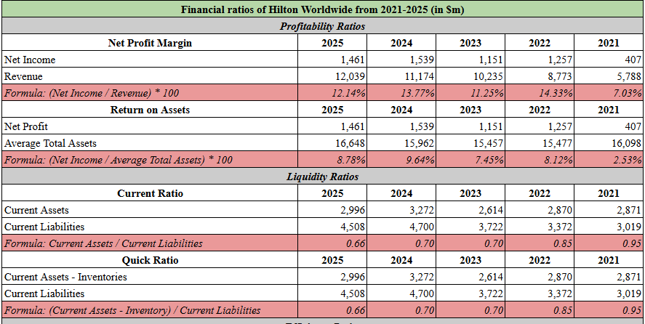
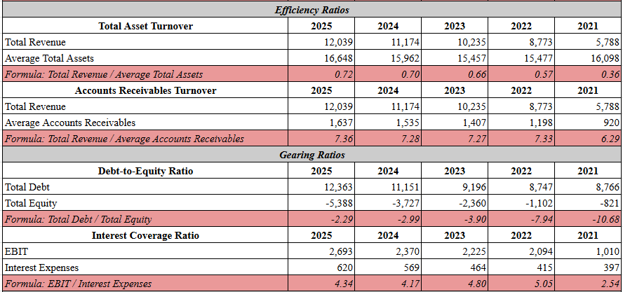
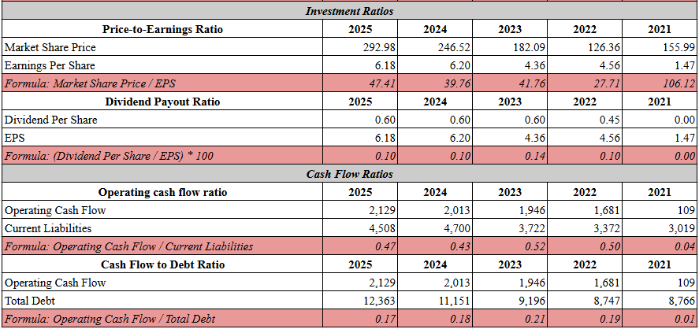
Summary table
“Graphs
Ratios | 2025 | 2024 | 2023 | 2022 | 2021
Net Profit Margin | 12.14% | 13.77% | 11.25% | 14.33% | 7.03%
Return on Assets | 8.78% | 9.64% | 7.45% | 8.12% | 2.53%
Ratios | 2025 | 2024 | 2023 | 2022 | 2021
Current Ratio | 0.66 | 0.70 | 0.70 | 0.85 | 0.95
Quick Ratio | 0.66 | 0.70 | 0.70 | 0.85 | 0.95
Ratios | 2025 | 2024 | 2023 | 2022 | 2021
Total Asset Turnover | 0.72 | 0.70 | 0.66 | 0.57 | 0.36
Accounts Receivables Turnover | 7.36 | 7.28 | 7.27 | 7.33 | 6.29
Ratios | 2025 | 2024 | 2023 | 2022 | 2021
Debt-to-Equity Ratio | -2.29 | -2.99 | -3.90 | -7.94 | -10.68
Interest Coverage Ratio | 4.34 | 4.17 | 4.80 | 5.05 | 2.54
Ratios | 2025 | 2024 | 2023 | 2022 | 2021
Price-to-Earnings Ratio | 47.41 | 39.76 | 41.76 | 27.71 | 106.12
Dividend Payout Ratio | 0.10 | 0.10 | 0.14 | 0.10 | 0.00
Ratios | 2025 | 2024 | 2023 | 2022 | 2021
Operating cash flow ratio | 0.47 | 0.43 | 0.52 | 0.50 | 0.04
Cash Flow to Debt Ratio | 0.17 | 0.18 | 0.21 | 0.19 | 0.01”
Liquidity with benchmark
“Liquidity ratios with industry benchmark
Ratios | 2025 | 2024 | 2023 | 2022 | 2021 | Industry Benchmark
Current Ratio | 0.66 | 0.70 | 0.70 | 0.85 | 0.95 | 0.97
Quick Ratio | 0.66 | 0.70 | 0.70 | 0.85 | 0.95 | 0.73”

Appendix 2: Investment Appraisal

