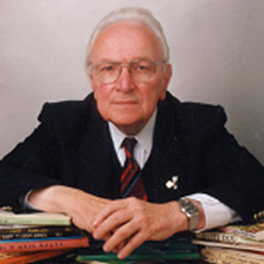
Darllenwch am yr awdur T Llew Jones.
Pa ffeithiau ddysgoch chi?

- ______________________________________________________________

- ______________________________________________________________

- ______________________________________________________________

- ______________________________________________________________

- ______________________________________________________________

- ______________________________________________________________

- ______________________________________________________________

- ______________________________________________________________

- ______________________________________________________________

- ______________________________________________________________

- ______________________________________________________________

- ______________________________________________________________

- ______________________________________________________________

- ______________________________________________________________


