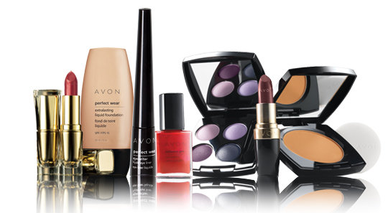  DAVID’S STRATEGY FORMULATION FRAMEWORK: AVON  (Teamdragonavon, 2012) | Abstract  Avon was founded by David H. McConnell, in 1886, the company produces beauty products, fashion and home products (New Avon, 2017d). Nonetheless, the company has been losing market-share for few years, but the SFF makes it possible to evaluate several strategies to revitalise the organisation  Adekoyejo Sobola (1601748)  SBUS6104 Contemporary Themes in E-Business

Contents
Executive Summary 2
1.0 INTRODUCTION 2
1.1. E-Business 3
1.2 Strategy 4
1.3. Financial 5
2.0 RESEARCH MODEL AND METHODOLOGY 10
2.1. Stage 1: The Input Stage 11
2.1.1 EFE 11
2.1.2 IFE 13
2.1.3 Competitive Profile Matrix 15
2.1.4 The Nature of the Cosmetics Industry 16
3.0. Stage 2: The Matching Stage 19
3.1. Avon’s Strengths-Weakness-Opportunities-Threats (SWOT) Matrix 19
3.2. Avon’s Strategic Position and Action Evaluation (SPACE) Matrix 23
3.3. Group (BCG) Matrix 25
3.4 Avon’s Internal- External (IE) Matrix 26
3.5 Grand Strategy Matrix 27
4.0 Decision Stage 27
4.1 Quantitative Strategic Planning Matrix (QSPM) for Avon 28
6.0 Advantages of SFF 29
6.1. THE LIMITATIONS OF THE STRATEGY FORMULATION FRAMEWORK 30
7.0. CONCLUSION 30
8. REFERENCES 32
Works Cited 32
9.0 Appendices 38

Executive Summary
Avon was founded by David H. McConnell, in 1886, the company produces beauty products, fashion and home products (New Avon, 2017d). Nonetheless, the company has bee losing market-share for few years, but the SFF makes it possible to evaluate several strategies to revitalise the organisation. The SFF, enabled a holistic diagnosis of a company’s operations and tools, such as the SWOT Matrix, SPACE Matrix, BCG Matrix, IE Matrix, and QSPM will be deployed to examine, Avon's positions, internally and externally, financially, and in the market. And these tools could enhance the quality of strategic decisions.

1.0 INTRODUCTION
Avon empowers women to be self-sufficient by earning an income, provides numerous training opportunities for Representatives, and are very keen on relationship marketing that is face-to-face but have adapted digital-technology to their relationship-marketing to enhance representatives reach and productivity (New-Avon, 2017c). Avon is one of the leading direct-sellers of beauty and related products (Avon-Products, 2019). This is the historical business model a B2B.
Avon prides itself to be a company for women, and this is attested to by numerous philanthropic actions for women by committing to Avon Foundation for Women, stand4her, Freedom to Earn, Power of Beauty, Breast Cancer and Violence Against Women and Girls. They are an ethical company by committing to reducing environmental impact, operating responsibly and adopting ‘be the company for women’ in their business-model (Avon-Product, 2019e;f). Despite these commitments, the company has been experiencing declining sales since 2014 (CSIMarket, 2019e). Nonetheless, Jan Zijderveld, Avon CEO, elucidated that the company was at the initial stages of turn-around plan and they are witnessing improvement in revenue trends in 4 of the top 5 markets (Avon-Products, 2019g; figure 1), but the company has been recording losses for several years (Avon-Products, 2019h)

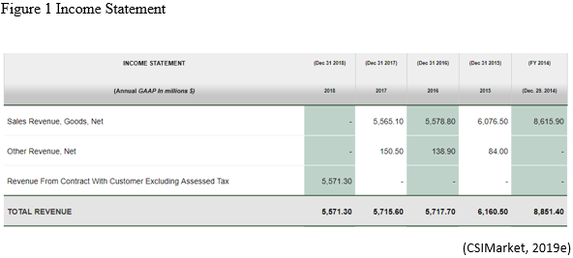

1.1. E-Business
Avon has always been the original social-seller, a door-to-door, face-to-face business-model which is a form of B2B, but the IoT era is forcing Avon to adopt the digital- B2B model, Avon needed to shift from ‘off- to online networks’, and Avon Cosmetics has gone Digital and now distribute brochure through WhatsApp or Facebook (Avon-Products, 2019h Bloomberg, 2018). Timmers (1999) defines a ‘business model’ as:
An architecture for product, service and information flows, including a description of the various business actors and their roles; and a description of the potential benefits for the various business actors; and a description of the sources of revenue.
The implication of digitization is disintermediation which is the direct selling from Avon’s web site and then secondly, the reintermediation which is selling through online intermediaries.
Still, Chaffey (2011) averred that a business model is a statement detailing how Avon would generate revenue, the targeted customer, to identify the product, the value-added services.
This has necessitated the appointment of key Vice-President to manage this strategy (Avon-Products, 2018j), and the strategy is accompanied by new IT capabilities Supply-Chain-Management in order to process and fulfil deliveries, a ‘15% reduction in inventory levels and 25% reduction in Stock Keeping Units (SKUs) and a 10% reduction in its global headcount.’ (Avon-Products, Inc, 2019c)

1.2 Strategy

For Avon’s Strategic management it would be pertinent for them to understand their strategic position before making strategic choices (Johnson et al 2011). To revitalise the company, the management team have set a new strategic direction, this must be after identifying their market position. This is possible by evaluating and analysing their internal and external environment (Hooley et al., 2008). Mintzberg (1978) alluded to the difficulty of defining strategy, however, Johnson, et al., (2011) suggested that strategy is an organisation’s long-term direction that must be agile and adaptable to volatile market conditions.

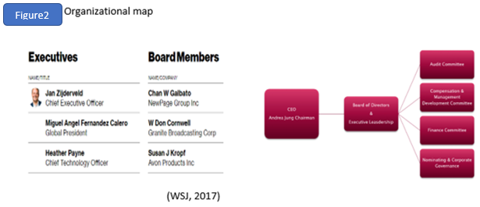
The new strategy to transform the fortunes of Avon is being led by the new CEO and new leaders including the appointment of a Chief Strategy and HR Officer to drive transformation and a new digital and Technology officers (New-Avon, 2017b; PRNewswire, 2018b; 2019d; WSJ, 2017; Bloomberg, 2018; MarketLine, 2018c; figure 2).

1.3. Financial
From Avon’s financial report, the company is operating at a loss (Bloomberg, 2019a;c), Avon has been underperforming in so many key sectors when compared to Loreal figures 3, 4, 5,6,7,8) (Avon-Products, Inc, 2018).
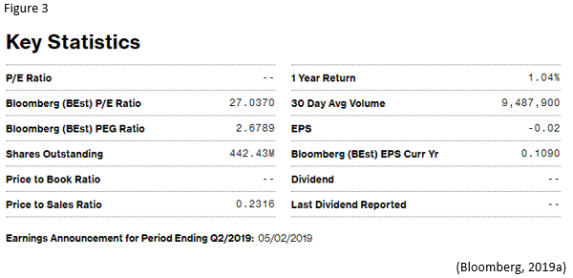
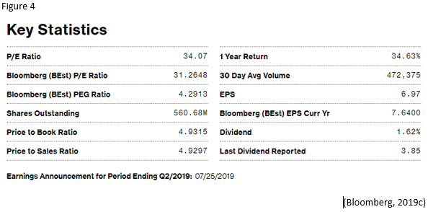

From figures 3 and 4, Avon’s P/E ratio is nil compared to Loreal’s 34.07. the P/E ratio measures Avon’s current share price relative to its per-share earnings (EPS). From figure 3 Avon did not pay any dividend, this company may not be attractive for investors, because the P/E ratios are used by investors and analysts to determine the relative value of a company's shares in comparison to a-like-for-like. The problem is evident in the balance sheet where the investors are in deficit of $904.5.

Figure 5. Avon’s Balance Sheets as at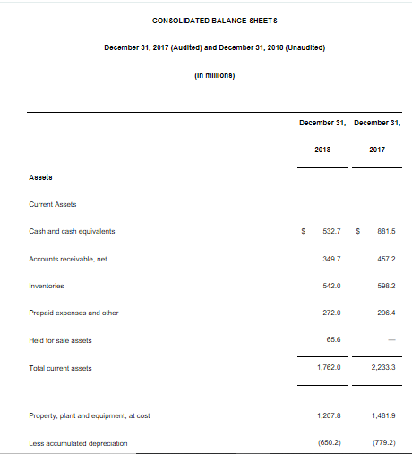
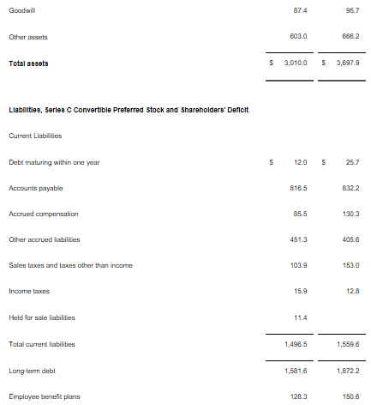
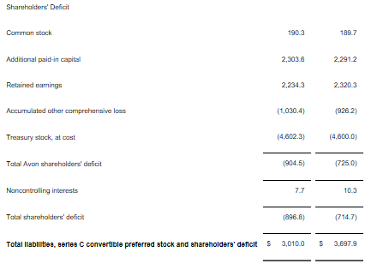
(Avon Products, Inc, 2019d)
Figure 6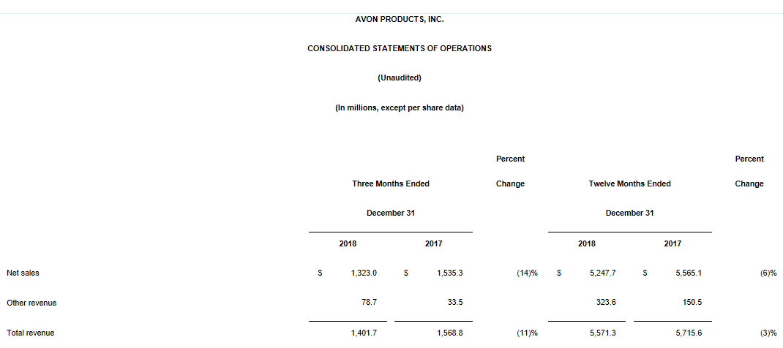

See appendix 1 for the rest.
From figurefigure, total asset is decreasing, and total liability is steady for 2018, but figure 8, shows Avon’s debt will increase from 2019 and beyond. This will impact the leverage or gearing ratio of the company.

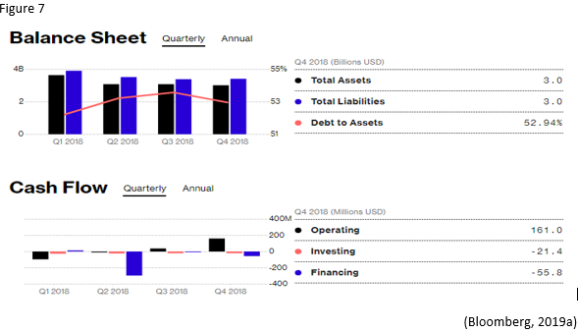

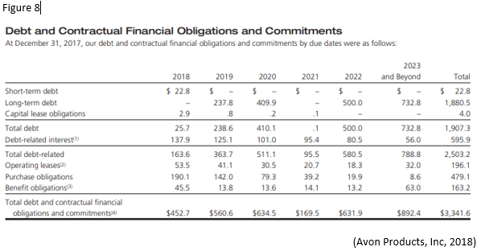
From figure 9, the profit margin is -5.54%, the company failed to capitalise at the end of the year sales.
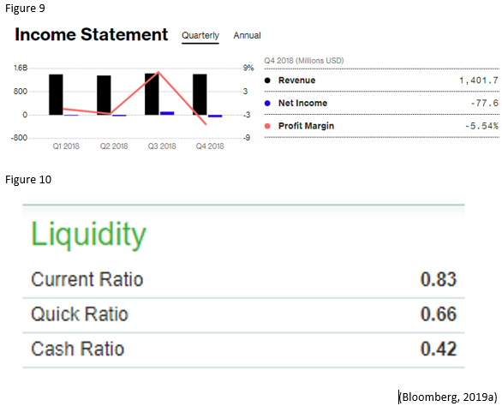

2.0 RESEARCH MODEL AND METHODOLOGY

David's strategy formulation framework (SFF) is a tool that helps strategists to generate feasible alternatives that could assist the company in its goal. Hence, this paper will utilise the SFF to update Avon's business strategy. The SFF is adaptable into a decision-making framework. The SFF could be identified, evaluated and selected in three stages: (1) input stage, (2) matching stage, and (3) decision stage (Figure 3) (David, 2011). Most importantly, the weightings used in the SFF are mere estimates without any quantitative data, but they are based on the strategist assumption. For the SFF to be effective, Avon’s input and collaboration are critical in order not to compromise culture, market know-how, local knowledge etc.
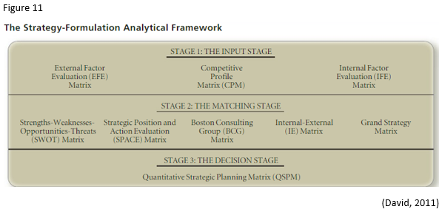

2.1. Stage 1: The Input Stage

2.1.1 EFE
Here , David (2011) posited the view that, this stage encapsulates the vital information that is necessary for the formulation of strategies that includes the External Factor Evaluation (EFE) which is the Matrix that summarises and evaluates economic, social, cultural, demographic, environmental, political, governmental, legal, technological, and competitive information. The EFE enables Avon, to evaluate opportunities and threats that face the company in the macro-environment (David, 2007).
From the previous SFF, Avon was acquiring companies, but now the company is divesting by selling many acquired companies to raise cash. In the same period, Avon was investing in many countries including Brazil, but they have faced several litigations in addition to sudden high taxes in Brazil. The rating and the weights (old 0.08/ new 0.07) for overseas investment is similar (3).
Furthermore, the global recession is not fully abated, and the company is severely impacted by currency fluctuations (Avon-Products, Inc, 2019d). Avon has got a bad name in Brazil and with shareholders. Their careless handling of bad-debt and Brazilian sales-representatives has led to shareholders investigation with potential litigation, unchanged from old SFF (MarketWatch, 2019c).
The old SFF viewed online-markets as becoming popular, but now, it has become a major reason why Avon is struggling and is also a major catalyst for survival and growth. Avon has made a significant investment into the digital platform to support face-to-face, direct-sales marketing, and efforts are directed towards-online marketing (opportunities 4,5,7,11), and these items carry a lot of weights and ratings. The company’s restructuring efforts look to be working even though they are yet to make a profit.

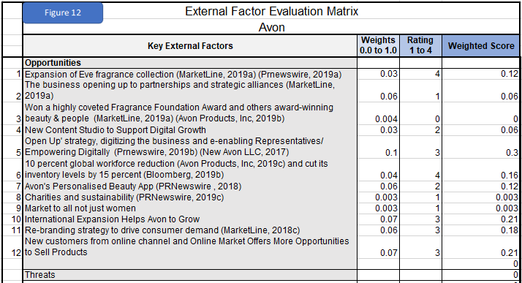
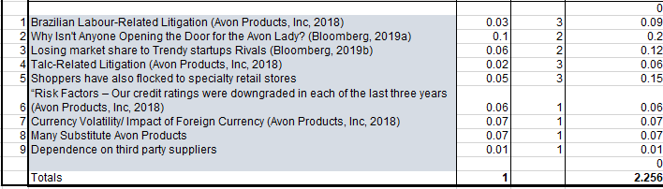

2.1.2 IFE
The IFE focuses on activities that could be controlled by the organisation (David, 2011), From the IFE matrix in figure 13, Avon is still a globally recognised company, but they are no longer the biggest B2B or B2C sellers in the world. Also, door-to-door sales are fading, and embracing online-sales will be critical in the era of IoT. The old SFF weights (0.07) and rating (4) for direct-seller is similar to the new. Despite all the ethical and charitable works done by Avon, it has not translated into profit so is not relevant.
Avon is a loss-making business and is unable to provide steady growth rather, its sales and market-share are declining. Unlike before, the local representatives are now cooperating and are embracing digital technology as a tool rather than as a threat, this will boost sales.
Avon has bigger problems than before, they have lower cash flow, they are divesting to raise cash. Avon has a new model to re-capture the American market, as they are losing market share.
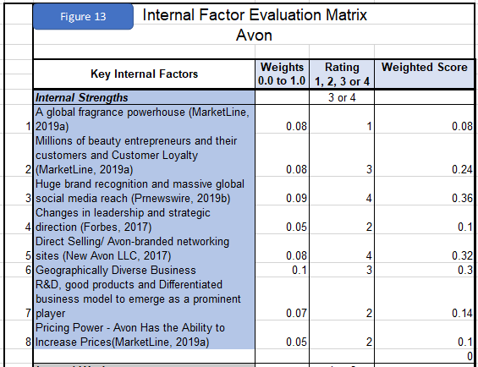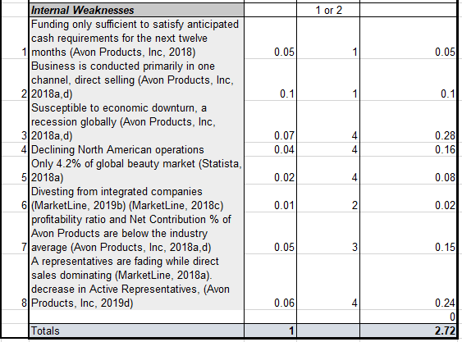

2.1.3 Competitive Profile Matrix

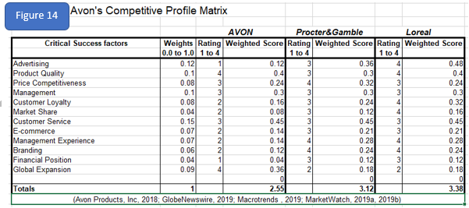

The CPM focuses on competition, (David, 2011) and Avon is losing market-shares to competition according to figures 14. Customers are no longer loyal (rating from 0.3 to 0.2. In figure 15, Avon’s sales are contracting in every region. In Latin America by -25.89% 16, while the industry has continued to experience yearly growth (figure 19). Avon’s revenue is far among the leading 20 beauty manufacturers worldwide in 2018 (in billion U.S. dollars) (Statista, 2018). Their competitors are more stable and adopted digital-technology earlier than Avon. But, in the skincare section Avon is still competing. Likewise, Avon has realised its error for not embracing digital-technology early, and digital-technology is now a tool to transform the organisation (Avon-Products, 2019h).
Again, Avon must capitalise on the Fragrance market, although it accounts for only 2.22% market share, it has growth potential ( CSIMarket, 2019b; Grand View Research, 2019; MarketWatch, 2019a). Worryingly, Tupperware Brands a relatively new company, copied the Relationship-based-Selling famously developed by Avon and they are outperforming Avon in the skincare department by having 25.45 % (Tupperware, 2019).
Still, the outstanding performance in Beauty segment improved Avon’s market share to 15.21 % (figure 17) and ensured that revenue grew by 83.44 % (CSIMarket, 2019c). The 0.89 % share in the Home sector needs urgent attention. In general, there is room for growth and increased market-share as global cosmetics market grows (figure 19).

2.1.4 The Nature of the Cosmetics Industry

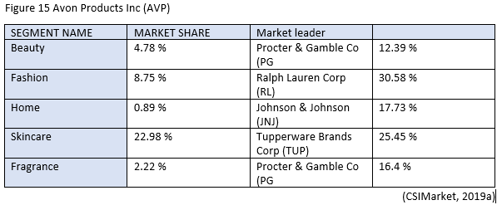

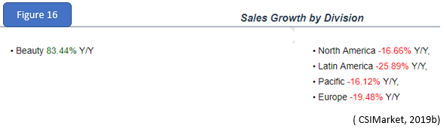

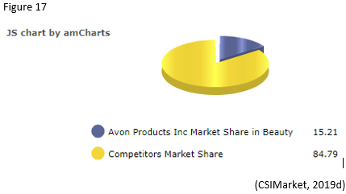

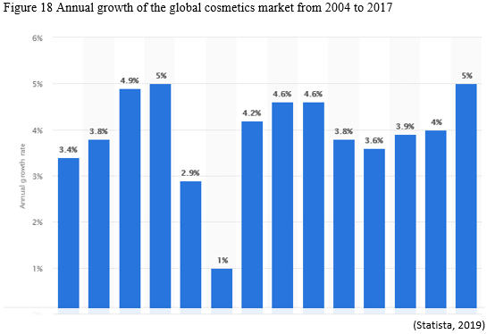
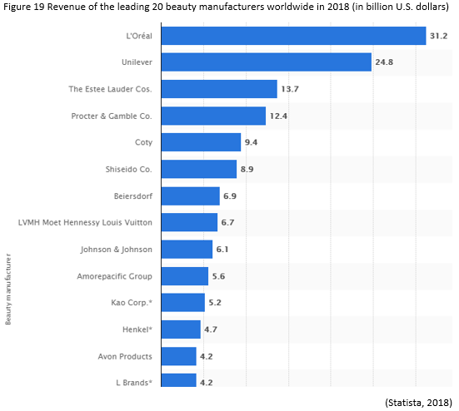

3.0. Stage 2: The Matching Stage
The Matching Stage evaluates both the micro and macro business environments and develops strategies for addressing the evaluation. Tools for this phase are the SWOT Matrix, the SPACE Matrix, the BCG Matrix, and the IE Matrix (David, 2007; figure 20).

3.1. Avon’s Strengths-Weakness-Opportunities-Threats (SWOT) Matrix

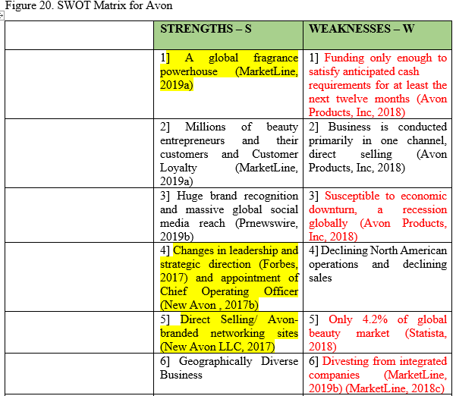
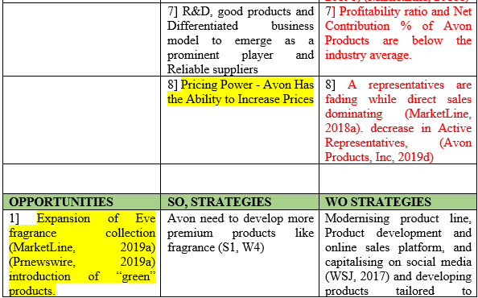
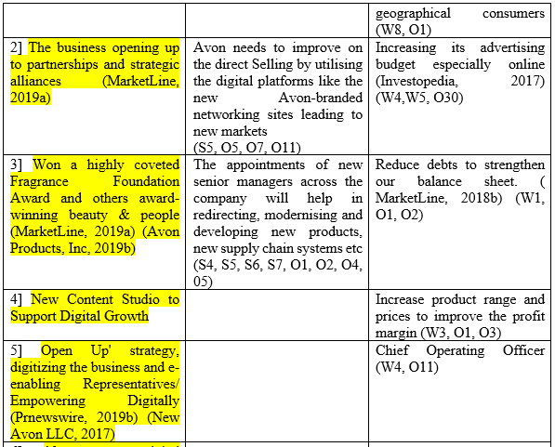
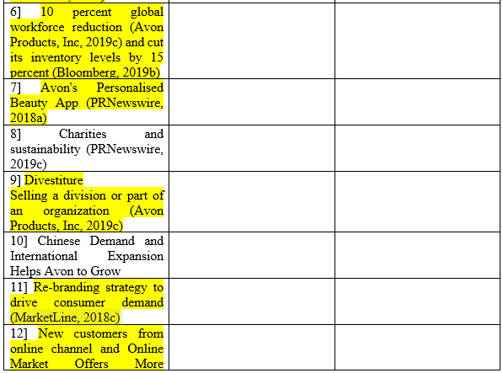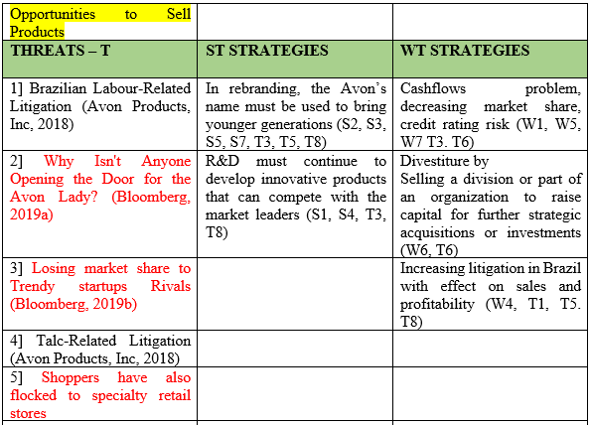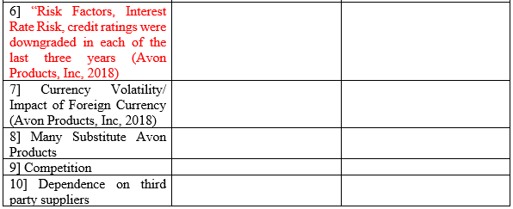

The TOWS approach to SWOT offers more than a snapshot. It facilitates strategy formulation. TOWS evaluates Avon's external opportunities and threats and compares them to their strengths and weaknesses. Nonetheless, from figure 20, the items coloured in yellow are new opportunities and strengths while the red coloured items are new developments in Avon’s weakness and threats.
From the SWOT analysis, Avon has a lot of strength, their brand name, the strength of their sales representatives, and their direct-Selling is boosted by utilising the digital platforms. The new Avon-branded networking sites could expose Avon to new demographics and new markets. The whole essence of rebranding Avon’s is to bring younger generations and boost sales.
Avon uses the strength to counter weakness; the R and D must continuously develop innovative products to compete with the market leaders and Avon need to develop more premium fragrance products, these product’s ‘contribution’ will improve profitability, and this is a way to counter weakness-threat.
The appointments of new senior managers across the company in redirecting, modernising and developing new products, new supply-chain-systems is leveraging Avon’s strengths and capitalizing opportunities. They are reducing staff and inventory by 10% and 15%. That’s a lot of overhead cost being eliminated, thereby improving their profitability.

3.2. Avon’s Strategic Position and Action Evaluation (SPACE) Matrix
The SPACE Matrix focuses on the strategic position of the company and is based on internal dimensions; financial-strength and competitive-advantage, are essential to the organisation’s strategic position, while the external-dimensions of environmental stability and industry strength highlights the strategic position of the entire industry (Radder and Louw, 1998; figure 21), and SPACE evaluates the best strategy in moving forward. Avon must choose the best strategy and the options include aggressive, conservative, defensive or competitive.
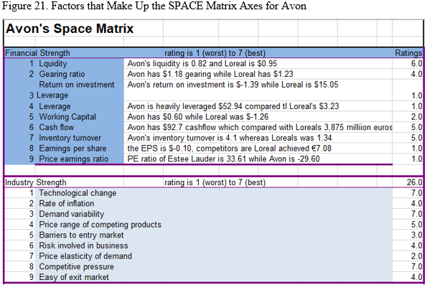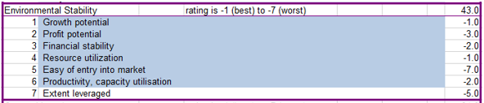
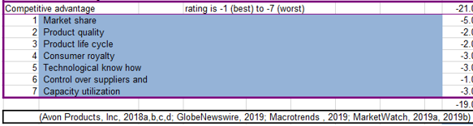

Macrotrends (2019); MarketWatch (2019a,b); GlobeNewswire (2019) all alluded to Avon’s is in a vulnerable financial position. Avon is underperforming in virtually every major financial indices. In figure 22, Avon’s inventory turnover was is 4.1 whereas Loreals was 1.34, which means Avon maybe incurring more holding cost, while the Loreal supply-chain-management system looks to be more efficient.

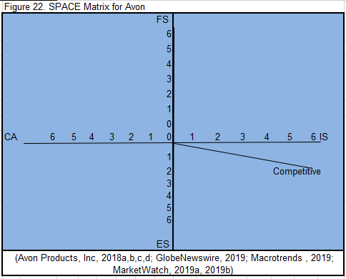
Avon is in a very competitive market, but with major competitive advantages in a high-growth industry (Grand View Research, 2019; GlobeNewswire, 2019). A Competitive strategy is characteristic of an attractive industry in an unstable environment. Therefore, Avon must continue its investment in digital-technology and the digital contents to attract younger generations to increase market-share and expand the product offering. The restructuring exercise must be continued to invest in productivity, improve operational efficiency, cut costs, collaborate with other organisations for economies of scales or product development.

3.3. Group (BCG) Matrix
The BCG enable corporations to analyse their business units or product lines. The BCG identifies the various "Strategic Business Units" (SBU's) in Avon’s portfolio that is the various products/brands. SBU's are classified into two dimensions: relative market-share and industry growth rate. The BCG evaluates the market-share position and is defined as the ratio of each brand market-share in its industry to the market-share held by the largest rival firm in that industry (David and David, 2016).
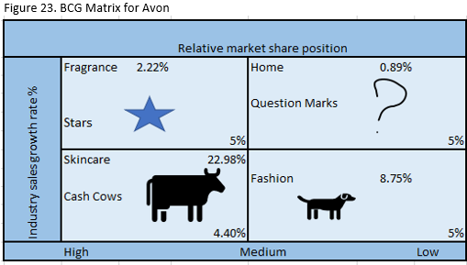
The BCG in figure 23 (appendix 2,3) reveals that the Skincare brands is the cash-cow for Avon, Avon has about 22.98% market-share. This is important as the global Skin Care Products Market will be worth $183.03 Billion By 2025 with a growth of 4.4%. Avon needs to step up R&D as well as marketing efforts as there is increasing demand for natural, herbal, and organic products (Grand View Research, 2019)

3.4 Avon’s Internal- External (IE) Matrix

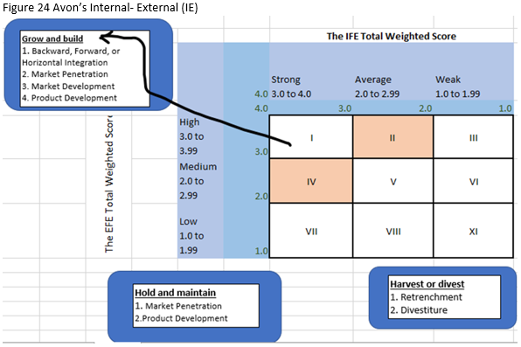

From the IE, Avon was average on both the EFE and IFE weighted scores, the IE matrix is still the same as previous SFF (figure 24).
Financial strength is, however, of critical importance and Avon could pursue a competitive-strategies that includes backward, forward, and horizontal integration; market penetration; market development; product development; and joint ventures (Avon-Products, Inc, 2019c; Bloomberg, 2019b).

3.5 Grand Strategy Matrix

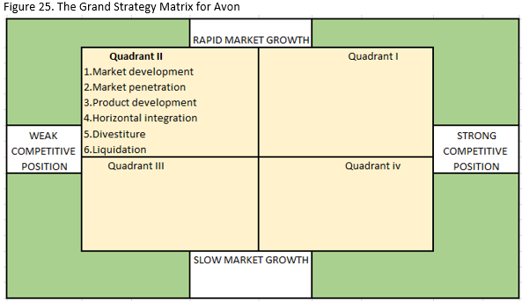

Avon competes in a growing industry, but they can’t effectively compete. They have competence in the b2b and b2c, thus, market development, product development and market penetration are there focus.

4.0 Decision Stage
- Phase Two – The Matching Stage. Here, both the micro and macro business environments are analysed and considers, then further strategies are developed to remedy the findings. Tools for this phase are the SWOT Matrix, the SPACE Matrix, the BCG Matrix, and the IE Matrix (David, 2011).

4.1 Quantitative Strategic Planning Matrix (QSPM) for Avon
The QSPM tool utilises the other matrices in establishing the best, the most attractive and most beneficial alternative strategy to Avon. The QSPM tool is used to examine which key external and internal critical success factors that could be capitalised upon or improved. Please note, all the numbers used in these matrices are based on the researcher’s intuition (Chaffey, 2011) (David, 2011). From the QSPM matrix beneath (figures 27 and 26), Avon is advised to pursue option 2. Which is to Improve the digital, online marketing strategies. The company was very slow in adopting digital B2B, B2C.
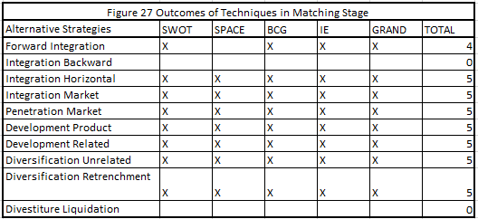
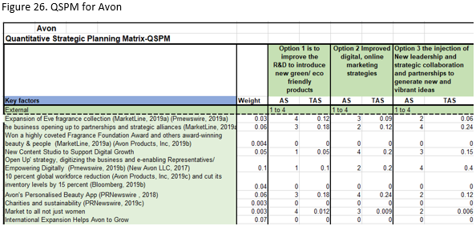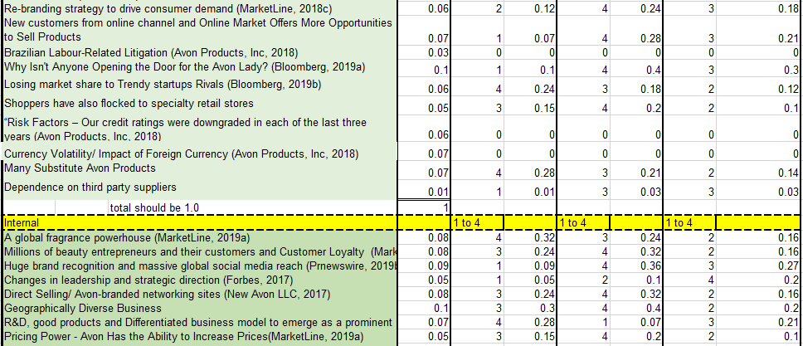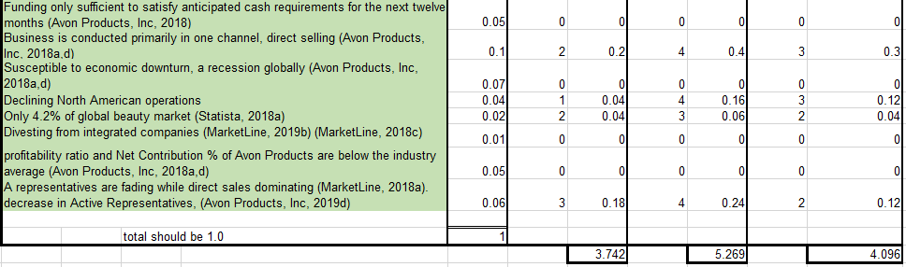

6.0 ADVANTAGES OF SFF

David (2011) advanced that SFF makes it possible to evaluate several strategies simultaneously. Peter Drucker believed that in Strategic management, quantification alone is not planning. Drucker argued that some important issues in strategic management are unquantifiable. Although, quantitative approach is very useful in gaining a quantitative perspective.
Furthermore, the SFF is a tool that shows a step by step stages and allows the previous factors into the next stage in the strategic analysis of the decision-making process (David, 2011).

6.1. THE LIMITATIONS OF THE STRATEGY FORMULATION FRAMEWORK
A notable limitation of SFF is it relies on the consultant’s intuitive judgement and assumptions. The attractiveness scores, the ratings and weights were not really based on objective information (David, 2011).
Other limitations are that the QSPM depends on the quality of the prerequisite information and matching analysis and materials it is based on.
SFF could also be limited by regional culture, organisational culture and political climate such as BREXIT, the Mexico wall President Trump is trying to build (USAToday, 2019), trade wars between US and China (CNBC, 2018).

7.0. CONCLUSION
David (2011) argued that the essence of SFF is to determine how well Avon is doing, whether they are doing the right things and how it can be improved or amended. It is clear through Avon's struggles that is a strategic failure for many years.
The SFF despite its limitations, enabled a holistic diagnosis of a company’s operations by using several tools, such as the SWOT-Matrix, SPACE-Matrix, BCG-Matrix, IE-Matrix, and QSPM to examine, evaluate Avon’s positions, internally and externally, financially, and in the market. And these tools could enhance the quality of strategic decisions. Still, the SFF also ensure that alternative strategies are developed until the most appropriate strategy is found.
Finally, the SFF cannot stand in isolation, but it must recognise an organisation’s culture and political environment.

8. REFERENCES

Works Cited
CSIMarket, 2019b. Sales Growth by Division. [Online]
Available at: https://csimarket.com/stocks/financials_glance.php?code=AVP
[Accessed 15 3 2019].
MarketLine, 2018b. Avon announces Q2 2018 results. [Online]
Available at: https://advantage-marketline-com.ezproxy.uwtsd.ac.uk/Product?ptype=Company+News&pid=7423FA97-844B-43FC-BCF8-35D7259D2A83
[Accessed 15 3 2019].
ADVFN, 2019. Avon Products Inc. [Online]
Available at: https://uk.advfn.com/p.php?pid=financials&symbol=NYSE%3AAVP
[Accessed 22 3 2019].
Andrews, K. R., 1995. The Concept of Corporate Strategy. 3 ed. Homewood, II: : Richard d Irwin.
Avon Products, Inc, 2018. ANNUAL REPORT 2017. [Online]
Available at: file:///C:/Users/koyes/Downloads/avon-annual-report-2017.pdf
[Accessed 15 3 2019].
Avon Products, Inc, 2019b. AWARD-WINNING BEAUTY & PEOPLE. [Online]
Available at: https://www.avonworldwide.com/about-us/awards
[Accessed 15 3 2019].
Avon Products, Inc, 2019c. Avon Products, Inc. Announces Steps to Improve Operational Efficiency and Reduce Portfolio Complexity. [Online]
Available at: http://investor.avonworldwide.com/file/Index?KeyFile=396548925
[Accessed 15 3 2019].
Avon Products, Inc, 2019d. Avon Reports Fourth-Quarter and Full-Year 2018 Results. [Online]
Available at: http://investor.avonworldwide.com/file/Index?KeyFile=396741853
[Accessed 16 3 2019].
Avon Products, 2019. About Avon. [Online]
Available at: https://www.avon.uk.com/301-581/make-up/mark/?pn=1
[Accessed 21 3 2019].
Avon-Product, 2019e. Supporting women. [Online]
Available at: https://www.avonworldwide.com/supporting-women/stand4her-report
[Accessed 21 3 2019].
Avon-Products, 2018j. Avon to step change digital with the appointment of new Chief Digital Officer. [Online]
Available at: http://investor.avonworldwide.com/file/Index?KeyFile=394412624
[Accessed 21 3 2019].
Avon-Products, 2019f. Responsible business. [Online]
Available at: https://www.avonworldwide.com/responsible-business
[Accessed 21 3 2019].
Avon-Products, 2019g. Avon Reports Fourth-Quarter and Full-Year 2018 Results. [Online]
Available at: http://investor.avonworldwide.com/file/Index?KeyFile=396741853
[Accessed 21 3 2019].
Avon-Products, 2019h. Changeboard conference: Jan Zijdvereld shares insight into Avon’s digital transformation. [Online]
Available at: https://www.avonworldwide.com/news/changeboard-conference-jan-zijderveld-digital-transformation
[Accessed 21 3 2019].
Avon-Products, 2019h. Financials. [Online]
Available at: http://investor.avonworldwide.com/AsReported/Index
[Accessed 21 3 2019].
Bloomberg, 2018. Avon Cosmetics Goes Digital. [Online]
Available at: https://www.bloomberg.com/news/videos/2018-07-21/avon-cosmetics-goes-digital-video
[Accessed 21 3 2019].
Bloomberg, 2019a. Why Isn't Anyone Opening the Door for the Avon Lady?. [Online]
Available at: https://www.bloomberg.com/quote/AVP:US
[Accessed 15 3 2019].
Bloomberg, 2019b. Avon to Cut 10% of Global Workforce in Bid to Further Trim Costs. [Online]
Available at: https://www.bloomberg.com/news/articles/2019-01-30/avon-to-cut-10-of-global-workforce-in-bid-to-further-trim-costs
[Accessed 15 3 2019].
Bloomberg, 2019c. L'Oreal SA. [Online]
Available at: https://www.bloomberg.com/quote/OR:FP
[Accessed 22 3 2019].
Chaffey, D., 2011. E-Business and E-Commerce Management: Strategy, Implementation and Practice. 4 ed. s.l.:Pearson.
CIM, 2011. CIM Coursebook: The Marketing Planning Process. London: Butterworth Heinemann.
CNBC, 2018. Trade War begins: US and China exchange $34 billion in tariffs. [Online]
Available at: https://www.cnbc.com/2018/07/06/trade-war-worries-us-china-tariffs-to-kick-in-on-friday.html
[Accessed 22 3 2019].
CSIMarket, 2019a. AVP's Competition by Segment and its Market Share. [Online]
Available at: https://csimarket.com/stocks/competitionSEG2.php?code=AVP
[Accessed 15 3 2019].
CSIMarket, 2019c. Beauty Segment Market Share Q4 2018. [Online]
Available at: https://csimarket.com/stocks/compet_glance.php?code=AVP
[Accessed 15 3 2019].
CSIMarket, 2019d. Avon Products Inc Income Statement Quarterly. [Online]
Available at: https://csimarket.com/stocks/income.php?code=AVP
[Accessed 19 3 2019].
CSIMarket, 2019e. Avon Products Inc Income Statement Annual. [Online]
Available at: https://csimarket.com/stocks/income.php?code=AVP&annual
[Accessed 21 3 2019].
David, F. & David, F., 2016. Strategic Management; A competitive advantage approach, concepts and cases. 16 ed. s.l.:Pearson Education.
David, F. R., 2007. Strategic Management Concepts and Cases. 11 ed. New York: Prentice Hall.
David, F. R., 2011. Strategic Management CONCEPTS AND CASES. 13 ed. s.l.:Prentice Hall.
Dow Jones & Company, 2019. Avon Products Inc.. [Online]
Available at: https://quotes.wsj.com/AVP/financials
[Accessed 19 3 2019].
Forbes, 2017. Avon CEO To Depart Amid Mounting Losses, Investor Pressure. [Online]
Available at: https://www.forbes.com/sites/laurengensler/2017/08/03/avon-ceo-sheri-mccoy-resigns/#169097bfeb6a
[Accessed 15 3 2019].
GlobeNewswire, 2019. Annual-Results. [Online]
Available at: https://www.globenewswire.com/news-release/2019/02/07/1712439/0/en/L-Or%C3%A9al-News-release-2018-Annual-Results.html
[Accessed 17 3 2019].
Grand View Research, 2019. Skin Care Products Market Worth $183.03 Billion By 2025 | CAGR: 4.4%. [Online]
Available at: https://www.grandviewresearch.com/press-release/global-skin-care-products-market
[Accessed 17 3 2019].
GuruFocus, 2019. L'Oreal SA (OTCPK:LRLCY) Inventory Turnover: 1.34 (As of Dec. 2018. [Online]
Available at: https://www.gurufocus.com/term/InventoryTurnover/LRLCY/Inventory%252BTurnover/L%2527Oreal+SA
[Accessed 22 3 2019].
Hooley, G., Piercy, N. F. & Nicoulaud, B., 2008. Marketing Strategy and Competitive Positioning. London: Prentice Hall.
Investopedia, 2017. Avon Focuses On Overlooked Demographic (REV). [Online]
Available at: https://www.investopedia.com/news/avon-focuses-overlooked-demographic-rev/
[Accessed 15 3 2019].
Johnson, G. & Scholes , K., 2004. Exploring Corporate Strategy. London: Prentice Hall.
Johnson, G., Scholes, K. & Whittington, R., 2011. Exploring Corporate Strategy: Text and Cases. London: Prentice Hall.
Macrotrends , 2019. Avon Products EPS - Earnings per Share 2006-2018 | AVP. [Online]
Available at: https://www.macrotrends.net/stocks/charts/AVP/avon-products/eps-earnings-per-share-diluted
[Accessed 17 3 2019].
MarketLine, 2018a. Avon must innovate after Q3 results suffer in midst of Brazil crisis. [Online]
Available at: https://advantage-marketline-com.ezproxy.uwtsd.ac.uk/Product?ptype=Analyst+Comment&pid=7BCEE249-7A38-422C-B44C-C008F657683C
[Accessed 15 3 2019].
MarketLine, 2018c. Ginza Stefany Cosmetics to Acquire 100% Stake in Avon Japan. [Online]
Available at: https://advantage-marketline-com.ezproxy.uwtsd.ac.uk/Product?ptype=Financial+Deals&pid=FD1758103
[Accessed 16 3 2019].
MarketLine, 2018c. Tech makeover at Avon. [Online]
Available at: https://advantage-marketline-com.ezproxy.uwtsd.ac.uk/Product?ptype=Company+News&pid=5D16C0BC-8CEB-4EB1-97AA-AA797AA9B701
[Accessed 16 3 2019].
MarketLine, 2019a. Avon to expand Eve fragrance collection. [Online]
Available at: https://advantage-marketline-com.ezproxy.uwtsd.ac.uk/Product?ptype=Company+News&pid=38A98E5C-C656-49B9-BF03-032ECF3BC4E1
[Accessed 15 3 2019].
MarketLine, 2019b. The Face Shop to Acquire Beauty Manufacturing Division from Avon Products. [Online]
Available at: https://advantage-marketline-com.ezproxy.uwtsd.ac.uk/Product?ptype=Financial+Deals&pid=FD1842486
[Accessed 16 3 2019].
MarketWatch, 2019a. Avon Products Inc. [Online]
Available at: https://www.marketwatch.com/investing/stock/avp/profile
[Accessed 17 3 2019].
MarketWatch, 2019b. L'Oreal S.A. ADR. [Online]
Available at: https://www.marketwatch.com/investing/stock/lrlcy/profile
[Accessed 17 3 2019].
MarketWatch, 2019c. SHAREHOLDER ALERT: Pomerantz Law Firm Investigates Claims On Behalf of Investors of Avon Products, Inc. - AVP. [Online]
Available at: https://www.marketwatch.com/press-release/shareholder-alert-pomerantz-law-firm-investigates-claims-on-behalf-of-investors-of-avon-products-inc---avp-2019-03-21-19184718
[Accessed 22 3 2019].
Mintzberg, H., 1978a. Patterns in Strategy Formation. The Institute of Management Sciences, 24(9).
New Avon , 2017a. Why Sell Avon. [Online]
Available at: https://about.avon.com/avon-about-us/representatives/why-sell-avon.html
[Accessed 15 3 2019].
New Avon , 2017b. Leadership Team. [Online]
Available at: https://about.avon.com/company/leadership-team/steve-bosson
[Accessed 16 3 2019].
New Avon, 2017c. Why Sell Avon. [Online]
Available at: https://about.avon.com/us-about/representatives/why-sell-avon
[Accessed 20 3 2019].
New Avon, 2017d. About Avon. [Online]
Available at: https://about.avon.com/us-about/company/history
[Accessed 20 3 2019].
Porter, M. E., 1985. Competitive Advantage. New York.: The Free Press.
PRNewswire, 2018a. Avon Launches Personalised Beauty App. [Online]
Available at: https://www.prnewswire.co.uk/news-releases/avon-launches-personalised-beauty-app-698878821.html
[Accessed 16 3 2019].
PRNewswire, 2018b. Avon Announces Changes to Senior Management Team. [Online]
Available at: https://www.prnewswire.com/news-releases/avon-announces-changes-to-senior-management-team-300769849.html
[Accessed 21 3 2019].
Prnewswire, 2019a. Avon expands Eve fragrance collection with launch of Eve Truth. [Online]
Available at: https://www.prnewswire.co.uk/news-releases/avon-expands-eve-fragrance-collection-with-launch-of-eve-truth-826103302.html
[Accessed 15 3 2019].
Prnewswire, 2019b. Avon To Launch New Content Studio To Support Digital Growth. [Online]
Available at: https://www.prnewswire.co.uk/news-releases/avon-to-launch-new-content-studio-to-support-digital-growth-809689346.html
[Accessed 15 3 2019].
PRNewswire, 2019c. Avon launches stand4her - a global plan to improve the lives of 100 million women a year. [Online]
Available at: https://www.prnewswire.co.uk/news-releases/avon-launches-stand4her-a-global-plan-to-improve-the-lives-of-100-million-women-a-year-881781294.html
[Accessed 16 3 2019].
PRNewswire, 2019d. Avon appoints Kay Nemoto as Chief Strategy and HR Officer to drive transformation. [Online]
Available at: https://www.prnewswire.com/news-releases/avon-appoints-kay-nemoto-as-chief-strategy-and-hr-officer-to-drive-transformation-300793977.html
[Accessed 20 3 2019].
Radder, L. & Louw, L., 1998. The SPACE matrix: A tool for calibrating competition. Long Range Planning, 31(4), pp. 549-559.
Statista, 2018. Revenue of the leading 20 beauty manufacturers worldwide in 2018 (in billion U.S. dollars). [Online]
Available at: https://www.statista.com/statistics/243871/revenue-of-the-leading-10-beauty-manufacturers-worldwide/
[Accessed 15 3 2019].
Statista, 2019. Annual growth of the global cosmetics market from 2004 to 2017. [Online]
Available at: https://www.statista.com/statistics/297070/growth-rate-of-the-global-cosmetics-market/
[Accessed 17 3 2019].
Teamdragonavon, 2012. Avon in Your Home Parties. [Online]
Available at: https://teamdragonavon.wordpress.com/2012/05/24/avon-in-your-home-parties/
[Accessed 24 3 2019].
Timmers, P., 1999. Electronic Commerce Strategies and Models for Business-to-Business Trading. Chichester, England: Wiley.
Tupperware, 2019. Relationship-based Selling Opportunity. [Online]
Available at: https://www.tupperwarebrands.com/company/relationship-based-selling
[Accessed 22 3 2019].
USAToday, 2019. 'We hope he learned his lesson,' Pelosi says of report Trump wants $8.6B more for wall. [Online]
Available at: https://eu.usatoday.com/story/news/politics/2019/03/10/trump-border-wall-8-6-billion-more-funding/3123288002/
[Accessed 22 3 2019].
WSJ, 2017. Avon Freshens Up in a Bid to Win Back Middle America. [Online]
Available at: https://www.wsj.com/articles/avon-ladies-backed-by-private-equity-aim-to-reconquer-middle-america-1490107605
[Accessed 15 3 2019].

9.0 Appendices
Appendix 1 consolidated statement of operation continued

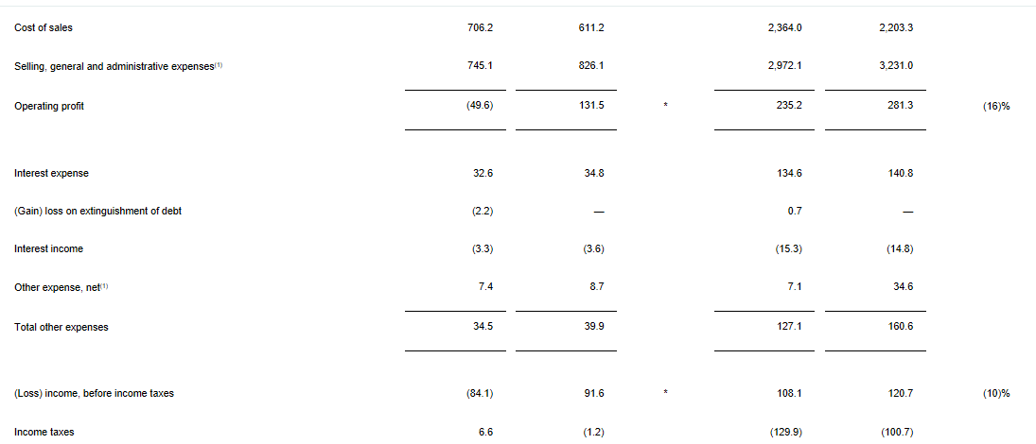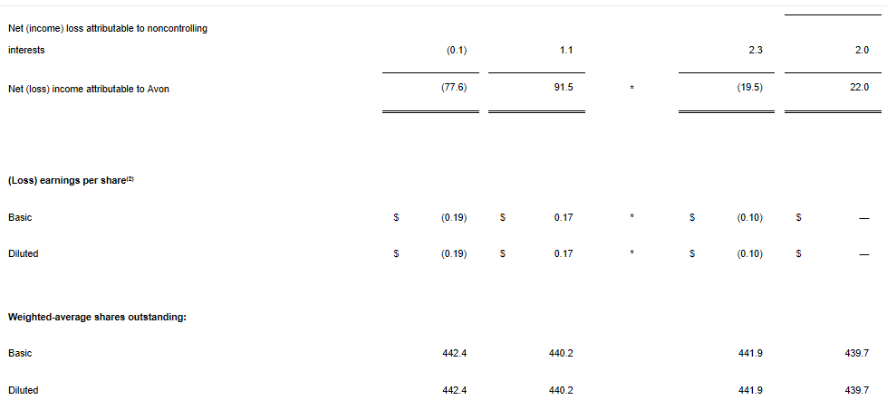
Appendix 2 SBUs in Terms of Sales and Profits in Avon in the Cosmetics industry
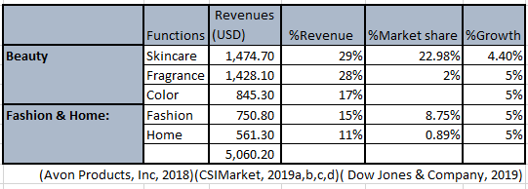

Appendix 3 RELATIVE MARKET SHARE POSITION


