ACADEMIC AND EMPLOYABILITY SKILLS

STUDENT NAME: FLORENCE ODONKOR
STUDENT ID:1818734
LECTURER’S NAME: ANITA NAN

BMSW4001: ACADEMIC AND EMPLOYABILITY SKILLS
ASSESSMENT 1

Executive summary
In the modern world, there is tough competition among students for employability. Academic skills are key factors for the students to stay ahead of computers. This also encourages individuals to learn more efficiently. It increases the confidence of students in various sectors. There are many talented students who are unable to use their talent in appropriate sectors. This is because of the improper use of skills. They lack personal and professional planning. The reason is that there are not any academic strategies among them. There are different theories of learning which are more effective if used practically. This assignment will discuss all those necessary topics related to learning and proper implementation in case of employment.

Table of Contents
Task 1 4
1. Introduction 4
2. Theories and Models for personal development and self-reflection 4
3. Models for learning 7
4. Essential skills for personal and professional development academically 8
5. Personal SWOT analysis 9
6. Personal and professional development plan 10
7. Tools for time management 11
8. Conclusion 12
Task 2 13
1. Introduction 13
2. Reflection on learning (Gibbs Model) 13
3. Usefulness of learning 15
4. Conclusion 17
Reference list 18

Task 1

1. Introduction
The mixture of theoretical learning and practical knowledge is very important for academic and employability skills. The employability skills of any student depend on the particular sector of study. In the competitive market of employment, the requirement of skills and merit is high. There are different theories related to behaviour and learning models to support a student for creating the basement of employability. The report of personal skills contains the explanation of the practical use of those theories. This is the importance of the mixture of theory and practice. It helps an individual to go through various employment stages and apply appropriate learning contents accordingly. This starts with a personal development plan and SWOT analysis. This guides an individual to the correct path and monitors if there is any weakness. Frequent SWOT analysis within a certain duration and PDP help students to increase skills that can be used as employability skills in future, this report will discuss all the mentioned stages.

2. Theories and Models for personal development and self-reflection
Theories of learning
There are different stages of learning, and all those are important for creating the character of an individual. If this can be followed appropriately, then it will help an individual to develop their academic and employability skills. Usually, distinct people have different characteristics on the basis of their skills.
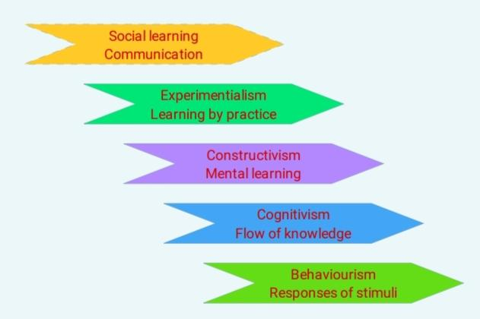
Figure 1: Learning Theories
(Source: Self-Created)
- Cognitivism
The theory is dependent on past knowledge of an individual. It helps an individual to build new connections and reflect on that. It increases the effectiveness of learning methods and students can recognise new things which can be related to the past. Cognitive learning is for the long run, and an individual can use the previous learning experience in a similar situation during employment. It provides an opportunity to apply the learning materials in practical life. This benefits a student by developing the power of exploration and increasing problem-solving skills. More specifically, it is about teaching the skills for or the identification of similar situations where the learnings are applicable (Khalil and Elkhider, 2016). Therefore, the individual becomes able to create and apply the previous concepts which are already known to them. The learning is also for long-term, and it enhances the confidence of a student. All these will help an individual to apply learnings in an academic way.
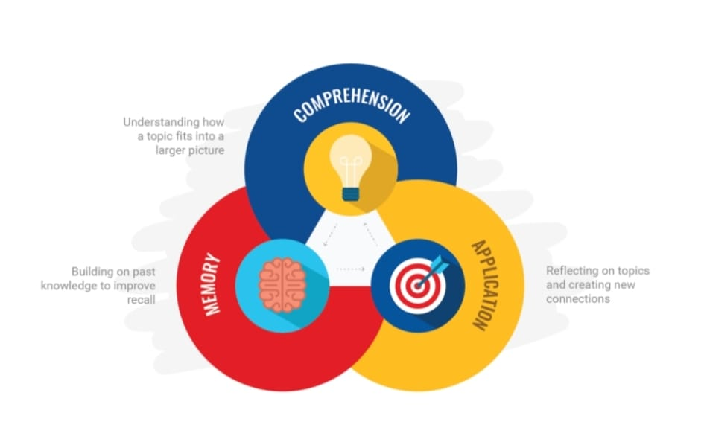
Figure 2: Factors of cognitive learning
(Source: Green, 2016)
- Experimentalism
The concept of experimentalism was established by John Dewey, and this concept is primarily about upgrading an individual on a timely basis. In this modern world, the situations are changing quite frequently and previously learning methods may not seem appropriate in the current situation. Experimentalism is about the exploration of learning to upgrade the concept. If it is not there, then an individual cannot even apply the learning of cognitive theory (Green, 2016). It is because, before applying any learning, it is necessary to identify the similarities among situations. The benefit of it is on innovating new ideas by continuous experiment. There are certain times when traditional methods look ineffective, and that is where it is important to apply experimentalism theory of learning.
- Behaviourism
It is a psychological fact that every human being has established inside themselves unknowingly. It is mostly dependent on observation, and people learn it from the circumstances. People of diverse behaviours are seen throughout the world, and different circumstances are the reasons behind this diversity. But in case of learning the approach is different. If someone is trying to learn from surroundings, then the reason for observation is for learning. Therefore, behaviourism also depends on individual objectives. That is why it is related to learning theory, and it has a tremendous benefit in improving academic and employability skills. If cognitive theory and behaviourism can be used together, then it will help an individual to identify appropriate solutions according to different situations.
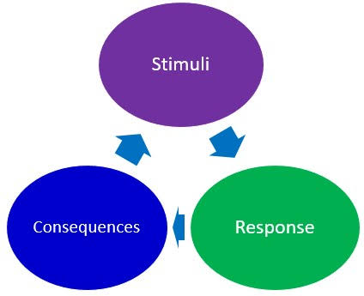
Figure 3: Concept of Behaviourism
(Source: Austin, 2016)
- Social learning
Social learning is like the comparison between educational learning and reality. People have the tendency to imitate others by the application of new models. During childhood, children follow the behaviour and actions of the parents, and they imitate it accurately. Therefore, people have the important quality of social learning. In adulthood, the way for imitating others is changed according to an individual's objective in life. There is a gap between traditional learning and cognitivism. That gap is fulfilled by "social learning theory". By using cognitive theory, an individual can survive in similar situations, but the combination of social learning makes it stronger. It is because people produce different concepts as per their surroundings or on the basis of what they are observing. There is a stimulus in human beings that helps an individual to identify previous incidents and help to tackle the current situation.
- Constructivism
It is the base of enhancing knowledge by gathering information from the surroundings. It is the stage of constructing where an individual focuses on observation for finding similarities and gathering knowledge. There is much information which is received passively, but the method of understanding must be active. Constructivism creates meaningful connections among different situations for an improved understanding. It helps to find the difference between learning and knowledge. Learning can be theoretical or social, but knowledge is personal for an individual. Therefore, the teaching of the same materials may lead to different learning for different people. It is because of the differences in subjective interpretation (Haffajee et al. 3019). It creates a contradiction between the socially gathered knowledge and learnt principles, and this contradiction is the initial period of constructivism. All these are steps of constructivism and by going through these individual construct’s knowledge in different segments (Austin, 2016). This is for increasing academic standards and enhancing personal skills for employability.

3. Models for learning
- VAK
The simplest form of learning is to follow the model of "Visual-Auditory-Kinesthetic". This style is dependent on human senses, and it is known that there are dependencies on different senses in different human beings. Some people prefer to observe and read any particular information for learning it, and they are visual learners. Some of them are auditory learners, and they believe in speaking and listening to getting knowledge on any subject. On the other hand, Kinaesthetic learners like to learn new things by practical examples, i.e. touching are you doing like an experiment. I personally prefer to use a balanced method by mixing up these three styles and using that accordingly.
- Kolb learning model
The learning model of Kolb is an experimental model. It starts with encountering new experiences or interpretation of past incidents in life. It asks an individual to have a reflective observation of that experience. A proper reflection will help to find the importance of that incident and create new concepts from that. After that, the new concept should be applied in the surroundings or in future events to get outcomes (Rao, 2018). It helps an individual to explore and experiment on the available information and create something new. Therefore, it increases the capability, and in the case of academic quality, it has better outcomes than other models.
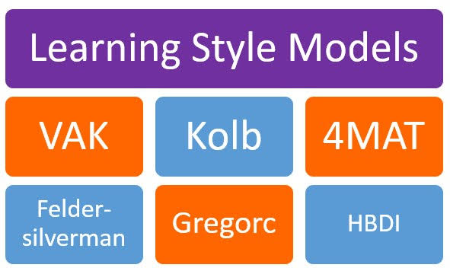
Figure 4: Learning style models
(Source: Baldwin et al. 2017)

4. Essential skills for personal and professional development academically
The methods of personal and professional development are interconnected. Being successful in one will automatically lead to success in another one.
- Being confident and overcome obstacles
Fear of obstacles and losing prevent an individual from getting progress. There are different situations in life, and we need to be in the flow for success. An individual can follow an action plan for getting rid of obstacles only if he or she is confident enough.
- The intention of learning new things
The intention of learning must always be there. It is not about any particular target, and there shouldn't be any thought of 'maximum'. After reaching the current target, there must be the next level, and it will inspire an individual to learn continuously.
- Being integral and maintain ethics
For professional development, there must be some inborn quality like integrity and honesty. People have a tendency to believe or work with people who are honest and stand by their promises (Baldwin et al. 2017). Having integrity helps an individual to get a good reputation and future opportunities.
- Adaptability and leadership quality
The quality of quick adjustment in adults and individuals to be familiar with any environment. It creates a strong personality in a human being, and that is as a leadership quality. These kinds of people are able to motivate others and be more successful than others.
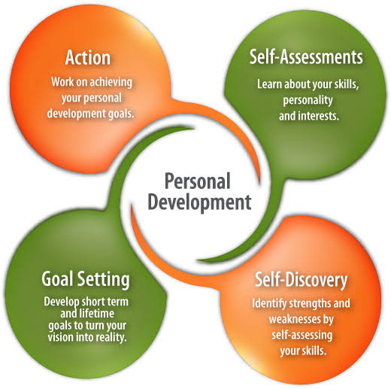
Figure 5: Skills for personal development
(Source: Agarwal et al. 2020)

5. Personal SWOT analysis
Strength  - My communication skills are good enough, and I have the ability to discuss any point in an explanatory way.  - I can adjust to different situations and make myself feel comfortable.  - I always stay motivated and focused on objectives  - I am also able to motivate others by inspiring them with examples | Weakness  - I don't have much practical experience in employment, and most of my knowledge is theoretically based.  - Sometimes I get into an in-depth discussion, and it takes a lot of time, and that affects my time management skills.  - I am confident enough while sharing my views, but in front of seniors, I cannot share my views properly as I think it can be insulting for them.
Opportunities  - I have the opportunity to improve my communication and leadership skills by participating in various debate competitions.  - There are many part-time options for me to gather employment experience. This experience will help me in my future for full-time jobs. | Threat  - In the market of employability, the rate of competition is high, and in case of any particular designation, it is even tougher.  - It is very tough for me to choose a particular designation for the progress of my employability.

6. Personal and professional development plan

Skills | Current State | What to do? | Impact
Communication | Good | I will prioritise communication for improvement, and for this, I will focus on my body language and eye contact. These two factors are key success factors of successful communication. | High standard of communication will help me to communicate more efficiently in case of any kind of business operation. If I personally am aware of my communication skills, then I will also be more confident.
Self-awareness | Good | I will observe myself as an object and create a checklist for self-reflection on a daily basis. I will also ask a few of my friends to get their views about me. | This will help me to know myself, and I can make more accurate decisions on the basis of my strengths and weaknesses. Therefore, it is going to make me more eligible for any kind of employment.
Time management | Poor | I will set some boundaries during communication which will stop me from making it more extended. I will also prioritise different factors during communication to complete it successfully within the shortest time | It will allow me to use time effectively. I can use the excess of time for improving other skills.
Leadership | Moderate | I will try to be more disciplined and take on different responsibilities at a time to understand my capability. My aim will be to keep on learning, and there should not have any fixed objective throughout the progress. | It will help me to boost confidence and influence others during communication. I will be able to resolve conflicts easily.
Team working | Moderate | I will take on some basic projects with my friends to understand the concept of teamwork and the importance of it. | It will enable me to have a clear purpose during any operational project. I will also be able to understand my responsibility clearly.

7. Tools for time management
Time management is more a practical task than being dependent on tools. It should be focused on long term visions. For example, what will be the impact of it in the long-term future. There must be a priority for some chosen factors, and if an individual is aware of the importance of the sector, then automatically the effectiveness in time management will improve (Agarwal et al. 2020).
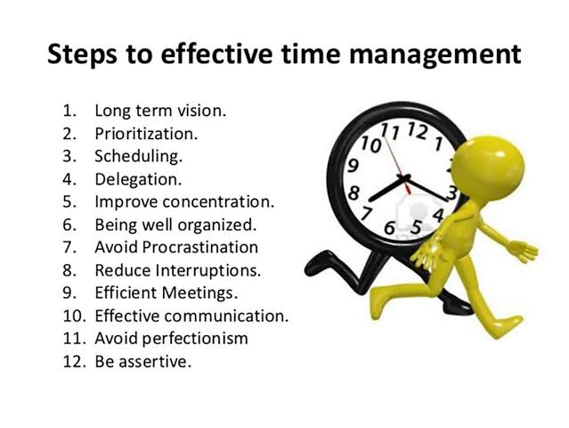
Figure 6: Steps for time management
(Source: Norvoll et al. 2018)

8. Conclusion
One needs to be disciplined and aware of personal and professional life to be eligible for employment. High academic skills will be another success factor if properly used. Success completely depends on personal awareness about the strengths and weaknesses of an individual. If one can identify the key issues in oneself, then it will be easier for him to be able to improve. The strings of an individual will help him to get rid of his weakness, and all this enhancement will lead to eligibility for employment

Task 2

1. Introduction
There are various academic skills that are applied to learning. There is a strong relationship between academic skills and employability. The concept of academic skills is mixed together to create eligibility for employability. There are various academic strategies for responding to different situations. The difference is on the particular platform because, in the case of University, an individual has to respond to a particular lecture, but in the case of employment, responses are for particular situations. In this assignment, there will be a discussion about the learnings in a reflective way (Horgan et al. 2016). Besides, the usefulness of those learning in employability will also be discussed.

2. Reflection on learning (Gibbs Model)
Order learning materials will be reflected by using the Gibbs model.
- Description
Academic skills contain skills like problem-solving, adaptability, organisational skills, resource management, use of technology etc. In the case of problem-solving one needs to analyse facts and define challenges for further progress. In most cases, the employer looks for employees who are capable of a certain position (Malik, 2016). But in most cases, there are some primary requirements, and those are the skill of leadership, good communication skills, the capacity of tackling tough situations etc. In the case of communication, there are some factors like body language, eye contact. Therefore, the primary thing is to understand that to be successful in achieving long-term goals; one must have short term objectives. Some accurate strategies and appropriate way of learning and using those practices should be the ultimate aim of an individual.
- Feelings
There can be different situations during a job, and an employee must adjust with those to be successful in career development. I think the quality of leadership and adaptability should be the primary focus of an individual. There is the importance of all the learnt factors in case of employability, but if I have to rate those, then I will choose these two at the top. It is because one must have the capability of adjusting then it will be easier for him to improve other skills. But without having the capability of adjusting or leadership, there will be no use of communication or other good skills. In my opinion, there must be a different priority in case of personal development plans. It will help an individual to focus on a particular factor at a time.
- Evaluation
In case of evaluation of learning skills, it is necessary to consider both the positive and negative things. For example, most people believe in a personal development plan, and they create it to improve their skills. But the practical implementation of the plan is more necessary than creating a plan. We usually focus on some basic personal skills at the beginning, but in case of professional development, there are for other skills like organisational skills, management skills, customer service skills (Ginsberg and Wlodkowski, 2019). These professional skills are a combination of those personal skills. For example, during handling customers, it is necessary to have good communication and be confident. Therefore, two different personal skills are working at a time.
- Analysis
Each and every individual has some basic behavioural traits, and those remain with all of their activities. Sometimes, people focus on those to get rid of (Duffy and Kelly, 2017). But usually, this doesn't happen. Instead, it removes the focus from the primary area. Distinct qualities of human beings must be used appropriately to have the best possible outcome from that. I have learnt all these things from the lectures and my learning materials. This is not all my theoretical learning; instead, it is the combination of both theoretical learning and my conceptions. Hence, I will consider that I have appropriately learnt it when I can use these conceptions in my practical life.
- Conclusion
The term academic and employability skills refer to the mixture of hard and soft skills and as well as some basic characteristics of an individual. All these together create the platform for a candidate. These skills are not any written information, or there is not any theory that talks about only this particular skill. But this depends on the requirements of different businesses, and we prepare ourselves accordingly. Therefore, the aim of this learning is to start the progress of an individual and help him to choose the correct way for the future.
- Action Plan
At the very beginning, I need to identify my objectives. It is not about setting random aims as per random objectives. I must be specific, and there must be some authentic reason for any particular objective. After choosing that I need to focus on my priority and priorities will be selected on the basis of my strengths and weaknesses. The ultimate stage is about the implementation of all chosen tasks. I need to complete those by theoretical and practical training. After successful completion, I will be able to reach my goal.
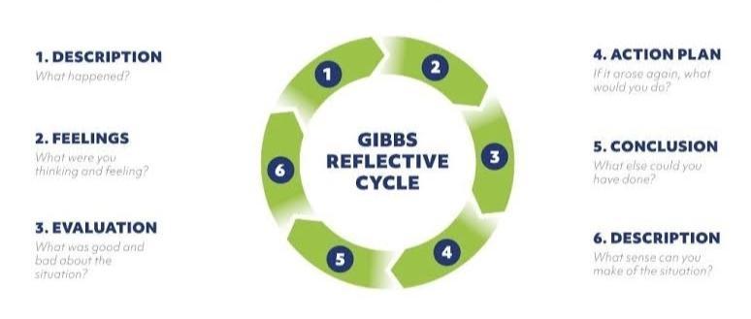
Figure: Gibbs Reflective Cycle
(Source: Brackett et al. 2019)

3. Usefulness of learning
Employability skills are generally referred to as core competence on increasing general skill which is usually required for competing in the ultimate business market. The basic skill that really developed for keeping the performance in the business organisation and also improving the technical skill that is used is important for gaining success and also result in updating the position in a business organisation. Employability skills usually result in determining the significant way that is usually arranged for categorising the personal skill and trade, which are usually resulting for development (Brackett et al. 2019).
From the course, I have generally described various skills of employment that are usually required to gain for a student. Where it is also seen that communication relation, human behaviour work survival leadership planning and recharge are the core concepts which are usually required to develop. It also helps in becoming a good manager for a better organisational person by developing a proper relationship with their subordinate and also motivating for analysing the resources which leave will help in serving and providing various Idea reading the objective of an organization. I have also been generous in various ideas by looking over the human relationship and also neglecting various turnovers that is important for me and employability skill has also provided a ladder which will result in increasing the enforcement of work and survival in the work environment. It is usually provided various component ideas which initiative order better communication skill that is usually required and also should develop after providing feedback regarding per receiving nonverbal negotiation messages and other interview sources. The enforcement usually provided a proper responsibility for meeting variables and also a teaser for getting success by making proper changes in the lifestyle (Gray and Vawda, 2016). Moreover, they develop skills and usually distinguish between Teenage life, which also provides the ability to change our behaviour and adapting regarding the requirements of society. It usually results in developing an appropriate skill which is determined as a time skill and also provides identification about that time that is required for gaining success. Generally, help in taking various responsibilities and also supporting automatically regarding the failure. Moreover, the attachment also provides a better identification that will result in planning for the future by managing time while gaining maturity regarding motivation and success.
Creating a proper skill for brainstorming is also one of the creative lessons that are usually provided and determines good ideas which are vague compared between the screen and project. It usually provides a new definition and distinguishes between the individual brainstorming and the group brainstorming which always results in providing a group activity and also result in agreeing and disagreeing with this statement (Beltram Gallant, 2017). According to an external point of view, there are various near ideas that could be easily made by providing a better judgment and also opening a new door for opportunity by the group brainstorming which also results in building a proper and good image regarding the situation. The best reinforcement results in dealing with other calls in the work environment and also present various ideas regarding security and privacy of personal developing skills which are documented. It is also a result of the simple and amazing process of experience about the finding of a subject and begins with the session of brainstorming where it is really focused over the task presentation and research that is usually conducted.
Decision Tree and Statistic defines the branches or represents it according to the alternative number in choices while classifying or making decisions about various issues. The battery used to describe their decision and result in providing classification about the input of decision-making while conducting any business operation. It usually helps me in developing areas employability skills for basic skill is one of the important essential requirements that differentiate about the performance and job performance. It usually determines various communication skills like marble rate and nonverbal and reading skills like integrating understanding and retaining data. It also helped me in gaining my professional skills by listening, understanding and analysing various information regarding basic skills. Handling information, result in including various mathematical ability and handling of financial revenue of organization. It also helps me in gaining my higher-order skill which emphasizes about the success as an employee for a work environment by analysing providing logic and also taking various decisions for conducting the job (Gordon et al. 2020). It is a result including various problem-solving decisions after identifying and analysing and also result in developing a risk management skill by meeting, getting and predicting the risk in the work environment. It also helps in analysing and memorizing various skills that are required for achieving organizational goals.

4. Conclusion
A reflection report helps an individual to understand the subject accurately. In this case, the subject is personal and professional skills. Therefore, after analysing this, it will increase the self-awareness of an individual. It is a kind of self-assessment for evaluating one's skills to know the factors that require improvement. There are different time periods, but any random learnt materials will not be appropriate anywhere. There are also specific requirements for a particular situation, and a confident learner will be capable of doing so. Before analysing the professional skills of an individual, it is very crucial to know that individual personally. Personal skills are enough for enhancing professional skills. Therefore, the usefulness of learning theories and one's own conception about those will be successful if there is the practical implementation of it.

Reference list
Agarwal, N., Chakrabarti, R., Prabhu, J. and Brem, A., 2020. Managing Dilemmas of Resource Mobilization Through Jugaad: A Multi‐Method Study of Social Enterprises in Indian Healthcare. Strategic Entrepreneurship Journal.
Alhussein, M. and Muhammad, G., 2019. Automatic voice pathology monitoring using parallel deep models for smart healthcare. IEEE Access, 7, pp.46474-46479.
Assab, R., Nekkab, N., Crepey, P., Astagneau, P., Guillemot, D., Opatowski, L. and Temime, L., 2017. Mathematical models of infection transmission in healthcare settings: recent advances from the use of network structured data. Current Opinion in Infectious Diseases, 30(4), pp.410-418.
Austin, W., 2016, May. Contemporary healthcare practice and the risk of moral distress. In Healthcare management forum (Vol. 29, No. 3, pp. 131-133). Sage CA: Los Angeles, CA: SAGE Publications.
Baldwin, A.M., Dodge, B., Schick, V., Sanders, S.A. and Fortenberry, J.D., 2017. Sexual minority women's satisfaction with health care providers and state-level structural support: Investigating the impact of lesbian, gay, bisexual, and transgender nondiscrimination legislation. Women's Health Issues, 27(3), pp.271-278.
Bertram Gallant, T., 2017. Academic integrity as a teaching & learning issue: From theory to practice. Theory into Practice, 56(2), pp.88-94.
Bordonaro, K., 2018. Adult education and academic libraries. Information and Learning Science.
Brackett, M.A., Bailey, C.S., Hoffmann, J.D. and Simmons, D.N., 2019. RULER: A theory-driven, systemic approach to social, emotional, and academic learning. Educational Psychologist, 54(3), pp.144-161.
Carvalho, J.V., Rocha, Á. and Abreu, A., 2016. Maturity models of healthcare information systems and technologies: a literature review. Journal of medical systems, 40(6), p.131.
Duffy, R.M. and Kelly, B.D., 2017. Concordance of the Indian Mental Healthcare Act 2017 with the World Health Organization’s checklist on mental health legislation. International Journal of Mental Health Systems, 11(1), p.48.
Ginsberg, M.B. and Wlodkowski, R.J., 2019. Intrinsic Motivation as the Foundation for Culturally Responsive Social-Emotional and Academic Learning in Teacher Education. Teacher Education Quarterly, 46(4), pp.53-66.
Gordon, A., Goodman, C., Actherberg, W., Barker, R.O., Burns, E., Hanratty, B., Martin, F., Meyer, J., Schols, J. and Spilsbury, K., 2020. COVID in Care Homes–Difficulties and Dilemmas in Healthcare Delivery. Age and Ageing.
Gray, A. and Vawda, Y., 2016. Health policy and legislation. South African health review, 2016(1), pp.3-15.
Green, V.L., 2016. Mammographic breast density and breast cancer risk: Implications of the breast density legislation for health care practitioners. Clinical obstetrics and gynecology, 59(2), pp.419-438.
Haffajee, R.L., Mello, M.M., Zhang, F., Busch, A.B., Zaslavsky, A.M. and Wharam, J.F., 2019. Association of Federal Mental Health Parity Legislation With Health Care Use and Spending Among High Utilizers of Services. Medical care, 57(4), pp.245-255.
Havnes, A. and Prøitz, T.S., 2016. Why use learning outcomes in higher education? Exploring the grounds for academic resistance and reclaiming the value of unexpected learning. Educational Assessment, Evaluation and Accountability, 28(3), pp.205-223.
Horgan, C.M., Hodgkin, D., Stewart, M.T., Quinn, A., Merrick, E.L., Reif, S., Garnick, D.W. and Creedon, T.B., 2016. Health plans’ early response to federal parity legislation for mental health and addiction services. Psychiatric Services, 67(2), pp.162-168.
Joynt Maddox, K., Bleser, W.K., Crook, H.L., Nelson, A.J., Hamilton Lopez, M., Saunders, R.S., McClellan, M.B., Brown, N. and American Heart Association Value-Based Models Learning Collaborative, 2020. Advancing value-based models for heart failure: a call to action from the value in healthcare initiative’s value-based models learning collaborative. Circulation: Cardiovascular Quality and Outcomes, 13(5), p.e006483.
Khalil, M.K. and Elkhider, I.A., 2016. Applying learning theories and instructional design models for effective instruction. Advances in physiology education, 40(2), pp.147-156.
Malik, M., 2016. Assessment of a professional development program on adult learning theory. portal: Libraries and the Academy, 16(1), pp.47-70.
Norvoll, R., Hem, M.H. and Lindemann, H., 2018. Family members’ existential and moral dilemmas with coercion in mental healthcare. Qualitative Health Research, 28(6), pp.900-915.
Purushotham, S., Meng, C., Che, Z. and Liu, Y., 2017. Benchmark of deep learning models on large healthcare mimic datasets. arXiv preprint arXiv:1710.08531.
Rao, X., 2018. Learning Theories that Impact English Teaching and Learning. In University English for Academic Purposes in China (pp. 21-39). Springer, Singapore.
Reps, J.M., Schuemie, M.J., Suchard, M.A., Ryan, P.B. and Rijnbeek, P.R., 2018. Design and implementation of a standardized framework to generate and evaluate patient-level prediction models using observational healthcare data. Journal of the American Medical Informatics Association, 25(8), pp.969-975.
Sezgin, D., O’Donovan, M., Cornally, N., Liew, A. and O’Caoimh, R., 2019. Defining frailty for healthcare practice and research: A qualitative systematic review with thematic analysis. International journal of nursing studies, 92, pp.16-26.
Smith, A.F. and Plunkett, E., 2019. People, systems and safety: resilience and excellence in healthcare practice. Anaesthesia, 74(4), pp.508-517.
Valsamis, E.M., Ricketts, D., Husband, H. and Rogers, B.A., 2019. Segmented linear regression models for assessing change in retrospective studies in healthcare. Computational and mathematical methods in medicine, 2019.

