

Assessment 1 – Reading Task
PART 1: Upload your photo of your A3 in-class notes here:
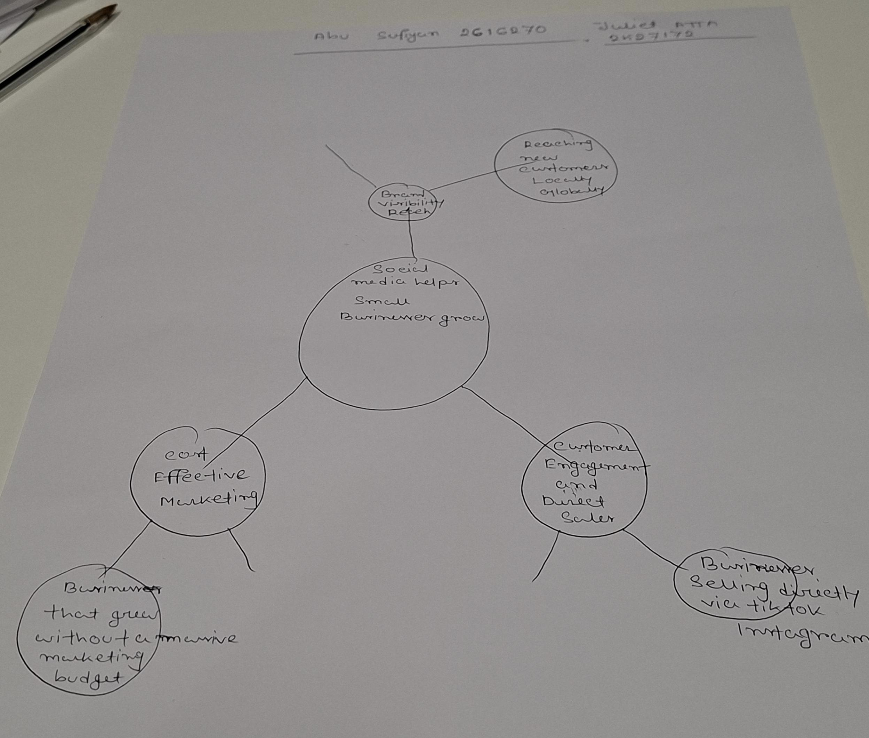

PART 2:

- What is the main idea of the whole text?
Answer: Social media platforms like TikTok and Instagram have made it easier for small businesses to go viral, helping them boost their sales and attract customers from far away.
- What is one key point that supports the main idea, and which specific example from the text shows this?
Answer: Customer created content on social media can drive people to travel massive distances to visit local food shop. Owner Murat Mutlu was surprised to discover that customers travelled for three hours just to try the chicken burger at Honywood Sandwich Shop in Basildon.
- What is a different key point that supports the main idea, and which specific example from the text shows this?
Answer: Wider reach of customers expanding business, Chloe Huggins and Rose Bliss gained 45 million views for Little Love’s pamper bus attracting party inquiries from the United States and the Bahamas.
- Which part of the text do you think is most important, and why?
Answer: The statistic that millions of businesses now operate on platforms like TikTok and Instagram is the most important part because it shows how essential social media has become for modern business survival.

Reflection:
- What did you find difficult in this task (including in-class components), and why was it difficult?
Answer: I found it challenging to choose which specific detail and examples to include because the text contained so many different business success stories.
- What helped you with this difficulty, and how did it help you?
Answer: Discussing the reading during our in-class session helped me narrow down the information and match the right examples to each specific key point.

