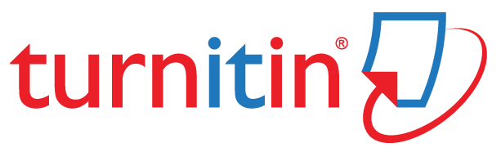


BMMB7012 – Marketing Management
Assignment 1
Submission Template

Printed Name: Gurleen kaur

Table of Contents
Introduction/Background: 2
Task 1: 2
The concept and the importance of marketing: 2
SWOT analysis 3
The micro and macro marketing environment: 4
PESTEL analysis: 4
Porter’s five forces analysis: 5
Target markets: 6
Selection of media: 8
Measurement of success: 9
Task 2: Conclusion: 10
Task 3: Recommendation: 10
Reference list 11

Introduction/Background:
The report entails a thorough strategic analysis of the chosen organisation VI. It is more popularly known as the Vodafone Idea Limited, which is regarded as an "Aditya Birla Group" and "Vodafone Group Partnership". It is further to be noted that it is one of India's leading telecom service providers and the company tends to provide "Pan India Voice and Data services" in the form of 2G, 3G and 4G platforms (MYVI, 2023). It is to be noted that on September 7, 2020, the "Vodafone Idea" ad unveiled their new brand identity ", VI" which tends to involve the holistic integration of the erstwhile separate brands of the company, that is "Idea" and "Vodafone: into one particular Unified brand (Jha, 2021). The headquarters of the company is situated in Mumbai, India and VI is referred to as a joint venture between Idea Cellular and Vodafone Group (Tripathi, 2023). The report, analyses and discusses the current strategic activities of the organisation, followed by some effective recommendations for further improvement based on the analyses.

Task 1:

The concept and the importance of marketing:
It is important to note that the importance of marketing of the business is manifold. It tends to make the customers aware of the company's services and products, hence fostering their engagement and guiding their buying decisions (Upadhyay, 2022). Furthermore, the concept of marketing is of utmost importance as it also helps in maintaining, creating, demanding and maintaining the demands and reputations of the competitions and so on. In the case of the Vodafone idea group, they have been realigning and streamlining the various consumer digital resources to sharpen their focus on driving operational scales and the pace of deliveries (MYVI, 2023). Moreover, the organisation has also been proposing to bring all kinds of digital resources from different functions under a more holistic and integrated "consumer digital product" curation and delivery organisation.
It is further to be noted that these investments of Vodafone on the realigned digital set-up would tend to comprise 3 important verticals of the consumer digital products as well as partnerships, consumer digital marketing as well as digital deliveries (Tripathi, 2023). In addition to this, VI also invests heavily in a wide range of promotional campaigns to gradually position the revamped version of the business (Jha, 2021). Due to the constraints of the current times, they organised virtual events to put forward their "refurbished and amalgamated identity VI" out of the world (Jha, 2021).
On the basis of the contemporary marketing strategies and activities of the VI group, the strengths, weaknesses, opportunities and threats have been identified in the SWOT matrix below:

SWOT analysis
Strengths  - One of the main strengths of the VI group is that it has gained massive market coverage till date.  - Their marketing strategy is legendary and “Vodafone pug” is known all over the world (Sikdar and Ashraf, 2020).  - Vodafone ZooZoo was also a very endearing and brilliant campaign and earned millions of users (Sikdar and Ashraf, 2020)  - Vodafone follows a differentiation strategy which is also one of their strengths as they are able to get some premium about their customers. | Weaknesses  - The company's brand valuation had dropped significantly, resulting in a further potential drop in subscribers.  - Another major weakness of the company is its inadequate marketing efforts in the United States, where the company could have demanded premiums to keep itself "afloat" (Sikdar and Ashraf, 2020).  - However, it has been further losing its market share in Europe due to Brexit.  - Limited rural market presence is another weakness of Vodafone as many of its competitors, including Airtel, Jio and so on, have successfully entered the rural markets (Upadhyay, 2022)
Opportunities  - “Rural market penetration” would be one of the most important opportunities for Vodafone Idea as a substantial number of subscribers are from India (Upadhyay, 2022).  - Vodafone can also expand its market share by expanding to other markets such as those of Africa and other emerging telecom markets.  - Vodafone can also leverage the opportunities to foster effective network coverage and strengthen connectivities to ensure customer acquisition (Pai, 2021. | Threats  - One of the major threats incurred by Vodafone is the level of competition the company faced, which had been strongly affecting the brand globally (Pai, 2021).  - Moreover, the market saturation problem is another big threat for Vodafone as saturation leads to brands spending more and more on acquiring customers and obtaining fewer customers for the same amount spent (Pai, 2021).

From the above SWOT analysis, it can be said that Vodafone mainly invests in marketing resources such as ad campaigns, media ads like TV and Social media and other digital platforms and so on. However, due to high competition within the telecom industry, it should be noted Vodafone has been losing its customers and its brand value has been dropping (Idea and Towers’dues, 2022). Thus, it needs to further reshape its marketing activities, focus on rural and underdeveloped and emerging markets, and work on network coverages to ensure its marketing success.

The micro and Macro marketing environment:
The micro and macro marketing environment of the Vodafone Idea (VI) group has been discussed below with the help of PESTEL and Porter's five forces analysis:

PESTEL analysis:
Political: It is to be noted that the Indian government had been very serious regarding trying to save these ventures. Also, it has been predicted by many analysts that the government might purchase stakes in it as a remedy. However, in countries like the UK, there is high political stability. Hence, the level of democracy and freedom of opinion persists in the country, making it a good market for VI (Idea and Towers'dues, 2022).
Economic: It is further to be noted that India's "Vodafone Idea group" had further faced tremendous losses from the first quarter of 2020 to the first quarter of the year. Also, their revenues have dropped by 14 percent in the last 3 years (Idea and Towers'dues, 2022). However, the Covid19 pandemic has not hit the company too hard and has not suffered much economic loss as people's dependence on telecom increased due to the isolation and quarantine trends.
Social: The company promptly realised the importance of its role in helping people, businesses and society and to stay afloat, particularly since the Covid-19 pandemic (Idea and Towers’dues, 2022). For that reason, it is to be noted that they had developed a plan where their priority is to enhance and strengthen their connectivity, realising that telecom is one of the major ways of communication in the present-day social world. Also, its diverse culture and trends of involving people from all cultural backgrounds tend to make it an inclusive company.
Technological: It is important to note that VI has cutting-edge technological feats under its belt. Vodafone also has technologies to make "single digital cores" in order to enhance the connectivity within global HR systems for the organisation (Chundi and Kumar, 2022). In addition to this, it is also to be noted that the company has also deployed the uses of "SAP S/4HANA" and is planning to roll out 5G all over the world to further enhance their operations all over their business units, including finances, information and technologies and supply chains (Chundi and Kumar, 2022).
Environmental: It is further to be noted that the world has a very careful eye on "global businesses", and they keep a watchful eye on how companies maintain their "Corporate Social Responsibilities (CSR)" (Raju and Madhuri, 2020). Thus, companies have been striving and investing in reducing their impact on the built environment. For example, they have set a goal of using 100% renewable electricity by 2025 in Europe (Raju and Madhuri, 2020).
Legal: India is one of the largest market shares of Vodafone. However, lately, the company's performance has been terribly deteriorating in India (Paul and Babu, 2020). In 2020, they faced some legal taxation issues in India, for which they had to pay a huge ransom to the country's government (Shaikh and Aggarwal, 2020).

Porter’s five forces analysis:
Threats from new entrants (LOW): VI has their active operations within Asia, Africa and Europe and the company faces low threats from new entrants as the businesses who want to enter the market have to pay huge amounts of capital as "licensing price" is very high and since the spectrum allocations take place in auctions, only heavily potential companies can enter the market (Shaikh and Aggarwal, 2020).
Threats from substitutes (HIGH): It is important to note that people mostly tend to jump from one company to another quite frequently. The concept of Dual SIM usage has long been in the market and that causes the users to easily switch telecom operations (rivals of VI) if they find the services are not satisfactory enough (Dhankhar and Dasgupta, 2023). Thus, it can be said that the threats from the substitutes are quite high for Vodafone (Dhankhar and Dasgupta, 2023).
Bargaining power of customers (HIGH): Telecom customers always want the best of services with the lowest possible costs and the services provided by various telecom operators are more or less standardised with negligible differentiation (Charan and Devaru, 2021). Therefore, the bargaining power of customers is very high as they can easily switch tier telecom operators with very little or no switching cost (Charan and Devaru, 2021).
Bargaining power of suppliers (MODERATE): The raw materials required to run a telecom company, that is, telecom equipment, is "standardised", and differentiation is very less and these are readily available from several players. VI tends to have "easy accessibility" to the raw materials and hence it can be said that suppliers' bargaining power is moderate (Charan and Devaru, 2021).
Competitive rivalry: it is to be noted that the rival companies are easily able to attract new users by giving “one-time offers” due to low switching costs and since every firm has invested heavily within the industry, it is highly unlikely for them to leave the market (Lakshana, 2019). The competitive rivalry is high as the telecom is almost saturated in almost all countries and hence cut-throat competition follows Vodafone wherever it goes. For example, Vodafone faces high competition from Reliance Jio and AirTel in India, AT&T Inc in the USA, Deutsche Telekom AG in Germany, and so on and hence it can be said that the competitive rivalry is very high (Nune and Kozhikode, 2022).

Target markets:
Segmentation | Targeting | Positioning
Demographics: Age> 13 to 60  Earnings: High, medium and small-level markets  Location: Urban, semi-urban and semi-rural areas (Nune and Kozhikode, 2022)  Psychographic: VI prefer Youth and people living the urban and semi-urban areas  They also prefer people who have the potential and desire to pay more for premium services | B2C: VI's recharge plans begin from as low as INR 10 and go up to INR 500.  Data plans tend to range from INR 99 to INR 1000  B2B: VI launched recent plans and packages for small and medium-sized organisations and also large-scale businesses that can be customised as per the needs  Value-added "Services and discounts": They mainly focus on students, working professionals and homemakers. | Product: They provide premium and basic services, including voice calls, data, SMS services, Mobile Transfer services and also IT solutions for business enterprises.  Price: They offer a wide range of prices suitable for all types of customers and businesses.  Distributions: Exclusive retail stores and the sale within smaller "retail shops" to reach out to a large number of customer base (Dhakad, 2021).
The segmentation services that Vodafone offers are combinations offered in "mobile network services", "enterprise services", and "psychographic segmentation" (Vats and Shah, 2023). | It is to be noted that the targeting strategy of "Vodafone" has been concentrating on various sections of societies with their various offerings (Dhakad, 2021). Moreover, it also uses a "differentiated" and "selective" targeting strategy. | It is imperative to note that "Vodafone Idea" positions itself as "The fastest 4G network" in India (Vats and Shah, 2023).

In the STP analysis, "Porter's diamond model" theory can be applied to understand the location chosen by VI for their business operations to attain a high "competitive advantage". The most important factors that Vodafone tends to focus on are "local factors", "demand conditions", and "associated and supported industries", along with the firm strategies, structures and rivalries (Kalam, 2020). These factors tend to determine the advantages that can be extracted from geographical expansions of the services. Vodafone has used global sourcing to gain effective insights into the purchasing trends, which further helps them decide on their prices (Vats and Shah, 2023).
Further, the "CAGE framework" theory can also be applied to VI's STP strategy. The key components of the CAGE framework include "Cultural distances", "administrative and political distances", "geographic distances", and "economic distances" (Kalam, 2020). The "global outsourcing programs" undertaken by Vodafone are one of the major agents for the expansion of the scope and arena of "Supply Chain Networks" (Shetty, 2021). The provision of checking the network coverages tends to suffice the need for addressing the various external environmental factors. Technologies also guide VI in establishing "unique challenges" such as 5G networks. However, the "start-up telecommunication services providers" tend to exploit the opportunities of the company (Shetty, 2021).
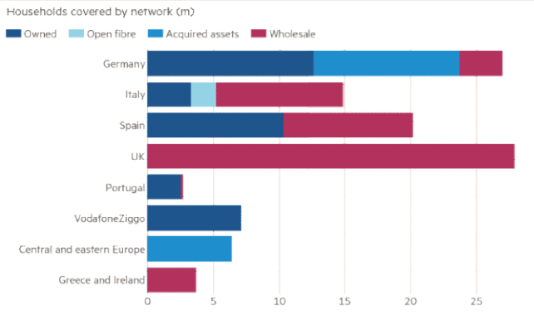
Figure: Different countries’ households covered by networks
Source: (Kalam, 2020)

Selection of media:
VI uses several media platforms and channels as a medium to transform and convey its marketing promotions. These media are discussed below:
Social media: VI takes under consideration various social media platforms such as “Instagram”, “facebook”, “LinkedIn”, “Twitter” and so on (MYVI, 2023). It is again important to note that VI mostly keeps posting about the various offers, special discounts, festive plans and different campaigns launched by them (Kalam, 2020).
Influencer Marketing: Vodafone often casts popular celebrities as their brand ambassadors across different countries to make their ad campaigns reach as many people as possible. For example, Vodafone launched their new ad campaign about the "Vodafone play app" with the famous Indian Singer Shankar Mahadevan. They also have a vast portfolio of Hollywood, Bollywood, and regional content by partnering with the "most famous content creators" ad aggregators such as "SonyLiv”, “Zee 5”, “HoiChoi” and so on.

Measurement of success:
To measure the success, the company measures their success by tracking the key performance indicators that tend to reflect its operational and strategic performances and progresses (Vats and Shah, 2023). They have various metrics such as digital sales, End-to-end TOBi completion rates, revenue growth metrics, data users, plan subscribers, IT solution users, etc. Some of the metrics for measuring VI success are shown below:
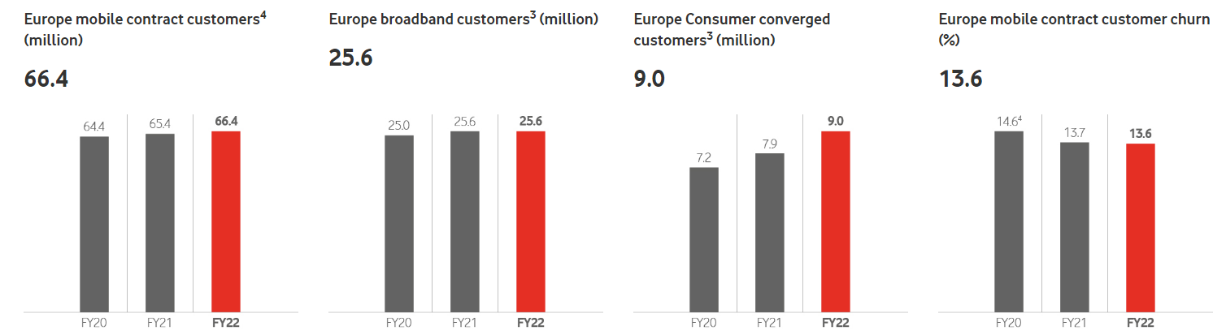
(Source: Investors.vodafone.com., 2023)
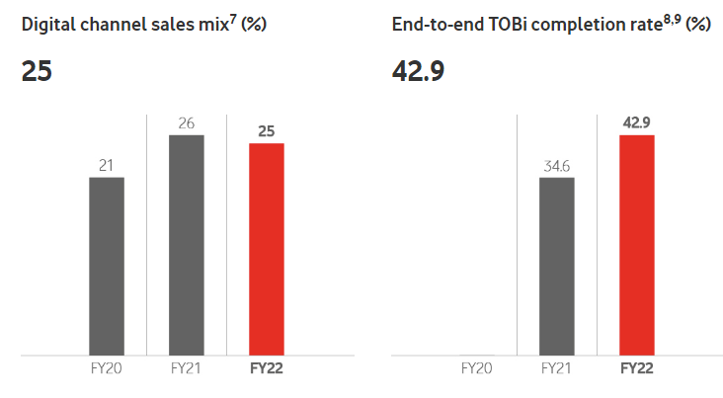
(Source: Investors.vodafone.com., 2023)
Apart from that, VI also tends to survey their consumers and employees to measure their success and takes effective feedback from them regarding their performances and progress. Moreover, to further enhance their marketing success, Vodafone came up with further differentiation strategies and offered "Vodafone to vodafone free unlimited calls for life" and good network strengths compared to other rivals in the market.

Task 2: Conclusion:
This task mainly had a critical evaluation of the selected organisation, that is, VI group and its marketing activities and addresses the various shortcomings of the chosen company's marketing strategies (Sikdar and Ashraf, 2020). The report, at last, also provided some viable recommendations as to how the concerned organisation’s marketing strategies could be enhanced. It can be inferred from the report that the engagement level of the various promotional activities had always remained high such as the zoo-zoo ads and the pug ads. These ads were popular across special media platforms, television, and newspapers. The VI's marketing activities mainly focus on promotions of their products and services, user engagement, consumer experiences and so on. It is also to be noted that VI has wisely used different digital marketing strategies to reach as many customers/users as possible. Furthermore, from the analysis of the report, it can be concluded that VI targets almost all groups of people and also provides a wide range of plan rates so that they can fit every pocket and cater better to the specific telecom needs of people. By positioning itself as the fastest 4G network, VI also tries to attract the customer's attention and represent itself as a potential telecom brand that is confident about its services (Idea and Towers’dues, 2022).

Task 3: Recommendation:
Some effective recommendations for VI to improve its marketing strategies are:
- They should transform their business to become a "new generation connectivity" and "digital service provider" for Africa and Europe (Charan and Devaru, 2021). And they should also enhance their HR strategies and establish an inclusive environment for growth to accelerate their transformation strategies (Vats and Shah, 2023).
- Vodafone can also invest more in "celebrity endorsement strategies" to popularise its marketing advertising strategies within different countries (Lakshana, 2019).
- Vodafone must invest more in research and development to understand the competition better and should focus on enhancing its CSR strategies (Charan and Devaru, 2021).
- Vodafone faces high competition from Reliance Jio and AirTel in India, AT&T Inc in the USA, Deutsche Telekom AG in Germany, etc. Therefore, to stay ahead of the competition, VI should also expand its data analytics into designing more personalised experiences for individual users (MYVI, 2023). VI can use its "My Vodafone Application" along with various digital marketing channels as its main customer acquisition and management platforms (Vats and Shah, 2023).
- In addition to this, aligning with the dictates of the present situation, the company further would need to advertise itself on various media platforms, including televisions, digital streaming platforms, social media and so on (MYVI, 2023).
- Furthermore, the organisation must also need to follow the higher decibels of "marketing strategies" to resonate with the aims and values of the brand whilst establishing itself as a "substantial agency" (Jha, 2021).
- It is also to be noted that VI is surrounded by strong competitors, such as Reliance Jio and Airtel, in India and many other telecom services abroad, it needs to finance its company more and reinvent its network services to make its presence be felt in the market (Vats and Shah, 2023). It is important for VI to refinance its existing loans and also to obtain another round of "equity conversion" from the government so as to survive the competitive market and to come back as a giant and a competitive telecom brand which is, at present, the need of the hour (Charan and Devaru, 2021).
- VI should work towards growing its service range for both enterprises as well as individual customers, addressing the increasing data-oriented needs in the contemporary digital environment (Charan and Devaru, 2021). Thus, they should make more and more investments in improving their business model and establishing strong brand recognition within both national and international markets (Charan and Devaru, 2021).
- Emerging international markets, such that of Africa, should be explored by VI and they must also penetrate the rural markets by enhancing their network coverage (Charan and Devaru, 2021). Most of their competitors have already entered the rural regions and hence in order to sustain the competition, rural penetration is one of the most important prerequisites for VI (Charan and Devaru, 2021).
- Regular feedback and surveys should also be conducted by VI to know about their progress and to address the issues as per the present trends and changes (Charan and Devaru, 2021).

Reference list
Charan, H.N. and Devaru, S.D.B., 2021. MARKETING STRATEGIES OF INDIAN TELECOM SERVICES IN TUMKUR, KARNATAKA, INDIA. Journal homepage: www. ijrpr. com ISSN, 2582, p.7421.
Chundi, P. and Kumar, P.S., 2022. Impact of Team Work at Vodafone Idea. International Research Journal of Innovations in Engineering and Technology, 6(3), p.35.
Dhakad, P., 2021. MARKETING STRATEGIES OF TELECOM COMPANIES IN INDIA (Doctoral dissertation, Delhi Technological University).
Dhankhar, A. and Dasgupta, H., 2023, January. A study on factors influencing customer brand switching behavior in the Indian telecom market. In AIP Conference Proceedings (Vol. 2523, No. 1, p. 030007). AIP Publishing LLC.
Idea, V. and Towers’dues, I., 2022. Market snapshot.
Investors.vodafone.com., 2023. Key Performance indicators. Available at: https://investors.vodafone.com/reports-information/key-performance-indicators?tab=strategic-progress
Jha, B., 2021. Case Analysis II: Vodafone India Ltd—Managing in a Turbulent Emerging Market. Vision, 25(1), pp.120-121.
Kalam, K.K., 2020. Market segmentation, targeting and positioning strategy adaptation for the global business of Vodafone Telecommunication Company. International Journal of Research and Innovation in Social Science, 4(6), pp.427-430.
Lakshana, R., 2019. Analysis of A Corporate Transaction: Merger of Vodafone India & Idea Cellular. Journal of Corporate Governance and International Business Law, 2(1), pp.1-9.
MYVI., 2023. VI (Vodafone idea) - VI max postpaid: Prepaid: VI Games & More (no date) MYVI. Available at: https://www.myvi.in/ (Accessed: April 17, 2023).
Nune S.C. and Kozhikode, I., 2022. STUDY ON ADVERTISING ACTIVITIES OF AIRTEL IN THE INDIAN TELECOM MARKET.
Pai, V.S., 2021. Vodafone India Ltd: Managing in a Turbulent Emerging Market. Vision, 25(1), pp.103-117.
Paul, A. and Babu, D., 2020. A STUDY ON PERCEPTION OF CUSTOMERS AND THEIR SATISFACTION TOWARDS REBRANDING OF VODAFONE-IDEA AS VI. DE PAUL JOURNAL OF SCIENTIFIC RESEARCH (DJSR).
Raju, R. and Madhuri, G., 2020. Vodafone and Idea Merger: A Shareholder’s Dilemma. Global Business Review, p.0972150920934256.
Shaikh, S. and Aggarwal, A., 2020. Vodafone Idea.
Shetty, S., 2021. A Study Of Preference Of Telecom Operators Amongst College Students In Mumbai. Idea, 19, pp.22-5.
Sikdar, S. and Ashraf, H., 2020. An Analytical Performance of CSR Activities of Telecom Industry in India-A Study on Vodafone Idea and Reliance Jio.
Tripathi, D.M., 2023. MERGER OF VODAFONE AND IDEA. EPRA International Journal of Multidisciplinary Research (IJMR), 9(3), pp.256-258.
Upadhyay, R.K., 2022. Conversion of AGR into Equity and Revival of Vodafone Idea. ACADEMIA Letters (2022).
Vats, S. and Shah, H.,2023. Strategic Restructuring Through Merger and Acquisition-A Case Study on Indian Telecommunication Sector.

