
Name: Ishrat Nasar
Student Number: 2508113
Module code: LCHS4003 Component 1 Guidance Portfolio (Poster + Essay) – January 2026
Lectures Name : Wafa Nasir


Residential Care Homes
A residential care home provides 24-hour
support for elderly residents,
usually aged 70 or above, who require daily assistance.
This care includes meals, help with personal care such as washing,
dressing, as well as support with day-to-day living.
Many residents in care homes live with conditions such as dementia,
Alzheimer’s disease, chronic illnesses, or age.
They are supported by trained carers/nurse practitioners.
Residential care homes are important in the wider community
as they provide a stable and safe environment for elderly people.

History of care Homes in the United Kingdom
In 1945 it was very clear that no care homes were formed and hospitals
has no space for the ill health and elderly. In the 20th
century the NHS was formed in the United Kingdom.
“Ministry of Health had to tackle the problem posed by
70,000 hospital beds in England occupied by chronic sick patients”
British Geriatrics Society Accessed: 10 March 2026).

Challenges faced with residential care
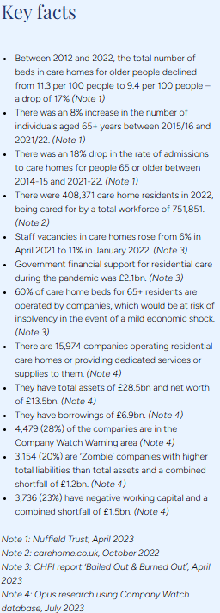
Staffing issues have become an increasing concern,
and the government has allowed overseas carers to enter the UK to support
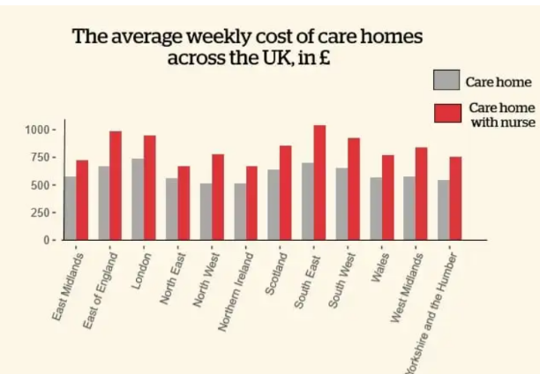
the care system. “There are an estimated 150,000 vacancies in adult social care, representing a vacancy rate of around 9.9%. With one in ten positions unfilled. (Bellwood, 2024)”
This leads to poor quality of care in residential homes. In March 2025 the care quality commission issued a report informing the government that 2500 care homes were not meeting the needs of residents. A news report cited A total of 132 facilities were ranked 'inadequate' – the worst possible score, MailOnline can reveal. (Price, 2025) Short staffing meant that staff were overworked and individual needs were not met such as hygiene and personal care. This challenge leads to overall Overworked staff
- Reduced quality of care
  - Missed personal care tasks
  - Increased safeguarding risks
Financial implicationsCovid-19 impacted the care system due to fatalities a report cites that over 42000 residents passed away and almost 1300 care workers. This led to the closure of care homes and also lead to government funding being utilised to pay out staff who had to go on furlough. Care homes had to make pay cuts which led to redundancy. Also rising costs in care homes such as food, pay increases for staff working longer hours ]goes back to our main concern around cost of living. According to Care Home Magazine (2024)The gap between the National Living Wage and the typical pay of a care worker has narrowed, and it has become more difficult for providers to offer competitive pay. An additional financial strain on the residential care system is the pay increase for trained registered nurses. The following stats show the increase in pay in home with our without nurses.

Task 2 Essay:

Introduction
In this assignment the service I will be discussing and looking in to is the ambulance service, I will be looking into the history of the ambulance service and how this has developed over the years and the benefits it has brought to the national health system. Ambulance services were originally created to transport patients to and from hospital, but over time they have become a critical part of emergency services. Not only does the ambulance service transport patients to hospitals but they also provide emergency care for those who are injured, critically unwell, or sudden health concerns. The modern ambulance service is run by paramedics whose training can take up to four years, and they work closely with a range of agencies such as GP services, counselling teams and care homes. According to NHS Careers (n.d.), “Paramedics are trained to resuscitate and stabilise patients using sophisticated techniques, equipment and drugs… using high-tech equipment such as defibrillators, spinal and traction splints, as well as administering oxygen and drugs.”
In the early 1950s, the ambulance service was used as a transport service. workers were not medically trained, and their role was mainly to drive patients to hospital. Newton (2012) explains that ambulance personnel were regarded as “manual labourers” whose primary role was to act as drivers rather than healthcare professionals. This limited the quality-of-care patients received during emergencies resulting in high death rate and further deterioration to health. By the late 1950s, advances in medical science began to take over the service. Equipment such as early defibrillators and ECG machines was being developed, created and tested, although these were often heavy and difficult to use. As weaknesses in the service became more visible, the “Ministry of Health responded to concerns raised by programmed such as BBC Panorama (1963)”, which highlighted the lack of training and poor emergency care. As a result, ambulance drivers began receiving basic first aid training, making the first step towards a more skilled department.
The history of the ambulance service goes all the way back to the roots of poor ambulance care and can be traced even further during world war. Dominique Jean Larrey, a French surgeon during the Napoleonic wars, is often credited as the founder of the modern ambulance and the developer of triage. Richardson (1974) describes Larrey as the “father of ambulance services,” and his work during war time laid the starting for organised emergency response systems. Over time, these ideas started the development of organised ambulance services across the world.

As the medical field has developed and technology has been enhanced this continued to advance, the ambulance service evolved into a highly specialised emergency care system. Today, paramedics are trained to use a wide range of advanced equipment, including diabetic monitoring tools, EpiPens, ECG machines, oxygen therapy, and medications such as GTN spray for cardiac emergencies. Ambulances themselves have also diversified, with different types such as patient transport vehicles, rapid response units, and emergency ambulances. According to EMSUK Learning (2023), UK ambulance services continue to evolve with improvements in technology, training, and medical knowledge.
When evaluating the service today, there are clear strengths but also ongoing challenges. On the positive side, paramedics can deliver life saving interventions before a patient reaches hospital, improving survival rates for conditions such as heart attacks, strokes, and major trauma. Modern communication systems such as radio systems and IPADS allow paramedics to send ECG readings directly to cardiology teams, enabling hospitals to prepare for urgent treatment. However, the service also faces pressures such as increasing demand, long waiting times in some regions, staff shortages, and delays caused by overcrowded emergency departments. These issues can reduce

the effectiveness of the service and impact patient outcomes, showing that while the service has advanced significantly, it continues to face systemic challenges.
The ambulance service plays a significant role in enhancing the quality of life for service users. Rapid response times mean that injuries and illnesses can be treated quickly, reducing long term complications. For example, if a patient is experiencing a potential heart attack, paramedics can use ECG equipment to identify the issue early, administer GTN spray and pain relief, and alert the cardiology team before arrival. This early intervention can prevent severe damage and improve recovery. NHS England (2026) reports that the mean response time in February 2026 was 7 minutes 50 seconds, supporting the importance of timely care. Beyond physical health, the ambulance service also provides reassurance to the public, making sure that emergency help is available at any time. Overall, the ambulance service has developed from a basic transport system into a highly skilled emergency care provider. Its progression has been shaped by increases in medical technology, historical influences, and growing expectations of healthcare. While challenges remain, the service continues to play a vital role in saving lives and improving the quality of life for people across the UK.

Reference
carehome.co.uk (n.d.) Care home statistics: number of settings, population & workforce. Available at: https://www.carehome.co.uk/advice/care-home-stats-number-of-settings-population-workforce (Accessed: 02 March 2026).
British Geriatrics Society (n.d.) A brief history of the care of the elderly. Available at: https://www.bgs.org.uk/resources/a-brief-history-of-the-care-of-the-elderly (Accessed: 10 March 2026).
Bellwood, L. (2024) The serious challenges facing residential care and nursing homes. Paperclip. Available at: https://www.paperclip.co.uk/care-homes/ (Accessed: 10 March 2026)
Price, O. (2025) England’s worst care homes named and shamed – so is your loved one staying at one of the 2,500 failing services? Daily Mail, 23 March. Available at: https://www.dailymail.co.uk/health/article-14511303/worst-care-homes-named-shamed-map.html (Accessed: 10 March 2026).
Opus Business Advisory Group (2023) The UK residential care sector in crisis: many more problems than solutions. Available at: https://opusllp.com/report/the-uk-residential-care-sector-in-crisis-many-more-problems-than-solutions/ (Accessed: 10 March 2026).
Care Home Magazine (2024) Balancing the books: the financial pressures reshaping the care home sector. Available at: https://carehomemagazine.co.uk/balancing-the-books-the-financial-pressures-reshaping-the-care-home-sector/ (Accessed: 10 March 2026).
Connolly, R. (2018) The striking regional differences in care home costs in Britain revealed. iNews, 14 May. Updated 17 July 2020. Available at: https://inews.co.uk/news/health/care-home-costs-revealed-153687 (Accessed: 12 March 2026).
NHS Careers (n.d.) Paramedic. Available at: https://www.healthcareers.nhs.uk/explore-roles/allied-health-professionals/roles-allied-health-professions/roles-allied-health-professions/paramedic (Accessed: 12 March 2026)
Newton, A. (2012) The ambulance service: the past, present and future. Journal of Paramedic Practice, 4(5). Available at: https://www.paramedicpractice.com/content/features/the-ambulance-service-the-past-present-and-future (Accessed: 12 March 2026).
BBC Panorama (1963) [Television broadcast]. BBC Television.
Richardson, J. (1974) The evolution of ambulance services. London: HMSO.
EMSUK Learning (2023) History of UK ambulance services. Available at: https://www.emsuklearning.co.uk/history-of-uk-ambulance-services/ (Accessed: 12 March 2026).
NHS England (2026) Ambulance Quality Indicators: Statistical Note, 12 March 2026. Available at: https://www.england.nhs.uk/statistics/wp-content/uploads/sites/2/2026/03/20260312-Stats-Note-of-AQI-LB32C-1.pdf (Accessed: 12 March 2026).

