ACCOUNTING FUNDAMENTALS

Student: Basiul Vlada ( 2028043 )
Table of Contents
Introduction 3
Question 1 3
a. P&L and Balance sheet 3
b. the reason for balancing financial position 5
Question 2 6
a. ratio analysis 6
b. commenting on financial performance 13
Conclusion 13
References 14
Profit and Loss Statement……………………………………………………………………………15
Balance Sheet ………………………………………………………………………………………….16
Ratio of CHOCCO PLC ………………………………………………………………………………..17
Profitibility………………………………………………………………………………………………18
Profitibility………………………………………………………………………………………………..19

Introduction
The account is the most important component in a business organization. It is very effective to run a successful business. Accounts help to track all the income and expenditures that are related to the organization. The accounting fundamentals help to cover all the financial statements of an organization. Therefore, it helps to provide necessary information about the financial health of the organization so the owners can take necessary steps to improve their business performance. In this study, the P&L statement and balance of Kedision PLC have been presented and analysis has been done on it. Ratio analysis is also presented here according to the Chocco plc performance.

Question 1

a. P&L and Balance sheet
P&L
Profit and loss account is the most common and effective method of knowing the financial ability of a business. It helps to summarize all the respective revenue, expenses, costs that are occurred for a specific time period (Calotă et al. 2020, p.82). This provides information about the financial ability of a business so the investors and owners can calculate the return of investments.
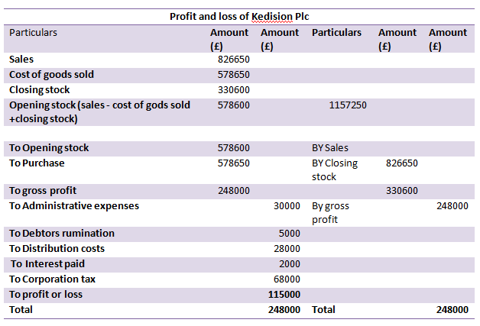
Figure1: P&L
(source: self-prepared)
The above figure reflects the P&L account of Kedision PLC. The total sales record by the business on 31st December 2020, is £826650, and the expense paid by the business as the cost of sales is £578650 respectively. The closing stock was recorded by the business £330600 and the actual amount of opening stock record by the firm after deduction of COGS and closing stock is £578600 respectively. After adding the purchase amount of £578600 with the opening stock the gross profit reflects £248000.
Balance sheet
This is considered as one of the most important financial statements that record the share holder’s equity, assets, and liability position of a business. It helps to summaries the amount of assets own and the amount of liability owes by the firm.
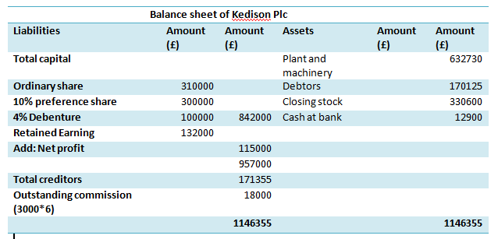
Figure2: balance sheet
(Source: self-prepared)
The above figure reflects the balance sheet of Kedision PLC. The balance sheet has been produced on 31st December 2020. In the liability portion of the balance sheet ordinary share recorded by the organization was £310000 and the preference share recorded £300000 respectively. The debenture recorded in the business is £10000. The net profit amount of £115000 record in the business is helpful for further consideration. The total amount paid to creditors was £171355 and 18000 is paid as outstanding commission. Therefore, the total liability portion of the business shows £1146355 respectively. In the assets portion plant and machinery recorded £632730 and debtors recorded £170125 respectively. The closing stocks and cash at bank shows in the business were £330600 and £12900 respectively. Therefore the assets and liability sides get matched.

b. the reason for balancing financial position
The balance sheet of the Kedision PLC is balanced for getting a snapshot regarding its assets and liability. Therefore, the owners and investors can get the net worth of the business at a single point. According to the accounting principles when the accountant makes a double-entry system in their accounts section then they need to balance them (Fleckenstein and Longstaff, 2020, p.5053). In the double-entry system, all the transactions are recorded in the two different accounts; therefore, it helps to reduce the chances of errors and miscalculation.

Question 2

a. ratio analysis
ROCE
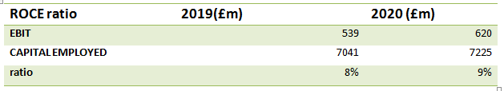
Figure 3: ROCE
(Source: Self-prepared)
Meaning
The financial efficiency of a business is presented by the ROCE ratio. It helps to measure the profitability of the business.
Changing figures
In the year 2019, the EBIT shows £539m, and the amount of capital employed shows £7041 respectively. In the year 2020, the EBIT shows £620m and the value of capital employed shows £7225m respectively.
Comparison
According to the financial condition of Chocco plc, the ROCE ratio of the firm gets an increase in 2020 as compared to 2019 business. It reflects that the firm increases its financial efficiency while their business.
Ways to improve
Removing unnecessary assets from the business can help the firm to improve its ROCE ratio better by reducing its capital employed.
ROE
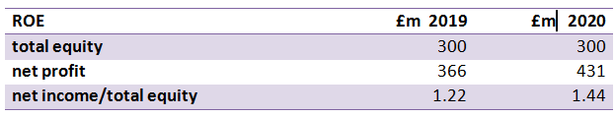
Figure 4: ROCE
(Source: Self-prepared)
Meaning
The net income of the shareholders by their share equity has been calculated by the ROE ratio. It helps to measure the financial performance of a business (Nariswari and Nugraha, 2020, p.92). It is an effective ratio for knowing financial ability.
Changing figures
In 2019 the equity amount shows £300m and the net profit earned by the business was £366m respectively.
In 2020 the equity amount shows £300m and the net profit earned by the business was £431m respectively.
Comparison
According to the changes in net profit amount the ROE ratio of the Chocco plc gets increase 2020 from 1.22 to 1.44 respectively. It will help to provide valuable returns to the investors.
Ways to improve it
Reducing the cost of labour and raising the price of the product can help to improve this ratio.
EPS
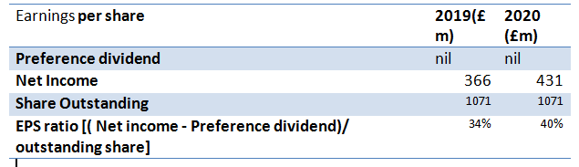
Figure 5: EPS
(Source: Self-prepared)
Meaning
The amount of earnings each investor gets from their investment amount is considered as the EPS of the investment.
Changing figures
In 2019 the Net income was recorded at £366m and the total outstanding share shows £1071 respectively.
In 2020 the net income was recorded £431m and the total outstanding share shows £1071 respectively.
Comparison
According to the changes in the net income figure, the EPS get increase 34 percent to 40 percent as compared to 2019 to 2020. Therefore, it will be beneficial to provide better returns to the investors.
Ways to improve
With buying their own share the Chocco plc can improve their EPS, which will help them to reduce their outstanding cost.
NP MARGIN
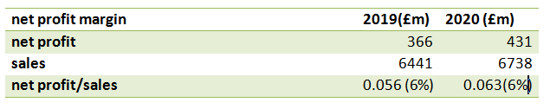
Figure 6: NP margin
(Source: Self-prepared)
Meaning
The amount of profit a firm earns after paying all the expenses and tax is called net profit. It is calculated on the basis of sales amount.
Changing figure
In 2019 the Net income was recorded at £366m and the sales recorded were £6441m respectively.
In 2020 the net income was recorded £431m and the sales recorded were £6738m respectively.
Comparison
The increasing amount of sales helps to increase the NP margin ratio in 2020 as compared to 2019. It shows 0.056 in 2019 and 0.063 in 2020.
Ways to improve
Chocco plc can increase their sales volume and increase their product price to improve this ratio.
Asset turnover
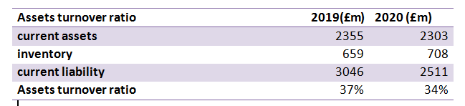
Figure 7: Assets turnover
(Source: Self-prepared)
Meaning
The ratio between average assets and total revenue or sales is regarded as asset turnover. This ratio is helpful for any investor to understand the usage of assets.
Changing figure
In 2019 the current asset shows £2355m, the inventory amount shows £659m, and the current liability shows £3046m respectively.
In 2020 the current asset shows £2303m, the inventory amount shows £708m, and the current liability shows £2511m respectively.
Comparison
The changes in the assets and inventory level decrease the assets turnover of Chocco plc. It decreases 37 percent to 34 percent in 2020. Therefore it will decrease the value of the assets of the business.
Ways to improve
The firm needs to focus on increasing their revenue and needs to lease necessary equipment for their business which will help to hold the cash.
Stock holding period
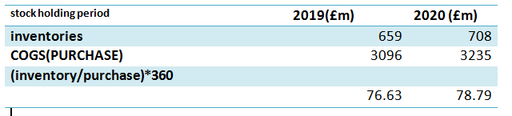
Figure 8: stock holding
(Source: Self-prepared)
Meaning
A time period from purchasing stock to selling this stock is regarded as stock holding days. This term is very relevant in terms of business processes.
Changing figure
In 2019 the inventory amount shows £659m and the COGS shows £3096m respectively.
In 2020 the inventory amount shows £708m and the COGS shows £3235m respectively.
Comparison
The increasing amount of inventory and COGS are increased the stock holding period. In 2020 it increases 78.79 from 76.63 respectively.
Ways to improve
Chocco plc needs to prioritize their inventors and increase their demand forecast more accurately to improve this period.
Debtors collection period
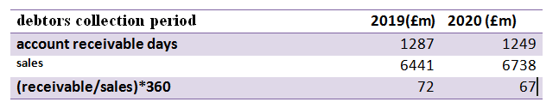
Figure 9: collection period for debtors
(Source: Self-prepared)
Meaning
The term debtor’s collection period is related to the time span in which the collection of money from the trade debtors is done.
Changing figure
In 2019 receivable amount was £1287m and the sales amount was £6441m respectively.
In 2020 receivable amount was £1249m and the sales amount was £6738m respectively.
Comparison
The changes in the reliable amount and sales amount decrease the receivable dates 72 to 67 in 2020. It will be beneficial for the organization in reducing their bad debt amount.
Ways to improve
Chocco plc can improve this period future by doing receivable management in their business.
Current ratio
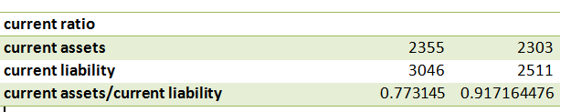
Figure 10: Current ratio
(Source: Self-prepared)
Meaning
The current ratio helps to analyze the liquidity of the organization and it leads to paying the short-term liabilities of the company. The current ratio can get increased by selling some assets which will increase the liquidity part of the basics here and will b helpful for paying the liability of the year. Chocco plc needs to prioritize their inventors and increase their demand forecast more accurately to improve the inventory stock holding period.
Changing figure
The figure helps to understand that the ratio of the current year had been increased than the previous year by the ratio of 0.917. The previous year ratio was 0.773 which is lss at the current year ratio.
Comparison
The ratio has been increased in the year 2020 and it helps to identify the liquidity position of the company to pay its short-term liabilities.
Ways to improve
The current ratio can get increased by selling some assets which will increase the liquidity part of the basics here and will b helpful for paying the liability of the year.
Gearing ratio
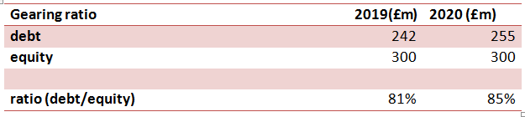
Figure 11: Gearing ratio
(Source: Self-prepared)
Meaning
A measurement of financial leverage in demonstrating relevant degree of an organization’s operation is regarded as gearing ratio. With equity versus capital in debt financing this is related.
Changing figure
The figure of the year 2019 regarding debt has been amount to £242 and the debt of the year 2020 amount to £255. The figure has been increased in the year 2020.The ratio has also been increased from 81% to 85%.
Comparison
The ratio of the year 2020 is more than the year 2019. The ratio helps to analyze the increase in gearing of the company.
Ways to improve
The ratio can get improved by increasing the depth of the organization.

Inventory cover ratio
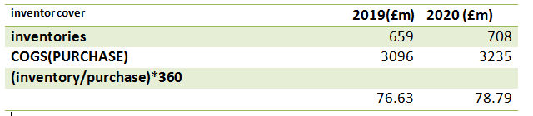
Figure 12: Inventory cover ratio
(Source: Self-prepared)
Meaning
In order to describe inverter cover ratio borrowed funds and its effects on the organization is relevant. An investor can take help of this ratio to understand the business.
Changing figure
In 2019 the inventory amount shows £659m and the COGS shows £3096m respectively.
In 2020 the inventory amount shows £708m and the COGS shows £3235m respectively.
Comparison
The increasing amount of inventory and COGS are increased the stock holding period. In 2020 it increases 78.79 from 76.63 respectively.
Ways to improve
Chocco plc needs to prioritize their inventors and increase their demand forecast more accurately to improve this period.

b. commenting on financial performance
The ROCE ratio and ROE ratio of Chocco plc indicate the firm efficiently increases its business efficiency. The net profit ratio indicates the firm increases its profit percentage as compared to their previous year’s business (Maeenuddina et al. 2020, p.13765). The efficacy ratios also indicate the firm will provide a valuable return to their investors as a reword of their investment.

Conclusion
The study can be concluded that the P&L statement helps to summarize all the respective revenue, expenses, costs that are occurred for a specific time period. This is considered as one of the most important financial statements that record the share holder’s equity, assets, and liability position of a business. With buying their own share the Chocco plc can improve their EPS, which will help them to reduce their outstanding cost.

References
Calotă, T.O., Robu, S.A., Oncioiu, I. and Burlacu, G., 2020. The Informational Value of the Profit and Loss Account in Line With International Accounting Standards. In Management Accounting Standards for Sustainable Business Practices (pp. 80-91). IGI Global.
Fleckenstein, M. and Longstaff, F.A., 2020. Renting balance sheet space: Intermediary balance sheet rental costs and the valuation of derivatives. The Review of Financial Studies, 33(11), pp.5051-5091.
Maeenuddina, R.B., Hussain, A., Hafeez, M., Khan, M. and Wahi, N., 2020. Economic Value Added Momentum & Traditional Profitability Measures (ROA, ROE & ROCE): A Comparative Study. TEST-Engineering Management, 83, pp.13762-13774.
Nariswari, T.N. and Nugraha, N.M., 2020. Profit Growth: Impact of Net Profit Margin, Gross Profit Margin and Total Assests Turnover. International Journal of Finance & Banking Studies (2147-4486), 9(4), pp.87-96.

Profit and loss of Kedison Plc for the period ended 31st December 2020
Particlulars | Amount (£) | Amount (£) | Particlulars | Amount (£) | Amount (£)
Sales | 826650
Cost of goods sold | 578650
Closing stock | 330600
Opening stock (sales - cost of godds sold +closing stock) | 578600 |  | 1157250
To Opening stock | 578600 |  | BYSales
To Purchase | 578650 |  | BY Closing stock | 826650
To gross profit | 248000 |  |  | 330600
To Adminitrative expenses |  | 30000 | By gross profit |  | 248000
To Debtors remunation |  | 5000
To Distribution costs |  | 28000
To Interest paid |  | 2000
To Corporation tax |  | 68000
To profit or loss |  | 115000
Total |  | 248000 | Total |  | 248000

Profit and Loss Statement

Balance sheet of Kedison Plc as at 31st December 2020
Liabilities | Amount (£) | Amount (£) | Assets | Amount (£) | Amount (£)
Total capital |  |  | Plant and machinery |  | 632730
Ordinary share | 310000 |  | Debtors |  | 170125
10% preference share | 300000 |  | Closing stock |  | 330600
4% Debenture | 100000 | 842000 | Cash at bank |  | 12900
Reterned Earning | 132000
Add:Net profit |  | 115000
 |  | 957000
Total creditors |  | 171355
Outstanding commission (3000*6) |  | 18000

Balance sheet

Ratio of CHOCCO PLC
Liquidity ratio |  | 2019(£m) | 2020(£m)
current assets |  | 2355 | 2303
current liability |  | 3046 | 2511
inventory |  | 659 | 708
sales |  | 6441 | 6738
 |  | 2019£ | 2020 £
current ratio
current assets |  | 2355 | 2303
current liability |  | 3046 | 2511
current assets/current liability |  | 0.7731451 | 0.917164476
quick ratio
(current assets-inventory)/current liability |  | 0.5567958 | 0.635205098
Assets turnover ratio |  | 2019(£m) | 2020 (£m)
current assets |  | 2355 | 2303
inventory |  | 659 | 708
current liability |  | 3046 | 2511
Assets turnover ratio |  | 37% | 34%

ROCE ratio | 2019(£m) | 2020 (£m)
EBIT | 539 | 620
CAPITAL EMPLOYED | 7041 | 7225
ratio | 8% | 9%

Ratio of CHOCCO PLC

PROFITIBILITY RATIO
 |  |  | 2019 | 2020
sales |  |  | 6441 | 6738
total equity |  |  | 300 | 300
total assets |  |  | 10087 | 9736
net profit margin |  |  | 2019(£m) | 2020 (£m)
net profit |  |  | 366 | 431
sales |  |  | 6441 | 6738
net profit/sales |  |  | 6% | 6%
ROE
total equity |  |  | 300 | 300
net profit |  |  | 366 | 431
net income/total equity |  |  | 1.22 | 1.44
ROA
net income/total assets |  |  | 0.0362843 | 0.044268694
 |  |  |  | 0
 |  |  | 2019 | 2020
Gearing ratio |  |  | 2019(£m) | 2020 (£m)
debt |  |  | 242 | 255
equity |  |  | 300 | 300
ratio (debt/equity) |  |  | 81% | 85%
efficiency ratios
 |  |  | 2019 | 2020
inventories |  |  | 659 | 708
COGS(PURCHASE) |  |  | 3096 | 3235
sales |  |  | 6441 | 6738
receivable |  |  | 1287 | 1249

debtors collection period |  | 2019(£m) | 2020 (£m)
account receivable days |  | 1287 | 1249
sales |  | 6441 | 6738
(receivable/sales)*360 |  | 71.93293 | 66.73196794
Earning per share |  | 2019(£m) | 2020 (£m)
Preference divident |  | nil | Nil
Net Income |  | 366 | 431
Share Outstanding |  | 1071 | 1071
EPS ratio [( Net income - Prefernce divident)/ outstanding share] |  | 34% | 40%
invetor cover |  | 2019(£m) | 2020 (£m)
inventories |  | 659 | 708
COGS(PURCHASE) |  | 3096 | 3235
(inventory/purchase)*360
 |  | 76.63 | 78.79

stock holding period |  | 2019(£m) | 2020 (£m)
inventories |  | 659 | 708
COGS(PURCHASE) |  | 3096 | 3235
(inventory/purchase)*360
 |  | 76.63 | 78.79

