

ASSIGNMENT PART ONE & TWO
Fundamentals of Construction Technology (ACBA4022)
HNC / HND / BSc Quantity Surveying
Lecturer – Rhodri Thomas

Bibek Khatri
Student Id – 2503477

Table of Contents
1.0. Introduction 2
2.0. Images of “Rhyd-y-car Terrace” taken during field visit from university 3
3.0. Windows and Doors 6
4.0. Wall Coverings 7
5.0. Roof Coverings 7
6.0. Eaves details and rainwater goods 8
7.0. Floor Covering 8
8.0. Internal Joinery 9
9.0. Summary of Rhyd -Y-Car Terrace cottages Changes over time 9
10.0. Cross Section of Houses (1900, 1950 and 2000) 10
11.0. References 13

1.0. Introduction
We have visited to St Fagans National Museum where we see row of houses called “Rhyd-y-car Terrace”. These small terrace houses were built by Richard Crawshay around 1795 to provide housing for the workers in his iron ore mine. We can see six houses there, which are intended to demonstrate different period of their history built on different time 1805, 1855, 1895, 1925 ,1955 and 1985.
As per the scenario given for the assignment, we now need to describe the modification or changes in each house and explain whether they were done to overcome defects or to improve performance in terms of item mentioned below,
- Windows and Doors
- Wall Coverings
- Roof Coverings
- Eaves details and rainwater goods
- Floor coverings
- Internal Joinery

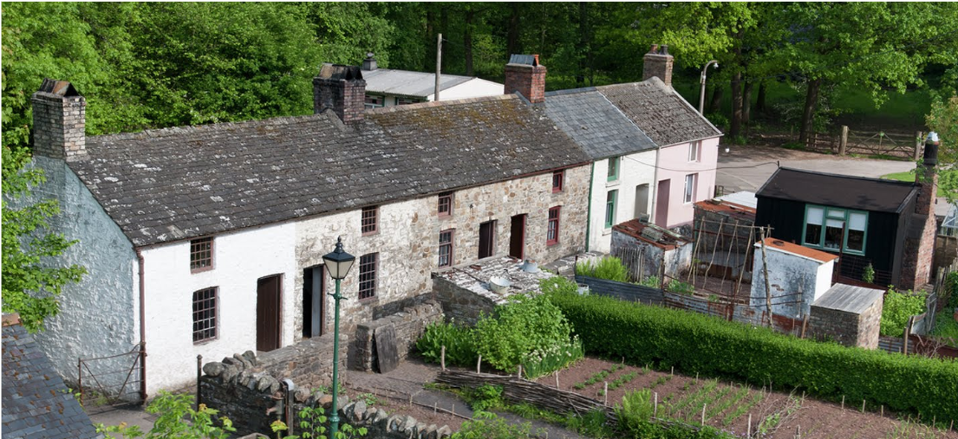
(Google Arts & Culture,2024)

2.0. Images of “Rhyd-y-car Terrace” taken during field visit from university

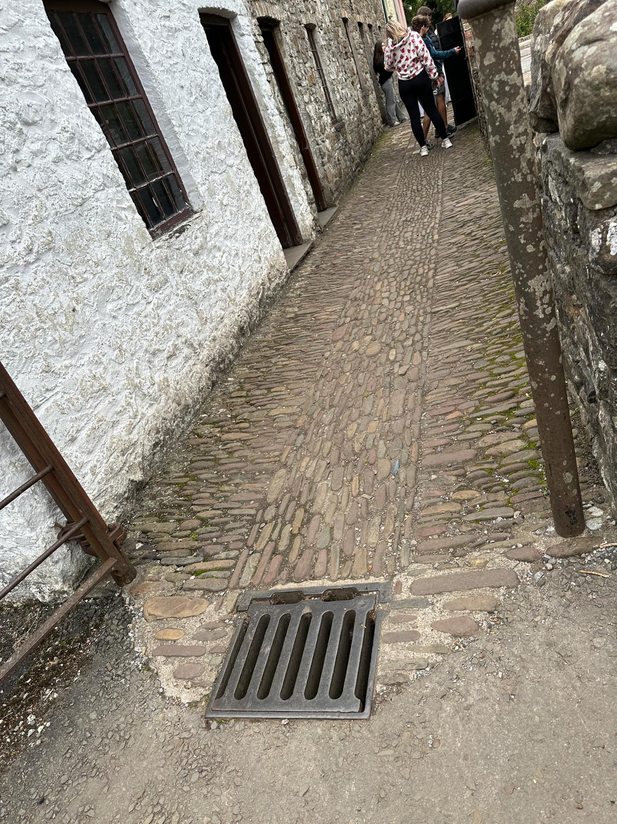
Picture showing drain

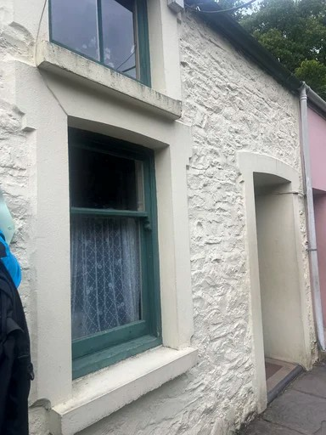

Picture showing rendering in door and window reveal

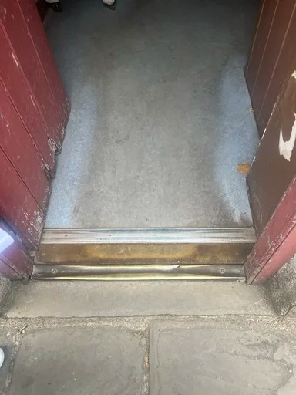

Linoleum flooring with aluminium door bar
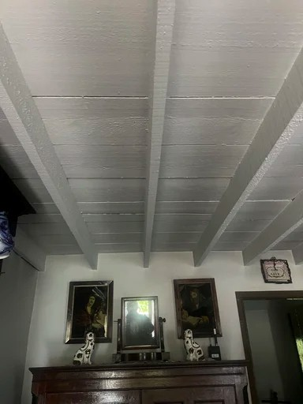

Wooden plank ceiling with wooden joist
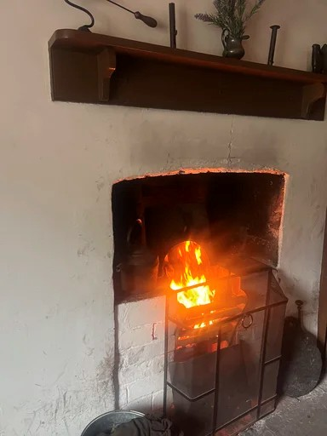
Fireplace

3.0. Windows and Doors
Windows are the glass opening in the walls of the house that helps to let light and air in. They usually have a frame and can be open and close. Frame can be made of woods, metal or plastic. Doors are the panels that allow you to go in and out of rooms or the house. They are usually made of wood, metal or plastic. (Britannica, 2024)
With the time there are lots of changes in construction method, materials etc. The way used to construct windows and doors centuries ago and now have completely changed. Let’s discuss some changes in windows and doors over time in Rhyd-y-car terrace houses by analysing the picture. (Google Arts & Culture, 2024)

1805 - In early 1800 materials were limited. 1805 1st house was built quickly for miners where windows were small and there was no option of opening the window, lots of wooden were used to save glass at that time wood was locally available and glass were expensive. The door was made of solid wood, Ledged and braced door, they were all done manually. Window can’t be open at any time. They were only for letting in light.
1855 - there were basic changes like painting in door and windows for protection. They were all done manually. They look quite like 1805 houses. They can’t be open at any time. They were only for light. Door was still Ledged and braced with frame.
1895 - By this time size of windows are bigger in size and these windows can be open and close as need. Windows can be used to let light and air in. They use more glass less panelled than previous one. The door has upgraded to panel which looks nice.
1925 - There was not much change in the structure of door and window just some decorative changes (similar to1895).
1955 - Modern wooden frame windows with single glazed has introduced. Bigger in size, can be open and close from top as needed. They were made in factory with smooth finishing. Door looks nice, panelled door with glass on top.
1985 - PVC window has introduced by this time there is no trace of wood in the window. They look classy. Window look very nice, painted on both side, 4 panel with semi-circle design glass on top.
In summary early house were basic and cheap (small windows, LB door), Over time mass production of glass and timber making affordable so size of windows and doors got bigger and decorative. By the time late 1980s factory made materials like PVC replaced the traditional wooden windows and door because of durability and cost efficiency.

4.0. Wall Coverings
Wall coverings are a fundamental component in interior design and furnishing. They help define enhance the style and atmosphere of a space, in addition to many other benefits like protecting wall from wear or humidity. (ideal work, 2024)
Let’s discuss about some changes in wall covering from 1805 to 1895 with the help of inside picture. (Museum Wales, 2025)
(1805, 1855, 1895) With the help of images we can clearly see the lime washed in walls and ceiling, they were locally available, cheaper to use and give brighten and good look to room. We can’t see much difference in 1805 and 1855 they both look lime washed. 1895 it is brighter and we can clearly see the wall finishing which looks very smoother than previous ones.1895 wall looks rendered and painted which makes it slightly different from previous.
1925 – By the time 1925 we can clearly see the difference in the wall. They look very classy attractive wallpaper which makes the aesthetical pleasing.
1955 – We can see lots of difference between 1955 and 1925, we can clearly see the wallpaper in the ceiling in 1955 and advancement in the wallpaper. We can see the enamel painting in wall and gloss paint in wood ceiling.
1985 – By the time 1985 we can see the very decorative walls with mix painting and wallpaper.
In summary early 1805 houses were lime washed used to fight damp, mid-century (1855-1895) Improving decoration and comfort. And (1925-1985) Painted plaster modern wallpaper which were durable and aesthetically pleasing.

5.0. Roof Coverings
The roof covering is the outermost layer of the roof assembly, visible from the exterior of structure. This system functions as the primary shield for the building against the elements. The material, colour and texture contribute significantly to the overall aesthetic presentation for the architecture. The choice of this exterior layer is a long-term decision that impacts the integrity and appearance of the entire structure. (Engineer Fix, 2025)
After analysing the picture, it looks like first five houses has got slate and last one has got tiles as a roof covering. In the first 4 houses 1805, 1855,1895 and 1925 they are Welsh slate and are manually produced. In fifth one 1955 it looks well-dressed slate which was manufactured in a factory, looks neater, slate was cut uniformly and looks aesthetically pleasing. Last one 1895 looks like concrete tile roofing which was manufactured in factory. As per the report (Google Arts & Culture,2024) it says the house has been improved up to 1980s standards where modern roof tiles replaced the old slate tiles.

In summary in old days there were no options of machine dressed slate, or tile and slate was available locally in Wales that is why they were cheap at that time. With the time in 1985 last one concrete tile are used instead of slate it is because by the time 1985 tile were cheaper than slate and can be manufactured in a large quantity easily.

6.0. Eaves details and rainwater goods
Rainwater goods can usually be found in our building. They help to manage the rainwater and take it away from the building which reduces the adverse effects of rain to the building. Good conditions rainwater goods help to prolong the life of the building. (The International National Trusts Organisation ,2025)
Eaves are the part of a roof that extends beyond the exterior wall of building creating and overhang. They typically include soffit, fascia, and the structural rafters which support them. They protect walls from water damage, provide essential ventilation and provide an aesthetically appealing look. (Karimi, D.,2025)
The first building which was built in 1805 we can clearly see the downpipe which might be made up of lead or cast iron. At that time there were no good pipeline for water so that downpipe might be built to collect rainwater for house utility purposes rather than structure support to house.
Later in 1855, 1895 and 1925 there is no downpipes which means by that time they might have the water pipe installed, there was no need for collecting water.
In 1955 we can see downpipe by that time people were completely aware of the purpose of downpipe and it looks like the metal downpipe. It is painted to save the metal from corrosion.
Later in 1985 last one was installed with upvc gutter and downpipes. The house has been improved up to 1980s standards. plastic rainwater pipes replaced metal ones. (Google Arts & Culture,2024)
We can see the eaves not very wide nor very narrow. They looked same in all the houses. In the first 4 houses eaves work as a shed for the wall and carry the rainwater directly to the ground from where it goes to drain. Later in last two houses rainwater is carried by gutter, downpipes to ground then to drain.
No gullies were built in any houses instead there is underground drain in between footpath which carries rainwater coming from the roof to ground in first four houses. Later in last two houses rainwater is carried by gutter, downpipes to ground then to drain.

7.0. Floor Covering
Flooring is a term used in construction industry to describe the surface that covers ground or base of a structure. It refers to the material or covering installed of a sub floor or foundation which provides a smooth and durable surface for walking, working and other activities. (Construo, n.d.)
Flooring can be made from various material such as wood, tile, carpet, vinyl etc. Let’s discuss about the flooring in “Rhyd-y-car Terrace” house.
In 1805 house has got the not properly dressed stone flooring at that time stone was easily available so most of the houses at that time uses tile as a flooring. It was same till 1855 and 1895, but the flagstone looks well dressed in 1855 and 1895.
By the time 1925 linoleum flooring has been invented so we can see linoleum flooring and flagstone half and half. Which makes it looks good.
1955 house we can clearly see wooden flooring wall to wall which makes it aesthetically pleasing and rug on top of it which makes it comfortable to walk. By the time 1985 lots has changed and carpet was used as flooring. Which is very comfortable to walk around and keeps the room warm by not letting cold in. (Google Arts & Culture,2024)

8.0. Internal Joinery
Joinery is a skilled practice that involves creating wooden joints and fittings without the use of nails or metal fasteners, resulting in precise joint. It plays an important role in shaping interior design including furniture windows doors and floors. Joinery not only provides structural integrity but also enhances the overall visual appeal of a room. (Coohom.com, 2024)
In the first house 1805 we can see the open fireplace, we can see the open ceiling joist, handmade oak furniture and table. It looks similar in 1855 and 1895.
By the time 1925 couple of extra wood were added to ceiling. In 1955 fireplace was well decorated, glass panel was added to main door. Wall and ceiling were covered with wallpaper. Window looks more attractive.
In 1955 we can see wooden cladding in ceiling and walls. Wall unit has been added to store kitchen stuff. Interior includes in built storage.
In 1985 door has been changed to panelled door with glazing on top which makes it looks very nice. Sofa has been added kept in the middle of the room. The fireplace has been changed to electric. The room has been completely changed to living room by 1985 there was a separate kitchen room. (Google Arts & Culture,2024)

9.0. Summary of Rhyd -Y-Car Terrace cottages Changes over time
Over the time Ryd -Y-Car Terrace cottages evolved from very basic finishes to modern standards. Small timber windows and plank doors of 1805 were replaced by larger modern Upvc windows and Panelled door in 1985. Limewashed walls changes to smooth rendered and painted walls. Eaves details changes from no gutters, cast iron down pipe to modern Upvc gutter and downpipes. Floor changes from stone flooring to carpets and vinyl. Internal joinery changes from simple timber doors to panel doors, simple storage to built in storage and fitted kitchen. Slate roofing in 1805 has been changed to company manufactured concrete tile in 1985.
In my point of view these changes were made partly to overcome defects like poor durability and lack of comfort. In overall these changes demonstrated the shifting from basic survival needs to improved living standards and aesthetic preferences over time.

10.0. Cross Section of Houses (1900, 1950 and 2000)
After analysing these 3 houses we can clearly see some differences and change in way of constructing them over time 1900,1950 and 2000. Following are some major items,
1900 House
- Stone foundation
- Stone wall
- Casement window or sash window
- Stone flooring
- Lath and Plaster to wall and ceiling
- Wooden Lintels to door and windows
1950 House
- Strip concrete foundation
- Concrete floor
- Plasterboard to wall and ceiling
- Brick outside and block inside to wall
- 50mm clear cavity to wall
- Floorboards
- Concrete tiles to roof
- Concrete lintels to windows and door
- Single glazed windows
- Damp proofing course
2000 House
- Strip Concrete foundation (Strip sometimes raft foundation)
- Damp Proofing course
- Suspended concrete floor
- Cavity with insulation to wall
- Ventilator for suspended floor
- Chipboard flooring to floor and ceiling
- Plasterboard to wall and ceiling
- Skim coat to wall and ceiling
- Cavity closure
- Triple glazing upvc window
- Loft Insulation
- Breathable membrane

11.0. References
Google Arts & Culture. (2024). Rhyd-y-car: Miner’s Homes Through Time - Google Arts & Culture. [online] Available at: https://artsandculture.google.com/story/GwWhwQqgrbN8mA [Accessed 7 Nov. 2025].
Museum Wales. (2025). Virtual Tour of Rhyd-y-car: Homes through Time. [online] Available at: https://museum.wales/learning/activity/401/Virtual-Tour-of-Rhyd-y-car-Homes-through-Time-/. [Accessed 7 Nov. 2025].
Idealwork: concrete finishes for internal and external use. (2024). Wall coverings: a guide to an informed choice. [online] Available at: https://www.idealwork.com/wall-coverings-a-complete-guide/ [Accessed 9 Dec. 2025].

Encyclopedia Britannica. (n.d.). window | Description & Facts. [online] Available at: https://www.britannica.com/technology/window. [Accessed 05 Jan. 2026].

Engineer Fix. (2025). What Is Roof Covering? Types, Functions, and Selection. [online] Available at: https://engineerfix.com/what-is-roof-covering-types-functions-and-selection/ [Accessed 9 Dec. 2025].

The International National Trusts Organisation (INTO). (2025). Rainwater goods - The International National Trusts Organisation (INTO). [online] Available at: https://www.into.org/rainwater-goods/ [Accessed 31 Dec. 2025].

Karimi, D. (2025). Weather Shield Roofing. [online] Weather Shield Roofing. Available at: https://weathershieldroofers.com/blog/what-are-roof-eaves-complete-guide/ [Accessed 31 Dec. 2025].

Construo. (n.d.). What is flooring? Definition for flooring in construction & building. [online] Available at: https://construo.io/tags/flooring. [Accessed 05 Jan. 2026].

Coohom.com. (2024). What is Joinery in Interior Design: Understanding the Role and Importance of Joinery in Creating Functional Spaces. [online] Available at: https://www.coohom.com/article/what-is-joinery-in-interior-design [Accessed 5 Jan. 2026].

