DS 1 Template

My Screenshots/Photos
- Please add 4–6 screenshots or photos of your digital life.
- You can use your phone or laptop.
- For each screenshot, write one or two sentences explaining what it shows.

Screenshot/Photo 1
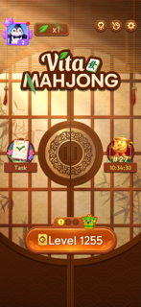
This shows my favourite Chinese tile game

Screenshot/Photo 2
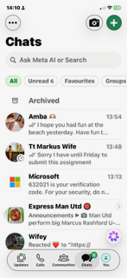
This shows my Whatsapp page

Screenshot/Photo 3
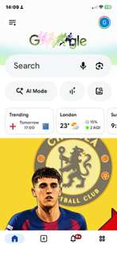
This shows my Google page

Screenshot/Photo 4
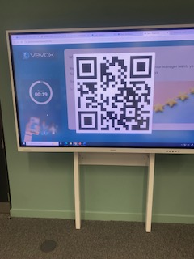
This shows me using a QR Code

Screenshot/Photo 5
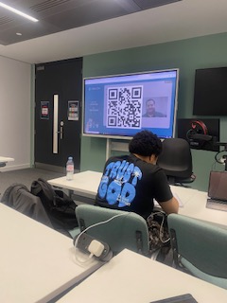
This shows me taking a photo in class

Screenshot/Photo 6
[Insert Photo/Screenshot below]

[Write what this shows of your digital life]

My Short Reflection
- Write 5–8 simple sentences about your digital life.
- You can use the sentence starters below if helpful.
I use digital tools to navigate my way through all my APPS on my phone daily.
I feel confident when I use my phone to Google something online or using my WhatsApp.
I want to improve my knowledge of how to navigate my way around all the aspects of computers and use my phone to its full potential.
I often use these tools every day in one form or another to access one App or another.
I hope this module will help me to gain confidence in the way I use a computer or phone Apps in the future.
Digital skills are important for me because as I want to use all the Apps available to me with confidence in the future. .

Sentence starters
- I use digital tools to …
- I feel confident when I …
- I want to improve …
- I often use these tools: …
- I sometimes feel nervous about …
- I hope this module will help me …
- Digital skills are important for me because …
You can write more if you want.

Submission Checklist
Before you submit, please check:
​​​ ☒ I added 4–6 screenshots
☒ I wrote short sentences for each screenshot
☒ I wrote my short reflection
☒ My work is my own
☒ My file opens correctly
​​☒ My file opens correctly

