BMSP6007: Economics of sustainability.
Global risks.

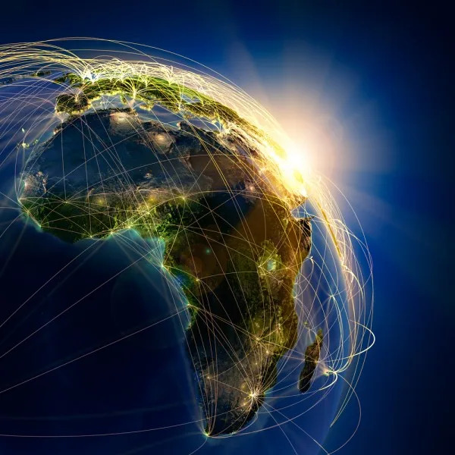

(Yahoo Finance, 2023)

By George Howell.
Executive summary.
The report refers to the World Economic Forum's 'Global Risks 2033' report to identify the world's biggest challenges over the next years. Furthermore, the report discusses the risks of biodiversity loss and ecosystem collapse and considers how these risks may impact sustainable development. Firstly, the report refers to various credible sources to assess the environmental damage caused by human activity.

Secondly, the report considers the potential impact of biodiversity loss and applies several sustainability theories, such as the 'Malthusian Theory of Population', 'Ricardian Theory of Rent', and ‘Environmental Kuznets Curve’. Also, the report refers to the 'Sustainable Development Goals' and discusses their relevance to biodiversity loss and ecosystem collapse. Finally, the report provides three recommendations which outline several measures that Governments can implement to protect global biodiversity.

Table of Contents
1.0. Introduction. 4
2.0. Main body. 5
2.1. Overview of biodiversity loss and ecosystem collapse. 5
2.2. Impact of biodiversity loss and ecosystem collapse. 7
3.0. Conclusion. 10
4.0. Recommendations. 11
5.0. Bibliography. 11

Introduction.

The report's primary aim is to identify a global risk and discuss how the identified risk may impact global efforts on sustainable development. For the purpose of this report, the risks that will be discussed are biodiversity loss and ecosystem collapse. Furthermore, the report will apply several sustainability theories to help understand how biodiversity loss and ecological collapse may impact sustainable development.

To achieve the aim, the report outlines four primary objectives:

- To conduct secondary research to determine the environmental, societal, and economic impact of biodiversity loss and ecosystem collapse.
- To conduct secondary research to identify the main factors contributing to biodiversity loss and ecosystem collapse.
- To apply the Malthusian theory, Neo-Malthusian theory, and Neo-Classical theory to understand how biodiversity loss and ecosystem collapse may impact sustainable development.
- To provide a set of recommendations to support sustainable development and reduce the risk of biodiversity loss and ecosystem collapse.

Each year the World Economic Forum (WEF) publishes an annual report titled ‘Global Risks’. The report outlines several global risks and discusses the potential environmental, geopolitical, social, and economic implications. Furthermore, the report discusses various strategies that can be implemented to address the world’s biggest challenges. Additionally, findings presented in the report are gathered from the ‘Global Risks Perception Survey’ (GRPS), an annual study that gathers responses from 1,200 experts across various industries and fields (WEF, 2023).

In chapter two of its most recent ‘Global Risks’ report, the (WEF) outlined the most significant risks for the next ten years. The diagram below shows the responses from the (GRPS) and ranks each risk by severity. The findings reveal that respondents believe the four biggest challenges over the next ten years are environmental risks such as climate change, natural disasters, extreme weather events, biodiversity loss, and ecosystem collapse. Therefore, the report will explore the threat of biodiversity loss and ecosystem collapse in greater depth and identify the solutions that can be implemented to address the challenges posed by this risk.
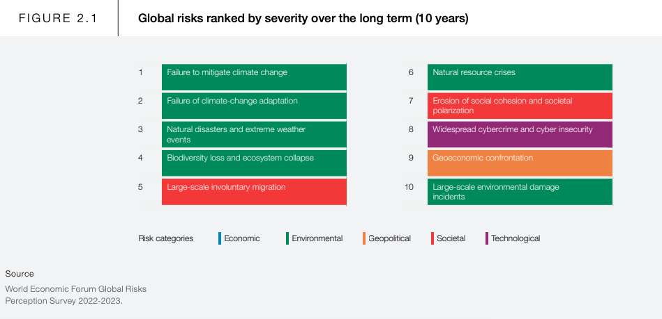

(WEF, 2023).

2.0. Main body.

2.1. Overview of biodiversity loss and ecosystem collapse.
An article published by the National Geographic Society (NGS) (2022) explains that biodiversity refers to all living things on Earth, including animals, plants, bacteria, and humans. Furthermore, research conducted by Mora et al., (2011) reveals that there are approximately 8.7 million types of species globally, and the majority of species are insects that live on land. Moreover, an ecosystem refers to a geographic area where biotic factors such as plants and animals interact with abiotic factors such as soil and water (NGC, 2022).

An article published by Earth.Org defines biodiversity loss as “the loss of life on Earth at various levels, ranging from reductions in the genetic diversity to the collapse of entire ecosystems” (Earth.Org, 2022). Furthermore, Dearing (2020) explains that ecological collapse occurs when ecosystems lose structure, function, and size. Moreover, ecosystem collapse drastically changes the natural landscape and causes extinction among some species (Lewis, 2011).

According to an article published by the European Parliament (2021), the primary causes of biodiversity loss and ecosystem collapse include land use, overexploitation of natural resources, climate change, pollution, and invasive species. Furthermore, an article published by the Royal Society (2020) explains that changes in human consumption have increased the demand for natural resources such as water, air, sand, and fossil fuels. Moreover, the majority of natural resources are used to support human activities such as agriculture, mining, industrial construction, and urban development.

In 2022, the World Wide Fund for Nature (WWF) published the 14th edition of the ‘Living Planet Report’. The report provides a comprehensive analysis of the impact of human activity on global biodiversity and natural ecosystems. Furthermore, the report is underpinned by the ‘Living Planet Index’ (LPI), a scientific indicator that measures the health of global biodiversity based on population trends among various species across different ecosystems (LPI, 2022). Additionally, the report uses 'Ecological Footprint', which is a metric that measures human demand for natural resources (Global Footprint Network, n/a).

Findings from the report reveal that wildlife populations have decreased by an average of 69% since 1970. Furthermore, data gathered from the report shows that freshwater populations have decreased by an average of 83% over the same period (WWF, 2022). Also, the report measures biodiversity loss by region to highlight the areas most at risk of ecosystem collapse. The diagram shows that biodiversity in Latin America and the Caribbean has decreased by an average of 94% since 1970. Additionally, the data shows that biodiversity in Africa has decreased by an average of 66% over the same period (WWF, 2022).
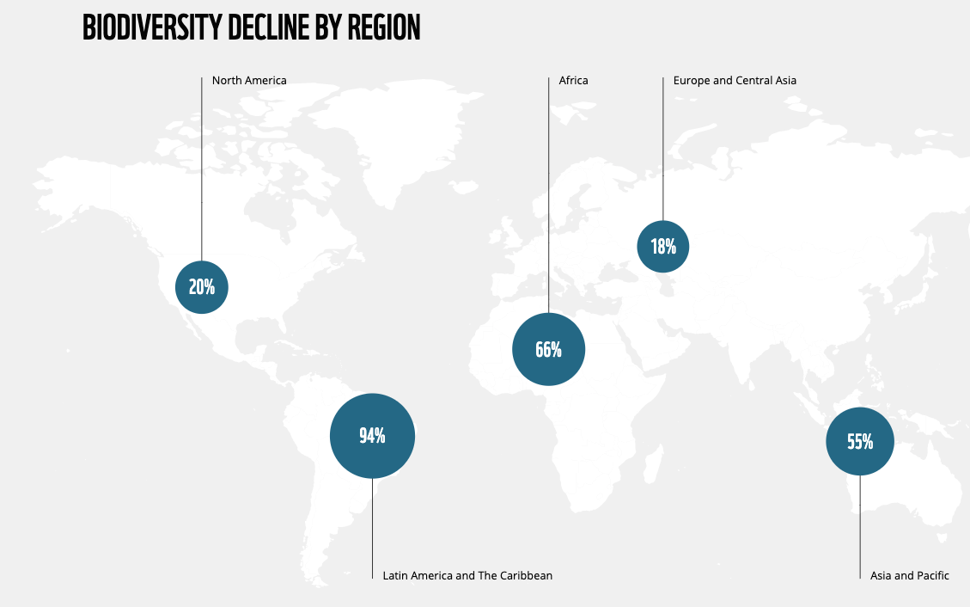

(WWF, 2022).
Firstly, agriculture practices have a significant impact on biodiversity and natural ecosystems. For example, a report published by Chatham House (2021) reveals that global food production is the primary cause of biodiversity loss, and approximately 49% of habitable land is used for agriculture worldwide. Furthermore, findings from the report show that agriculture is responsible for 80% of global land-use change and approximately 42 million hectares of forest were lost due to ranching in Latin America between 1980 and 2000 (Chatham House, 2021). Moreover, data published by Statista (2020) reveals that an estimated 420 million hectares of forest have been destroyed worldwide since 1990.

Secondly, climate change is a key driver of biodiversity loss and poses several risks to ecosystems worldwide. For example, an article published by the (UN) (2022) explains that rising global temperatures could alter natural ecosystems, and approximately 1 million species are at risk of extinction over the next two decades. Furthermore, the article states that if the average global temperature exceeds 3 degrees Celsius (°C), approximately 41% of mammals would lose half of their habitat worldwide (UN, 2022). Additionally, climate change poses several risks to coral reefs, and since 2009, the total number of coral reefs worldwide has declined by approximately 14% (Statista, 2021).

Thirdly, pollution has a negative impact on global biodiversity and natural ecosystems. For example, an article published by the International Union for Conservation of Nature (IUCN) (2021) states that an estimated 14 trillion tonnes of plastic waste enter the ocean annually.
Furthermore, research shows that approximately 100 thousand sea mammals and 1 million sea birds die each year because of plastic pollution in the ocean (Keep Britain Tidy, 2022).
Also, research published by Tang et al., (2021) shows that 64% of agricultural land worldwide is at risk of pesticide pollution. Additionally, the agriculture industry is responsible for approximately 35% of all greenhouse gas (GHG) emissions worldwide (UN, 2021).

Fourthly, invasive species are a key driver of biodiversity loss and ecosystem collapse. In 2019, the Intergovernmental Science-Policy Platform on Biodiversity and Ecosystem Services (IPBES) published the ‘Global Assessment Report on Biodiversity and Ecosystem Services’. Findings from the report show that there has been a 70% increase in the number of invasive species across 21 countries that have been studied since 1970 (IPBES, 2019).
Additionally, research shows that invasive species contribute to approximately 33% of animal extinctions worldwide (Blackburn et al., 2019).

Finally, an article published by the Royal Society (2022) states that human population growth has a negative impact on biodiversity and natural ecosystems. According to data published by Statista (2022), the human population is approximately 8 billion. Moreover, the human population is expected to reach 10 billion by 2060 (Statista, 2022). Consequently, the demand for natural resources increases as the human population increases (UN, 2017).

An article published by the Guardian (2020) reveals that humans extract an estimated 100 billion tonnes of natural resources annually. Also, research shows that the global consumption of natural resources will likely increase to 186 billion tonnes annually by 2050 (UN, 2017). Lambert (2019) states that the overexploitation of natural resources leads to biodiversity loss and land degradation. For example, data published by the Global Environment Facility (GEF) (2022) reveals that approximately 25% of Earth’s total land area has been significantly degraded.

2.2. Impact of biodiversity loss and ecosystem collapse.
An article published by the (WEF) (2020) reveals that approximately half of global gross-domestic-product (GDP) is dependent on natural ecosystems. However, research suggests that ecological collapse would have severe economic consequences and would significantly reduce global (GDP) (WEF, 2020). Furthermore, the agriculture sector is highly dependent on natural resources such as soil, water, and land. Therefore, biodiversity loss poses several threats to global food security, and the collapse of ecosystems could significantly reduce the global food supply (WEF, 2020).

An article published by the (UK) Parliament (2022) defines food security as “a measure of people’s access to safe and nutritional food”. However, data published by the (UN) (2021) reveals that in 2020, an estimated 811 million people were undernourished worldwide. Also, research suggests that approximately 2.37 billion people do not have access to adequate food (UN, 2021). Furthermore, research conducted by the World Food Programme (2021) reveals that an estimated 42 million people are at risk of famine, which is considered an emergency level of hunger.

This trend supports the ‘Malthusian Theory of Population’, a theory developed by economist Thomas Malthus. The theory posits that the human population grows faster than the global food supply. Furthermore, the theory is underpinned by the 'Law of Diminishing Returns', which states that after an optimal level of production is reached, everything produced after this point results in smaller levels of output (Investopedia, 2022). Therefore, the theory states that there is an imbalance between human population growth and food supply, thus creating a food shortage if the population grows exponentially (Economics Online, 2019).

Similarly, economist David Ricardo argued that there are biophysical limits to economic growth and that growth in the human population leads to the overexploitation of agricultural land. Furthermore, Ricardo developed the 'Ricardian Theory of Rent', which posits that as the human population increases, the demand for land increases, thus increasing the price of land. However, as the price of land increases, the quality of land decreases, which leads to diminishing returns (Investopedia, 2022).

The graph (figure 1) shows the average price for farmland in the United Kingdom (UK) since 1992. Interestingly, the data shows that the price of farmland has increased substantially since 1993, which supports the ‘Ricardian Theory of Rent’. Furthermore, as the demand for land has increased, the demand for food has also increased, which has led to higher food prices (UN, 2021). For example, the graph (figure 2) shows that the ‘World Food Price Index’ has sharply increased since 2000.

Figure 1.
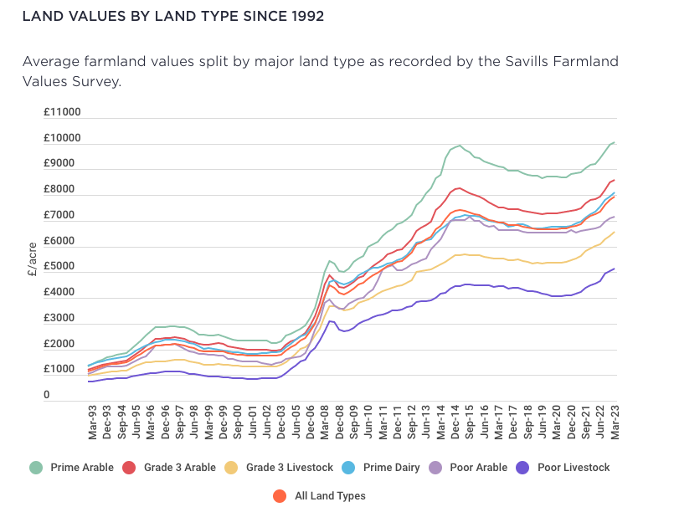

(Savills, 2023).

Figure 2.
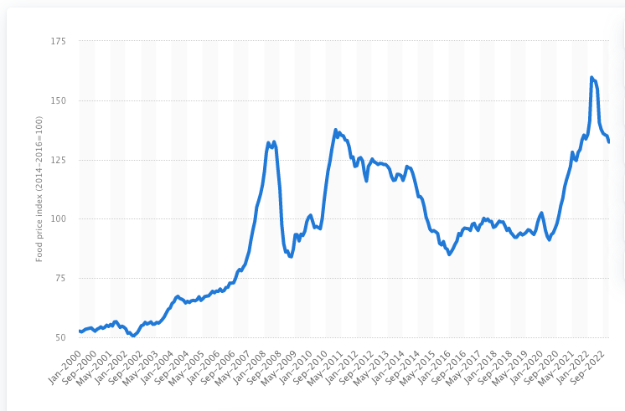

(Statista, 2023).

Overall, Malthusian and neo-Malthusian theorists argue that there are biophysical limits to economic and population growth. Furthermore, theorists who support this viewpoint believe that Earth’s resources are finite and that economic growth leads to biodiversity loss and ecosystem collapse. However, neo-Classical theorists argue that economic growth is an effective strategy for reducing humanity's environmental impact. Furthermore, some theorists suggest that economic growth helps to reduce pollution and limit the environmental damage caused by human activity (Steiguer, 1995).

For example, economist Simon Kuznets developed the ‘Environmental Kuznets Curve’ (EKC), which posits that environmental degradation decreases once countries reach an optimal level of (GDP). Furthermore, the theory suggests that as countries grow their economies, they develop more efficient processes and utilise innovative technologies to extract natural resources more effectively, which helps to reduce pollution.

The diagram (figure 3) shows that as countries move towards industrialisation, they significantly impact the environment. However, once (GDP) reaches a certain point, countries transition to a service-based economy which helps to reduce high levels of industrial pollution.

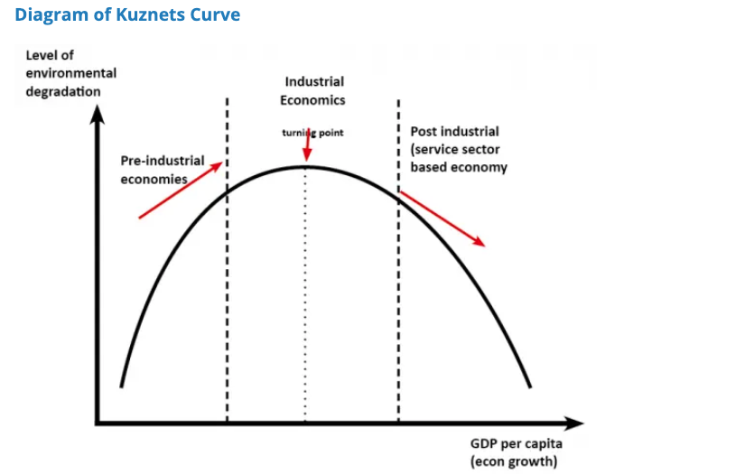
Figure 3.

(Economics Help, 2019)
Interestingly, research conducted by the Office for National Statistics (ONS) supports the (EKC) theory and shows that there is a decoupling between the (UK's) (GDP) rate and (C02) emissions. The findings show that between 1985 and 2016, (GDP) per capita increased by 70.7%, whereas (C02) emissions reduced by 34.2% (ONS, 2019).

Furthermore, the research paper suggests that several factors have contributed to the trend, such as Government regulations, the emergence of new industries and technological advances. For example, the (UK) Government introduced the ‘Climate Change Act 2008’ which states that the (UK) must achieve net zero (CO2) emissions by 2050 (Gov.UK, 2023).

However, a disadvantage of the (EKC) theory is that it does not account for indirect pollution caused by international trade (ONS, 2019). For example, in 2020, the (UK) imported approximately $75 billion worth of goods and services from China (Statista, 2021). However, the data shows that in 2021, China’s total (C02) emissions were approximately 11.47 billion metric tonnes, making it the largest polluter of (CO2) worldwide (Statista, 2022).

Furthermore, the diagram (figure 4) shows global (C02) emissions from 1940 to 2021. The data shows that global (C02) emissions have increased by approximately 60% since 1990. Therefore, the data shows that economic growth has a negative impact on biodiversity loss and ecosystem collapse.
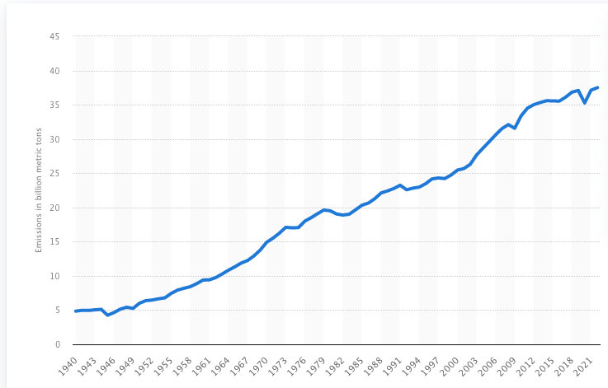

(Statista, 2022).

2.3. Sustainable development goals (SGDs).
In response to the environmental damage caused by human activity and economic growth, the (UN) developed the (SDGs). The (SDGs) were introduced in 2015 and consist of 17 goals that address various global challenges, such as poverty, climate change, environmental degradation, and inequality. Also, 193 countries have agreed to attempt to achieve the (SDGs) by 2030 (UN, 2015). Furthermore, several of the (SGDs) are focussed on preventing biodiversity loss and ecosystem collapse.

For example, goal 15 of the (SDGs) ‘Life on Land’ is focussed on protecting biodiversity and restoring natural ecosystems. Furthermore, the primary objective of the goal is to combat climate change and reduce the environmental damage caused by human activity (UN, n.a). Also, goal 12 of the (SGDs) 'Responsible Consumption and Production', addresses the overexploitation of natural resources and promotes sustainable development (UN, n.a).

Furthermore, the goal promotes the principles of a circular economy, an economic model that attempts to extend the product life cycle through reusing, recycling, re-purposing, and refurbishing (EU, 2015). Therefore, to address the risks posed by biodiversity loss and ecosystem collapse, it is essential that Governments and business leaders implement strategies that align with the (SGDs).

3.0. Conclusion.
To conclude, the report has discussed the global risk of biodiversity loss and ecosystem collapse. Furthermore, the data presented in the report highlights the extent to which human activity has caused catastrophic damage to global biodiversity. Also, the findings suggest that biodiversity loss could significantly reduce global (GDP) and negatively impact global food security. Additionally, the report discussed Malthusian and neo-Malthusian theories, which suggest that exponential human population growth leads to resource scarcity and land degradation.

Secondly, the report applied the (EKC) theory, which shows a decoupling between (GDP) and (C02) emissions in the (UK). However, the model does not factor in indirect pollution caused by international trade. Finally, the report referred to the (SGDs) and discussed the goals that are focussed on reversing the environmental damage caused by human activity. Overall, findings from the report show that biodiversity loss and ecosystem collapse are significant global risks. Furthermore, to address the global risk, Governments and businesses must work towards the (SDGs) and implement sustainable practices that protect biodiversity.

4.0. Recommendations.
This section of the report presents three recommendations that aim to reduce the risk of biodiversity loss and ecosystem collapse. The recommendations are:

- To reverse biodiversity loss by establishing protected areas on land.

As stated, the primary cause of biodiversity loss and ecosystem collapse is deforestation and cattle ranching. Furthermore, both practices cause land degradation and air pollution. Therefore, Governments should introduce legislation to establish protected areas on land to promote biodiversity and reduce the environmental impact caused by deforestation and agriculture.

- To impose excise taxes on meat to reduce consumption.

Secondly, the findings presented in the report show that the agriculture sector emits approximately 35% of all (GHG) emissions globally. Therefore, to address the market failure and internalise the negative externality, Governments should use market-based solutions and impose excise taxes on meat to reduce consumption.

- To implement deposit-return schemes to reduce plastic waste pollution.

As stated, findings from the report show that 14 trillion tonnes of plastic waste are thrown into the ocean annually. Therefore, to reduce plastic waste pollution and protect the ocean, Governments should implement deposit-return schemes to encourage consumers to return plastic containers to businesses once empty.

5.0. Bibliography.

Blackburn, T., Bellard, C., & Ricciardi, A. (2019). Alien versus native species as drivers of recent extinctions. Frontiers in Ecology and the Environment. Vol. 17. (4). Pp- 203-207.
https://esajournals.onlinelibrary.wiley.com/doi/abs/10.1002/fee.2020
(Accessed 07/06/2023).

Chatham House. (2021). Food system impacts on biodiversity loss.
https://www.chathamhouse.org/sites/default/files/2021-02/2021-02-03-food-system-biodiversity-loss-benton-et-al_0.pdf
(Accessed 06/06/2023).

Dearing, J. (2020). One-fifth of ecosystems in danger of collapse: Here’s what that might look like.
https://theconversation.com/one-fifth-of-ecosystems-in-danger-of-collapse-heres-what-that-might-look-like-148137
(Accessed 05/05/2023).

Earth.Org. (2022). Biodiversity loss definition and examples.
https://earth.org/biodiversity-loss-definition-and-examples/
(Accessed 05/05/2023).

Economics Help. (2019). Environmental Kuznets curve.
https://www.economicshelp.org/blog/14337/environment/environmental-kuznets-curve/
(Accessed 07/05/2023).

Economics Online. (2021). What is the Malthusian theory of population?
https://www.economicsonline.co.uk/managing_the_economy/what-is-the-malthusian-theory-of-population.html/
(Accessed 07/05/2023).

European Parliament. (2021). Biodiversity loss: What is causing it and why is it a concern?
https://www.europarl.europa.eu/news/en/headlines/society/20200109STO69929/biodiversity-loss-what-is-causing-it-and-why-is-it-a-concern
(Accessed 06/05/2023).

European Parliament. (2015). Circular economy: Definition, importance and benefits.
https://www.europarl.europa.eu/news/en/headlines/economy/20151201STO05603/circular-economy-definition-importance-and benefits#:~:text=The%20circular%20economy%20is%20a,reducing%20waste%20to%20a%20minimum
(Accessed 07/06/2023).

Global Environment Facility. (2022). Land degradation.
https://www.thegef.org/what-we-do/topics/land-degradation
(Accessed 07/05/2023).

Global Footprint Network. (n/a). Ecological footprint.
https://www.footprintnetwork.org/our-work/ecological-footprint/
(Accessed 06/05/2023).

Gov.UK. (2023). Climate Change Act 2008.
https://www.legislation.gov.uk/ukpga/2008/27/part/1/crossheading/the-target-for-2050
(Accessed 07/05/2023).

Guardian. (2020). World’s consumption of materials hits record 100bn tonnes a year.
https://www.theguardian.com/environment/2020/jan/22/worlds-consumption-of-materials-hits-record-100bn-tonnes-a-year
(Accessed 07/05/2023).

Intergovernmental Science-Policy Platform on Biodiversity and Ecosystem Services. (2019). Global assessment report on biodiversity and ecosystem services.
https://www.ipbes.net/global-assessment
(Accessed 07/05/2023).

International Union for Conservation of Nature. (2021). Marine plastic pollution.
https://www.iucn.org/resources/issues-brief/marine-plastic-pollution
(Accessed 06/05/2023).

Investopedia. (2022). Law of diminishing marginal returns: Definition, example, use in economics.
https://www.investopedia.com/terms/l/lawofdiminishingmarginalreturn.asp
(Accessed 07/05/2023).

Investopedia. (2022). Who is David Ricardo and what is he famous for?
https://www.investopedia.com/terms/d/david-ricardo.asp
(Accessed 07/05/2023).

Keep Britain Tidy. (2022). Plastic’s impact on wildlife.
https://www.keepbritaintidy.org/get-involved/support-our-campaigns/plastic-challenge/impactwildlife#:~:text=Every%20year%2C%20plastic%20kills%201,sea%20mammals%2C%20turtles%20and%20fish.
(Accessed 07/05/2023).

Lampert, A. (2019). Over-exploitation of natural resources is followed by inevitable declines in economic growth and discount rate. Nature Communications Journal. Vol. 10. (1). Pp.
1419.
https://www.nature.com/articles/s41467-019-09246-2
(Accessed 07/06/2023).

Lewis, R. (2011). Species loss tied to ecosystem collapse and recovery.
https://news.brown.edu/articles/2011/01/extinction
(Accessed 06/05/2023).

Living Planet Index. (2022). Data and monitoring.
https://www.livingplanetindex.org/
(Accessed 06/05/2023).

Mora, C., Tittensor, D., Adl, S., Simpson, A., & Worm, B. (2011). How many species are there on earth and in the ocean? PLOS Biology Journal. Vol. 9. (8). Pp. 1-9.
https://journals.plos.org/plosbiology/article/info:doi/10.1371/journal.pbio.1001127
(Accessed 05/05/2023).

National Geographic Society. (2022). Biodiversity.
https://education.nationalgeographic.org/resource/biodiversity/
(Accessed 05/05/2023).

National Geographic Society. (2022). Ecosystem.
https://education.nationalgeographic.org/resource/ecosystem/
(Accessed 05/05/2023).

Office for National Statistics. (2019). The decoupling of economic growth carbon emissions: UK evidence.
https://www.ons.gov.uk/economy/nationalaccounts/uksectoraccounts/compendium/economicreview/october2019/thedecouplingofeconomicgrowthfromcarbonemissionsukevidence
(Accessed 07/05/2023).

Savills UK. (2023). Rural land values.
https://www.savills.co.uk/landing-pages/rural-land-values/rural-land-values.aspx
(Accessed 07/06/2023).

Statista. (2022). Annual C02 emissions worldwide 1940-2022.
https://www.statista.com/statistics/276629/global-co2-emissions/#:~:text=Global%20carbon%20dioxide%20emissions%20from,by%20more%20than%2060%20percent
(Accessed 07/06/2023).

Statista. (2021). Chart: The biggest coral reef regions of the world.
https://www.statista.com/chart/25924/size-of-largest-coral-reef-areas-by-region/
(Accessed 06/05/2023).

Statista. (2022). China: C02 emissions 1960-2021.
https://www.statista.com/statistics/239093/co2-emissions-in-china/#:~:text=Carbon%20dioxide%20emissions%20emissions%20in%20China%201960%2D2021&text=China%20released%2011.47%20billion%20metric,world%27s%20largest%20polluter%20that%20year
(Accessed 07/05/2023).

Statista. (2023). Food price index worldwide 2022.
https://www.statista.com/statistics/1111134/monthly-food-price-index-worldwide/
(Accessed 07/05/2023).

Statista. (2020). Global deforestation rate by climatic domain.
https://www.statista.com/statistics/1292859/global-rate-of-deforestation-by-climatic-domain/
(Accessed 06/05/2023).

Statista. (2022). Population – Statistics & facts.
https://www.statista.com/topics/776/population/#topicOverview
(Accessed 07/05/2023).

Statista. (2021). UK imports of trade goods from China 2020.
https://www.statista.com/statistics/477961/united-kingdom-uk-import-value-trade-goods-from-china/
(Accessed 07/05/2023).

Steiguer, J-E. (1995). Three theories from economics about the environment. BioScience Journal. Vol. 45. (8). Pp. 552-557.
https://www.jstor.org/stable/1312701?seq=3
(Accessed 07/05/2023).

Tang, F., Lenzen, M., McBratney, A., & Maggi, F. (2021). Risk of pesticide pollution at the global scale. Nature Geoscience Journal. Vol. 14. (1). Pp. 206-210.
https://www.nature.com/articles/s41561-021-00712 5#:~:text=We%20find%20that%2064%25%20of,lower%2Dmiddle%2Dincome%20nations
(Accessed 06/05/2023).

The Royal Society. (2022). How does the growing global population affect biodiversity.
https://royalsociety.org/topics-policy/projects/biodiversity/how-does-the-growing-global-population-and-increasing-consumption-affect-biodiversity/
(Accessed 07/06/2023).

The Royal Society. (2020). What is the human impact on biodiversity.
https://royalsociety.org/topics-policy/projects/biodiversity/human-impact-on-biodiversity/#:~:text=The%20main%20direct%20cause%20of,timber%20which%20drives%20around%2020%25.
(Accessed 06/05/2023).

UK Parliament. (2022). Impact of climate change and biodiversity loss on food security.
https://lordslibrary.parliament.uk/impact-of-climate-change-and-biodiversity-loss-on-food-security/#heading-1
(Accessed 07/05/2023).

United Nations. (2021). Food systems account for over one-third of global greenhouse gas emissions.
https://news.un.org/en/story/2021/03/1086822
(Accessed 07/05/2023).

United Nations. (2021). Global issues: Food.
https://www.un.org/en/globalissues/food#:~:text=It%20is%20estimated%20that%20between,pandemic%20on%20global%20food%20security.
(Accessed 07/05/2023).

United Nations. (n.a). Goal 15: Life on land.
https://www.unep.org/explore-topics/sustainable-development-goals/why-do-sustainable-development-goals-matter/goal-15
(Accessed 07/05/2023).

United Nations. (n.a). Goal 12: Sustainable consumption and production.
https://www.unep.org/explore-topics/sustainable-development-goals/why-do-sustainable-development-goals-matter/goal-12
(Accessed 07/05/2023).

United Nations. (2015). 193 Member states: United Nations sustainable development.
https://www.un.org/sustainabledevelopment/blog/tag/193-member-states/
(Accessed 07/05/2023).

United Nations. (2017). Smarter use of natural resources can inject $2 trillion into global economy by 2050.
https://news.un.org/en/story/2017/03/553452
(Accessed 07/05/2023).

United Nations. (2022). UN Report: Nature’s dangerous decline ‘unprecedented; ‘species extinction rates accelerating’.
https://www.un.org/sustainabledevelopment/blog/2019/05/nature-decline-unprecedented-report/
(Accessed 06/05/2023).

World Economic Forum. (2020). Half of world’s GDP moderately or highly dependent on nature.
https://www.weforum.org/press/2020/01/half-of-world-s-gdp-moderately-or-highly-dependent-on-nature-says-new-report/
(Accessed 07/05/2023).

World Economic Forum. (2020). Nature loss is eating away at our food supply and diversity.
https://www.weforum.org/agenda/2020/03/world-wildlife-day-biodiversity-nature-loss-future-of-food/
(Accessed 07/05/2023).

World Economic Forum. (2023). The global risks report 2023. (18th edition).
https://www3.weforum.org/docs/WEF_Global_Risks_Report_2023.pdf
(Accessed 05/05/2023).

World Food Programme. (2021). 45 Million people at risk of famine require urgent intervention.
https://www.wfp.org/stories/45-million-people-are-famines-door
(Accessed 07/05/2023).

World Wide Fund for Nature. (2022). Living planet report 2022. (14th edition).
https://www.wwf.org.uk/sites/default/files/2022-10/lpr_2022_full_report.pdf
(Accessed 06/05/2023).

