COMMUNITY ENGAGEMENT OF AUTOTRADER
Student’s name:Anamaria-Roxana Surdu
Institution affiliation:University Of Wales Trinity Saint David London
Profesor’s name:Olusoyi Ashaye
Course:Community Engagement
Date:12.05.2021

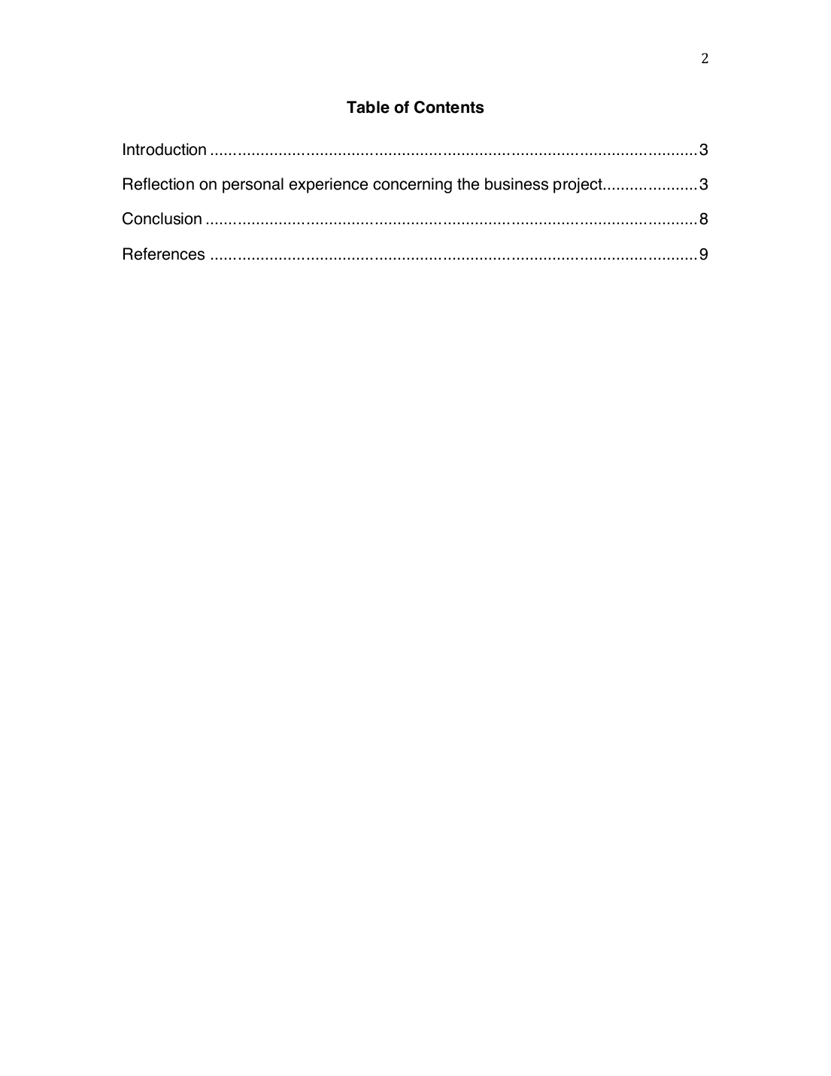
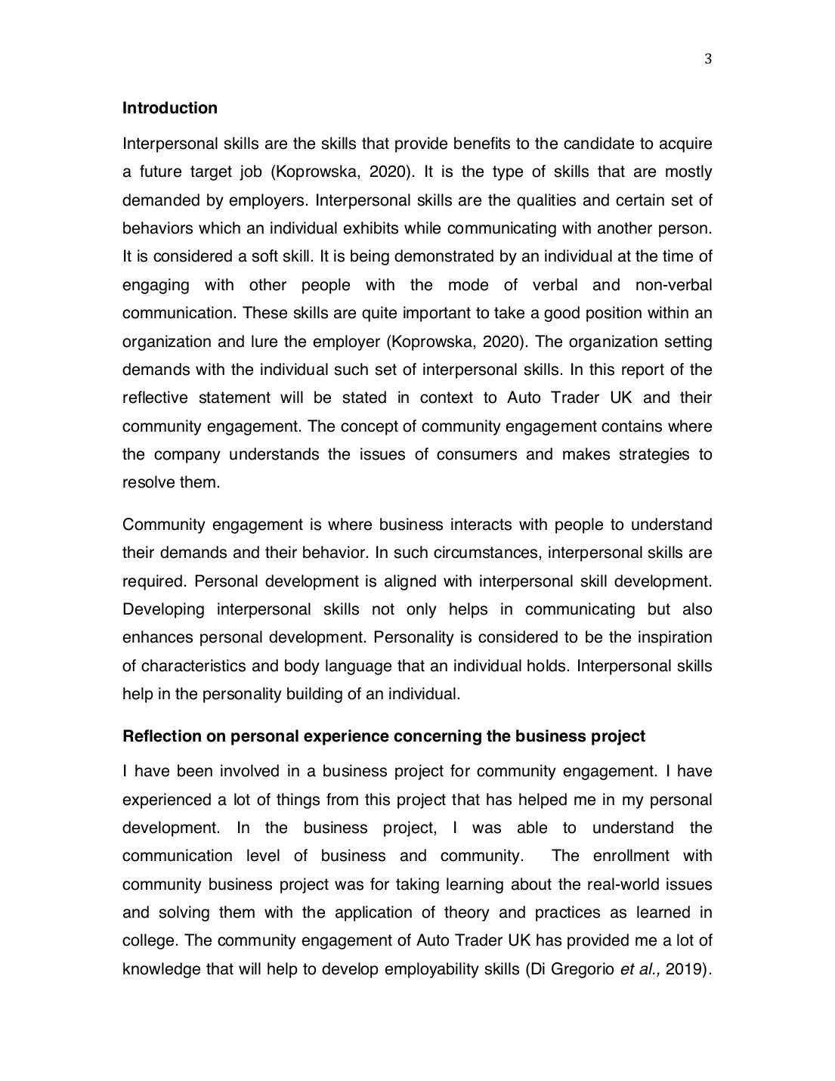
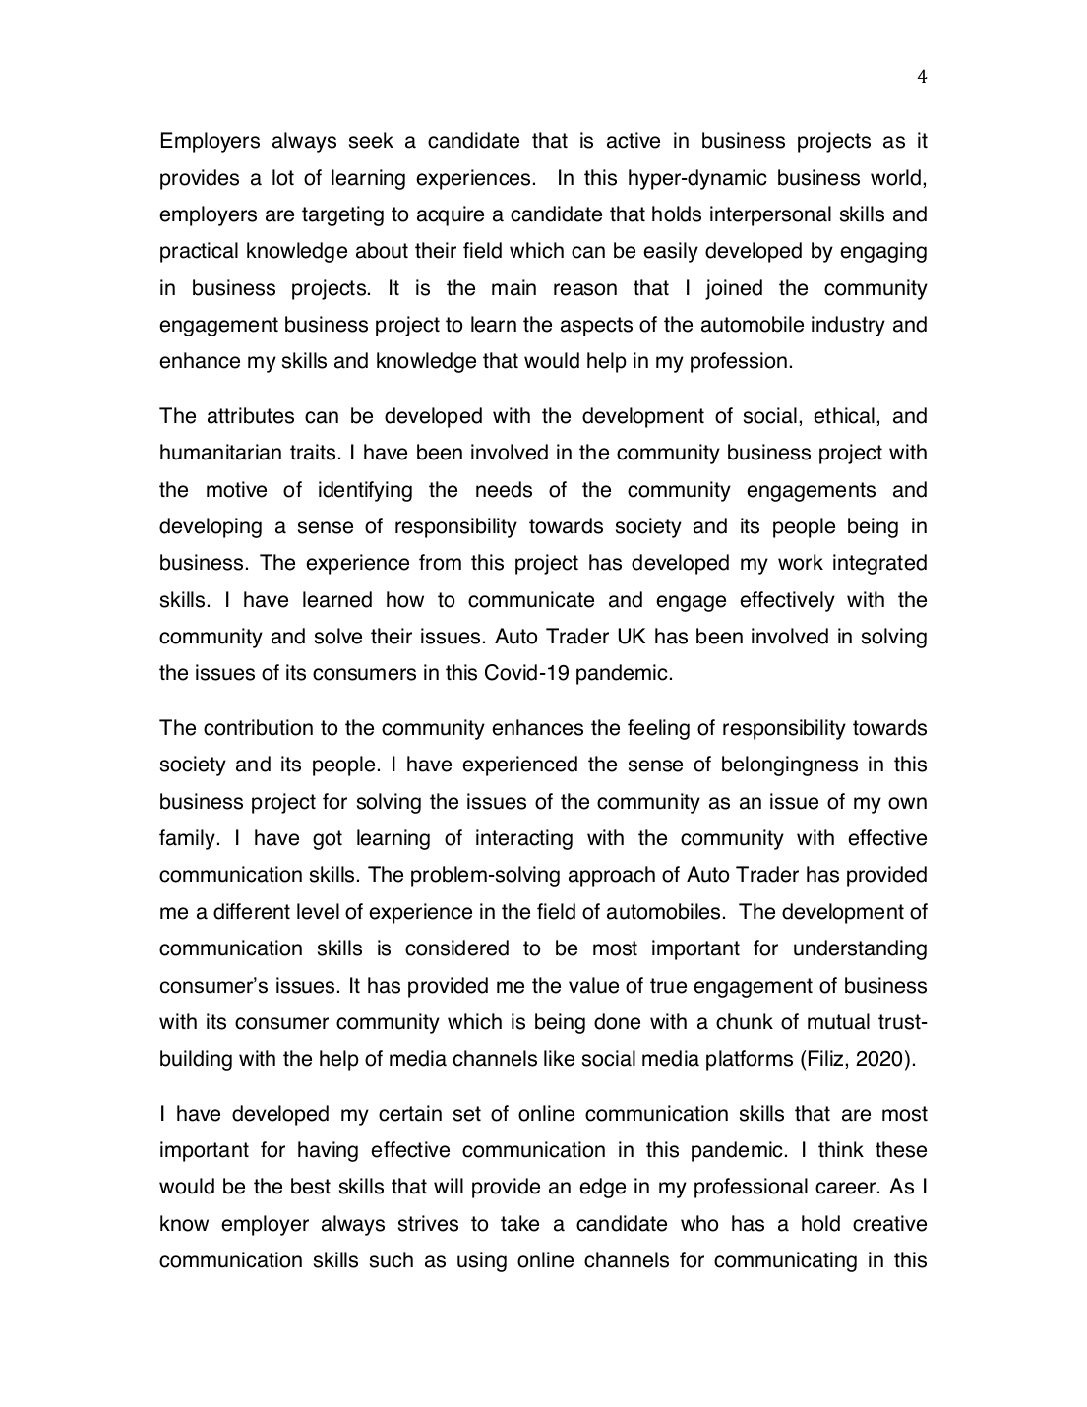
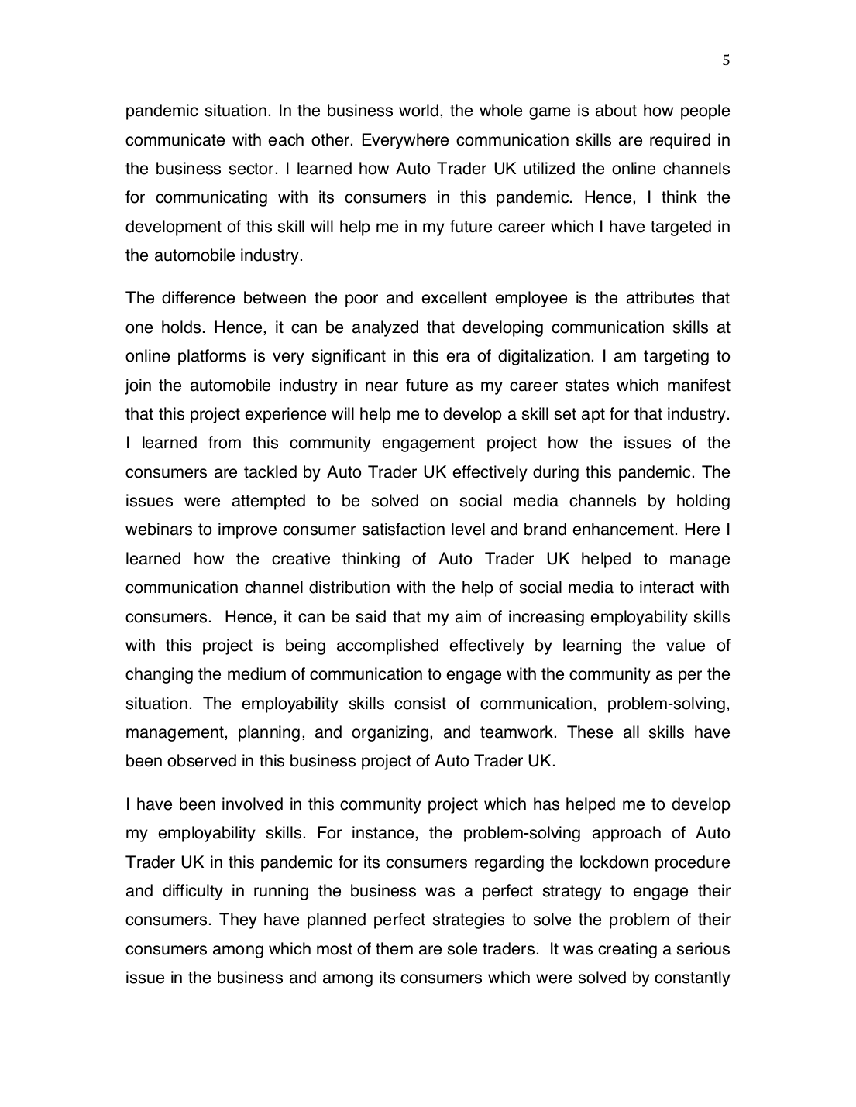
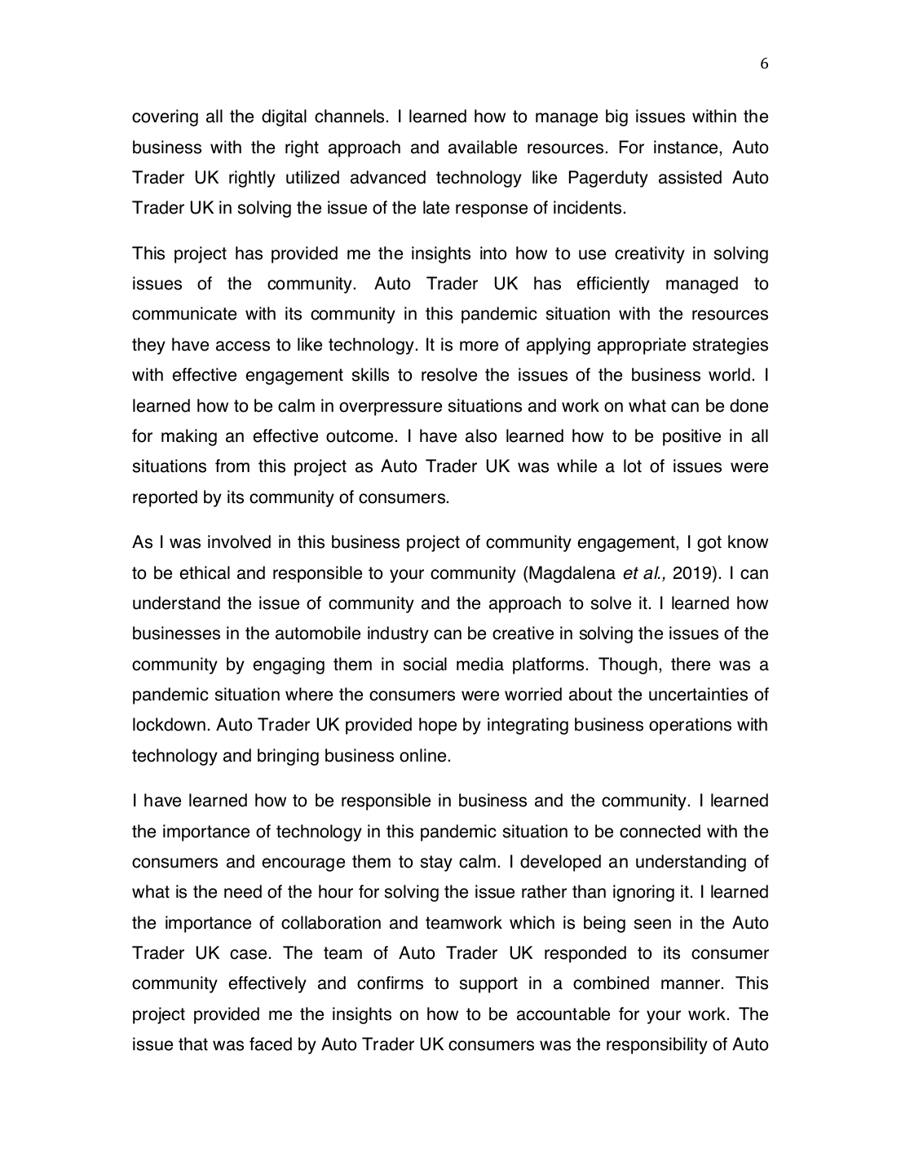
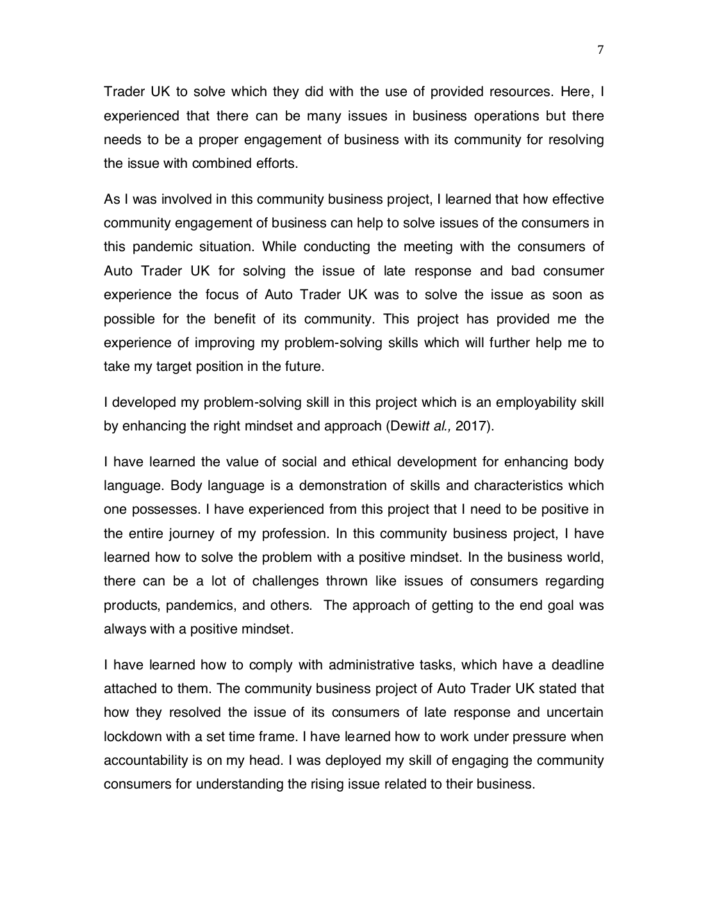
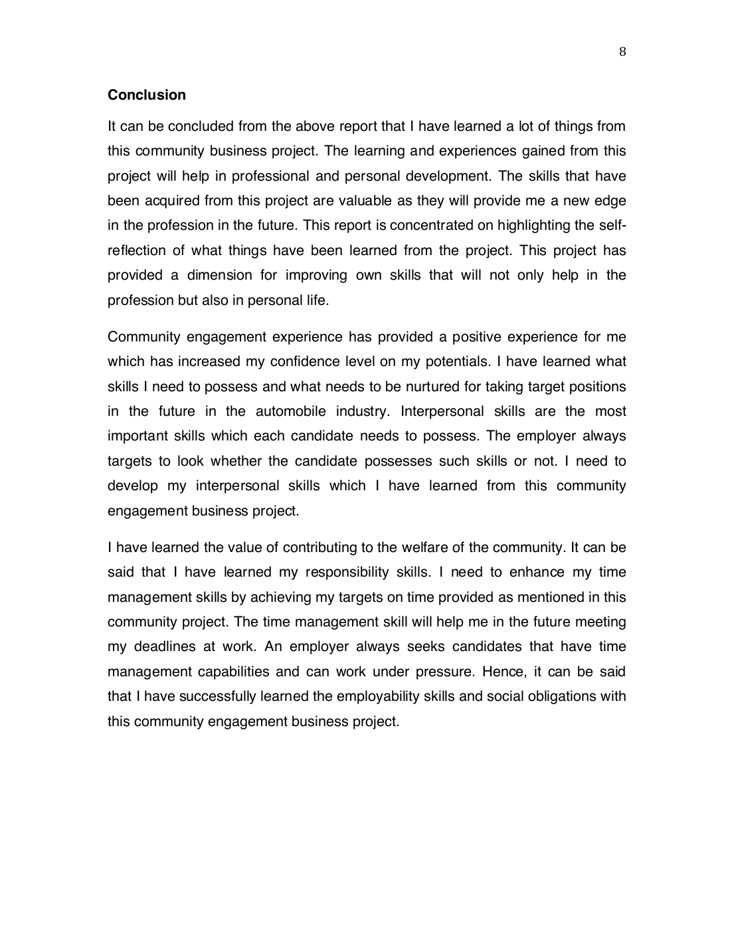
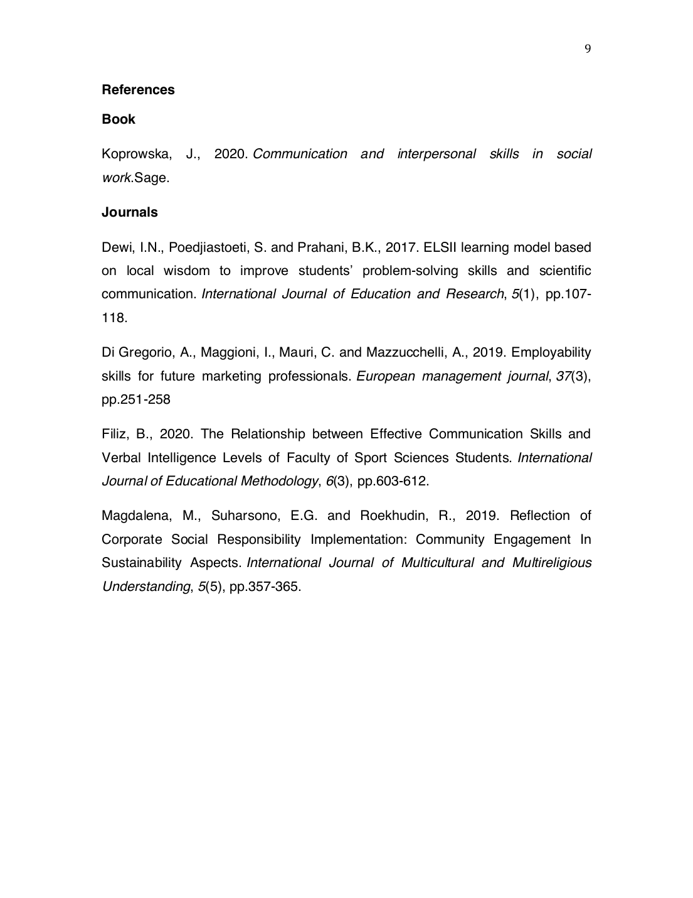
COMMUNITY ENGAGEMENT.docx
ORIGINALITY REPORT
0% 0% 0% 0%
SIMILARITY INDEX INTERNET SOURCES PUBLICATIONS STUDENT PAPERS

PRIMARY SOURCES

Exclude quotes On Exclude matches Off
Exclude bibliography On
COMMUNITY ENGAGEMENT.docx
GRADEMARK REPORT

FINAL GRADE
GENERAL COMMENTS

Instructor

/0

PAGE 1

PAGE 2

PAGE 3

PAGE 4

PAGE 5

PAGE 6

PAGE 7

PAGE 8

PAGE 9

