PHARMACY SERVICES

WHAT ARE PHARMACY SERVICES?


Pharmacy services are held are services that ensure the safe and effective use of medicines. Pharmacists dispense prescriptions, provide advice on medicine use, and help patients manage long term conditions.
BRIEF HISTORY
Ancient Herbal Remedies, Medieval Apothecaries ,19th century Community Pharmacies Modern Clinical Pharmacy Practice. Pharmacy evolved from Preparing herbal treatment to become a highly regulated healthcare profession focused on patient evidence-based care.

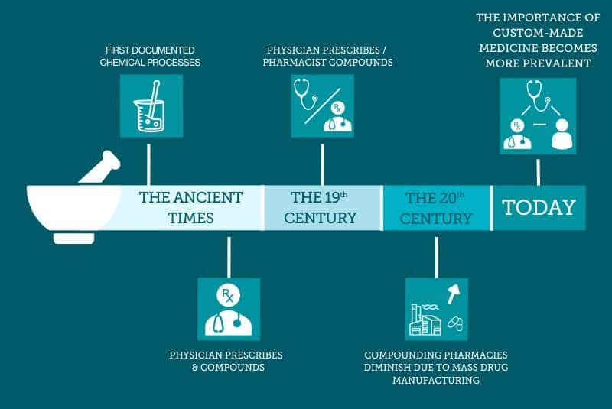
Pharmacy services have evolved from ancient civilisation, where healers prepared medicines from natural substances such as herbs and minerals to highly specialised healthcare profession. During the Middle Ages, apothecaries appeared as dedicated medicine preparers and sellers, and over time advances in chemistry and medicine led to the development of modern pharmaceuticals. By the 19th and 20th centuries, formal pharmacy education, licensing, and professional standards were proved, while the mass production of medicines expanded access to treatment. Today, pharmacists play a vital role not only in dispensing medications but also in providing patient counselling, managing chronic diseases, administering vaccinations, and promoting the safe and effective use of medicines as part of multidisciplinary healthcare teams.
Current function of pharmacy services: The current functions of pharmacy services have expanded far beyond simply dispensing medicines. Modern pharmacy services play a key role in patient care, medication safety, and public health.

Main Functions of Pharmacy Services
- Dispensing Medications
  - Preparing and supplying prescribed medicines accurately.
  - Ensuring correct dosage, formulation, and labelling.
- Medication Counselling
  - Educating patients on how to use medicines safely and effectively.
  - Explaining side effects, precautions, and drug interactions.
- Medication Therapy Management (MTM)
  - Reviewing patients’ medications.
  - Showing drug-related problems and improving treatment outcomes.
- Clinical Pharmacy Services
  - Working with doctors and other healthcare professionals to refine medication use.
  - Monitoring treatment effectiveness and adverse drug reactions.
- Health Promotion and Disease Prevention
  - Providing health education on topics such as smoking cessation, nutrition, and lifestyle changes.
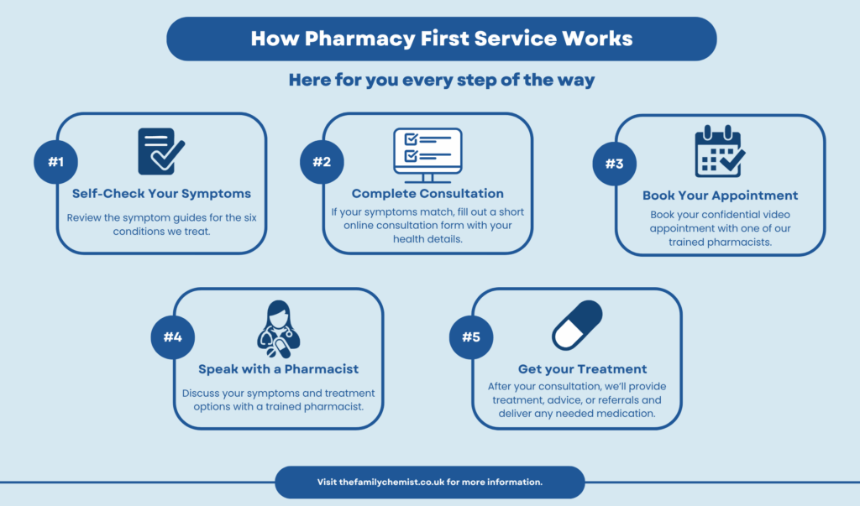
  - Supporting vaccination and immunisation programs where authorised.
- Drug Information Services
  - Providing reliable information about medicines to patients and healthcare professionals.
  - Answering questions about drug interactions, contraindications, and proper use.
- Public Health Services
  - Participating in disease screening (e.g., blood pressure, blood glucose).
  - Supporting community health initiatives and health awareness campaigns.
- Pharmaceutical Care
  - Focusing on patient-centred care to achieve the best therapeutic outcomes.
  - Monitoring adherence to medication regimens.
- Compounding Services
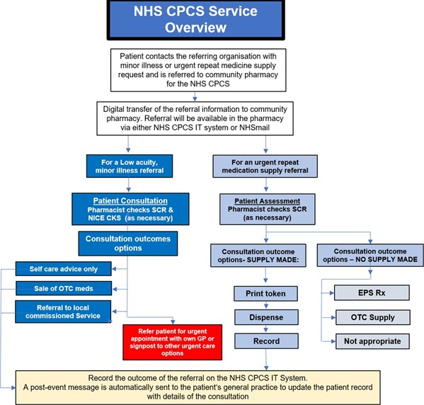
  - Preparing customised medications for patients with specific needs when commercially available products are unsuitable.
- Inventory and Supply Management
  - Ensuring the availability and proper storage of medicines.
  - Managing stock levels and preventing medication shortages.

Summary
The modern pharmacy profession has evolved from a product-oriented role to a patient-entered healthcare service that ensures the safe, effective, and rational use of medicines while contributing to overall public health and improved patient outcomes.

CHALLENGES FACED BY SERVICE

1. Medication Errors
One major challenge faced by pharmacy services is medication errors. These errors can occur when prescriptions are interpreted incorrectly, medicines are dispensed wrongly, or patients do not receive proper instructions on how to use their medications. Medication errors can lead to adverse drug reactions, poor treatment outcomes, and increased healthcare costs. Pharmacists must carefully review prescriptions and counsel patients to minimise the risk of such errors.

2. Shortage of Pharmacists and High Workload
Another significant challenge is the shortage of pharmacists and the increasing workload in pharmacies. As the demand for healthcare services grows, pharmacists must often process many prescriptions while also providing patient counselling and clinical services. This heavy workload can cause stress, reduce efficiency, and limit the time available for patient care. Ensuring adequate staffing and support is essential for supporting high-quality pharmacy services.
Funding Cuts and Financial Pressures
One of the most significant challenges facing UK pharmacies is funding cuts. Reduced government reimbursement rates and changes in funding models have put immense financial strain on many pharmacies. According to a report by the National Pharmacy Association, 72% of pharmacy owners believe their financial situation has worsened over the past year. This financial pressure makes it difficult for pharmacies to keep profitability and continue offering a full range of services.
Workforce Shortages
The pharmacy sector is grappling with a shortage of qualified pharmacists and support staff. Recruitment and retention issues are prevalent, driven by increased workload, stress, and competition from other healthcare sectors. The Pharmaceutical Journal reports that 45% of pharmacies have struggled to recruit locus pharmacists over the past year, worsening the staffing crisis.
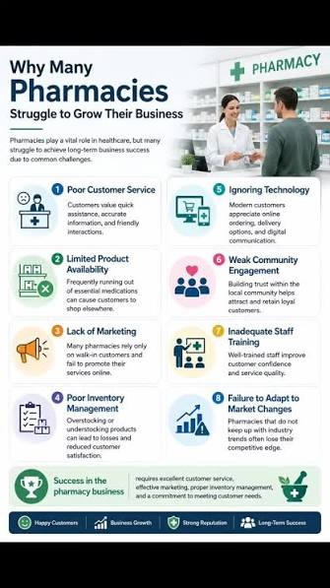
Increased Workload and Stress
The role of pharmacies have significantly expanded, especially following the COVID-19 pandemic. With added responsibilities like administering vaccinations, conducting health screenings, and managing chronic disease services, pharmacists are facing increased workloads. This surge in duties has led to higher stress levels and burnout among pharmacy staff, making it even harder to keep experienced professionals.

Supply Chain Disruptions
Brexit and the COVID-19 pandemic have caused significant disruptions in the supply chain, affecting the availability of medicines and other pharmaceutical products. Pharmacies have had to deal with shortages and delays, affecting their ability to meet patient needs promptly. A survey by the British Medical Association found that 67% of pharmacies experienced supply issues in the past year, highlighting the extent of this problem.
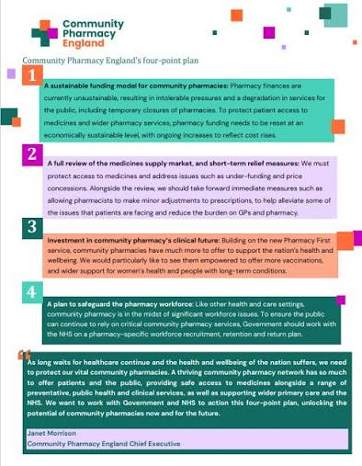
Technological Integration
Many pharmacies are struggling to keep up with the pace of technological advancements. Implementing modern technologies for electronic prescriptions, digital health services, and automation requires investment and training. Smaller, independent pharmacies often find it challenging to distribute the necessary resources for these upgrades, putting them at a disadvantage compared to larger chains.

