Draft -------- Effective Teamwork and Communication
BMSW 4002
Khizar Fareed
2028871
Course Lecturer; Sujeewa Herath

Contents Page
Executive Summary
Introduction
Defining a Team and team roles
The impact of having an effective team
Barriers to effective team working
How students can develop an effective team refer to UWTSD here)
Recommendations (refer to UWTSD here)
Conclusion

Executive summary

Introduction

This report aims to describe the various roles that can be found within a team and also discuss the effectiveness of teamwork, as well as the barriers and impact an effective team may have on productivity.
At UWTSD, the student cohort represents a very diverse, broad group of individuals. They are tremendously different in terms of sexual orientation, social standing, age, foundation, and experience. While variety benefits learners, inequalities in the classroom provide barriers to teamwork and group work. As part of their evaluation, students enrolling in the Effective Communication and Team Work module, for example, must give a presentation. Students are placed into groups at random for this introduction and are expected to work together to manage the presentation. However, because of the unique characteristics of the student cohort, communication concerns and group management issues are the most prevalent.
The report will inform the module lecturing team and will explain how students may form a productive team, the importance of excellent teamwork in achieving team success, the obstacles to productive collaboration, and the various team roles required to form a cohesive and effective team.

Defining a team and team roles

(dictionary ref) A group of people who work together to achieve a common goal is referred to as a team. Individuals who make up a team should have comparable goals and objectives and think in similar ways. Individuals that are incompatible with each other can never function as a team. Interests, thought processes, attitudes, perceptions, and preferences should be comparable, if not identical.
Responsibilities and success criteria can have an instant positive impact by consciously defining each team member's role. It ensures that everyone is working towards the same goals, people work well together, and communication is improved (Lennon-smith, 2019).
Erikson (2012) argues in an article found in the Harvard Business Review, that role descriptions that are not made clear would cause employees to waste their time and energy negotiating their positions within the team rather than focus on productivity and the primary objectives. Employees frequently become involved in unnecessary politics and turf wars when their roles are ambiguous, according to the article. The study found that, when roles were defined and understood, collaboration improved. This conclusion was based upon the finding that team behaviours dramatically improved when people felt their roles had clear boundaries, leading to an increase in productivity (Erikson, 2012).
Belbin (1981) developed a tool that is widely implemented today and defines the diverse team roles that exist. A team role, according to Belbin, is a proclivity to behave, contribute, and interact with others in a specific manner. Shaper, Implementer, and Completer Finisher are action-oriented roles; Co-ordinator, Teamworker, and Resource Investigator are people-oriented roles; and Plant, Monitor Evaluator, and Specialist are cerebral roles. The team roles are summarized below.
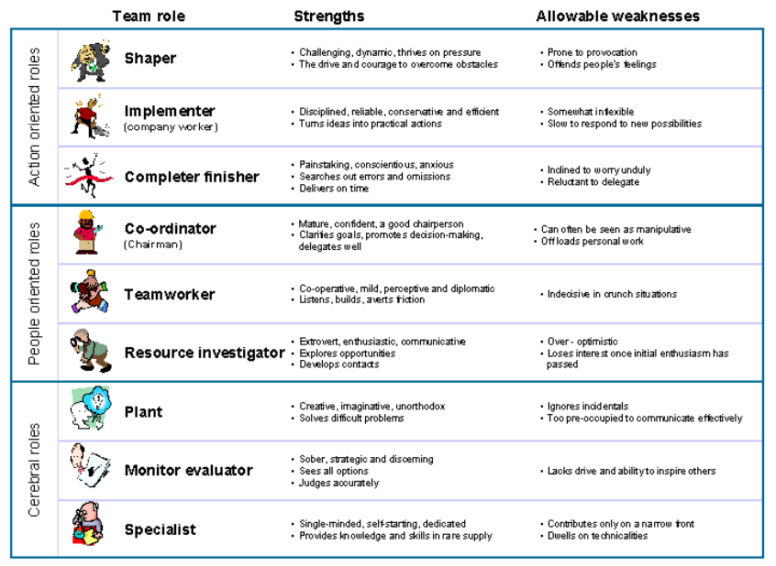

(Moultrie, 2016)
Being able to identify the position of each team member can help a team become more effective and productive, as well as avoid placing too many of the 'same type' of team members together. A diverse team can lead to greater effectiveness and productivity. It is also important to note that not all teams have nine or more members, so many team members serve in a secondary capacity.
When a group is coming to 'exist', it will go through several phases or stages. Bruce Tuckman's (1965) developmental process model describes this process below.

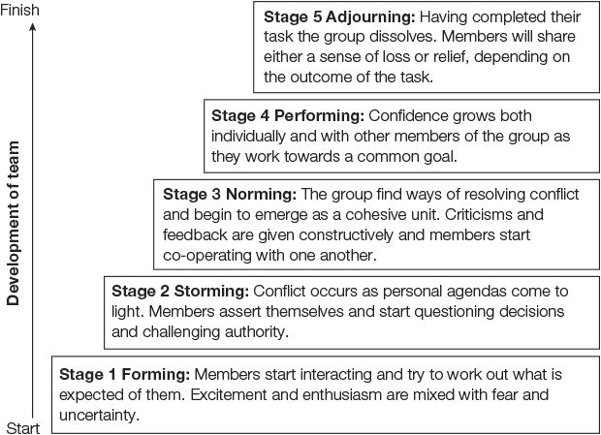
(Bates and McGrath, 2013)

As a team goes through a period of time together, they will eventually go through all these stages. In the latter stage, ‘Adjourning’ was added in collaboration with Mary Jensen (1977).

The impact of having an effective team

What does an effective team look like? To detail the impact of an effective team, you first need to identify the traits/characteristics of what make a team effective. Having an effective team can be very beneficial and positive.
Below is a table that summarizes the features of having effective teamwork, taken from Mickan and Rodger (2000).
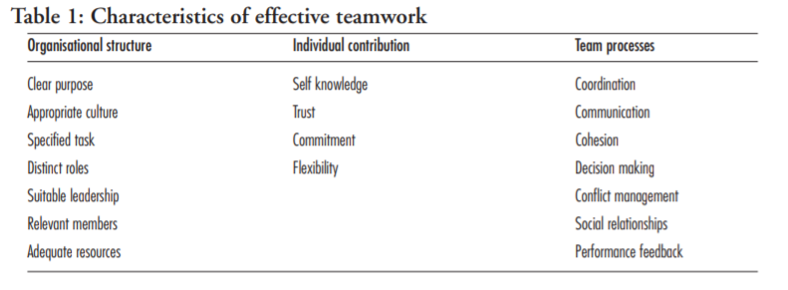
Supportive organisational structures and optimal individual contributions enable effective teamwork. Integration within teams improves, having the adequate support when they have an obvious purpose that aligns with the organization's aim, furthermore strategic planning procedures can help clarify the alignment of many teams (Mickan and Rodger, 2000).
Productivity, morale and the over-all quality increase when teams collaborate effectively. Conflict among team members reduce when there are effective partnerships and team working. Overall, successful teams may have a significant impact on the production and performance of a business (McQuerrey, 2019).
When working in teams, team members begin to support each other in achiving the collective goal becomes easier to achive and also the focus then shifts on to maximizing the productivity and delivering a higher quality service and/or product.

Barriers to effective team

Barriers in general
Recognize the barriers in uwtsd – the communication and inequalities

How students can develop an effective team

To develop an effective team, it's important to recognize and identify what makes an effective team.
- Same vision/goals
- Motivation
- Great communication
- Team roles assigned
- Time management
- Effective management/leadership
It is important to lay a great foundation for building a successful team. Gersick (1988) and Feldman (1984) recommend how effectively a team performs is determined by the first meeting. This meeting can then be the start and development of expected group norms, rules, and expectations.
Doing a form and identifying what type you are in Belbin's role- avoids to many shapers or leaders being placed together
Assess skills using a pro forma
Past experiences of group working who works well together who doesnt
Creating effective teams with individuals
Wheelan

Recommendations

Assess the group - identify where they best fit
Get to know your students
Proformas – assessment tools.
Inspire and manage the class well – provide motivation and support where needed.
Communication – open discussions, trust confidence, offer EAL support where necessary
Best not to place students together randomly together because of identifying team roles and basically all of what this report has gone through for recognizing what makes a good team.

Conclusion

Celebrate Diversity in Teams
The diversity in society should be reflected in the composition of teams as much as possible. Different genders, ages, cultural backgrounds, ethnic heritages and belief systems bring diversity of ideas to the team. One team member may present an idea that wouldn't have occurred to the others because it originated from a cultural background that the others didn't experience. New or unusual ideas have a way of fostering more novel ideas as the entire team digs deeper into a wider net of possibilities.

References

Bates, D. and McGrath, D., 2013. Little Book of Big Management Theories. 2nd ed. [Place of publication not identified]: Pearson.

Belbin, R., 1981. Management teams. London: Heinemann.

Erikson, T., 2012. The Biggest Mistake You (Probably) Make with Teams. [online] Harvard Business Review. Available at: <https://hbr.org/2012/04/the-biggest-mistake-you-probab> [Accessed 9 October 2021].

Feldman, D., 1984. The Development and Enforcement of Group Norms. Academy of Management Review, 9(1), pp.47-53.

Gersick, C., 1988. Time and Transition in Work Teams: Toward a New Model of Group Development. Academy of Management Journal, [online] 31(1), pp.9-41. Available at: <https://doi.org/10.5465/256496> [Accessed 14 October 2021].

Lennon-smith, s., 2019. The Power of Defining Roles in the Workplace. [online] Kennedypearce.com. Available at: <https://www.kennedypearce.com/blog/2019/04/the-power-of-defining-roles-in-the-workplace> [Accessed 9 October 2021].

McQuerrey, L., 2019. Team Effectiveness & Increased Productivity. [online] Small Business - Chron.com. Available at: <https://smallbusiness.chron.com/team-effectiveness-increased-productivity-48735.html> [Accessed 20 October 2021].

Mickan, S. and Rodger, S., 2000. Characteristics of effective teams: a literature review. Australian Health Review, [online] 23(3), p.201. Available at: <https://www.publish.csiro.au/ah/pdf/AH000201> [Accessed 20 October 2021].

Moultrie, J., 2016. Belbin's team roles. [online] Ifm.eng.cam.ac.uk. Available at: <https://www.ifm.eng.cam.ac.uk/research/dmg/tools-and-techniques/belbins-team-roles/> [Accessed 10 October 2021].

Smith, M., 2005. Bruce W. Tuckman – forming, storming norming and performing in group. [online] Webspace.science.uu.nl. Available at: <https://webspace.science.uu.nl/~daeme101/infed.org-Bruce_W_Tuckman__forming_storming_norming_and_performing_in_groups.pdf> [Accessed 14 October 2021].

Tuckman, B. and Jensen, M., 1977. Stages of Small-Group Development Revisited. Group & Organization Studies, 2(4), pp.419-427.

