

University of Wales
Trinity Saint David

Level 7 Assessment

Programme: MSc Advanced Manufacturing (Industry 4.0)

Module: Industry 4.0 Advanced Manufacturing

Module Code: ACFA 7004

Assignment Title: Research Proposal

Presented by: Mike Davies
Date: December 2022

Research Title
Industry 4.0 communication – The machines are talking -why aren't the people
An investigation into management workforce communications and interactions to ensure workplace changes due industry 4.0, will ensure be successfully implemented with workforce acceptance.
Mike Davies

Senior Quality Engineer
Marelli Automotive Systems Ltd UK

Content
Title Page 1
Contents 2
Abstract 3
1.0 Introduction 4
2.0 Aims and Objectives 5
3.0 Implementation Methodology 6
4.0 Background Research 7
5.0 Conclusion 22
6.0 Table of Images 23
7.0 References 24

Abstract
This systematic review intends to identify the pros and cons of introducing Industry 4.0 technologies into SME manufacturing businesses in Wales. The majority of Industry 4.0 research papers highlight the various benefits of the industry 4.0 technologies, with improved performance, communication, traceability and productivity, but there is little research information on the impact on the workforce and socioeconomic affects to a company. For a successful introduction of any new technology, there must be a culture change within the organisation, but by the very nature of industry 4.0 technological advances, not only would workforce, company assets and data be at risk, but also those of customer and the supplier bases, if the new technologies are not introduced correctly, with the appropriate safety & security as well as management and workforce communications and training.

1.0 Introduction
The technological advances being made with Industry 4.0 or the Fourth Industrial Revolution will revolutionise all aspects of the business world. The Term Industry 4.0, first Introduced during Hannover Fair in 2011, (Lydon, 2014), refers to the achievement of innovation, developments, and improvements to processes in all aspects of business.
The nine pillars of industry 4.0 (Helix, 2018) are: -
- Big Data and Data analytics
- Simulation
- Horizontal and Vertical Integration
- Industrial Internet of Things
- Autonomous Robots
- The Cloud
- Cyber Security in Industry 4.0
- Augmented Reality
- Additive Manufacturing and 3D printing

For the benefits of these technological advances to be fully realised, there needs to be a culture change within the workforce and end users, to adapt any new working methods, processes and procedures. This is an area of research that has not been fully investigated and this research proposal plans to investigate this important subject area.

2.0 Aims and Objectives
It is believed that for successful Industry 4.0 technology advancements to be optimised, cooperation and buy in is required from all stakeholders and by identifying the pros and cons of industry 4.0 technology rollout, the output of this research is planned to be a matrix identifying best practices for the successful adaption of new technologies, considering the stakeholders involvement and feelings towards new technologies and required communications and training to be the key drivers to a flexible technology. (Seegrid, 2021).

3.0 Implementation Methodology
The investigation undertaken in this research proposal incorporated a wide spectrum of stakeholders, from business leaders and managerial staff to academic professionals to industry shop floor employees, industry 4.0 technology end users and Trade union officials.
3.1 Literature reviews
This was used to develop a greater understanding of industry 4.0 technology introduction as a subject, looking at the current philosophies and principles.
Type of Literature to be reviewed include: -
Books
Professional journals
Online subject related journals and blogs
Websites
Published research papers
Industry related publications
Industry related databases
Automotive OEM portal data and publications
3.2 Research Methods (Type of data collection)
Qualitative Research
Qualitative research is defined as a market research method that focuses on obtaining data through open-ended and conversational communication.” (QuestionPro, 2018)
This method is not only about “what” people think but also “why” they think so. The use of questionnaires, Teams Meetings and old-fashioned face to face interviews were used during this research investigation.
Quantitative Research
Quantitative research is defined as a systematic investigation of phenomena by gathering quantifiable data and performing statistical, mathematical, or computational techniques. (QuestionPro, 2018).
This method is not only about “what” but about “how much” the results of which can be expressed in a numerical form. The data collected from the qualitative research results were grouped and categorised, which allowed quantitative analysis to be conducted.

4.0 Background Research
An issue that came to light early on in the research was the no standard definitions for industry 4.0 technologies. There were different interpretations from the technologies being discussed and the stakeholder group being questioned. (Microsoft, 2022).
It was found that some highly automated companies have implemented what have been listed in industry 4.0 literature, as the key drivers, but these companies don’t class these key drivers as cutting-edge technological advances, whilst some in academia classify these key drivers as the standard model for industry 4.0 introduction; others don’t understand or see the relevance of these technology drives as being linked to industry 4.0.
It has also been observed that some companies are introducing industry 4.0 technologies for prestige reasons and it is felt by the author that industry 4.0 technologies should be a driver for change and not the reason for change.
From the differences observed, a standard definition needed to be introduced for Industry 4.0, so to this end a questionnaire was designed and distributed to participants to gain an understanding of what industry 4.0 technologies mean to the different stakeholders.
Fig.1 shows the levelling questionnaire sent to participants to understand digital competency of respondents

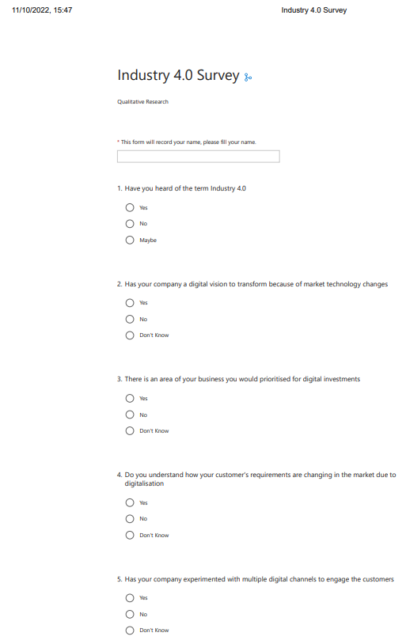
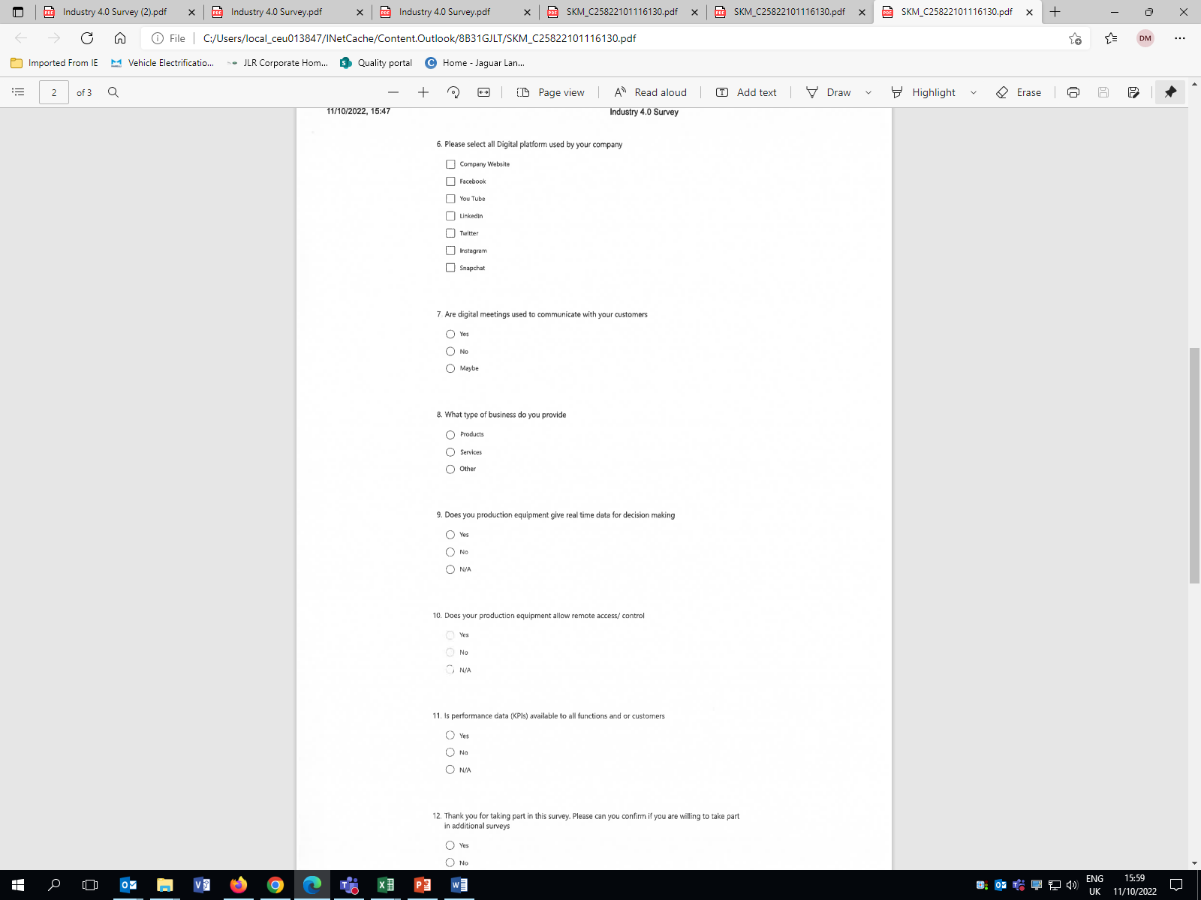
Fig.1 (Davies, 2022).
From the initial responses received to questionnaire 1, it became apparent that the degree of involvement with the technology was related to the enthusiasm shown to the innovation being adopted, and also the stakeholders’ physical interactions with the new technologies, as shown the apprehension stated by some shop floor operators with the ideas of working in close proximity to cobots, especially in industries where robotic arms are already in use, having a caged off working envelop.
There was also reported cases from the trade union representatives of abuse of ‘new technologies’, such as internet of things lone worker monitoring devices being used to track workers and monitor workers productivity, with the term ‘human robots’ being used to describe this situation.
From the data, the stakeholders can be split into 4 separate groups from the
- Enthusiastic pioneers - Activate involvement for change

- Willing participants – Passive involvement for change

- Unwilling participants - Passive indifference for change

- Innovation Saboteurs – Actively causes delays to change introduction
These groups are shown graphically in table 1
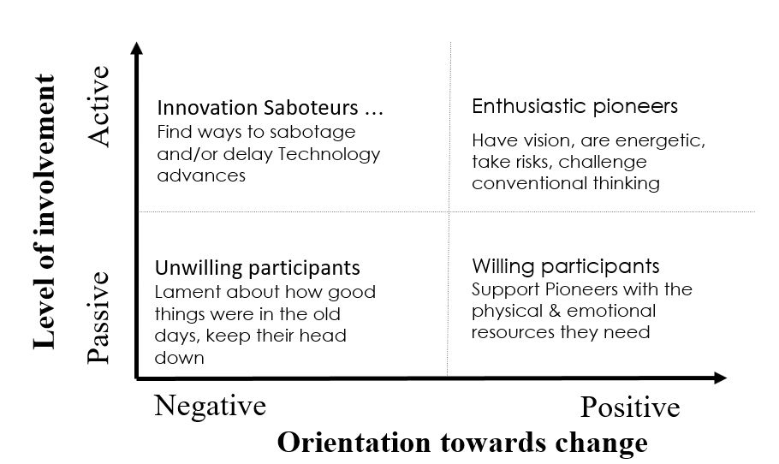
Fig. 2 (Davies, 2022).
Further research found similarities between the survey results and groupings to the work of Professor Melissa Schilling in her work on Innovation Strategy: Patterns of Innovation and Everett Rogers’ 5 categories of diffusion of innovation

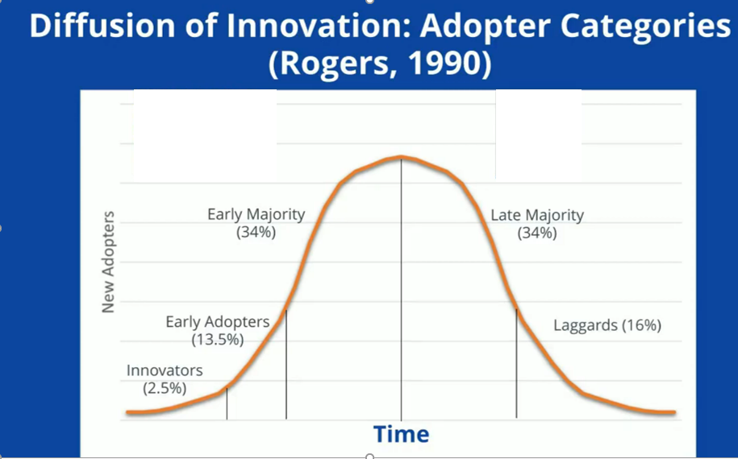

Fig 3 (Rogers, 1990).

Although this report covers the introduction of industry 4.0 technologies, which brings in new challenges with participant interactions and acceptance and also the requirements for new quality control methods, to ensure product and services quality, security and safety.
The resistance to change has a long history, with the cases of the Luddites and Tolpuddle Martyrs being well known, and there are many publish articles covering the resistance to change and the cultural aspects of change, which are relevant to this research.
Models for change evaluated for this report include: -
- Trott Innovation Typology
- Satell Innovation Matrix
- Kubler-Ross Change Curve
- Bridges’ Transition Model
- Robert Dilts six logical Levels of change
- John P Kotter Eight steps to Transforming Your Organization
- The ADKAR Change Management Model
Although Kotter’s Eight Steps to Transforming Your Organization was deemed to be the benchmark for change management, due to the limited access to an organisations top management to review the sense of urgency or the forming of a powerful guiding coalition, steps of Kotter’s model. It could not be used, therefore the ADKAR Model of change management aligned to the author’s perception of the issues identified with industry 4.0 technological advancement introductions.

The ADKAR Model of Change Management was created by Jeff Hiatt – a former Bell Labs engineer and program manager – developed the model and founded Prosci in 1994.
(Prosci 2021)
ADKAR is an acronym standing for
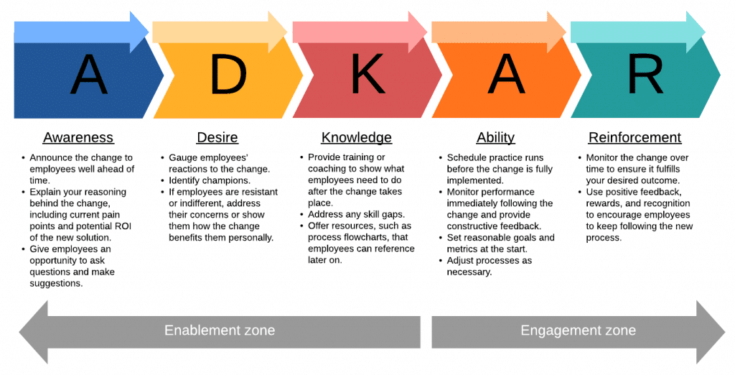
Fig 4 (Caredda, 2020).
In the ADKAR, awareness and desire move from the status quo, as current state, so change is required but not yet started.
Knowledge and ability is the transition stage, and reinforcement focuses on the future post change state.

Fig.5 (Davies, 2022).
The ADKAR Model sets clear milestones to be reached throughout the process to facilitate change.
All stakeholders in the change must reach the set goals, though different people may reach the goals at different times.

Awareness
Awareness of the need to change- means communicating the need for change is urgent & vital for the business, but change awareness is more than just making an announcement.

Employees must not only understand the reasoning behind the change but also agree with reasons for the change must be sought.

A clear explanation of why the change is needed should be given.
Benefits of the change should be explained especially, as they apply to the people affected.
How the change was decided, how the change will be implemented, the process plan milestones should be discussed in an open forum in a question - answer format meeting.

Desire to make the change

Don’t Just Tell Employees Organizational Changes Are Coming — Explain Why,
Galbraith, 2018)
The use of designated ‘change leaders’.
Who can publicly support the change, and have connection with the people are affected by the change.
Who can explain how daily routines will be affected so that they can provide specific support and guidance.
Who can get specific about the benefits of the change as they apply to particular individuals or teams. Avoid touting advantages for the company.
Resistance to change is a major obstacle. (Kotter, 2016)

Resistance is to be expected, but you need to understand the core reason for it.
- Are people scared that they don’t have the skills to make the change?
- Are people worried about how it will affect their job duties?
- Will employees feel frustrated by the extra effort needed to learn something new?
- Once you understand the root cause of the resistance, it can be addressed and, make adjustments to your change implementation plan, if required.

Provide knowledge on the change
This is the main area of the ADKAR process and will be the key to the success or failure of the change and is about training and education. Staff need to understand how their responsibilities, skills, tools, and processes will be impacted.
Given that everyone must reach each milestone individually, knowledge-building needs to be specific.
Provide knowledge that applies directly to each team’s or individual’s responsibilities.
The knowledge needed to perform distinct roles in the change is different for each function/ department, even though the overall change may be the same.
Take time to evaluate what additional skills, tools, and duties the change will require.
This allows planning the change schedule around the necessary skill development.
It should also be considered that too many changes, all at once can lead to additional resistance.
If your change requires employees to learn a large amount of new material and/or master new skills, implement the change gradually.
Another way to increase comprehension is to use a variety of creative employee training methods:
- Traditional classroom training
- Job shadowing/mentoring
- Videos
- Blog series
- Interactive self-guided learning
Knowledge-building should go beyond facilitating the change. It is equally important to provide knowledge that allows your team to see the change through to the end.
Ensure that employees have the ability to make the change

Regardless of how well employees know how to do something, having confidence in their own competencies determines whether or not they can or even will do something.

Fig. 6 (Davies,2022)

While plenty of football fans understand the mechanics behind taking a penalty, not all of them would score from the penalty spot.
To bridge the gap between knowledge and ability, change leaders should coach individuals or teams.
Reinforce the change

To stop employees relying on old habits. Once new processes are in place, keep reinforcing the change after its implementation.
Celebrate success during and after the transformation so enthusiasm can be maintained.
Correct mistakes and poor behaviour in private when people slip back into old habits.
On the other hand, give praise publicly so that the entire organization can celebrate together.
In the meantime, continue to collect feedback. The change process may be “complete,” but employee feedback is still valuable.
Listen to employees to identify pinch points and see where extra support would be beneficial.
Include time for reinforcement of the change management plan.
Continue monitoring and reinforcing the change for a period at least as long as the original change implementation plan.

It should be noted that the ADKAR process is required in both directions,
The Management Team need to be trained to consider the root causes of any lack of awareness, desire, knowledge and ability within the workforce or end users and empathy shown with measures being introduced to reduce identified causal factors.
Awareness and knowledge training should be given to both management and workforce to ensure understanding of any concerns raised by all stakeholders.
Using the data sets collected during the research of this investigation, correlation can be conducted using the 9 types (pillars) of industry 4.0 technologies with the 4 identified stakeholder groupings and then using the ADKAR change management system to identify high risk areas that could affect advancement introductions. Suggested adjustments can be recommended to reduce risks for these project ‘pinch points’.

Big Data and Data analytics
(Not applicable for this investigation)

Simulation
(Limited input to investigation)
Enthusiastic pioneers - Activate involvement for change
Awareness and desire review not required for these stakeholders, but confirmation of Knowledge and ability, reinforcement maybe required if Knowledge and ability found to be not aligned to actual new processes.
Willing participants – Passive involvement for change
Full ADKAR review required for these stakeholders, would make the good change leaders
Unwilling participants - Passive indifference for change
Full ADKAR review required for these stakeholders, investigate reason for unwillingness.
Review Knowledge to concern understanding of changes and allowances for any increase work load or additional training requirements.
Innovation Saboteurs – Actively causes delays to change introduction
Full ADKAR review required for these stakeholders, investigate reason for unwillingness.
Review change Knowledge to try and understand objections to identified changes and consider additional allowances for any increase workload or additional, training requirements. Review ability to see if issue is competency and additional training content would resolve concerns
Reinforcement requirement need to be increased and for extended period.

Horizontal and Vertical Integration
(Limited input to investigation)
Enthusiastic pioneers - Activate involvement for change
Awareness and desire review not required for these stakeholders, but confirmation of Knowledge and ability, reinforcement maybe required if Knowledge and ability found to be not aligned to actual new processes.
Willing participants – Passive involvement for change
Full ADKAR review required for these stakeholders, would make the good change leaders
Unwilling participants - Passive indifference for change
Full ADKAR review required for these stakeholders, investigate reason for unwillingness.
Review Knowledge to concern understanding of changes and allowances for any increase work load or additional, training requirements.
Innovation Saboteurs – Actively causes delays to change introduction
Full ADKAR review required for these stakeholders, investigate reason for unwillingness.
Review change Knowledge to try and understand objections to identified changes and consider additional allowances for any increase workload or additional, training requirements. Review ability to see if issue is competency and additional training content would resolve concerns
Reinforcement requirement need to be increased and for extended period.

Industrial Internet of Things
Enthusiastic pioneers - Activate involvement for change
Awareness and desire review not required for these stakeholders, but confirmation of Knowledge and ability, reinforcement maybe required if Knowledge and ability found to be not aligned to actual new processes.
Willing participants – Passive involvement for change
Full ADKAR review required for these stakeholders, would make the good change leaders
Unwilling participants - Passive indifference for change
Full ADKAR review required for these stakeholders, investigate reason for unwillingness.
Review Knowledge to concern understanding of changes and allowances for any increase work load or additional, training requirements.
Innovation Saboteurs – Actively causes delays to change introduction
Full ADKAR review required for these stakeholders, investigate reason for unwillingness.
Review change Knowledge to try and understand objections to identified changes and consider additional allowances for any increase workload or additional, training requirements. Review ability to see if issue is competency and additional training content would resolve concerns
Reinforcement requirement need to be increased and for extended period.

Autonomous Robots
(Biggest cause of concern raised by stakeholders)
Enthusiastic pioneers - Activate involvement for change
Awareness and desire review not required for these stakeholders, but confirmation of Knowledge and ability, reinforcement maybe required if Knowledge and ability found to be not aligned to actual new processes.
Willing participants – Passive involvement for change
Full ADKAR review required for these stakeholders, would make the good change leaders
Unwilling participants - Passive indifference for change
Full ADKAR review required for these stakeholders, investigate reason for unwillingness.
Review Knowledge to concern understanding of changes and allowances for any increase work load or additional, training requirements. Use of tours/ visits to other facilities using this technology would be required, as well as full unrestricted communications between
Innovation Saboteurs – Actively causes delays to change introduction
Full ADKAR review required for these stakeholders, investigate reason for unwillingness.
Review change Knowledge to try and understand objections to identified changes and consider additional allowances for any increase workload or additional, training requirements. Review ability to see if issue is competency and additional training content would resolve concerns.
Review ability to see if issue is competency and additional training would resolve concerns
Reinforcement requirement need to be increased and for extended period.

The Cloud
(Limit access until stakeholders deemed to be at willing participant status)
Enthusiastic pioneers - Activate involvement for change
Awareness and desire review not required for these stakeholders, but confirmation of Knowledge and ability, reinforcement maybe required if Knowledge and ability found to be not aligned to actual new processes.
Willing participants – Passive involvement for change
Full ADKAR review required for these stakeholders, would make the good change leaders
Unwilling participants - Passive indifference for change
Full ADKAR review required for these stakeholders, investigate reason for unwillingness.
Review Knowledge to concern understanding of changes and allowances for any increase work load or additional, training requirements.
Innovation Saboteurs – Actively causes delays to change introduction
Full ADKAR review required for these stakeholders, investigate reason for unwillingness.
Review change Knowledge to try and understand objections to identified changes and consider additional allowances for any increase workload or additional, training requirements. Review ability to see if issue is competency and additional training content would resolve concerns
Reinforcement requirement need to be increased and for extended period.

Cyber Security
(Additional security actions required due to risk to customers and supply base)
Enthusiastic pioneers - Activate involvement for change
Awareness and desire review not required for these stakeholders, but confirmation of Knowledge and ability, reinforcement maybe required if Knowledge and ability found to be not aligned to actual new processes.
Willing participants – Passive involvement for change
Full ADKAR review required for these stakeholders, would make the good change leaders
Unwilling participants - Passive indifference for change
Full ADKAR review required for these stakeholders, investigate reason for unwillingness.
Review Knowledge to concern understanding of changes and allowances for any increase work load or additional, training requirements. Additional reinforcement and Security measures need to be in place.
Innovation Saboteurs – Actively causes delays to change introduction
Full ADKAR review required for these stakeholders, investigate reason for unwillingness.
Review change Knowledge to try and understand objections to identified changes and consider additional allowances for any increase workload or additional, training requirements. Review ability to see if issue is competency and additional training content would resolve concerns -.
If Reinforcement requirement are not being met remove stakeholders away from new processes

Augmented Reality
(Could be used to enhance training of new processes)
Enthusiastic pioneers - Activate involvement for change
Awareness and desire review not required for these stakeholders, but confirmation of Knowledge and ability, reinforcement maybe required if Knowledge and ability found to be not aligned to actual new processes.
Willing participants – Passive involvement for change
Full ADKAR review required for these stakeholders, would make the good change leaders
Unwilling participants - Passive indifference for change
Full ADKAR review required for these stakeholders, investigate reason for unwillingness.
Review Knowledge to concern understanding of changes and allowances for any increase work load or additional, training requirements.
Innovation Saboteurs – Actively causes delays to change introduction
Full ADKAR review required for these stakeholders, investigate reason for unwillingness.
Review change Knowledge to try and understand objections to identified changes and consider additional allowances for any increase workload or additional, training requirements. Review ability to see if issue is competency and additional training content would resolve concerns
Reinforcement requirement need to be increased and for extended period.

Additive Manufacturing and 3D Printing
(Limited input to investigation)
Enthusiastic pioneers - Activate involvement for change
Awareness and desire review not required for these stakeholders, but confirmation of Knowledge and ability, reinforcement maybe required if Knowledge and ability found to be not aligned to actual new processes.
Willing participants – Passive involvement for change
Full ADKAR review required for these stakeholders, would make the good change leaders
Unwilling participants - Passive indifference for change
Full ADKAR review required for these stakeholders, investigate reason for unwillingness.
Review Knowledge to concern understanding of changes and allowances for any increase work load or additional, training requirements.
Innovation Saboteurs – Actively causes delays to change introduction
Full ADKAR review required for these stakeholders, investigate reason for unwillingness to adapt changes.
Review change Knowledge to try and understand objections to identified changes and consider additional allowances for any increase workload or additional, training requirements. Review ability to see if issue is competency and additional training content would resolve concerns
Reinforcement requirement need to be increased and for extended period.

5.0 Conclusion
Industry 4.0 technological advances need full involvement by the workforce and end users for it to be successful, and using the ADKAR change management system would be recommended, as this system encourages all stakeholder involvement from the planning stage of the new technology introduction. From interviews conducted with the shop floor operators who expressed disenfranchised with no input into the new systems, which in some cases led to the Innovation Saboteurs – Actively causes delays to change introduction group of stakeholders. Also there was no mechanism to raise personnel safety concerns with working in close proximity to new technological systems, particularly where there had been issues with earlier versions of the technologies, an example quoted from various interviewees, was the case of robotic arms malfunctioning and either hurting operators or damaging other equipment. Concern was expressed that companies’ management teams were either unaware of these issues, acted blaise about these concerns or even worst actually ignored the concerns raised.
As recommended by the ADKAR change management system, an educational program should be undertaken, which could include site visits and tours to other establishments already using the new technologies, where the technology operators could candidly discuss their own experiences of working with the new technologies or processes and answer any questions and concerns raised.
Discussions with the individual members of the workforce should be instigated prior to developing the introduction program, to establish the stakeholder groups each of the operator candidates fit into and then a tailor-made training and development plans should be made set at the appropriate level.
At this stage the change managers within the implementation teams should be selected and where the new technology introduction involves many changes or the changes are of a complex nature, additional time should be added to the timing plan to reduce pressure on operators to reach the required competency levels, as this was another concern raised during the interview stage.
The recommendation of allowing additional testing and training times within the implementation timing plan, the stresses of trying to meet unrealistic timing plans, lead to more project timing and budget failures, than adding the requested additional times to the original project timing plan.
The next stage of this proposal would be creating a decision matrix aligning the stakeholder categories against the ADKAR criteria for each of the nine industry 4.0 pillars, to draw up a specific plan for each grouping in the matrix, so not only can tailor-made training programs be constructed, but specific areas of concerns can be identified and eliminated at an early stage of the implementation program.
6.0 Table of Images
Fig. 1 Davies, M. (2022, Stakeholder Survey, distributed 11/10/2022
Fig. 2 Davies, M. (2022), Stakeholder grouping matrix graphic, constructed 20/11/2022
Fig. 3 Rogers, E (1990), Categories of diffusion of innovation, available via Melissa Schilling you tube channel -Innovation Strategy: Patterns of Innovation, https://www.youtube.com/watch?v=bvjvo6M2zRI&t=191s, (Accessed 22/11/2022)
Fig. 4 Caredda, S. (2020) Models: the ADKAR Change Management Model Available from https://sergiocaredda.eu/organisation/tools/models-the-adkar-change-management-model/ (Accessed 30/11/2022)
Fig. 5 Davies, M. (2022) Adkar Model stages graphic, constructed 05/12/2022
Fig. 6 Davies, M. (2022) Adkar Model – Knowledge & Ability graphic, Constructed 05/12/2022

7.0 References
Bridges, W. (2019) Transitions: Making Sense of Life's Changes Revised anniversary edition, 2019
Caredda, S. (2020) Models: the ADKAR Change Management Model Available from https://sergiocaredda.eu/organisation/tools/models-the-adkar-change-management-model/ (Accessed 30/11/2022)
Galbraith, M (2018). Don’t Just Tell Employees Organizational Changes Are Coming — Explain Why. Available from https://hbr.org/2018/10/dont-just-tell-employees-organizational-changes-are-coming-explain-why. (Accessed 11/12/2022)
Helix. (2018) Nine pillars of industry 4.0 Available from https://www.helixlinear.com/blog/automation-library/the-nine-pillars-of-industry-40/ (Accessed 23 July 2022).
Kotter, J (2011) HBR's 10 Must Reads on Change Management (including featured article "Leading Change," by John P. Kotter) Available from https://store.hbr.org/product/hbr-s-10-must-reads-on-change-management-including-featured-article-leading-change-by-john-p-kotter/12599?sku=12599E-KND-ENG. (Accessed 02/12/2022)
Kotter, J. (1997). Leading change: A conversation with John P. Kotter. Strategy & leadership, 25(1), pp. 18-23.
Kotter, J. & Holger, R. (2016) That’s Not How We Do It Here! A Story About How Organizations Rise and Fall--and Can Rise Again’, Library journal (1976), 141(16), p. 48.

Kubler-Ross, E., (1969). Kubler-Ross Model of Change. [image] Available from <https://silverlobster.files.wordpress.com/2015/09/kubler-ross-change-curve-001.jpg> [Accessed 10 November 2022].
Kwun, E. (2020) Dilts’ Neurological Levels Available from https://drerwinkwun.com/dilts-logical-levels/#:~:text=The%20six%20logical%20levels%20of,%2C%20capability%2C%20behaviour%20%26%20environment. (Accessed 26 November 2022)
Lydon, B. (2014) The 4th Industrial Revolution, Industry 4.0, Unfolding at Hannover Messe 2014, Available from https://www.automation.com/en-us/articles/2014-1/the-4th-industrial-revolution-industry-40-unfoldin (Accessed 18 November 2022).
Microsoft, (2022) How to use Microsoft Forms Available from file://gbllsv18xfilea/UserData/ceu013847/2016/Downloads/An-Introduction-Guide-to-Change-Management-guide.pdf https://forms.microsoft.com/Pages/DesignPageV2.aspx (Accessed 11 October 2022).
Prosci. (2022) The Prosci ADKAR Model: Why it Works Available from https://www.prosci.com/resources/articles/why-the-adkar-model-works (Accessed 15 November 2022)
Prosci. (2021)An Introduction to Change Management Available from https://empower.prosci.com/introduction-to-change-management-guide-ty?submissionGuid=e0e1da98-61b7-42ea-a3cc-921172c6ba0e (Accessed October 2022)
QuestionPro, (2018) Qualitative Research: Definition, Types, Methods and Examples. Available from: https://www.questionpro.com/blog/quantitative-research/ (Accessed 07 July 2022).
Rogers Everett, M., 1995. Diffusion of innovations. New York, 12.
Satell, G. (2017) Mapping Innovation: A Playbook for Navigating a Disruptive Age. USA. McGaw Hill​
Schilling, M., (2016). Strategic Management of Technological Innovation. Available from https://www.researchgate.net/publication/298786885_Strategic_Management_of_Technological_Innovation (Accessed 26 November 2022)
Seegrid, (2021) The 4 Drivers of Industry 4.0 & How They Will Steer the Future, Available from https://hub.seegrid.com/blog/industry-4-0-taking-look-past-present-future-manufacturing#:~:text=Now%2C%20instead%20of%20looms%20and,data%20analytics%2C%20and%20cloud%20computing. (Accessed 19 July 2022).
Trott, P. (2016) Innovation Management and New Product Development. London. Pearson.​

