

Dissertation Proposal
Consumer Perception of Electric Vehicles: A Case Study of BMW in India
Student Name : Aniket Rajvansh
Student ID : 2505472
Table of Contents
1. Introduction / Background / Research Problem 3
2. Research Aim, Objectives and Questions 4
2.1 Research Aim 4
2.2 Research Objectives 4
2.3 Research Questions 5
3. Preliminary Literature Review 5
3.1 Concept of Electric Vehicles 5
3.2 Consumer Perception toward Electric Vehicles 6
3.3 Factors Influencing EV Purchase Decisions 6
3.4 Sustainability and Green Consumer Behaviour 7
3.5 Literature Gap 8
4. Research Methodology 8
4.1 Research Philosophy 8
4.2 Research Approach 8
4.3 Research Strategy 9
4.4 Data Collection Method 9
4.5 Data Analysis Technique 9
4.6 Ethical Considerations 9
5. Risks and Limitations 9
6. Timeline / Gantt Chart 10
References 11

1. Introduction / Background / Research Problem
Electric vehicles (EVs) have become an important part of the global automobile industry due to increasing environmental concerns, technological advancements, and the growing demand for sustainable transportation. In the last ten years, EV usage worldwide has grown tremendously as a result of the governments' and automobile manufacturers' efforts to lower carbon emissions and reliance on fossil fuels. According to NITI AAYOG (2025), global EV sales increased from 918,000 units in 2016 to approximately 18.78 million units in 2024, demonstrating significant growth in the sector. Government policies and initiatives are also driving a promising growth in the EV market in India with the growing awareness of the environment and high fuel prices among consumers. According to the reports, India's EV sales have surged from approximately 50,000 units in 2016 to an estimated 2,081,000 units in 2024 (NITI AAYOG, 2025). Moreover, the Indian EV industry was estimated at USD 8.49 billion in 2024 and will see significant growth over the next few years (Grand View Research, 2023).
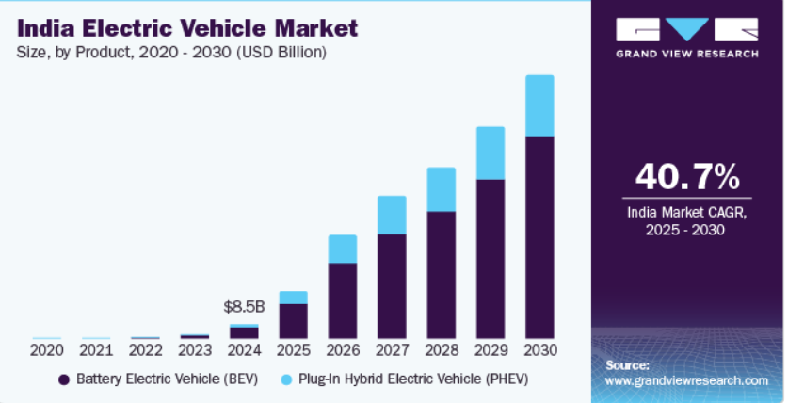
Figure 1 Indian electric vehicle Market
(Source: Grand View Research, 2023)

The Indian government has implemented a number of measures to promote EV adoption and sustainable transportation. The Faster Adoption and Manufacturing of Hybrid and Electric Vehicles (FAME) scheme, Production Linked Incentive (PLI) scheme and the reduced Goods and Services Tax (GST) on EVs have been some of the major factors that have assisted the market growth (Shah, 2022). Further, the growing adoption of charging stations nationwide has boosted consumer trust in EV, and India is expected to have over 29,000 fast charging stations by 2025 (EV Reporter, 2026).
BMW is one of the leading brands in the premium electric vehicle (EV) market among the global automakers. BMW's foray into the electric mobility segment has been through its ground breaking BMW i-series cars and has launched the BMW i4, BMW iX and BMW i7 in the Indian market. The company frames itself as a luxury car brand that embodies sustainable, innovative and high-performance technologies. The latest reports indicate that BMW has over 70% market share of luxury EVs in India and witnessed impressive EV sales in the past years as well (TOI, 2026). This reflects the growing consumer interest on buying a premium electric vehicle in India.
While EVs are growing in popularity in India, the sales of luxury EV brands like BMW are still to get consumers' attention. Even though many consumers are buying vehicles, issues such as high purchase prices, low charging station availability, battery performance, driving range and long-term reliability remain concerns. Furthermore, some customers may wonder if luxury EV brands are truly helping to promote sustainability or making it a marketing ploy. Current studies on EV adoption in India largely centre on mass market EVs, and there are few studies which specifically focus on consumers' perception of BMW's EVs in the Indian market.
This study is significant as it seeks to gain insight into the perceptions of Indian consumers towards the BMW electric vehicles and to understand the various factors influencing them to purchase the same. The study also will discuss the influence of sustainability issues on consumer perceptions of luxury EVs. The results could provide insights for BMW to enhance its marketing and sustainability initiatives and help build the body of knowledge on consumer behaviour and EV adoption in India.

2. Research Aim, Objectives and Questions

2.1 Research Aim
To examine consumer perception of BMW electric vehicles in India and analyse the factors influencing purchasing decisions and sustainability attitudes.

2.2 Research Objectives
- To analyse the perceptions of consumers toward BMW electric vehicles in India.
- To identify the factors influencing consumer purchasing decisions regarding BMW electric vehicles.
- To examine the impact of sustainability concerns on consumer attitudes toward BMW electric vehicles.

2.3 Research Questions
- How do consumers perceive electric vehicles offered by BMW?
- What factors influence consumer purchasing decisions toward BMW electric vehicles?
- How do sustainability concerns affect consumer attitudes toward BMW electric vehicles?

3. Preliminary Literature Review

3.1 Concept of Electric Vehicles
Electric vehicles (EVs) are automobiles powered either fully or partially by electricity instead of conventional internal combustion engines. There are two types of EVs: Battery Electric Vehicles (BEVs), Hybrid Electric Vehicles (HEVs) and Plug-in Hybrid Electric Vehicles (PHEVs). Zope, Swami and Patil (2024) report that EVs are regarded as an environmental friendly alternative due to their dependence on fossil fuels and low greenhouse gas emission. The research also states that technological developments and reduced requirements for maintenance have made EVs more appealing to customers. The research is, however, primarily on EV adoption in general and does not adequately cover premium EV brands like BMW.
Rising climate change awareness and government policies encouraging eco-friendly travel have led to a substantial growth in EV use worldwide. Despite challenges like charging infrastructure and range anxiety, Deloitte (2024) reports that consumer interest in EVs is on the rise, globally. But the report also notes that high price and charging constraints remain a deterrent for many consumers. Government initiatives like FAME-II and tax benefits for EV adoption are encouraging EV adoption in the Indian context. However, research shows that EV adoption in India is lagging behind in comparison to developed countries due to the lack of consumer awareness and confidence in EVs.
Moreover, Khajuria & Singh 2025 concluded that besides technological advancements, consumer perception and social acceptance also play a crucial role in influencing EV adoption. While these studies give an insight into the growth of EVs, few studies deal with the Indian luxury EV market. So it's crucial to know the perceptions of premium brands like BMW EVs.

3.2 Consumer Perception toward Electric Vehicles
Consumer perception is a key factor in the EV market, as the adoption of EVs is largely driven by EV awareness, attitudes, and EV trust. Gupta et al (2024) found that consumers believe EVs are environmentally friendly and technologically up-to-date. The factors that were found to be important in the study in influencing perception were convenience, safety and operational cost. But the study also revealed that many consumers remain skeptical about EVs being costlier and less viable than cars.
The Technology Acceptance Model (TAM) has been used to explain that the perceived usefulness and perceived ease of use are two important factors that affect the adoption of technology. Salari (2022) applied TAM to the EV market and determined that the consumer is more likely to adopt EVs if they think the technology is reliable, beneficial and easy to use. The study also found that psychological factors like fear of battery failure and lack of charging stations have an adverse impact on the adoption intention.
Consumer Behaviour Theory also states that there are social, psychological and economic factors which affect the consumer's buying decision. Venus et al. (2024) report that brand trust and brand reputation are important influences on consumer attitudes toward EVs. Consumers tend to think of car brands that have established a name as more reliable and of a higher quality. But luxury brands like BMW are burdened with even more pressure to optimize performance, luxury and sustainability all in one. There is limited research on the BMW in particular, particularly in India.

3.3 Factors Influencing EV Purchase Decisions
There are a few factors that determine what consumers are buying with respect to EVs. Price sensitivity is one of the major challenges for EV adoption, according to Zope, Swami and Patil (2024). Consumers are concerned about the high initial cost of EVs and battery replacement expenses. The study contends, however, that the price of fuel and government incentives help to improve the willingness of consumers to buy EVs.
Likewise, Bansal et al. (2021) concluded that Indian consumers will pay higher prices for EVs with better charging ability, range and operating costs. This shows that there is a significant link between practical and buying decisions. The study, however, primarily investigates the general EV consumer and not luxury consumers in particular.
Across the board, charging infrastructure and range anxiety are also a big concern. The lack of charging stations and the ambiguity of long-distance travel are the main obstacles that hinder EV adoption from consumer’s perspective as per Deloitte (2024). But top-tier manufacturers like BMW try to alleviate these worries by employing state-of-the-art batteries and offering opulent driving experiences.
The brand reputation of a company also plays a part in consumer purchasing behaviour, in the case of BMW it is a positive one. BMW cars are known for their cutting-edge engineering, top-tier materials, luxurious interiors, and cutting-edge technology, the ETimes (2026) report. The higher-end amenities, though, come at a higher cost, making BMW EVs only viable for high-end buyers. This leaves room for uncertainty on the broader acceptance of luxury EVs in India.

3.4 Sustainability and Green Consumer Behaviour
Sustainability is now an important consideration in consumer EV decision making. Kottala et al. (2025) found that the perception of sustainability positively affects consumers' EV purchase intentions. The study determined that those consumers who felt EVs are helping protect the environment are more likely to buy them. But the study also identifies that there is a lack of technological trust and affordability in addition to being aware of sustainability.
Likewise, results from Noman and Siam (2025) showed that the perceived advantage of EVs is that they reduce carbon emissions and air pollution, which are deemed to be good for the environment. However, the study revealed that high purchase prices, and the lack of charging stations were significant obstacles despite the positive attitudes towards environment. This indicates that sustainability issues make an impact on the consumer's behaviour, but not necessarily in actual buying.
In the case of BMW, sustainability plays an important role in brand positioning. Schmitt (2023) states that BMW is trying to build up its reputation as a sustainable luxury brand with its EV product line. The study suggests that despite the growing shift towards sustainability, consumers still identify BMW more with performance and luxury than sustainability. So it's essential to grasp whether Indian consumers actually see BMW EVs as 'green' products or just as a luxury status symbol.

3.5 Literature Gap
There is significant discussion in the existing literature around EV adoption, consumer perception and attitudes towards sustainability. But most studies are conducted on the EV markets as a whole, and not on premium EV brands. There has been little research that has taken a specific focus on luxury EV companies like BMW in the Indian market. Furthermore, previous studies predominantly focus on the practical issues related to charging networks, price, and battery performance, while failing to fully examine the impact of sustainability on the buying decision process of luxury EVs.
In addition, while the Technology Acceptance Model and Consumer Behaviour Theory describes the overall patterns of EV adoption, limited research has been conducted as to the unique perception of premium EVs of Indian consumers as compared to the mass market EVs. To address this, the aim of this study is to specifically analyse the consumer perception towards the BMW electric vehicles in India and explore the influence of sustainability on consumer behaviour of luxury EVs.

4. Research Methodology

4.1 Research Philosophy
This study will use interpretivism as a research philosophy as it is based on understanding the perception, attitude and meanings of the consumers about the electric vehicles of BMW in India. Interpretivism is appropriate for studies where the focus is on human actions and beliefs but not numerical relationships (Junjie and Yingxin, 2022). The philosophy enables the researcher to comprehend consumer perceptions of luxury EVs and sustainability ideas. It is also suitable for analyzing qualitative secondary data, such as academic and industry sources

4.2 Research Approach
The research method that will be used in the study is an inductive research. This is suitable because the aim of the research is not to test a hypothesis, but to uncover patterns and themes in the existing secondary data. The researcher will take the inductive approach to analyse published research and reports on the topics of Electric vehicles, Sustainability, and BMW in India (Mulisa, 2022). This approach enables themes to emerge organically from the data, concerning consumer attitudes, luxury perception and awareness of sustainability.

4.3 Research Strategy
This research will adopt a secondary research strategy. Secondary research is the process of obtaining information from different reliable sources in the academic and industry field, but not from respondents themselves. This study will rely on various sources such as journal articles, BMW reports, Governmental publications, market research reports, and news articles to learn about the perception of the consumers and EV market trends in India (Zieger and Scudder, 2025). This approach is appropriate as it offers a wealth of information and prior research on electric vehicle adoption and consumer behavior.

4.4 Data Collection Method
Qualitative secondary data will be obtained from reliable and published sources. Information pertaining to EV consumer perception and BMW electric vehicle market in India will be sourced from academic journals, company reports, government reports, and trusted industry publications. The data is suitable because secondary qualitative data can be used to analyse the discussion and findings that have been produced by other people who have already carried out surveys and interviews.

4.5 Data Analysis Technique
Thematic analysis will be used to analyse the collected data. First, information from academic articles, industry reports, and government publications will be reviewed and coded that is relevant to the study. These similar codes will then be clustered under larger themes, such as environmental concern, brand reputation, charging infrastructure and purchase cost. These themes will then be analysed and iterated to identify patterns across the consumers' perception of the BMW electric vehicles (Squires, 2023). Finally, themes will be explained in terms of research aims and questions in order to get meaningful knowledge.

4.6 Ethical Considerations
Ethics will be adhered to in conducting the research. The study does not require direct participation from the study subjects since it is a study that uses secondary data that is publicly available. Academic integrity will be upheld by providing accurate referencing, paraphrasing correctly and distinguishing between the analysis of others and own analysis. In addition, all the findings will be presented honestly and transparently to ensure the reliability and credibility of the research.

5. Risks and Limitations
This study has some limitations that might influence its results. Firstly, the research is solely based on secondary data as this reduces the direct consumer viewpoints about the BMW electric vehicles in India. Secondly, access to the internal BMW consumer data and company information is limited, which could limit the depth of analysis. Additionally, some market reports and published studies may contain outdated information due to the rapidly changing EV industry. There may be some bias in industry reports, news articles or previous research. Moreover, the results cannot be generalised to the entire Indian population as there can be regional and income group differences in the attitudes of consumers. These limitations will be minimized by utilizing recent and credible academic and industry sources, and by comparing multiple sources to enhance the reliability and accuracy.

6. Timeline / Gantt Chart
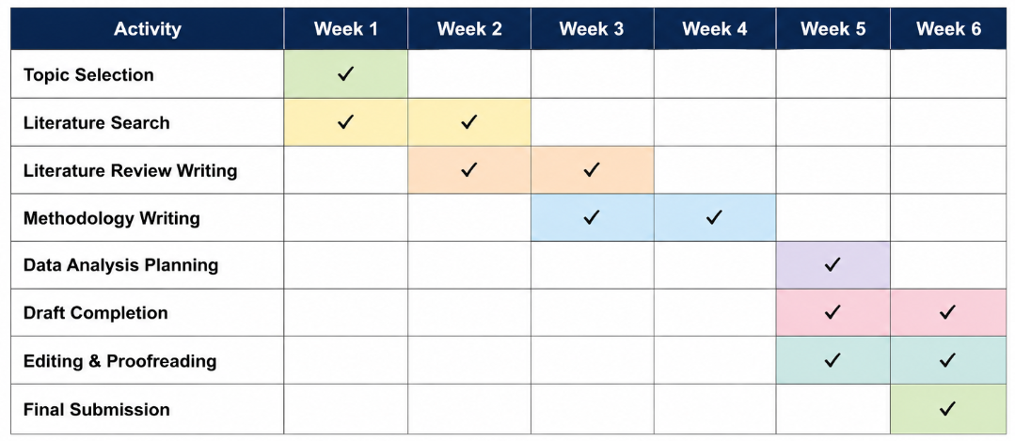
Figure 2 Gantt Chart
(Source: Self-created)
The Gant chart above displays a time frame of six weeks for the dissertation proposal, detailing the various research activities, from topic selection to dissertation submission. It supports effective planning and timely completion of the research project.

References
Bansal, P., Kumar, R.R., Raj, A., Dubey, S. and Graham, D.J. (2021). Willingness to Pay and Attitudinal Preferences of Indian Consumers for Electric Vehicles. [online] arXiv.org. Available at: https://arxiv.org/abs/ 2101.08008.
Deloitte (2024). 2024 Global Automotive Consumer Study: The Evolution of Mobility. [online] WSJ. Available at: https://deloitte.wsj.com/sustainable-business/2024-global-automotive-consumer-study-the-evolution-of-mobility-ea70756a [Accessed 23 May 2026].
ETimes (2026). ​​Why BMW cars are so expensive: The features that make them stand out. [online] The Times of India. Available at: https://timesofindia.indiatimes.com/auto/news/why-bmw-cars-are-so-expensive-the-features-that-make-them-stand-out/photostory/127900767.cms [Accessed 23 May 2026].
EV Reporter (2026). Charging India’s EV revolution: Bridging the gap between ambition and infrastructure reality • EVreporter. [online] EVreporter. Available at: https://evreporter.com/charging-indias-ev-revolution-bridging-the-gap-between-ambition-and-infrastructure-reality/ [Accessed 23 May 2026].
Grand View Research (2023). India Electric Vehicle Market Share Report, 2021-2030. [online] www.grandviewresearch.com. Available at: https://www.grandviewresearch.com/industry-analysis/india-electric-vehicle-market-report [Accessed 23 May 2026].
Gupta, A., Srivastava, G., Wadhwa, J., Kumari, S. and Raghav, V. (2024). A Study on Consumer Perception towards Electric Vehicles in India: With Special Reference to Noida City of Gautam Budhha Nagar, Uttar Pradesh. European Economic Letters (EEL), [online] 14(2), pp.620–633. Available at: https://www.eelet.org.uk/index.php/journal/article/view/1385 .
Junjie, M. and Yingxin, M. (2022). The Discussions of Positivism and Interpretivism. [online] ERIC, Eric. Available at: https://eric.ed.gov/?id=ED619359 .
Khajuria, V. and Singh, H. (2025). Consumer Perception Towards Adoption of Electric Vehicles: A Literature Review. RESEARCH HUB International Multidisciplinary Research Journal, 12(6), pp.48–52. doi:https://doi.org/10.53573/rhimrj.2025.v12n6.007 .
Kottala, S.Y., Chanagala, S., Balaji, C., Reddy, N. and Babu, V. (2025). Exploring electric vehicle consumer behavior: impact of digital innovation, environmental concern, perceived value, and social influence on purchase intentions. Frontiers in Sustainable Cities, 7. doi:https://doi.org/10.3389/frsc.2025.1655074 .
Mulisa, F. (2022). When Does a Researcher Choose a Quantitative, Qualitative, or Mixed Research Approach? Interchange, [online] 53(1), pp.113–131. doi:https://doi.org/10.1007/s10780-021-09447-z .
NITI AAYOG (2025). Electric Vehicles in India Unlocking a $200 Billion Opportunity. [online] Available at: https://www.niti.gov.in/sites/default/files/2025-08/Electric-Vehicles-WEB-LOW-Report.pdf .
Noman, A.A. and Siam, H.H. (2025). The economic, social & Environmental impact of Electric Vehicle (EV) adaptation on Bangladeshi Society. [online] arXiv.org. Available at: https://arxiv.org/abs/2508.08398 .
Salari, N. (2022). Electric vehicles adoption behaviour: Synthesising the technology readiness index with environmentalism values and instrumental attributes. Transportation Research Part A: Policy and Practice, 164, pp.60–81. doi:https://doi.org/10.1016/j.tra.2022.07.009 .
Schmitt, D. (2023). THE EUROPEAN ELECTRIC VEHICLE MARKET: AN ANALYSIS OF CONSUMER PERCEPTIONS AND PREFERENCES: GREEN MOBILITY AND CONSUMER BEHAVIOUR Maxim-Leon Daniel Schwenk Covelo (54581) Group Part 1 Acknowledgments. [online] Available at: https://run.unl.pt/bitstream/10362/178944/1/The_European_electric_vehicle_market_An_analysis_of_consumer_perceptions_and_preferences_Green_mobility_and_consumer_behaviour.pdf .
Shah, R.V. (2022). Financial Incentives for Promotion of Electric Vehicles in India- An Analysis Using the Environmental Policy Framework. Nature Environment and Pollution Technology, [online] 21(3), pp.1227–1234. doi:https://doi.org/10.46488/nept.2022.v21i03.028 .
Squires, V. (2023). Thematic Analysis. Springer Texts in Education, [online] pp.463–468. Available at: https://link.springer.com/chapter/10.1007/978-3-031-04394-9_72 .
TOI (2026). BMW India posts best-ever Q1 17% growth: 2nd fastest growing market globally. [online] The Times of India. Available at: https://timesofindia.indiatimes.com/auto/cars/bmw-india-posts-best-ever-q1-17-growth-number-1-luxury-ev-player-in-india/articleshow/130106154.cms [Accessed 23 May 2026].
Venus, A., Schaufuss, P. and Möller, T. (2024). How European consumers perceive electric vehicles. [online] McKinsey & Company. Available at: https://www.mckinsey.com/industries/automotive-and-assembly/our-insights/how-european-consumers-perceive-electric-vehicles? .
Zieger, M. and Scudder, N. (2025). Ethical and legal reflections on secondary research using genetic data acquired for criminal investigation purposes. Forensic Science International: Genetics, 75, p.103178. doi:https://doi.org/10.1016/j.fsigen.2024.103178 .
Zope, A., Swami, R.K. and Patil, A. (2024). Electric Vehicles: Consumer Perceptions and Expectations. Lecture notes in mechanical engineering, pp.221–236. doi:https://doi.org/10.1007/978-981-99-7445-0_20 .

