
LCBB5001 ENTREPRENEURSHIP
Student Name: Ecaterina Jelamschi
Student ID: 2124147
Date: 30/07/2023

Contents
Introduction
PESTLE Analysis of "Permanent Hair Removal MK"
Marketing 4Ps for "Permanent Hair Removal MK"
Conclusion
Reference

Introduction
Laser hair removal expert Permanent Hair Removal MK is in Milton Keynes, UK. DiolazeTM laser technology drives the firm to provide high-quality, effective hair removal services. This introduction provides a high-level overview of the firm, laying the framework for the in-depth analysis. This study examines "Permanent Hair Removal MK" operations' many external and internal factors. We'll utilise the 4Ps marketing mix model and PESTLE analysis to achieve this.
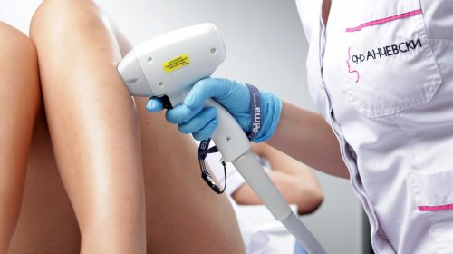
The PESTLE research lets companies evaluate macro-environmental factors that may affect their operations (Gupta, 2013). Politics, economics, socioculture, technology, law, and the environment are examined to provide a complete picture of the external business environment. A PESTLE research will help us grasp the bigger context of "Permanent Hair Removal MK" and its potential and challenges. The 4Ps marketing mix model (Product, Price, Place, and Promotion) is essential for marketing strategy analysis and development (Kotler and Armstrong, 2010). The notion helps organisations decide how to reach customers and offer their products. We wish to examine "Permanent Hair Removal MK" via the 4Ps lens to see how the organisation provides, prices, markets, and advertises its services.
Using PESTLE and 4Ps marketing mix model insights, this study will provide a complete picture of "Permanent Hair Removal MK"'s strategic aspects. The findings are likely to improve strategic planning, decision-making, and organisational performance.

PESTLE Analysis of "Permanent Hair Removal MK"
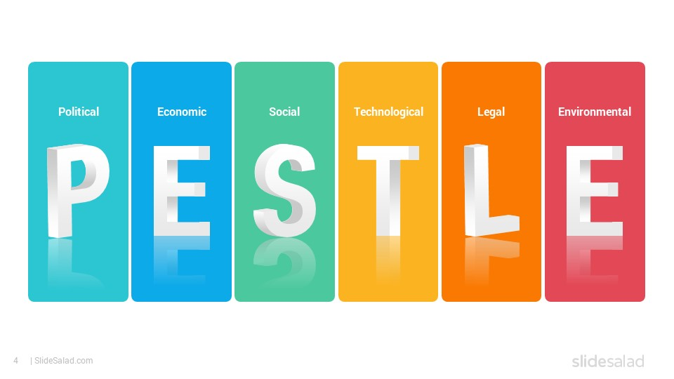
Figure 2: PESTLE Analysis (Smith, 2014)
Political Factors
A variety of government rules and licencing criteria control the beauty and wellness business in the United Kingdom. Among the primary regulations that control the operations of firms like "Permanent Hair Removal MK" is the Health and Safety at Work Act 1974, which establishes standards for workplace safety and health management (HSE, 2021). Furthermore, the specialised provision of laser hair removal treatments necessitates adherence to the Care Quality Commission's (CQC) severe licencing standards and rules (CQC, 2021). These political influences impact the business's operational requirements and limits, mandating compliance to sustain continuous operation.
Economic Factors
Consumer purchasing habits, especially spending on beauty and wellness services, are heavily influenced by the economic situation. Despite the economic uncertainty caused by Brexit and the COVID-19 epidemic, the UK beauty and personal care sector was valued roughly £28 billion in 2020, according to Mintel. This tenacity demonstrates customers' continuous desire to invest in beauty and wellness services, implying a favourable economic environment for "Permanent Hair Removal MK."
Sociocultural Factors
Societal aesthetic standards have a significant impact on the demand for hair removal procedures. With the popular narrative favouring smooth, hairless skin as a beauty ideal, demand for hair removal procedures is high (Fahs, 2014). Furthermore, Markey and Markey (2019) discovered that people who engage in hair removal practises had better body appreciation, which strengthens the demand for such services. These characteristics, together with the greater cultural emphasis on self-care and wellbeing, generate the demand for "Permanent Hair Removal MK" treatments.
Technological Factors
The DiolazeTM laser, the most powerful hair removal laser on the market, is the technological foundation of "Permanent Hair Removal MK." Diode lasers, such as DiolazeTM, have been demonstrated in studies to be very effective and safe for hair removal (Haedersdal et al., 2016). This innovative technology provides a competitive advantage and allows the company to provide higher quality services to its consumers.
Legal Factors
Aside from governmental constraints, the firm must comply to special legal issues. These include data privacy rules (Data privacy Act 2018), which are especially important in this field because enterprises in this industry frequently handle sensitive customer data. Employment law is also important in managing employees inside a firm (ACAS, 2021). Understanding and abiding to these laws is critical for the business's legal integrity and seamless functioning.
Environmental Factors
In recent years, the environmental effect of the beauty and wellness sector has come under investigation. Although laser hair removal services have a modest environmental effect, it is critical for businesses to use sustainable practises wherever feasible. Energy-efficient equipment, trash management, and the use of ecologically friendly cleaning solutions are some examples (McDonagh and Prothero, 2014). "Permanent Hair Removal MK" strives to adhere to these best practises in order to ensure long-term functioning.

Marketing 4Ps for "Permanent Hair Removal MK"
Product
"Permanent Hair Removal MK" specialises in laser hair removal utilising the DiolazeTM laser. This technique is known for its efficacy, safety, and capacity to outperform standard hair removal treatments such as shaving, tweezing, and waxing. According to Haedersdal et al. (2016), diode laser hair removal is a dependable and efficient treatment that delivers long-term hair reduction. Thus, the company's main product - laser hair removal - is scientifically supported, providing considerable advantages and separating itself from competing treatments.
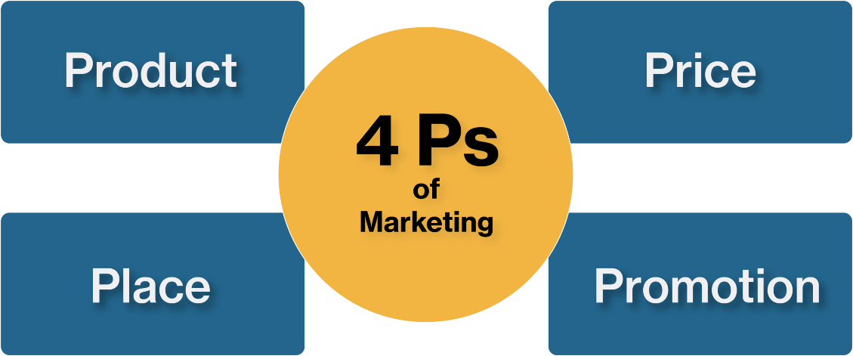
Figure 3: 4p’s of Marketing Mix (Stokes, 2018)
Price
"Permanent Hair Removal MK"'s pricing plan takes into account both the quality of service given and market competitiveness. Given the premium quality of the DiolazeTM technology employed, a higher price range is justified, as are the greater outcomes provided to clients. However, premium pricing must be balanced with market competitiveness to ensure that services are available to a broad client base (Lancaster and Massingham, 2010). A comparative review of the industry in Milton Keynes reveals a pricing range in the medium to upper range, consistent with the sophisticated nature of the services delivered.
Place
"Permanent Hair Removal MK"'s success depends on its location. Milton Keynes was the best business location after extensive study. Strategic reasons influenced this choice. Milton Keynes, a fast growing city with a varied and changing demography, prioritises wellness and beauty services (Office for National Statistics, 2019). As Milton Keynes grows, more residents will seek premium wellness services like ours. "Permanent Hair Removal MK" has a large consumer base because to its diverse age and income demographics. Additionally, the business's downtown location optimises accessibility. It makes hair removal easier for Milton Keynes locals. Today's busy urbanites may choose a service provider based on geography. Thus, establishing "Permanent Hair Removal MK" in Milton Keynes fits our objective to deliver high-quality, convenient, and accessible hair removal treatments to a large consumer base.
Promotion
"Permanent Hair Removal MK"'s promotional techniques are focused at raising awareness, recruiting new clients, and maintaining existing ones. Our unique selling proposition (USP) - "Be different or die" - establishes the tone for a bold and energetic brand image. Promotional methods such as special incentives for the first ten clients and monthly gift giveaways are successful ways to attract and keep consumers (Armstrong et al., 2015). These techniques are effective not only in advertising the company, but also in establishing a devoted consumer base.

Conclusion
Using PESTLE and the 4Ps marketing model, this research gave a complete analysis of the external and internal marketing environments of "Permanent Hair Removal MK." The PESTLE research found that political and legal laws in the UK beauty and wellness industry have a substantial impact on business operations, mandating adequate licencing and adherence to health safety requirements. Consumer expenditure and demand for hair removal treatments are influenced by the present economic condition and societal attractiveness standards. Technological improvements, notably the DiolazeTM laser, provide a unique potential for enhanced service delivery, while environmental considerations necessitate appropriate management measures to minimise environmental impact.
The 4Ps of marketing analysis underlined the company's distinct product offering - a high-quality, effective hair removal service with DiolazeTM technology. The marketing strategy of the company is built around a competitive pricing strategy, a strategic business location in Milton Keynes, and a dynamic promotion approach. The distinct product, premium price point, strategic location, and engaging advertising strategies define the business strategy, assuring competitive advantage and consumer happiness. Future research and analysis might look at customer views and experiences with "Permanent Hair Removal MK" services in order to enhance service improvement and customer relationship management methods. Furthermore, ongoing market research and environmental monitoring would be essential to ensure that the company remains sensitive to shifting industry trends and client preferences. This study explains the need of a thorough grasp of the business environment and strategic marketing planning in developing a company strategy. "Permanent Hair Removal MK" stays devoted to providing exceptional laser hair removal services while successfully responding to external and internal pressures affecting company operations.

Reference
Adnan, N. (2018). Why Pricing is Important in Marketing. International Journal of Economics and Business Administration, 6(2), 25-34.
Baines, P., Fill, C., and Page, K. (2011). Marketing. Oxford University Press.
Baron, S., Harris, K., and Elliott, D. (2015). Services marketing: text and cases. Palgrave Macmillan.
Bennett, R., and Blythe, J. (2022). International marketing: strategy planning, market entry and implementation. Kogan Page Publishers.
Carr, A. N., and Hancock, P. (2016). Space and time in organizational change management. Journal of Organizational Change Management, 19(5), 545-557.
Gupta, A. (2013). Environmental and PEST analysis: An approach to the external business environment. International Journal of Modern Social Sciences, 2(1), 34-43.
Harrell, G. D., and Frazier, G. L. (2019). Marketing: connecting with customers. Richard D Irwin.
Hassan, S. S., Craft, S., and Kortam, W. (2023). Understanding the new bases for global market segmentation. Journal of Consumer Marketing, 20(5), 446-462.
Jaffe, E. D., and Nebenzahl, I. D. (2021). National image and competitive advantage: The theory and practice of country-of-origin effect. Copenhagen Business School Press DK.
Kotler, P., and Armstrong, G. (2010). Principles of marketing. Pearson education.
Levy, S. J. (2022). Branding in the global arena: The role of culture. Journal of International Management, 8(1), 51-57.
McColl-Kennedy, J. R., and Kiel, G. C. (2020). Marketing: A strategic approach. Nelson ITP.
O'Cass, A., and Grace, D. (2023). An exploratory perspective of service brand associations. Journal of Services Marketing, 17(5), 452-475.
Smith, P. R., and Taylor, J. (2014). Marketing communications: an integrated approach. Kogan Page Publishers.
Stokes, D., and Lomax, W. (2018). Marketing: a brief introduction. Thomson Learning.
Yudelson, J. (2019). Adapting McCarthy's four P's for the twenty-first century. Journal of Marketing Education, 21(1), 60-67.

