4/15/2026
Assessment
Operating Systems Assignment

Module NaMe: COMPUTER ARCHITECTURE AND OPERATING SYSTEMS
Module Code: ACCA 4022
Lecturer: Dr. REDHWAN AL AMRI
Trinity saint david University of Wales (London Campus)



Student Name: Semra Ozturk
Student ID: 2510165
Table of Contents
1. Introduction 2
2. General Operating System: Important Functions 2
2.1. Process Management 2
2.2. Memory Management 3
2.3. File Management and Directory Management 5
2.4. Network Management 6
2.5. User and Security Management 7
2.6. Task Scheduling 7
3. Usage of Windows OS CLI Commands 9
3.1. Process Management 9
3.2. File and Directory Management 10
3.3. Networks Testing and Monitoring 14
3.4. Task Scheduling 15
3.5. User Management 16
4. Use of Linux OS CLI Commands 18
4.1. Process Management 18
4.2. File Management and Directory Management 19
4.3. Network Testing and Monitoring 21
4.4. User Management 23
4.5. Task Scheduling 24
5. Use of Windows OS Scripts 25
5.1. Automated Backup 25
5.2. Calculator Script 27
6. Use of Linux OS Scripts 28
6.1. File Counter Script 28
6.2. User Creation Script 30
7. Conclusion 32
8. References 33

Introduction

The current computing environment is built on the operating systems that handle the hardware resources and provide services to the applications and users. Popular operating systems such as Microsoft Windows and Linux are general-purpose operating systems that can support multitasking, memory allocation, file management, network communication and security enforcement [1]. The key functions of the operating system are discussed in this report, and the practise of administration in Windows Command Line Interface (CLI), Linux Bash commands and scripting methods are displayed. The report, through command execution and automation scripts, demonstrates how well the system administrators can control the performance of a system, manage users and networks, and how easily they can automate tasks that are used every day.

General Operating System: Important Functions

Operating System can execute certain essential functions and ensure that hardware and programmes are in good communication with each other. These essential functions are process management, memory management, file system management, user management, device management and security control.

Process Management

Scheduling and allocation of the CPU capacity allow the multi-use of applications through process management. Figure 1 shows the Task Manager that enables one to monitor running processes in Windows [2]. The following commands are used to display the processes and real-time CPU usage in Linux ps aux and top. Direct control in the implementation of the system can be demonstrated by the availability of killing the process using taskkill in Windows and kill -9 PID in Linux.

Processes Tab – Displays running applications and background services and their usage. Helps identify the CPU, memory or network resources to determine the processes.
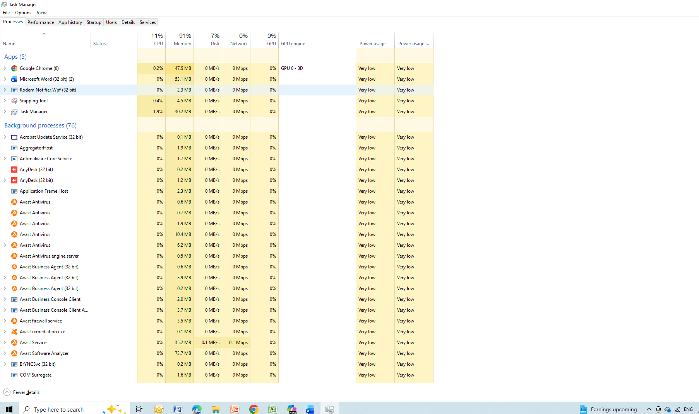
Figure 1: Processes Tab Screenshot

Memory Management

The memory management ensures that the RAM is assigned to the process in an efficient manner. Windows performance monitor displays statistics of memory usage as compared to free -m commands in Linux. This is achieved by proper management of memory to ensure that the resources are not exhausted, and the systems are well stabilised [3].

Memory Usage – Displays the RAM used (3.6 GB used). Illustrates that most of the memory is occupied, and little space exists where new activities can be caried out.

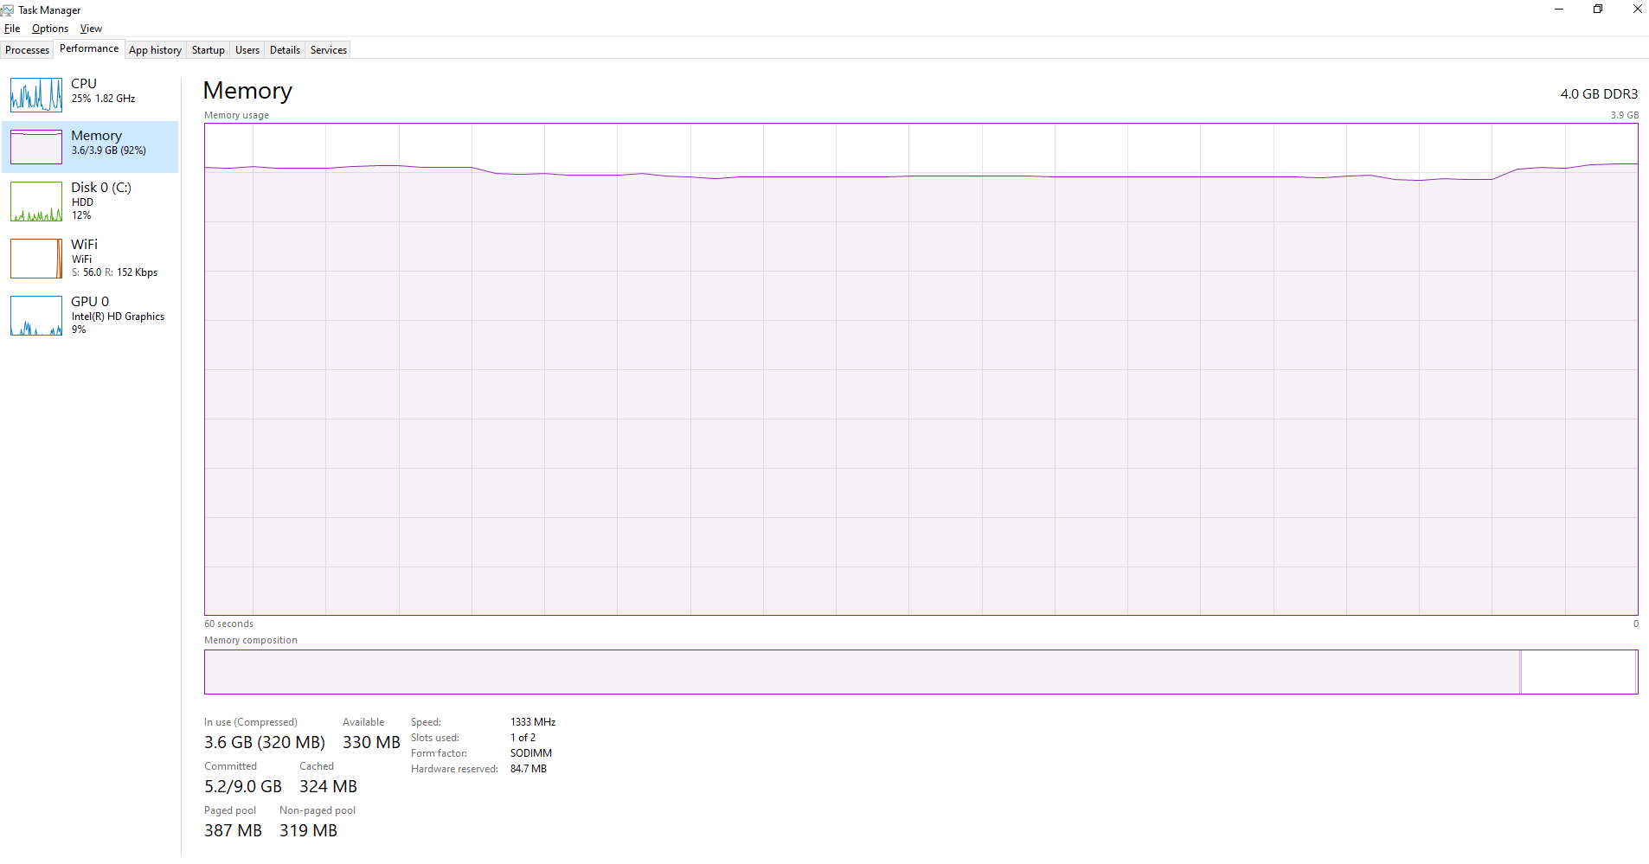
Figure 2: Memory Usage Screenshot

GPU Performance – Shows the level of usage of the GPU in different activities, e.g. 3D, video processing. Registers that there is low use, i.e. no intensive graphics processes are currently underway.

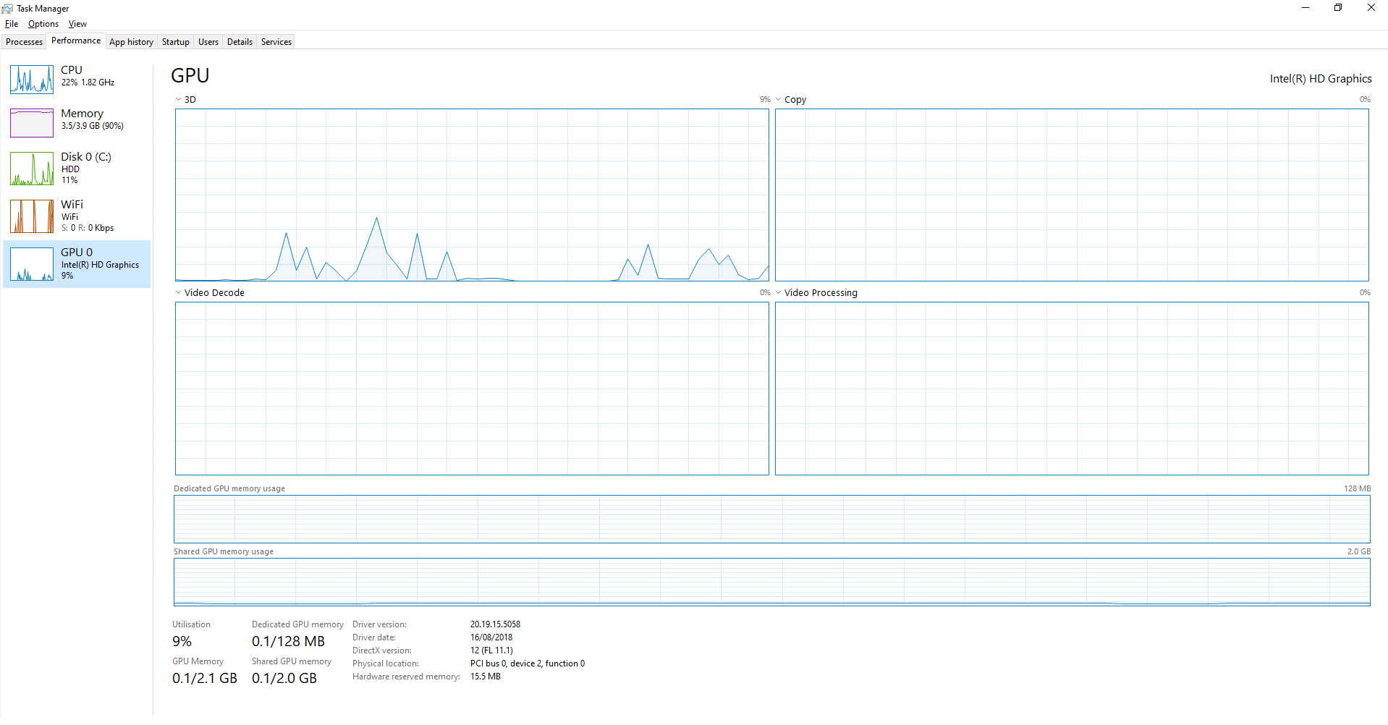
Figure 3: GPU Performance Screenshot

File Management and Directory Management

Organisation of data in operating systems is conducted in hierarchical file systems. NTFS is used in Windows, and ext4 is mostly used on Linux. It is possible to use such commands as dir/s to view directories in Windows repeatedly. Similarly, the permissions of files are also provided in detail by ls -la in Linux. Practical file system management may be discussed with references to such file operations as creation of folders (mkdir), copying files (cp) and deleting files (del).

Disk Activity – Shows read/write on the disk with spikes periodically. Means background processes or access to a file can lead to temporary increased usage.

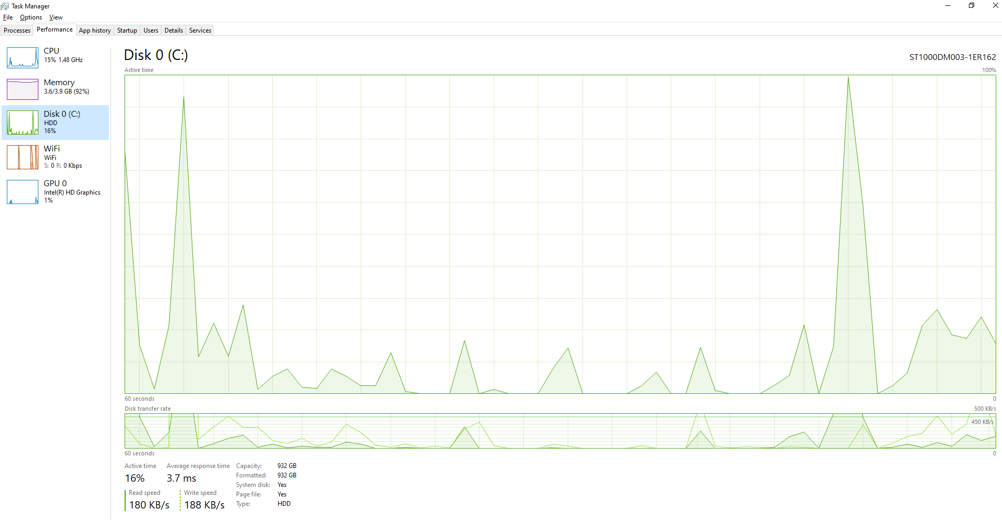
Figure 4: Disk Activity Screenshot

Network Management

Operating systems regulate the network settings and the communication protocols. In Windows, the network interface is displayed, containing ipconfig /all, and in Linux, it is displayed using ip a. Windows uses ping and tracert as network diagnostics, which are used to identify the nature of connection issues and routing issues.

Wi-Fi Performance Graph – Shows network usage trends over time with bursts. Represents sporadic data exchange, probably as a result of navigation or automatic updates.

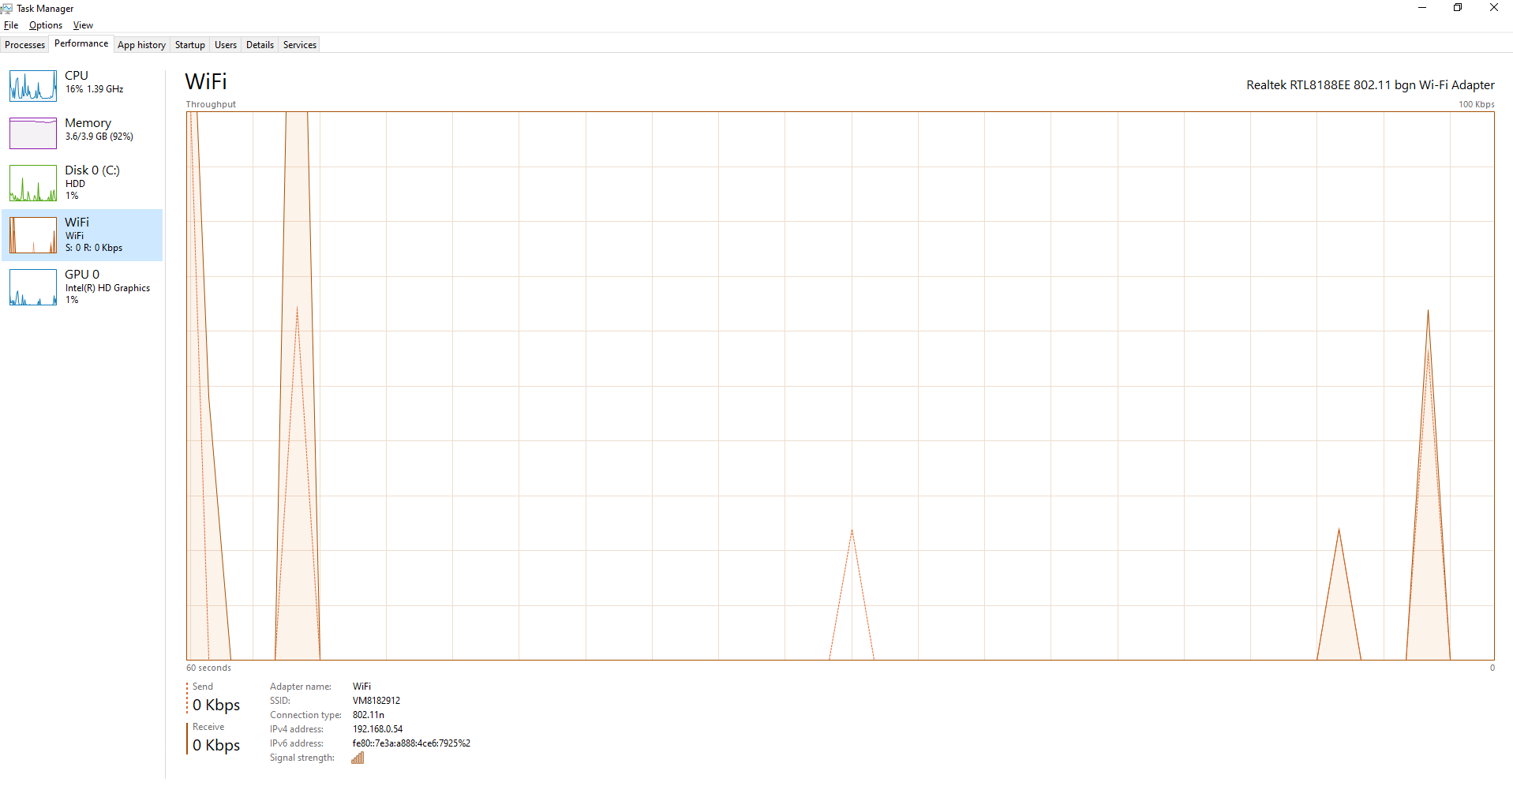
Figure 5: Wi-Fi Performance Graph Screenshot

User and Security Management

User management is done to accomplish authentication and access control. In the Windows commands such as net user and whoami, the user account information can be observed. The user credentials and system accounts in the Linux system are displayed with the help of the following commands: whoami, id, and cat / etc / passwd. The mechanisms utilise access control policies and enhance the security of the system.

Task Scheduling

Task scheduling automation is the scheduling of system tasks. Windows works with the assistance of schtasks, which regulates the job scheduled. Cron job configuration is done using Linux, crontab -l and crontab -e. The cron service status may be used to prove the scheduling functionality.

CPU Performance – This shows CPU utilisation, whose peaks and lows vary. Signifies active processing where the CPU load is being incremented by periods of tasks.

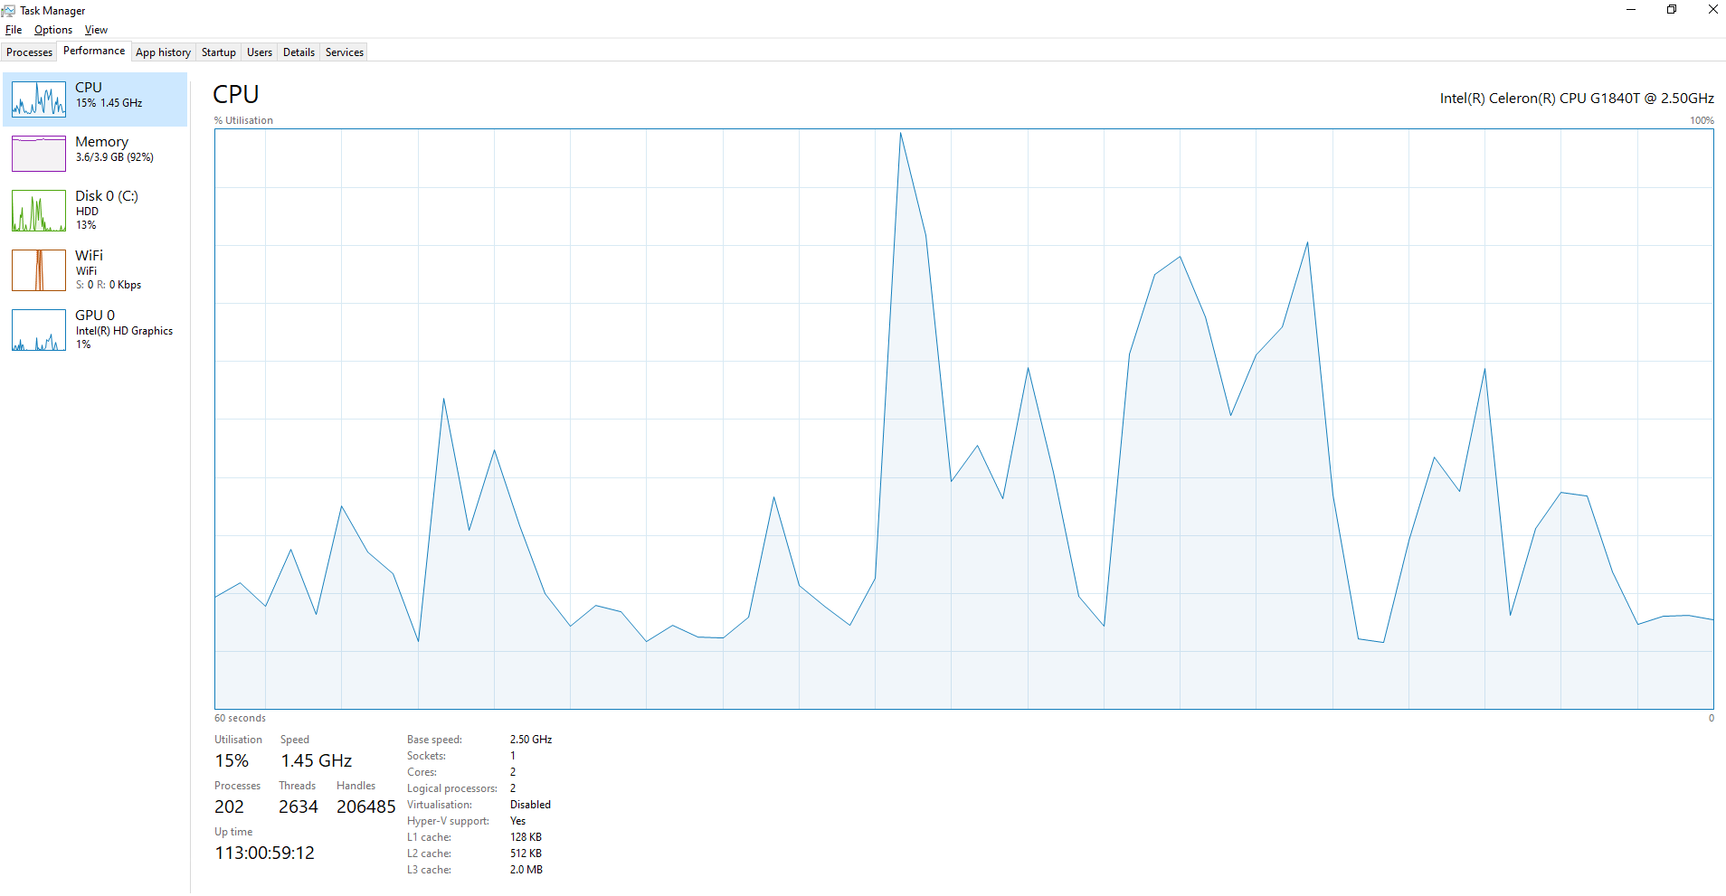
Figure 6: CPU Performance Screenshot

Overall, these core activities enable computing systems to be secure, work well, and be stable. In addition to the fundamental management functions, the operating systems also provide system protection, a feature of error detection and performance optimisation. Modern operating systems are also set up with the policy of access control, relevant to encryption, and with firewalls that enhance safety against unauthorised access and cyberattacks. They should also maintain a record of system logs and event monitoring tools as one of the methods of monitoring abnormal behaviour and assisting in troubleshooting. Moreover, the operating system will offer robust resource sharing with multiple users and applications and encourage scalability, reliability, and overall system performance in both personal and enterprise contexts.

Usage of Windows OS CLI Commands

Windows also has very powerful command-line tools which are executed through Command Prompt and PowerShell, providing the ability to monitor the system and administrative control.

Process Management

Figure 7 displays a tasklist command that is used to identify the running processes and the Process IDs (PID). The desired processes are forcefully terminated by the taskkill / PID command. These commands allow the administrators to restrict the quantity of resources consumed and also to debug issues with the systems.

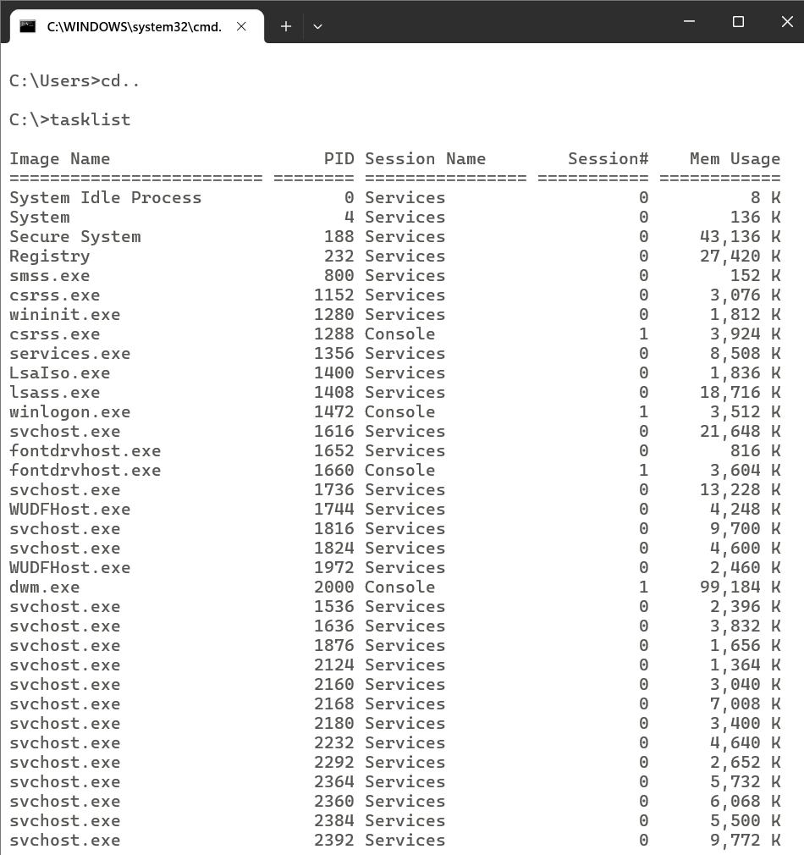
Figure 7: View Running Process

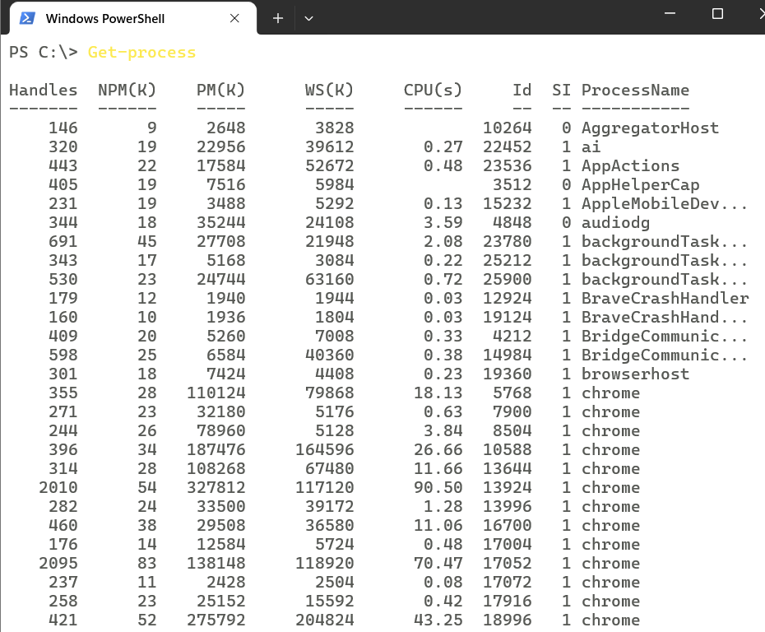
Figure 8: View Processes Using PowerShell

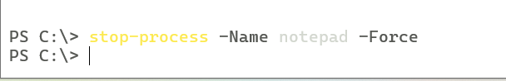
Figure 9: Stop Process Using PowerShell

File and Directory Management

Work done on the manipulations of files involved the assistance of dir / s, which enabled viewing recursive directory contents. The mkdir command is used to create new directories, creation of files and the copying is demonstrated with the assistance of the echo and copy commands. Deletion of files by using del was also done to demonstrate that directory management ability was present.
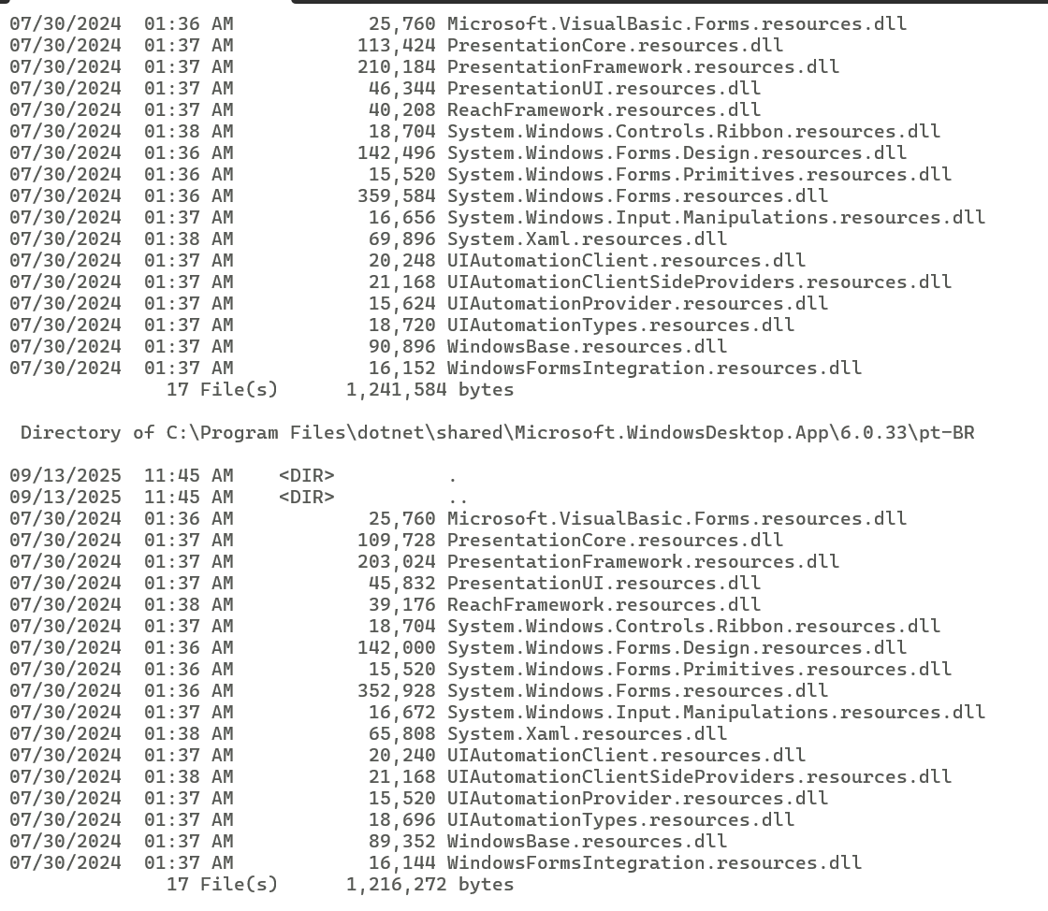
Figure 10: dir / s View Files in the Directory

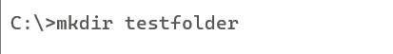
Figure 11: Create Folder
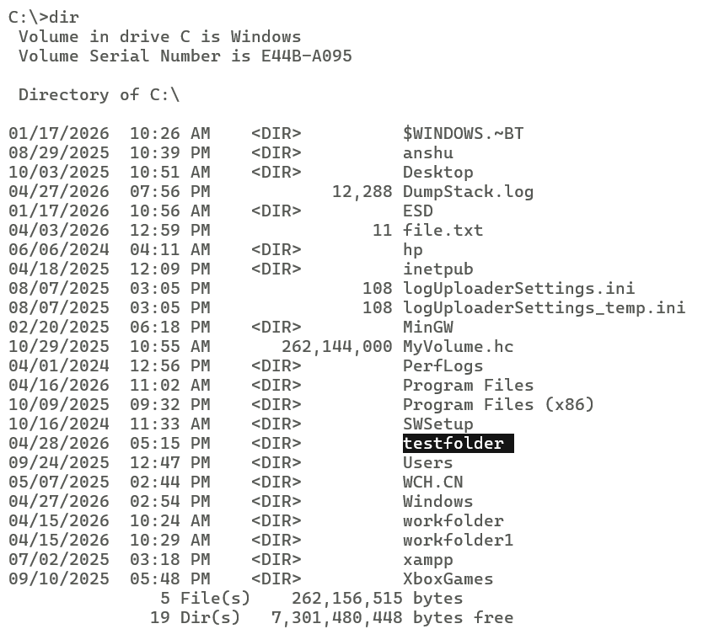
Figure 12: Shows Folder Created

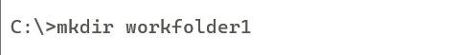
Figure 13: Workfolder Created Using mkdir

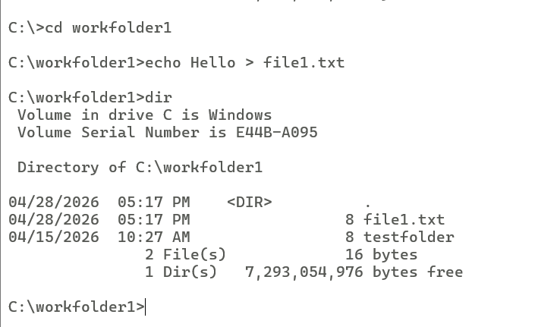
Figure 14: Create a File Inside a Folder

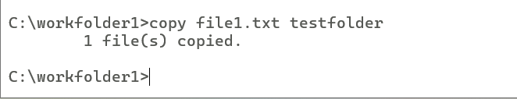
Figure 15: Copy File

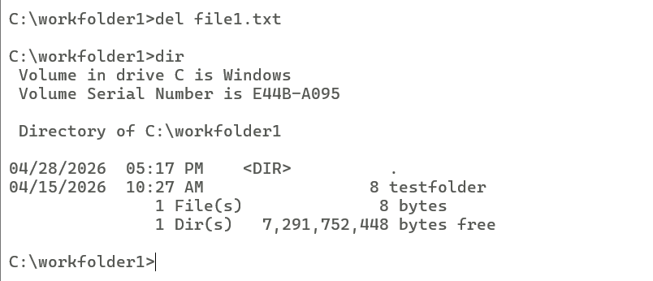
Figure 16: Delete File

Networks Testing and Monitoring

IP address configuration, DNS servers and MAC addresses are displayed on ipconfig / all. Ping testing is also conducted to test the network connection to Google. The Tracert command is applied in order to trace the route packets through networks, and this provides information on how to analyse network paths [4].
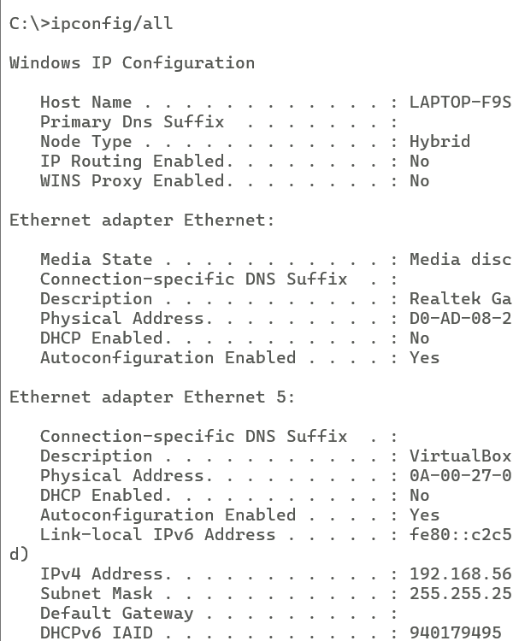
Figure 17: View IP Configuration

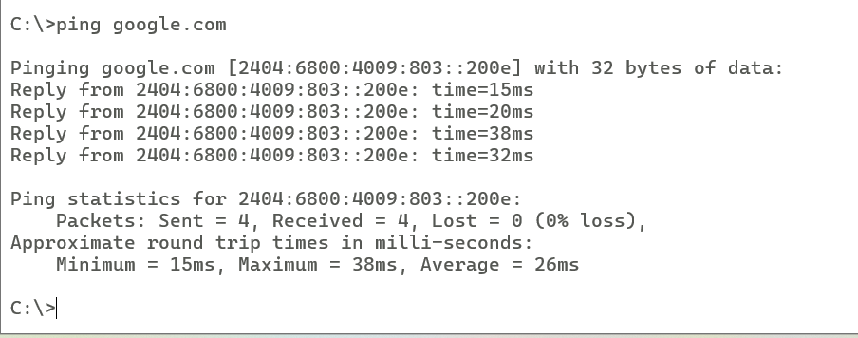
Figure 18: Test Connectivity

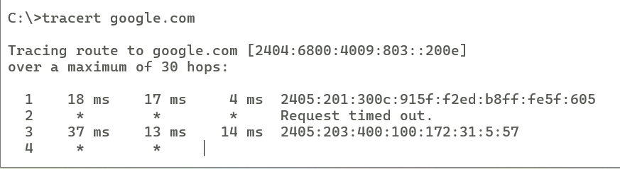
Figure 19: Trace Route

Task Scheduling

The tasks can be automated using Windows Task Scheduler, where schtasks / query is used to list scheduled tasks and schtasks/ create is used to create a task that opens Notepad at specified times. This process runs automatically in the background.
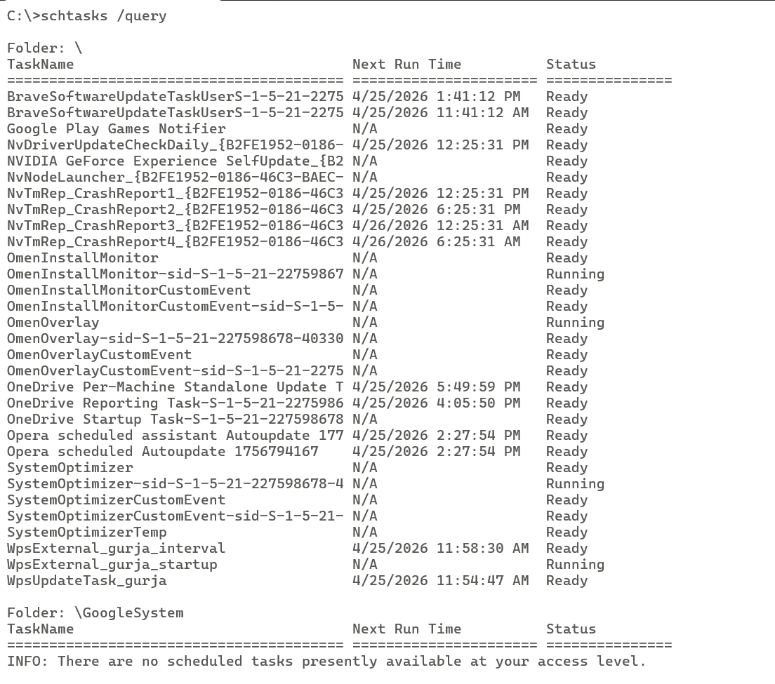
Figure 20: View Scheduled Tasks

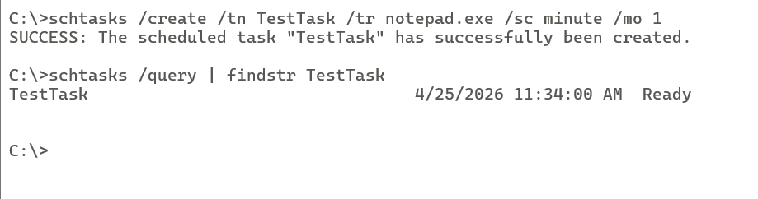
Figure 21: Create Scheduled Task

User Management

User account information can be retrieved with the help of net user (Figure 22), and current user and security identifiers could be viewed with the help of whoami and wmic useraccount get name, respectively [5].

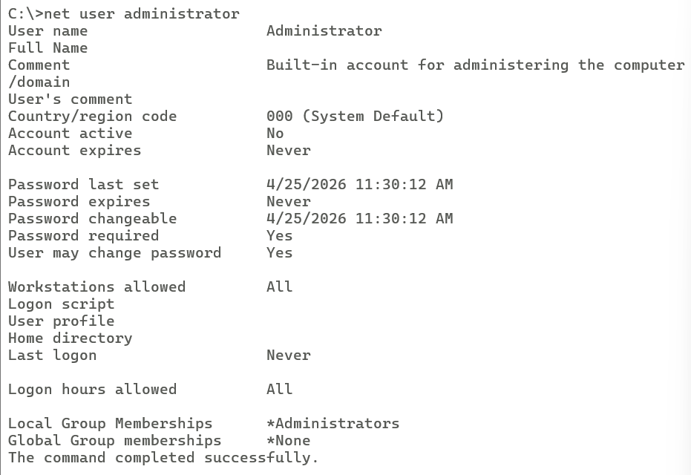
Figure 22: View Detailed User Information

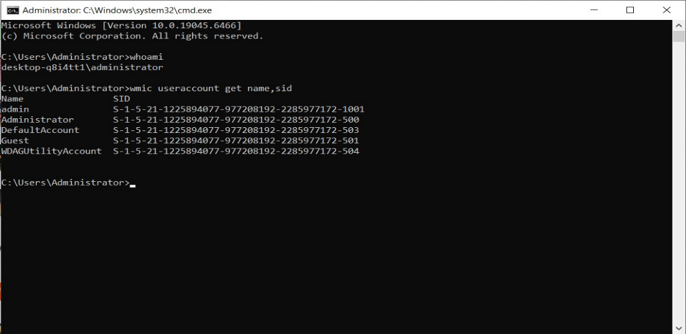
Figure 23: Current Logged-In User and User SID

All these commands state that Windows CLI can work in the management of systems, troubleshooting, and automation.
Windows CLI tools are also used in the more complex system diagnostics and automation, as well as simple administration. Some of these commands are wmic, netstat and schtasks, these commands enable the administrator to have a complete view of the system, monitor the open ports, as well as easily automate the background processes. PowerShell is still more operational with the megabuild of scripting functions and object-oriented output, which gives an option of better managing the activities and configuration. The Windows command-line environment certainly comes in handy when the enterprise environment is considered, and remote administration, batch processing and troubleshooting are required to be performed on several systems in a fast and reliable fashion.

Use of Linux OS CLI Commands

Linux is properly supported by a Bash shell environment for the administration of the system.

Process Management

The running processes were indicated by the command ps aux as shown Figure 24, and the top command provides real-time information at a given time as indicated in Figure 25. Kill -9 was the one that was used to kill processes with a PID [6].

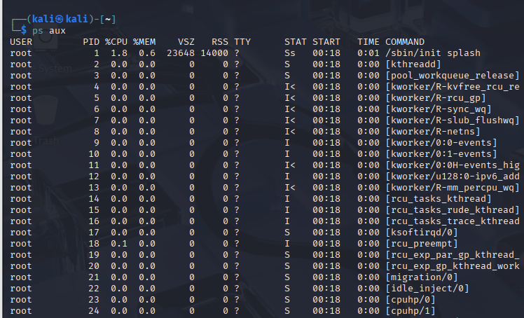
Figure 24: ps aux

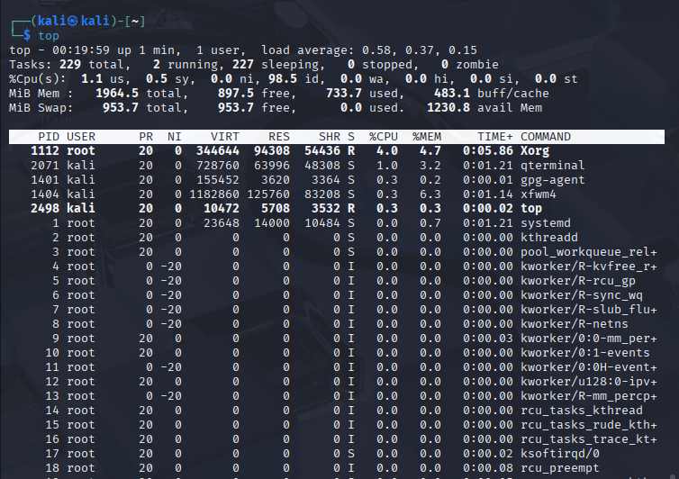
Figure 25: Real-Time Process Monitoring

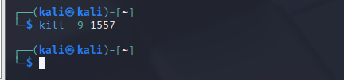
Figure 26: Kill a Process by PID

File Management and Directory Management

Figure 27 is obtained with ls -la listing the directory using permissions and ownership. The folders are created by means of the command mkdir, and the files were created with the use of the command echo. cp is implemented to copy the files, and with the assistance of the option -v, which indicated that duplication is successful [7].

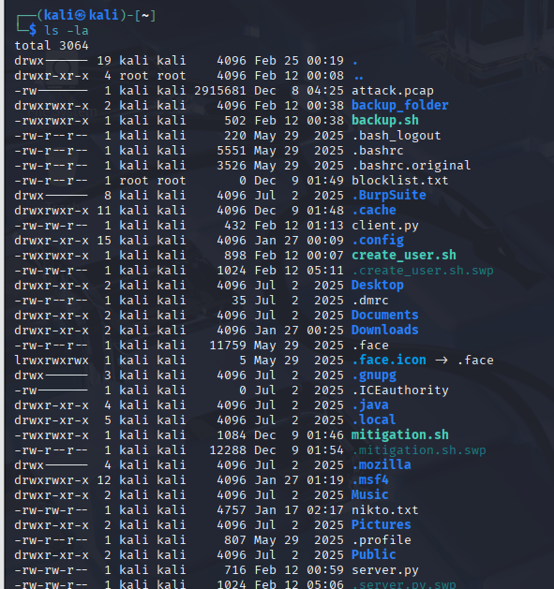
Figure 27: List Files with Detailed Info

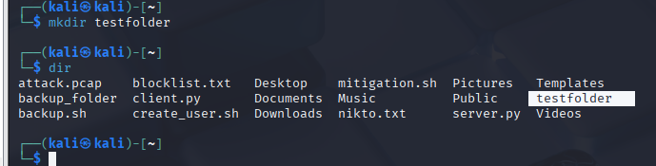
Figure 28: Create Directory

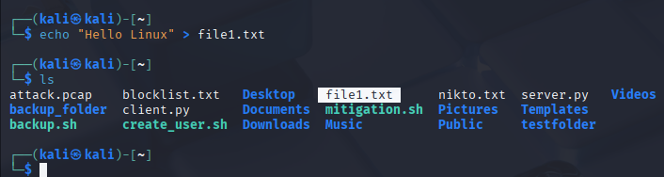
Figure 29: Create File

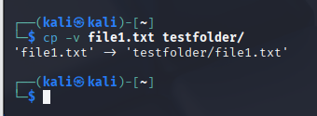
Figure 30: Copy File

Network Testing and Monitoring

Figure 31 is a display of ip a command, which displayed IP address configuration. A ping -c 4 was used to check the connectivity of the network (Figure 32). The open ports are identified using the ss -lnt, which aids in monitoring the network services.

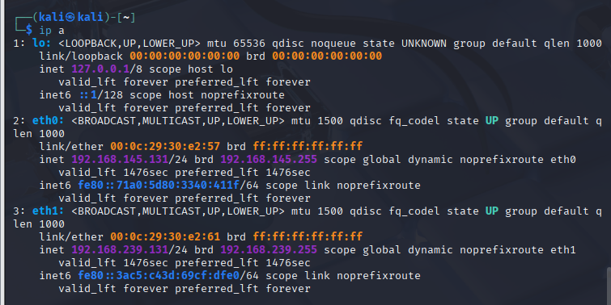
Figure 31: Show ip Address Info

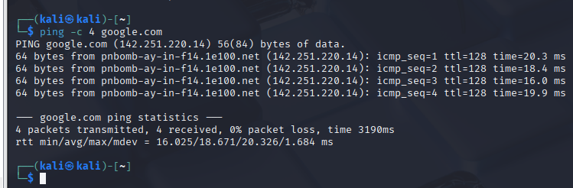
Figure 32: Test Network Connectivity

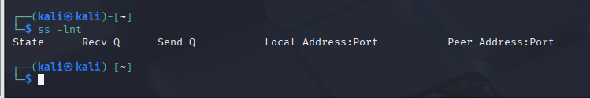
Figure 33: Open Ports

User Management

Figures 34 and 35 also display the current user through the whoami command and group details using the id command. The file defining all the system was /etc/passwd.

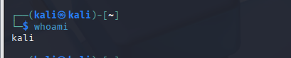
Figure 34: Current User

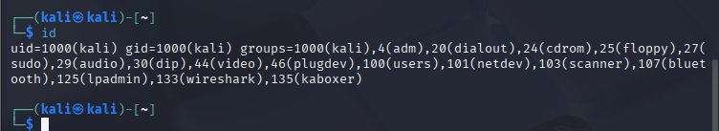
Figure 35: User ID Info

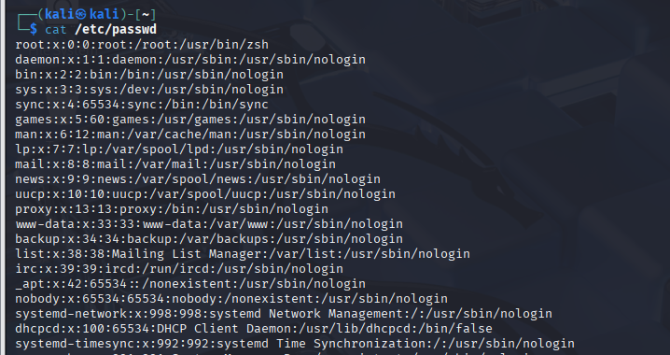
Figure 36: View All System Users

Task Scheduling

Crontab scheduling was analysed using crontab -l (Figure 37) and crontab -e (Figure 38). The scheduling services were enabled, which is depicted by the command systemctl status cron [8].


Figure 37: Crontab -l Showing Cron Entries

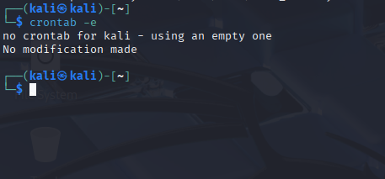
Figure 38: Crontab -e

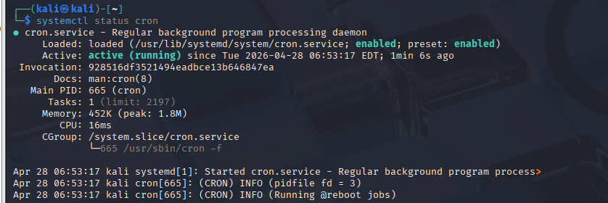
Figure 39: Cron Service Status

These commands demonstrate the flexibility, and control Linux provides over system resources.

Other than typical system monitoring, Linux command-line utilities provide detailed service configuration and resource management. systemctl and crontab are some of the applications that allow the administrators to control the services, monitor network sockets and automate processes to be repeated. The modularity of Linux allows the use of pipes to chain commands, enabling flexibility and efficiency. This model of command style is preferred to gain server management, DevOps and cloud infrastructure management. Thus, the knowledge of Linux CLI has become a prerequisite in the current system administration and cybersecurity environment.

Use of Windows OS Scripts

Automated Backup

The code depicted in Figure 40 is the Batch script code that prompts the user to type in a folder name, checks whether it exists, creates a backup directory and copies the files with the assistance of a loop structure. The script contains variables (set), conditionals (if) and iteration (for) as well.
The result of the execution is demonstrated in Figure 41, which indicates that it copied files and automated. It means that one can automate regular backup operations and conserve man-hours through Batch scripting.
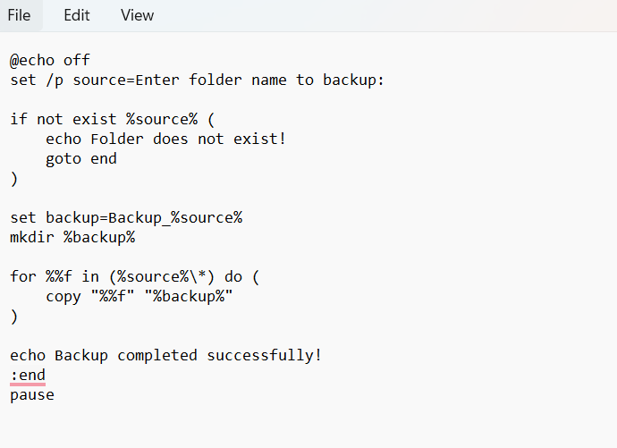
Figure 40: Backup Script Code

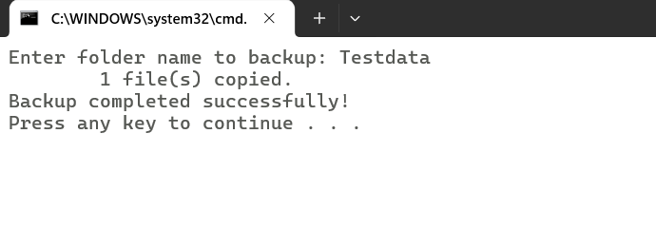
Figure 41: Execution Output of Backup Script Showing Successful File Copy

Calculator Script

Calculator batch script with user input (set /p), arithmetic (set /a) and conditional (if) statements is found in figure 42.
The calculation gave the output in Figure 43. Repeated operations can be done with the assistance of a loop (go to menu), which represents organised control flow.

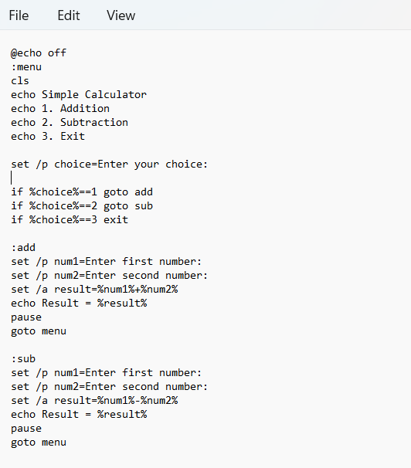
Figure 42: Calculator Script Code

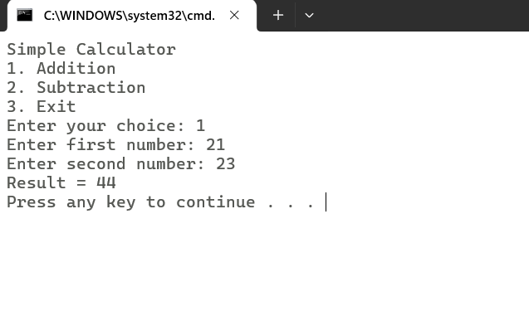
Figure 43: Execution Output Showing the Arithmetic Result

Use of Linux OS Scripts

File Counter Script

The script creation is shown in Figure 44, and the Bash script code in Figure 45. Script use variables, user input (read), arithmetic $( ( ) ), loops (for) and conditional statements (if).
Figure 46 indicates the execution output in order to signify the number of files taken into account within a directory in general. This script automatically counts files in a directory.


Figure 44: Bash File Counter Script Creation

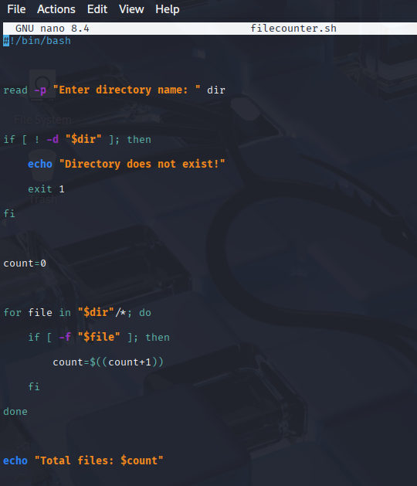
Figure 45: Bash File Counter Script Code

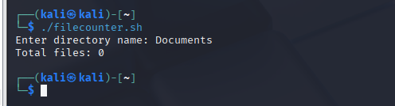
Figure 46: Execution Output Showing Total File Count

User Creation Script

The scripts are written as shown in Figure 47, is the code based on conditionals is written as shown in Figure 48 ensure that there is a user by their ID.
Figure 49 indicates the result of the execution, which proves the successful creation of a user. This demonstrates automation in a Linux system administrator.


Figure 47: Bash User Script Creation

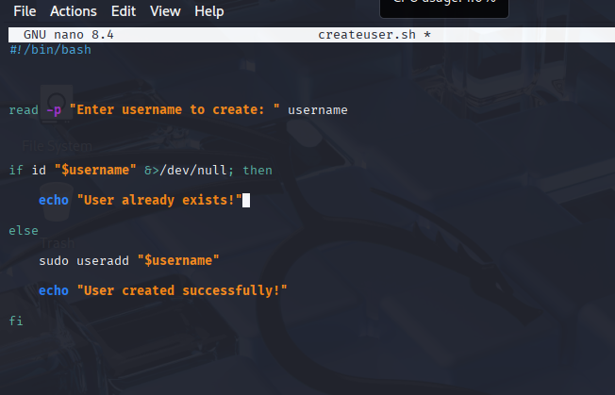
Figure 48: Bash User Creation Script Code

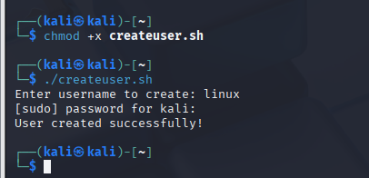
Figure 49: Execution Output Showing Successful User Creation

Conclusion

This report discusses the primary uses of the general-purpose operating systems and provides practical system administration in consideration of the Windows and Linux command-line interfaces. In this report, the core OS functionality is graphically explained using terminal commands, which involved process control, file system, network configuration, user authentication and task scheduler. The administrator system proves to be capable of monitoring and controlling the activities of the system, as evidenced by the use of Windows CLI such as tasklist, ipconfig, and schtasks and Linux such as ps aux, ip a, and crontab.
In addition to that, the development of Batch and Bash scripts unveiled the importance of automation, considering the reduction of the number of individuals who should handle work on assignments and efficiency in processes. The concepts of structured programming were applied in the realisation of the functions that acted within a system, and were reflected in the use of variables, loops, arithmetic operations and conditionals of Windows and Linux scripting. Overall, the training exercises demonstrate that command-line knowledge and scripting skills are essential conditions for modern IT specialists and system administrators.

References

[1] | M. T. Awan and K. Khan, Linux vs Windows: A Comparison of Two Widely Used Platforms, vol. 4, no. 1, pp. 41-53, 2022.
[2] | M. G. Rodriguez, L. O. Cerdeira, E. G. Rufino and F. J. R. Martinez, Study and Evaluation of CPU Scheduling Algorithms, vol. 10, no. 9, 2024.
[3] | J. R. C. Jalaman and J. I. Teleron, Optimizin Operating System Performance through Advanced Memory Management Techniques: A Comprehensive Study and Implementation, vol. 9, no. 5, 2024.
[4] | A. A. Kulshrestha, G. Song and T. Zhu, “arXiv.org,” The Inner Workings of Windows Security, 23 December 2023. [Online]. Available: https://arxiv.org/abs/2312.15150. [Accessed 15 April 2026].
[5] | R. Chouhan, “arxiv.org,” A Dynamic Take on Window Management, 8 October 2025. [Online]. Available: https://arxiv.org/abs/2511.17516. [Accessed 20 April 2026].
[6] | R. S. Boldrito, “Introduction to Linux,” Fundacio Universitat Oberta de Catalunya, Barcelona, 2022.
[7] | J. Hao, Y. Xiao, W. Zhou and P. Wang, in Operating System Basics and Practice, Shenzhen, Springer Natue Singapore, pp. 233-278.
[8] | R. S. Alhamidi and R. A. Hamoudi, ChronoBak: Automated Cost-Effective Incremental Backup Software for Large-Scale Data, vol. 3, no. 4, pp. 170-176, 2024.

