

Programme: Master of Business Administration

Module: Financial Management

Module code: LCMB7002

Assignment Title: Assessment component: Financial performance and management

FINANCIAL TURNAROUND AND INVESTMENT APPRAISAL REPORT FOR GENERAL ELECTRONIC

Lecturer Name: Patrick Yeboah (Birmingham)

Student Name: Harshil Bharatkumar Desai

Student ID: 2504765

Word count: 5290
Submission date: Monday 24th November 2025 by 2pm

Table of Contents
Introduction 4
1. Financial Health Check 4
1.1 Overview of Financial Performance 4
1.2 Ratio Analysis 5
1.3 Trend Analysis 9
1.4 Corporate Failure Prediction 9
1.5 Summary of Findings 11
2. Working Capital Management Analysis 11
2.1 Cash Operating Cycle 11
2.2 Liquidity Improvement Strategies 12
2.3 Financing Strategy 12
2.4 Summary 13
3. Strategic Financial Restructuring Plan 14
3.1 Overview of the current financial conditions 14
3.2 Strategic Options 14
3.3 Evaluation of Each Option 15
3.4 Global and Ethical Considerations 16
3.5 Recommended Restructuring Plan 17
4. Investment Appraisal and Capital Budgeting 18
4.1 Project Overview 18
4.2 Evaluation Techniques 18
4.3 Comparative Analysis 19
4.4 Capital Rationing Decision 20
4.5 Recommendations 21
Conclusion 22
References 23
Appendices 28
Appendix 1: Ratio tables and graphs 28
Appendix 2: Investment appraisal calculations 33

Introduction

Investment appraisal is a very important part of establishing projects that will provide long-term profits and also correspond to the turnaround objectives of the firm. In context to predict cases or probabilities of corporate failure, asset realignment and retrenchment are key measures that can help prevent insolvency. Acquisitions and restructuring are the methods that can help to increase the level of competitive advantage and guarantee long-term sustainability. General Electronics is in dire financial distress, its profitability is dropping and its liquidity is tightening, as well as it is getting more leveraged. The financial reorganisation is, therefore, the strategic option that is needed to put its operations back on its feet, revive investor trust, and allow growth in the long term.

1. Financial Health Check

1.1 Overview of Financial Performance
The consumer electronics market has remained unstable in the past 5 years as General Electronics has experienced significant financial turbulence. The profitability changed dramatically as it was moderate in 2020-2021, but losses were severe in 2022-2023, and a minor improvement was recorded in 2024. Gross profit margin was between 23 and 29, with some control at the production level, even when facing pressure on prices. Nevertheless, the operating margin decreased in 2023 to -20.28% as compared to 2020, of 6.06%, and it went up to -3.87% in 2024. Net profit margin also decreased by 6.27% and then to -23.3%, and then to -6.08%, indicating high costs and low demand. ROA declined to -27.60% in 2023 and to -7.43% in 2024, which was an improvement of 7.56% in 2020. ROE decreased to 12.31 to -54.91, followed by a slight recovery to -15.698, which is equal to strong erosion of shareholder value. The ROCE has dropped to -43.80 after 11.26, which proves poor use of capital. These patterns indicate some underlying structural problems, such as ineffective market positioning and inefficiency. According to Baliouskas et al. (2023), troubled companies are not always able to adjust to new markets, and the only change that can help restore profitability is the repositioning and financial restructuring of companies.

1.2 Ratio Analysis
Profitability Ratios
Severe volatility is ensured by profitability ratios. Despite the steady gross margins, negative operating and net margins represent poor cost control and earnings pressure. Deteriorating ROA, ROE and ROCE affirm ineffective utilisation of assets and capital. These results show that it is high time for entrenchment and efficiency to be corroborated. Corporate turnarounds are based on the ability to sell unprofitable businesses and reduce fixed costs (Rico and Puig, 2021).

A. PROFITABILITY RATIOS |  | 2024 | 2023 | 2022 | 2021 | 2020
Gross Profit Margin (%) | (Gross Profit / Net Revenue) x 100 | 28.87 | 23.20 | 28.06 | 28.76 | 28.67
Operating Profit Margin (%) | (Operating Income/Net Sales)*100 | -3.87 | -20.29 | 2.68 | 3.87 | 6.06
Net Profit Margin (%) | (Net Income/Net Sales)*100 | -6.09 | -23.36 | 0.07 | 0.88 | 6.28
Return on Assets (ROA) (%) | (Net Income/Total Assets)*100 | -7.43 | -27.60 | 0.08 | 1.04 | 7.56
Return on Equity (ROE) (%) | (Net Income/Total Equity)*100 | -15.69 | -54.91 | 0.15 | 1.92 | 12.31
Return on Capital Employed (ROCE) (%) | (Operating Income/(Total Assets - Current Liabilities))*100 | -9.27 | -43.81 | 5.06 | 7.92 | 11.27

Liquidity Ratios
The liquidity of the company is still average and declining. The current ratio was 1.55 on average, which is fairly short-term solvency. Nevertheless, the cash ratio decreased to 0.17 in 2024 compared to 0.32 in 2020, and working capital decreased to £147,333m to £84,203m, which is a sign of constrained liquidity. The quick ratio of 1.0 or close to it indicates a low degree of shock absorption. Tanui et al. (2021) stated that these declines are indicative of a low-efficient structure of assets and a necessity to advance cash generation and solvency control.
LIQUIDITY RATIOS |  | 2024 | 2023 | 2022 | 2021 | 2020
Current Ratio | Total Current Assets/Total Current Liabilities | 1.53 | 1.61 | 1.56 | 1.56 | 1.82
Quick Ratio (Acid Test) | (Current Assets - Inventories)/Current Liabilities | 1.03 | 1.06 | 0.91 | 0.93 | 1.15
Cash Ratio | Cash/Current Liabilities | 0.17 | 0.27 | 0.31 | 0.28 | 0.32
Working Capital (£m) | Total Current Assets - Total Current Liabilities | 84203.00 | 97703.00 | 121567.00 | 120359.00 | 147333.00
Working Capital Ratio (%) | (Working Capital/Total Assets)*100 | 26.04 | 27.45 | 24.11 | 23.58 | 28.87

Efficiency Ratios
There is a decline in operational efficiency. The asset turnover was also stable at 1.2, whereas the receivable turnover and Days Sales Outstanding improved to 3.46 and 105 days, respectively, indicating slower collections. Turnover Payables turnover was low, and this implies that the company was not paying its suppliers on time, but the cash conversion cycle had gone up to 96 days. These tendencies illustrate poor management of working capital. Nyatsumba and Pooe (2022) added that these inefficiencies are usually attributed to instability within the organisation and require a great deal of managerial discipline to reduce it.
EFFICIENCY RATIOS |  | 2024 | 2023 | 2022 | 2021 | 2020
Asset Turnover Ratio | Net Sales/Total Assets | 1.22 | 1.18 | 1.08 | 1.18 | 1.20
Inventory Turnover | Cost of Sales/Average Inventory | -3.54 | -3.66 | -2.79 | -3.19 | -3.64
Days Inventory Outstanding (DIO) | 365/Inventory Turnover | -103.12 | -99.78 | -131.04 | -114.52 | -100.26
Receivables Turnover | Net Sales/Average Accounts Receivable | 3.46 | 3.73 | 4.83 | 4.66 | 4.75
Days Sales Outstanding (DSO) | 365/Receivables Turnover | 105.54 | 97.74 | 75.55 | 78.40 | 76.86
Payables Turnover | Cost of Sales/Average Accounts Payable | -3.90 | -5.66 | -5.47 | -4.62 | -5.27
Days Payable Outstanding (DPO) | 365/Payables Turnover | -93.60 | -64.47 | -66.72 | -78.95 | -69.29
Cash Conversion Cycle (Days) | DIO + DSO - DPO | 96.03 | 62.43 | 11.23 | 42.83 | 45.89
Fixed Asset Turnover | Net Sales/Property & Equipment | 11.54 | 9.42 | 8.64 | 8.06 | 7.04

Gearing Ratios
Increasing leverage risk is exhibited by capital structure. Debt-to-equity ratio has risen to 1.11 in 2024 compared to 0.63 in 2020, and the debt-to-assets ratio has changed to 0.53 to 0.39. In 2023, interest coverage was 19.69, and in 2024, it was 4.55, showing that the company was not earning enough to cover its debts. High leverage lowers flexibility and investor confidence, wherein capital restructuring becomes the key to financial recovery (Imhanzenobe, 2021).
GEARING (LEVERAGE) RATIOS |  | 2024 | 2023 | 2022 | 2021 | 2020
Debt-to-Equity Ratio | Total Liabilities/Total Equity | 1.11 | 0.99 | 0.88 | 0.85 | 0.63
Debt-to-Assets Ratio | Total Liabilities/Total Assets | 0.53 | 0.50 | 0.47 | 0.46 | 0.39
Equity Ratio | Total Equity/Total Assets | 0.47 | 0.50 | 0.53 | 0.54 | 0.61
Interest Coverage Ratio | Operating Income/Interest Expense | 4.55 | 19.69 | -6.61 | -41.08 | -26.21
Debt Service Coverage Ratio | Operating Income/(Interest + Current Portion of Debt) | -0.46 | -1.68 | 0.17 | 0.42 | 2.01

Cash Flow Ratios
It has poor cash flow. The free cash flow decreased to a deficit of -3,796m in 2024 compared with a positive figure of £83,113m in 2020, and the margin of the cash flows decreased to -5% in 2024, as compared to 11% in 2020. The cash flow to debt ratio has remained negative, which has ensured that there is a low capability to meet the obligations using internal sources. Such performances depict liquidity weakness. As stated by Kamal and Awan (2025), it is possible to establish financial resilience and stability through the use of structured instruments and innovative financing to stabilise the cash flow of troubled companies.
CASH FLOW RATIOS |  | 2024 | 2023 | 2022 | 2021 | 2020
Operating Cash Flow Ratio | Cash from Operations/Current Liabilities | -0.12 | -0.22 | 0.09 | -0.10 | 0.37
Free Cash Flow (£m) | Cash from Operations - Capital Expenditures | -3796.00 | -10790.00 | 14574.00 | -25686.00 | 83113.00
Cash Flow Margin (%) | (Cash from Operations/Net Sales)*100 | -5.01 | -8.27 | 3.78 | -3.66 | 10.73
Cash Flow to Debt Ratio | Cash from Operations/Total Liabilities | -0.12 | -0.20 | 0.09 | -0.09 | 0.33
Operating Cash Flow to Net Income | Cash from Operations/Net Income | 0.82 | 0.35 | 50.37 | -4.16 | 1.71

1.3 Trend Analysis
In 2020-2024, General Electronics turned the relative profitability into open financial distress. The decline in profitability began in 2021 and showed a sharp negative change following poor cost control and high competition. The liquidity was satisfactory, but cash holdings had reduced. There was an efficiency decline and an increase in the collection cycle and working capital turnover. Debt exposure is greater, as demonstrated by gearing ratios, and risk was increased by cash flow volatility. These trends signify not short-term but structural problems. There has been poor utilisation of the capital of the company, and fluctuating cash flows have destroyed investor confidence. According to the perspective of Oliveira Saraiva et al. (2024), declining companies need to focus their strategy on turnaround activities by restructuring finances, innovating and controlling costs. Harrigan and Wing (2021) further believed that turnarounds can be successful only through asset optimisation, governance improvement, and recapitalisation. Thus, General Electronics needs to focus on cost discipline, capital efficiency, and financial reorganisation to make a recovery.

1.4 Corporate Failure Prediction
The Altman Z-score is calculated using weighted ratios of working capital (X1), retained earnings (X2), EBIT (X3), market value of equity (X4) and Sales/total assets (X5). The score of 1.8-3.0 is in the grey zone, which indicates a moderate risk of financial distress (Rashid et al. 2023).
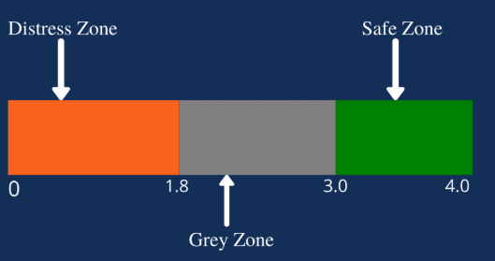
Figure 1: Altman Z-score model
(Source: Inspired by the ideas of Rashid et al. 2023)
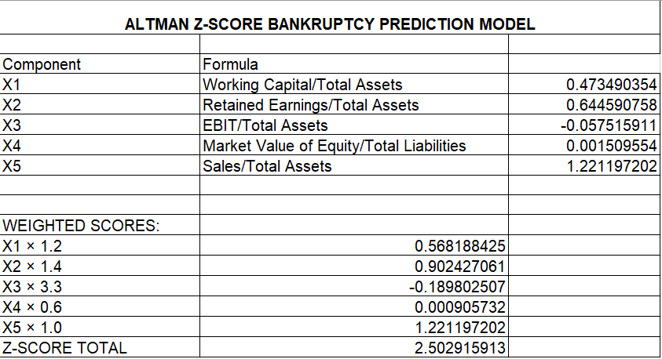
The Altman Z-score of General Electronics is 2.50.
These positive elements include working capital (0.47) and retained earnings (0.64) to counter the poor EBIT/Total Assets (-0.06) and market value of equity/liabilities (0.0015). The sales-to-assets ratio (1.22) has little stability and is unable to offset the poor earnings of the firm. The score suggests that there is a vulnerability with no redress taken promptly. In the category of risks, companies should be subjected to operational and financial restructuring to restore their stability (Oduor et al. 2021). The situation of the firm is an indication that it requires turnaround measures, which can avert possible default.

1.5 Summary of Findings
General Electronics is recovering partially after a major decline, although it is still weak financially. The company is unprofitable because of high expenditures and a large debt. The liquidity is average and is strained by the falling cash reserves. The poor working capital control is shown in the efficiency ratios and the high leverage increase the default risk. Liquidity issues are supported by cash flow deficits. The Altman Z-score of 2.50 puts the firm in a borderline distress area, which proves that the firm is sensitive in case it does not implement reforms promptly. Entrepreneurial thinking that fosters the use of adaptive strategies is what is needed to achieve turnaround success. Structured financial instruments stabilise liquidity and minimise the uncertainty of cash flows. All in all, General Electronics is showing decreasing profitability, constricting liquidity, ineffective results, and increasing leverage, a combination that demands urgent financial and operational reform. The recovery should be equipped with cost restructuring, optimisation of working capital and balance sheet repair to regain profitability. Sustainable turnaround is dependent on strategic realignment and innovation. General Electronics can recover through strategic reorganising, sound management, and financial creativity to revive its strength, confidence of shareholders, and to rebrand itself to recover in the long term globally.

2. Working Capital Management Analysis

2.1 Cash Operating Cycle
The working capital cycle measures the efficiency of the company in terms of its ability to convert resources into cash. In the case of General Electronics,
Cash Operating Cycle = Inventory Days + Receivable Days - Payable Days
Here, inventory period is 82 days
Receivable period is 105 days and
Payable period is of 91 days
Therefore, Cash Operating Cycle = 82 + 105 -91
= 96 days
This long turnover indicates that money invested in the operation is returned slowly, which causes liquidity pressure. A long receivable period is a sign of poor credit management and excessive reliance on generous terms, whereas large inventory levels are a sign of overproduction or poor demand forecasting. The payables also offer relief, but the total cycle is longer than the industry average of 45-60 days, which indicates inefficiency in managing cash. In accordance with the perspective of Okeke et al. (2022), high inventory and delayed collections are specific obstacles to financial sustainability in manufacturing companies. Therefore, it is necessary to minimise the cycle to stabilise cash flow in order to facilitate the turnaround of the firm.

2.2 Liquidity Improvement Strategies
Liquidity ratios need to be improved through reforms in receivables, inventory and payables. Receivable management is aimed at closer control over credit and automatic notices to monitor timely payment. Rivera-Prieto et al. (2025) added that turnarounds require financial discipline that is sustained through human resource coordination of turnarounds, in which accountability is internalised in cash management. Early payment discounts may also be introduced, but it is possible to accelerate the inflows without ruining the relationships with clients. Through the just-in-time (JIT) practice and better demand forecasts, inventory levels could be minimised to ensure that stock levels are in line with the market demand. Matching production plans and sales projections enhances liquidity and increases operational efficiency (Beekun and De Carvalho, 2021). In the case of payables, it is more advantageous to negotiate longer credit terms with the suppliers, as long as the relationships are not compromised. According to Jamal and Salisi (2021), reorganising supplier contracts in times of downfalls allows companies to remain afloat as well as reduce short-term cash commitments. Transparency and payment consistency will save the trust of the suppliers. Another important factor is governance, wherein effective governance systems is said to promote financial control and mean that liquidity management is in line with more general recovery goals (Tron et al. 2023). Maintaining consistency and accountability of financial decisions can be achieved through the use of board-level monitoring of cash cycles.

2.3 Financing Strategy
Short-term facilities like overdrafts, trade and factoring offer instant liquidity at increased interest rates or reliance on external lenders. Equity, bonds or retained earnings are long-term options that are stable but lack flexibility. Troubled companies enjoy the advantages of retrenchment policies, which minimise borrowing of external funds and boost liquidity by using asset-based financing. One strategy that General Electronics can adopt is a hybrid financing model, whereby entails short-term facilities to meet the working needs but long-term capital restructuring to restore balance sheets. Short-term factoring has the potential to unlock cash in receivables, whereas trade credit can continue the relationship with suppliers without making payments. In the long-term sustainability, financial stability can be strengthened by equity injections from investors or strategic partners. Kim et al. (2021) added that companies operating in uncertain markets ought to be financially agile by ensuring that their capital structures are flexible to changes in the volatile market. Maintaining a low cost of capital is important to profitability. The bargaining of good credit line terms and balance of capital mix lowers the weighted average cost of capital of the firm. Companies that incorporate flexible financing mechanisms into the resource-based model make their resilience and recovery more robust (Xu et al. 2022). The integration of financing flexibility and operation reform helps General Electronics to control the liquidity risk and invest in recovery. This strategy will guarantee adequate cash levels, higher investor confidence and recovery of financial strength in the long term.

2.4 Summary
The cash operating cycle of 96 days of General Electronics indicates late conversion of cash in its forms because it has poor control of its receivables and inventory. The solution of these inefficiencies by tightening credit, adopting JIT, and renegotiating suppliers will improve liquidity and reduce the cycle. The governance of strategies will be in control and accountable. Stability in finance meant a balanced financing model that entailed short-term funding of the day-to-day running of the organisation and long-term capital funding for restructuring the operations. Turnaround management is tied to the ability to integrate financial discipline, human resources, and strategic adaptability.

3. Strategic Financial Restructuring Plan

3.1 Overview of the current financial conditions
Restructuring will help to re-align the capital structure of the firm, optimise costs, and improve the efficiency of operations, as well as maintain ethical and sustainable operations. Bukhori et al. (2022) found financial restructuring to be beneficial in preventing insolvency and ensuring that the financial restructuring of companies is always timely. To recover, the company will have to do a mix of divestiture, merger or acquisition, equity injection, and debt restructuring. These are the strategic alternatives which are backed by the governance reform and international risk management that can enhance financial flexibility and competitiveness in the dynamic consumer electronics market.

3.2 Strategic Options
Divestiture
Disposing of non-core or poorly performing divisions can create liquidity now, cut debt and allow management to concentrate on the profitable areas. Divestiture will enable the company to unlock capital that has been held up in non-productive assets and redirect the money towards innovation and digitisation. Abdillah et al. (2022) added that strategic divestitures in bad times help the companies to restore efficiency and concentrate on high-margin operations. In the case of General Electronics, liquidation of old product lines or business units that do not contribute to growth will sustain financial salvaging and operational flexibility.
Merger or Acquisition
A merger or strategic alliance may be able to increase economies of scale, decrease the cost of production and increase market access. Consolidation may also enhance the resilience and innovation capability of the supply chain in a very competitive global electronics market. Mergers may also help to align the firms with sustainable business operations, enhancing the environmental and social performance with financial results (Altunbaş et al. 2023). The collaboration with a technologically advanced firm might thus be quick to recover and foster ethical and sustainable value creation.
Equity Injection
Bringing new equity funds will stabilise the capital base of the firm and lower the level of financial leverage. Equity infusion provides a non-debt form of financing which provides long-term liquidity. The practice is also effective in enhancing investor trust and creditworthiness, which makes borrowing in the future cheaper. According to Hentry et al. (2024), start-ups and troubled companies usually revitalise via equity recapitalisation that offers not only the finances but managerial capabilities to improve such companies. General Electronics has the option of private equity partnerships or strategic investors who will be in line with its innovation-based recovery plan.
Debt Restructuring
The points of renegotiating current debt conditions are crucial to alleviate the cash pressure in the short term and avoid default. Restructuring of debt can be the extension of debt repayment terms, lowering of interest rates or equitization. This strategy has the capability of releasing liquidity to reinvest and normalising cash flow. Walela et al. (2022) added that the high leverage helps firms to enjoy structured refinancing because it allows reducing the chance of default and improving the continuity of operations. In the case of General Electronics, the focus on a cooperative relationship with lenders will guarantee the positive mutual results and safeguard the interests of stakeholders.

3.3 Evaluation of Each Option
The effect of every restructuring strategy on shareholder value, debt ratios, and stability of earnings need to be evaluated, and the tax, interest and currency implications taken into account.
- Divestiture increases liquidity and lowers the debt ratio, which directly increases solvency. It frees cash and enhances the turnover of assets by concentrating on effective investments. Nevertheless, over-divestment can lead to loss of market share in case central capabilities are divested. The sale of high-value assets is subjected to taxation, especially capital gains taxes.
- Acquisitions or mergers may bring about strategic synergies that increase the stability of earnings and competitiveness in the market. They, however, demand heavy due diligence to ascertain a fit between the culture and operations. The cross-border mergers will come with some complexities in exchange rate and taxation, which need to be well structured to avoid loss of value.
- Immediate benefits of equity injections are an improvement of debt-to-equity positioning and credit position, as the capital base is enhanced instantly. The long-term effect of new capital on the firm value is positive, although the current shareholders may suffer dilution in case the new capital is not efficiently used.
- Restructuring of debts helps to reduce interest payments and increases the interest coverage ratio to reinstate liquidity and debt-servicing ability. It can, however, reduce a credit rating when seen as a financial weakness. The strategy, thus, needs to be balanced, and open communication will keep the investors confident.
- As stated by Nyatsumba and Pooe (2023), the defect in turnaround implementation is usually caused by the inadequate harmony between strategic intent and financial restructuring. General Electronics should thus make sure that every restructuring program can be used to complement its operational and strategic objectives, as opposed to a short-term solution.
- Digital integration is also needed in effective restructuring. Companies that integrate digitalisation in turnaround strategies get quicker efficiency growth, better governance, and more transparency to the stakeholders (Barker III et al. 2024). In the case of General Electronics, expenses related to digital transformation, such as automation, data analysis, and e-commerce, can enhance the returns of financial restructuring by enhancing cost management and reaching out to the customers.

3.4 Global and Ethical Considerations
Taxation
Since General Electronics operates internationally, the restructuring of the firm will entail cross-border transactions in different tax regimes. The overall tax exposure can be reduced by the use of transfer pricing management and tax treaties to optimise the tax structure of the group. Nonetheless, to ensure both ethics and adherence to the regulations, aggressive tax avoidance must be prevented.
Currency Risk
The volatility in the exchange rate is a major risk to profitability as well as debt servicing. To help it deal with unfavourable currency changes, the company needs to implement hedging mechanisms such as forward contracts and natural offsets. As per Kinyua and Kihara (2021), financial planning and currency risk management are part of maintaining the post-restructuring performance.
Inflation and Interest Rates
The cost of capital is affected directly by high inflation and fluctuating interest rates. Therefore, it is essential for General Electronics to strike a balance between fixed and variable interest payments, whereby refinancing is adopted where interest rates are on a decreasing trend. Long-term investments can also be protected with the help of strategic employment of inflation-linked instruments.
CSR and Ethics
Restructuring should be done with ethical accountability. Mass layoffs should not be the order of the day, and the company should consider redeploying, retraining and reforming based on productivity. Every business operation should have the elements of sustainable sourcing and carbon-reduction programs. In accordance with the opinion of Abdillah et al. (2022), ethical business conduct in the restructuring process increases corporate reputation and trust in the stakeholders, which are vital in recovery and long-term development.

3.5 Recommended Restructuring Plan
General Electronics needs to consider a combined reorganising strategy that involves divesting, equity financing, and refinancing of debts, although a long-term merger should be left as an option for synergy building.
- Short-term Measures: Incurring selective dispositions of non-core assets to raise liquidity and decrease debt
- Medium-Term Measures: Seeking debt restructuring to reduce the pressure of the repayments and the burden of interest, as well as maturities
- Long-Term Measures: a secure capital injection by means of strategic investors is essential to enhance the capital base and finance technology revival
Such a multi-prong solution will decrease leverage, enhance cash flow, and achieve solvency. Operational improvement and efficiency will be based on governance reform and digital transformation. Sustainable turnaround suggests the alignment of financial restructuring and innovation and strategic agility. Ethics and international business should keep the focus on board, ensuring that the tax standards of the global market are followed, the currency exposure is controlled, and the labour practices are ethical. By incorporating sustainability in the restructuring, the financial performance will be stabilised, besides improving the image of the company globally.

4. Investment Appraisal and Capital Budgeting

4.1 Project Overview
General Electronics is evaluating three main investment opportunities, namely Project A, Project B, and Project C, each of which involves a high start-up capital and different cash flow patterns over a period of five years.
Project A is expected to cost £40 million to start with and annual inflows of 10 million, 12 million, 14 million, 10 million and 8 million.
Project B is an investment of 30 million, in which the inflows would be constant at 6 million every year over a period of five years.
In Project C, the initial capital outlays are 50 million, and the inflows are 5 million, 10 million, 20 million, 25 million and 15 million within the same time. The discount rate used will be 110%, and the depreciation will take place in a straight-line fashion to zero.
These parameters enable a realistic evaluation of the time-adjusted returns and profitability. The choice of projects with good cash flow consistency and enhancing solvency is one of the most important factors in determining the recovery after the distress and long-term development (Altman et al., 2025). Hence, a combined method of appraisal through the various financial measures would guarantee a decentralised, balanced and informed decision.

4.2 Evaluation Techniques
Payback period (PBP) weighs the speed at which an investment pays back the initial investment as a result of net cash inflows. The 4th year shows a positive cumulative cash flow in Project A, showing that the payback period is four years. Project B cannot recover its investment in the next five years, and Project C breaks even in the fourth and fifth years, and it also has a payback period of four years. A lower payback period implies faster payback in terms of cash and lower risk cap. As stated by Nyantika et al. (2022), efficient cash flow management and a short operating cycle increase the financial stability. Therefore, Projects A and C are moderately liquid, but Project B is not attractive. The accounting rate of return (ARR) is a measure of the profitability using accounting profits and not cash flows. Project A has a record of ARR of -94, Project B -80 and Project C -100. Although it provides profitability data, ARR does not consider the time value of money and has to be supplemented by discounted measures. Accounting-based measures on their own are not enough to measure operational efficiency and profitability.
The net present value (NPV) method discounts inflows of cash to present value, indicating the cost of capital. Project A has an NPV of 1.32m positive, Project B has a negative NPV of 7.26m, and Project C has a positive NPV of 4.23m. When NPVs are positive, it means that wealth is created, and when they are negative, value is lost. High NPV projects are more competitive and increase investor confidence, which indicates Project C to be the most financially optimal. Additional outcomes are supported by the profitability index (PI) and internal rate of return (IRR). The PI of 1.08 and IRR of 12.72% of Project C are higher than the PI of 1.03 and IRR of 11.33% of Project A and 0.76 and 0% of Project B, respectively, which proves its optimal capital efficiency and profitability. Altman et al. (2025) emphasise that the investments with a superior IRR and NPV contribute to the financial stability and value creation in the long run.

4.3 Comparative Analysis
As seen in the comparative performance of the three projects, Project C performs better than the two alternatives in most financial indicators. It has the best NPV of 4.23 million, the largest IRR of 12.72% and the highest index of profitability of 1.08. These markers imply better profitability and the capacity for value creation. Project A, with an NPV of £1.32 million and an IRR of 11.33%, is fairly viable and has quicker liquidity recovery, whereas Project B has a poor financial performance with a negative NPV, and does not give any advantage in return.
Project C has larger inflows and greater variability in the cash flow risk, which indicates moderate risk exposure and greater reward potential. Project B is not worth investing in despite its steady inflows since the returns are low, whereas Project A has moderate stability and fair liquidity opportunities. According to Adeodu et al. (2021), lean investment models with a focus on operational efficiency are more likely to be profitable. Thus, the inflow pattern of Project C could be characterised by the strategic expansion to high-growth segments, which could be considered in accordance with the principles of lean capital deployment.
Another important consideration is strategic alignment. Project C fits the long-term growth and innovation goals because it has an increasing cash flow dynamic, which indicates growth potential. Candela and Ulises (2022) highlighted that effective supply chain and procurement operations can serve as a tool to promote the scalability of the project and its financial stability, which is also consistent with the growth-oriented orientation of Project C. Project A seems to be appropriate in terms of liquidity enhancement in the short term, but it does not ensure scalability to long-term competitiveness. Project B, on the other hand, can be a more developed business area with very little innovation or market growth opportunities.

4.4 Capital Rationing Decision
Since the firm has a maximum investment capacity of £60 million, it is necessary to pursue a rational approach of capital rationing so as to achieve optimal education of value. According to the financial data, Project A would demand 40 million, Project B would demand 30 million, and Project C would demand 50 million. Considering that the capital limit cannot be surpassed by adding two projects together, it is only possible to undertake one project. This decision is, therefore, based on the determination of the project with the best NPV and PI.
- The NPV and PI of project A stand at £1.32 million and 1.03 respectively, which are positive but small
- Project B has a poor performance in terms of its NPV and PI, which are -£7.26 million and 0.76 respectively
- Project C, however, has the most pleasing results, having an NPV of £4.23 million and PI of 1.08.
With this kind of capital constraint, Sewpersadh (2022) contends that it is best to pursue investments that can produce the highest net value per unit of capital to ensure the sustainability of profitability. As such, Project C turns out as the best investment option. It not only brings in the largest financial payoff, but it also strengthens the strategy of the firm to recover strategically because of increased value generation and cash flow.

4.5 Recommendations
It is preferable to choose Project C as the desired investment, considering the financial and strategic considerations. It gives the best NPV, IRR and the most preferred profitability index and an acceptable payback period. Project A can be used as a backup plan in case the availability of capital resources increases, whereas Project B cannot be accepted because of poor financial ratios and low returns. Due to the presence of Project C, the profitability is likely to increase, the financial stability is also likely to be reinforced, and the long-term growth is likely to be supported. In accordance with the ideas of Nyantika et al., (2022) controlled cash flow and working capital management are essential in order to maximise the performance of investments made in a company and reduce risk 2022. In the same way, transparent and digitally optimised financial activities can enhance the belief of the stakeholders and the accountability of capital. Also, lean and organised capital placement leads to efficiency in operations, cost and sustainability and can help General Electronics to yield maximum profit out of the investment.

Conclusion
Financial performance calculations of General Electronics have revealed initial decrease in net profit margin, depicting high costs and low demand. The same can be said about Return on Assets (ROA) and Return on Equity (ROE). As a means of improving liquidity, periodic audits can eliminate old stuff and free up cash tied up. At the same time, it is equally important to have a good financing strategy to support working capital improvements, which includes both short and long-term instruments. In general, reducing its working capital cycle, exercising strict liquidity management, and having a hybrid financing structure will enable General Electronics to recover its cash positions, regain investor confidence, and be placed in a position to recover sustainably worldwide. In the last segment, investment appraisal and capital budgeting on the three projects have revealed Project C to show high efficiency in using capital and high prospects of increasing shareholder value.

References

Abdillah, W., Usman, B. and Hasworini, F., 2022. Turnaround Strategy of the Subscription Television Industry in Indonesia. International Research Journal of Business Studies, 15(3), pp.293-315. https://irjbs.prasetiyamulya.ac.id/index.php/jurnalirjbs/article/view/291
Adeodu, A., Kanakana-Katumba, M.G. and Rendani, M., 2021. Implementation of Lean Six Sigma for production process optimization in a paper production company. Journal of Industrial Engineering and Management, 14(3), pp.661-680. http://jiem.org/index.php/jiem/article/view/3479
Altman, E.I., Balzano, M., Giannozzi, A., Liguori, E. and Srhoj, S., 2025. Bouncing back to the surface: Factors determining SME recovery. Journal of small business management, 63(4), pp.1856-1883. https://www.tandfonline.com/doi/abs/10.1080/00472778.2024.2415302
Altunbaş, Y., Khan, A. and Thornton, J., 2023. Do M&As impact firm carbon intensity?. Energy Economics, 128, p.107197. https://www.sciencedirect.com/science/article/pii/S0140988323006953
Baliouskas, P., Llopis, J., Gasco, J. and Gonzalez, R., 2023. Implementing turnaround strategies as an entrepreneurial process. International Entrepreneurship and Management Journal, 19(4), pp.2037-2063. https://link.springer.com/article/10.1007/s11365-022-00810-9
Barker III, V.L., Luger, J., Schmitt, A. and Xin, K.R., 2024. Corporate decline and turnarounds in times of digitalization. Long Range Planning, 57(1), p.102211. https://www.sciencedirect.com/science/article/pii/S0024630122000309
Beekun, B. and De Carvalho, Z., 2021. Effect of strategic management strategies on performance of the manufacturing firms in Mexico. Journal of Strategic Management, 5(1), pp.30-39. https://stratfordjournalpublishers.org/journals/index.php/journal-of-strategic-management/article/view/719

Bukhori, I., Kusumawati, R. and Meilani, M., 2022. Prediction of financial distress in manufacturing companies: evidence from Indonesia. Journal of Accounting and Investment, 23(3), pp.588-605. http://download.garuda.kemdikbud.go.id/article.php?article=2999187&val=8104&title=
Candela, A. and Ulises, F., 2022. E-procurement and performance of manufacturing firms in Buenos Aires, Argentina. Journal of Procurement & Supply Chain, 6(1), pp.1-10. https://stratfordjournalpublishers.org/journals/index.php/journal-of-procurement-supply/article/view/1038
Harrigan, K.R. and Wing, B.M., 2021. Corporate renewal and turnaround of troubled businesses: The private equity advantage. Strategic Management Review, 2(2), pp.363-90. https://www.strategicmanagementreview.net/assets/articles/Harrigan%20and%20Wing%20Corporate%20Renewal%20SI.pdf
Hentry, K., Philomina, I.G. and Oommen, J.G., 2024. Thrive to revive: turnaround strategies of startups in India. Access Journal, 5(2), pp.341-356. https://journal.access-bg.org/journalfiles/journal/issue-5-2-2024/thrive_to_revive-turnaround_strategies_of_startups_in_india.pdf
Imhanzenobe, J., 2021. Achieving competitive advantage and financial sustainability through acquisition and restructuring strategies. Journal of Accounting and Taxation, 13(3), pp.217-225. https://academicjournals.org/journal/JAT/article-full-text/DE2A83967798
Jamal, A.E.A. and Salisi, M.S., 2021. Retrenchment strategy and firm performance: evidence from Malaysian construction companies. International Journal of Academic Research in Accounting Finance and Management Sciences, 11(1), pp.120-138. https://www.academia.edu/download/88826056/retrenchment-strategy-and-firm-performance-evidence-from-malaysian-construction-companies.pdf
Kamal, S.S. and Awan, S.H., 2025. Engineering Financial Resilience: Structuring Turnaround and Maintenance Financing Using Derivatives and Structured Instruments. Advance Journal of Econometrics and Finance, 3(3), pp.143-153. http://ajeaf.com/index.php/Journal/article/view/106

Kim, J., Kim, J. and Wang, Y., 2021. Uncertainty risks and strategic reaction of restaurant firms amid COVID-19: Evidence from China. International Journal of Hospitality Management, 92, p.102752. https://www.sciencedirect.com/science/article/pii/S0278431920303042
Kinyua, F. and Kihara, A., 2021. Influence of organization restructuring on performance of selected media firms in Kenya. Journal of Business and Strategic Management, 6(3), pp.82-101. https://www.academia.edu/download/76647641/935.pdf
Nyantika, R.B., Nyangau, A. and Onwong’a, M., 2022. Effect of working capital management practices on financial performance of listed agricultural firms in Nairobi Securities Exchange. A moderating role of government policies. International Academic Journal of Economics and Finance, 3 (8), 1, 25, p.2. https://iajournals.org/articles/iajef_v3_i8_1_25.pdf
Nyatsumba, K. and Pooe, D., 2022. Turbulences associated with the implementation of turnaround strategies at Kenya Airways. Africa’s Public Service Delivery and Performance Review, 10(1), p.571. https://journals.co.za/doi/abs/10.4102/apsdpr.v10i1.571
Nyatsumba, K.M. and David Pooe, R.I., 2023. Failure to implement a turnaround strategy at South African Airways: Reflections from strategic players. Development Southern Africa, 40(1), pp.76-90. https://www.tandfonline.com/doi/abs/10.1080/0376835X.2021.1965865
Oduor, B.A., Kilika, J.M. and Muchemi, A.W., 2021. Accomplishing organisational turnaround through a repositioning strategy in a manufacturing context in Kenya. Journal of Business, 9(4), pp.165-180. https://www.academia.edu/download/85603881/jbms-9-4-3.pdf
Okeke, O.C., Okere, W., Dafyak, C.F. and Abiahu, M.F.C., 2022. Inventory management and financial sustainability: insight from quoted manufacturing firms in Nigeria. International Journal of Managerial and Financial Accounting, 14(1), pp.84-97. https://www.inderscienceonline.com/doi/abs/10.1504/IJMFA.2022.120939

Oliveira Saraiva, G., Ferreira, J.J. and Alves, M.C., 2024. Turnaround, decline, and strategic posture of SME: Empirical evidence. Journal of the Knowledge Economy, 15(4), pp.17972-18002. https://link.springer.com/article/10.1007/s13132-024-01734-1
Rico, M. and Puig, F., 2021. Successful turnarounds in bankrupt firms? Assessing retrenchment in the most severe form of crisis. BRQ Business Research Quarterly, 24(2), pp.114-128. https://journals.sagepub.com/doi/abs/10.1177/2340944421994117
Rico, M., Pandit, N.R. and Puig, F., 2021. SME insolvency, bankruptcy, and survival: an examination of retrenchment strategies. Small Business Economics, 57(1), pp.111-126. https://link.springer.com/article/10.1007/s11187-019-00293-z
Rivera-Prieto, J.C., Santana, M. and López-Cabrales, Á., 2025. Turnaround and human resource strategies during the COVID-19 crisis. BRQ Business Research Quarterly, 28(1), pp.37-58. https://journals.sagepub.com/doi/abs/10.1177/23409444221120053
Sewpersadh, N.S., 2022. An econometric analysis of financial distress determinants from an emerging economy governance perspective. Cogent Economics & Finance, 10(1), p.1978706. https://www.tandfonline.com/doi/abs/10.1080/23322039.2021.1978706
Tanui, P.J., Omare, D. and Omondi, M.A., 2021. Asset Structure, Corporate Governance, Capital Structure and Financial Performance of Construction and Manufacturing Firms Listed In Kenya. http://erepository.kafuco.ac.ke/handle/123456789/131
Tron, A., Dallocchio, M., Ferri, S. and Colantoni, F., 2023. Corporate governance and financial distress: lessons learned from an unconventional approach. Journal of Management and Governance, 27(2), pp.425-456. https://link.springer.com/article/10.1007/s10997-022-09643-8
Walela, E., Omagwa, J. and Muathe, S., 2022. Financial Risk, Firm Size and Financial Distress: Turbulent Times for Firms Listed at the Nairobi Securities Exchange, Kenya. Advanced Journal of Social Science, 10(1), pp.88-102. https://journals.aijr.org/index.php/ajss/article/view/4350
Xu, G., Dong, W. and Hu, S., 2022. Is political connection a panacea for corporate turnaround?—An analysis based on the resource-based view during the global financial crisis. Asia-Pacific Journal of Accounting & Economics, 29(3), pp.743-760. https://www.tandfonline.com/doi/abs/10.1080/16081625.2020.1789480

Appendices

Appendix 1: Ratio tables and graphs

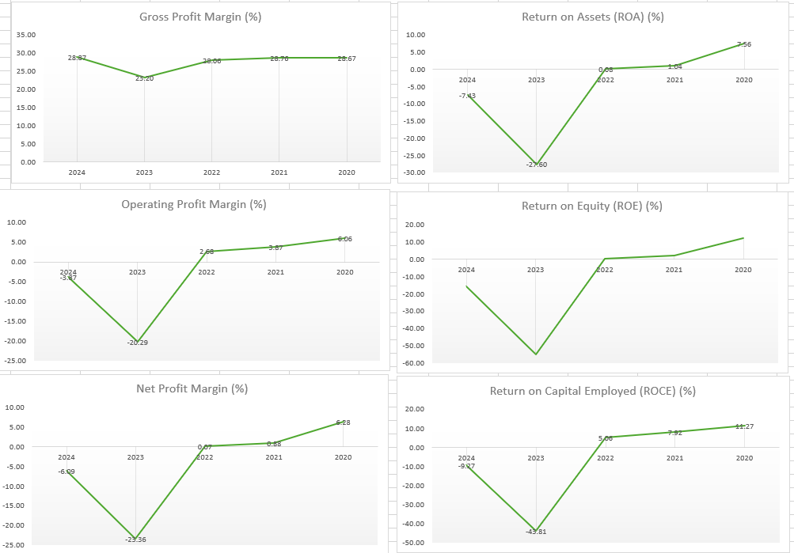

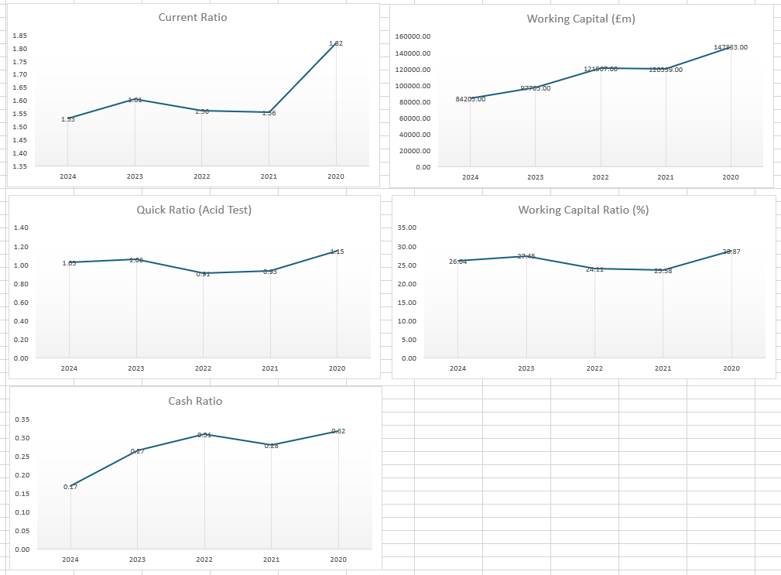
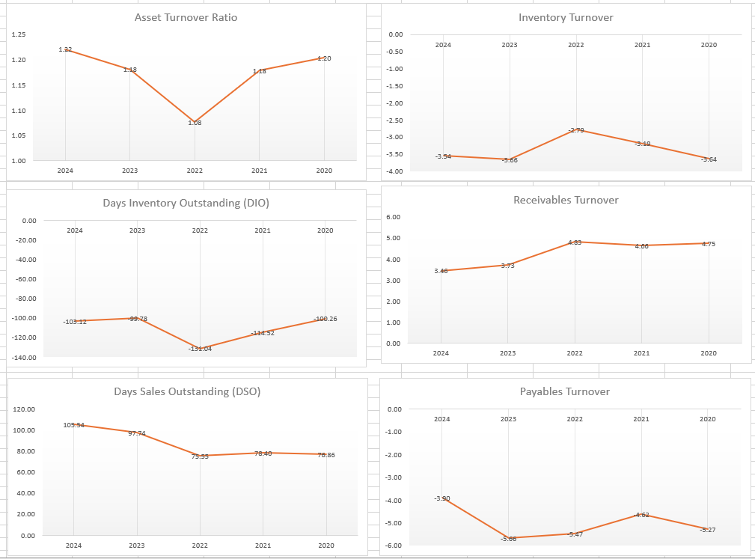
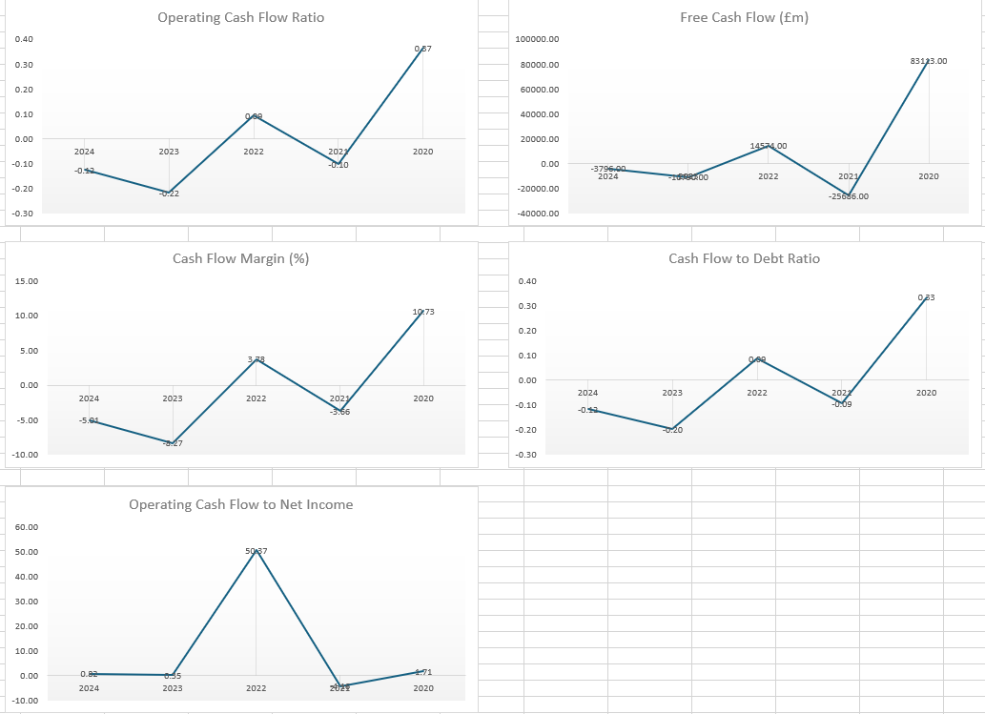
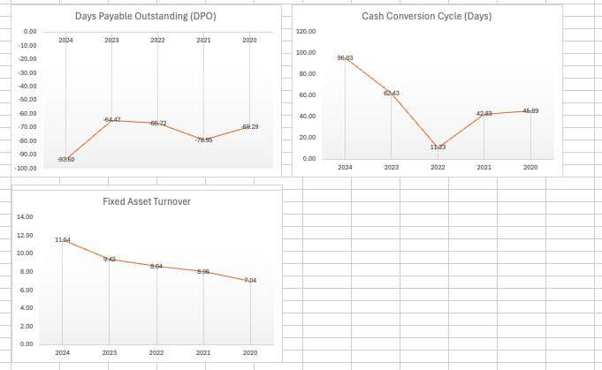
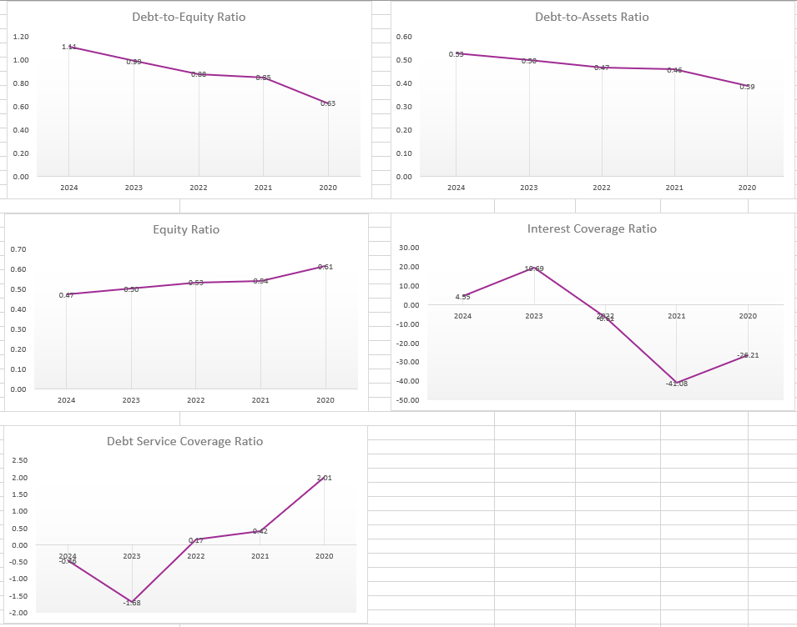
(Source: Refer to Excel)

Appendix 2: Investment appraisal calculations
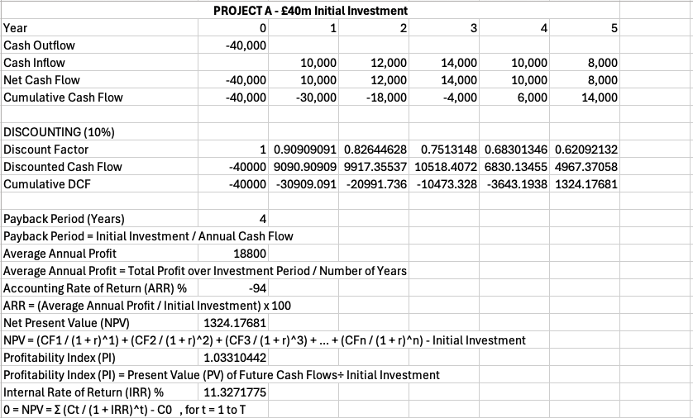
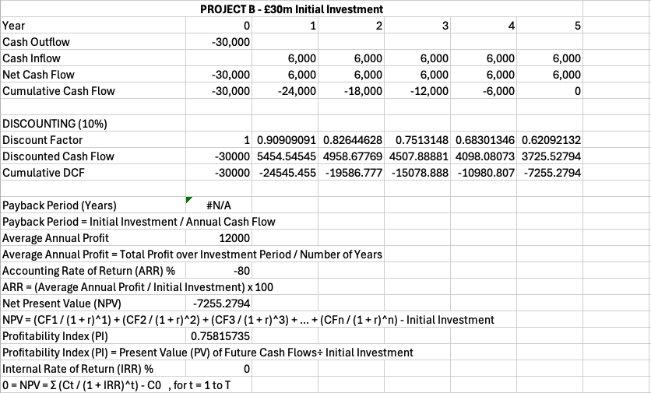
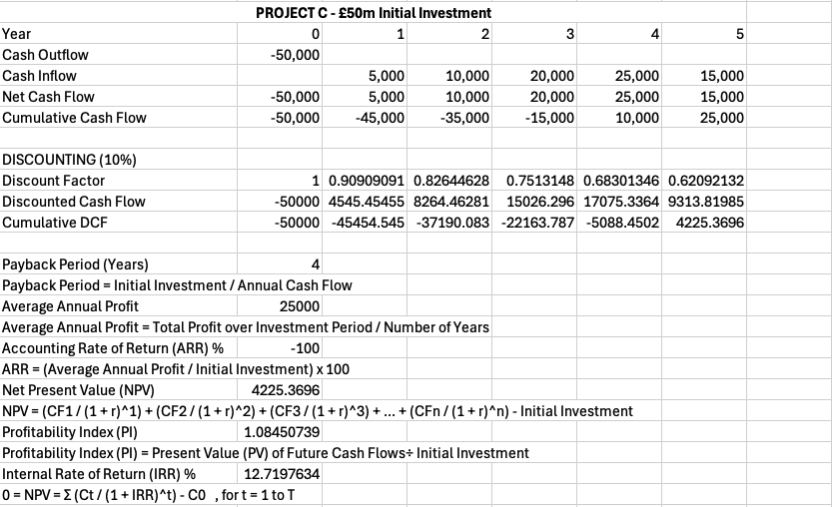
(Source: Refer to Excel)

1. Payback Period (PBP)
The Payback Period is the time required for cumulative cash inflows to equal the initial investment.
Project A: Initial investment £40,000.
Cumulative cash flow by year: Year 1 = –30,000, Year 2 = –18,000, Year 3 = –4,000, Year 4 = 6,000.
Payback occurs during Year 4.
PBP = 3 + (4,000 / 10,000) = 3.4 years ≈ 4 years.
Project B: Initial investment £30,000.
Cumulative cash flow by year: Year 5 = 0.
PBP = 5 years.
Project C: Initial investment £50,000.
Cumulative cash flow by year: Year 4 = –15,000, Year 5 = 25,000.
PBP = 4 + (15,000 / 15,000) = 5 years.
2. Accounting Rate of Return (ARR)
ARR measures profitability based on average annual accounting profit relative to initial investment.
Project A: Average annual profit = £18,800. ARR = 18,800 / 40,000 × 100 = 47%
Project B: Average annual profit = £12,000. ARR = 12,000 / 30,000 × 100 = 40%
Project C: Average annual profit = £25,000. ARR = 25,000 / 50,000 × 100 = 50%
3. Net Present Value (NPV)
NPV discounts future cash inflows at 10% cost of capital and subtracts the initial investment.
Project A: Discounted inflows = 9,091 + 9,917 + 10,518 + 6,830 + 4,967 = 41,323
NPV = 41,323 – 40,000 = £1,324
Project B: Discounted inflows = 5,455 + 4,959 + 4,508 + 4,098 + 3,726 = 22,746
NPV = 22,746 – 30,000 = –£7,254
Project C: Discounted inflows = 4,545 + 8,264 + 15,026 + 17,075 + 9,314 = 54,224
NPV = 54,224 – 50,000 = £4,224
4. Profitability Index (PI)
PI = Present value of inflows / Initial investment.
Project A: PI = 41,323 / 40,000 = 1.033
Project B: PI = 22,746 / 30,000 = 0.758
Project C: PI = 54,224 / 50,000 = 1.084
PI > 1 indicates a financially viable project.
5. Internal Rate of Return (IRR)
IRR is the discount rate that makes NPV = 0.
Project A: IRR ≈ 11.33% (above 10% cost of capital → modest profitability)
Project B: IRR = 0% (not viable)
Project C: IRR ≈ 12.72% (strong profitability)
Summary Table
Project A: PBP = 4 years, ARR = 47%, NPV = £1,324, PI = 1.033, IRR = 11.33%
Project B: PBP = 5 years, ARR = 40%, NPV = –£7,254, PI = 0.758, IRR = 0%
Project C: PBP = 5 years, ARR = 50%, NPV = £4,224, PI = 1.084, IRR = 12.72%

