Has Online Streaming Made Album Artwork Obsolete?
Caitlin Williams
Submitted in partial fulfilment of the requirements for the degree of BA (Hons) University of Wales Trinity Saint David, Swansea
12th December 2018
Contents:
- List of Illustrations page 3

- Introduction page 4

- Chapter One: The History of Cover Art page 6

- Chapter Two: The Digital Age page 13

- Chapter Three: The Revival of Album Art page 20

- Conclusion page 25

- Bibliography page 29

List of Illustrations
- Album Artwork for Smash Song Hits: Steinweiss, page 7

- Album Artwork for Sgt. Pepper’s Lonely-Hearts Band: Blake, page 8

- Album Artwork for Eat a Peach, page 10

- Album Artwork for Sound + Vision, page 11

- Album Artwork for Sound + Vision, page 11

- Album Artwork for Demon Days, page 19

- Album Artwork for The Eraser, page 23

- Album Artwork for The World is Yours, page 24

Introduction
This dissertation will discuss the question ‘Has online streaming of music made album artwork obsolete?’ To do this I will look into articles/books/interviews with artists and musicians that discuss the topic to get multiple different opinions, but I will also gain statistics of sales within albums in this current age. I will also see the statistics of the number of users on streaming sites such as Spotify and Apple Music and compare them to see if this has an impact on album art. Online streaming only shows a small thumbnail image for the album artwork and I feel when people stream they don’t notice the thumbnail. Tim Dee says “"Art on a screen is never as emotive as in the hand; almost like an email is to a postcard, it just means more." However, personally I really enjoy looking at the artwork people will produce for albums and it is actually a job aspiration of mine to become an artist commissioned for jobs such as these.
The Artists I will be focusing on are Sir Peter Blake, Peter Saville, and Alex Steinweiss, which will focus on the ‘classic’ vinyl covers that people supposedly still talk about today. Also, I will be looking at artists such as Jamie Hewlett and others to explore how the digital age has benefitted the music industry and the art community and how these two have been brought and used together in the new age. Concerning the digital age, I will also be researching how musicians actually take to it and whether it benefits their careers more too hard formats of music such as CD, Vinyl, and Cassette.
My first chapter will take us through the history of album artwork, from the very first LP record sleeve to the modern age of digital streaming. During this chapter I will discuss the role in which cover art has when promoting the band and the different techniques/tactics people used to help increase their sales. When the CD was invented and how that took over from Vinyl, the effect the new format and size of the CD had on the artwork. I will also look at memorable CD covers and how they were collected, the introduction of digital listening through iPods and buying digital downloads through iTunes, and how all of these have developed into the new digital age of streaming and the impact it has had, good and bad.
My second chapter will look at the digital age and the effect on the music/art industry. This chapter will be filled with various statistics about streaming, Vinyl/CD sales etc. to provide me with evidence regarding the need for album art. It will also talk in detail about the band Gorillaz which is an entirely virtual band and how this couldn’t have happened with the vast improvements with technology today.
My third and final chapter will discuss the revival of Vinyl and how this coincides with the digital age and the benefits they have with each other. This will then lead me to my conclusion which will be discussed in detail.

Chapter 1: The History of Cover Art
The phrase “album” originates from a pre-war era when it referred to the album that held the 78rpm shellac disc, inside a drab heavy paper sleeve with only a title embossed on the front and spine. Sometimes these discs were contained in a leather book, similar to a photographic album. (Chilton, 2018)
The initial changes happened in the 1930s, from ground-breaking designers like Alex Steinweiss, who created illustrated covers for performers much like Paul Robeson, or the classical music of Beethoven. (Chilton, 2018)
In 1939, Alex Steinweiss (1917–2011) was at work in Columbia Records when he had a creative idea. He grabbed hold of a photographer and the two of them went to New York's West 45th Street and stood outside the renowned Imperial Theatre. Admiring the building's distinguishing marquee, they both came to an agreement that it was exactly what they were looking for. (Kennedy, 2016)
Steinweiss had only started his job at Columbia Records where he became the label's very first art director. CBS had just opened a headquarters in Bridgeport, Connecticut and their advertising manager was keen to employ someone to create advertising displays and commercials for the label. This was a dream job but Steinweiss already had bigger things in mind. (Kennedy, 2016)
At the Imperial Theatre Steinweiss persuaded the owner to temporarily change the sign of the marquee. That same evening, they traded the letters and then lit them up: 'Smash Song Hits by Rodgers & Hart' it broadcasted. The photographer took a picture and by doing this, captured history. This image would go on to become the very first album cover. (Kennedy, 2016)
This started a large surge in sales. Nevertheless, it was the arrival of the long-playing 33⅓rpm record that transformed the way we presented albums. The heavyweight paper used for 78s impaired the gentle grooves on LPs, and record firms began using a folded-over board sleeve. The format was prepared for artistic research and finally headed to covers such as The Rolling Stones’ Sticky Fingers – quite unthinkable in more traditional times. (Chilton, 2018)
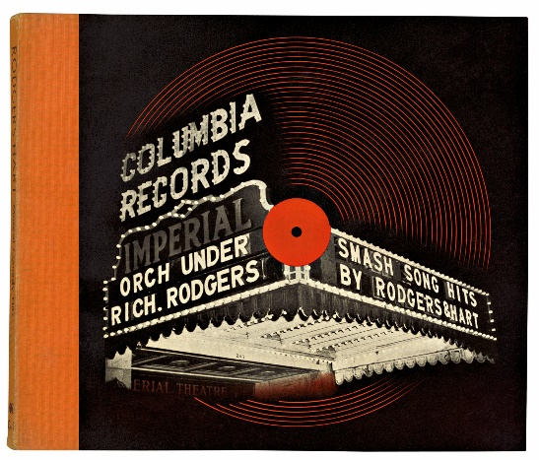

Figure 1: Steinweiss A. (1939) Album Artwork for Smash Song Hits
Ever since the creation of the LP in 1948, Columbia’s Microgroove LP, the whole recording industry saw the potential of using the record cover as one of its core promotion tools. A square consisting of an image/artwork that embodied what the artist and their music were all about. Possibly the largest effect that the record cover had on our culture is the marketing of a specific lifestyle. It is because of album artwork, that music turned out to be a principal inspiration for fashion, politics, and social identity. (Miller B. , 2015)
From a marketing point of view, the packaging is the image that the product displays to the world. Its role is to communicate information regarding the product to possible customers, and for highlighting the features of the product that will attract the targeted audience. (Lathrop, 2003)
Some may say that the jacket of a music record is a summary and a highly concentrated interpretation of the artists’ views about the essence of the music and how it ought to be presented in the market place. That is why in the corporate world the package design procedure acquires the focussed consideration of almost all people involved in the product launch, from the art director, the product manager, and the marketing manager to the recording artist. (Lathrop, 2003)
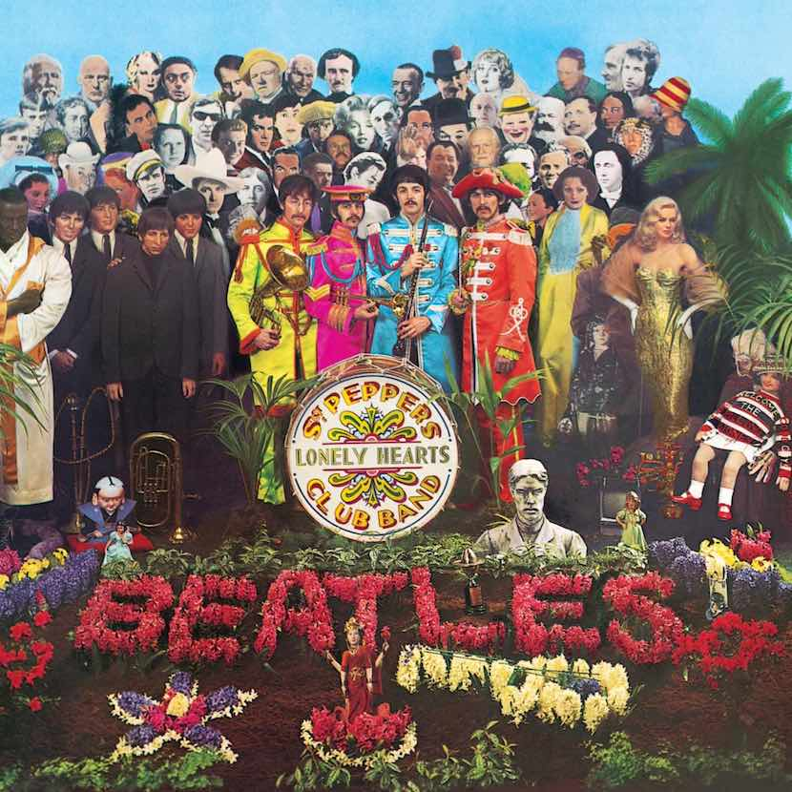

Figure 2: Blake, P (1967) Album Artwork for Sgt.Pepper’s Lonely-Hearts Band
In 1967, The Beatles – Sgt Pepper’s Lonely-Hearts Band was the first album to print the lyrics on the sleeve, enraging the sheet music publishers by depriving them of thousands of sales but truly providing something for everyone who bought it. It was meant to be a “family fun” album by providing an inner sleeve with The Beatles grinning “good love vibes” at the listener and a card pull-out which incorporated a fake moustache and a cut out drum front. This was created by artist Sir Peter Blake. (Barry Miles, 2005)

The CD which grew from various mediums, was manufactured in 1980 by James Russell. When Sony and Philips formed the well-known “Red Book” standard, which was a sequence of papers that defined a 120mm diameter disc bearing music at a resolution of 16 bit/44.1kHz. The sample rate is founded on the Nyquist theorem, which in this instance, shapes the minimum rate required to copy all frequencies people can hear. (Marshall, 2001) The resolution is still considered by many as the optimum digital standard. However, the CD wouldn’t be made public until 1983. (Waniata, 2018)
After an offer of about 20 available albums at launch, the CD advanced over the next few years. As stated by The Guardian, the CD’s off-the-record arrival came with the issue of Dire Straits’ Brothers in Arms album, which was created using the newest digital equipment and generated a tour sponsored by Philips. (Lynskey, 2015) Released on CD in May 1985, the album turned out to be a musical mainstay, and vinyl fans started to buy CD players in mass to move with the developing format. By 1988, CD sales overshadowed vinyl, and passed the cassette in 1991. (Waniata, 2018)
There was something rather ironic about accumulating album art in the age of CDs, when a 12x12 inch canvas had been reduced to a 5-inch square. Visual artists said when producing Blues CD covers they must express the spirit of a musician’s life and work. “The goal is to express the music visually” says Flournoy Holmes, creator of the ironic version of Arkansas bluesman CeDell Davis. CD art has changed completely since the day when Holmes formed the timeless LP cover of Allman Brothers’ Eat a Peach. Oil paintings and the wonderful photographs of the Blue Note prime have been exchanged by computer edited type and images. (Ted Drozodowski, 1997)
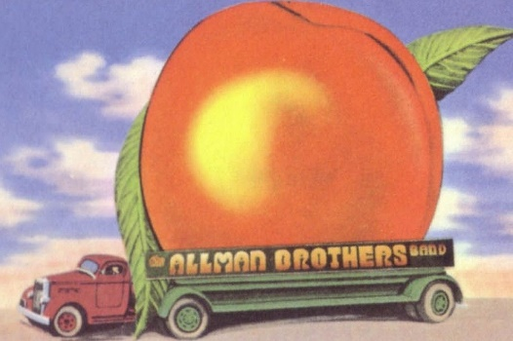
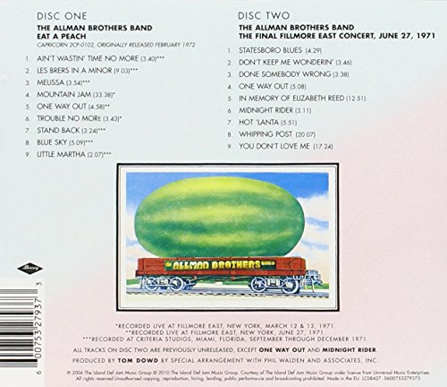
Figure 3. Holmes. F (1972) Album Artwork for Eat a Peach
At this time vinyl records were gradually becoming a thing of the past and while the large LP format, the retro notes, and stylish designs were generally gone along with them, the CD age had caused some new advances in the packaging of jazz. (Ted Drozodowski, 1997)
One of the greatest collections to be produced by Rhino Records was a seven-disc box set of John Coltrane’s The Heavyweight Champion. A detailed analysis of one of modern jazz’s outstanding musicians at the peak of his career. The Heavyweight Champion comes with photographs from the sessions, a stunning 70-page booklet featuring notes from critics and colleagues, and a discography of Coltrane’s Atlantic recordings. (Ted Drozodowski, 1997)
David Bowie’s Sound + Vision had a cleverly designed way to package the album. The group that assembled this innovative box – initially released the 12-inch square format to fit LP bins – pushed the boundaries to generate a package that captured not only the sound of Bowie’s career but his artistic vision. David Bowie’s album won a Grammy Award for packaging in 1989. (Ted Drozodowski, 1997)
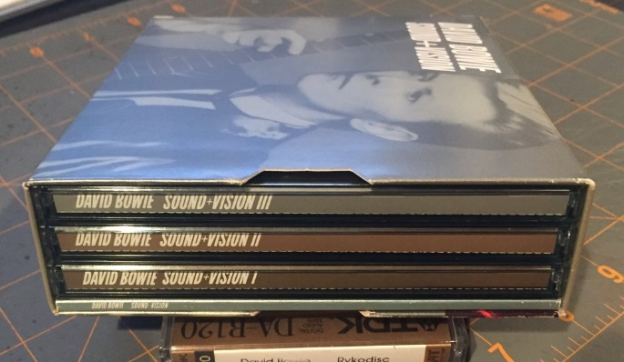
Figure 4. Gorman. R & Gorman. G (1977) Album Artwork for Sound + Vision

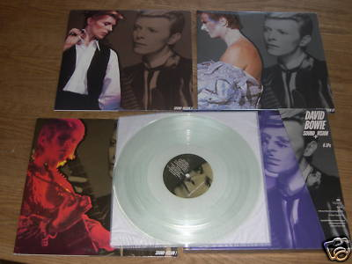
Figure 5. Gorman. R & Gorman. G (1977) Album Artwork for Sound + Vision
Moving on from the CD in October 2001, Apple’s visionary Steve Jobs released perhaps his best invention, the impressive little MP3 player named the iPod. The iPod was far from the first of its kind — and some might debate that it wasn’t the greatest — but accompanied with Apple’s iTunes music app - a service used in which to purchase digital copies of music to download and also for you to import your existing CD’s. The iPod took over and became the must-have music accessory. ITunes sales became a music capital for Apple, expanding its funds and changing the way people bought music. In 2005, iTunes overtook CD sales in two major physical stores for the first time. However, the humble success would be short-lived. (Waniata, 2018)
Pandora’s origin in January 2000 generated from the Music Genome Project, an “internet radio” service which follows an algorithm that organizes music with lots of features to show listeners music they’ll enjoy based upon artists, songs, and simple thumbs-up or thumbs-down ratings. The earliest major on-demand service, Spotify, arrived eight years later, and both of the companies rewrote the music playbook. Offering free and affordable music to anyone online — without breaking the law or taking up huge amounts of data — music streaming quickly became the ideal and convenient platform to enjoy music. In 2014, streaming revenue overshadowed CD sales for the first time, and also did the same to digital downloads in 2015. (Waniata, 2018)
When music started becoming available online, the album was still the go-to format. It’s what made the Apple store so successful a few years ago. Before streaming took hold, it was common for music consumers to buy and download full albums. Even though albums could be chopped up, moved around, put onto playlists or rearranged into a different order, they were still browsed and bought in the same way a physical release was. For a while, the album format simply moved online. (Seydel, 2016)

Chapter 2: The Digital Age
The Internet is an essential part of modern music distribution channels. Likewise, it is the main advertising alternative for unsigned musicians who desire to distribute original music. Jeff Paterson, co-founder of the Internet Underground Music Archive (IUMA), anticipated in 1998 that the Internet is “going to change the music industry as we know it.”
The Internet makes it achievable to get your music to millions of possible online consumers directly without the agreement, the support, and the direction of the corporate network of music industry groups. (Lathrop, 2003)
The benefit of this is as a consumer you can access all of your favourite music online and discover new artists that you will potentially enjoy, and you can then expand your music library. However, it grants access too easily for people to actually upload music that they have created, which means there’s a lot of “bad” music out there, which can be very off putting for people to actually try new music. Personally, I’m a creature of habit and rarely try listening to new artists/groups. This is a shame for the new musicians trying to make a break when others who upload anything they come up with are bringing the community down.
What started the escalation of music on the Web came mainly from peer-to-peer file sharing, a movement that launched in the late 1990s by a company named Napster. File sharing websites permitted users to look for and download music from the computers of other users in the same network and complete it for free. There were differences in opinion as to whether online file sharing would in the long run, support or damage sales of music in CD form. (Lathrop, 2003)

Tad Lathrop’s (author of The Business of Music - Marketing & Promotion Revised & Updated ) researchers decided that sampling music by downloading it from file sharing sites, it stimulated the consumer to go and purchase a hard copy CD by that artist. Although, a study by the Recording Industry Association of America (RIAA) discovered a connection amongst a growth in file sharing and a reduction in CD sales. (Lathrop, 2003)
Personally, if I really enjoy an album I will go out of my way and purchase a hard copy CD to keep. So, the CD has become a bit more of a novelty now as appose to a regular way to buy music.
A lot of old cars will have CD players in them, so I think it’s always handy to have hard copy music – however newer cars all come with Bluetooth abilities in which people will connect their phones and use their streaming services/apps such as Spotify to add music to their car journeys.
Inside an Associated Press article, the RIAA conveyed a 7% reduction in CD sales in the beginning of 2002. The deterioration of CD sales proposed that the future of music marketing would not be store based but moderately Internet based. Supporting that notion was a 2002 broadcast by research firm Ipsos-Reid that 40 million U.S. people over age 12 had operated a file sharing program. (Lathrop, 2003)
The embracing of streaming continues to rise, with Nielsen recording that on-demand streaming has escalated 92% year-over-year (from 70.3 billion streams to 135.2 billion). Video streams contribute a little over half of the total number and are up even more (109%) than audio streams (74%). With Apple's new service finally coming online, look for continued growth throughout the rest of the year. (Greenburg, 2015)
With video streams also contributing to the statistics in online streaming I think it’s fair to say that services like YouTube have rapidly have grown over the years and upload lots of music videos, making music channels on television slowly redundant. A popular channel on YouTube called VEVO mainly plays the newest pop music videos but also contains older music from various genres.
Rory Seydel says that streaming didn’t destroy the need for album art. It made it more important. 317 billion songs were streamed in 2015. That means that album art popped up 317 billion times as well. (Seydel, 2016) This is a strong opinion because not everyone has an appreciation for art anyway. Some people wouldn’t actually be concerned about the artwork that comes up when streaming music, especially if it is used as a background purpose and no one is actually looking at what comes up on the screen. However, there are music fans that also have an understanding and appreciation for the artwork created and selected to represent the album.
The album cover was said to have grabbed the imagination of a music-loving generation. John Sunyer states that CDs have left the record sleeve suffering, and that downloading has completely destroyed album artwork and the pure nature of its existence. He also thinks that the cover, as vital as the music it contained, was to be important to the entire experience of possessing an LP. Nowadays, as technology has over run everything, album art has become a postage stamp-sized image on an iPod screen. (Sunyer, 2008)
It’s understandable to have a negative attitude towards technology because it doesn’t always come with the benefits it is designed for. Making screens smaller with iPods and now the more current smart phones it is getting harder to take an appreciation for album artwork among other difficulties the small screens come with.
“The details are lost to our quick-scrolling attitudes and five-second attention spans.” (Staff, 2015) This is a very strong quote and I think it’s true. The smartphone has made people incredibly lazy and there are many studies out there that record the amount of time people will actually spend on them throughout the day. It’s actually an option on the settings of Apple’s iPhone to track the usage of your phone and you can see what applications you spend the most time on. There is also a study by OfCom (UK government approved communications service) that shows the usage people spend online:
Device | 2008 adoption rate | 2018 adoption rate
Smartphone | 17% | 78%
DVD player | 83% | 64%
Tablet | N/A | 58%
Digital video recorder | 20% | 56%
DAB radio | 27% | 56%
Smart TV | N/A | 42%
Desktop PC | 69% | 28%
MP3 Player | 44% | 27%
Smart speaker | N/A | 13%
Smart watch | N/A | 20%

(Hymas, 2018)
Remarkably, 1975 album artist David Drake debates that album artwork is solely there to serve its purpose, to market and promote the band. Not exactly for the artist to feel valued. (Staff, 2015) This is surprising to hear from an artist’s perspective, surely any work you produce as an artist especially if it is fit for purpose should give the artist some form of validation. On CD and Vinyl covers there is a section where it says who created the artwork for the album whereas with services like Spotify it doesn’t tell the consumer. They would have to go and search off of their own backs who created it, if they even cared. Although it probably wouldn’t be hard to find it’s still unnecessary and rather unfair to the artist/designer that worked hard to create the imagery for the album.
Artist/Illustrator Kieran Gabriel who has worked on many Album covers says "It's the first thing that the listener is presented with and is definitely vital in representing what's within,” “I'm not necessarily the kind to seek credit when I've done work, that's not really why I do it, but I can't help but feel a little peeved when the artwork is almost presented on the side line, as though it's an afterthought.” (Staff, 2015)
Tim Dee – Creative Director of London and Leeds who founded organisation Rabbit Hole, states the digitalisation of album artwork does mean it has lost some of its magic. "I guess the fact most people don’t actually own a physical copy of the artwork doesn’t help," he starts. "Art on a screen is never as emotive as in the hand; almost like an email is to a postcard, it just means more." (Staff, 2015)
As digital becomes the main platform we purchase and listen to music with it makes hard copy formats like CD and Vinyl more of a novelty item which may not be that bad. If anything, it could make them more special and appreciated a lot more than when they were the main and current platform of their time.
Sir Peter Blake, who created the sleeve for the Beatles' Sgt Pepper's Lonely-Hearts Club Band, said: "It (album art) survived from the LP to the CD, but... if that becomes obsolete then I guess album art won't exist. I think it would be a big loss." (Sunyer, 2008)
However, many benefits there are to the digital format in which we listen to music, in 2014 Taylor Swift removed her music from Spotify over its rejection to remove her work from its free platform. She also called Apple out for skipping out on paying musicians during the trial period of its streaming service; the company finally gave up and credited its result to Swift's encouragement. (Greenburg, 2015)
A big advancement on the digital age was Damon Albarn and Jamie Hewlett’s Gorillaz. It embodies a highly impressive and creative project that has advanced into a defining act of our generation. They are fronted completely by animated drawings which has demonstrated something past moving images, despite technically not existing. The phrase ‘virtual band’ was commercialised by Gorillaz in 2001 with the announcement of their self-titled album. (Campbell, 2017)
The success of such an innovative project is demonstrated through the sheer number of sales and accolades Gorillaz has received. The band’s second album, Demon Days, went 5 times platinum in the UK, while going double platinum in the US. Alongside this, one Grammy Award, two MTV Video Music Awards, an NME Award, three MTV Europe Music Awards and nine Brit Awards encompass widespread success. Albarn and Hewlett, as artists, completely reinvented what a band could create. (Taschen, 2018)
Albarn produced the music – a combination of musical styles which took over the finest chapters of the Pop Encyclopaedia, from reggae to country to psychedelia and dub. Hewlett created the band, a quartet of characters with wild backstories and immense personalities to boot. 2D was the captivating but vacant frontman and keyboardist, always butting heads with the disapproving bassist Murdoc Niccals. Ten-year-old Noodle the guitarist, and Russel Hobbs their drum player and percussionist, while also had the capability to contact the spirits of dead rappers from a fictional hip-hop catalogue. (Taschen, 2018)
The group smashed records in the US, Europe, Australia, and essentially world-wide, and obtained Brit and MTV Awards. Hewlett had a Designer of the Year Award from London’s Design Museum in 2006. (Director, 2018)
The band are actually performed live on tour – via 3D holograms. They were set out to play at 47 venues, around the world. (Garcia, 2017) This wouldn’t be possible without the advancements on technology and I think it would be an incredible and almost out of world experience to be a part of something as advanced as that. I think this could be the start of many more bands to follow, whether this is good or bad is another question.
With the success of Gorillaz, Albarn and Hewlett didn’t just exceed the limitations of what a band could be as much as redefine the musical landscape entirely. The pair more than accomplished what they planned to do – which was to bring out a huge standard change in pop music, and to make it reliable and significant for a new generation of receptive young music fans. (Taschen, 2018)
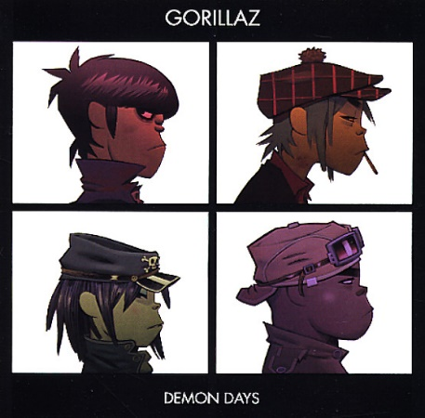

Figure 6. Hewlett. J (2005) Album Artwork for Demon Days
Chapter 3: The Revival of Album Art
Once abandoned, vinyl continues its revival, with album sales increasing by 38.4% to 5.6 million per annum. There's now one LP sold for every 10 CDs - The top selling vinyl album of the 2015 was Taylor Swift's 1989, which retailed 34,000 copies on the year. (Greenburg, 2015)
Over the years, it seemed like vinyl would take pleasure in a short-lived rebirth as a “must have” medium for “hipsters” and true “audiophiles”, but that statement has proved incorrect. For more than a decade, the format has been rising sales for miles, and it still gains momentum by the month. (McIntyre, Three Startups Cashing In On Vinyl's Resurgence , 2015)
Vinyl fans and entrepreneurs around the world have noticed the rise in interest of vinyl especially by the younger generation, and there have been many noteworthy participants into the market over the past couple of years, all grounding their new businesses on the increasing popularity of records.
The companies: Vinyl Me Please, and VYNL mounted a solid fan base early on in the game and have been striking while it’s the trend and relevant. (McIntyre, Three Startups Cashing In On Vinyl's Resurgence , 2015)
Vinyl Me, Please is a record club for the new vinyl age. The business has a basic idea, and it seems to be growing suitably. For $23 per month, the creators/workers of Vinyl Me, Please will send the consumer a record per month that they have selected as a record worth being heard. Every bundle includes a 12-inch vinyl, a specially-commissioned print, and a cocktail recipe that’s made to coincide with the album. (McIntyre, Three Startups Cashing In On Vinyl's Resurgence , 2015)
VNYL attends to its dedicated fan base to compose a library, contrasting to only selecting what the people who work at the company think are the greatest albums released. Subscribers are given three items per month, all of which were hand-picked by workers at the establishment, and which represent all genres and different varieties of talent. (McIntyre, Three Startups Cashing In On Vinyl's Resurgence , 2015)
Subscriptions such as this are part of quite a niche market for music fans and although cost more than a subscription to a streaming service per month offer a good value for the products they are sending. However, for over half of the price you can access almost every album out there, anytime you want on any device.
In 2014, Billboard examined vinyl providers liable for about 80% of all sales in the US and were capable to recognise these retailers as the five biggest in records: (McIntyre, Amazon Leads The Top Five Vinyl Retailers From 2014, 2015)
Urban Outfitters’ Chief Administrative Office, Calvin Hollinger stated that they were the world’s top vinyl seller, “Music is very, very important to the Urban customer…in fact, we are the world’s number one vinyl seller.” (McIntyre, Amazon Leads The Top Five Vinyl Retailers From 2014, 2015)
However successful they are, they are still second to Amazon by a significant percentage. The “hipster” chain has an 8.1% market share in the vinyl industry. Urban Outfitters’ target audience are the millennial crowd that is willing to spend more money for music if it comes on wax, which aided them get to second place. (McIntyre, Amazon Leads The Top Five Vinyl Retailers From 2014, 2015) Urban Outfitters is also quite an expensive retailer so it’s not going to be as successful as Amazon, who a lot of the time are affordable.
Amazon has become the one to shop with for people looking to purchase/download all kinds of music, and it is really growing in the streaming industry as well with their Prime Music service. The online retailer has developed into the number one seller of an old medium. The internet is presumed to be responsible for the collapse of the physical CD, but yet it is at the same time raising the popularity in the vinyl record. (McIntyre, Amazon Leads The Top Five Vinyl Retailers From 2014, 2015)
Amazon leads the field, possessing 12.3% of the market. Billboard states that the whole of vinyl sales in the United States in 2014 came to about $325 million, which means that all those records create a lot of business for Amazon. Their 12.3% not only presents them as the number one business to have a double-digit market share, but it’s possible that it can equate to just under $40 million. (McIntyre, Amazon Leads The Top Five Vinyl Retailers From 2014, 2015)
Also, within this resurgence of Vinyl leading illustrators are redesigning vinyl album art and are bringing a modern style to old classics from the likes of Joe Hisaishi and Elliott Smith.
The revival of vinyl has not only been a benefit to the music world, but also to the art community. With CD artwork declining in the face of streaming services such as Spotify, Apple Music etc. it's been the vinyl format that's seen a restoration of the lost art of illustrating for music. The 'vinyl revival' has led to consistent occasions like Secret 7, which sees 100 new 7-inch covers created by the finest illustrators, and a similar amount of talent upping their game to win a Best Art Vinyl award. (Lee, 2018)
The Album ‘The Eraser’ by Thom Yorke had a vinyl copy created by artist Stanley Donwood and also had a digital release by artist Graeme Swinton - this has an association with Radiohead. The artwork in question titled, London Views was made at the same time as the music on The Eraser album. Nevertheless, at the period it was produced, it was not automatically going to be used as the album artwork – this decision came later. The artwork has also been modified for usage in a digital brochure that was composed to accompany the digital album on iTunes. The pamphlet has been formed in QuickTime using Flash, and not only adds value to the digital download, but also provides the user an amusing, interactive way of scrolling through Donwood’s London Views landscape as well as listening to the album. (Rivers, 2008)
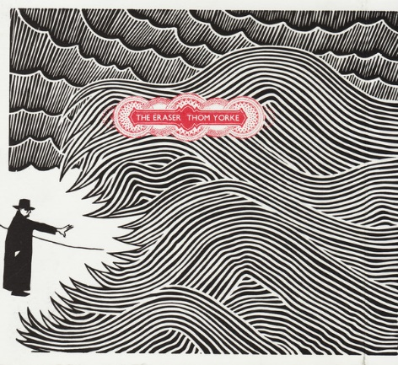

Figure 7. Donwood. S & Swinton. G (2006) Album Artwork for, The Eraser
Joe Lewis produced a digital, interactive leaflet, which became accessible as part of a package when downloading the whole album using iTunes. Its design required it to be consistent with the physical artwork so all images, fonts, etc. have been used from that. It holds album lyrics, a photo gallery, and acknowledgements, alongside a stencil image that can be downloaded and printed by the user. Also, Lewis created an easy menu to escort the consumer through the booklet. (Rivers, 2008)
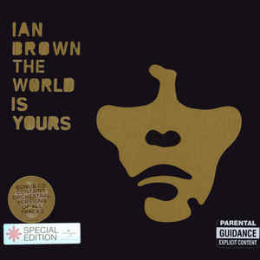

Figure 8. Walsh. B & Lewis. J (2007) Album Artwork for, The World is Yours
These examples are a good way to show how the digital age can be beneficial for the sales of Vinyl and how they can coexist and collaborate together.
Even though Vinyl is on a revival no one builds record presses anymore, which means that factories such as Rainbow Records, Los Angeles are depending on aged equipment. (Huet, 2018)
This could become a problem in the future, if these machines start breaking and they won’t be replaced this could increase the value of the vinyl record and would this have an impact on how they are selling?

Conclusion:
Throughout this study I have collected contrasting information from various sources to help with the titled question, “Has online streaming of music made album artwork obsolete?”
Online streaming services like Spotify and Apple Music gives people the opportunity to listen to any music they want, any time they want for a subscription fee, or Spotify offers a free version. You can access so many different artists and genres it opens people up to lots of new music that they can enjoy, as well as the older stuff they know. Although it can allow easy access for people to upload music that they have created, this means there’s a lot of “bad” music on there, which can be very off putting for people to try new music.
When Vinyl was the main format, a lot went into the packaging to create an actual experience with the music you have bought. You didn’t just buy the album/single. Sgt Pepper’s Lonely-Hearts Band was the first album to print the lyrics on the sleeve. It was meant to be a “family fun” album by providing an inner sleeve with The Beatles grinning “good love vibes” at the listener and a card pull-out which incorporated a fake moustache and a cut out drum front. (Barry Miles, 2005) A lot of albums came with limited edition posters, booklets, lyrics etc. which is a much more interactive experience than playing an album from your smartphone.
However, Joe Lewis produced a digital, interactive leaflet for Thom Yorke’s album The Eraser, which became accessible as part of a package when downloading the whole album through iTunes. Its design was coherent with the artwork on the Vinyl so all images, fonts, etc. have been used from that. It contains lyrics, and a photo gallery, alongside a stencil image that can be downloaded and printed. Also, Lewis created an easy menu to escort the consumer through the booklet. (Rivers, 2008)
Personally, if I really enjoy an album I will go out of my way and purchase a hard copy CD to keep. I will also buy the hard copies of albums by my favourite artists, so to me the CD has become a bit more of a novelty now as appose to a regular way to buy music. I think it’s handy to have hard copy music for when you’re in scenarios where the internet is not accessible. For example, older cars will have CD players in them as opposed to Bluetooth accessories. Which means having a glove box full of CD’s will be useful for long car journeys.
Rory Seydel says that streaming didn’t destroy the need for album art. It made it more important. 317 billion songs were streamed in 2015. That means that album art popped up 317 billion times as well. (Seydel, 2016)
Not everyone has an appreciation for art in general. A lot of people wouldn’t be concerned about the artwork that comes up when streaming music, especially if it is used as a background purpose. Music nowadays is mostly used to fill background noise when doing other things, as appose to sitting down, relaxing and listening to your favourite artist while going through the album. However, there are music fans that also have an understanding and appreciation for the artwork created and selected to represent the album. I myself am a big fan of album artwork, but is that because I’m an artist myself? I always look at the design/packaging of various items, and really take in the work that has gone into them.
Regarding the artwork displayed through online streaming I think that this is a very good quote, “The details are lost to our quick-scrolling attitudes and five-second attention spans.” (Staff, 2015) The smartphone has made people lazy and there’s a study by OfCom that records the amount of time people will spend on them throughout the day not even paying attention to what they’re looking at.
Device | 2008 adoption rate | 2018 adoption rate
Smartphone | 17% | 78%
DVD player | 83% | 64%
Tablet | N/A | 58%
Digital video recorder | 20% | 56%
DAB radio | 27% | 56%
Smart TV | N/A | 42%
Desktop PC | 69% | 28%
MP3 Player | 44% | 27%
Smart speaker | N/A | 13%
Smart watch | N/A | 20%
(Hymas, 2018)

From this graph you can really see the increase of usage of the smartphone and its
online usage in comparison to the decrease in usage of the MP3 player. It shows
the amount of time people spend wasting on their devices.

Has online streaming made album artwork obsolete? I don’t think it has but then I could be biased because like I said I take a great appreciation to artwork. With the resurgence of Vinyl there are obviously a lot of people who are interested in the artwork and the components an album comes with. Some people will actually buy an album because of the artwork on the front, even if it’s by an artist they don’t even know. The album cover lets the consumer know what they’re buying, who the artist is, and the general vibe the music will be. It’s a strong marketing tool that I believe will always be needed.

Word Count: 6,054

Bibliography
Barry Miles, G. S. (2005). The Greatest Album Covers of All Time. London: Collins & Brown.
Boon, H. (2016, October 13th). How Gorillaz created their mind-bending alternate universe. Retrieved from Dazed: http://www.dazeddigital.com/music/article/33343/1/how-gorillaz-created-their-mind-bending-alternate-universe
Butler, S. (2018, January 3rd). Music Industry. Retrieved from The Guardian: https://www.theguardian.com/business/2018/jan/03/digital-streaming-behind-biggest-rise-in-uk-music-sales-for-two-decades
Campbell, O. (2017, January 31st). Gorillaz and the rise of digital bands. Retrieved from Concrete: http://www.concrete-online.co.uk/gorillaz-rise-digital-bands/
Chilton, M. (2018, September 1st). Cover Story: A History Of Album Artwork. Retrieved from Udiscovermusic: https://www.udiscovermusic.com/in-depth-features/history-album-artwork/
Director, C. A. (2018). Gorillaz. Retrieved from Recording Academy Grammy Awards: https://www.grammy.com/grammys/artists/gorillaz
Garcia, T. (2017, October 9th). The Ageless Success Of The Gorillaz. Retrieved from Odyssey: https://www.theodysseyonline.com/the-ageless-success-the-gorillaz
Greenburg, Z. O. (2015, July 10th). Midyear Music Winners: Taylor Swift, Streaming, Vinyl. Retrieved from Forbes: https://www.forbes.com/sites/zackomalleygreenburg/2015/07/10/midyear-music-winners-taylor-swift-streaming-vinyl/#757a7e230b9f
Grundy, G. (2011, May 29th). Peter Saville on his album cover artwork. Retrieved from The Guardian: https://www.theguardian.com/music/gallery/2011/may/29/joydivision-neworder
Hamilton, E. (2017, December 12). Fifty years ago, Andy Warhol created the iconic banana “peel and see” cover for debut album of the Velvet Underground, now a rare collectible. Retrieved from The Vintage News: https://www.thevintagenews.com/2017/12/12/andy-warhol-banana/
Huet, E. (2018). The Revival of Vinyl Records. Retrieved from Forbes: https://www.forbes.com/vinyl/#77f1a6a7ebdd
Hughes, D. (2018, February 21st). Who are the Gorillaz? Retrieved from The Sun: https://www.thesun.co.uk/tvandshowbiz/2657606/gorilllaz-brit-awards-2018-nominee-new-album-humanz/
Jones, J. (2012, September 12th). Jonathan Jones on Art . Retrieved from The Guardian: https://www.theguardian.com/artanddesign/jonathanjonesblog/2012/sep/12/banana-cover-warhol-velvet-underground
Kennedy, P. (2016, June). Alex Steinweiss and the World's First Record Cover. Retrieved from Illustration Chronicles : https://illustrationchronicles.com/Alex-Steinweiss-and-the-World-s-First-Record-Cover
Lathrop, T. (2003). The Business of Music - Marketing & Promotion Revised & Updated . New York: Billboard Books.
Lee, G. (2018, September 7th). How lost album art is giving illustrators a chance to bring their magic to classic vinyl reissues. Retrieved from Digital Arts: https://www.digitalartsonline.co.uk/features/illustration/how-lost-album-art-giving-illustrators-chance-bring-magic-classic-vinyl-reissues/
Lynskey, D. (2015, May 28th). How the Compact Disc Lost its Shine. Retrieved from The Guardian: https://www.theguardian.com/music/2015/may/28/how-the-compact-disc-lost-its-shine
Marshall, D. (2001, April 10th). Nyquist's Sampling Theorem. Retrieved from Users: https://users.cs.cf.ac.uk/Dave.Marshall/Multimedia/node149.html
McIntyre, H. (2015, March 28th). Amazon Leads The Top Five Vinyl Retailers From 2014. Retrieved from Forbes: https://www.forbes.com/sites/hughmcintyre/2015/03/28/amazon-leads-the-top-five-vinyl-retailers-from-2014/#184a894759d2
McIntyre, H. (2015, June 9th). Three Startups Cashing In On Vinyl's Resurgence . Retrieved from Forbes: https://www.forbes.com/sites/hughmcintyre/2015/06/09/three-startups-cashing-in-on-vinyls-resurgence/#6030dc326163
Miller, B. (2015, March 3rd). The Importance of Your Album Artwork. Retrieved from iMusician: https://www.imusiciandigital.com/en/importance-album-artwork/
Miller, G. (2009). Perfecting Sound Forever. London: Granta Publications.
Noyer, J. D. (2008). A Brief History of Album Covers. London: Flame Tree Publishing.
Rivers, C. (2008). Best Of Disc Art 1 - Innovation in CD, DVD & Vinyl Packaging Design. Mies, Swizerland: RotoVision.
Rosso, J. (2008, August 18th). BLOG: Yes, the album cover is dead. Retrieved from Music Radar: https://www.musicradar.com/news/guitars/blog-yes-the-album-cover-is-dead-170008
Rouse, M. (2005, September). Nyquist Theorem. Retrieved from WhatIs.com: https://whatis.techtarget.com/definition/Nyquist-Theorem
Seydel, R. (2016, May 18th). Why Album Cover Art Will Always Be Crucial For Success. Retrieved from LANDR: https://blog.landr.com/album-art-absolutely-crucial-success-2016/
Shah, D. (2016). The Importance of Album Artwork. Retrieved from Humanhuman: https://humanhuman.com/articles/the-importance-of-album-artwork
Soloman, G. (2017, May 25th). What does the success of best-selling band Gorillaz tell us about collaboration and innovation? Retrieved from Linkedin: https://www.linkedin.com/pulse/what-does-success-best-selling-band-gorillaz-tell-us-guy-solomon
Staff, C. B. (2015, July 21st). Why does album artwork exist in the digital age? Retrieved from Creative Bloq: https://www.creativebloq.com/graphic-design/album-artwork-digital-age-71515796
Sunyer, P. B. (2008, August 17th). Rock Art...R.I.P? Retrieved from Independent: https://www.independent.co.uk/arts-entertainment/music/features/rock-art-rip-899779.html
Taschen. (2018). Jamie Hewlett - Works From the Last 25 Years. Hohenzollernring: Taschen.
Team, u. (2017, September 8th). The 25 Most Iconic Album Covers of All Time. Retrieved from udiscovermusic: https://www.udiscovermusic.com/stories/25-iconic-album-covers/
Ted Drozodowski, L. H. (1997). The Best Music CD Art and Design. Gloucester, Massachusetts: Rockport Publishers Inc. .
Waniata, R. (2018, July 2nd). The Life and Times of the Late, Great CD. Retrieved from Digital Trends: https://www.digitaltrends.com/features/the-history-of-the-cds-rise-and-fall/
Writer, S. (2017, March 16th). The Origin Of The Velvet Underground's Warhol Banana Has Finally Been Revealed. Retrieved from The Music: http://themusic.com.au/news/all/2017/03/16/the-origin-of-the-velvet-undergrounds-warhol-banana-has-finally-been-solved/

