Component 2: Practical: Group presentation
Amazon

Student Name: Mihaela Voicu ( ID: 2328066 )
Sofik Slavova ( ID: 2326064 )
Svetlin Kondakov ( ID: 2326084 )
Mihaela Teodorescu ( ID: 2233479 )
Module: Introduction to Business
Module Code: LCBB4007
Lecturer: Dr Faizu Edu

Table of Contents

Introduction 3
An overview of the organisation 3
The organisation structure, size, and functions 5
The internal and external environment analysis of Amazon 9
Explain SWOT framework 9
Explain PESTLE framework 11
The company stakeholders 14
Conclusion 15
References 16

Introduction
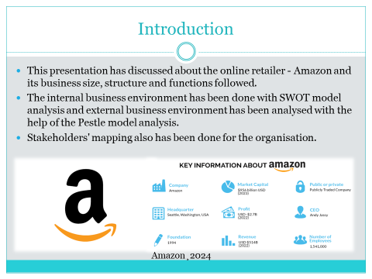

An overview of the organisation
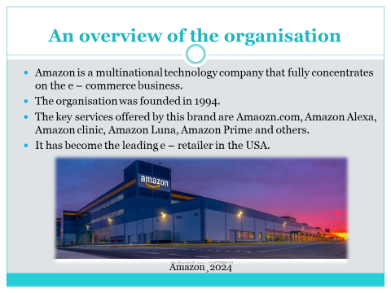
Amazon is a multinational technology company that fully concentrates on the e – commerce business. The organisation was founded in 1994. The headquarter of the organisation is at Washington USA.
The key services offered by this brand are Amaozn.com, Amazon Alexa, Amazon clinic, Amazon Luna, Amazon Prime and others. It started its journey in 1994 and became public in 1997. It started to sell videos, music and books online. In 2017, Amazon purchased the Whole Foods Market supermarket. It has become the leading e – retailer in the USA.

It has over 300 million active customers in the global market. Amazon stands with the 8.6% with share in the UK market as a retail giant. The key competitors of the brand are eBay and Etsy. Based on its product and service offering innovation and meeting the needs of the versatile customers, Amazon has become pioneer in the e – retail sector.
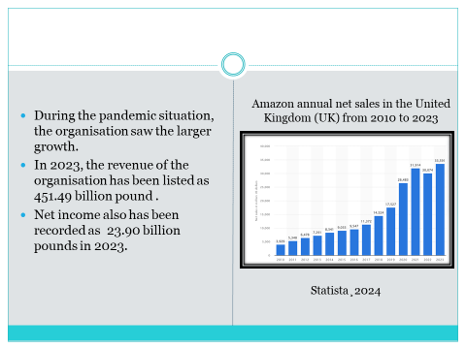
During the pandemic situation, the organisation saw the larger growth (Amazon¸2024). The revenue earning the net sales volume the net income and all other aspects of Amazon are in growing status. In 2023, the revenue of the organisation has been listed as 451.49 billion pounds and net income also has been recorded as 23.90 billion pounds.

The organisation structure, size, and functions
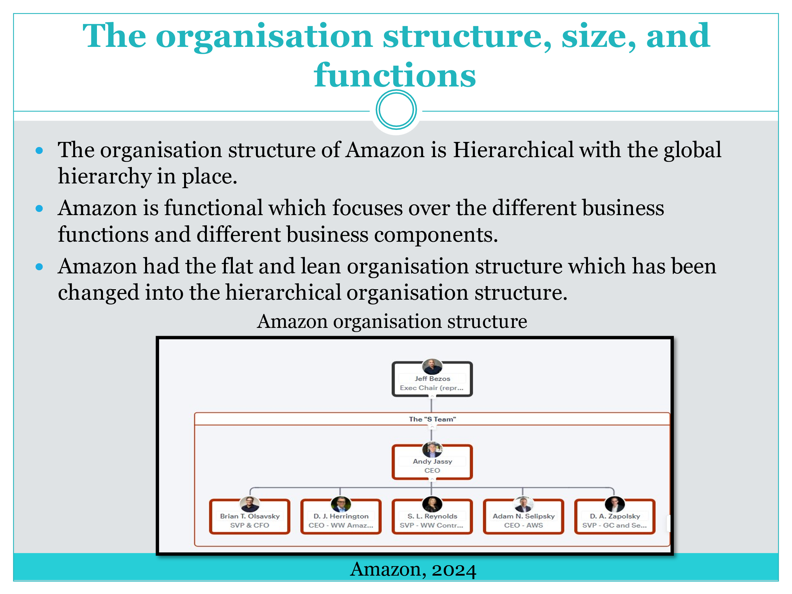
The organisation structure of Amazon is Hierarchical with the global hierarchy in place. It is also important to highlight the fact that organisation structure of Amazon is functional which focuses over the different business functions and different business components.
Amazon had the flat and lean organisation structure which has been changed into the hierarchical organisation structure.
With the help of the hierarchical business structure division of tasks and responsibilities, better coordination and communication management, better innovation and adaptation have been managed in the organisation. The basic organisational structure of Amazon is centralised with some elements as decentralised. Centralisation is prominently in Amazon with effective logistics and customer care service department. At some time, Amazon had the function based group and geographic divisions with higher flexibility towards the innovation.
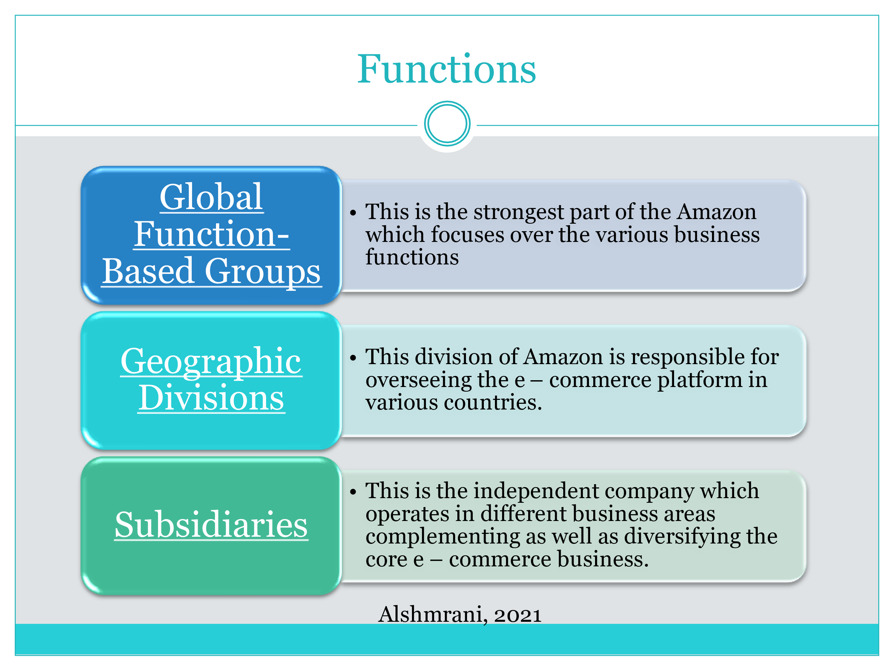
It is prominent that in the global platform Amazon follows the three tiers of the global corporate business structure as below:
Global Function-Based Groups
This is the strongest part of the Amazon which focuses over the various business functions and components developing strong interaction and developing interdepartmental relationships. Each of the group is responsible for different functions, done as finance, legal, human resource, advertisement, operations, e-commerce services and others (Amazon¸2024).
Geographic Divisions
This division of Amazon is responsible for overseeing the e – commerce platform in various countries. Each division is supported by country or region manager reporting to the senior vice president of the global region. This helps the organisation to take care of the local market needs and issues.
Subsidiaries
This is the independent company which operate in different business areas complementing as well as diversifying the core e – commerce business. The businesses here include the cloud computing, online grocery delivery AI, Online pharmacy and others. With the help of the diversification of the businesses, Amazon has developed new revenue streams ensuring better growth of the business.
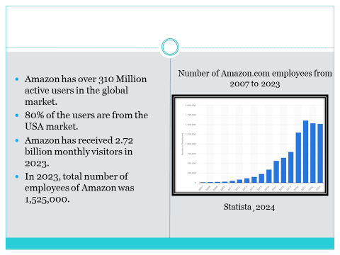
As per the size of the organisation, the number of active users that Amazon holds is over 310 Million in the global market. 80% of the users are from the USA market. Amazon has received 2.72 billion visitors in 2023 monthly wise (Amazon, 2024). In 2023, total number of employees of Amazon was 1,525,000 which are considered as 1.04% decline from 2022.
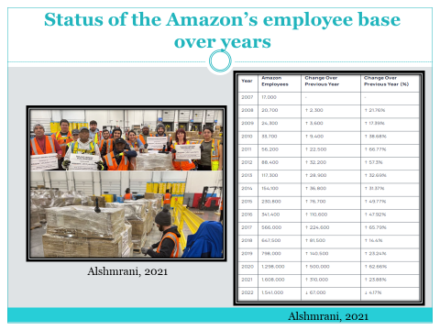
Since 2021, growth of the Amazon employees’ base has been observed and which has been started to get declined post this period. Overall, it can be addressed that the size of Amazon’s organisation from the point of view of Customers base and also from the point of view of the customer base is large. Along with the strong presence of the customers, strong presence of the employees also is maintained in Amazon.

The internal and external environment analysis of Amazon

Explain SWOT framework
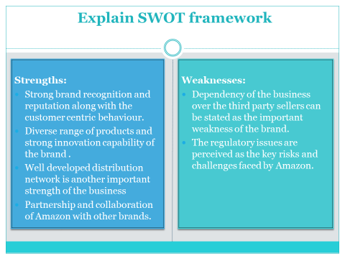
SWOT model analysis discusses the internal factors shaping the business environment along with internal capabilities of Amazons has been discussed.
Strengths:
- Strong brand recognition and reputation along with the customer centric behaviour of the brand is one strength factor of the company.
- Diverse range of products and strong innovation potential of the brand also is considered as the significant strength of the organisation.
- Partnership and collaboration of Amazon with other brands also is the key strength of success of Amazon (Charles & Uford, 2023).
- Well-developed distribution network is another important strength of the business.
- Larger customer base, cutting-edge technology usage, and strong financial performance of Amazon also are considered as the important strength factors.

Weaknesses:
- Dependency of the business over the third party sellers is one weakness of the brand.
- The business model of Amazon is easy to copy which is another weakness of the brand (Charles & Uford, 2023).
- The regulatory issues are perceived as the key risks and challenges faced by Amazon in the global market.
- Limited product control of Amazon in various countries is another important weakness of the brand.
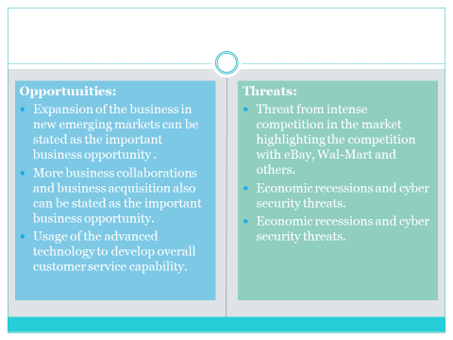
Opportunities:
- Business expansion in new emerging markets is one important business opportunity.
- Expansion of the physical stores is another important business opportunity of Amazon (Amazon¸2024).
- More business collaborations and business acquisition opportunity is important for Amazon to be looked after.
- Investment in new ventures by Amazon can be perceived as the important business growth prospects.
- Usage of the advanced technology to develop overall customer service capability of the organisation is another business growth opportunity.

Threats:
- Threat from intense rivalry in the market highlighting the competition with eBay, Wal-Mart and others is the important threat faced.
- Natural disasters are another important threat factor of the organisation.
- Economic recessions and cyber security threats is challenging threats faced by Amazon (Amazon¸2024).
To mitigate the threats, it is required by Amazon to develop contingency plans to handle the natural disasters and some unwanted business situation so that the effective business operational flow can be managed.

Explain PESTLE framework
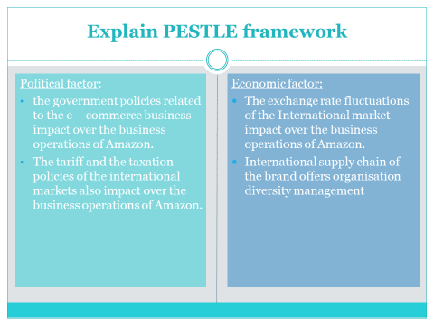
With the help of the Pestle framework model, external business environment analysis has been discussed here.
Political factor: the government policies related to the e – commerce business impact over the business operations of Amazon. The international trade agreements like the North American Free Trade Agreement, and the Comprehensive and Progressive Agreement for Trans-Pacific Partnership also influence business operations of Amazon. The tariff and the taxation policies of the international markets also influence the business operations of Amazon.
Restricted market access is important political factor triggering over the organisational activities of Amazon (Alshmrani, 2021).
Economic factor: the macroeconomic trend is the important business success driver of Amazon. The exchange rate fluctuations of the International market influence business activities of Amazon as the organisation operates its business in both the domestic and international markets. International supply chain of the brand offers organisation diversity management and also supports in profitability earning.
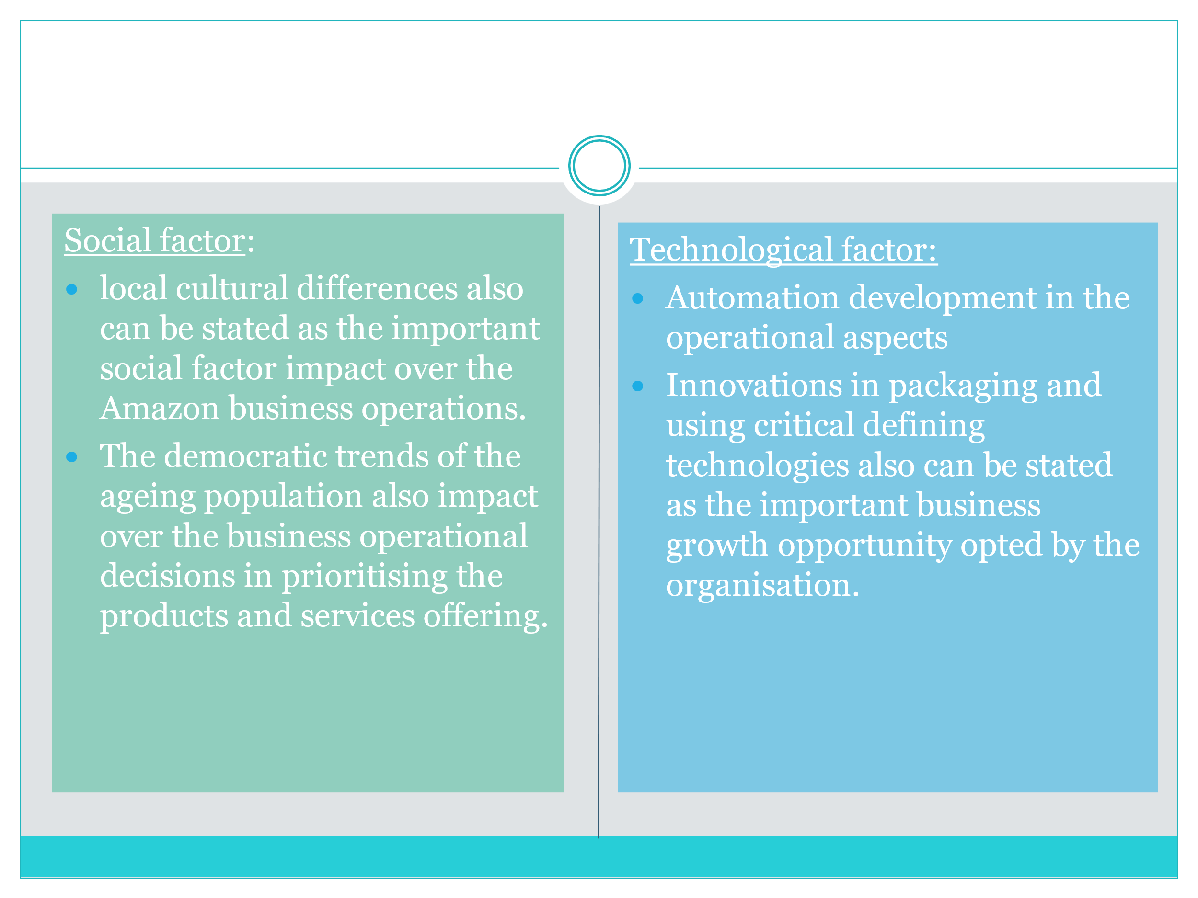
Social factor: The increasing popularity of the e-commerce business in the global market is the important social factor influences. Apart from that the consumer spending patterns, and the cultural differences also act as the important social factor to influence over the business operations of Amazon. The regional cultural difference impact over the consumer preferences regarding the types of the products to be used (Ali & Safaa, 2022). The democratic trends of the ageing population also impact over the business operational decisions in prioritising the products and services offering also is the important social factor. Social controversy like expansion of Amazon and closing down the local brand has also been negatively impacted business reputation of Amazon.

Technological factor: With the advancement of the technology impact, automation development in the operational aspects is the important business growth chance faced by the organisation. Increased automation has been used by Amazon to meet the employee’s shortage meeting. Innovations in packaging and using critical defining technologies are vital to adding to the growth factors of the company. Advancement in technology has been used to ensure better delivery of the orders to the target customers addressing business operational excellence.
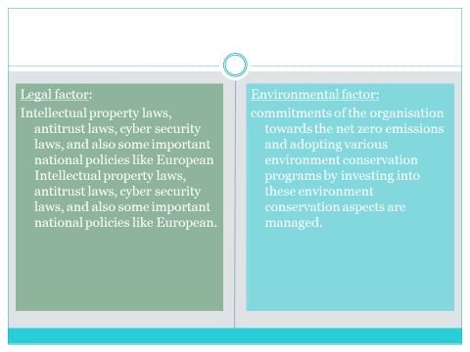
Legal factor: Intellectual property laws, antitrust laws, cyber security laws, and also some important national policies like European Union’s General Data Protection Regulation (GDPR), and others are the important laws impact over the business operations of Amazon. Legislations based on the worker's right also influence over the business operations of Amazon. Amazon is a major employer in the global market (Charles & Uford, 2023). Thus, the business operations are subjected to the labour laws, and also some regulations related with the workforce. An increase in the minimum wages to be offered to the Amazon employees can be managed by hiking the process to the customers.
Environmental factor: commitments of the organisation towards the net zero emissions and adopting various environment conservation programs by investing into these environment conservation aspects are managed. The impact of the extreme weather also has been considered as the most important aspect.
The adverse environment aspects have impacted the delivery network operations of Amazon which is required to be handled by the organisation effectively. Investing more, Amazon is required to develop suitable disaster management strategies so that the best Amazon business operations can be controlled. Amazon has pledged net zero carbon emission by 2040 being the part of the integrated programs as “Amazon climate pledge”. Reduction the size of the plastic usage by 7% and committing the business operations to concentrate over the recycling of the materials by 100% is another important strategy followed by Amazon.

The company stakeholders
Mendelow’s stakeholder matrix describes the stakeholder’s analysis of Amazon has been done.
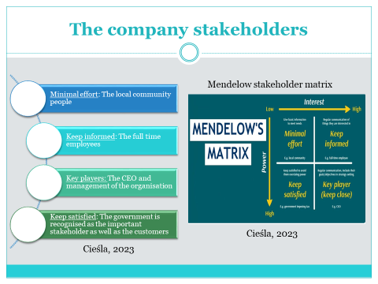
Minimal effort: The local community people can be sated as the stakeholders to offer minimal effort by making them informed about the business operations. They hold the low power and low interest.
Keep informed: The full time employees are considered as the important stakeholders those are always required to be kept informed about the changes in the organisation and also about the operations of the Amazon. Regular communication is needed to be managed by the authority of the organisation to meet their interest level.
Key players: The CEO of the Amazon is stated as the key player of the firm. Regular communication is required to be managed with the CEO as they have high level of interest and high level of power in the organisation to execute (Cieśla, 2023).
Keep satisfied: The government authority is recognised as the important stakeholder group those are always subjected to be kept pleased by obliging their regulations and laws imposed over Amazon. This is important to be managed by Amazon so that the unnecessary power exertion on Amazon can be controlled.

Conclusion
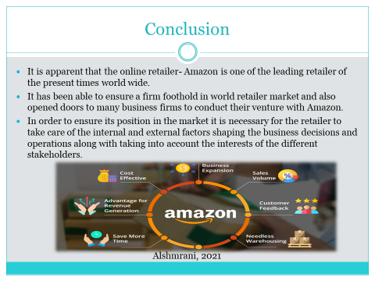

References

Ali, E., & Safaa, E. (2022). Amazon's Growth in the Context of the Opportunities and Challenges of Industry 4.0. Issue 4 Int'l JL Mgmt. & Human., 5, 1456.
Alshmrani, H. M. (2021). An analytical view of Amazon success in the worldwide. Life Science Journal, 18(6), 71-90.
Amazon (2024). Available at: https://www.amazon.com/ . Accessed on: 18th March, 2024.
Amazon (2024). Available at: https://www.yaguara.co/amazon-statistics/#:~:text=1%20.-,Amazon%20Has%20Over%20310%20Million%20Active%20Users%20Globally,unique%20monthly%20visitors%20in%202023. Accessed on: 18th March, 2024.
Charles, I. I., & Uford, I. C. (2023). Comparative analysis and evaluation of business and financial performance of Amazon. Com: A three-year period critical review of exceptional success. European Journal of Business, Economics and Accountancy, 11(2), 69-92.
Cieśla, M. (2023). Determining the strategic position of car-sharing services in Poland based on the stakeholder analysis method. Journal of civil engineering and transport, 5(1).
Statista( 2024). Available at : https://www.statista.com/statistics/1035592/net-sales-amazon-united-kingdom-uk/#:~:text=Amazon%20net%20sales%20in%20the%20United%20Kingdom%20(UK)%202010%2D2023&text=Amazon%20enjoyed%20staggering%20sales%20growth,billion%20U.S.%20dollars%20in%202023. Accessed on: 18th March, 2024.
Statista ( 2024). Available at : https://www.statista.com/statistics/234488/number-of-amazon-employees/. Accessed on: 18th March, 2024.

