

Student Name: Rusti Monica
Student Number: 1909952
Lecture name: Racheal Adebayo
Module name: Principles of Health and Social Care Practice
Module Code: BMHP5002

Table of Contents

Introduction………………………………………………………………………….….……..2
Care plan based on the case study……………………………………………………………..3
Implementation of principles of support within health and social care practice………………4
Evaluating the impact of policy, legislation, regulation, codes of practice and standards on organisation policy and practice………………………………………………………………7
Analysing the theories that underpin health and social care practice…………………………..9
Recommendations………………………………………………………………..……………9
Conclusion……………………………………………………………………………………11
References……………………………………………………………………………………14

Introduction

The assessment below has critically discussed the principles of support that will be adopted within the social and health care practices. Along with this, it has also discussed the effect of policy, legislation, regulations, and code of practice as well as standards that are vital for any care giving organisations such as NHS in formulating their practices.
In context to this, the following assessment will discuss the importance of person-centred care under NHS for providing them with support and care in case of any disability or illnesses.
In addition, it will also critically discuss the effect of policy, legislation, regulations and code of practice and standards within the policy and practices of the concerned organisation.
Lastly, the assessment has highlighted some of the theories that support all the practices related to the care and social care within NHS. Collectively, the implementations of this changes aim to bring in new reformation within the care system. All this would be discussed based on the case study of two elderly individuals and offer recommendation.

Care Plan based on the Case Study
According to the case study, it can be noted that both Mr and Mrs T are over 85 years old. Mr T for instance is suffering from progressive dementia.
Further, he is also suffering from other chronic conditions. Both of them have been taking care of one another independently until recently when Mrs T fell.
For this reason, she was admitted to the hospital and had to go for a hip operation. She has recovered and has returned to the home with a mobility frame. In such a chaotic crisis she feels that they in need of support if they want to carry their living independently.
In context to the current condition of Mr and Mrs T, person-centred care would be most suitable for them. According to Morton and Sellars (2019), geriatric care also referred to as elderly care is the act of delivering a range of medical treatment, personal care, and nursing care to the scenarios. The caregivers in this case are usually licensed as well as well-trained healthcare professionals.
Implementation of Principles of support within health and social care practice
Principles that are supported at NHS:
According to NHS (2021), NHS is focused in improving the quality of health and wellbeing of the locals in the UK. Along with this, they also offer to support the public for maintaining their mental and physical health that would eventually be helpful for improving the quality of living until the end of their lives.
Regmi and Mudyarabikwa (2020) stated that NHS works within the limits of science by bringing in highest level of human knowledge and skills for saving the lives of people in the UK. Further, NHS also aims to provide people of the UK with some basic human needs, care and compassion that are essential for them to lead a positive life.
According to Foster et al. (2018), NHS was initially started on a set of common principle and values for binding the communities and people of the UK that includes publics and patients as well as their working staffs. The constitution of NHS clearly mentions as to which patients, publics, and staff their facilities are entailed, for which they are committed to achieve greater stability of care system in the country with collaborations.
For instance, all the NHS bodies such as private and voluntary sectors in the UK are bound to supply their services to NHS (Scobie and Castle‐Clarke, 2020).
Further, the organisations also have an expert team of professionals who offer support and care to patients suffering from dementia. These particular aspects of the organisations would be a great help for Mr T in dealing with this progressive dementia.
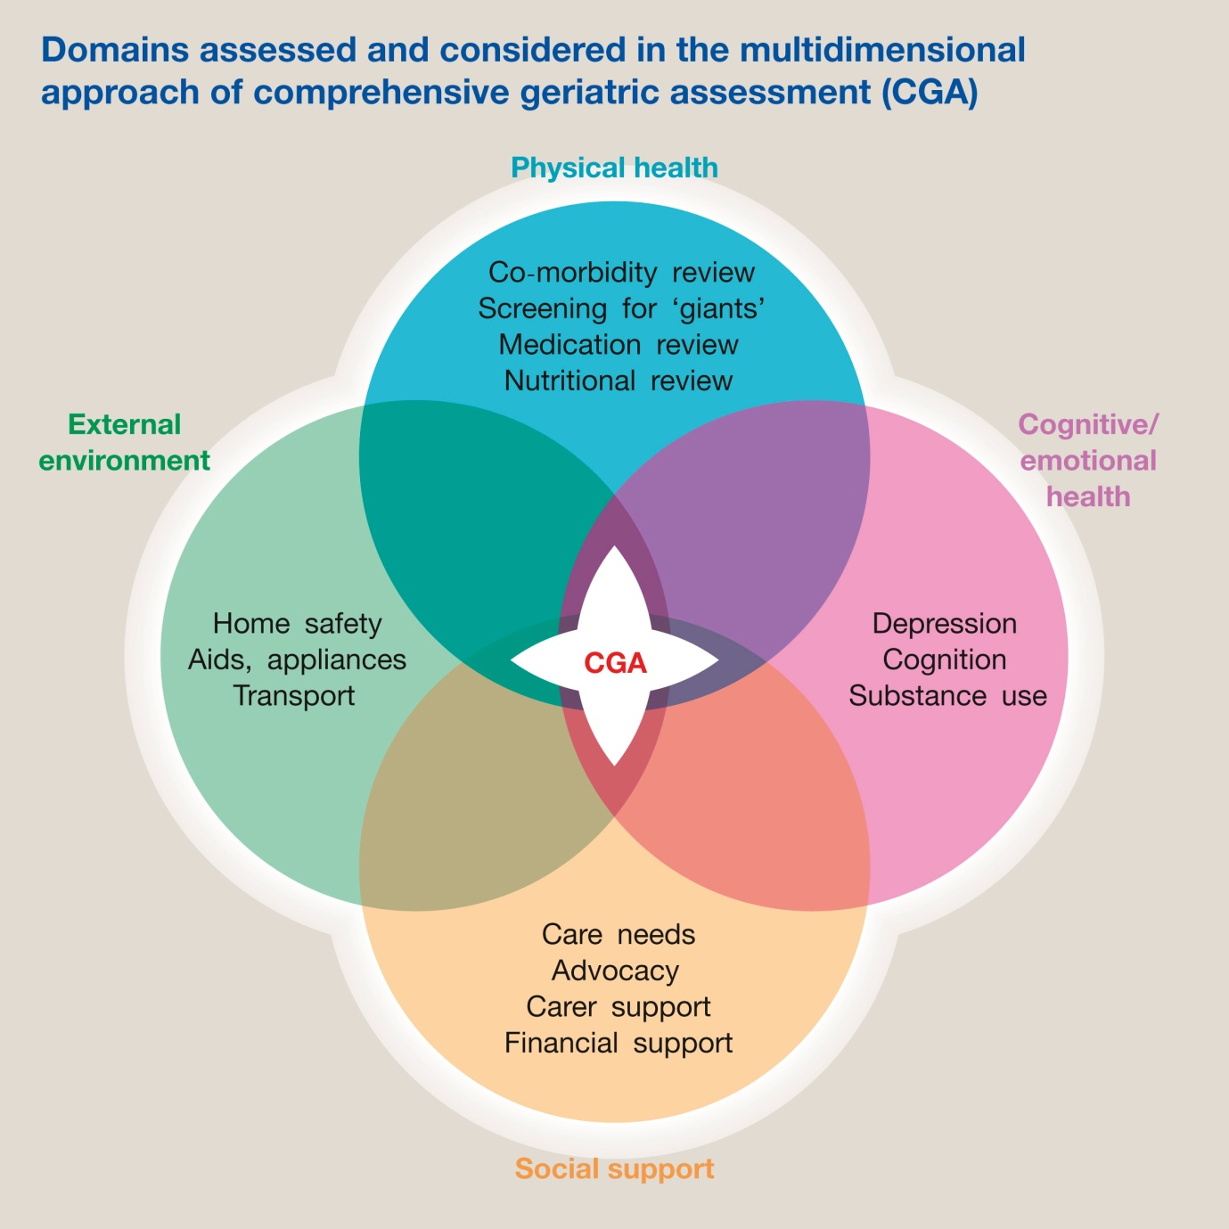
Figure 1: Principles of Support
(Source: Van Vlie et al., 2019)
Procedures that are to be adopted at NHS
The figure above shows the procedures that need to be strictly taken into account by NHS to offer protection to their clients and other working staff members from any kind of harm.
For instance, to enhance their protection management system, it is necessary for the NHS to re-design their policy for personalised care planning.
However, it is necessary for them to ensure that it is in accordance to their regulations and guideline and is followed as well as positively accepted by their service providers (Lewis et al., 2019).
Apart from this, risk management and risk assessment can help NHS in determining and managing their time. This will ensure that they are able to offer personalised care in most organised manner. Further, it will also help them in avoiding any conflicts among the employed.
In addition, it is also necessary for NHS to keep their working staff informed regarding all the important information, as it will help them in avoiding confusions and unnecessary conflicts among the employees. In order to achieve this, it necessary for NHS to establish a good communication between management team and the working staff as it will avoid any unnecessary confusion.
Benefits of Person-centre care approaches for patients of NHS
According to Zhang and Chignell (2020), all the person-centred approaches have been directed under recent health and social care practices of the UK. All models related to person-centred care are based on Carl Rogers’s therapeutic approaches.
This is especially emphasis on defending the personal rights of users and ensuring that decisions taken comply with their distinctive requirements.
A Person-centred approach has been significantly used in other organisations and social care organisations regularly.
Gosti et al. (2021) stated that a person-centred offer has an advantage in a wide, for instance, it enlarges the satisfaction of the service users and ensures that ethnicity, religion, and financial background of a person are valued as well as taken into account.
Considering, the implementations of person-centred care for the service use of NHS them with place preferences, requirements were meeting the needs and serving the service users would be the prime focus of the NHS.
Issues that can possibly arise while offering care, support, and protection
According to Kinley et al. (2018), several moral dilemmas and conflicts are often accounted by service providers while offering support, care, and security to health and social for the patients. The main task of health care professionals is to ensure that they are able to mitigate the problems of patient at both functional and biological levels.
However, in many cases ignoring the ethical challenges can be impractical. For instance, in the case of Mrs T, it can be noted that she is been dependent on her mobility frame due to her hips operations and Mr T is already a patient with progressive dementia and other chronic diseases. In such a situation, the care providers are in an ethical dilemma as to how they would help them offer support for independent living (Pringle et al., 2021).
This seems a huge challenge because, on one hand, the principle of health care states that people must be treated in the best possible manner, while on the other hand choices and dignity of a person must also be taken into account.
Evaluating the impact of policy, legislation, regulation, codes of practice and standards on organisation policy and practice
Implementing regulations, policies, legislation, codes of practice within the work culture of NHS
According to Hitchens et al. (2021), the NHS constantly brings new changes within their legislation, policies, regulations, and code of practice for ensuring that their actions are appropriate and fits specifically to bring change in ethnics, economical, and cultural background of the citizens.
Currently, Health and Social Care Act 2012 is regarded as one of the most widespread and accepted legislation that directs all the health and care fields within the UK.
This particular act has helped in providing policies for all the health and social care managers (Comino, 2021). The particular policy standards of this Act offer a superior voice to clients, offering better patient-centred care approaches. Along with this, they will also be able to bring required reformations within their health and safety services that would avoid any negligence in the deliverance of care.
If NHS can strictly implement this then they would be able to bring higher accessibility of care, along with enhancement in health and core competence.
Marti et al. (2019) stated that NHS is gives their major emphasis in creating positive and inclusive working environment, culture as well as offer conditions that will help people and their staff members in achieving the highest standards of services and performance.
Similarly, the person-cantered care support provided by NHS is focused in offering knowledge, care, skill, and confidence that is often required by an individual for securing healthy life. Along with this, it also ensures that people with any impartment or disorder are able to make informed decision about their own health and care without any pressure or dependency (Kyratsis et al. 2019).

It is also necessary for NHS to give their focus on other policies such as Right to Action, Quality Protects, valuing people, The Care Standard Act 2000. Further, as per NHS's codes of Practice they give their major emphasis in using their health records, management system of information security as well as application and relevance of the information (Flew and Wilding, 2021).
Collectively, all this will ensure that they can maintain all the required laws and orders while offering person-centric care to their service users.
Ways to develop policies and procedures at NHS according to a national policy requirement
Bull et al. (2020) stated that all the health and social care organisations are directed under the UK's legislation. Along with this, it also governs the policies and procedures that usually differ depending upon the needs of the populations.
For example, the locations with superior or lower socioeconomic status may depend upon local health and social care rules based on their preferences.
Further, all the policies and procedures at NHS must be developed with the requirement of national policy, as it will help them in eradicating all the barriers that hamper the incorporation of care (Bone et al., 2018).
NHS must work in collaboration with health and social care organisations to ensure that they are liable for meeting the needs of the people, to whom they are offering their care services. This will ensure that people can choose the services that are most suitable for them. In context to this even, Mr T and Mrs T would be able to make their decision independently without any confusion or dilemma (Pérez‐Escamilla et al., 2017).
All this would help them gain the support of the public, which could have been difficult for them to meet.
According to Corazzini et al. (2019), NHS has made a commitment in offering improved care plan by involving the patients to managing their own health and eventually makes them capable enough to take informed decision regarding their care and treatment.
Along with this, they also aim to provide support to the patients in enhancing their health and eventually offer them with better opportunity to lead a life of their choice.
The objectives of NHS’s person-centred care aim to coordinate and tailor the needs of the individuals and all the healthcare professionals in the UK so as in ensure a collaborative work for providing best care and support to the citizens of the UK.
Effect of policy, regulations, legislation, and code of practice at NHS
According to Rumbold and Pierscionek (2017), introduction of The Health and Social Care Act 2012 has shaped the first legal duties of NHS regarding their inequalities.
This has made a significant impact on the duties for health bodies of NHS, which compelled them to reduce their health inequalities among the public of England.
According to Drennan and Ross (2019), this Act has also brought a major change among the local authorities, who are responsible for public health functions in the UK. Similarly, as per The Social Act 2012, it is necessary for NHS to take in consideration the economic, social, and environmental wellbeing practices within their care and service plans.
Along with this, it is also necessary for them to give their major emphasis in determining social health that would be useful for them in reducing their local inequalities, improve the quality of health and wellbeing for the locals.
In order to maintain this, it is necessary for NHS to ensure that all their policies and practices are aligned with this Acts (Allen et al., 2017). Further, in case of any changes within their code of practice, it is necessary for NHS to keep their staff informed and ask them to include while dealing or handling any patients.
In context to this, it can be noted that policy, legislations, regulations, and code of practice make a major impact on the way NHS functions and operates. For this reason, it is necessary for NHS to align all their policies and practices in accordance to the aforementioned Acts.
Analysing the theories that underpin health and social care practice
Recommendation
The current situation in NHS indicates that system theory would be most suitable as well as applicable for them as it gives its major emphasis on human behaviour and its flexibility with the complexity of the system (Xu et al., 2017). The main body at NHS must focus on the system and eventually try to fulfil their daily targets such as care, timely services, achieving all the set attributes and expectations of their service users within their existing system.
According to Le et al. (2019), a system theory is a group effort that a group of individuals or an individual can apply, transforming their lives better and more conveniently. This approach is more applicable for NHS, because people are facing more issues because of disruptions and ineffectiveness when offering services to their patients.
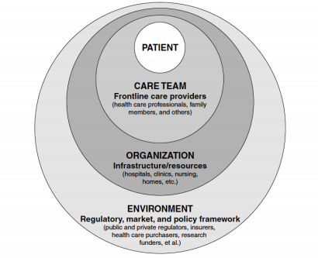
Figure 3: Concept of System Theory in Care Home
(Source: Grossman et al., 2018)
The application of this theory will help various individuals such as Mr T and Mrs T to survive most suitably and appropriately. Along with this, it can also be noted that social learning plays a very vital role in enhancing the knowledge, awareness, and literacy of the people. This increases their standards of living and enhances awareness for maintaining their health fit for longer. Apart from this, Mr and Mrs T can also acquire the support of various external agencies such as NGOs and other social organisations to improve their quality of life for independent living.
Grossman et al. (2018) stated that various home care could also conduct social programs where patients such as Mr and Mrs T gets to interact with one another and share those experiences with others to make them inspired for better living.
It is very essential to note that each individual must be given a chance to interact with the guides and share their thoughts on life and health care activists (Koch and Jones, 2018).
This kind of social indulgence will ensure faster recovery of the patients who are suffering from depression or any sort of psychological disease such as Mr T who have progressive dementia along with other chronic diseases.
Similarly, the implementation of inter-professional working can be another effective approach for NHS in effectively delivering their services and care to the patients.
According to Zuurmond et al. (2019), patients often suffer from different difficulties, due to which NHS must implement inter-personal working styles within their existing system.
This will help the staff members of NHS in facilitating the patients as per their needs and convenience. The implication of these approaches within the health and social care system of NHS will offer better stability and reformations within their services for person-centred care (Delaney, 2018).
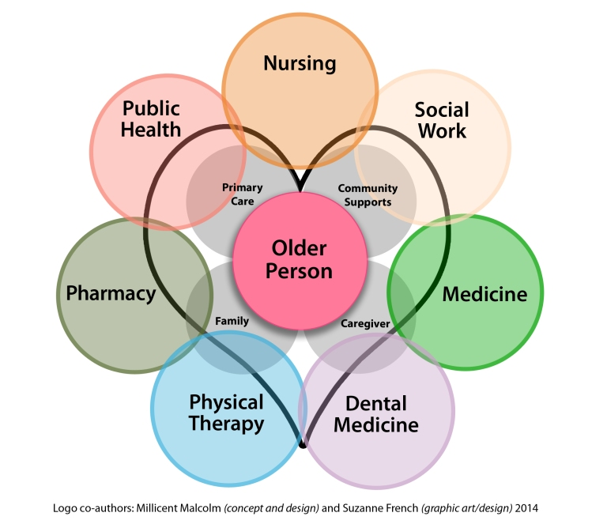

Figure 4: Inter-Professional Working (Source: Delaney, 2018)

Conclusion

In accordance with the above discussion, it can be noted that all the care homes such as NHS must meet the needs of the service users as well as their staff. This will help them in maintaining transparency while offering them their care under their supervision.
Further, it can also be noted that policy, legislation, regulations, and code of practice greatly affect the quality of services that are being offered in the care homes. In order to avoid such issues, all the care homes must have their practices and standards-aligned to the policy, legislation, regulations, and code of practice of the UK.

References
- Allen, P., Osipovič, D., Shepherd, E., Coleman, A., Perkins, N., Garnett, E. and Williams, L. (2017). Commissioning through competition and cooperation in the English NHS under the Health and Social Care Act 2012: evidence from a qualitative study of four clinical commissioning groups. BMJ open, 7(2), p.e011745.
- Bone, A.E., Gomes, B., Etkind, S.N., Verne, J., Murtagh, F.E., Evans, C.J. and Higginson, I.J. (2018). What is the impact of population ageing on the future provision of end-of-life care? Population-based projections of place of death. Palliative medicine, 32(2), pp.329-336.
- Bull, F.C., Al-Ansari, S.S., Biddle, S., Borodulin, K., Buman, M.P., Cardon, G., Carty, C., Chaput, J.P., Chastin, S., Chou, R. and Dempsey, P.C. (2020). World Health Organization 2020 guidelines on physical activity and sedentary behaviour. British journal of sports medicine, 54(24), pp.1451-1462.
- Comino, V. (2021). 'Corporate culture'is the'new black'-its possibilities and limits as a regulatory mechanism for corporations and financial institutions. University of New South Wales Law Journal, 44(1), pp.295-325.
- Corazzini, K.N., Anderson, R.A., Bowers, B.J., Chu, C.H., Edvardsson, D., Fagertun, A., Gordon, A.L., Leung, A.Y., McGilton, K.S., Meyer, J.E. and Siegel, E.O. (2019). Toward common data elements for international research in long-term care homes: Advancing person-centered care. Journal of the American Medical Directors Association, 20(5), pp.598-603.
- Delaney, M.C. (2018). Caring for the caregivers: Evaluation of the effect of an eight-week pilot mindful self-compassion (MSC) training program on nurses’ compassion fatigue and resilience. PloS one, 13(11), p.e0207261.
- Drennan, V.M. and Ross, F. (2019). Global nurse shortages: The facts, the impact and action for change. British medical bulletin, 130(1), pp.25-37.
- Foster, C., Calman, L., Richardson, A., Pimperton, H. and Nash, R., (2018). Improving the lives of people living with and beyond cancer: generating the evidence needed to inform policy and practice. Journal of cancer policy, 15, pp.92-95.
- Gostin, L.O., Friedman, E.A. and Wetter, S.A. (2020). Responding to COVID‐19: how to navigate a public health emergency legally and ethically. Hastings center report, 50(2), pp.8-12.
- Grossman, M.R., Zak, D.K. and Zelinski, E.M. (2018). Mobile apps for caregivers of older adults: Quantitative content analysis. JMIR mHealth and uHealth, 6(7), p.e162.
- Hitchens, P.L., Booth, R.H., Stevens, K., Murphy, A., Jones, B. and Hemsworth, L.M. (2021). The Welfare of Animals in Australian Filmed Media. Animals, 11(7), p.1986.
- Kinley, J., Hockley, J., Stone, L. and Brazil, K. (2018). Family perceptions of care at the end of life in UK nursing care homes. Journal of Research in Nursing, 23(2-3), pp.203-217.
- Koch, K.D. and Jones, B.L. (2018). Supporting parent caregivers of children with life-limiting illness. Children, 5(7), p.85.
- Kyratsis, Y., Ahmad, R., Iwami, M., Castro‐Sánchez, E., Atun, R. and Holmes, A.H. (2019). A multilevel neo‐institutional analysis of infection prevention and control in English hospitals: coerced safety culture change?. Sociology of health & illness, 41(6), pp.1138-1158.
- Lee, K., Puga, F., Pickering, C.E., Masoud, S.S. and White, C.L. (2019). Transitioning into the caregiver role following a diagnosis of Alzheimer’s disease or related dementia: A scoping review. International journal of nursing studies, 96, pp.119-131.
- Martin, G.P., Chew, S. and Dixon-Woods, M. (2019). Senior stakeholder views on policies to foster a culture of openness in the English National Health Service: a qualitative interview study. Journal of the Royal Society of Medicine, 112(4), pp.153-159.
- Morton, R.L. and Sellars, M. (2019). From patient-centered to person-centered care for kidney diseases. Clinical Journal of the American Society of Nephrology, 14(4), pp.623-625.
- NHS (2021). The NHS Constitution for England. [online] GOV.UK. Available at: <https://www.gov.uk/government/publications/the-nhs-constitution-for-england/the-nhs-constitution-for-england> [Accessed 16 August 2021].
- Pérez‐Escamilla, R., Lutter, C.K., Rabadan‐Diehl, C., Rubinstein, A., Calvillo, A., Corvalán, C., Batis, C., Jacoby, E., Vorkoper, S., Kline, L. and Ewart‐Pierce, E. (2017). Prevention of childhood obesity and food policies in Latin America: from research to practice. Obesity Reviews, 18, pp.28-38.
- Pringle, J., Mellado, A.S.A.V., Haraldsdottir, E., Kelly, F. and Hockley, J. (2021). Pain assessment and management in care homes: understanding the context through a scoping review. BMC geriatrics, 21(1), pp.1-13.
- Regmi, K. and Mudyarabikwa, O. (2020). A systematic review of the factors-barriers and enablers-affecting the implementation of clinical commissioning policy to reduce health inequalities in the National Health Service (NHS), UK. Public Health, 186, pp.271-282.
- Rumbold, J.M.M. and Pierscionek, B. (2017). The effect of the general data protection regulation on medical research. Journal of medical Internet research, 19(2), p.e47.
- Scobie, S. and Castle‐Clarke, S. (2020). Implementing learning health systems in the UK NHS: policy actions to improve collaboration and transparency and support innovation and better use of analytics. Learning health systems, 4(1), p.e10209.
- Van Vliet, L.M., de Veer, A.J., Raijmakers, N.J. and Francke, A. (2019). Is Information Provision about Benefits and Risks of Treatment Options Associated with Receiving Person-Centered Care?: A Survey among Incurably Ill Cancer Patients. Journal of palliative medicine, 22(7), pp.797-803.
- Xu, L., Tang, F., Li, L.W. and Dong, X.Q. (2017). Grandparent caregiving and psychological well-being among Chinese American older adults—the roles of caregiving burden and pressure. Journals of Gerontology Series A: Biomedical Sciences and Medical Sciences, 72(suppl_1), pp.S56-S62.
- Zhang, B.Y. and Chignell, M. (2020). A Person-Centered Design Framework for Serious Games for Dementia. In Proceedings of the Human Factors and Ergonomics Society Annual Meeting (Vol. 64, No. 1, pp. 18-22). Sage CA: Los Angeles, CA: SAGE Publications.
- Zuurmond, M., Nyante, G., Baltussen, M., Seeley, J., Abanga, J., Shakespeare, T., Collumbien, M. and Bernays, S. (2019). A support programme for caregivers of children with disabilities in Ghana: Understanding the impact on the wellbeing of caregivers. Child: Care, Health and Development, 45(1), pp.45-53.

