PROBLEM SOLVING AND DECISION MAKING


(BMSW4004_LON)
ASSIGNMENT TITLE
(PROBLEM SOLVING AND DECISION MAKING)

NAME: IDOWU LOWO
STUDENT ID: 1919461
NAME OF LECTURER: DR AKINSEYE ALUKO

PROBLEM SOLVING AND DECISION MAKING
ABSTRACT

Problem solving transpires every day and cannot be, avoided completely. The aptness to try and proffer solution immediately is one of the fundamental mistakes in problem solving and decision making process as the analytical should be establish at the extremity of the measure rather than the commencement. However, the essence of problems differs, so also applicability and decisions to each problems. The nature of problem can be small, vast, complex, and it is the responsibility of the management or the manager in the case of a company to establish an advance towards resolving the problem using personal skills, experiences, expertise and the information at hand to identify and implement solutions. (UKEssays. November 2018).

INTRODUCTION

Recently, companies has been experiencing or facing different problem either in the aspect of finance, structure, management, or production among others. Considering the gravity of this problem, and the devastating implications to both the employer and employee, the management decides to identify factor or factors responsible to establishing the root cause and proffer solutions using “ fishbone tool for root cause analysis” (Ishikawa). Finally, for an organisation to better, understand, broadly, its strength and weakness, and its position in the industrial environment, I will also talk about the “SWOT” and “PESTLE” analysis. The swot and pestle analysis give company or organisation the opportunity to know their weakness, strength, opportunities, and treat. Furthermore, talk about the “Porter’s Five Forces Model”.

WHAT IS PROBLEM SOLVING AND DECISION MAKING

Problem solving is an analytical process used to identify the possible solution to existing situation or position. (Easter R. A., John. L., 2021). However, the generally accepted definition of Problem Solving is as follows:
“Problem Solving is the process of finding the best applicable solution to a problem or identifying an innovative solution to an improvement opportunity” by (Rachael Jones, march,.31 2020).
We are born to face and solve problems, and in doing that, we build our confidence as problems solvers. Having a conscientious process and viewpoint to problems can solve them quickly and effectively.

However, there are six-step problemsolving process namely:
- Identify the problem / opportunity
- Define the problem / opportunity
- Analyse the problem / opportunity to identify the root cause
- Develop the best solution or improvement idea
- Implement the selected solution or idea
- Evaluate the outcome of the solution and identify new opportunities

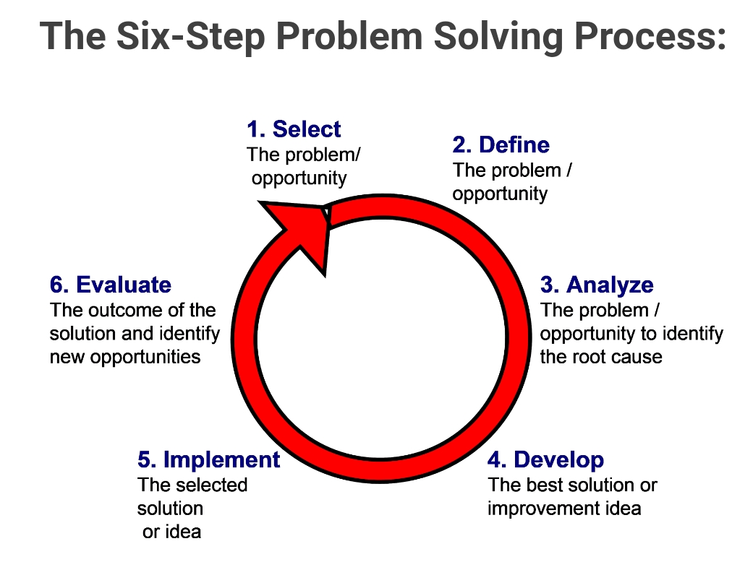

DAIGRAM 1:

The above six- steps problem solving process provides a familiar or common language that we can apply to define and analyse problems. It also gives the basis in a team to synchronise, calibrate and focus your problem solving processes.

NATURE OF PROBLEM
There is a communication challenges within my organisation, and this poses a great deal of concern to me as one of the employee of the company and the entire management.
PROBLEM STATEMENT
I worked in a company that deals in house hold products and confectionaries but recently observed continuous sharp decrease in, its sales output in our branch due to communication challenges within the organisation. Management, considering the implications of the problem try to identify the root with, the anticipation of proffering solution.

PROBLEM SOLVING AND DECISION MAKING USING THE
FISHBONE ROOT CAUSES &EFFECTS ANALYSIS (DIAGRAM)
The Fishbone Diagram which are also referred to as “ cause and effect diagrams”, are a problem solving and fault finding tool which facilitates the thought process in dissecting an issue or problem into a standard four contributing sources from which users than think of possible causes of the problem. It is a more constructed, and technical approach than some other tools available for brainstorming causes of a problem, (for example, the Five Whys tool).

Ishkawa Route Cause Diagram (1960)
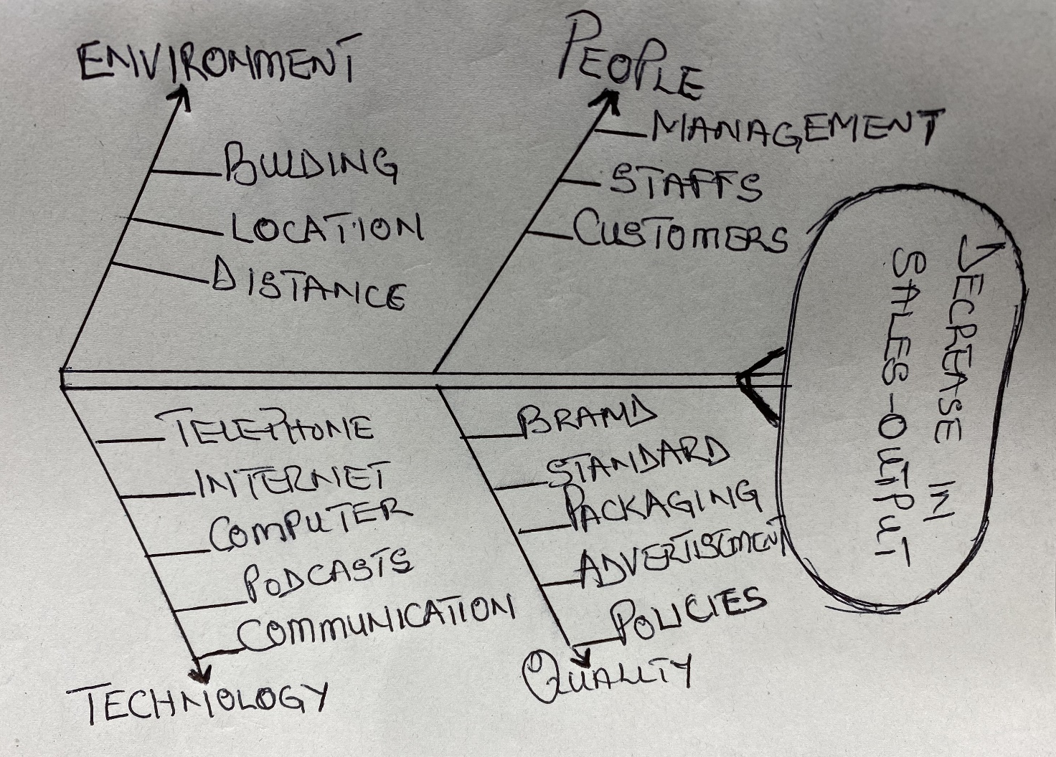
DAIGRAM2: CAUSES AND EFFECT ANALYSIS (ALSO CALLED ISHIKAWA DIAGRAM
After a critical analysis through idea shearing, deliberations, and contributions from various departmental head, it was, concluded that the low sales was due to a communication break – down or ineffective communication channel within the organization.
In addition to the fishbone cause and the effective analysis shown above, companies and business organizations can as well use the “SWOT”,”PESTEL” and the “FIVE PORTER FORCES MODEL” analysis to determine its strength, weakness, opportunity and threats.

WHAT ARE THE CAUSE OF COMMUNICATION PROBLEM IN THE ORGANISATION

Various factors could be responsible for communication problems or friction, frustration, confusion and extremely tense environment wherein worker are not motivated to be productive and are not even encouraged to collaborate. Rather, it is important to look into its causes thus preventing further progression of disintegration of the problem along the work force.(Anton Vdon September 21, 2017)
Here are some of the common causes of poor communication in the work place:

- Unclear Objectives: When a job description are given, accompanied word, it is a welcome idea, but it is not enough. It important as well to make sure there is face –to-face discussion with an employee in order to perform he or her responsibilities and expectations that go beside with his or her job

- Poor leadership: staffs members look to their boss or manager for direction. However, if people given managerial roles are poor leaders, there is high possibility that communication in the workplace will break down.

- Cultural diversity in the workplace: This factor is very vital, because technology has made the world a small place, so also the work environment. Considering this, it not unusual, to find people from different culture, races, religious beliefs, gender and others working in the same work environment, for same company.Though diversity is a positive development, it does poses a few challenges- including the potential for poor communication in the work place.

- Demoralised employees: When staff members know longer derive satisfaction in their work and organisation, are, considered, demoralised and when this happens, the employee feels unvalued, unappreciated, disrespect, and even disregarded despite their capacities and talents. In most cases, such worker tends to unproductive and irritable, and likely to be looking for opportunities elsewhere instead of contributing towards the company progress.

- Personal issues and challenges of employees: It is, recommended that employees should at all, time be concentrative on their job while working, some may be distracted by their own personal issues and challenges, such as death in the family or divorce issue. This, personal issues could influence an employee to communicate wrongly, and react in a negative fashion.

Having stated above the most common communication challenges in organisation from big enterprise business to small start-up, does not imply that there no other problems that could exist, it depends on so many factors within the organisation. The idea that communication problem can make a business less profitable cannot be over emphasised, statistic shows that communication problem can have a negative impact on everything from employee working performances toward success of the business.
THE IMPACT OF COMMUNICATION PROBLEM IN BUSINESS ORGANISATION
An increase in employee turnover: Whenever an employee is replace, according to report, it cost the organisation three time that salary, which can, be, prevented.

- Relationship suffer when communication is a problem: Two heads they say is better than one, but unabridged teams of head are vital for long-term success. When people cannot communicate with one another effectively because of communication barriers or, can communicate but feel uncomfortable doing so because of lack of openness culture at a company, collaboration may slow or even stop
- Customer service suffers: Employees need access to information to answer customer queries, respond to sales inquiries, or help customers get what they need. When they cannot get that information easily, they are prompt to feel strong sense of disengagement that can lead to everyone-employee and customers as well feeling frustrated during encounter.
- Poor communication leads to stress and healthcare cost: Communication problem at work can create stress in worker, and this may lead to physical and mental issues, eventually employer tends to spend more on heath issue.
- Internal communication problem can be a killer: Workers who did not feel like having a vital role to play, who does not comprehend what is, expected of them, and who feel like they did not have a say literally cannot give their best.

- Communication challenges leads to mistakes: When workers are, given access to information needed to contributed to a company, such workers makes fewer mistakes because they feel comfortable concentrating on the work before them. Employees whose centre of attention is on trying to identify what their priorities should be or simple emotional management are more prone to mistakes, in retail, environment, the outcome for this kind disengagement may be fewer sales.

- Poor communication makes boosting employee satisfaction impossible: A bad communication system in a business organisation makes boosting your worker overall satisfaction impossible if you do not have a clear idea of what employee like and do not like about their day to day.
- Furthermore, absenteeism rates are higher when there is communication issue: Employees who cannot be push out of his comfort zone at that moment may show their communication-related dissatisfaction by, simply not showing up.
However, having listed above the most likely causes and impact, of communication problems in an organisation, I will also look at the best solutions for overcoming this communication challenges. According to (Laurie Brown 2021) “The single most outstanding way to overcome communication pitfall is to improve listening skills.

- Make sure there is always a routine audit of the organisation current communication channel. By doing that, it will give a clear understanding of your current practices. Carry out a company, wide audit of the channels, and gather wide range of insights from across the business.
- Treat business communication as a resource to invest in, not a cost to minimized. As indicated above, the benefits of strong business communication eclipses the costs. Moreover, cutting corners can expose the company to risks that could put the company in a tight situation. It is important to invest in right solutions for the, your organisation, which is why it is good to commence with a detailed audit.
- Give every employee a voice, supported by a clear process: Leaders that comprehend the real value of business communication explore ways to make their entire workforce part the conversation or communication processes.
- Share your business communication roadmap: It involves a serious commitment to establish the communication culture that your business, and employees, deserve. Once that is accomplished, it demands consistent care and attention to nature. For all these to come reality, it requires a collective effort from everyone in your organisation. Create time to understand the important change. Involve a clear vision for what you want to achieve, and in turn share that vision with your workers. Give them a voice, to their contributions, refine, the, plan. If all these is observe, it is an entirely achievable goal. (Matt Bochenski., 7th September 2020)
THE SWOT ANALYSIS
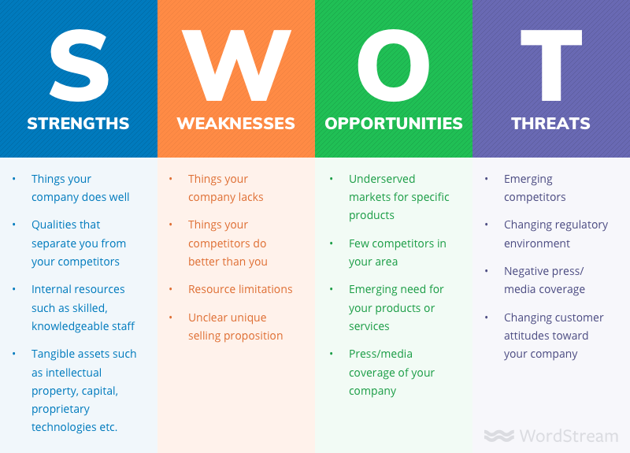
A SWOT analysis is an important analytical tool use by business organisations, companies, owners in deciding essential decisions. SWOT analysis consist of a plan you originated before stepping forward, or commencing a business

Diagram 3
Decisions. With this analysis, you can evaluate both negative and positive factors that are connected with your business. The SWOT analysis stands for Strengths, Weakness, Opportunities, and Treats. The concept is for it to permit the value of all those inputs that are most vital to your inception. This analysis can also help in the organisation of these inputs internally and externally. (Ang Azofeifa,. May 7th 2020).Furthermore, when organisation rely on free SWOT analysis templates, the exercise of filling or establishing one should help understand the state of the company better. Below is the diagram showing the SWOT analysis.

THE PESTEL ANALYSIS
Another important analysis framework use in business environment is the PESTEL analysis. There are many templates available for companies to conduct PESTEL analysis, or adopt to their environment but all with same objectives. The word PESTEL is an acronym for six sources of change: political, economic, social, technological, environmental, and legal. It is a powerful and widely used instrument for understanding strategic risk. It defines the changes and effects of the external macro environment on a firm’s competitive position. Strategists envisage to, understand, external factors and evaluate how business models will have to evolve to adapt to their environment. However, PESTEL analysis work best when the environmental factor are analyse from the angle of the firm’s resources, capabilities, and core competences. (Tanya Sammut-Bonnici, David Galea. January 2015).
All the six factors mentioned under the PESTEL analysis are all important points to be, considered for a better result in any business organisation.

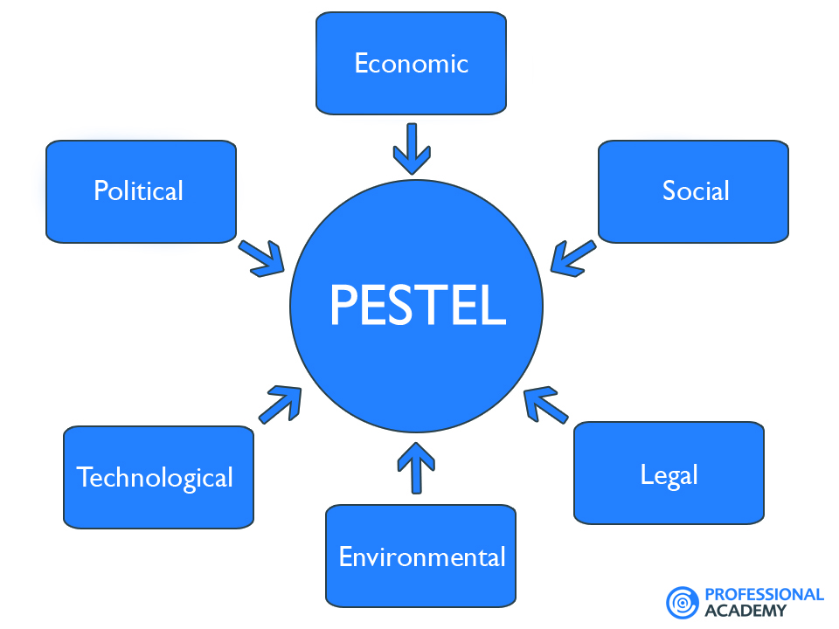

Diagram 4

THE PORTERS FIVE FORCES MODEL
Porters, five forces model, which was originally, developed by Harvard Business School’s Michael E. Porter in 1979 looks at the five specific factors that determine whether, or not a business can be profitable in compared to other business in the industry. Applying the Porter’s Five Forces, in conjunction with the SWOT, and PESTEL analysis, will help you to comprehend where your company or business fits in the industry environment having competitive advantages over other competitors Porter’s Five Forces and the PESTLEL is assumed, a macro tool in business analytics- it looks at the industry’s economy as whole, while SWOT analysis is a micro analytical tool, attending to a specific company’s data and analysis. (Marci Martin. December 03th 2019). In Porter’s model, the five forces that shape industry completion are Competitive Rivalry, The Bargaining Power of Suppliers, The Bargaining Power of Customers, The Treat of New Entrants, and finally, The Threat of Substitute Products or Services. Porter found the process not only useful for developing the strategic plan, but also critical to understanding the structure of the industry.

SOLUTIONS / RECOMMENDATION
To overcome the communication challenges, having observed all the above business analysis, I recommend the following solutions:
- Employee Orientation: If employee are, provided orientation about the organisation policies, objectives, procedures, authority relation, just to mention but few, communication challenges can be minimised considerably.
- Improving Interpersonal Relation: Improved interpersonal develop cordiality in organisations with employee becoming more cooperative and working together for achieving organisational goals.
- Empathetic Listening: Due to some managerial attitudes, in most cases upward communication is greatly, distorted. Manager often dominate managerial talks, not giving the subordinate the opportunity to express their opinion, feeling, or emotions. Such situation creates communication barriers.
- Using Proper Language: Communication challenges can be, avoided when simple and direct language is, employed. Using technical term or jargons having more than one meaning can create free flow communication. This must, be avoided.
- Communication Through, Actions: According to a popular say, “Action speaks louder than words”. When employee communicate and the boss do not act upon them, it gives a wrong feedback, which dissuades future communication. Such barrier need to be, eliminated through action and deeds. (Disha 2020)
- Judicious Use of Grapevine: Grapevine is vital for communication. But in a situation where there is over dependent on grapevine by the managers at the expense of the official channels of communication, it gives way to a culture of informal communication and thereby creates barrier to communication. Hence, grapevine needs to be judiciously, engaged.
- Lack of Information Feedback: Communication is suppose, to be a two-way process. Hence, feedback is most important. When information lacks a feedback, it creates a barrier to communication. Even in Face-to-face communication, body language may serve as a potential feedback.

CONCLUSION
I started by defining what is communication, its importance in business organisation, and the mostly causes of communication problems within the business environments. I also mentioned some possible solutions by using different business analysis and model in solving this problems or challenges. For example, The Fishbone Analysis, Swot Analysis, Pestle Analysis, and the Porter’s Five Forces Model. The good news is that when companies, focuses on improving communication system, they can often make a significant strides with management. When it is done well, there are many direct benefits to the business:- employee are engaged, high commitment from workers, and there is guaranteed general out-put. (David Grossman., September 9th 2019).

REFFERENCES

- UKEssays. (November 2018).
Problem creative thinking and decision-making
https://www.ukessays.com/essays/i
Accessed online 3/4/2021

- G.G.Brown. (August 11th 2012)
Communication Theory
Https://www.communcationtheory.org/servant-leadership/
Accessed online 4/4/2021

- ADAM HAYES. (March 24 2020)
Ishikawa Diagram Definition – investopedia
https://www.investopedia.com
Accessed online 15/4/2021

- UKEssays (November 2018)
Problem Solving
https://www.uke
Accessed online 6/4/2021

- Rachel Jones (March 31st 2020)
Problem solving and decision-making
Accessed online 5/4/2021

- Ester R.A. and John L.LIP-TALK,ELD (7th august 2018)
Problem Solving styles and skulls
https;//www.wholeperson.com>blog
Accessed online 5/4/2021

- Laurie Brown 2021
Overcoming Communication Barriers to easily relay your message
https://www.lauriebrown.com/articles
Accessed online 12/4/2021
- Disha
https://www.yourarticlelibrary.com
Accessed online 12/4/2021

- Matt Bochnenski (07/09/2020)
Business Communication Explained
https;//www.workplace.com
Accessed online 12/4/2021

- Anton Vdovin (21 September 2017)
The cause of poor communication in the workplace
https://www.alert-software.com
Accessed online 8/4/2021

- Tanya Sammut-bonnici, David Galea (January 22 2015)
Book – Wiley encyclopaedia of management
Published by John Wiley & Sons LTD (Volume 12 Strategic management)
https;//www.onlinelibrary.wiley.com
Accessed 14/4/2021
- Marci Martin (December 03 2019)
Business News Daily Contributing writer
Accessed on the 14/2/2021

- Ang Azofeifa., (May 7th 2020)
How to use a Swot analysis templates: 8 tips
https://www. Dn.amproject.org
Accessed Online 13/4/2021

- Disha (2020)
Overcoming organisational communication barriers
https://www.youraticlelibary.com
Accessed online 28/4/2020

APPENDIX:

PROBLEM SOLVING AND DECISION MAKING
ROLE – PLAY
(BMSW4004_LON)

NATURE OF PROBLEM
There is a communication challenges within my organisation, and this poses a great deal of concern to me as one of the employee of the company and the entire management.

PROBLEM STATEMENT
I worked in a company that deals on house- hold and confectionaries products, but recently observe continuous sharp decrease in the sales output in our branch due to communication challenges within the organisation. Management, considering the implication of this problem try to identify the root with, the anticipation of proffering solution.

ADVICE FROM ME AS A MANAGEMENT CONSULTANAT TO THE COMPANY AND THE STAKEHOLDERS
As a management consultant, I listened carefully to the employee’s complaint over her dissatisfaction over the communication challenges within her company, and the subsequent sharp decrease in the company output. As a professional, I dissected critically the issue, by trying to look at the causes, effects, and possible solutions. However, I was able to, arrived with the following steps:

RECOMMENDED STEPS TOWARD RESOLVING THE PROBLEM

- Define communication, and its importance in an organisation
- Established and evaluate the circumstances
- Causes that leads to the problem
- Effects of the problem
- Methods needed to solve the problem
- The application of the,” Fish-bone”, “Swot”, “Pestle”, and “The Porters Five Model Forces”
- Effective implementation of the business techniques
- Outcome of the exercise
- Finally, solutions / recommendations.
After the consultation, the employee was, assured that if all the above steps are taking, and well and effectively implemented; the communication challenges in her organisation shall reduce to barest minimum. Furthermore, the sales of the company will come back to normalcy, and the workers shall be happy to work with full confidence again. After all this, the dissatisfied employee left as a satisfied person.

