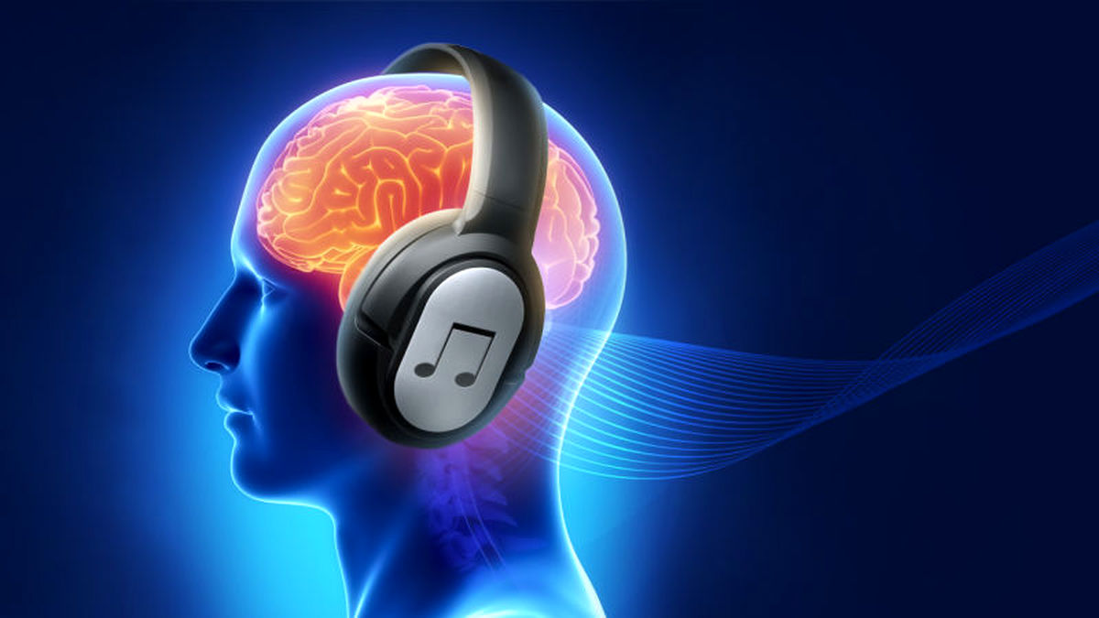
This Photo by Unknown Author is licensed under CC BY

E-portfolio
Donna Stock
2007575

Content page

Page 1
Cover page
Page 2
Content page
Page 3
Journal article
Page 4
Essay plan
Page 5
Library screenshot
Page 6
Library screenshot
Page 7
Summary of sources
Page 8
References

Task 1

Journal Summary: How does music make you feel?
Discussing the link between Music & Emotion.

In this article the writer reflects on their journey from A-level music studies to a final-year dissertation in their music degree. They start by acknowledging the impact music has on emotions, prompting questions about the criteria for music selection and the universality of emotional responses to specific compositions. They share their own personal experiences with specific songs and how they made them feel and how they connect them to a memory or feeling.

The Author explains his viewpoint while looking back as far as Pythagoras and gives us a further understanding on frequency ratios, octaves, pitch and tuning. They note other theorist and draw attention to the growing academic interest the relationship between music and emotion has on us. Accompanied to this they talk about various external factors such as the social context and whether the music is self-selected along with environment and how we are consuming the music. There are also internal factors, such as the listener’s emotional state or whether their listening motives are for positive or negative reasons, example's to get over a break up or to motivate themselves while exercising.
The writer goes on to discuss traditional notions such as the perception of major music as happy and minor music as sad, to delving into cultural influences on music perception during their Extended Project Qualification (EPQ) essay. The focus shifts to the emotional content of specific songs and albums, with a notable emphasis on the work of Patrik Juslin and the development of the BRECVEMA framework.
The study music-induced emotions through this framework and highlighting avenues for future exploration, particularly regarding individual differences and contextual factors. The narrative concludes by connecting emotional responses to music with applications in music therapy and consumer behaviour, inviting readers to introspect on their music consumption habits in the context of evolving technologies and personal preferences.

Task 2

Infographic: Time Management for students

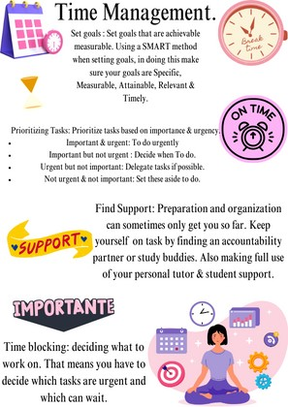

Task 3
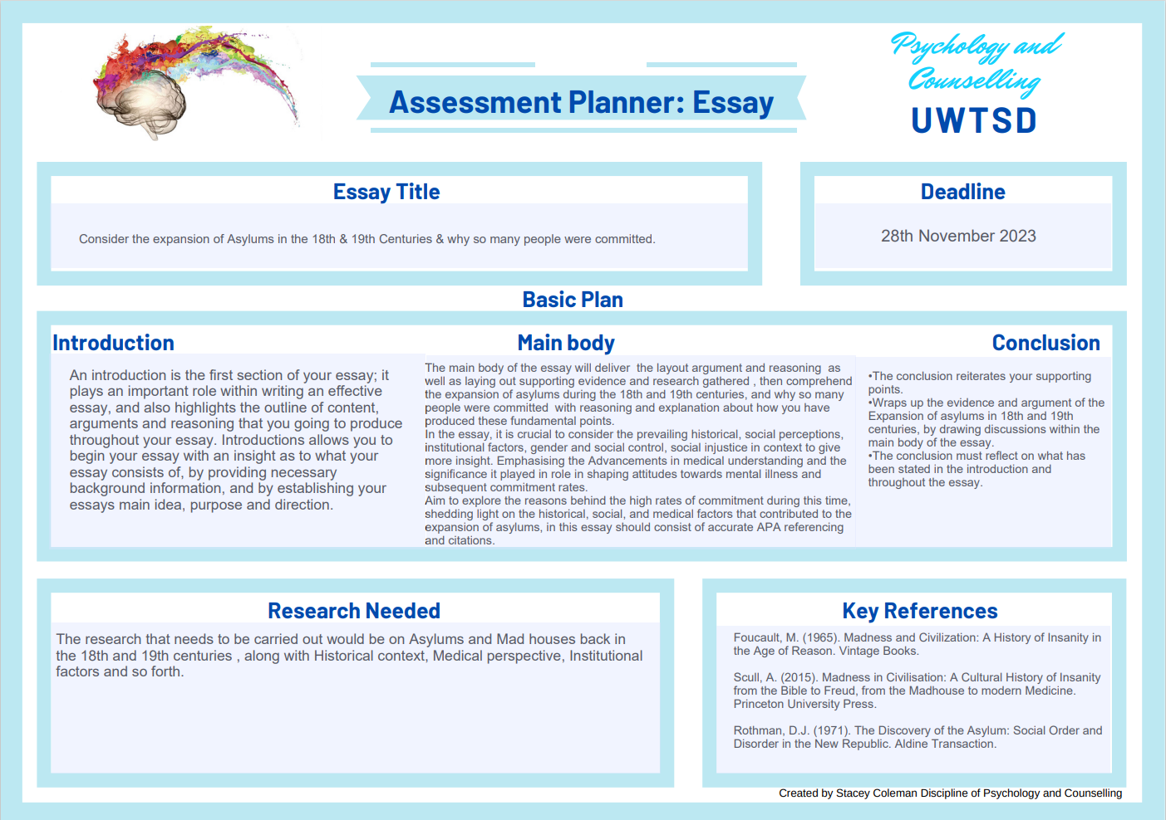

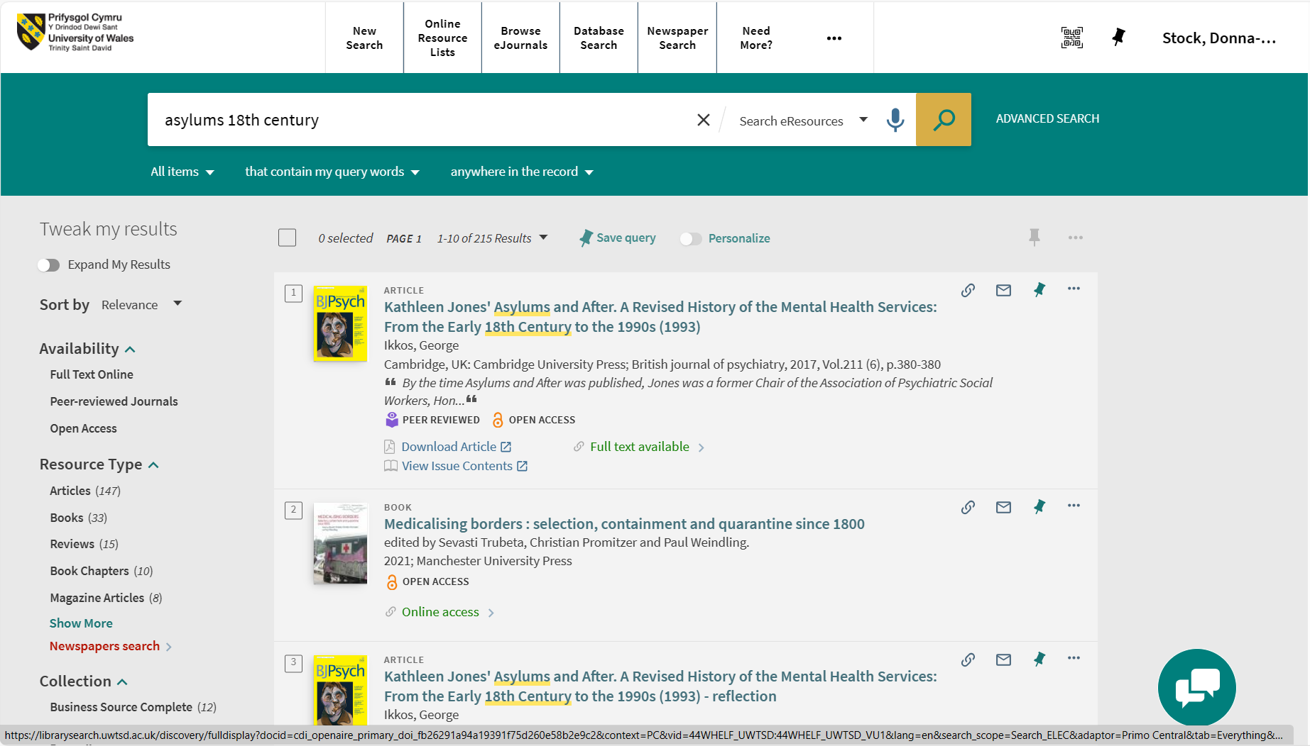

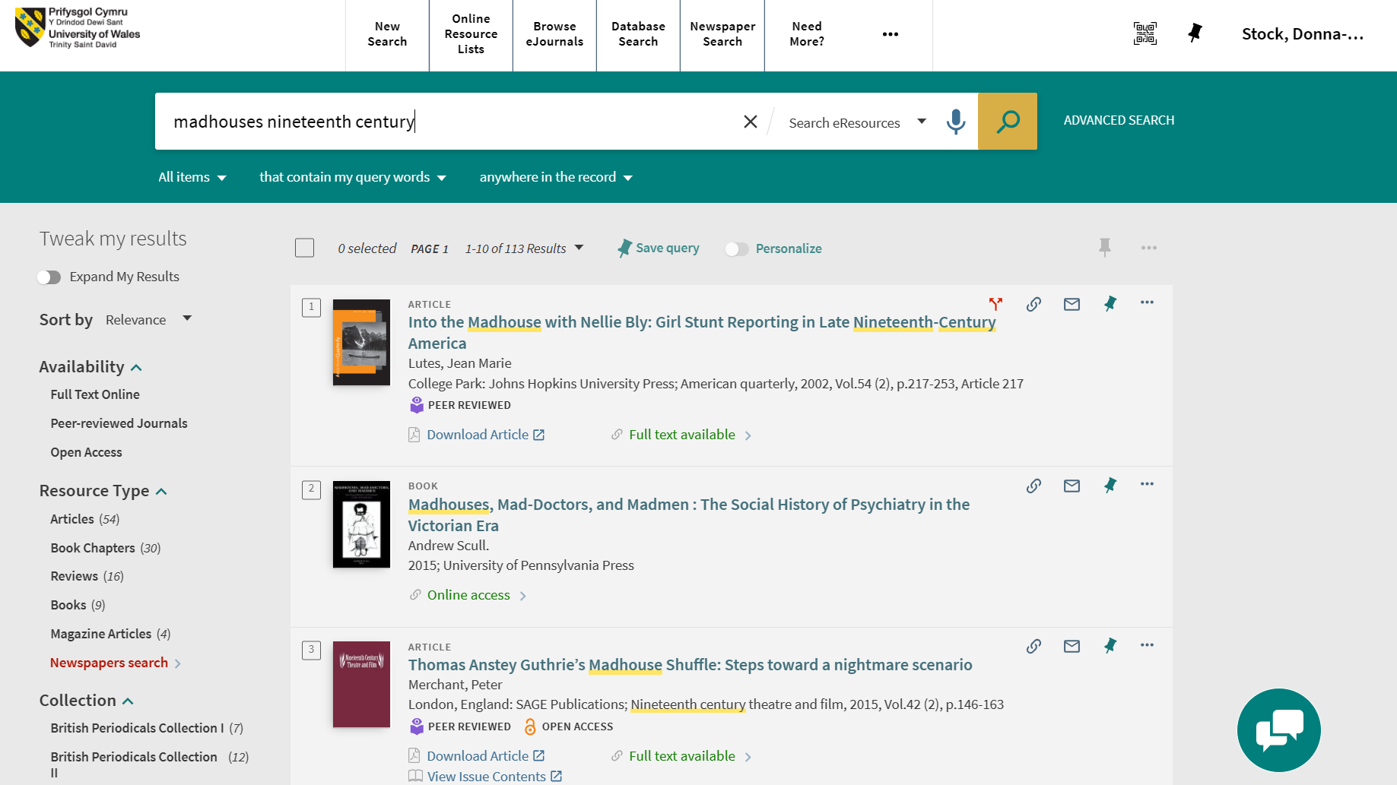

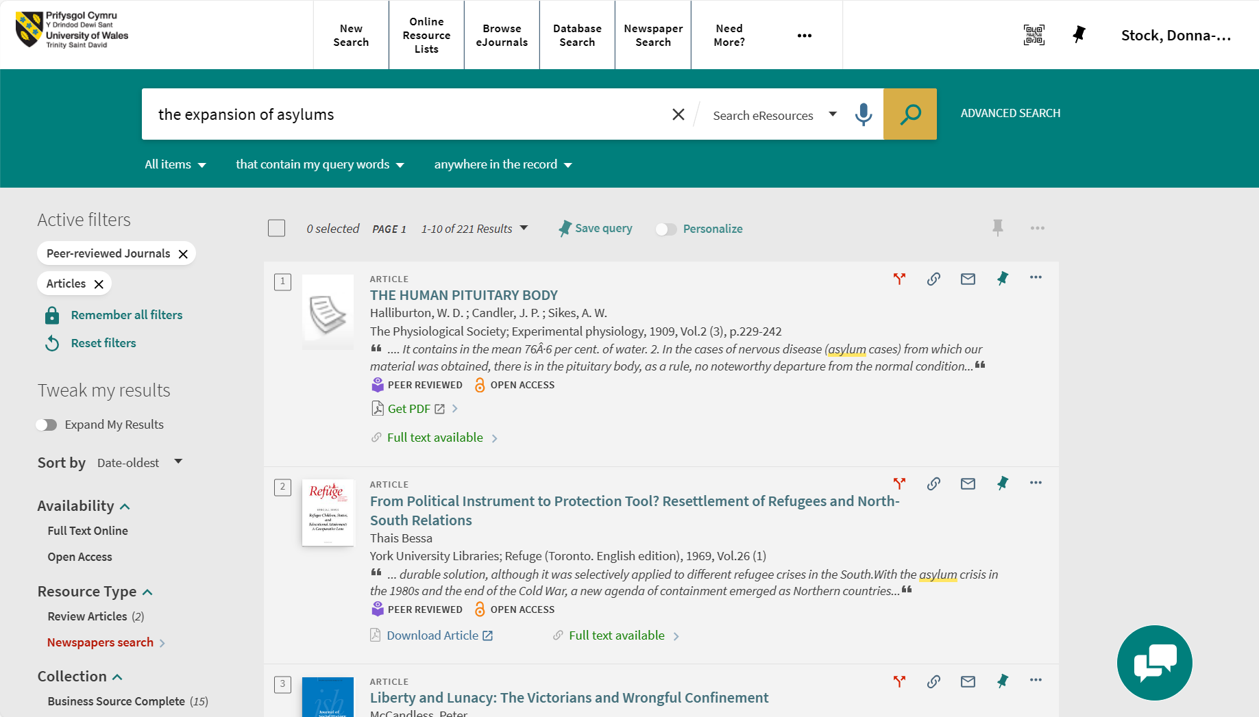

Summary of sources.
My research began by clarifying the specific information essential to my study. Subsequently, I established criteria to discern credible sources from less reliable ones. These criteria included evaluating the aurthors expertise, the accuracy, fairness, and currency of the information, along with its relavance to the topic. I actively sought sources from reputable outlets such as academic journals, articles, and specialized databases. Additionally, I scrutinized the publication venue and assessed the recency of the information. To ensure a comprehensive perspective, I integranted a diverse array of source types, prioritizing accessibility for my research.

References
British psychological society. (2022). How does music make you feel? The psychologist. http://www.bps.org.uk/psychologist/how-does-music-make-you-feel
http://corporatefinanceinstitute.com
http://summer.harvard.edu/blog/8-timemanagenment-tips-for-students
http://www.getclockwise.com/blog/time-blocking
Foucault, M. (1965). Madness and Civilization: A History of Insanity in the Age of Reason. Vintage Books.
Scull, A. (2015). Madness in Civilisation: A Cultural History of Insanity from the Bible to Freud, from the Madhouse to modern Medicine. Princeton University Press.
Rothman, D.J. (1971). The Discovery of the Asylum: Social Order and Disorder in the New Republic. Aldine Transaction.

