Coexistent ·Perspectives ·Essay
Coexistent ·Perspectives(ADCD7001)

The application of paradoxical spatial visual illusion art

Question 3 Space & Place

Name: Liu Yang
Student number:2200428

Submission Date:Tuesday, December 13th, 2022 Word Count:4134

Introduction
This essay will predominantly explore the works of M.C.Escher And USTWO company, using optical illusion art to create novel Spaces and locations, Thus, a pleasant mystical experience is brought about (Wang Lingzhong, 2005). Optical illusion is a kind of visual fantasy which is different from the reality caused by the visual system. It belongs to the category of visual perception and is also an indispensable part of visual art theory. It can blur the traditional concepts of space and location, creating an incredible sense of space and location. Mastering the application skills and rules of optical illusion in art design can make the design works more satisfying to the visual needs of people and achieve the purpose of better audience experience. Under specific conditions, artists use certain means to combine rationality and sensibility, thinking and perception, science and art, causing our distorted perception of objective things, but also bring us visual stimulation and psychological pleasure.

Escher was a Dutch graphic artist half a century ago. His prints often use geometric concepts, and he is particularly adept at the art of optical illusion.Escher's works reflect the subtle inner world, his reflection on the history of the time, and his desire to explore the mysteries of the cosmic order. Escher's printmaking technique is excellent enough to take full advantage of different techniques. He set up a distinctive style of printmaking with obvious contrast between black and white and precise lines. He also creates and interprets complex and fantastical morphing structures that subvert the laws of nature.
He was good at filling the space of the picture with repeated arrangements of figures, and even transformed the flat picture into a concave or convex sphere to make the perspective effect of the arrangement of figures more remarkable. He constantly challenged the boundary between plane and stereo, and even combined it with the technique of circular pictures, so that the audience could not confirm the beginning and end of the picture,
And get drunk on it.

Monument Valley cleverly uses the optical illusion principle of paradoxical space to create a realistic and realistic sense of three-dimensional space with a simple two-dimensional picture, creating a mysterious artistic conception space, which brings stimulating and pleasant game experience to the audience and enriches the audience's aesthetic needs.With the development concept of "See things in different angle", Monument Valley breaks through the traditional space restriction and the cage of rational vision, lets the masses walk in the huge architectural space full of illusions, creates a fresh and beautiful maze world, and quickly conquered the audience. Known as "The Art of The Impossible". The game takes impossible structure, paradox, cycle and plane Mosaic as design elements, and it can be seen that the pattern forms of mathematical concepts such as symmetry, fractal, hyperbolic geometry and polyhedron fill the whole picture, showing the unique visual charm of paradoxical space optical illusion art. If the story is the soul of the game, the paradoxical space optical illusion is the foundation of the entire game.

The misplaced beauty of Escher's art
The representation of a three-dimensional reality on a two-dimensional plane cannot avoid some visual error in the transformation of the two. Other hallucinations occur because an image violates a limitation based on our underlying prescription-based world（Secrel，2004）. It is these characteristics that Escher captures to create countless fascinating impossible worlds.

Exploration in perspective.The perfect application of unconventional perspective and the expression of spatial sense in his works are all due to his in-depth study of perspective. Escher's early works The Tower of Babel and St. Peter's Church in Rome fully reflected his in-depth study of the traditional Angle perspective. In 1946, he deeply studied the zenith as a vanishing point and made a woodcut We Shall Emerge.It is also a description of the mentality of oneself and the society after World War II.It can be seen from "Other world 1" and "Other world 2" that Escher was not satisfied with the study of traditional perspective.In fact, parallel perspective, looking up and looking down all have one thing in common, that is, there is only one vanishing point. If a group of straight lines are drawn to intersect a point, then the point can be either zenith, sky bottom or horizon point, Escher By using the commonality that all three are one-point perspective, Er drew three scenes with different perspective directions by using a vanishing point.

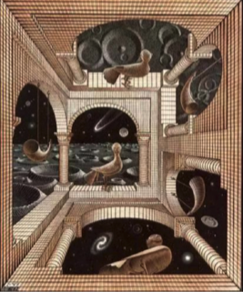
Figure 1.Escher,other world,1947

The birth of "Encounter" is also an important study of Escher in perspective. This most bizarre yet real picture looks very complicated and difficult to understand. In fact, the figures in it can be divided into three groups, one group is head up, the other group is head left, and the other group is head right. In fact, there are three different gravitational forces at right angles to each other, which means that one of the three main surfaces can be the ground, and Each group will be affected by one gravitational field, and only one.

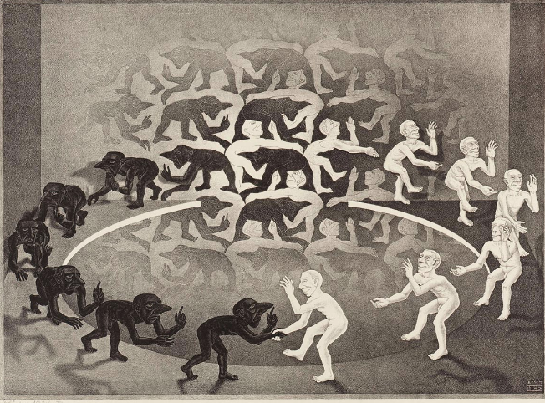
Figure 2.Escher,encounter,1944
Escher's most important innovation in the field of perspective is that he found that curves can reflect our feelings of space more directly and accurately than straight lines. However, Escher did not directly express this feeling in his works, but combined the relativity of the vanishing point to create High and Low. The reason for this picture is :1. All vertical lines are curved, and some horizontal lines are also curved. 2. All "vertical curves" radiate from the center of the picture. The bottom of the upper part of the picture is also the zenith of the lower part.

Coexistence World.Escher is like a child with a magic mirror, building his own magical new world. He seemed to be contained by the whole world, and seemed to contain the whole world. Use convex mirrors for art.Escher was not alone in his creation, but Escher's work on convex mirrors was absolute no accident, because he's always exploring the possibility of combining different worlds into one.And he made a lot of art about coexistence.In Escher's first important artistic creations, the use of convex mirrors accounted for the vast majority. The spherical works such as Still Life and Reflecting Ball and Holding Reflecting Ball in Hand also seemed to be a metaphor for the painter's own life. The mystery of mirror balls seemed to give Escher magical power After the Reflector, his work began to change. From the sphere of reflection, the blending of two worlds, to Dewdrop, Ripples,In "Three Worlds," each painting perfectly blends the three worlds of nature into one. If this is a possible world, then "Still Life and the Street" created in 1937.In this painting, the street and the desk are two completely independent and clearly identifiable real worlds, but in the picture, they are integrated in a completely impossible but very natural way. If it is seen as the landscape outside the window, then the houses become bookends and the pedestrians on the street become dolls. If you look at it as a street scene, the books seem to become houses, and a huge tobacco can stands at the crossroads. But in fact, the fit is pretty simple. Let us carefully observe together, we will find that the boundary between the windowsill and the street, in fact, there is no boundary, because of this so that the street and the windowsill formed a body.
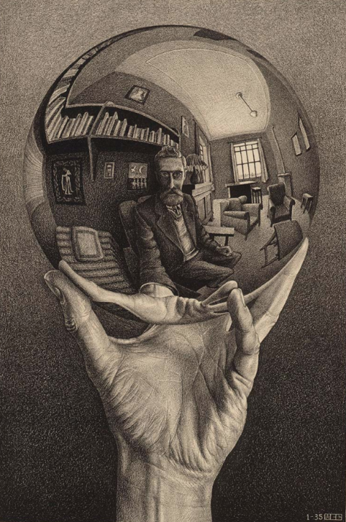
Figure 3.Escher,Hand with Reflecting Sphere

In Escher's artistic creation after the age of 60, we can feel that he has a deeper vision, skillfully uses the space of contradiction, and lets his works enjoy the game in the three-dimensional space. During this period, he made full use of the characteristics of the infinite circulation of Mobius belt and the impossible connection of Penrose Triangle to create the most fascinating impossible world, which is also the most interesting kind of works to me.

The three-dimensional world can be projected onto the two-dimensional picture, but the image in the two-dimensional picture may not be true in the three-dimensional world. The 1958 lithograph Beltway looks like a projection of a building, but the building in the picture is an impossible existence. First, in reality, the ladder built on the inside of the first floor cannot lean against the outside wall of the second floor as shown in the picture. Second, when the columns of the upper and lower floors are all connected, the axes of the upper and lower floors are at right angles to each other. In fact, Escher is the most rational artist, each work can be found the corresponding scientific basis, he has a large number of creative manuscripts, in the Beltway, the cube projected in the two-dimensional picture, the concept of the cube can be realized in the two-dimensional picture. A cube structure on a plane, which can represent either an overhead or an upward-looking projection of reality. Impossible cube The cube can be divided into two parts, the front and back of the top half and the front and back of the bottom half contradict each other, with different perspectives. When we view the top quadrilateral as an uplook pattern the bottom quadrilateral as an uplook pattern, and when we view the top quadrilateral as an uplook pattern the bottom quadrilateral as an uplook pattern. In the cube structure of the two-dimensional plane, there are two places where the structure lines cross, and only one of the crossing places needs to be correctly reversed to obtain the impossible cube with the opposite perspective of Escher (BrunoErnst,2002).

Escher drew inspiration from Penrose Triangle in his work Waterfall. There were three connected poles in his sketch. After a lot of research, he chose waterfall to show the absurdity of the three poles. The path of the waterfall cycle seems to be a perpetual motion machine, where the waterfall begins and ends, and the highs are relative to the lows. The moss-covered plants in the picture strengthen the weirdness, while the houses and the ground around the waterway weaken the weirdness and absurdity, making the picture both harmonious and absurd.

The lithograph Gallery created in 1956 is one of the most influential works in the field of mathematics. Escher has unparalleled intuitive ability for mathematical concepts (Escher, 2003). The effect we see in Gallery is very similar to the infinite image one sees in a barbershop mirror. Escher showed his obsession with infinity again, after trying the infinity in the heart, the infinity in the edge, the infinity in the loop, the infinity in the sphere and the infinity in the tile. Escher instinctively prepared to achieve his goal of painting within painting. Escher's idea was to enlarge the painting along the sides of the border. To achieve this, Escher designed a loop deformation grid. Starting with the young adult part, it gradually enlarges until it becomes four times the original size. Then gradually zoom in by a factor of four to the far right, gradually zoom down by a factor of four, and finally zoom in by a factor of four to get back to where we started. It's 256 times larger, and it took a lot of effort to design this grid, and it took a lot of effort to straighten it out to meet his own requirements. In it we see the most famous Riemann surface, an abstract structure with a hole in the middle. Enthusiasts will see pictures of black holes, Yin and Yang, even the wave-particle duality of matter in the Riemann curve. They see eternity in it.

The beauty of reason. In Escher's works, both the purpose and the technique are very rational. In his artistic creation, it can be seen that he pays great attention to the aesthetic sense of form. Each work has a complete composition and a rigorous structure, and the image depiction in the picture is very accurate and clear. Escher's paintings are in line with visual aesthetics and can withstand careful scrutiny. No matter what kind of art form, the pursuit of conveying the real feelings in one's head through the picture is the most proud thing for artists. However, Escher managed to convey his thoughts through the combination of rational and emotional feelings To construct beauty? By using some strange and familiar objects such as concave mirrors, prisms and pinhole cameras, he could not describe them with words or words through perspective depiction, but painting gave him the opportunity to highly integrate these understandings of three-dimensional space into the picture. Regardless of art or science, technology or emotion, Escher really gave full play to the ultimate rational beauty in his paintings. His works can also make the audience see or feel his rational side. Escher's exploration and application of spatial logic in the creation process make his pictures give people an unprecedented aesthetic feeling of spatial logic. He will make a very logical and rigorous architectural form to attract you, you will walk in the space he made, explore, but as you go, you will find more and more confused, like a dream, those buildings completely subvert your cognition. Escher is using our knowledge itself to question the reliability of knowledge, revealing the internal logical relations of things through rationality(Asensio P，2000), and at the same time letting readers feel and experience the amazing beauty in contradiction. The study of mathematics and topology makes the picture full of mystery.

The beauty of sensibility. Escher seems to have always been associated with mathematician, scientist and even psychologist as the ultimate rational identity, but as a successful artist, he must also have his own unique and delicate emotional presence. As far as the audience and artists are concerned, artists have a high ability of visual integration. They know how to integrate the perception of various things with different attributes into a whole, and they know how to arrange the picture to be more acceptable and avoid visual fatigue, which is also the intuitive feeling of artists. However, as far as the audience is concerned, the contradictions and inconsistencies presented in the picture make them difficult to swallow and cause discomfort. Many artists' works and the audience cannot perceive each other because of this, but Escher is a veritable wise man. He lived in an era when science was constantly being innovated and discovered, but Escher did not blindly carry out scientific discoveries Directly into his own creation, the reason why he is a wise man is that Escher did not push scientific research out of the door with his own wisdom and keen thoughts that artists should have. Instead, he conducted artistic exploration with a conscious or involuntary scientific objective attitude to deal with the object of research, and followed the principle that the world is a harmonious system to study and explore the object It is precisely because of his wisdom and scientific principles that he created numerous exquisite, harmonious and orderly pictures, which are full of emotions. For him, science is a way to help him achieve his artistic pursuit. Just because of this, Escher has attracted high attention from all sides. Many artists and scientists have their own unique interpretation of his works of art. In spite of this, in fact, Escher is a self-deprecating person who makes people feel that he is too self-deprecating. However, for this reason, combined with his creation notes, we can also feel that Escher, like every artist who cares about the pursuit of art and has achieved great achievements, is aware of the universe and life. When creating, he does not put himself above the nature, but the nature and the universe With reverence, the only difference is that Escher has his own yearning for science. From a certain point of view, his paintings show us a world that painting cannot bear. He uses scientific methods and his own practice to discover various special possibilities, deduces practice step by step, and finally chooses art forms and artistic habits to express emotions and ideas instead of imagination. The concrete form he presents, he says, is the abstract transformation of what he knows and knows（Jacqueline B，1975）. Escher's paintings change people's traditional viewing mode, always conceals his desire to realize the strong visual impact, and his paintings also challenge people's visual observation. Even in today's digital world, his paintings always show special beauty, unique lyrical beauty with mathematical delicacy. He gave full play to his unique harmonious beauty of science and art, as well as the coexistence of sensibility and rationality. Like every excellent artist, he always gave full play to his perfection in some aspect, and won sincere praise and admiration from everyone. He also dedicated priceless visual arts feast for everyone and countless paintings opened the door of sensibility and rationality, science and art for us ".

Monument Valley “See things in different angle”
When Monument Valley first came out, people were captivated by the advanced color palette, poetic atmosphere, and surreal architectural structure of the game interface, as well as the clever design of walking against gravity, portals, folding, spiraling, nesting, mirroring, and more. "We borrowed from M.C.," game designer and visual designer Ken Wong says of the initial design inspiration Escher's style, made a lot of impossible structure, so in the game can see many of Escher's classic optical illusion works restoration. (Zhu Cuifeng, 2010)"

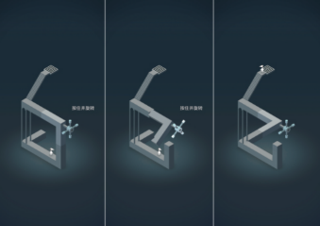
Figure 4.The interface of Monument Valley

Penlos triangle.The Penlos triangle, described as "impossibility in its purest form", is the impossible realization of triangular objects. Its properties cannot be realized in any normal three-dimensional object. Its impossibility comes from spatial juxtaposition: each corner is normal, and together it creates a contradiction. The level of Monument Valley, on the other hand, transforms it into a time series. For example, in the first scene of the opening, there is only an S-shaped three-dimensional structure, which can be changed by turning a button to form a W, so that the hero can successfully reach his destination. In this seemingly simple structure, we add two auxiliary lines in the S shape and the W shape respectively before and after the change, and we will find the Penlos Triangle puzzle hidden in it. The first chapter of Monument Valley 2 also borrows from the Penrose Triangle principle and clearly illustrates the clever combination of the capstan and Penrose Triangle. A careful observation of the relationship between the winch controlled corridor and the ground will find that the step on the ground at the lower right corner covers the intersection of the corridor and the floor, creating the illusion that the corridor and the step are on the same plane visually, but in fact the corridor is on the same plane with the floor. And use the same color number to make it perfectly inlaid -- this makes a clear difference between the optical illusion of Monument Valley and the static Penlos Triangle, allowing the audience to feel the unique optical illusion art experience more directly.

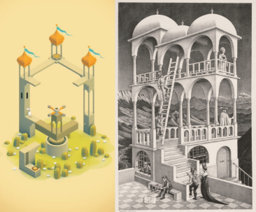
Figure 5.In Monument Valley “Lost Falls” versus “Observation Deck”

Necker Cube.The game also uses the "Necker Cube" optic error principle, that is, the "impossible cube" created by using different connecting points of the cube. It was designed by Necker, a Swiss naturalist, in 1832, to show that the visual understanding of the transparent cube can be different. The plane with diagonal lines can be in front or behind. Form "tuning fork optical illusion" pattern. These principles have been applied and developed in graphic design. In Chapter 5, Lost Falls, this principle is cleverly used in the design, which is also closely related to Escher's The Lookout. In Lookout, when viewers look closely at the column in front of the staircase of the observation platform, they will find that the connection point of the column originally in front of the observation platform is actually in the rear, while the connection point of the rear column is in the front. In real life, this impossible building makes the audience believe it through the optical illusion effect. In the picture of Lost Falls, there are similar ladders and similar structural models to construct the structural model of "tuning fork optical illusion" (Lampugnani, 2000). However, slightly different from Escher's works, Monument Valley does not use a lot of perspective to reflect the contradictory space, but uses shading and shadows to better realize the dynamic contradictory space.

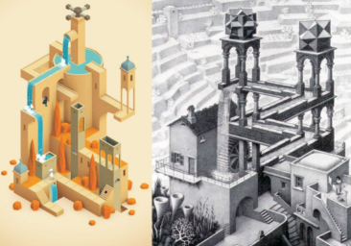
Figure 6.In Monument Valley “The Quiet Courtyard” versus “The Waterfall”

Mobius Ring.In Monument Valley, the Mobius ring also appears in a variety of deformed structures, such as the convex ground that distorts the gravitational field. A quarter of a circle of curved ground is often present in the game, and either the protagonist, Carol and her daughter or Ada, can change from standing vertically to standing horizontally by distorting this structure, distorting the direction of gravity in the picture, which does not exist in reality. In fact, in addition to the arched floor, the gallery design that can be twisted is also borrowed from the Mobius ring. The perpendicular corridor at a 90° Angle is impossible to distort in reality, but in the game, not only the direction of gravity changes, but also the corridor structure twists like a twist, making the original single building more aesthetic and visual impact.

Escher's Theory of Relativity.As the original design inspiration of the game, Escher's works are restored in many architectural designs in the game, and many of the chapters can be regarded as the perfect use and combination of geometric art in Escher's works, reflecting the concave and convex illusion, mirror illusion and other optical illusion effects.
. In the game, players can break through the inertia of thinking and make the protagonist Ada walk on any side of the building through "click", "slide", "rotate" and other operations to get out of the illusion dilemma. This is surreal, but it makes perfect sense in the picture. Let the audience have a more comprehensive understanding of the relative optical illusion caused by contradictory common usage and graphic mixed dimension, and feel the incredible optical illusion art.

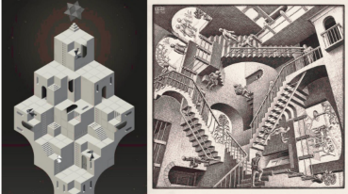
Figure 7.In Monument Valley "The Castle of Illusion" versus "Relativity"

Conclusion
Illusion art is to lead people from two-dimensional like three-dimensional exploration, is a bold attempt of space and location. The main results obtained through the theoretical research and practice of optical illusion art are as follows: first, classic art is enduring, and the application of classic optical illusion art in game visual design has certain application value, and has certain guiding role in visual communication design. The second is to learn more about the deep relationship between philosophy, art, psychology and aesthetics when sorting out related materials of optical illusion art. Based on aesthetics, the key to making a design classic lies in its rich content, and I have a deeper understanding that aesthetics is an indispensable bridge of communication between philosophy and art (Gombrich,1980). Two of them prominent representatives are Escher and Monument Valley.

Throughout his life, Escher built a bridge between art and science. As a rational man, he always had an interesting soul in his body. Through the most rational analytical thinking, he expressed the complex mathematics in the form of art in the most understandable and interesting way. He gave full play to the artistic expression of the illusion contradiction space.
The reason Monument Valley has done so well, both commercially and for consumers, is that first of all, it takes and redesigns a great classic. It is through the use of Escher's art that the game has achieved what it is today. Secondly, we should take the essence and discard the dross of traditional classical art. Although the graphic design of Monument Valley is based on the classic works of Escher, it does not copy, adhere to the old fashioned, but refines Escher's art to form its own minimalist game style. And the use of modern multimedia technology to Escher's single color of black and white art into another form of rich color collocation, using the soil environment provided by Escher's art works, in the game opened a gorgeous flowers.

References

Psychology of Visual Art [M]. People's Fine Arts Publishing House, Wang Lingzhong, 2005
Visual Games [M]. Hainan Publishing House, (UK) Secker (Secrel, 2004）

The Magic Mirror [M]. Shanghai Science and Technology Education Press, (BrunoErnst, 2002)

Escher Master Atlas [M]. Shaanxi Normal University Press, [(He) Escher (M.C.Escher) painting], 2003

Study on Gombrich's Theory of Aesthetic Illusion [D]. Zhu Cuifeng. Shandong University 2010

Lampugnani.New simplicity-A thought on architecture in the new millennium[J].Time Architecture.2000(2):48

Gombrich,E.H.Art and Illusion A study in the psychology of pictorial representation[M]. Phaidon,Oxford,1980.

Aristotle.Metaphysics[M].New York:Cosimolmc,2008:13.

Ekman. Conversations with Goethe [M]. Translated by Huang Mingjia. Beijing: China Children's Publishing House, 2000:336.

Li Zhi-xuan. Research on Escher's Illusion Art [D]. Xiangtan: Xiangtan University, 2014.

Asensio P.Minimalist Interiors[M].New York USA:Hesrst Book,2000

Ronald G.Carraher,Jacqueline B.Optical illusion and Visual Art [M].1975

Li Qing. The Application of Optical illusion in Design [J]. Art of Design, 2001

List of Illustrations

Figure 1
Escher,other world,1947.Available at
https://www.escherinhetpaleis.nl/showpiece/other-world/?lang=en

Figure 2
Escher,encounter,1944.Available at
https://www.escherinhetpaleis.nl/showpiece/encounter/?lang=en

Figure 3
Escher,Hand with Reflecting Sphere,1935.Available at
https://www.escherinhetpaleis.nl/showpiece/hand-with-reflecting-sphere/?lang=en

Figure 4
The interface of Monument Valley

Figure 5
In Monument Valley “Lost Falls” versus “Observation Deck”

Figure 6
In Monument Valley “The Quiet Courtyard” versus “The Waterfall”

Figure 7
In Monument Valley "The Castle of Illusion" versus "Relativity"

