Assignment Title: Design, Implementation and Evaluation of a Virtualised Enterprise Network
Module Name: Network Operating Systems and Services
Module Code: ACCA5023
Student name: Fatima Lo
Student ID: 2421636

Table of Contents
TASK 1 – RESEARCH REPORT 3
1. Introduction 4
2. Hypervisor Analysis & Justification 4
2.1 Hypervisor Types (Type 1 vs Type 2) 4
2.2 Selected Hypervisor: VirtualBox 5
3. IP Addressing & Subnetting Analysis 5
4. Routing Approach Analysis 6
5. Network Services Overview 6
6. Task 1 Summary 7
TASK 2 – TECHNICAL DOCUMENTATION 7
7. Virtualisation Environment Setup 7
8. Virtual Machine Deployment 8
9. Network Design & Configuration 10
10. IP Addressing Implementation 11
11. Connectivity Testing & Troubleshooting 14
TASK 3 – REFLECTION 15
12. Technical Reflection 15
13. Personal & Professional Reflection 15
References 16

List of Figures
Figure 1 Logical IP addressing and subnetting diagram 6
Figure 2 Installation Virtual machine 8
Figure 3 Network adapter configuration to windows server 2022 9
Figure 4 Development of the Debian Server virtual machine in Oracle VirtualBox 9
Figure 5 Making the windows server 2022 virtual machine on the Oracle VirtualBox 10 10
Figure 6 Network adapter settings of the Debian Server virtual machine of the same Internal Network (NOS_INTERNAL) 11
Figure 7 Network adapter configuration of the windows server 2022 virtual machine over the Internal Network (NOS_INTERNAL) 11
Figure 8 Debian Server date and time shown to confirm the date and time when the system was configured 12
Figure 9 Checking the IP configuration of Windows Server 2022 through ipconfig command, with timestamp visible 13
Figure 10 Checking the IP configuration of the Debian Server with ip a command 13
Figure 11 authentication of windows server 2022 IP setting 13
Figure 12 Static IP configuration file on Debian Server with the IPv4 addresses assignment. 14
Figure 13 ping test Failure in pinging to another network through the Debian Server, 14 proves correct network isolation 14
Figure 14 Successful ping testing between the Debian Server and the Windows Server 15

TASK 1 – RESEARCH REPORT

1. Introduction
The scenario of this report is NOSSLOND2026 which is a small network of enterprise constructed with the use of virtual machines. The network is setup in virtual environment rather than on the use of physical servers just as it is done in contemporary organisations. Virtualisation is cost-effective and less complicated to manage the systems.
This report aims to describe the research of significant networking decisions. These are decisions such as the selection of the hypervisor, IP addressing design, routing strategy and network services. The study offers justifications of choice of technologies and practices. The practical network setup done in Task 2 is also supported by this research. Through making the research and practice connected, the report demonstrates how the planning and implementation of a simple enterprise network can be conducted in an organized and efficient fashion.

2. Hypervisor Analysis & Justification

2.1 Hypervisor Types (Type 1 vs Type 2)
The initial action in the development of an enterprise network is the selection of the hypervisor. A hypervisor can be defined as a type of software, which uses the hardware of the host computer to execute virtual machines and permits the coexistence of several virtual machines running on the same physical machine. Hypervisor is divided into two major categories, that is, Type 1 and Type 2 hypervisor. Type 1 hypervisors run directly on the computer's hardware and not on top of an operating system. This means that they have better performance and better security compared to Type 2 hypervisors. This type of hypervisor is mostly used in large enterprise data centres (Aliev, Gazul and Bobova, 2023).
Type 2 hypervisors are installed on an existing operating system such as Windows. They are easier to install and use, especially for personal computers. However, they are dependent on the host OS, which may slightly affect their performance and security. Nonetheless, Type 2 hypervisors are extremely useful for testing purposes, learning, and small enterprise computer networks (Alshawki et al., 2022).

2.2 Selected Hypervisor: VirtualBox
VirtualBox is chosen as the hypervisor of this network. This option is appropriate since VirtualBox can be run using a normal hardware like a student laptop. It is compatible with Windows Server 2022 and Debian Server, both of which are needed when using this network (Alshawki et al., 2022). Virtual machines are also created and managed easily in VirtualBox and this assists in future expansion of coursework. Security and management VirtualBox has sufficient control and isolation to provide as a small enterprise solution.

3. IP Addressing & Subnetting Analysis
IP addressing is an important aspect in computer networking since it helps devices to recognize each other in the network. It helps to ensure that data reaches the intended destination. Therefore, each device is assigned an IP address to ensure the data reaches the intended destination (Bahri et al., 2025). When data is being sent to the destination, the data is divided into smaller parts called data packets. These data packets contain the IP address of the sender and the IP address of the receiver. Therefore, the data reaches the destination accurately.
IP addressing uses two versions: IPv4 and IPv6. IPv4 uses 32-bit IP addresses written in dotted decimal notation. An example of an IP address using IPv4 is 192.168.1.1. IPv6 uses 128-bit IP addresses written using both alphabets and numbers. IPv6 is used to replace IPv4 since the number of IP addresses generated by IPv4 is limited. The IPv4 addressing system is not sufficient for large computer networks (Arogundade, 2023).
Sub-netting helps to segment the network into smaller sections, thus enhancing performance and regulating traffic flow. Effective use of IPs helps to avoid wastage and accommodate expansion. When the enterprise networks are well designed with the IPs, the networks are easier to maintain and manage.
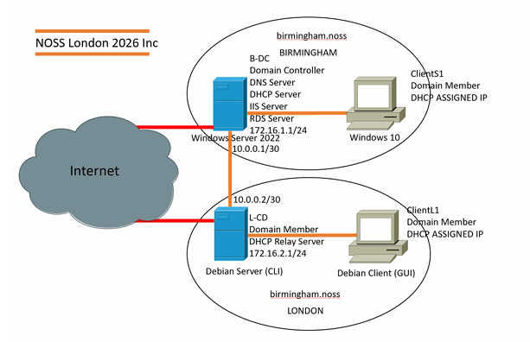
Figure 1 Logical IP addressing and subnetting diagram

4. Routing Approach Analysis
The process through which the data is passed across different networks is referred to as Routing. A router lays a comparison between the destination IP address and routes data to go through the proper route. Routing can be under two primary routing methods that are dynamic routing and static routing. The configurations of the static routing are manually set and stay in place unless altered by the administrator. It is easy to administer and it is suitable in small networks (Binu and Rubini, 2026).
Dynamic routing involves routing protocols which are used to automatically reconfigure routes as network changes occur. Although this approach is practical in big and complex networks, it is more resource-intensive and official. In the case of the topology provided, it is better to use the option of static routing since the network is small and not dynamic. Under this setup, the Debian Server will perform DHCP relay and that must have routing behaviour which is predictable (Đorđević et al., 2022). This is because the routing can precisely control and give uniformity of routing to the windows server (static routing).

5. Network Services Overview
Management of users, devices, and security in an enterprise network makes use of network services. A Virtual Private Network (VPN) assists users to connect a network remotely in a safe manner by encrypting data. This helps protect data from unauthorized access. Dynamic Host Configuration Protocol (DHCP) automatically assigns IP addresses to devices. This eliminates errors in address configuration, which could have been time-consuming (Haseeb, Talpur and Abro, 2022).
Active Directory Domain Services (AD DS) is used for central management of users and computers. This helps in improving network security and organization. Certificate Authorities (CA) are used for issuing digital certificates. These certificates are used to establish trust between two systems. Best practices in an enterprise network are using secure authentication, central management, and access control to network resources (Isyaku et al., 2022).

6. Task 1 Summary
This research discussed key networking concepts used in the NOSSLONDON2026 scenario. t described the choice of the hypervisor, IP addressing strategy, routing strategy, and network services. The study indicated the reason why Windows server 2022 and Debian server could be run on small hardware using VirtualBox. It also emphasized that a good IP design and routing is a factor that provides a reliable communication. Services of networks were checked to demonstrate their position in enterprise settings. This study was a direct influence in the technical choices that were made in Task 2; the network was carried out in orderly and efficient manner.

TASK 2 – TECHNICAL DOCUMENTATION

7. Virtualisation Environment Setup
The Oracle VirtualBox was selected as the hypervisor in which a virtualised environment was created. VirtualBox was selected as it is stable, simple to use and can be run on the normal desktop hardware. It helps in supporting windows and Linux operating systems, which are necessary in this network set up. The results of Figure 2 show that VirtualBox is properly installed on the host system (Jacob, 2024).
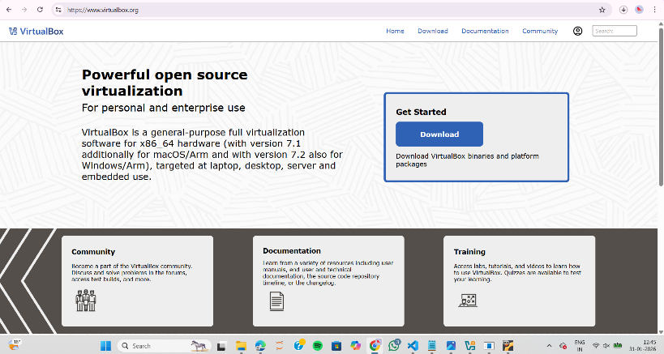
Figure 2 Installation Virtual machine
The host machine where such deployment will take place is a windows-based computer which has sufficient memory and processing power to run several virtual machines at a given time. Virtualisation allows a variety of servers to be used on a particular hardware which reduces hardware cost and increases flexibility. It is also easy to test and configure without compromising a running system using this approach. Virtualisation can be applied in enterprise settings to do both development and training; thus, it will be appropriate in the current course work and in the future network extension (Jagannath, Ramezanpour and Jagannath, 2022).

8. Virtual Machine Deployment
Two virtual machines were developed in order to facilitate the functionality of the proposed enterprise network environment. Win server 2022 is the first virtual machine that will be developed in the environment and it will be bringing the windows server environment to the network. The second virtual machine that will be established in the environment is DEBIAN-SERVER that will be the Linux environment of the network. Figure 3 and Figure 4 represent the creation of the virtual machines of the environment.
The virtual machine environment has been named appropriately to represent the operation of an enterprise environment. The name chosen for the virtual machine represents the environment being simulated, which makes the process simpler for the operation of the environment. The name convention for the virtual machine environment is illustrated in Figure 4 (Jagannath, Ramezanpour and Jagannath, 2022).
Windows Server 2022 was chosen because it supports enterprise services such as Active Directory and DHCP. Debian Server was chosen because it is light and stable, making it appropriate for a server environment (Venu et al., 2022). Appropriate resources were assigned to each virtual machine depending on their functionality. More resources were assigned to the Windows Server than to the Debian Server because it runs server services. The Debian Server was assigned enough resources to run network-related services.
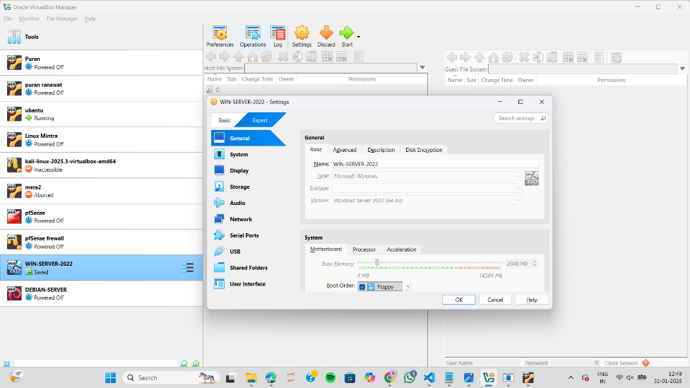
Figure 3 Network adapter configuration to windows server 2022
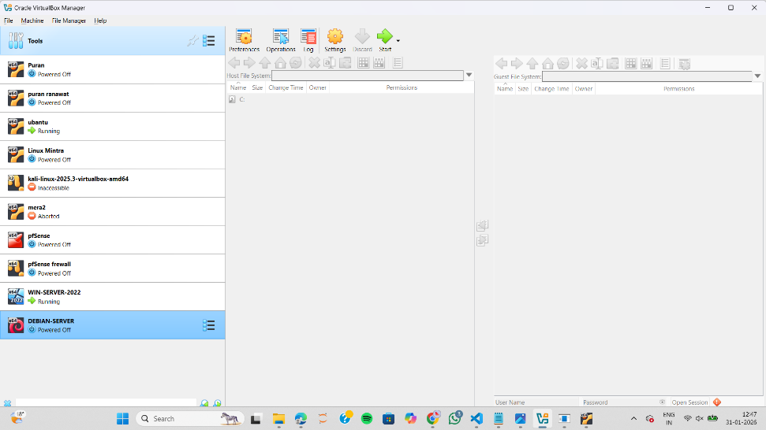
Figure 4 Development of the Debian Server virtual machine in Oracle VirtualBox
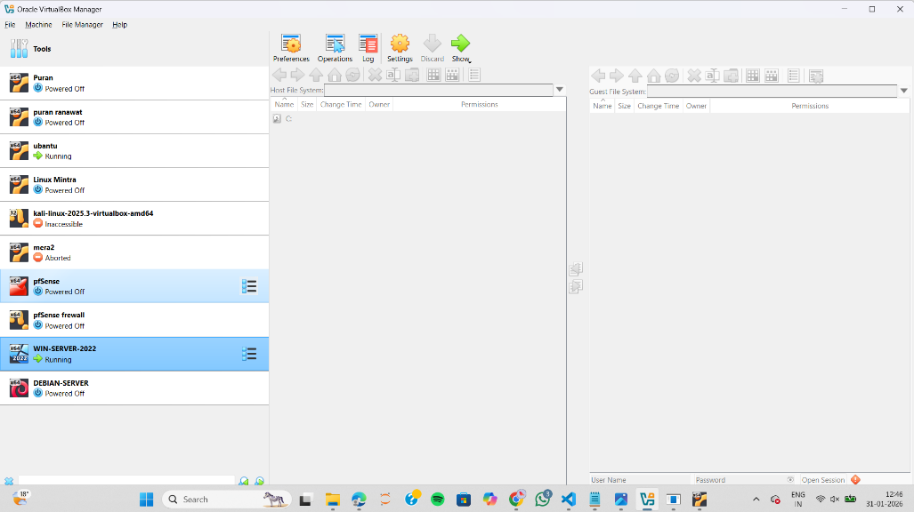
Figure 5 Making the windows server 2022 virtual machine on the Oracle VirtualBox 10

9. Network Design & Configuration
The network was designed with a logical internal network that would allow the virtual machines to communicate with one another safely. VirtualBox was applied to create an Internal Network named NOS_INTERNAL and which would be used to connect the Windows Server and Debian Server. The design will ensure that the servers are able to communicate with one another but not have any connection to external networks (Kodakandla, 2023).
The network adapter for WIN-SERVER-2022 was configured to use the Internal Network as shown in Figure 6. This will ensure that the Windows Server is connected to the enterprise network internally (Tymoshchuk and Yatskiv, 2025). The network adapter to DEBIAN-SERVER was set to utilize the same Internal Network as Figure 7 shows. This will make sure that it will be able to communicate with the windows server.
This design for the network follows the topology given. It is also appropriate for a controlled environment for an enterprise. The use of an internal network for this design improves security since access is restricted. It also makes it easier to test the network since the behavior is predictable (Lyu, Gharakheili and Sivaraman, 2022). The design also accommodates future expansion, such as adding servers in the coming coursework.
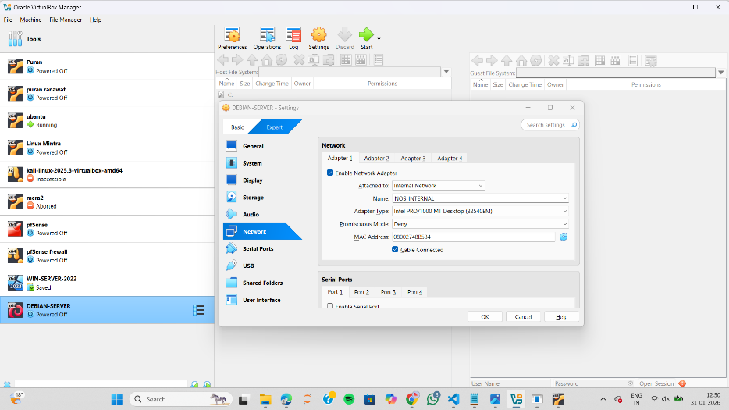
Figure 6 Network adapter settings of the Debian Server virtual machine of the same Internal Network (NOS_INTERNAL)
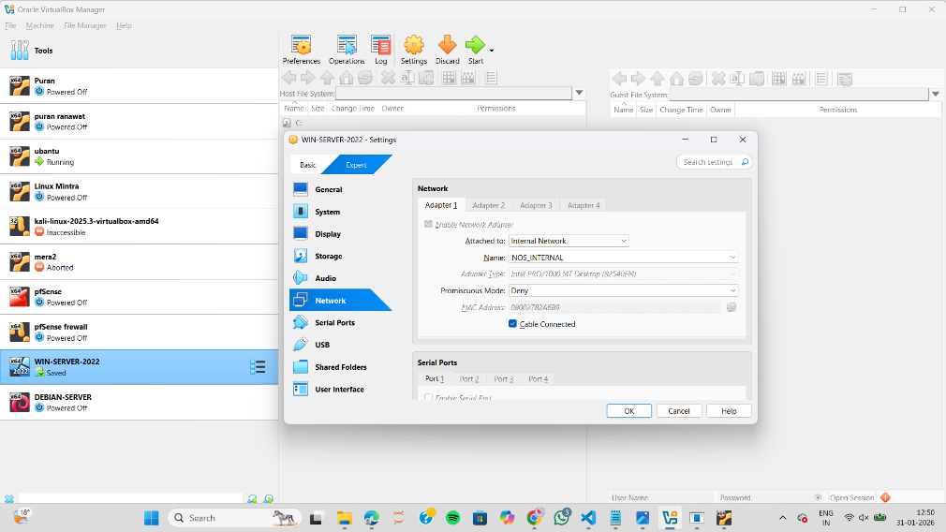
Figure 7 Network adapter configuration of the windows server 2022 virtual machine over the Internal Network (NOS_INTERNAL)

10. IP Addressing Implementation
In this task, custom IP addressing technique was employed in order to make the internal enterprise network communication efficient among the servers. To this end, a private network address range of 172.16.1.0/24 was selected because it is apt in usage as an internal network and it is easy to manage. This address range provides sufficient addresses to support the current number of servers, while it can be expanded if the need arises (Thyagaturu et al., 2022). For this task, the IP address of the Windows Server 2022 virtual machine was assigned the address 172.16.1.1, while the Debian Server virtual machine was assigned the address 172.16.1.2. In this IP addressing scheme, the subnet mask of 255.255.255.0 was used to define the network and host parts of the IP address.
This design of addressing is based on VLSM since a single subnet was utilized in this small topography that will assist in saving on the consumption of IP addresses. A fixed IP was assigned to each server so that there was constant communication and the network behaviour is predictable. The significance of using static addressing in an enterprise environment is that the servers need to always be reachable at the same address (Okoh et al., 2024).
The Windows Server IP was configured to accept the IPv4 settings that was manually configured as Figure 8 and tested with the help of ipconfig command as Figure 9. Figure 10, and Figure 11 shows that Debian Server IP was configured through editing network configuration file and validation of the IP a command through ip a command. The timestamps of Figure 12 will confirm that configuration was done during the normal working time (Ramirez, Huang and Liang, 2022).
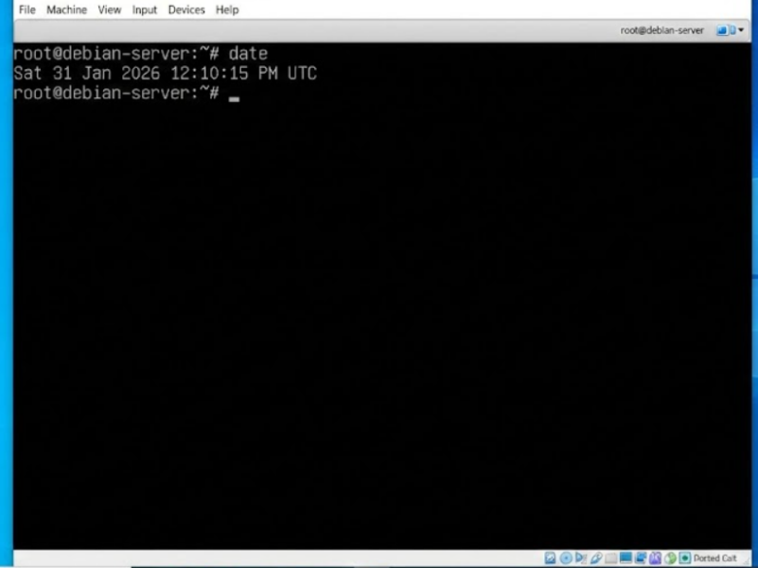
Figure 8 Debian Server date and time shown to confirm the date and time when the system was configured

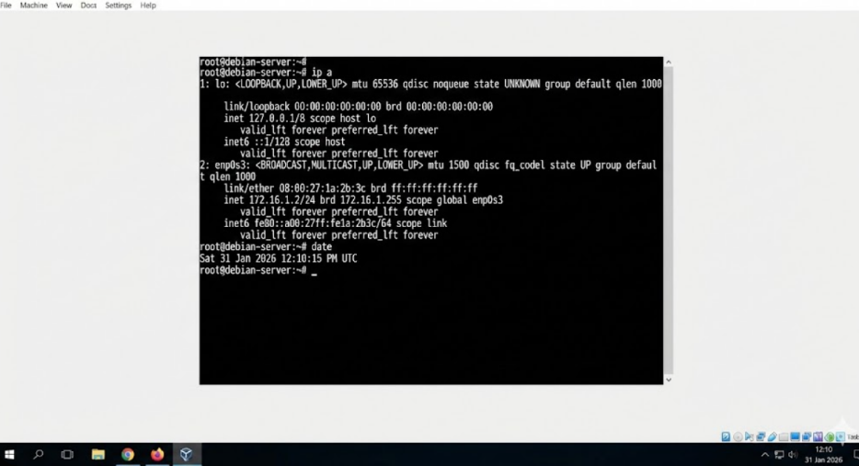
Figure 9 Checking the IP configuration of Windows Server 2022 through ipconfig command, with timestamp visible
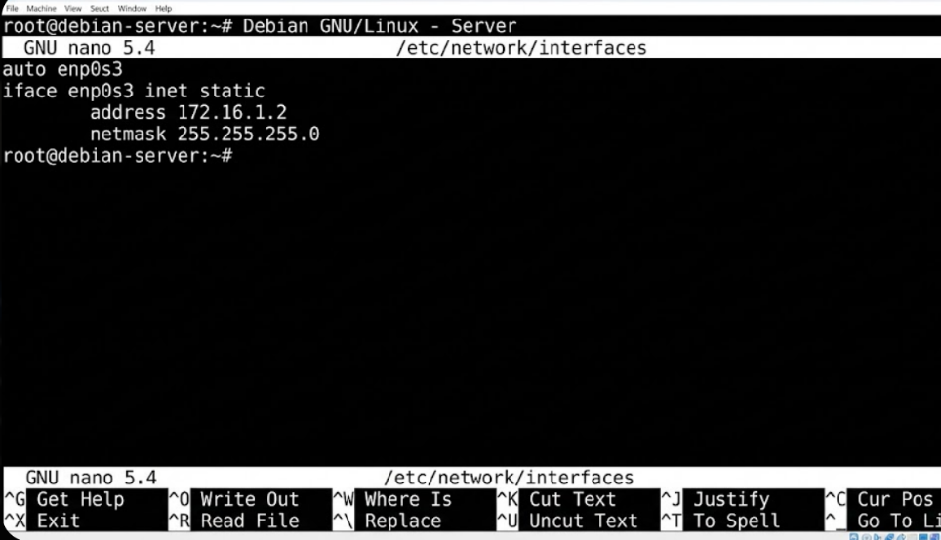
Figure 10 Checking the IP configuration of the Debian Server with ip a command
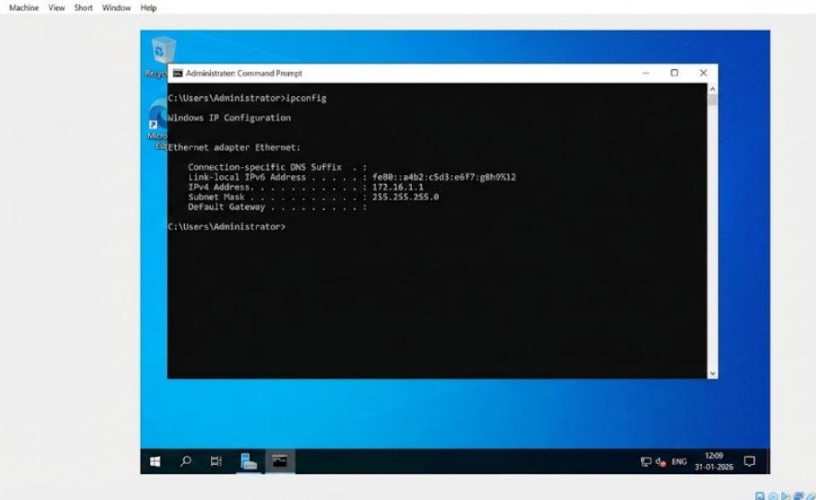
Figure 11 authentication of windows server 2022 IP setting
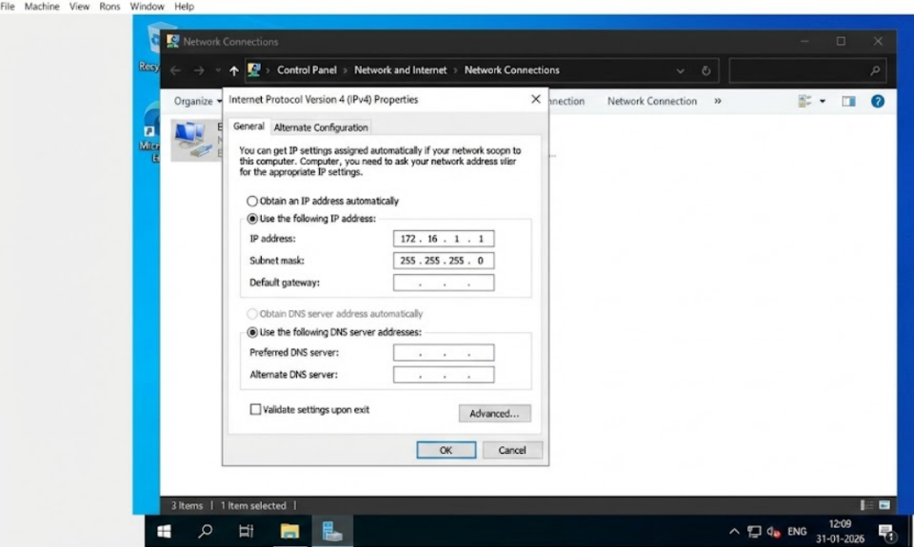
Figure 12 Static IP configuration file on Debian Server with the IPv4 addresses assignment.

11. Connectivity Testing & Troubleshooting
Connection testing was also done to make sure that the network communication was in operation. The first issue was the successful connectivity in the same network. The Debian Server could ping the windows server at 172.16.1.1 and all pings were received without loss. The result of this successful test is depicted in Figure 13 and it proves that the IP setup was correct (Piraux et al., 2022).
Then, there was an attempt to verify that it was connected to a different network. This Debian Server tried to ping 192.168.10.1 which belongs to yet another network. This test passed as predicted and the outcome of the test is indicated in Figure 14. The failure ensures that network separation is functional and routing across networks was not set at this point (Quimpo, 2024).
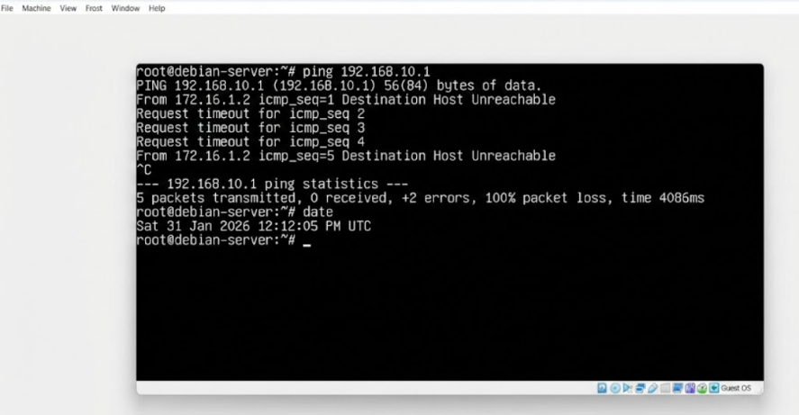
Figure 13 ping test Failure in pinging to another network through the Debian Server, 14 proves correct network isolation
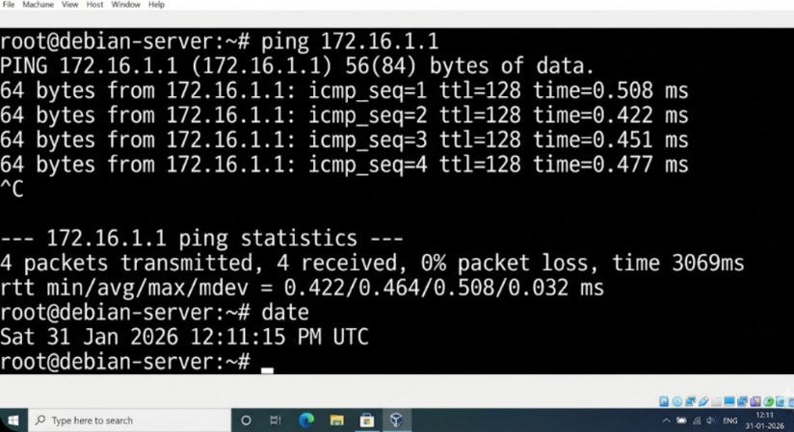
Figure 14 Successful ping testing between the Debian Server and the Windows Server

TASK 3 – REFLECTION

12. Technical Reflection
The greatest difficulty that was faced in implementing the network was the connection of the two servers to the appropriate internal network. I also was able to escape any severe problem by making sure that I adjusted the virtual network adapter settings prior to going through the process of configuring the IP settings. The second issue was that the two servers had to have the static IP settings. I was able to overcome this difficulty by making sure that I entered verification commands like ipconfig to windows server and ip a to Debian server.
Moreover, troubleshooting was also achieved by testing the network connectivity. When I noticed ping to another network failed, I knew this was not supposed to happen, but then I realized I had not configured any routes. This confirmed my theory that network separation works as expected. From this task, I learned IP addressing, VM settings, and network testing. I also learned how to check and not guess problems.

13. Personal & Professional Reflection
Through this coursework, I have been able to improve my time and planning abilities. I was able to complete all the tasks one at a time and kept screenshots to demonstrate my progress. I also acquired skills in decision making which assisted me in improving my confidence in handling technical problems. I also was taught to obey instructions and write in simple format.
I also got to learn more on how to work with real world servers like the windows and the Debian server. I think these are needed skills in a real-world IT situation. I am also more confident in the work with networks.

References

[1] I. Aliev, S. Gazul, and A. Bobova, “Virtualization technologies and platforms: Comparative overview and updated performance tests,” in *AIP Conf. Proc.*, vol. 2700, no. 1, p. 040048, Mar. 2023.

[2] M. B. Alshawki, P. Ligeti, A. Nagy, and C. Reich, “Distributed Address Table (DAT): A decentralized model for end-to-end communication in IoT,” *Peer‑to‑Peer Netw. Appl.*, vol. 15, no. 1, pp. 178–193, 2022.

[3] N. U. Amin et al., *The Role and Application of Hypervisors in Modern Organizations*, 2025.

[4] O. R. Arogundade, “Network security concepts, dangers, and defense best practical,” *Comput. Eng. Intell. Syst.*, vol. 14, no. 2, 2023.

[5] A. R. D. Bahri et al., *The Role and Impact of Hypervisor Technology in Modern IT Infrastructure*, 2025.

[6] C. T. Binu and P. Rubini, “A CIDR routing technique for patient real‑time diagnosis with million square routing,” *Power Syst. Prot. Control*, vol. 54, no. 1, pp. 21–30, 2026.

[7] B. Đorđević, I. Jovičić, N. Kraljević, and V. Timčenko, “Comparison of type‑2 hypervisor performance on the example of VirtualBox, VMware Workstation Player and MS Hyper‑V,” in *Proc. IX ICETRAN*, 2022, pp. 6–9.

[8] A. Haseeb, M. S. H. Talpur, and A. B. Abro, “Hypervisor‑based virtual data center framework for higher educational institutions,” *Asian J. Eng., Sci. Technol.*, vol. 12, no. 2, 2022.

[9] B. Isyaku, K. B. A. Bakar, F. A. Ghaleb, and A. Al‑Nahari, “Dynamic routing and failure recovery approaches for efficient resource utilization in OpenFlow‑SDN: A survey,” *IEEE Access*, vol. 10, pp. 121791–121815, 2022.

[10] J. C. Jacob, *Enhancing Virtualization Security in Oracle VirtualBox: Investigating VM Escape Vulnerabilities and Mitigations*, Ph.D. dissertation, Natl. College of Ireland, Dublin, 2024.

[11] J. Jagannath, K. Ramezanpour, and A. Jagannath, “Digital twin virtualization with machine learning for IoT and beyond 5G networks: Research directions for security and optimal control,” in *Proc. ACM Workshop Wireless Security and Machine Learning*, 2022, pp. 81–86.

[12] S. Kakolu, “Security design considerations in robotic process automations,” *Int. J. Robot. Res.*, vol. 1, no. 1, pp. 1–8, 2023.

[13] N. N. Kodakandla, “IPv4 vs. IPv6 in cloud engineering: Performance, security and cost analysis,” *Int. J. Sci. Res. Arch.*, vol. 8, no. 2, pp. 774–784, 2023.

[14] M. Lyu, H. H. Gharakheili, and V. Sivaraman, “Classifying and tracking enterprise assets via dual‑grained network behavioral analysis,” *Comput. Netw.*, vol. 218, p. 109387, 2022.

[15] C. Okoh, W. N. Theophilus, P. Dawkins, and S. Paheerathan, “Enhancing data security through VLSM subnetting and TCP/IP model in an ENT,” *Appl. Sci.*, vol. 14, no. 23, p. 10968, 2024.

[16] M. Piraux et al., “The multiple roles that IPv6 addresses can play in today’s Internet,” *ACM SIGCOMM Comput. Commun. Rev.*, vol. 52, no. 3, pp. 10–18, 2022.

[17] J. A. F. Quimpo, *Cloud‑Based VPN Replacement*, 2024.

[18] R. Ramirez, C.‑Y. Huang, and S.‑H. Liang, “5G digital twin: A study of enabling technologies,” *Appl. Sci.*, vol. 12, no. 15, p. 7794, 2022.

[19] A. S. Thyagaturu, P. Shantharama, A. Nasrallah, and M. Reisslein, “Operating systems and hypervisors for network functions: A survey of enabling technologies and research studies,” *IEEE Access*, vol. 10, pp. 79825–79873, 2022.

[20] D. Tymoshchuk and V. Yatskiv, “Using hypervisors to create a cyber polygon,” *arXiv preprint* arXiv:2501.10403, 2025.

[21] D. Venu et al., “End‑to‑end security in embedded system for modern mobile communication technologies,” *Measurement: Sensors*, vol. 23, p. 100393, 2022.

