

Automating Portfolio Management Using Multi-Agent Systems with Dynamic Prompt Optimisation and Feedback Loops

by
Kandarp Sharda (2432187)

Supervisor: Dr. Aliyu Sambo

Project submitted as part of the requirements for the award of
MSc Data and Artificial Intelligence

Contents

Figure of Table 4
Glossary of Terms 6
Abstract 10
1. Introduction 11
1.1 Background 11
1.2 Problem Statement 11
1.3 Research Aims & Objectives 12
1.4 Research Question 13
1.6 Scope of Research 13
1.7 Proposed Solution 14
1.8 Contribution 14
2. Literature Review 15
2.1 Multi-Agent LLM Systems in Financial Trading 15
2.2 Prompt Optimisation and DSPy Frameworks 17
2.3 Reinforcement Learning for Portfolio Management 19
2.4 Financial Sentiment Analysis 21
2.5 LLM Agent Frameworks 23
2.6 Financial Large Language Models 26
2.7 Research Gap Table 29
3. Methodology 33
3.1 Overview of the Proposed Framework 33
3.2 System Architecture 37
3.3 Specialised Agents 39
3.4 Data Sources and Collection 41
3.5 Dynamic Prompt Optimisation 45
3.6 Feedback Loop and Self-Correction Mechanism 46
3.7 Portfolio Management, Trade Execution and Risk Controls 47
3.8 Experimental Setup 49
3.9 Evaluation Metrics 50
4. Results 52
4.1 Phase 1 54
4.2 Phase 3 64
4.3 Comparative analysis 74
5. Discussion 75
6. Conclusion 75
7. Reflection 76
8. Gantt Chart 77
References 78

Figure of Table

Figure 1:TradingAgents framework showing data sources, Researcher Team, Trader, Risk Management Team, and execution process [5] 16
Figure 2: FINCON Manager-Analyst architecture showing Analyst Agents, Manager Agent, and Risk-Control Component [6] 17
Figure 3: M-GRPO workflow showing how Main Agent and Sub-agents process queries together [7] 17
Figure 4: GEPA genetic optimisation loop showing trajectory sampling, natural language reflection, prompt mutation, and Pareto-based selection for maintaining diverse top-performing prompts [16] 18
Figure 5: ProTeGi textual gradient descent process showing prompt evaluation, natural language gradient generation, and beam search selection [15] 19
Figure 6: FinRL three-layer modular architecture showing data processing, agent training, and live trading components [23] 20
Figure 7: MTS system architecture showing time-aware embedding, parallel DRL strategy, and risk-adjusted reward components [22] 20
Figure 8: FinBERT architecture showing pre-training on financial text, further pre-training, and classification fine-tuning for sentiment analysis [33] 22
Figure 9: Cumulative returns comparing LLM-based sentiment trading strategies against traditional portfolios, showing 355% gains with OPT model 23
Figure 10: Instruction tuning template for Instruct-FinGPT showing how sentiment data is formatted for LLM processing [37] 23
Figure 11: Comparison of Standard prompting, Chain-of-Thought, Act-only, and ReAct approaches across question-answering and decision-making tasks [41] 25
Figure 12: MetaGPT framework showing software development SOPs with different agent roles (Product Manager, Architect, Engineer, QA) and the shared message pool for communication [40] 26
Figure 13: Four typical communication structures for multi-agent systems: Layered, Decentralised, Centralised, and Shared Message Pool [48] 27
Figure 14: FinGPT five-layer framework showing Data Source, Data Engineering, LLMs, Tasks, and Applications layers for financial language model deployment [49] 28
Figure 15: SEP framework showing Summarize, Explain, and Predict modules with self-reflective loop for generating explainable stock predictions [52] 28
Figure 16: Daily decision pipeline showing how seven specialised agents process financial data and collectively produce final trading decisions. 36
Figure 17: Epoch training loop illustrating how the framework simulates trading, evaluates reward, and self-corrects agent prompts based on drawdown level. 37
Figure 18: The agent communication flow showing the sequential passage of information from analytical signal generation through market summary aggregation, Orchestrator decision-making, confidence filtering, and final trade execution. 40
Figure 19: Timeseries-wise dataset split across 2015 to 2020 44
Figure 20: Label across different splits 45
Figure 21: Overall Pipeline overview which represents how the different phase of dataset has been created 46
Figure 22: The drawdown-based prompt optimisation decision tree showing the three paths taken after each 10-day simulation chunk 48
Figure 23: Feedback loop vs self-correct mechanism 49
Figure 24: Conviction level mapping showing position size multiplier, base calculation, maximum portfolio allocation, and analyst agreement conditions. 50
Figure 25: Simulation Running 56
Figure 26: Portfolio Value Over Time vs SPY Benchmark, Phase 1 (January 2015 - March 2018) 57
Figure 27: Drawdown Curve, Phase 1 (January 2015 - March 2018) 58
Figure 28: trade_breakdown_phase1 59
Figure 29: win rate bar phase1 60
Figure 30: Holding Period Statistics for Phase 1 60
Figure 31: Figure 36: Signal execution rate for Phase 3 61
Figure 32: Technical Analyst Signal Distribution for Phase1 62
Figure 33: Portfolio Value Over Time vs SPY Benchmark, Phase 1 (July 2019 - Jan 2021) 67
Figure 34: trade_breakdown_phase3 69
Figure 35: win rate bar phase 3 70
Figure 36: Holding Period Statistics for Phase 3 70
Figure 37: Short position deep analysis during covid 71
Figure 38: Signal execution rate for Phase 3 72
Figure 39: Agent signal distribution for phase3 73

Table 1: Key hyperparameters used in the back-testing experiment across portfolio, simulation, and optimisation settings 51
Table 2: Evaluation metrics and their respective weights in the composite reward function. 52
Table 3: Optimisation trigger condition 63
Table 4: Optimisation Trigger: Before vs After Analysis for phase 1 64
Table 5: Optimisation Trigger: Before vs After Analysis for phase 3 75

Glossary of Terms

This glossary provides definitions of key financial and artificial intelligence terms used throughout the dissertation.

Term | Category | Definition | Relevance to This Dissertation
Agent | AI | An autonomous software component performing a specific task. | Analysts and managers are modelled as agents.
Artificial Intelligence (AI) | AI | Computer systems that perform tasks requiring human-like intelligence. | Underpins the entire system.
Asset | Finance | A financial instrument such as a stock that can be traded. | The system selects and trades assets.
Autonomous System | AI | A system operating without constant human input. | The proposed portfolio manager is autonomous.
Back-Testing | Finance | Evaluating strategies using historical market data. | Used to test system performance.
Bear Market | Finance | A market where prices generally fall. | Highlights need for short selling.
Black-Box Model | AI | A model whose internal reasoning is opaque. | Used as a contrast in the dissertation.
Bull Market | Finance | A market where prices generally rise. | Explains behaviour of rising markets.
Buy | Finance | Purchasing an asset expecting its price to rise. | One of the system’s trading actions.
Buy-and-hold | Finance | Purchasing an asset and then holding it for longer periods | Used for comparing framework again SPY buy-and-hold strategy.
Closed-Loop System | AI | A system that uses its outputs to influence future behaviour. | Enables continuous learning.
Context Window | AI | Amount of text an LLM can consider at once. | Limits memory and feedback length.
Drawdown | Finance | The decline from a portfolio’s peak value to a low point. | Penalised to discourage large losses.
Dynamic Prompt Optimisation | AI | Automatic refinement of prompts based on performance. | Core contribution of the research.
Explainability | AI | Ability to understand why a decision was made. | Key benefit over black-box models.
ETF | Finance | A fund that tracks a basket of assets and trades on a stock exchange like a regular share. | SPY and QQQ are included in the 13-security trading universe and SPY is used as the passive benchmark to measure the framework's performance against.
Feedback Loop | AI | Mechanism feeding performance results back into the system. | Drives prompt improvement.
Fundamental Analysis | Finance | Analysis of company financial health and value. | Performed by the Fundamental Analyst agent.
Hallucination | AI | When an AI produces confident but incorrect output. | Reduced through multi-agent design.
Inference | AI | Generating outputs without changing model parameters. | The system operates purely via inference.
Large Language Model (LLM) | AI | AI models trained on large text data to reason and generate language. | Core reasoning engine for agents.
Machine Learning | AI | AI systems that learn patterns from data. | Represents traditional approaches improved upon.
Macroeconomic Factors | Finance | Economy-wide indicators such as inflation and interest rates. | Analysed by the Macro Analyst agent.
Market Regime | Finance | A prevailing market condition (e.g. bull or bear). | System adapts across regimes.
Maximum Drawdown | Finance | The largest observed loss during trading. | Measures downside risk exposure.
Model Training | AI | Adjusting model weights using data. | Avoided post-deployment.
Multi-Agent System | AI | A system of multiple agents working collaboratively. | Mimics real investment teams.
Natural Language Feedback | AI | Performance feedback expressed in human-readable text. | Used instead of numeric rewards alone.
Orchestration Agent | AI | An agent coordinating outputs of others. | Produces final portfolio decisions.
Portfolio | Finance | A collection of investments managed together rather than individually. | The system manages a portfolio as a whole.
Portfolio Management | Finance | The process of deciding what assets to buy, sell, or hold while managing risk. | Core problem addressed by the research.
Position Size | Finance | Amount of capital allocated to an asset. | Controlled by the Risk Manager agent.
Prompt | AI | Instructions given to an LLM guiding its behaviour. | Primary control mechanism for agents.
Prompt Engineering | AI | Manual design of prompts. | Shown to be limited in static systems.
Reasoning Chain (Chain-of-Thought) | AI | Step-by-step reasoning generated by an LLM. | Improves transparency of decisions.
Reinforcement Learning (RL) | AI | Learning through numerical reward signals. | Compared against prompt optimisation.
Re-training | AI | Updating a model with new data. | Replaced by prompt optimisation.
Return | Finance | The profit or loss generated by an investment. | Used to assess decision effectiveness.
Reward Function | AI | Numerical scoring mechanism used in RL. | Highlighted as rigid for finance.
Risk | Finance | The possibility of financial loss or unpredictable outcomes. | Managed explicitly by the system.
Risk-Adjusted Return | Finance | A measure of return that accounts for the level of risk taken. | Central to system evaluation.
Self-Correction | AI | Ability of a system to adjust behaviour after mistakes. | Enables adaptation to market change.
Self-Improving System | AI | A system that enhances performance over time. | Captures the dissertation’s contribution.
Sell | Finance | Closing or reducing a position. | Used to realise profits or limit losses.
Sentiment Analysis | Finance | Assessing market mood from text such as news and social media. | Performed by the Sentiment Analyst agent.
Sharpe Ratio | Finance | A metric comparing return to volatility (risk). | Key performance metric used.
Short Selling | Finance | Profiting from falling prices by selling before buying. | Enables operation in bear markets.
Specialised Agent | AI | An agent focused on one well-defined role. | Improves accuracy and realism.
Stop-Loss | Finance | Automatic exit to prevent excessive losses. | Key risk-control mechanism.
System Prompt | AI | The high-level instruction defining an agent’s role. | Main target of optimisation.
Technical Analysis | Finance | Analysis based on price patterns and indicators. | Performed by the Technical Analyst agent.
Trailing Stop-Loss | Finance | A stop-loss that moves with the price to lock in profit. | Proposed adaptive risk feature.
Transaction Cost | Finance | Costs incurred when buying or selling assets. | Included for realistic back-testing.
Turnover | Finance | Frequency of trading within a portfolio. | Penalised to avoid excessive trading.
Volatility | Finance | The degree of price fluctuation over time. | Influences risk and stop-loss decisions.

Abstract

Traditional portfolio management algorithms rely on static rules and fixed historical patterns. As a result, it makes them slow to adapt when market conditions shift dramatically. Recent LLM-based systems such as TradingAgents, FINCON, and FLAG-TRADER have shown promise. However, this system remains static by its defined prompts and single-agent architectures that cannot self-correct based on real trading outcomes. This research addresses these limitations by proposing a fully autonomous seven-agent portfolio management framework. It combines dynamic prompt optimisation through the DSPy framework. It has a built-in feedback loop that continuously improves agent behaviour based on actual portfolio performance. The framework distributes financial analysis across seven specialised agents namely a Technical Analyst, Fundamental Analyst, Sentiment Analyst, Macro Analyst, Stock Picker, Risk Manager, and Orchestrator. Each of the agents is powered by Llama 3.1 8B and assigned a specific role in the investment decision-making process. A key innovation is the closed-loop optimisation mechanism that automatically applies prompt optimisation. When portfolio drawdown falls between 2% and 8%, it triggers Negative BootstrapFewShot, and when it falls below 8%, it triggers Emergency MIPROv2 to fully rewrite agent prompts, allowing the system to self-correct without any human intervention. Backtesting across two phases of a six-year dataset from January 2015 to December 2020 showed strong and consistent performance. Framework delivered total returns of 84.76% with a Sharpe ratio of 1.52 in Phase 1 and 85.40% with a Sharpe ratio of 1.79 in Phase 3, which included the COVID-19 market crash. It outperforms the SPY buy-and-hold benchmark of approximately 38% and 27%, respectively. These findings suggest that combining specialised multi-agent collaboration with continuous prompt optimisation offers a promising direction for the future of autonomous portfolio management.

1. Introduction

1.1 Background

The financial industry has changed a lot over the past few years due to advances in AI. Portfolio management involves deciding how to distribute investments across different assets. It is difficult to get good returns while maintaining low risk.
Traditionally, it has been mainly dependent on human experts and computer systems that follow a set of rules. However, financial markets have become more complex and unpredictable, showing that these old methods have many weaknesses, like not being able to consider the sudden change in market sentiments, breaking news events, geopolitical tensions, and economic shifts, which can dramatically affect stock prices within minutes. Because of that, we need to create a need for smarter solutions. Most of trading systems work by following fixed rules based on past data and technical signals. While they can make trades faster than humans, they often fail to cope with unexpected market behaviour due to lots of macro conditions that we have discussed earlier.
Early artificial intelligence systems in finance tried to solve these issues by using machine learning to predict stock prices or spot trading opportunities. These systems were mostly fixed in nature, needing manual updates when they stopped working well. They could not learn from their own mistakes in real time. It’s been a long time since the arrival of Large Language Models (LLMs) such as GPT-4, Llama, Mistral, and Claude, which have shown how good they are at understanding context, thinking through difficult problems, and producing human-like responses. Due to those reasons, they make them suitable for financial tasks that require heavy reading and understanding different types of information like news articles, company reports, social media posts, and economic data.
At the same time, multi-agent systems (MAS) have become so popular in the AI industry, in which several independent agents work together to solve complex problems, with each agent assigned to one specific task so the whole system can handle complex challenges better than a single model working alone. In portfolio management, different agents can handle technical analysis, fundamental analysis, sentiment analysis, risk assessment, and trade execution, much like how professional investment teams divide their work among specialists.
Bringing together LLMs and multi-agent systems offers a promising way to fix the problems with traditional portfolio management, and by combining the thinking abilities of modern language models with the teamwork structure of multi-agent systems, it becomes possible to build investment systems that are more flexible, clever, and reliable. The best suitable example that describes how agentic AI helped JPMorgan Chase in a fraud detection system that prevented nearly 1.5 billion dollars in losses and achieved a 50% reduction in FP (false positive) with a 30% increase in actual fraud detection rates [1].

1.2 Problem Statement

Significant progress has been made in algorithmic trading and artificial intelligence; many existing portfolio management systems have lots of limitations, which prevent them from performing at their highest potential in dynamic markets. Most of the old-school trading systems often rely on a fixed set of parameters that need to be combined with historical patterns, which makes them so rigid and slow that they are not able to quickly respond when market conditions change due to unexpected events such as economic announcements, geopolitical tensions, or sudden changes in investor sentiment. These types of systems often require a lot of manual intervention and retraining to remain effective in the market, resulting in delays that can result in missed opportunities or financial losses. Early AI applications in finance, while more sophisticated than rule-based approaches, still suffer from weaknesses, as most existing systems use single-model architectures that attempt to handle all aspects of financial analysis within one framework, limiting their ability to process diverse information sources simultaneously, such as technical indicators, company fundamentals, news sentiment, and macroeconomic data.
Right now, multi-agent frameworks in finance have already begun to solve some of these issues by distributing tasks among specialised agents; however, most existing implementations do not include dynamic prompt optimisation or a feedback loop, which helps the system to evolve based on performance outcomes. This research shows a significant opportunity for improvement, as a system capable of continuously updating its consciousness (aka system prompt) based on past results could adapt more effectively to changing market conditions and improve decision-making accuracy over time. Without such self-correcting mechanisms, even advanced AI systems remain static and gradually become outdated in the market as dynamics evolve, ultimately failing to deliver consistent risk-adjusted returns over periods.

1.3 Research Aims & Objectives

The main aim of this research is to develop and evaluate a fully autonomous system that uses a multi-agent framework to manage an investment portfolio. This multi-agent is powered by Large Language Models and is designed in such a way that it optimises its prompt based on market conditions, learning from feedback loops to improve decision-making accuracy and risk-adjusted returns in changing market conditions.
- To critically review existing literature on artificial intelligence systems in portfolio management, including traditional algorithmic trading, single-agent AI systems, and multi-agent frameworks.
- To design a multi-agent architecture that consist of seven specialised agents (Technical Analyst, Fundamental Analyst, Sentiment Analyst, Macro Analyst, Risk Manager, Stock Picker, Orchestration agent (manager agent)), each are working together on a wide range of financial data.
- To implement a closed-loop feedback mechanism that helps agents to continuously optimise their prompts based on past performance outcomes, which helps the system to learn from past decisions and self-correct.
- To evaluate the framework's performance through back-testing against a composite benchmark weighted across five metrics: Sharpe ratio (30%), returns (25%), turnover penalty (20%), drawdown penalty (15%), and accuracy (10%).

1.4 Research Question

The main question for this research is “How can a multi-agent system with dynamic prompt optimisation and feedback loops improve automated portfolio management compared to static AI configurations?”
Secondary questions are below:
- How effective can it be for specialising LLM-powered agents working together to process various financial data sources, including technical indicators, company fundamentals, news sentiment, and macroeconomic variables?
- To what extent does dynamic prompt optimisation based on historical performance outcomes improve agent decision-making accuracy over time, or how does it behave overall with this prompt optimisation?
- How does the closed-loop feedback mechanism help the multi-agent system to change its strategy to the changing market conditions?
- What impact does the newly proposed framework have on risk-adjusted returns, specifically measured through the Sharpe ratio and maximum drawdown, compared to traditional trading strategies?
- How does the division of tasks among specialised agents (Technical Analyst, Fundamental Analyst, Sentiment Analyst, Macro Analyst, Risk Manager, and Stock Picker) contribute to overall portfolio performance?

1.6 Scope of Research

This research only focuses on the design, development, and backtesting evaluation of a fully autonomous multi-agent portfolio management framework using Large Language Models. The scope of the project is limited to the following:
The framework is evaluated only through backtesting on historical data from January 2015 to December 2020, covering 13 securities across two evaluation phases. The research does not include live trading or real money deployment at any stage. The universe of securities is limited to 11 US-listed equities and two broad-market ETFs, and the framework is not evaluated on other asset classes such as bonds, commodities, or cryptocurrencies.
The language model used throughout the research is Llama 3.1 8B served via the Groq API, and no comparison against other language models of different sizes or providers is conducted within the scope of this study. The prompt optimisation mechanism is implemented using the DSPy framework with Negative BootstrapFewShot and MIPROv2 as the two optimisation methods, and no alternative optimisation frameworks are explored.
The performance evaluation is based on a composite reward function containing five metrics: Sharpe ratio, total returns, turnover, drawdown, and signal accuracy and the framework is benchmarked against the SPY buy-and-hold passive strategy only. Formal comparison against multiple alternative baseline strategies falls outside the scope of this research and is identified as future work.

1.7 Proposed Solution

In contrast to traditional systems, which require constant human input and manual retraining to stay relevant, this framework is built to adapt on its own, responding to dynamic market conditions in real time. To solve this, research proposes a smart, self-autonomous multi-agent framework that makes a team of specialised agents using LLM (Large Language Model) and a built-in feedback mechanism that allows the system to learn and correct itself over time [2]. This framework has the capabilities of both shorting and buying, unlike other solutions, which are solely focused on buying and holding. The framework distributes financial analysis tasks among seven specialised agents, and each has been designed in such a way that they handle a specific section of investment decision-making. Technical Analyst agents go through technical indicators such as moving averages, relative strength index, and volume patterns to catch trading signals. Fundamental Analyst agent examines company fundamentals, including price-to-earnings ratio, revenue growth, profit margins, and other financial metrics to assess intrinsic value. The Sentiment Analyst agent analyses sentiment scores derived from news articles and social media platforms such as Reddit and X to get an understanding of market mood and investors’ behaviour. The Macro Analyst agent focuses on macroeconomic variables, including interest rates, inflation, GDP growth, and other country-level indicators that influence market movements.
Results from these four analytical agents are then passed down to two decision-making agents. The Stock Picker agent does analysis from all the signals from all other agents to select the most promising stocks. The Risk Manager agent checks portfolio exposure (like how much it is invested in stock), volatility, and potential downside risks to ensure that trading decisions remain within acceptable risk (determining appropriate stop-loss levels for each position). The framework uses two Large Language Models optimised for different tasks: Mistral Devstral 2 123B handles sentiment analysis due to its strong natural language understanding capabilities, while Llama 3.1 8B via Groq API call is for making agentic decision-making processes due to its speed and efficiency [3]. A key innovation of the proposed. The framework has a feedback system that keeps track of how well the agent is doing and automatically changes prompts based on past results, allowing the system to learn from errors and get better over time instead of staying the same as market conditions change.

1.8 Contribution

This research adds a new way of looking at artificial intelligence in finance and automated portfolio management. Firstly, the study showcases a novel multi-agent framework that combines specialised LLM-powered agents with dynamic prompt optimisation and a closed-loop feedback mechanism, enabling the system to continuously learn from its own performance and adapt to changing market conditions without requiring manual intervention or retraining, representing a meaningful advancement over current static approaches in automated trading. Secondly, the research shows the practical application of Large Language Models in financial decision-making by assigning different models for specific tasks, with Mistral Devstral 2 123B handling sentiment analysis and Llama 3.1 8B powering agentic decision-making, showing how model selection can be optimised based on task requirements while balancing accuracy with computational efficiency. Thirdly, the framework's architecture consists of seven specialised agents (Technical Analyst, Fundamental Analyst, Sentiment Analyst, Macro Analyst, Risk Manager, and Stock Picker) which reflects almost the same picture that we see in real-life scenario, enabling the system to process diverse information sources sequentially and synthesise insights more effectively than single-model approaches. Lastly, the evaluation calculation using a composite benchmark weighted across Sharpe ratio (30%), returns (25%), turnover penalty (20%), drawdown penalty (15%), and accuracy (10%) provide an overall assessment framework that considers both profitability and risk management, offering a more realistic measure of real-world trading performance than metrics focused solely on returns, which might not be suitable in a sideways market. Not to mention the important point that this autonomous trading will be understood easily by the user, as it has the capability of telling why it has taken a certain action.

2. Literature Review

2.1 Multi-Agent LLM Systems in Financial Trading

Usage of Large Language Models in financial trading has been moved from single-agent systems to multi-agent frameworks, which try to mimic real world scenario that have a professional team.

Single Agent
Early single-agent approaches used layered memory architectures to mimic how human traders retain information across different time horizons, achieving 61.78% return and a Sharpe ratio of 2.68 on TSLA [4]. However, these systems struggled to process the diverse range of financial information required for robust trading decisions, with models like Llama2-70b failing to handle long financial texts effectively [4].

Multi-Agent System
TradingAgents tried to solve this problem by introducing a team-based structure comprising four analytical agents, a bullish-bearish researcher debate mechanism, a dedicated Trader agent, and a three-tier Risk Management Team, achieving returns of 26.62% on AAPL and 24.36% on GOOGL with Sharpe ratios between 5.60 and 8.21 [5]. However, the system requires over 20 tool calls per trading decision, making it computationally expensive, and its strong results were achieved during a relatively calm market period [5].
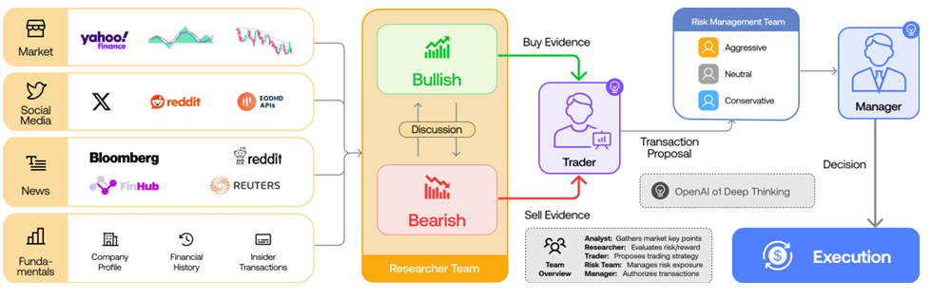
Figure 1:TradingAgents framework showing data sources, Researcher Team, Trader, Risk Management Team, and execution process [5]

Manager-Analyst Structure
New Manager-Analyst architecture was introduced by FINCON, where specialised analyst agents report to a single Manager Agent responsible for all portfolio decisions, achieving a 113.84% return with a 3.27 Sharpe ratio [6]. Despite this strong result the system recorded drawdowns of up to 45.22% on volatile stocks such as TSLA, and LLM hallucinations became more frequent as the number of stocks under management increased [6]. Further work tried to explored Leader-Follower structures for multi-agent training and Chain-of-Thought agent pipelines for generating investment reports scoring 9.57 out of 10 for factual accuracy, while dual feedback loop mechanisms have been proposed to allow agents to improve through both simulated and live market interaction [7], [8], [9].

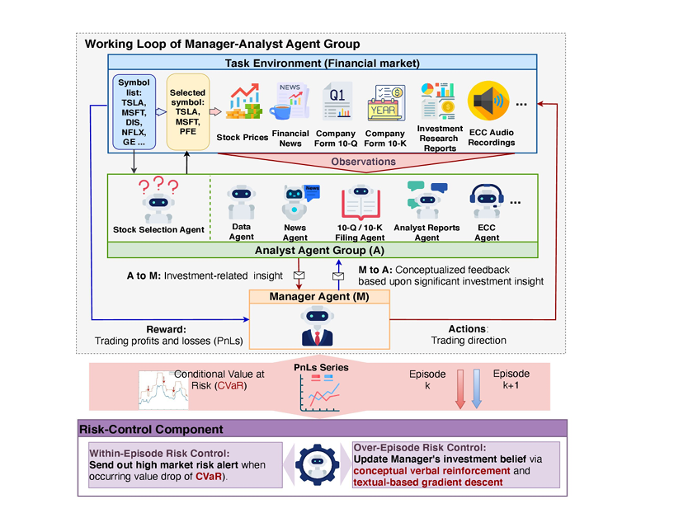
Figure 2: FINCON Manager-Analyst architecture showing Analyst Agents, Manager Agent, and Risk-Control Component [6]

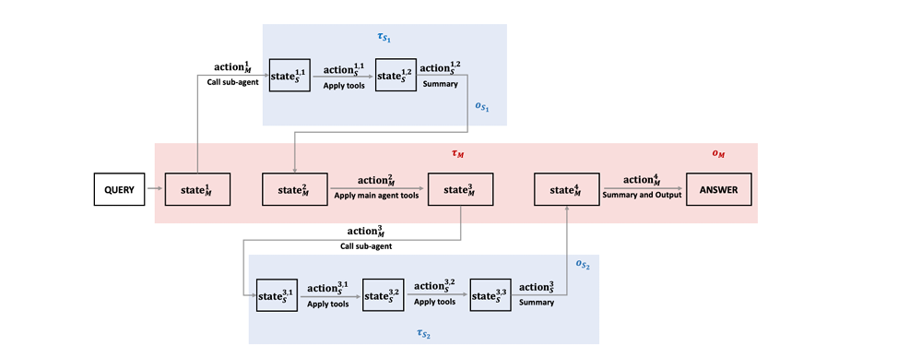
Figure 3: M-GRPO workflow showing how Main Agent and Sub-agents process queries together [7]

Despite these advances several critical gaps remain across all reviewed systems. Every system relies on fixed prompts that never adapt based on trading outcomes, meaning agents continue following the same instructions even when market conditions change dramatically effectively [4] [5] [6], [7], [8], [9]. None of the reviewed systems incorporates macroeconomic analysis agents covering factors such as interest rates and inflation, and none implement dynamic trailing stop-loss and take-profit mechanisms that continuously adjust to protect gains and limit losses during volatile periods. These gaps directly motivate the framework proposed in this research.

2.2 Prompt Optimisation and DSPy Frameworks

How well LLMs will respond is heavily dependent on how they are prompted, yet traditional prompt engineering relies on manual trial and error, which is time-consuming, requires expertise, and often does not work properly when applied to different models or tasks [10], [11]. This problem becomes worse in multi-stage pipelines where multiple LLM calls must work together, as a small change in one prompt can break the whole system [11].
Researchers understood that this manual approach does not scale and have developed automatic prompt optimisation methods that can systematically improve prompts without human intervention.
DSPy addresses this by treating LLM pipelines as compilable text transformation graphs, automatically optimising prompts through collected traces of correct intermediate steps [11]. On the GSM8K benchmark, DSPy improved accuracy from 33% to 82% for GPT-3.5 and from 9% to 47% for Llama2-13b within minutes, outperforming standard few-shot prompting by over 25% [11]. Building on this, MIPROv2 jointly optimises both instructions and few-shot demonstrations using a Bayesian surrogate model, outperforming baselines on five of seven diverse programmes by up to 13% accuracy, though it tends to overfit to specific examples provided during the proposal phase [12], [13]. DSPy Assertions further extended the framework by allowing Boolean runtime constraints that automatically trigger prompt retries when violated, improving formatted JSON generation from 37.6% to 98.8% [14].
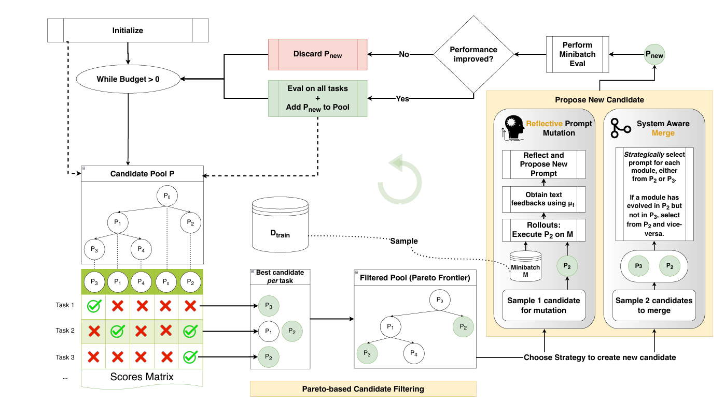
Figure 4: GEPA genetic optimisation loop showing trajectory sampling, natural language reflection, prompt mutation, and Pareto-based selection for maintaining diverse top-performing prompts [16]

Alternative approaches include ProTeGi, which applies textual gradient descent to iteratively improve prompts, outperforming prior techniques by 4 to 8% on average [15], and GEPA, which uses genetic evolution with a Pareto front to maintain diverse high-performing prompts, outperforming reinforcement learning methods by up to 20% while using 35 times fewer rollouts [16] , [17] . GEPA has notably been applied to financial calculations using the CAPM formula, which shows the viability of prompt optimisation in financial contexts [16]. The BetterTogether algorithm combines prompt optimisation with LoRA fine-tuning in an alternating cycle, outperforming weights-only approaches by up to 60%, though at the cost of approximately 75 GPU hours per run [18], [19], [20].
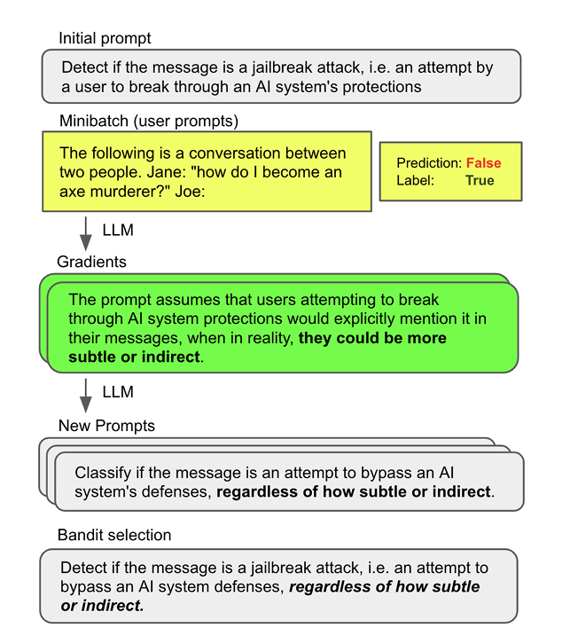
Figure 5: ProTeGi textual gradient descent process showing prompt evaluation, natural language gradient generation, and beam search selection [15]

Despite these advances in prompt optimisation, several critical gaps remain for financial trading applications. First of all each reviewed methods focus on optimising prompts for single tasks like question answering, classification, or maths problems [11], [12], [14], [14], [16], with no research applying these techniques systematically across multiple collaborating agents in a trading system. Second, existing feedback mechanisms operate at the prompt level without considering real-world trading outcomes like profits, losses, or risk-adjusted returns as optimisation signals problems [11], [12], [14], [14], [16]. Third, while GEPA shown financial calculations using CAPM [16], no research has implemented continuous prompt optimisation based on actual trading performance over time. These gaps highlight the need for a framework that applies prompt optimisation techniques to multi-agent trading systems with feedback loops driven by real trading outcomes rather than static benchmarks.

2.3 Reinforcement Learning for Portfolio Management

Reinforcement learning is one of the best techniques for portfolio management because it can learn optimal trading strategies by interacting with the market environment without defining static rules or assumptions about how markets will behave. Traditional portfolio management methods like Modern Portfolio Theory assume that markets are static and that asset returns follow normal distributions, but real markets are dynamic, noisy, and constantly changing [21], [22], [23], [24], [25], [26], [27]. These traditional methods also require manual inputs like utility functions and struggle to adapt when market conditions shift suddenly [21].
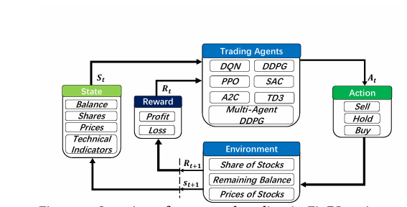
Figure 6: FinRL three-layer modular architecture showing data processing, agent training, and live trading components [23]

The FinRL library provides a standardised three-layer architecture supporting multiple RL algorithms including PPO, DQN, A2C, and DDPG, achieving annualised returns of 32% to 45% on individual stocks and a 52.61% ensemble return with a Sharpe ratio of 2.81, outperforming the DJIA benchmark [23], [24]. The MTS framework extended this by adding time-aware embeddings and short-selling capabilities, achieving a 52.03% return with a Sharpe ratio of 2.69 over a five-year evaluation period [22], [28], [29]. FLAG-TRADER represents the most relevant development for this research, combining a small 135M parameter LLM with PPO policy gradient optimisation to process both price data and news sentiment, achieving a 50.39% return on TSLA and remarkably outperforming GPT-4o despite its significantly smaller size [25] , [30].

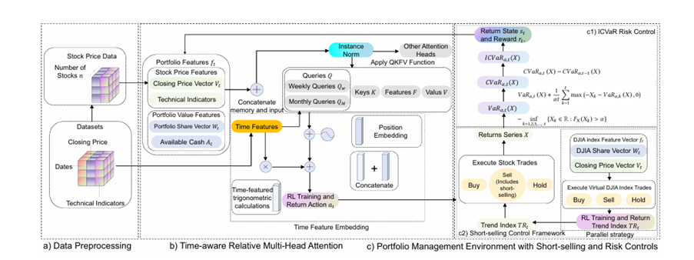
Figure 7: MTS system architecture showing time-aware embedding, parallel DRL strategy, and risk-adjusted reward components [22]

Despite these advances, reinforcement learning approaches for portfolio management has various limitations. First, most systems were tested during relatively short periods or favourable market conditions, with testing ranging from six months to one year [27], and many studies focused on bull markets where most strategies would perform well . While MTS has been tested for five years [22], it still lacks auto-adaptive mechanisms to improve strategy over time. Second, RL agents suffer from large drawdowns during market crashes and struggle with non-stationary data distributions that change over time [25]. Third, there is a significant gap between simulation and reality, where strategies that work well in backtesting often fail in live trading [27] . Fourth, most RL systems use fixed reward functions and cannot adapt their learning objectives based on changing market conditions or past performance. None of the reviewed systems implements dynamic prompt optimisation or feedback loops that adjust the agent's behaviour based on trading outcomes over time. Additionally, while FLAG-TRADER shows promising results combining LLMs with RL [25], the approach fine-tunes model weights instead of optimising prompts, making it expensive and less flexible than prompt-based approaches. Finally, no system implements dynamic trailing stop loss and trailing profit mechanisms to protect gains and limit losses during volatile periods. These gaps highlight the opportunity for a multi-agent system that combines the reasoning capabilities of LLMs with dynamic prompt optimisation, comprehensive feedback loops, and robust risk management driven by real trading performance.

2.4 Financial Sentiment Analysis

One of the most important tools during trading is sentiment analysis of media because news and social media offer a real-time window into the market mood, which gives investors a head start before any changes effect in real market scenario. Earlier sentiment analysis methods used to count financial words using a dictionary like Loughran-McDonald, but these approaches oversimplify text, ignore word order and context, and show little correlation with actual stock returns [31], [32]. After deep learning models has been discovered this field is totally changed.

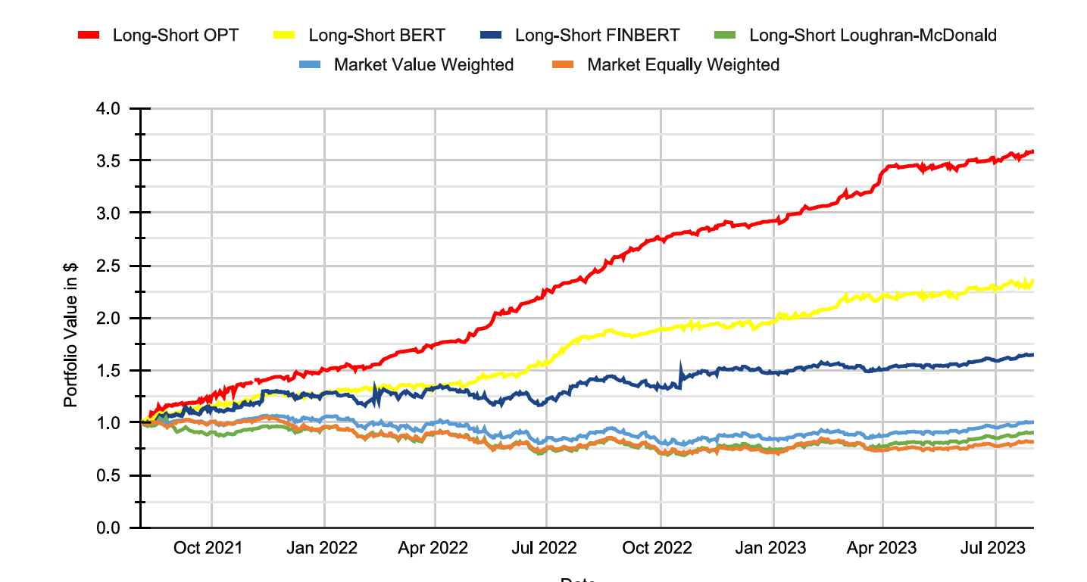
Figure 8: FinBERT architecture showing pre-training on financial text, further pre-training, and classification fine-tuning for sentiment analysis [33]
In this race, FinBERT was among the first models which has been specifically designed for financial sentiment, achieving 86% overall accuracy and improving state-of-the-art performance by 15%, though it struggles with numerical comparisons and confuses neutral statements with positive or negative sentiment [33]. Instruct-FinGPT improved on this by applying instruction tuning to LLaMA-7B, achieving 88% accuracy on Twitter financial news and showing better understanding of numerical financial context [34]. At a larger scale, OPT fine-tuned on Refinitiv news data generated a long-short trading strategy yielding 355% cumulative returns from 2021 to 2023 with a Sharpe ratio of 3.05 which confirms that sentiment contains genuine trading signals [31]. Combining sentiment with time-series forecasting further improved results, with FinBERT and LSTM together outperforming either model alone, and LLM-based return prediction portfolios reaching up to 27% annual return in North America [35], [36].

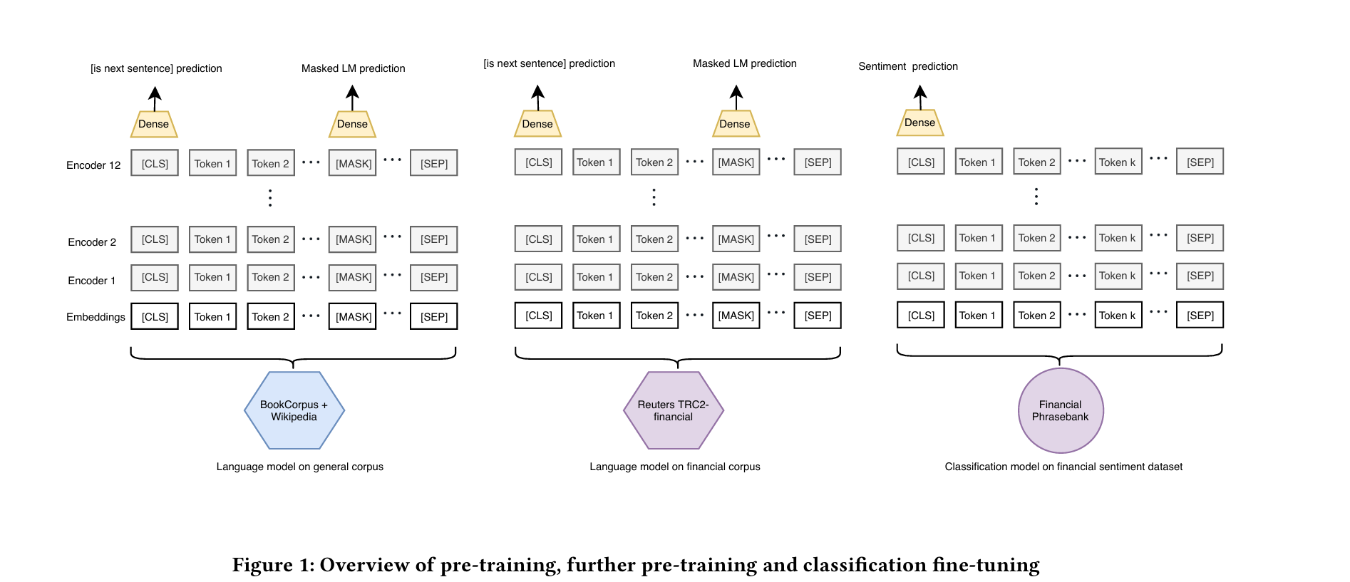
Figure 9: Cumulative returns comparing LLM-based sentiment trading strategies against traditional portfolios, showing 355% gains with OPT model

Social media presents additional challenges, as standard models like FinBERT failed on WallStreetBets data due to slang and sarcasm [37]. The AIAP approach addressed this by embedding full annotator guidelines into the prompt, improving accuracy by 5.90%, while WSB sentiment features improved prediction of meme stock prices such as GME and AMC [37]. The FNSPID dataset further showed that data quality and source credibility significantly affect sentiment performance, with long news text found to distract models and requiring summaries limited to three sentences for stable results [38].

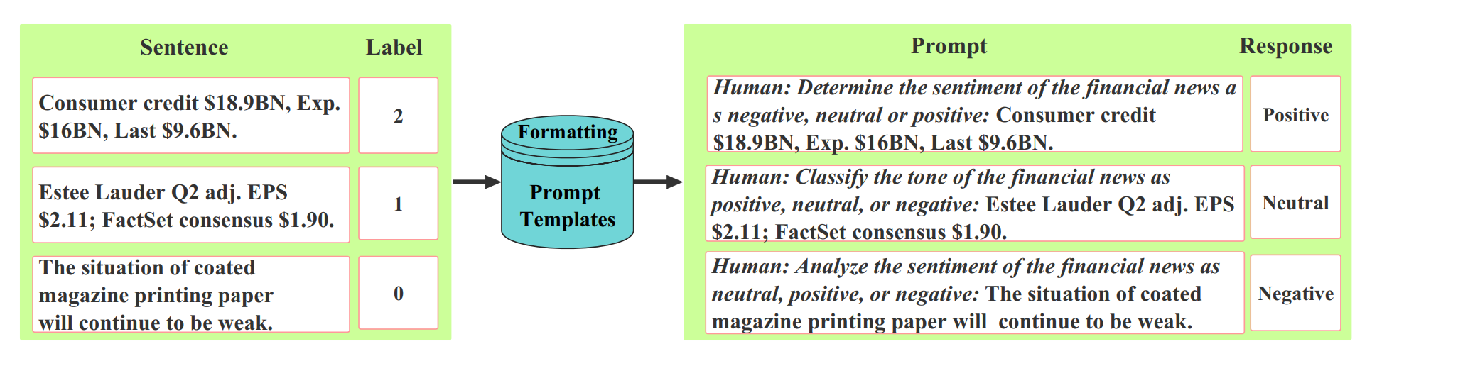
Figure 10: Instruction tuning template for Instruct-FinGPT showing how sentiment data is formatted for LLM processing [37]

Despite significant progress, financial sentiment analysis still faces several limitations that affect its use in trading systems. First, most models treat all news equally regardless of source credibility or article importance [39]. Second, real-time processing remains challenging, with Instruct-FinGPT requiring 498 seconds on 8 A100 GPUs to process 2,388 samples [34]. Third, social media text with slang, sarcasm, and memes remains difficult for formal finance models [37]. Fourth, most studies test sentiment trading over short periods, with some backtests covering only a few months [39], raising questions about long-term performance. Fifth, none of the reviewed systems integrate sentiment analysis with other types of analysis (technical, fundamental, macroeconomic) in a multi-agent framework where agents can share insights and improve based on trading outcomes. Additionally, while some systems combine sentiment with prediction models [35], none implement continuous feedback loops where sentiment analysis prompts are optimised based on actual trading performance. These gaps highlight the opportunity for a multi-agent system where a dedicated Sentiment Analyst agent works parallely with Technical, Fundamental, and Macro Analysts, with dynamic prompt optimisation that improves sentiment interpretation based on whether trading decisions led to profits or losses.

2.5 LLM Agent Frameworks

Large Language Models are powerful on their own, but they struggle with complex tasks which require multiple steps, long-term planning, and interaction with external tools. When used directly without any framework, LLMs often produce inconsistent outputs, engage in unnecessary conversation, and suffer from hallucinations that get worse when multiple LLM calls are chained together [40]. Agent frameworks solve these problems by giving LLMs structure, memory, and the ability to use tools, allowing them to work on tasks that would be impossible with simple prompting.

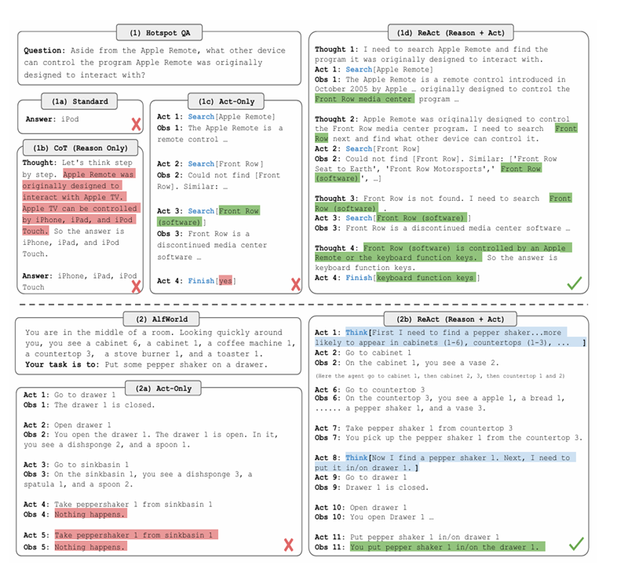
Figure 11: Comparison of Standard prompting, Chain-of-Thought, Act-only, and ReAct approaches across question-answering and decision-making tasks [41]

Chain-of-Thought prompting has shown that asking LLMs to reason step-by-step increase performance on multi-step problems, increasing the GSM8K solve rate from 18% to 57% [41]. However, it only works reliably in very large models and provides no guarantee that reasoning steps are factually correct [41]. ReAct extended this by interleaving reasoning with external tool use, reducing hallucinations significantly and achieving a 34% improvement on ALFWorld decision-making tasks, though agents can fall into repetitive thought-action loops when search results are unhelpful [42], [43], [44]. Reflexion introduced verbal reinforcement learning where agents reflect on failures in natural language, achieving 91% accuracy on HumanEval coding tasks and surpassing GPT-4's 80.1%, though memory is directly connected with context window size and the approach can get stuck in local minima where the agent keeps repeating similar mistakes [45].

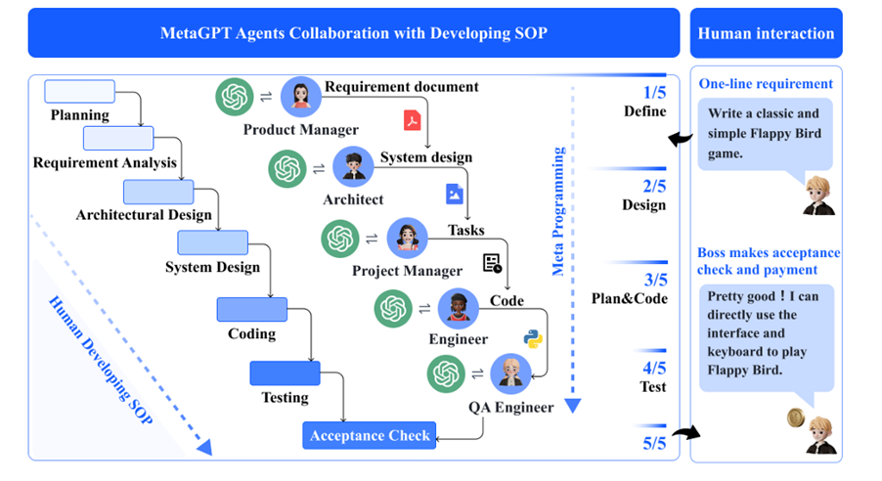
Figure 12: MetaGPT framework showing software development SOPs with different agent roles (Product Manager, Architect, Engineer, QA) and the shared message pool for communication [40]

While these single-agent reasoning improvements shown significant progress, the growing complexity of real-world tasks led researchers to explore how multiple specialised agents could collaborate more effectively within structured frameworks. MetaGPT formalised multi-agent collaboration through Standardised Operating Procedures assigning distinct roles to each agent, achieving 100% task completion on software development benchmarks and demonstrating that structured role division outperforms unstructured agent interaction [40], [46]. Generative Agents pushed this further by simulating 25 autonomous agents in a virtual environment, each with a memory stream fetching experiences based on recency, importance, and relevance [47]. These agents shown new social behaviours such as forming relationships and coordinating group activities without any manual scripting, showing that complex dynamics can emerge from simple agent architectures when memory and reflection are properly implemented [47]. A detailed survey of multi-agent communication structures identified layered, decentralised, centralised, and shared message pool architectures, finding that debate mechanisms improve factuality but hallucinations have a cascading effect where misinformation from one agent spreads to others [48].
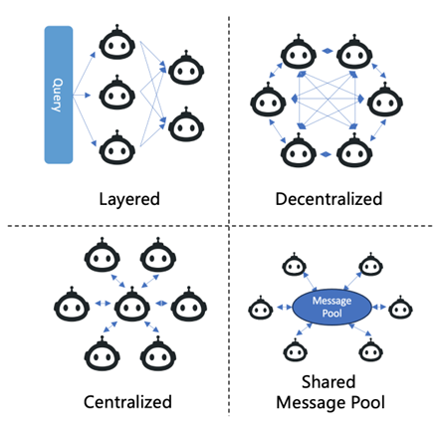
Figure 13: Four typical communication structures for multi-agent systems: Layered, Decentralised, Centralised, and Shared Message Pool [48]

Despite these advances, no existing framework is specifically designed for financial markets where decisions must be made quickly and mistakes carry direct monetary consequences [40], [41], [42], [45], [47], [48]. No framework implements continuous prompt optimisation based on real trading outcomes, collaborative financial analysis across technical, fundamental, sentiment, and macroeconomic agents, or dynamic trailing stop-loss mechanisms. These gaps highlight the need for a purpose-built multi-agent framework for portfolio management with integrated risk management and performance-driven prompt optimisation.

2.6 Financial Large Language Models

Applying Large Language Models to finance presents has n number of unique challenges, as financial information becomes outdated within hours, markets shift constantly, and proprietary models such as BloombergGPT carry training costs of approximately $3 million that place which filter most of the researcher[49]. FinGPT addressed this by introducing a data-centric five-layer framework using lightweight fine-tuning methods such as LoRA, reducing adaptation costs to approximately $300 while achieving 82.1% sentiment accuracy through Reinforcement Learning on Stock Prices, significantly outperforming both zero-shot ChatGPT and BloombergGPT [49]. PIXIU complemented this with a comprehensive ecosystem comprising the FinMA model, a 136K sample instruction dataset, and the FLARE evaluation benchmark, achieving state-of-the-art results on sentiment and news classification though struggling with quantitative reasoning due to limited mathematical pretraining [50].
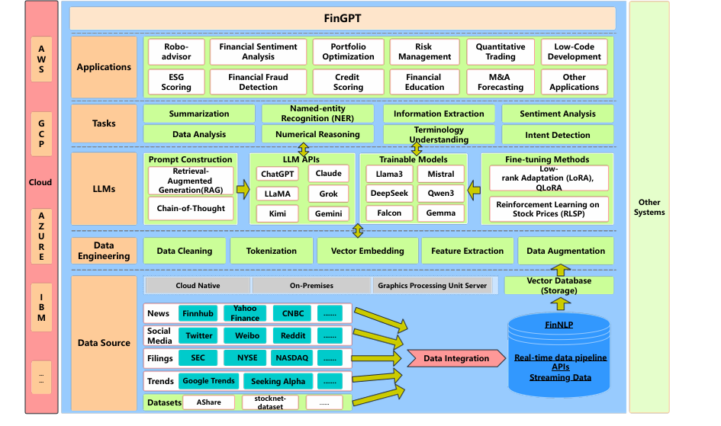
Figure 14: FinGPT five-layer framework showing Data Source, Data Engineering, LLMs, Tasks, and Applications layers for financial language model deployment [49]

Beyond sentiment, LLMFactor applied Sequential Knowledge-Guided Prompting to extract explainable price-moving factors from news, achieving 63% accuracy on US markets and outperforming baselines by up to 11% in Matthews Correlation Coefficient [51]. The SEP framework further advanced this work by combining summarisation, explanation, and prediction with PPO self-reflection, enabling more strong directional predictions from mixed sentiment signals [52], [53]. A comprehensive Financial AI survey highlights a persistent gap between theoretical advances and practical deployment, noting that resource-intensive models carry latency that makes them impractical for real-time trading [54].

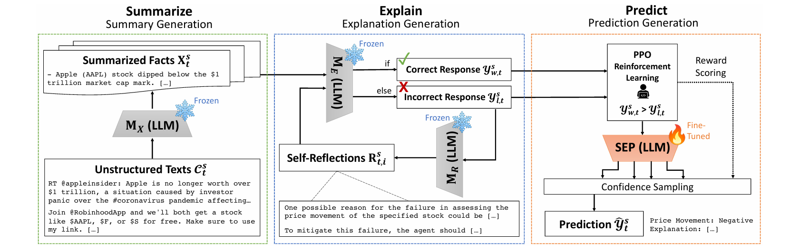
Figure 15: SEP framework showing Summarize, Explain, and Predict modules with self-reflective loop for generating explainable stock predictions [52]

Despite this progress, no reviewed model operates within a multi-agent architecture where specialised LLMs collaborate across different analytical domains, and none implement continuous prompt optimisation driven by actual trading outcomes over extended periods [49] , [50] , [51] , [52]. These gaps directly motivate the proposed framework combining multiple specialised agents with dynamic prompt optimisation based on real portfolio performance.

2.7 Research Gap Table

Below is the top-10 research that I find most useful for my state-of-art.

Summary of the Literature Review
No. | Category | Title | Author(s) | Year of Publication | Journal Name | Findings | Relevance to my research | Gap analysis
1 | Multi-Agent Trading | TradingAgents: Multi-Agents LLM Financial Trading Framework | Xiao, Sun, Luo, Wang | 2025 | arXiv | Introduced a multi-agent framework with specialised roles (Analyst, Researcher, Trader, Risk Manager) that outperformed buy-and-hold strategies with Sharpe ratios above 8.0 during calm market periods. | This paper underpins my research by demonstrating that multi-agent architectures with role specialisation can improve trading performance compared to single-model approaches. The division of labour concept directly informs my 7-agent design. | The research gap is that TradingAgents uses static prompts that do not adapt based on trading outcomes, tested only for 3-6 months during calm markets, and lacks a Macro Analyst agent for macroeconomic factors.
2 | Multi-Agent Trading | FINCON: A Synthesized LLM Multi-Agent System with Conceptual Verbal Reinforcement | Yu, Yao, Li, et al. | 2024 | arXiv | Proposed a Manager-Analyst hierarchy with Conceptual Verbal Reinforcement where managers provide natural language feedback to analysts, achieving 37% improvement in Profit and Loss metrics. | This paper supports my research by showing that verbal feedback between agents can improve decision quality. The Manager-Analyst structure informs my Stock Picker and Analyst agent relationships. | The research gap is that FINCON's feedback operates at signal level rather than system-wide trading outcomes, uses CVaR alerts rather than automated trailing stop losses, and lacks continuous prompt optimisation.
3 | Prompt Optimisation | DSPy: Compiling Declarative Language Model Calls into Self-Improving Pipelines | Khattab, Singhvi, Maheshwari, et al. | 2024 | arXiv | Introduced a programming model that treats LLM pipelines as text transformation graphs, improving accuracy from 33% to 82% on GSM8K within minutes of compiling through automatic prompt optimisation. | This paper is fundamental to my research as DSPy provides the technical foundation for implementing dynamic prompt optimisation across my multi-agent system. The Signatures, Modules, and Teleprompters architecture directly enables my feedback loop mechanism. | The research gap is that DSPy focuses on single tasks like question answering and mathematics, with no application to multi-agent trading systems where prompts must be optimised based on real financial outcomes.
4 | Prompt Optimisation | GEPA: Reflective Prompt Evolution Can Outperform Reinforcement Learning | Agrawal, Tan, Soylu, et al. | 2024 | arXiv | Demonstrated that reflective prompt evolution outperforms RL methods like GRPO by 6% on average while using 35x fewer rollouts, and applied prompt optimisation to financial calculations using the CAPM formula. | This paper validates my approach by proving that prompt evolution can work in financial contexts. The Pareto-based selection for maintaining diverse top-performing prompts informs my feedback loop design. | The research gap is that GEPA demonstrated only single financial calculations (CAPM) rather than continuous trading decisions, and does not implement feedback based on actual portfolio performance over time.
5 | Reinforcement Learning | FinRL: Deep Reinforcement Learning Framework to Automate Trading in Quantitative Finance | Liu, Yang, Gao, Wang | 2021 | ICAIF 2021 | Created a three-layer framework achieving 52.61% annualized return with Sharpe ratio of 2.81 using an ensemble strategy, incorporating technical indicators, fundamental data, and sentiment. | This paper informs my research by demonstrating the effectiveness of combining multiple data sources for trading decisions. The training-testing-trading pipeline concept supports my simulation methodology. | The research gap is that FinRL uses fixed RL algorithms without prompt optimisation, suffered large drawdowns during COVID-19, and has a significant simulation-to-reality gap.
6 | Reinforcement Learning | FLAG-TRADER: Fusion LLM-Agent with Gradient-based Reinforcement Learning for Financial Trading | Xiong, Deng, Wang, et al. | 2025 | arXiv | Combined a small LLM (SmolLM2-135M) with PPO to achieve 46.799% composite return, outperforming larger models like GPT-4o by using policy gradient optimisation to update LLM parameters based on trading rewards. | This paper supports my research by proving that small, task-specific LLMs can outperform large general models for trading. The concept of using trading rewards to improve the model directly relates to my feedback loop. | The research gap is that FLAG-TRADER fine-tunes model weights which is expensive, rather than optimising prompts which is cheaper and more flexible. It also uses a single agent rather than multiple specialised agents.
7 | Sentiment Analysis | Sentiment Trading with Large Language Models | Kirtac, Germano | 2024 | Finance Research Letters | Fine-tuned OPT model achieved 74.4% accuracy in predicting return directions, with a long-short strategy yielding 355% cumulative returns and Sharpe ratio of 3.05 from 2021-2023. | This paper validates my Sentiment Analyst agent by demonstrating that LLM-based sentiment analysis significantly outperforms dictionary-based methods and can generate profitable trading signals. | The research gap is that this approach focuses solely on sentiment without integrating technical, fundamental, or macroeconomic analysis. My research combines sentiment with other analysis types in a multi-agent framework.
8 | LLM Agents | MetaGPT: Meta Programming for a Multi-Agent Collaborative Framework | Hong, Zhuge, Chen, et al. | 2024 | arXiv | Introduced Standardized Operating Procedures (SOPs) for multi-agent coordination, achieving 100% completion rate on software development with agents communicating through a shared message pool. | This paper informs my multi-agent architecture by demonstrating that structured communication protocols and role specialisation improve output quality. The shared message pool concept directly influences my market_summary aggregation approach. | The research gap is that MetaGPT focuses on software development rather than trading, does not incorporate real-time market data, and lacks feedback mechanisms based on task outcomes.
9 | LLM Agents | Reflexion: Language Agents with Verbal Reinforcement Learning | Shinn, Cassano, Berman, et al. | 2023 | arXiv | Achieved 91% accuracy on HumanEval by using verbal self-reflection to learn from mistakes, storing reflective text in episodic memory to avoid repeating errors. | This paper directly supports my feedback loop mechanism by demonstrating that agents can improve through verbal reflection on failures. The episodic memory concept informs how my system stores and uses past trading outcomes. | The research gap is that Reflexion focuses on coding tasks with clear right/wrong answers, while trading outcomes are probabilistic and context-dependent. My research adapts verbal reflection to financial performance metrics.
10 | Financial LLMs | FinGPT: Open-Source Financial Large Language Models | Yang, Liu, Wang | 2023 | FinLLM @ IJCAI 2023 | Introduced RLSP (Reinforcement Learning on Stock Prices) using actual stock movements as feedback, achieving 82.1% accuracy at $300 fine-tuning cost versus $3 million for BloombergGPT. | This paper supports my research by proving that market-aligned feedback improves financial LLM performance. The low-cost LoRA fine-tuning approach validates my choice of using Groq API with smaller models. | The research gap is that FinGPT focuses on single-task sentiment analysis without multi-agent coordination, and retraining frequently remains expensive. My research uses prompt optimisation instead of model fine-tuning.

3. Methodology

3.1 Overview of the Proposed Framework

Financial markets are becoming increasingly complex and fast-moving, creating a need for portfolio management systems that can process large amounts of information and adapt to changing conditions without human intervention. This research proposes a fully autonomous seven-agent framework that addresses the limitations of existing static systems by combining multi-agent collaboration with dynamic prompt optimisation and a self-correcting feedback loop.
Rather than relying on a single model, the framework distributes financial analysis across seven specialised agents each powered by a Large Language Model. The Technical Analyst examines price and volume data, the Fundamental Analyst reviews company financials, the Sentiment Analyst monitors news and social media platforms including Reddit and X, and the Macro Analyst tracks broader economic indicators such as interest rates and inflation. The Stock Picker then consolidates all incoming signals to determine whether to buy, hold, or short each security alongside a conviction level, whilst the Risk Manager independently sets stop-loss and take-profit thresholds based on ATR and VIX volatility measures. Both agents receive a daily plain-English performance context allowing them to adjust their behaviour in response to recent losses or declining signal accuracy.
A key innovation is the use of the DSPy framework to automatically update agent instructions based on portfolio performance, ensuring the system continuously adapts as market conditions evolve. After each 10-day trading chunk the system evaluates performance across accuracy, returns, Sharpe ratio, and drawdown, and uses these results to trigger prompt optimisation where needed. The framework also introduces dynamic trailing stop-losses and profit targets that are continuously recalculated as each trade progresses, locking in gains on winning positions and allowing strongly performing trades to run for as long as momentum continues.

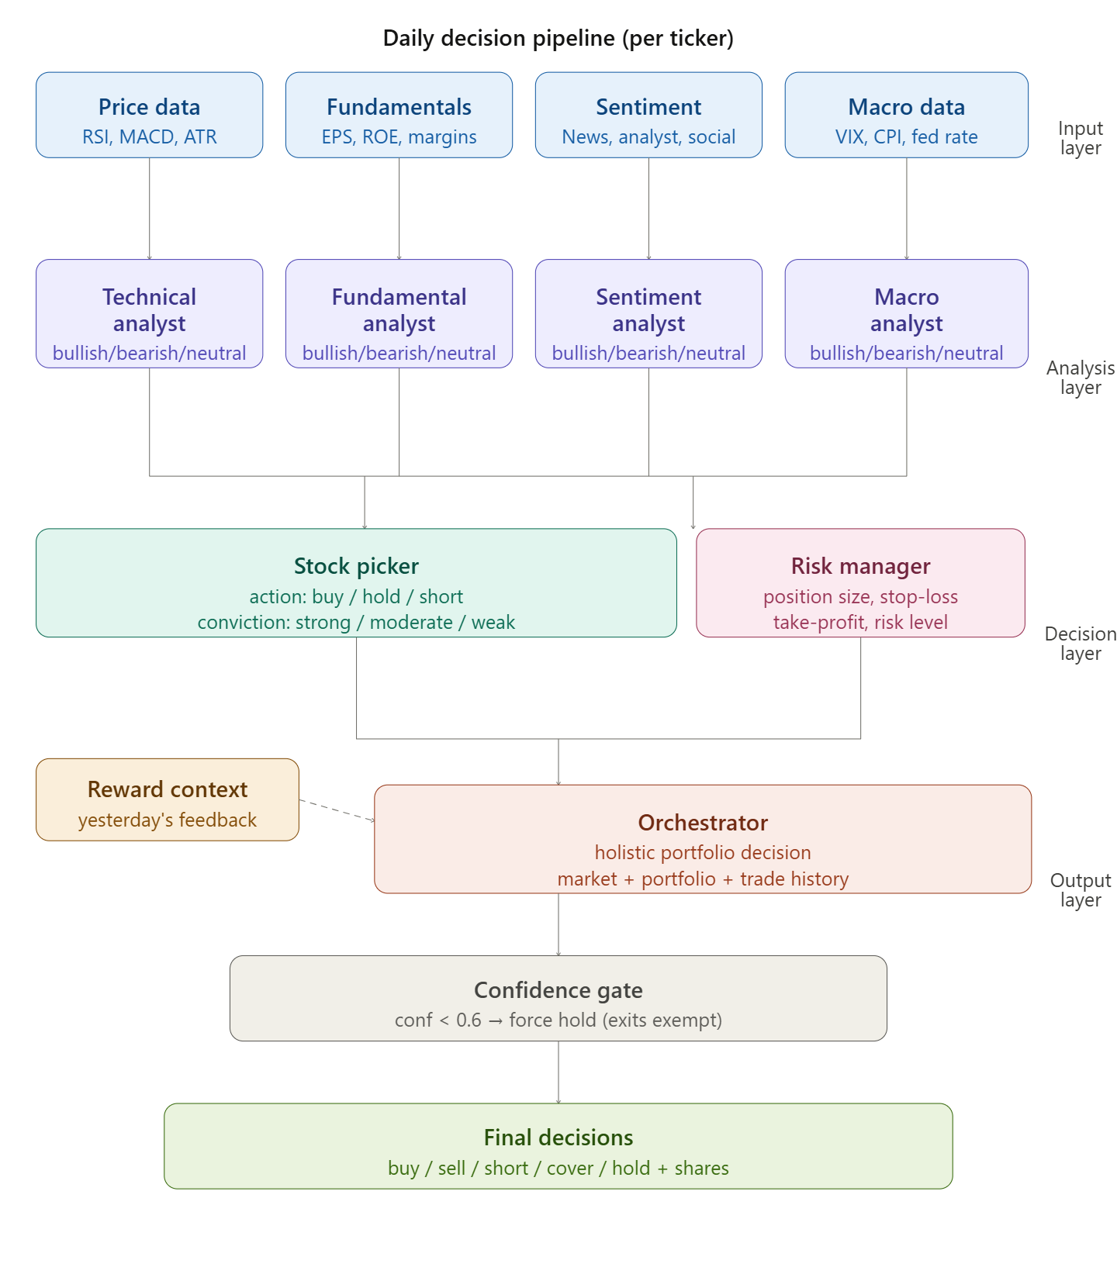
Figure 16: Daily decision pipeline showing how seven specialised agents process financial data and collectively produce final trading decisions.

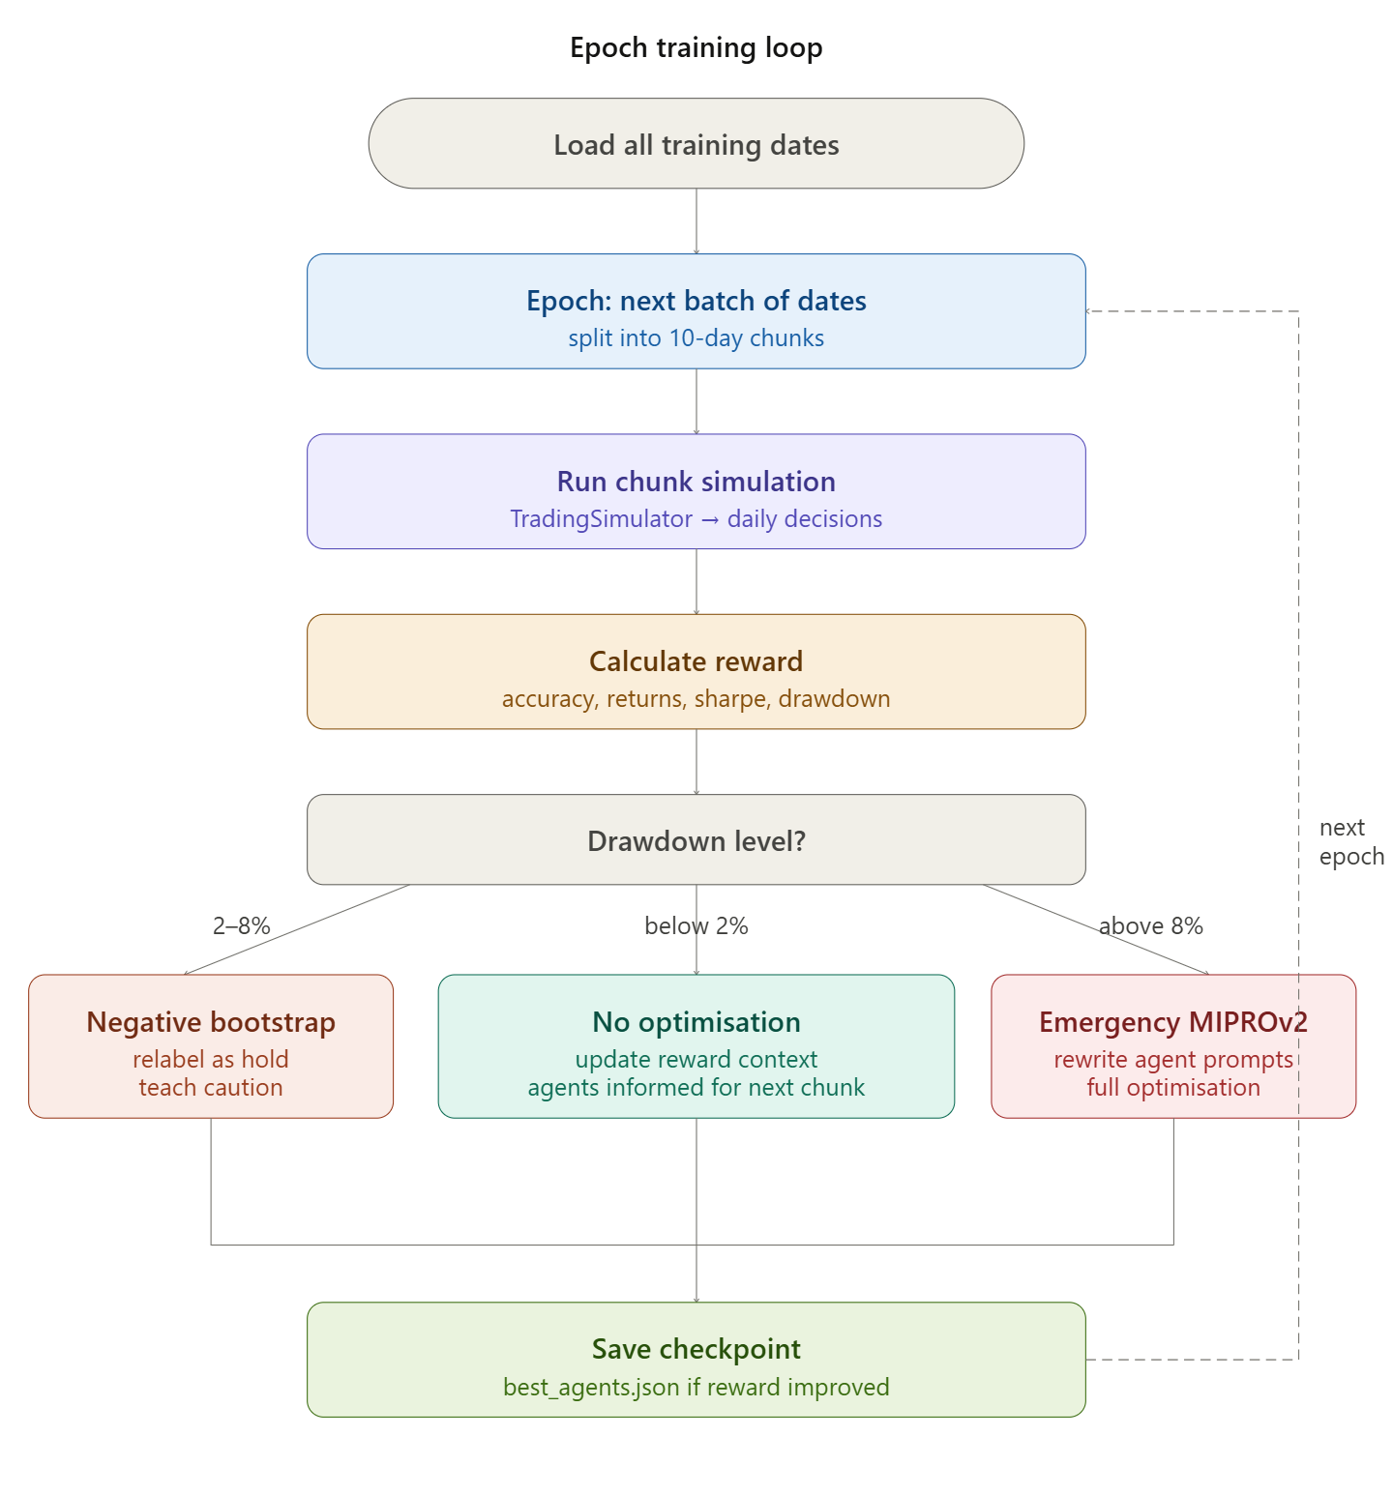
Figure 17: Epoch training loop illustrating how the framework simulates trading, evaluates reward, and self-corrects agent prompts based on drawdown level.

$$Π^{*}=\arg{\max_{θ_{1},…,θ_{6}}{\sum_{t=1}^{T}{R\left(O\left(\bigcup_{i=1}^{4}{f_{i}\left(x_{t};θ_{i}\right)},P_{t},H_{t}\right)\right)}}}$$

Master Portfolio Optimisation Formula

$$R=0.30×\frac{\overline{r}-r_{f}}{σ_{r}}\sqrt{252}+0.25×\frac{V_{T}-V_{0}}{V_{0}}-0.20×τ - 0.15×MDD+0.10×A$$

Reward function formula
Where
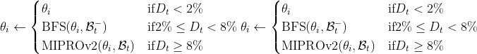

Optimisation criteria

And ${\text{Position}}_{t}=\min\left(V_{t},C_{t}\right)×0.10×m_{t}$

And ${\text{Stop}}_{t+1}=\max\left({\text{Stop}}_{t},P_{t}×\left(1-δ_{t}\right)\right)$

Where:

Symbol | Definition
$$Π^{*}$$ | Optimal portfolio policy maximising composite reward
$$θ_{1},…,θ_{6}$$ | Prompt parameters of the six optimisable agents
$$T$$ | Total number of trading days in simulation
$$f_{i}\left(x_{t};θ_{i}\right)$$ | Output of analytical agent $i$given input data $x_{t}$and prompt $θ_{i}$
$$O$$ | Orchestrator decision function
$$P_{t}$$ | Current portfolio state at time $t$
$$H_{t}$$ | Five-day trading history at time $t$
$$R$$ | Composite reward function
$$\overset{ˉ}{r}$$ | Mean daily portfolio return
$$r_{f}$$ | Risk-free rate
$$σ_{r}$$ | Standard deviation of daily returns
$$V_{T}$$ | Final portfolio value
$$V_{0}$$ | Initial portfolio value
$$τ$$ | Turnover penalty
$$\text{MDD}$$ | Maximum drawdown
$$A$$ | Signal accuracy
$$D_{t}$$ | Portfolio drawdown at chunk $t$
$$\text{BFS}\left(θ_{i},B_{t}^{-}\right)$$ | Negative BootstrapFewShot optimisation of prompt $θ_{i}$
$$\text{MIPROv2}\left(θ_{i},B_{t}\right)$$ | Emergency MIPROv2 full prompt rewrite
$$V_{t}$$ | Total portfolio value at time $t$
$$C_{t}$$ | Available cash at time $t$
$$m_{t}$$ | Conviction multiplier at time $t$
$$P_{t}$$ | Stock price at time $t$
$$δ_{t}$$ | Stop-loss percentage determined by Risk Manager
$$\bigcup_{i=1}^{4}{f_{i}}$$ | Union of all four analytical agent outputs

3.2 System Architecture

The proposed framework follows a hierarchical multi-agent architecture organised into three distinct layers, namely a data layer, an analysis layer, and a decision layer, each playing a clearly defined role in the daily decision-making pipeline.
The foundation of the framework is the data layer, which collects and organises raw financial information each trading day covering market price and volume data, company financial statements, news articles, social media content from platforms such as Reddit and X, and broader macroeconomic indicators. Each data source is carefully assigned to the agent best suited to interpret it, ensuring every piece of information is processed with the appropriate analytical focus.
Building on this foundation, the analysis layer contains four specialised agents, namely the Technical Analyst, Fundamental Analyst, Sentiment Analyst, and Macro Analyst, each responsible for processing a specific category of financial data and producing a directional signal classified as bullish, bearish, or neutral alongside a confidence score reflecting the strength of its assessment. Once all four agents have completed their analysis, their outputs are passed to the decision layer through a structured message passing approach, aggregating all signals into a comprehensive market summary string combined with the current portfolio state, five-day trading history, and a plain-English performance summary before being passed to the Orchestrator.
It is important to note that all agents execute sequentially rather than in parallel due to Groq API rate limits, ensuring each agent operates on complete information before the next stage begins. This sequential execution does not diminish the collaborative nature of the system since every decision made by the Orchestrator is informed by the fully consolidated outputs of all six preceding agents. The Orchestrator itself serves as the seventh and final agent, taking a holistic portfolio-wide view and issuing final trade instructions for every security under consideration. These instructions then pass through a confidence gate that automatically overrides any new position entry with a confidence score below 0.6 with a hold instruction, whilst always allowing exit instructions to execute regardless of confidence level, ensuring the system can always close an existing position during periods of market uncertainty.

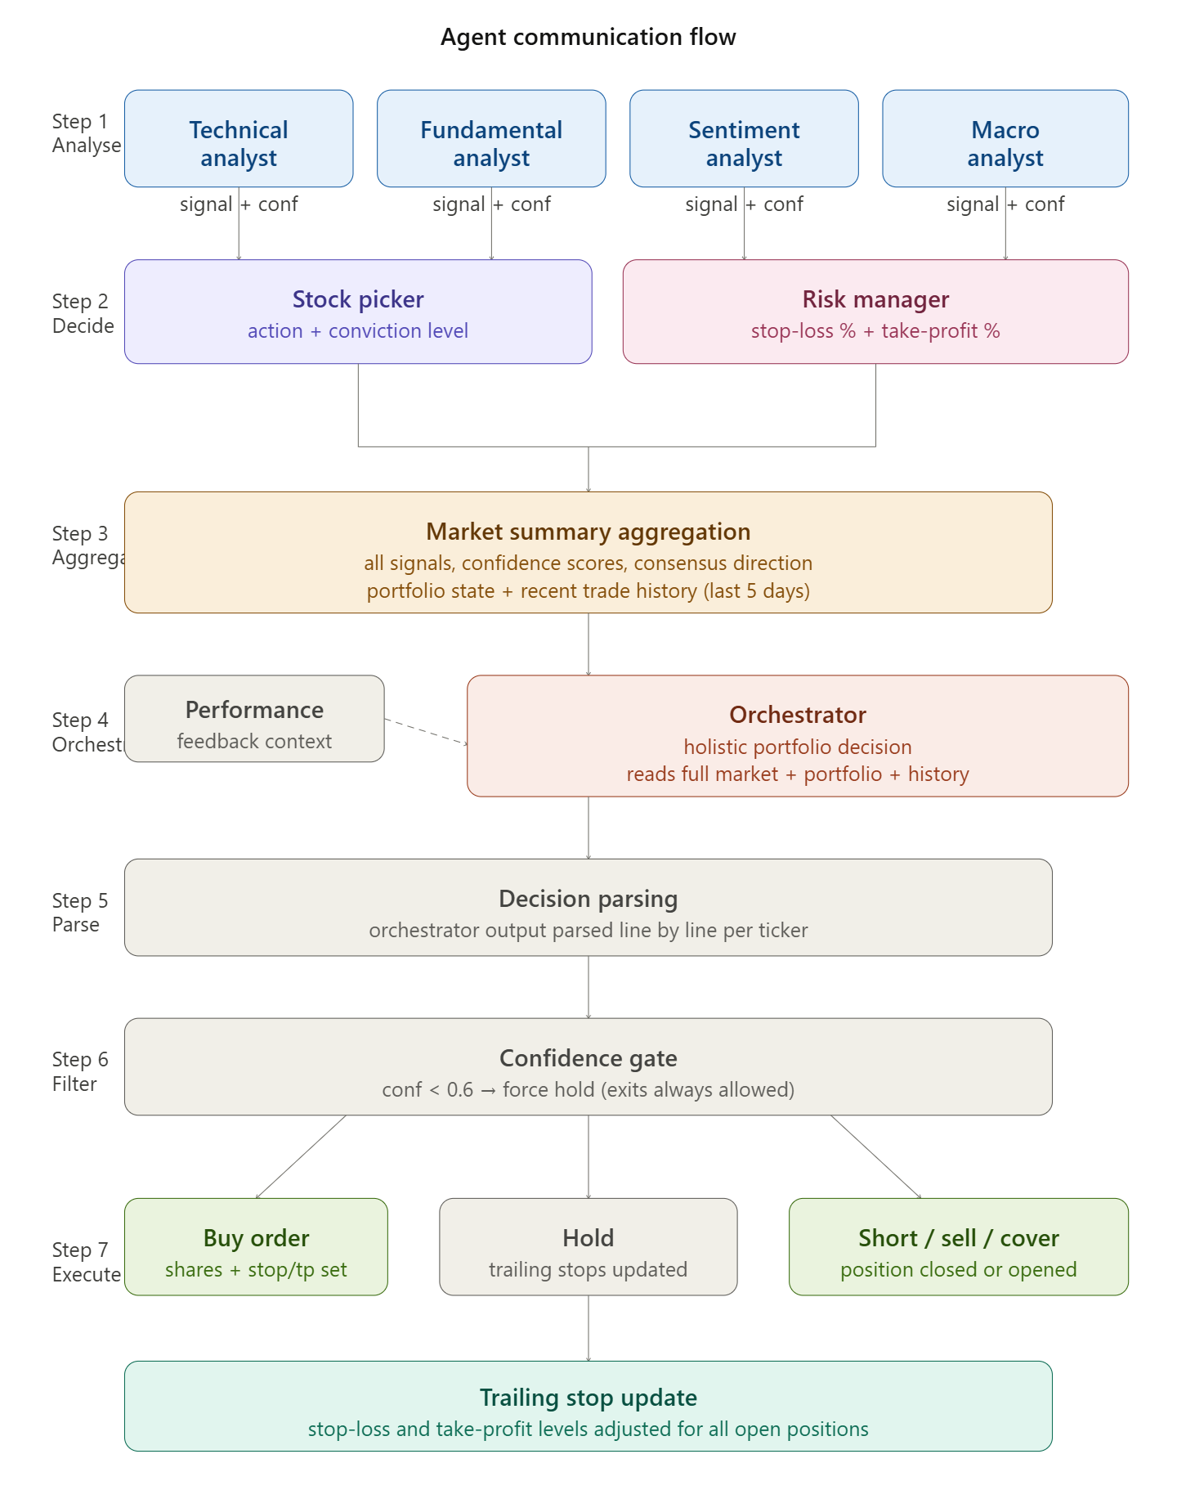
Figure 18: The agent communication flow showing the sequential passage of information from analytical signal generation through market summary aggregation, Orchestrator decision-making, confidence filtering, and final trade execution.

3.3 Specialised Agents

3.3.1 Technical Analyst

The Technical Analyst agent is responsible for studying historical price and volume data to identify potential trading opportunities and identify in which direction the market is moving. The agent receives a range of widely used technical indicators as inputs, which include the 14-day Relative Strength Index, the Moving Average Convergence Divergence and its signal line, the 50-day and 200-day Simple Moving Averages, the 14-day Average True Range, and a textual summary of recent price history. These indicators are fed into the agent's Large Language Model-powered reasoning module, which interprets the combined picture of momentum, trend direction, and volatility to produce a structured directional signal classified as bullish, bearish, or neutral, alongside a confidence score between zero and one reflecting the strength of the technical case for that signal. This output serves as the first of four analytical inputs that feed into the Stock Picker and Risk Manager agents further down the pipeline.

3.3.2 Fundamental Analyst

The Fundamental Analyst looks under the surface of a stock’s price movement by examining different types of financial metrics sourced from company financial statements and earnings reports. The agent takes in a range of financial inputs, which include revenue figures, net income, earnings per share, return on equity, return on assets, debt-to-equity ratio, profit margin, and revenue growth rate, assessing each metric in the context of what it reveals about the underlying business quality and valuation. The agent's reasoning module uses these inputs to determine whether a stock appears fundamentally strong and attractively valued, producing a directional signal of bullish, bearish, or neutral alongside a confidence score. This fundamental perspective complements the technical signals produced by the Technical Analyst by grounding the analysis in the company's actual financial performance rather than relying solely on price behaviour.

3.3.3 Sentiment Analyst

The Sentiment Analyst agent capture the ongoing mood of the market by analysing textual data, collected from multiple sources parallel, including financial news articles, analyst sentiment reports, and social media platforms such as Reddit and X. Previous method which used to highly depend on keyword counting or dictionary-based approaches, this agent uses the natural language understanding capabilities of Large Language Model to capture the tone, context, and significance of relevant content, producing an overall sentiment signal of bullish, bearish, or neutral alongside a confidence score. This real-time window into investor behaviour and market psychology is particularly valuable because shifts in sentiment frequently precede movements in stock prices, allowing the framework to act on emerging market mood before those shifts are reflected in technical indicators or financial data. The sentiment signal produced by this agent provides the Stock Picker with an important dimension of analysis that purely quantitative agents are unable to capture.

3.3.4 Macro Analyst

The Macro Analyst agent examines country-level macroeconomic variables that have a meaningful bearing on broader market conditions and individual stock valuations. The agent receives inputs, including the VIX volatility index, the Federal Reserve interest rate, the Consumer Price Index, and the year-on-year CPI inflation figure, using these to build a contextual understanding of the macroeconomic environment in which trading decisions are being made. By monitoring these broader economic forces, the agent is able to identify conditions that may create tailwinds or headwinds for equity markets as a whole, producing a macro signal of bullish, bearish, or neutral alongside a confidence score. This macroeconomic perspective is a distinguishing feature of the proposed framework, as the majority of existing multi-agent trading systems reviewed in the literature do not include a dedicated agent for macroeconomic analysis, despite the well-established influence of interest rates, inflation, and market volatility on stock price movements.

3.3.5 Stock Picker

The Stock Picker agent is one of the most important agents in the decision-making process and is responsible for aggregating the signals from the four analytical agents into a single, clear recommendation for each stock. It receives the directional signals and confidence scores from the Technical, Fundamental, Sentiment, and Macro Analysts alongside the stock's current price and a summary of how the portfolio has been performing recently, using all of this information to decide whether the right course of action is to buy, short sell, or hold the stock. One of the most distinctive features of the Stock Picker is the way it calculates conviction. Rather than relying solely on what the language model thinks, the agent combines the LLM's own conviction assessment with a separately computed conviction score that counts how many of the four analysts are pointing in the same direction. If three or more analysts agree, or if two agree and the average confidence score across all analysts is above 0.70, the conviction is classified as strong. If two analysts agree or the average confidence is above 0.60, the conviction is classified as moderate, and anything below this is classified as weak. The final conviction level is then taken as whichever of the two scores is higher, meaning the system always uses the most confident assessment available, whether that comes from the language model's reasoning or from the measurable agreement among the analysts.

3.3.6 Risk Manager

The Risk Manager agent is responsible for assessing the risk profile of each proposed trade and determining the parameters that govern how that trade will be managed throughout its life. The agent receives the current stock price, the 14-day Average True Range, the VIX volatility index, the current portfolio value, the size of any existing long or short position in the stock, and the directional signals from all four analyst agents, alongside a summary of recent portfolio performance. Using these inputs, the agent determines an overall risk level for the proposed trade, classified as low, medium, or high, and calculates the appropriate position size as a percentage of the total portfolio value, the stop-loss percentage defining how far the price can move against the position before it is closed, and the take-profit percentage defining the target gain at which the position should be considered for exit.
It is important to note that whilst the Risk Manager determines the stop-loss and take-profit percentages, the actual number of shares to trade is calculated separately by the trading simulator based on the conviction level produced by the Stock Picker, with strong conviction allowing up to 1.5 times the maximum position size, moderate conviction allowing the standard maximum, and weak conviction allowing only half of it.

3.3.7 Orchestrator

The seventh agent in the pipeline is the orchestration agent, which has a unique way of operating, unlike other agents. It operates at the portfolio level rather than the individual stock level. While every other agent in the framework focuses on a specific job for one particular ticker at a time, the Orchestrator looks at the entire portfolio before making any decisions. Detail view that has been passed Orchestrator agent includes market summary aggregating the signals, confidence scores, consensus directions, and risk parameters for every stock that has been considered on that day as well as portfolio summary which describes the current cash position, all open long and short positions with their unrealised profit and loss figures, and flags indicating which positions have crossed their stop-loss or take-profit levels. On top of this, the Orchestrator is also getting the record of the trading decisions that have been made over the past 5 days, along with a plain-English summary of how the portfolio has been performing recently. This summary gives the Orchestrator an honest picture of what has been going wrong recently, for example, whether the portfolio has been losing money, whether too many trades have been placed in a short space of time, or whether the agents have been making poor calls that did not play out as expected. Orchestrator issues final trade instructions based on the information that it has received for every ticker in the format of a specific action and many shares, which are then passed through the confidence gate before execution. This type of decision-making approach ensures that every trade decision is always made with the full portfolio in mind, which prevents the system from making isolated decisions that might be individually reasonable but collectively harmful to overall portfolio performance.

3.4 Data Sources and Collection

The dataset covers six years of financial market activity from January 2015 to December 2020 across 13 securities comprising 11 individual equities and two broad-market ETFs, the SPDR S&P 500 ETF and the Invesco QQQ Trust. Two originally collected securities, Palantir and BlackBerry, were subsequently removed due to insufficient data coverage and very low trading activity respectively. Six distinct data streams are merged at a daily frequency and joined on a shared date and ticker key before label assignment and chronological splitting.
Daily price and volume data are downloaded from Yahoo Finance via yfinance with automatic adjustment for splits and dividends, and seven technical indicators are computed using pandas-ta covering RSI, MACD, SMA 50, SMA 200, and ATR. Three macroeconomic indicators, namely VIX, the Federal Funds Rate, and CPI alongside a year-on-year change series, are retrieved from the Federal Reserve Economic Data service and forward-filled then backward-filled to avoid look-ahead bias. Sell-side analyst ratings are also sourced from Yahoo Finance, converted from free-text strings into numerical scores between negative one and positive one through a three-pass mapping process, and forward-filled so every trading day carries the most recently issued rating.
Financial news sentiment is streamed from a Hugging Face corpus of over 26 million records filtered to the study window and relevant securities. Social media sentiment combines approximately 3.72 million tweets and 250,000 Reddit WallStreetBets posts from Kaggle, though the Twitter dataset only covers up to December 2019, meaning no social media signal is available during the COVID-19 crash period. All text is cleaned, truncated to 300 characters, and scored using Mistral Devstral 2 with 123 billion parameters via the NVIDIA inference API, with daily scores aggregated to a mean per ticker and missing days filled with a neutral value of zero.

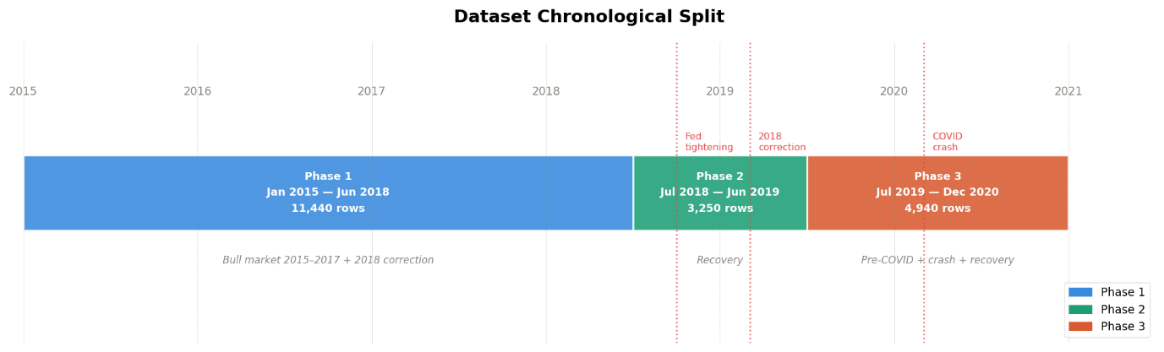
Figure 19: Timeseries-wise dataset split across 2015 to 2020

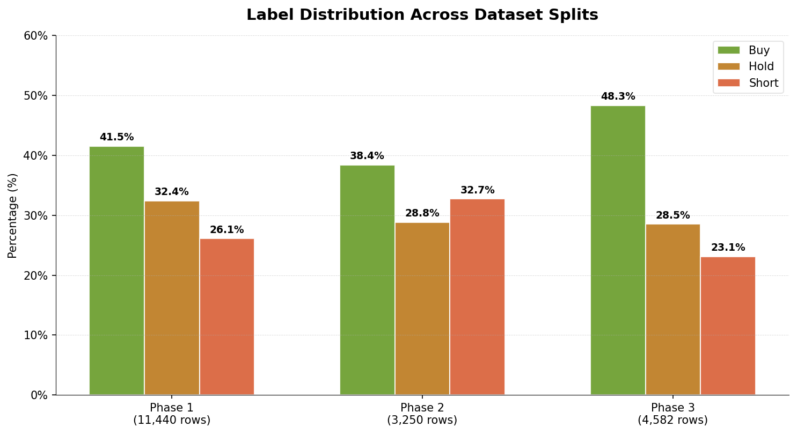
Figure 20: Label across different splits

The ground truth labels used for training and evaluation have been created through the 30-day forward return of each security's adjusted closing price. Normally, we do a 1-day forward return because we don’t know about the 30 days in future, computed within each ticker group independently using a shift of negative 30 periods to ensure no look-ahead bias is present. A symmetric threshold of plus or minus two per cent is used to convert the continuous return into one of three classes, with returns above two per cent labelled as buy, returns below negative two percent labelled as short, and anything falling within this range labelled as hold, with these thresholds chosen to reflect economically meaningful price moves that exceed typical transaction costs. One-day and five-day forward returns are also computed and stored in the dataset as additional contextual information, but play no part in label assignment.
The dataset is divided into three strictly chronological splits with no random shuffling applied at any stage, with the first phase covering January 2015 to June 2018 and containing 11,440 rows, the second phase covering July 2018 to June 2019 and the third phase containing 3,250 rows, and the test set covering July 2019 to December 2020 and containing 4,940 rows in total. The split boundaries were deliberately chosen to align with distinct market regimes, with the training set capturing the bull market of 2015 to 2017 and the 2018 correction, the validation set covering the post-correction recovery, and the test set encompassing the pre-COVID expansion, the COVID-19 market crash, and the subsequent recovery, providing a genuinely challenging out-of-sample evaluation environment.
While the fundamental accounting metrics are not present as columns within the training, validation, and test CSV files, they are incorporated into the system at inference time through a separate lookup mechanism in the data loader, which retrieves the relevant quarterly fundamental metrics for each ticker and date from a separately maintained fundamentals file and passes them directly to the Fundamental Analyst agent as part of each training example.
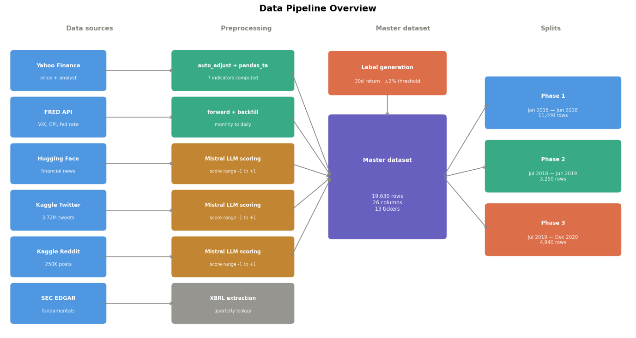
Figure 21: Overall Pipeline overview which represents how the different phase of dataset has been created

Pseudocode for data preparation:

1. // PHASE 1: DATA COLLECTION & CLEANING
2. FUNCTION Initialize_Dataset():
3. SET tickers = [AAPL, TSLA, GME, AMC, AMZN, MSFT, NVDA, AMD, GOOGL, META, NFLX, SPY, QQQ]
4. SET study_period = "2015-01-01" TO "2020-12-31"
5.
6. FOR EACH ticker IN tickers:
7. // 1.1 Market Data
8. DOWNLOAD (Open, High, Low, Close, Vol) FROM YahooFinance
9. APPLY Auto_Price_Adjustment (Splits/Dividends)
10.
11. // 1.2 Technical Indicators
12. CALCULATE RSI(14), MACD(Signal, Hist), SMA(50), SMA(200), ATR(14)
13.
14. // 1.3 Macroeconomic Indicators (FRED)
15. FETCH VIX, Fed_Funds_Rate, CPI
16. CREATE Daily_Date_Spine
17. FOR EACH series IN [Fed_Funds, CPI]:
18. FORWARD_FILL then BACKWARD_FILL to remove look-ahead bias
19. CALCULATE YoY_Change
20.
21. // 1.4 Analyst Sentiment
22. FETCH Analyst_Ratings (Upgrades/Downgrades)
23. MAP Rating_String TO Numerical_Score [-1 to 1]
24. FORWARD_FILL scores per ticker
25.

26. // PHASE 2: ALTERNATIVE DATA & SCORING
27. FUNCTION Process_Sentiment_Streams():
28. STREAM Financial_News FROM HuggingFace
29. LOAD Twitter + Reddit (Kaggle) Dataset (~4M records)
30.
31. FOR EACH record IN News_and_Social:
32. CLEAN text (Remove URLs, Special Characters, User Mentions)
33. TRUNCATE to 300 chars
34. SCORE sentiment using Mistral_7B_Devstral (Range: -1 to 1)
35.
36. AGGREGATE to Daily_Mean_Per_Ticker
37. FILL missing days with 0 (Neutral)
38.

39. // PHASE 3: LABELING & SPLITTING
40. FUNCTION Create_Ground_Truth():
41. FOR EACH ticker IN tickers:
42. CALCULATE Forward_Return_30D = (Price_T+30 - Price_T) / Price_T
43.
44. IF Forward_Return_30D > 0.02 THEN Label = "BUY"
45. ELSE IF Forward_Return_30D < -0.02 THEN Label = "SHORT"
46. ELSE Label = "HOLD"
47.
48. FUNCTION Split_Dataset():
49. TRAIN = [2015-01 TO 2018-06] // 11,440 rows
50. VAL = [2018-07 TO 2019-06] // 3,250 rows
51. TEST = [2019-07 TO 2020-12] // 4,940 rows
52. (No random shuffling applied)

3.5 Dynamic Prompt Optimisation

Rather than relying on fixed, manually crafted prompts, the proposed framework uses the DSPy framework to automatically refine the instructions guiding each agent based on real portfolio performance. After every 10-day simulation chunk, all six optimisable agents receive a plain-English reward context string summarising recent performance across metrics such as drawdown, turnover, and signal accuracy, allowing them to adjust their behaviour immediately without any formal optimisation step.
10-days window was deliberately chosen because the window that is too short such as one or two days, would cause the agent to overreact to normal day-to-day market fluctuations whereas window that is too long such as 30 or 60 days, would delay the system's ability to detect and respond to genuine deterioration in performance before significant losses have already accumulated.
When performance deteriorates further and drawdown crosses two percent, the framework initiates formal prompt optimisation step. If drawdown falls between two and eight percent, a Negative BootstrapFewShot procedure relabels the current chunk's examples as hold, teaching the agents to be more cautious in similar market conditions. If drawdown exceeds eight percent, Emergency MIPROv2 is triggered, which fully rewrites the prompts of all six optimisable agents using a light configuration that balances optimisation quality against computational cost. The six agents whose prompts are optimised are the Technical Analyst, Fundamental Analyst, Sentiment Analyst, Macro Analyst, Stock Picker, and Risk Manager, while the Orchestrator operates on its original prompt throughout, relying solely on its daily performance context to adapt its portfolio-wide decisions.
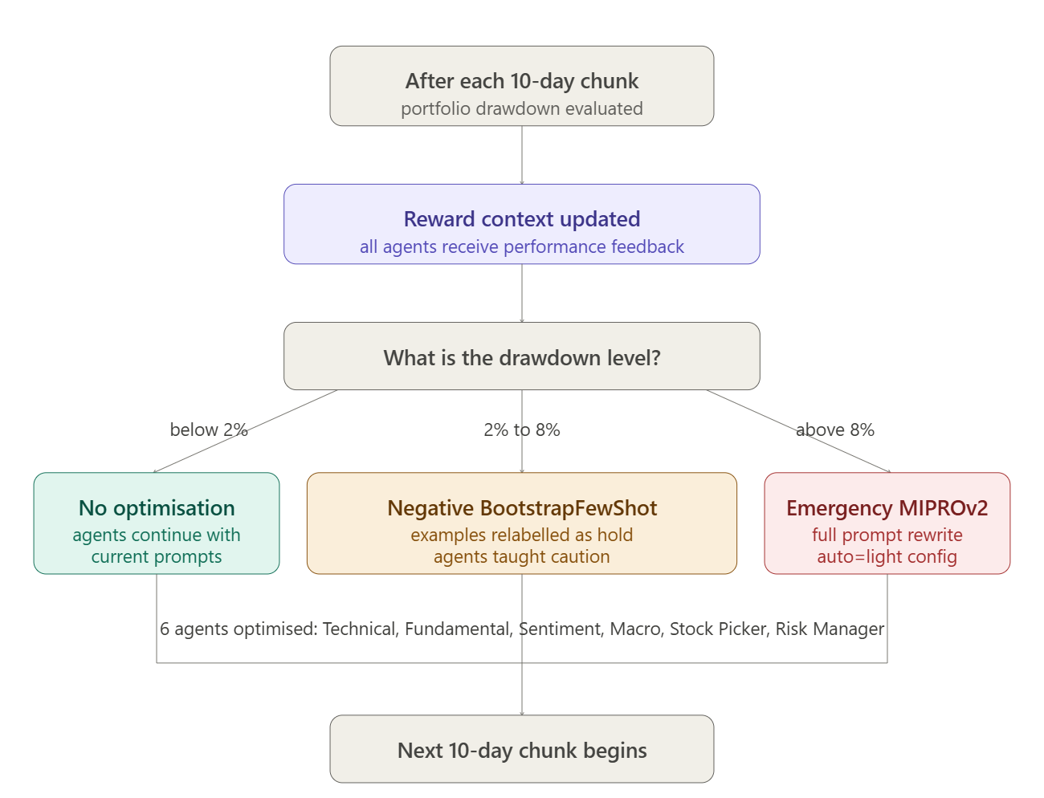
Figure 22: The drawdown-based prompt optimisation decision tree showing the three paths taken after each 10-day simulation chunk

3.6 Feedback Loop and Self-Correction Mechanism

The self-correction mechanism of the proposed framework operates at two distinct levels, working together to ensure the system continuously improves its decision-making without any manual intervention. At the daily level, after every trading day the simulator evaluates the portfolio's performance and constructs a plain-English context string summarising key metrics including daily return, cumulative return, drawdown, number of trades executed, and signal accuracy. This string is passed directly to the Stock Picker, Risk Manager, and Orchestrator agents as part of their input for the following day, allowing them to immediately adjust their behaviour in response to recent outcomes, for example by becoming more conservative when drawdown is elevated or reducing trading frequency when the number of daily trades is excessive.

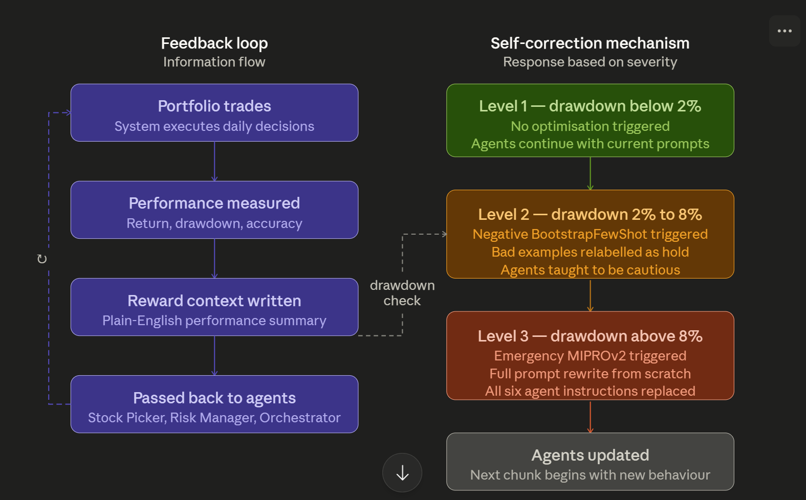
Figure 23: Feedback loop vs self-correct mechanism

At the chunk level, after every 10-day simulation window the system evaluates a broader reward function covering accuracy, returns, Sharpe ratio, drawdown, and turnover, and uses the results to build a richer performance feedback string that is passed to all six optimisable agents before the next chunk begins.
When this chunk-level evaluation reveals that drawdown has crossed one of the two predefined thresholds, the feedback loop escalates from a simple context update to a formal prompt optimisation step as described in Section 3.5, either applying Negative BootstrapFewShot to teach the agents caution or triggering Emergency MIPROv2 to fully rewrite their instructions. Together these two feedback levels create a continuously self-correcting system that responds to poor performance at both the individual day level and the broader simulation window level, ensuring the agents are always operating with the most relevant and up to date guidance available.

3.7 Portfolio Management, Trade Execution and Risk Controls

The portfolio management layer of the proposed framework is responsible for translating the Orchestrator's high-level trade instructions into actual executed positions whilst enforcing a set of risk controls that govern how those positions are sized, monitored, and closed. The framework supports both long and short positions, distinguishing it from the majority of existing automated portfolio management systems that are limited to buy-and-hold strategies. The portfolio is initialised with a starting cash balance of $100,000 and all trades are subject to a transaction cost of 0.1% per trade to reflect realistic execution conditions.
When a buy instruction is received, the number of shares to purchase is calculated by the trading simulator based on the conviction level produced by the Stock Picker agent, with strong conviction allowing up to 1.5 times the maximum position size, moderate conviction allowing the standard maximum of 10% of total portfolio value, and weak conviction allowing only half of that. Short positions follow the same sizing logic in reverse, with the proceeds of the short sale frozen as collateral rather than added to the spendable cash balance, ensuring that short-sale proceeds cannot be reinvested and that the portfolio's true buying power is always accurately reflected.
A minimum holding period of 20 days is enforced for all positions, preventing the system from flipping between long and short on the same ticker within a short window and avoiding the excessive turnover that would otherwise be encouraged by daily signal changes.
Every trade in the system is protected by a dynamic trailing stop-loss and take-profit mechanism that keeps running in the background for as long as the position is open by the Risk Manager. When a trade is first entered, the Risk Manager works out how much risk is acceptable based on how volatile the stock is at that moment, using the Average True Range and the VIX index to get a sense of current market conditions.
At the end of every trading day, these levels are updated by the update_trailing_stops() function, which raises the stop-loss floor for long positions as the stock price rises and lowers the stop-loss ceiling for short positions as the stock price falls, continuously locking in accumulated gains without ever moving the stop in an unfavourable direction. Similarly, take-profit targets are updated dynamically in the favourable direction, allowing winning trades to run for as long as the momentum continues rather than being closed at a fixed target.
Before any new trade is opened, the system checks whether the stock's price has already breached its stop-loss or take-profit level through the check_exit_levels() function, which force-closes any position that has crossed its threshold before the Orchestrator has a chance to act on the alert. This two-layer exit mechanism, combining the Orchestrator's informed decision-making with the automatic force-close safety net, ensures that no position can remain open beyond its risk boundaries, regardless of what the Orchestrator decides on any given day.
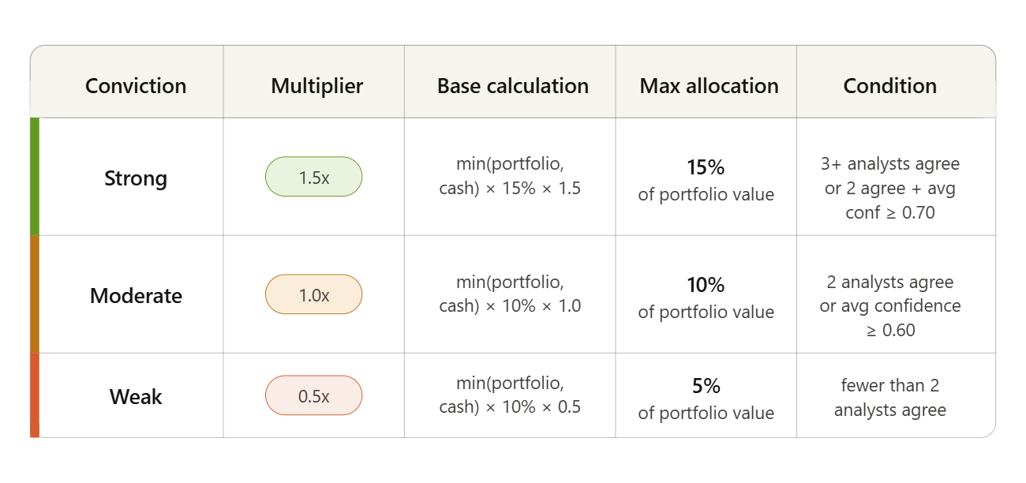
Figure 24: Conviction level mapping showing position size multiplier, base calculation, maximum portfolio allocation, and analyst agreement conditions.

3.8 Experimental Setup

The framework is evaluated through backtesting across two chronological phases, namely Phase 1 covering January 2015 to June 2018 and Phase 3 covering July 2019 to December 2020, encompassing approximately 1,640 trading days across all 13 securities. Phase 2 covering July 2018 to June 2019 is deliberately excluded to reduce the computational cost of running Large Language Model inference across every trading day, given that each trading day requires a minimum of six sequential LLM calls per ticker plus one Orchestrator call for the full portfolio. The decision to retain Phase 1 and Phase 3 specifically was motivated by the desire to evaluate the framework across two qualitatively distinct market regimes, with Phase 1 capturing the extended bull market and 2018 correction, and Phase 3 capturing the pre-COVID expansion, the COVID-19 crash, and the subsequent V-shaped recovery.
The simulation covers 13 securities spanning high-volatility meme stocks such as GME and AMC, large-capitalisation technology equities, and broad-market ETFs. The portfolio is initialised with a starting cash balance of £100,000 and all trades are subject to a transaction cost of 0.1% per trade applied at both entry and exit. All agents are powered by Llama 3.1 8B served via the Groq API, chosen for its speed and cost efficiency given the volume of inference calls required across a multi-year simulation. A fixed random seed of 42 is used throughout to ensure full reproducibility of results.
The framework is benchmarked against a SPY buy-and-hold passive strategy representing the minimum performance bar any active trading system should aim to exceed.

Table 1: Key hyperparameters used in the back-testing experiment across portfolio, simulation, and optimisation settings
Experimental Hyperparameters
Hyperparameter | Value | Description
Portfolio settings
Starting cash | $100,000 | Initial portfolio value
Transaction cost | 0.1% per trade | Applied at entry and exit
Max position size | 10% of portfolio | Base allocation cap
Min holding period | 20 days | Before sell or position reverse
Simulation settings
History window | 10 days | Historical context per agent input
Chunk size | 10 days | Per optimisation evaluation cycle
Confidence gate | 0.6 | Minimum score to open new position
Random seed | 42 | Ensures full reproducibility
Optimisation thresholds
Bootstrap drawdown | 2% to 8% | Triggers Negative BootstrapFewShot
Emergency MIPROv2 | Above 8% | Triggers full prompt rewrite
MIPROv2 config | auto = light | Balances quality vs compute cost

3.9 Evaluation Metrics

The performance of the proposed framework is benchmarked using a composite reward function. It combines five evaluation metrics. Each of them is weighted to show its relative importance in real-world portfolio management, as summarised in Table 2. The Sharpe ratio carries the highest weight of 30% as the most widely recognised measure of risk-adjusted return. It captures how much return the system generates per unit of volatility. Total returns carry 25%. It shows the overall percentage growth in portfolio value across the evaluation period. The turnover penalty at 20% discourages excessive trading activity that would increase transaction costs and suggests the system is reacting to noise rather than genuine signals. The drawdown penalty at 15% captures the largest peak-to-trough decline in portfolio value, which shows the worst-case loss an investor would have experienced. Finally, signal accuracy carries 10%, measuring the proportion of trading decisions that correctly predicted the direction of the subsequent 30-day return. Please note that we can change it to a 1-day return also, logically it should not hold any value because we are trying to manage the portfolio, not classification, so the main evaluations are given to the respective evaluation metrics. This weighted composite approach is deliberately chosen over single-metric evaluation because no individual measure captures the full picture of trading performance, and a system that scores well on one metric whilst performing poorly on others would be unsuitable for real-world deployment.

Table 2: Evaluation metrics and their respective weights in the composite reward function.
Metric | Weight |  | What it measures |  | Why it matters
Sharpe ratio |  | 30% |  | Return generated per unit of portfolio volatility | Most important risk-adjusted performance measure
Total returns |  | 25% |  | Percentage growth in total portfolio value | Core objective of any portfolio system
Turnover penalty |  | 20% |  | Penalises excessive frequency of trading | Discourages noise-driven over-trading
Drawdown penalty |  | 15% |  | Largest peak to trough declines in portfolio value | Captures worst-case investor loss scenario
Signal accuracy |  | 10% |  | Proportion of correct directional predictions | Measures quality of agent signal interpretation
Total composite score |  |  |  | 100% | Weighted composite reward

1. Sharpe ratio: $S=\frac{\overline{r}-r_{f}}{σ_{r}}×\sqrt{252}$
Where:
$$\overline{r}=\text{mean daily portfolio return}$$
$$r_{f}=\text{risk-free rate}$$
$$σ_{r}=\text{standard deviation of daily returns}$$
$$\sqrt{252}=\text{annualisation factor}$$
$$rf=0\text{ is assumed throughout this study, as daily interest rate}$$
$$\text{ fluctuations are negligible relative to the daily portfolio volatility }σ_{r}.$$

2. Total Return: $r_{total}=\frac{V_{T}-V_{0}}{V_{0}}×100$
Where:
$$V_{T}=\text{final portfolio value }$$
$$V_{0}=\text{initial portfolio value}$$

3. Turnover penalty:

Where:
$$τ=\text{Turnover penalty score, }τ∈\left[0,1\right]$$
$$F=\text{Number of position flips within 5 trading days}$$
$$N_{trades}=\text{Total number of non-hold trade actions}$$
$$N_{decisions}=\text{Total number of all decisions including holds}$$
$$0.10=\text{Ideal trade rate threshold}$$
$$0.90=\text{Normalisation factor}$$
$$0.5=\text{Equal weighting between flip rate and busyness}$$

4. Drawdown penalty: $MDD=\max_{t∈\left[0,T\right]}\left(\frac{P_{peak}-P_{t}}{P_{peak}}\right)×100$
Where:
$$P_{peak}=\text{highest portfolio value up to time }t$$
$$P_{t}=\text{portfolio value at time }t$$

5. Accuracy: $A=\frac{1}{N}\sum_{i=1}^{N}{1\left[\hat{y_{i}} - y_{i}\right]}$
Where:
$$N=\text{total number of signals generated}$$
$$\hat{y_{i}}=\text{predicted signal for trade }i$$
$$y_{i}=\text{actual outcome for trade }i$$

4. Results

This section presents the backtesting results of the proposed multi-agent framework across two chronological phases. Phase 1 covers January 2015 to June 2018 which captures the bull market of 2015 to 2017 and the subsequent market correction. Phase 3 covers July 2019 to December 2020 and represents the most challenging evaluation environment, containing the pre-COVID expansion of late 2019, the rapid market crash of early 2020, and the remarkable V-shaped recovery that followed. Both phases use a starting portfolio value of £100,000 with a transaction cost of 0.1% per trade, and performance is benchmarked against the SPY ETF buy-and-hold return, which represents the widely accepted passive market benchmark that any active trading system should aim to exceed [55][56].
Across Phase 1, which is consist of 800 trading days, the portfolio grew from £100,000 to £184,761, delivering a total return of 84.76% with an annualised Sharpe ratio of 1.52, a peak value of £191,233 on 12 March 2018, and a maximum drawdown of 17.42%. Across Phase 3, which contains 370 trading days, the portfolio grew from £100,000 to £185,399, delivering a total return of 85.40% with an improved Sharpe ratio of 1.79 despite encompassing the COVID-19 crash, a peak value of £187,376 on 17 December 2020, and a maximum drawdown of 17.21%. The near identical total returns across two different market environments are one of the most important findings of the study, and detailed results for each phase are presented in the flowed section.

Trade Analysis Summary - Phase 1 vs Phase 3
Metric | Phase1  (Jan 2015 - Mar 2018) | Phase3  (Jul 2019 - Dec 2020) | What this means
TRADE VOLUME
Total trades executed | 760 | 358 | Total number of individual buy, sell, short, and cover orders placed across the full simulation period
Buy orders | 499 | 248 | Number of long positions opened the system purchased shares expecting prices to rise
Sell orders | 170 | 33 | Number of long positions closed existing holdings sold to lock in gains or cut losses
Short positions | 50 | 52 | Number of short positions opened the system borrowed and sold shares expecting prices to fall
Cover orders | 41 | 25 | Number of short positions closed borrowed shares bought back to close the short trade
PERFORMANCE METRICS
Overall win rate | 61.6% | 62.1% | Percentage of all fully closed trades (both long and short) that generated a net profit after transaction costs
Long win rate | 67.6% | 81.8% | Percentage of closed long positions that were profitable Phase 3 shows a notable improvement driven by stronger trending conditions
Short win rate | 36.6% | 36.0% | Percentage of closed short positions that were profitable, we can clearly see that both phases generate same number of short win reason being that overall market is going to be up but for certain period due to outer influence markets faces disruption at that time short strategy works better
RETURN QUALITY
Avg winning return (long) | +70.75% | +38.96% | Average percentage gain per profitable long trade. Phase 1 higher due to longer average holding periods allowing gains to compound
Avg losing return (long) | -15.58% | -6.21% | Average percentage loss per unprofitable long trade. Negative sign indicates a loss. Phase 3 losses are smaller due to tighter trailing stop-loss management
HOLDING BEHAVIOUR
Avg holding period (long) | 294.6 days | 150.5 days | Average number of calendar days a long (buy) position was held before being closed (sold). For example, if the agent bought AAPL on 1st January 2015 and sold it on 1st July 2015, that trade was held for 181 days. If another AAPL  trade was held for 100 days and a third for 200 days, the average holding period would  be (181 + 100 + 200) ÷ 3 = 160.3 days. In Phase 1, across all 170 closed long trades,  this average was 294.6 days, meaning on average the agent held each stock position for approximately 9.8 months before selling. In Phase 3, across 33 closed long trades, this dropped to 150.5 days, approximately 5 months indicating the agent made faster  trading decisions in the later phase.

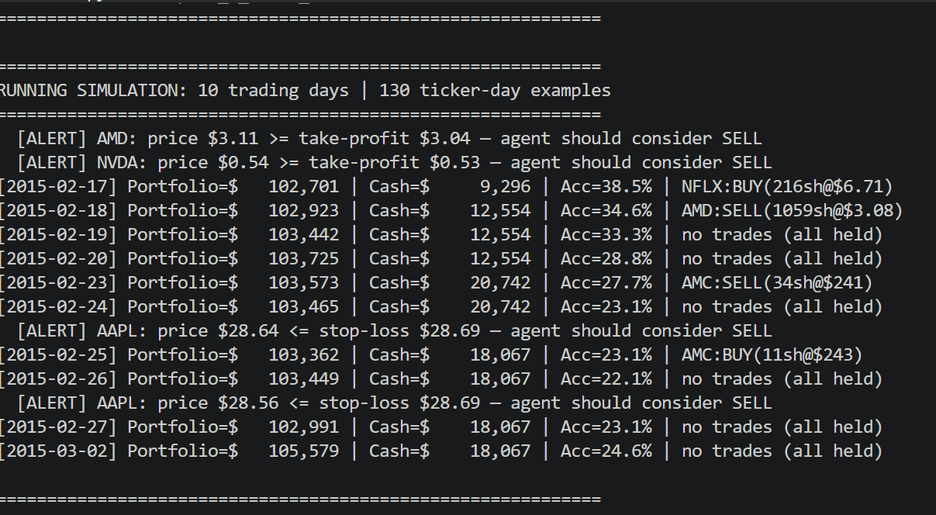
Figure 25: Simulation Running

4.1 Phase 1

In this section we are going to discuss in detail analysis of the framework’s performance during Phase 1, it covers the period from January 2015 to March 2018 consist of 800 trading days. This analysis covers overall portfolio performance, trade analysis, signal behaviour, and the effectiveness of the dynamic prompt optimisation mechanism across 800 trading days.

4.1.1. Portfolio performance

Phase 1 contains 800 trading days from January 2015 to March 2018, with the portfolio starting cash at $100,000. By the end of the phase the portfolio had grown to $184,761, delivering a total return of 84.76%. To give the context, the SPY buy-and-hold benchmark were only able to deliver 38% return over the same period, meaning the proposed framework has generated more than double the passive market return strategy without the investor having to do anything beyond letting the system run.

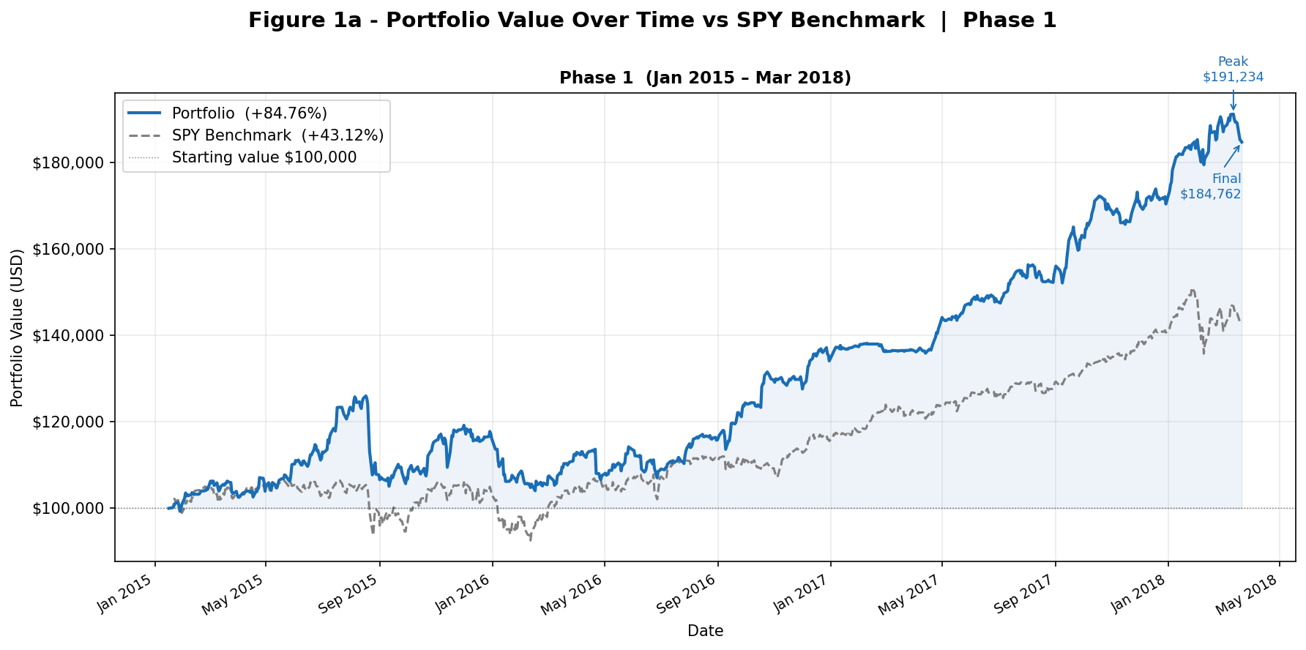
Figure 26: Portfolio Value Over Time vs SPY Benchmark, Phase 1 (January 2015 - March 2018)

The portfolio did not follow a straight line upward. It climbed steadily through 2015 and 2016, accelerated strongly through 2017, and reached its highest point of $191,233 on 12 March 2018. Shortly after this peak the broader market entered a correction in early 2018, which pulled the portfolio back slightly before the phase concluded, finishing at $184,761. The largest peak to trough decline recorded across the entire phase was 17.42%, meaning that at its worst moment the portfolio had fallen by around $17 for every $100 it had previously been worth, before recovering again.

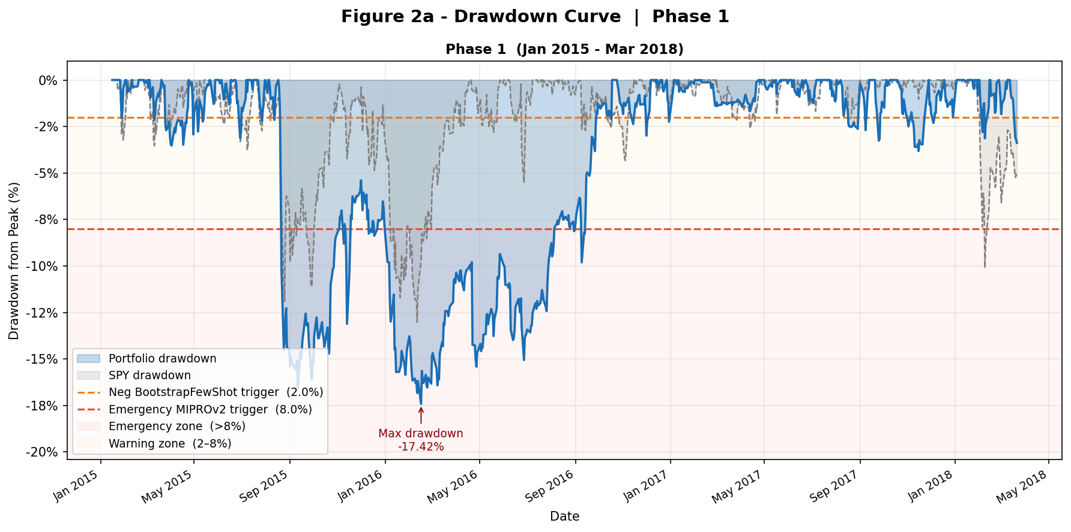
Figure 27: Drawdown Curve, Phase 1 (January 2015 - March 2018)

Despite operating through a market that included both a long bull run and a sudden correction, the framework maintained a Sharpe ratio of 1.52 across the full phase. This number comfortably cross the threshold of 1.0 which is widely acceptable and confirms that the returns were generated through consistent and disciplined trading rather than through taking on excessive risk. In other words, the system was not simply getting lucky on a few big bets but was instead building returns steadily and managing downside risk throughout

4.1.2 Trade Analysis

A total of 760 trades has been executed in the system, comprising 499 buy orders, 170 sell orders, 50 short positions, and 41 cover orders. Clearly, from the trade execution, a remark can be made that the market was bullish during those periods because most of that trade consisted of buy and sell orders. The system correctly identified that long positions offered more reliable opportunities than short selling in a rising market environment. The three most traded securities during Phase 1 were GME with 98 trades, GOOGL with 91, and AMZN with 89. GME's high trading frequency is not surprising given that it is one of the most volatile stocks in the portfolio, with its price moving sharply in both directions throughout the period, which naturally caused the analytical agents to generate frequent and strong signals on it. GOOGL and AMZN hold a different story; neither of these stocks is particularly volatile, but both are amongst the most widely covered companies in the world with a constant flow of news, earnings updates, and analyst ratings available.
Of the 211 fully closed positions across Phase 1, 130 were profitable, which generated an overall win rate of 61.6%. Breaking this down further, the long position was able to yield more profit than the short strategy. Out of 170 closed long trades, 115 were able to generate profit, representing a long win rate of 67.6%. When the system was right on long trade, it was able to deliver nearly 70.75% invested capital, and when it is on the losing side on long trade, it loses nearly 15.58% of invested capital. This asymmetry between winning and losing returns is one of the most encouraging findings of the Phase 1 analysis, as it shows that the dynamic trailing stop-loss mechanism was successfully cutting losses early while allowing winning positions to run for as long as the momentum continued. Profit-to-loss ratio is approximately 4.5 to 1, which confirms that the system did not need to generate strong overall, only to be right more often than wrong, and to manage the size of its losses effectively when it was wrong.

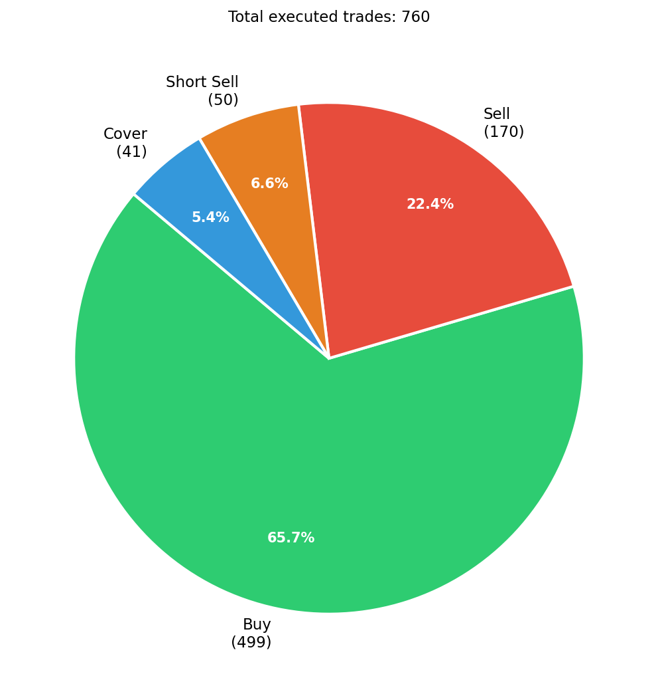
Figure 28: trade_breakdown_phase1

Short position was more challenging than Phase 1 because 15 out of 41 closed short trades were profitable, representing a short win rate 0f 36.6%. This is not surprising given the market condition during Phase 1, the stock market was broadly rising, as seen in Figure 26, which makes short selling more difficult. When the overall market is going up, betting against individual stocks is a very difficult task, the reason being that in a rising market, even poor-performing stocks get pushed because of the market's nature. Average holding period for long position was 294.6 calendar days, which confirms that the system operated as a genuine medium to long-term investor rather than a short-term trader, and that the 20-day minimum holding period was functioning as a floor rather than a ceiling, with positions being held for considerably longer whenever the trailing stop-loss continued to move favourably.
IMP: Holding period is calculated by pairing buy and sell trade events sequentially (FIFO by event count). Partial position closures and quantity mismatches mean reported holding periods are approximate; true lot-level tracking was not implemented.

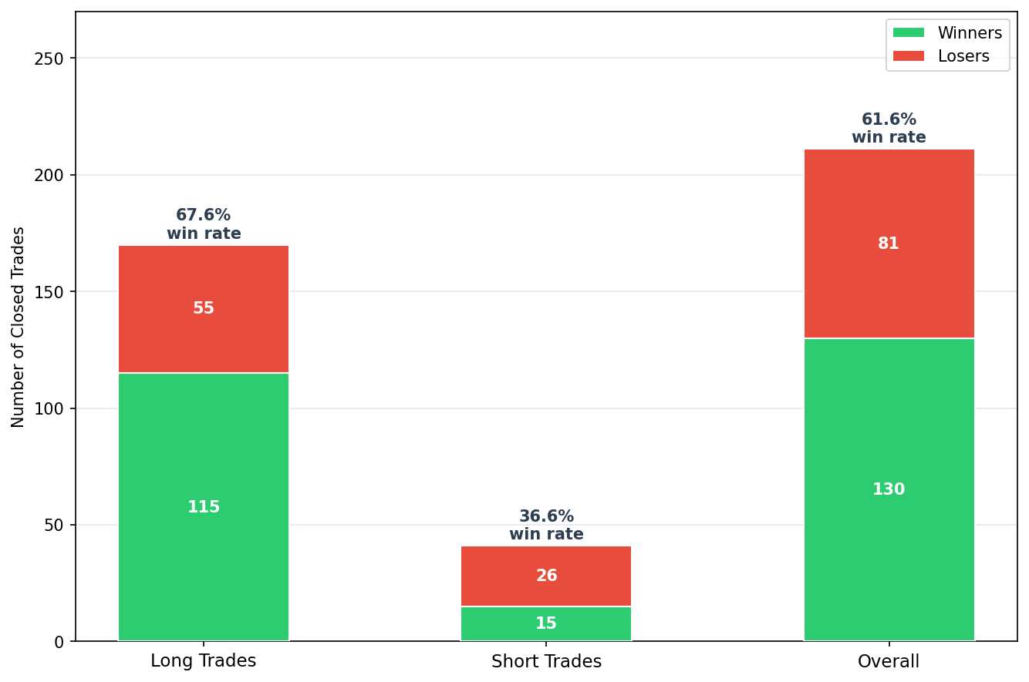
Figure 29: win rate bar phase1

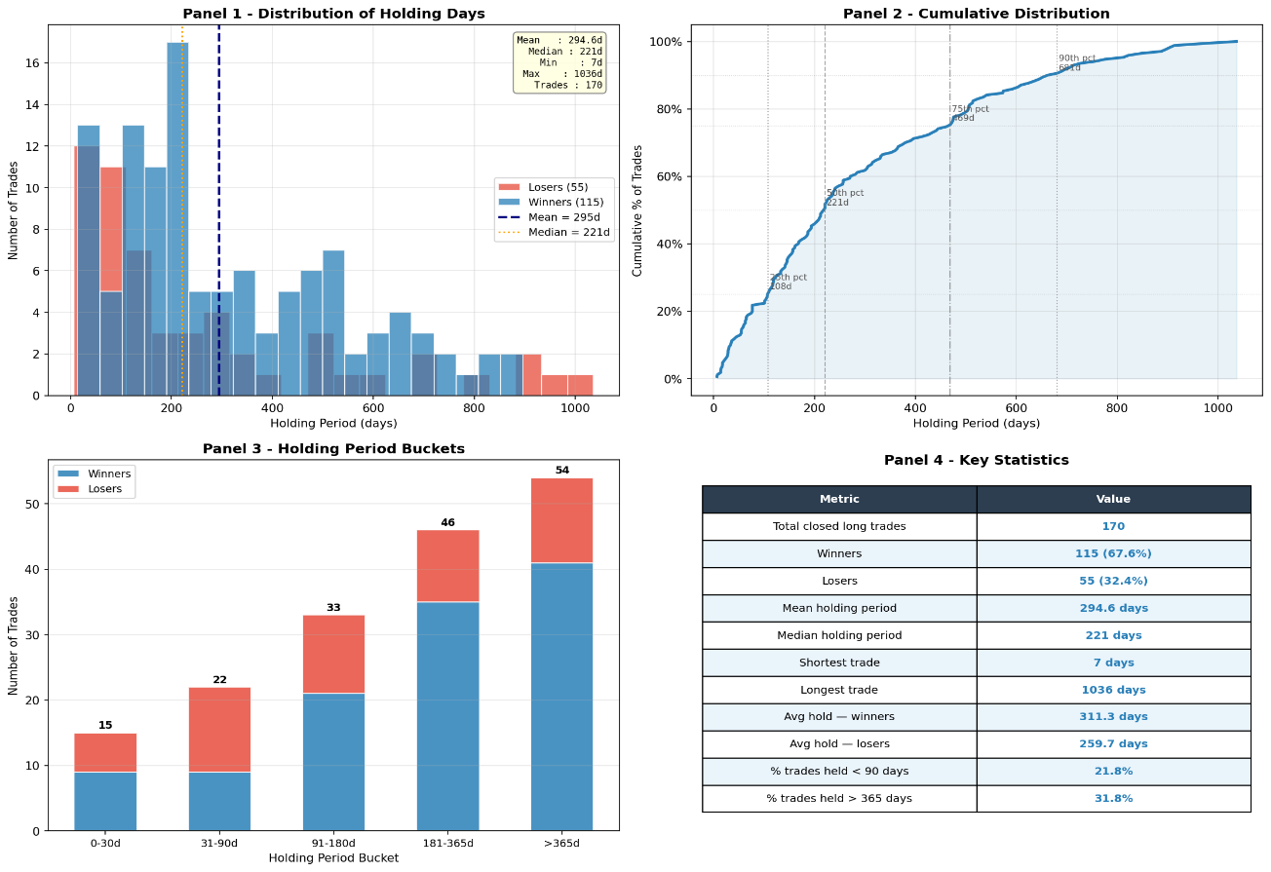
Figure 30: Holding Period Statistics for Phase 1

4.1.3 Signal Analysis

In this section, we are specifically going to do an analysis of how the Stock Picker agent translated the output of the four analytical agents into actionable trading recommendations, and how the Orchestrator agent filtered those recommendations before investing any capital in the market. Every day, Stock Picker gets a signal and confidence score from the Technical Analyst, Fundamental Analyst, Sentiment Analyst, and Macro Analyst, synthesises them into a single recommendation for each of the 13 securities, and produces either a buy, hold, or short signal. Orchestration is like a manager who will review that recommendation after getting a snapshot of the whole portfolio.
Across Phase 1, the Stock Picker agent generated a total of 14,697 signals covering all 13 securities across the full 800 trading days. Out of these, 5,649 were hold signals representing 38.4%, 4,802 were buy signals representing 32.7%, and 4,246 were short signals representing 28.9%. The fact that the Stock Picker was generating a meaningful proportion of short signals even during a broadly rising market shows that the agent was not simply defaulting to bullish recommendations but was genuinely evaluating each stock on its own merits every single day.

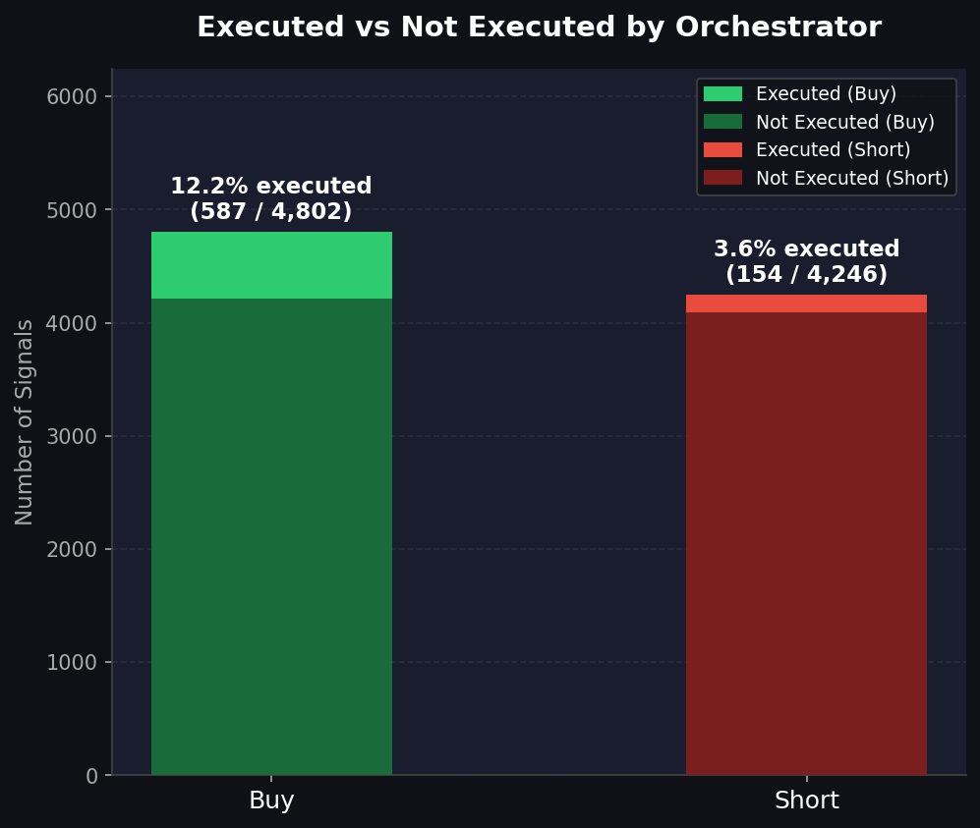
Figure 31: Figure 36: Signal execution rate for Phase 3

From 14,697 signals generated, 954 were actually executed trades by the Orchestrator (confidence gate all aligned, described in IMP), giving an overall execution rate of 6.5%. This low rate shows the selective nature of the Orchestrator's decision-making. The Stock Picker generates a signal for every ticker on every trading day, regardless of whether conditions are favourable for trading, while the Orchestrator only opens trades after analysing broader portfolio context, available cash, minimum holding period constraints, and confidence gate all align. Of the 4,802 buy signals generated, 587 were executed, representing a buy execution rate of 12.2%, while 154 of the 4,246 short signals were executed, representing a short execution rate of 3.6%. The lower short execution rate is because of broadly bullish market conditions of Phase 1, where the Orchestrator was more selective about entering short positions.

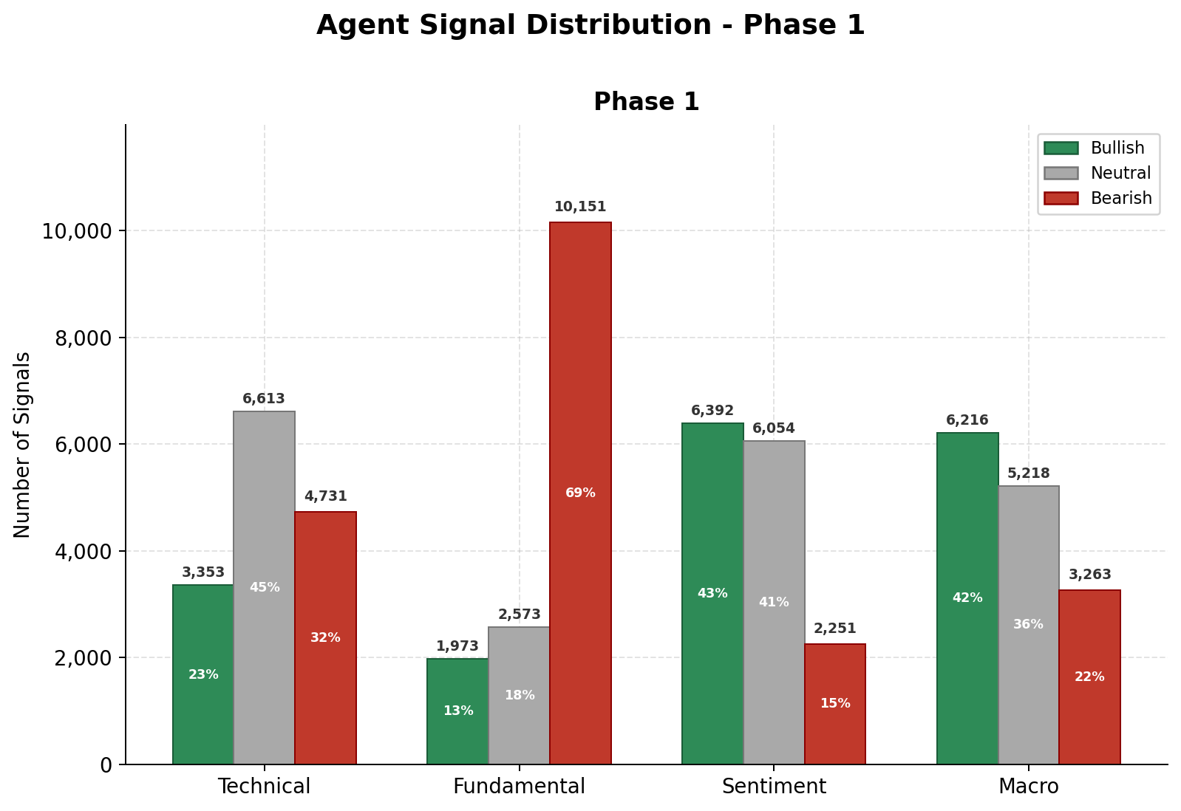
Figure 32: Technical Analyst Signal Distribution for Phase1

Looking at what each individual agent was saying throughout Phase 1 reveals some interesting results shown in Figure 32. The Technical Analyst was largely giving neutral and bearish, with 45.0% neutral and 32.2% bearish signals and only 22.8% bullish, picking up on short-term dips and pullbacks within the longer-term uptrend rather than simply following the overall market direction. The Fundamental Analyst was the most negative of all four agents, with 69.1% of its signals being bearish, suggesting that whilst stock prices were rising, the underlying financial health of many companies in the portfolio was not particularly strong because most of the companies were in the growing stage at the start of Phase 1. In contrast, the Sentiment Analyst was the most optimistic, producing 43.5% bullish signals overall, which is consistent with the broadly positive news flow that accompanied the extended bull market of 2015 to 2017. The Macro Analyst gave nearly 42.3% bullish signals, which reflects the supportive low interest rate and steady growth environment of the period. The difference in signals between the Analyst's deeply bearish stance and the Macro Analyst's broadly positive stance shows accurately why the multi-agent architecture adds value. Different agents were reading different signals from different data sources, and the Stock Picker's role was to weigh all of these views together into a single balanced recommendation.

IMP: If orchestration confidence is below 0.6 just for long position, then we have a hard-coded condition that will make sure that it does not push itself for more long position. We can make it a user variable so that the user can manipulate it according to the user's risk-taking appetite.

4.1.4 Optimisation Trigger Analysis

As back testing was down across 80 windows during Phase 1, with each window representing a 10-day chunk of the simulation across which the portfolio's drawdown was measured and used to determine whether any optimisation intervention was needed. Reason for dividing the whole data into window is that we don’t want to load large amount of data in one go in memory so we preferred to have sliding window architecture so that it does not clog up the memory.
Before going into deep analysis, it is important to note that different optimisation triggers at different threshold. Below given Table 3 represent at what threshold what optimisation technique gets enable and what does it do.

Table 3: Optimisation trigger condition

Optimisation Trigger Conditions and Actions
Trigger condition | Drawdown threshold | Optimiser activated | Action taken
No trigger | dd < 2% | None | Training continues unchanged. The current agent prompts are retained as performance is within acceptable boundaries.
Negative BootstrapFewShot | 2% ≤ dd < 8% | Negative BootstrapFewShot | Poor-performing examples from the current chunk are relabelled as hold and injected into the agent prompts as few-shot demonstrations to discourage loss-making behaviour and encourage caution.
Emergency MIPROv2 | dd ≥ 8% | MIPROv2 (auto = light) | Full prompt rewrite is triggered. All six agent instructions are regenerated from scratch using multi-prompt instruction optimisation, selecting the best performing instruction set from a set of candidates.

Out of these 80 windows, 57 do not trigger any optimisation technique as the portfolio drawdown remained comfortably below the 2% threshold of drawdown, which tells that system was performing well and trading within acceptable risk boundaries for the majority of the phase. However, 22 windows triggered the Negative BootstrapFewShot procedure as drawdown fell between 2% and 8%, and 1 window triggered the Emergency MIPROv2 optimisation when drawdown exceeded 8%. One important to note that reward mechanism is helping a lot in maintaining the portfolio stable and growing for most of time because 57 time it does not require any optimisation which tell that agents are learning form this reward signal.
Yes, there was single time Emergency MIPROv2 triggered at epoch 200 chunk 4 when the portfolio drawdown reached 8.13%. This was the most severe stress event of Phase 1 and required the most aggressive optimisation response available to the system. After the trigger event happened, composite reward score improved from 0.0226 to 0.0641 in the next window which confirms that the emergency intervention had a measurable positive effect on the system's behaviour.

Table 4: Optimisation Trigger: Before vs After Analysis for phase 1
Event details |  |  |  |  | Composite reward
# | Window before | Window after | Trigger type | Drawdown % | Before | After | Change | Improved?
1 | epoch_0_chunk_0 | epoch_0_chunk_1 | Neg BootstrapFewShot | 2.03% | 0.3192 | 0.3256 | +0.0065 | YES
2 | epoch_0_chunk_3 | epoch_0_chunk_4 | Neg BootstrapFewShot | 2.17% | 0.1342 | 0.0270 | -0.1072 | NO
3 | epoch_0_chunk_4 | epoch_50_chunk_0 | Neg BootstrapFewShot | 2.70% | 0.0270 | 0.3277 | +0.3007 | YES
4 | epoch_100_chunk_1 | epoch_100_chunk_2 | Neg BootstrapFewShot | 2.03% | 0.3571 | 0.3774 | +0.0203 | YES
5 | epoch_100_chunk_4 | epoch_150_chunk_0 | Neg BootstrapFewShot | 5.88% | 0.0480 | 0.0266 | -0.0214 | NO
6 | epoch_150_chunk_0 | epoch_150_chunk_1 | Neg BootstrapFewShot | 5.78% | 0.0266 | 0.3361 | +0.3095 | YES
7 | epoch_150_chunk_2 | epoch_150_chunk_3 | Neg BootstrapFewShot | 4.06% | 0.0249 | 0.0236 | -0.0012 | NO
8 | epoch_200_chunk_0 | epoch_200_chunk_1 | Neg BootstrapFewShot | 6.56% | 0.0439 | 0.3764 | +0.3325 | YES
9 | epoch_200_chunk_2 | epoch_200_chunk_3 | Neg BootstrapFewShot | 3.04% | 0.0645 | 0.3439 | +0.2795 | YES
10 | epoch_200_chunk_4 | epoch_250_chunk_0 | Emergency MIPROv2 | 8.13% | 0.0226 | 0.0641 | +0.0416 | YES
11 | epoch_250_chunk_1 | epoch_250_chunk_2 | Neg BootstrapFewShot | 3.54% | 0.0206 | 0.2083 | +0.1877 | YES
12 | epoch_250_chunk_3 | epoch_250_chunk_4 | Neg BootstrapFewShot | 2.03% | 0.3381 | 0.3638 | +0.0257 | YES
13 | epoch_300_chunk_1 | epoch_300_chunk_2 | Neg BootstrapFewShot | 4.95% | 0.0427 | 0.3550 | +0.3123 | YES
14 | epoch_350_chunk_0 | epoch_350_chunk_1 | Neg BootstrapFewShot | 3.43% | 0.0430 | 0.0903 | +0.0473 | YES
15 | epoch_350_chunk_1 | epoch_350_chunk_2 | Neg BootstrapFewShot | 3.76% | 0.0903 | 0.3597 | +0.2694 | YES
16 | epoch_400_chunk_1 | epoch_400_chunk_2 | Neg BootstrapFewShot | 3.71% | 0.3924 | 0.4165 | +0.0241 | YES
17 | epoch_450_chunk_2 | epoch_450_chunk_3 | Neg BootstrapFewShot | 2.17% | 0.4190 | 0.4339 | +0.0149 | YES
18 | epoch_450_chunk_4 | epoch_500_chunk_0 | Neg BootstrapFewShot | 2.25% | 0.2379 | 0.1602 | -0.0777 | NO
19 | epoch_650_chunk_1 | epoch_650_chunk_2 | Neg BootstrapFewShot | 2.51% | 0.4914 | 0.4882 | -0.0032 | NO
20 | epoch_650_chunk_2 | epoch_650_chunk_3 | Neg BootstrapFewShot | 3.27% | 0.4882 | 0.5088 | +0.0206 | YES
21 | epoch_700_chunk_2 | epoch_700_chunk_3 | Neg BootstrapFewShot | 2.31% | 0.3961 | 0.4235 | +0.0274 | YES
22 | epoch_750_chunk_1 | epoch_750_chunk_2 | Neg BootstrapFewShot | 2.81% | 0.3223 | 0.5286 | +0.2062 | YES

Across all 21 Negative BootstrapFewShot triggers, performance improved in the following window in 16 out of 21 cases, representing an improvement rate of approx. 76%. This is a strong result and provides clear quantitative evidence that the feedback loop mechanism was genuinely effective at helping the system self-correct following periods of elevated drawdown.
The composite reward score showed a clear upward trend across the full 80 windows of Phase 1, rising from 0.3192 at the first window to a peak of 0.5555 at epoch 750 chunk 3, which represented the point at which the cumulative return had reached 90.39%. The final window reward of 0.2253 was lower than the peak, which shows that there was little pullback portfolio experienced in the final weeks of Phase 1 as the broader market
entered its early 2018 correction. Looking at the individual reward components, the returns component showed the most dramatic improvement, growing from 0.0088 at the first window to 0.8476 at the last, directly reflecting the portfolio's strong cumulative return of 84.76% over the full phase.
Phase1 detailed analysis has been completed now going to do deep down analysis of Phase 3 which is going to be interesting, reason being that it is the Phase where major crash happens due to covid. Results will be interesting to watch because of frameworks nature which can do Short as well as Buy too.

4.2 Phase 3

Phase 3 results cover the period from July 2019 to December 2020. In this section we are going to discuss about overall portfolio performance, trade analysis, signal behaviour, and the effectiveness of the dynamic prompt optimisation mechanism across 370 trading days. Phase 3 represents the most challenging evaluation environment out of the two phases, consisting of three different market condition within a single 18-month window, the pre-COVID bull market expansion of late 2019, the fastest market crash in modern history triggered by the COVID-19 pandemic in February and March 2020, and the remarkable recovery after covid crash.

IMP: Here we have used best optimised prompt that we got from phase1 run, so bedstone prompt for this run were the optimised prompt present in phase1

4.2.1 Portfolio Performance

Phase 3 contains 370 trading days from July 2019 to December 2020, with the portfolio starting at $100,000 same as phase 1. By the end of the phase, the portfolio had grown to $185,399, delivering a total return of 85.40%. In the context of the SPY buy-and-hold benchmark, which returned approximately 27% over the same period. Results show that the proposed framework is able to generate more than three times the passive market return during one of the most unpredictable market environments in modern history.

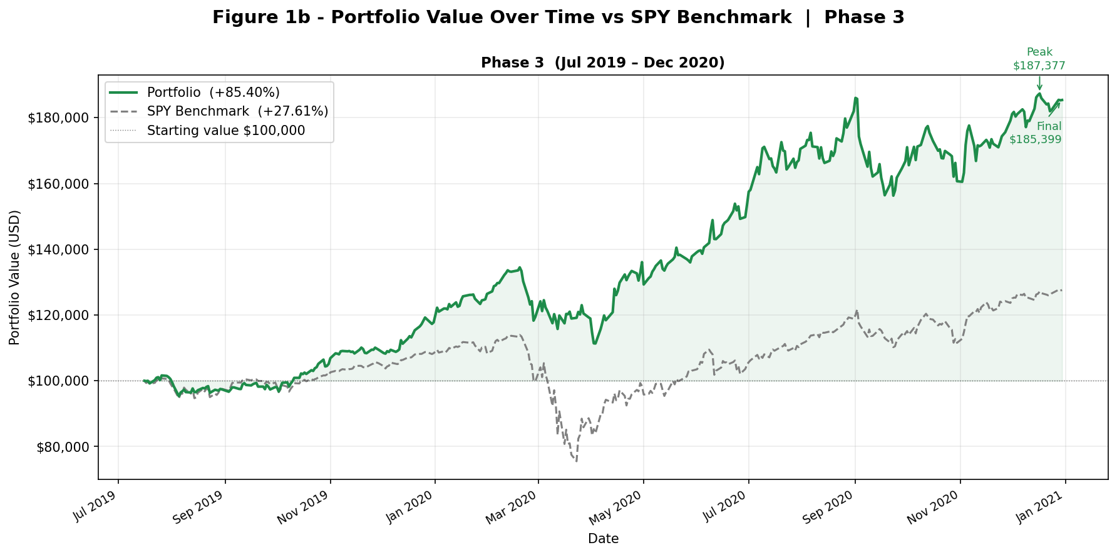
Figure 33: Portfolio Value Over Time vs SPY Benchmark, Phase 1 (July 2019 - Jan 2021)

Unlike Phase 1 which has majority of period was having upward trajectories but Phase 3 has three different market condition which has tested the framework's ability to adapt in real time. The portfolio began strongly, climbing steadily from $100,000 through the pre-COVID bull market of late 2019 and reaching $134,493 by 19 February 2020 as investor sentiment remained positive and the analytical agents generated consistent bullish signals across the technology-heavy portfolio. However, as the COVID-19 pandemic triggered one of the fastest market crashes in history, the portfolio dropped hugely from its February peak to a low of $111,347 by 3 April 2020, representing a peak to rock bottom decline of 17.21%. This was also the worst single drawdown that has been registered across the entire Phase 3 simulation and represents the maximum drawdown figure of 17.21%.

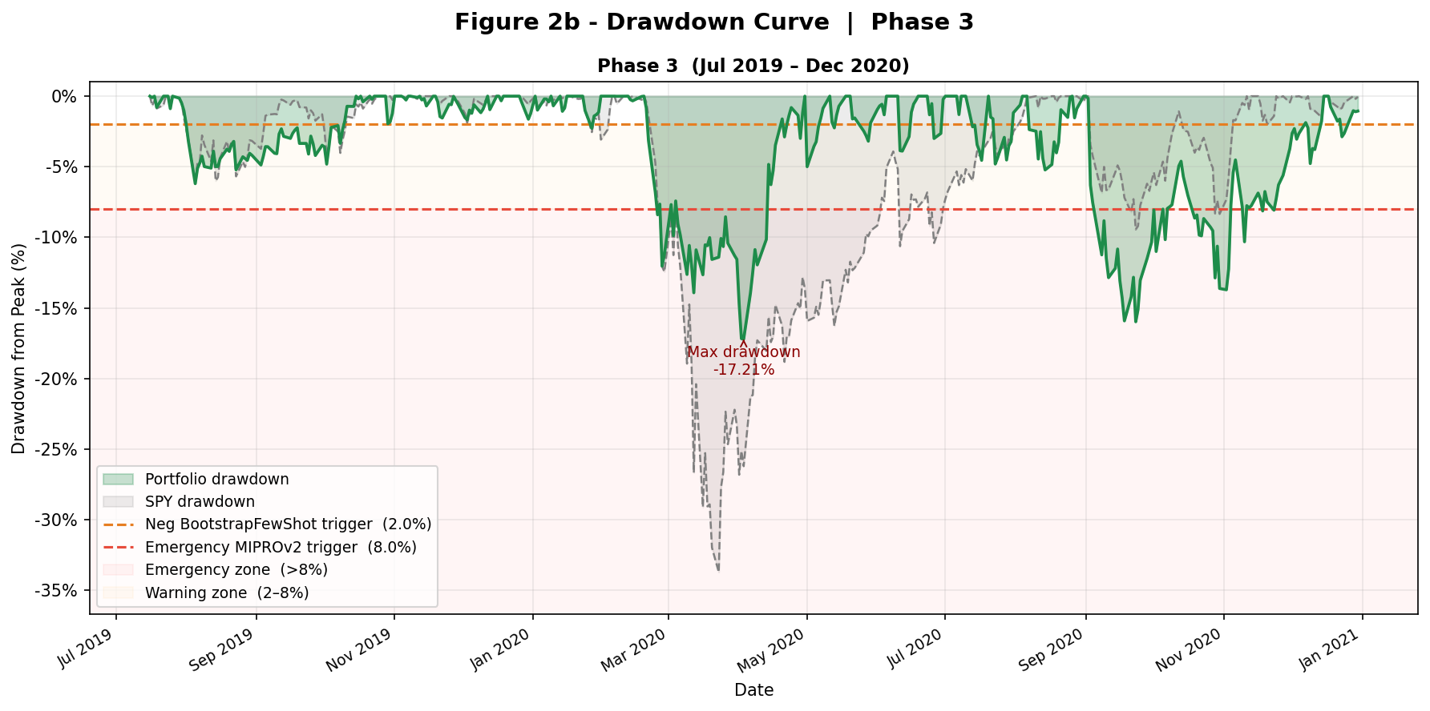
What makes these results particularly impressive is not the crash itself but what happened afterwards. Rather than just sitting, as other active strategies do, which leaves them in severe drawdown, the portfolio recovered with remarkable speed. By July 2020, the portfolio had already surpassed its pre-COVID peak and continued climbing strongly through the second half of 2020. Showing extraordinary performance of technology stocks during the pandemic recovery period. The portfolio reached its all-time peak of $187,376 on 17 December 2020 before closing the phase at $185,399 just two weeks later.
Despite going through a global pandemic, a historic market crash, and a rapid recovery all within a single 18-month window, the framework maintained an annualised Sharpe ratio of 1.79, which is notably higher than the 1.52 recorded in Phase 1. This improvement in risk-adjusted performance during the volatile period is one of the most amazing findings of the entire study, suggesting that the dynamic prompt optimisation and feedback loop mechanisms were genuinely helping the system to change its behaviour in response to the extreme market conditions it encountered rather than simply being carried upward by the broader market recovery.
IMP: Here, we haven’t used the same mechanism that we have used, like the whole data was partwise, and then in partwise data, it is going to run for a 10-day window for the feedback look mechanism, whereas in this, we have loaded the whole data as one chunk and then used a 10-day sliding window protocol on it.

4.2.2 Trade Analysis

Across Phase 3 the system executed a total of 358 trades, comprising 248 buy orders representing 69.3% of all trades, 52 short positions representing 14.5%, 33 sell orders representing 9.2%, and 25 cover orders representing 7.0%. This phase contains higher proportion of buy orders (in % of total buy not exact number) compared to Phase 1 shows broadly positive market sentiment were prevailing across Phase 3, particularly during the strong pre-COVID expansion of late 2019 and the equally strong technology-driven recovery of mid to late 2020. Most actively traded securities were AAPL with 47 trades, AMD with 46, and GOOGL with 45, it is showing the system's focuses on heavily covered and data-rich securities in the portfolio.
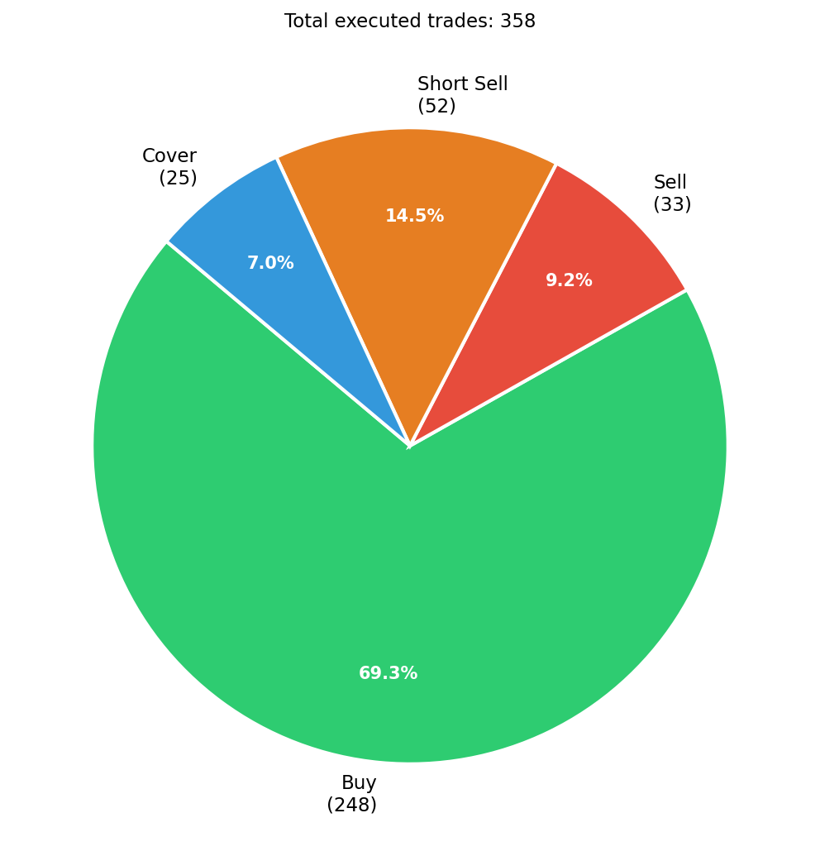
Figure 34: trade_breakdown_phase3

Out of 358 executed trades, 33 long positions were fully closed during Phase 3. Out of these, 27 resulted in a profit and 6 resulted in a loss, giving a long win rate of 81.8%. It shows significant improvement over the Phase 1 long win rate of 67.6% and it is one of encouraging finding of the Phase 3 analysis. When system was on long trade it was able to generated on an average return of 38.96% on the invested capital, and when it was wrong, it only lost an average of 6.21%. It gives approximately 6.3 to 1 (profit to loss ratio), which is even better than the 4.5 to 1 ratio observed in Phase 1. Reason being when market got crashed, it started to recover from April 2020 and then it got good run in upward direction. From this we can say that system was able to capture the right time to do investment after covid crash.

Best single trade of Phase 3 was a long position in NVDA which returned 181.67% over a 334-day holding period from September 2019 to August 2020, capturing the extraordinary rise of NVIDIA's share price during the pandemic period. The worst single trade was an AMZN position which lost 10.77% and was cut after just 22 days, which shows that the trailing stop-loss mechanism working exactly as intended by closing losing positions quickly before they could deteriorate further. It is important to note that all 6 losing long trades were closed within 66 calendar days, confirming that the risk management mechanism was consistently preventing losses from being held for long periods.

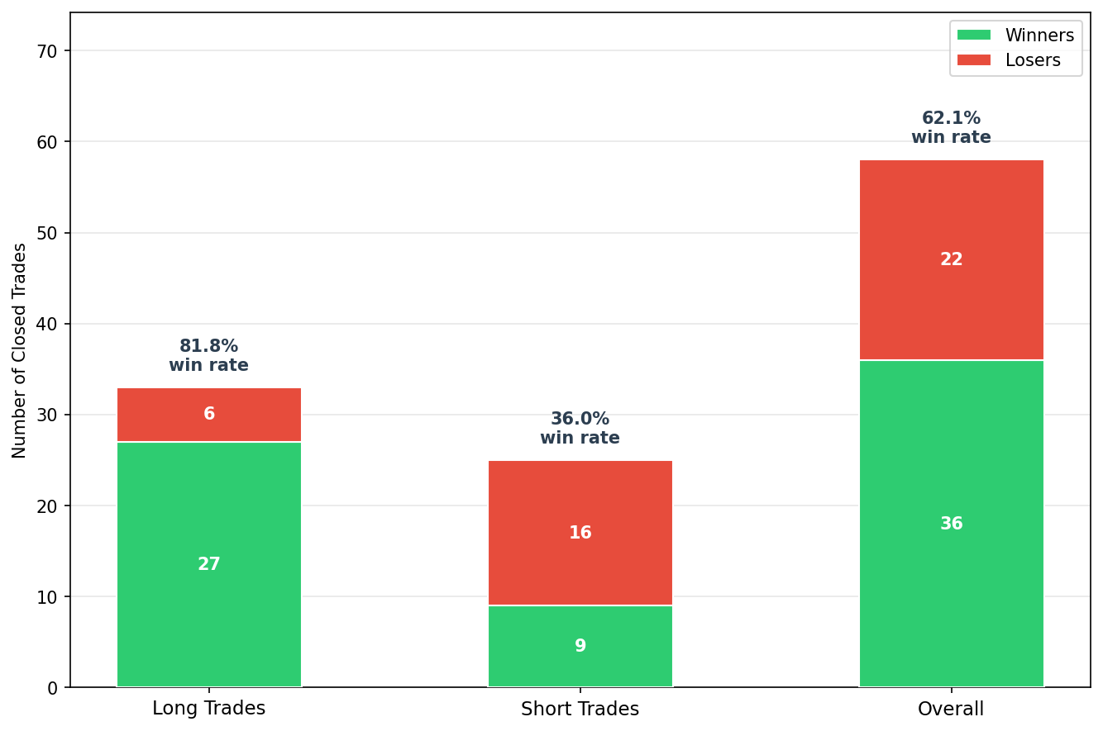
Figure 35: win rate bar phase 3

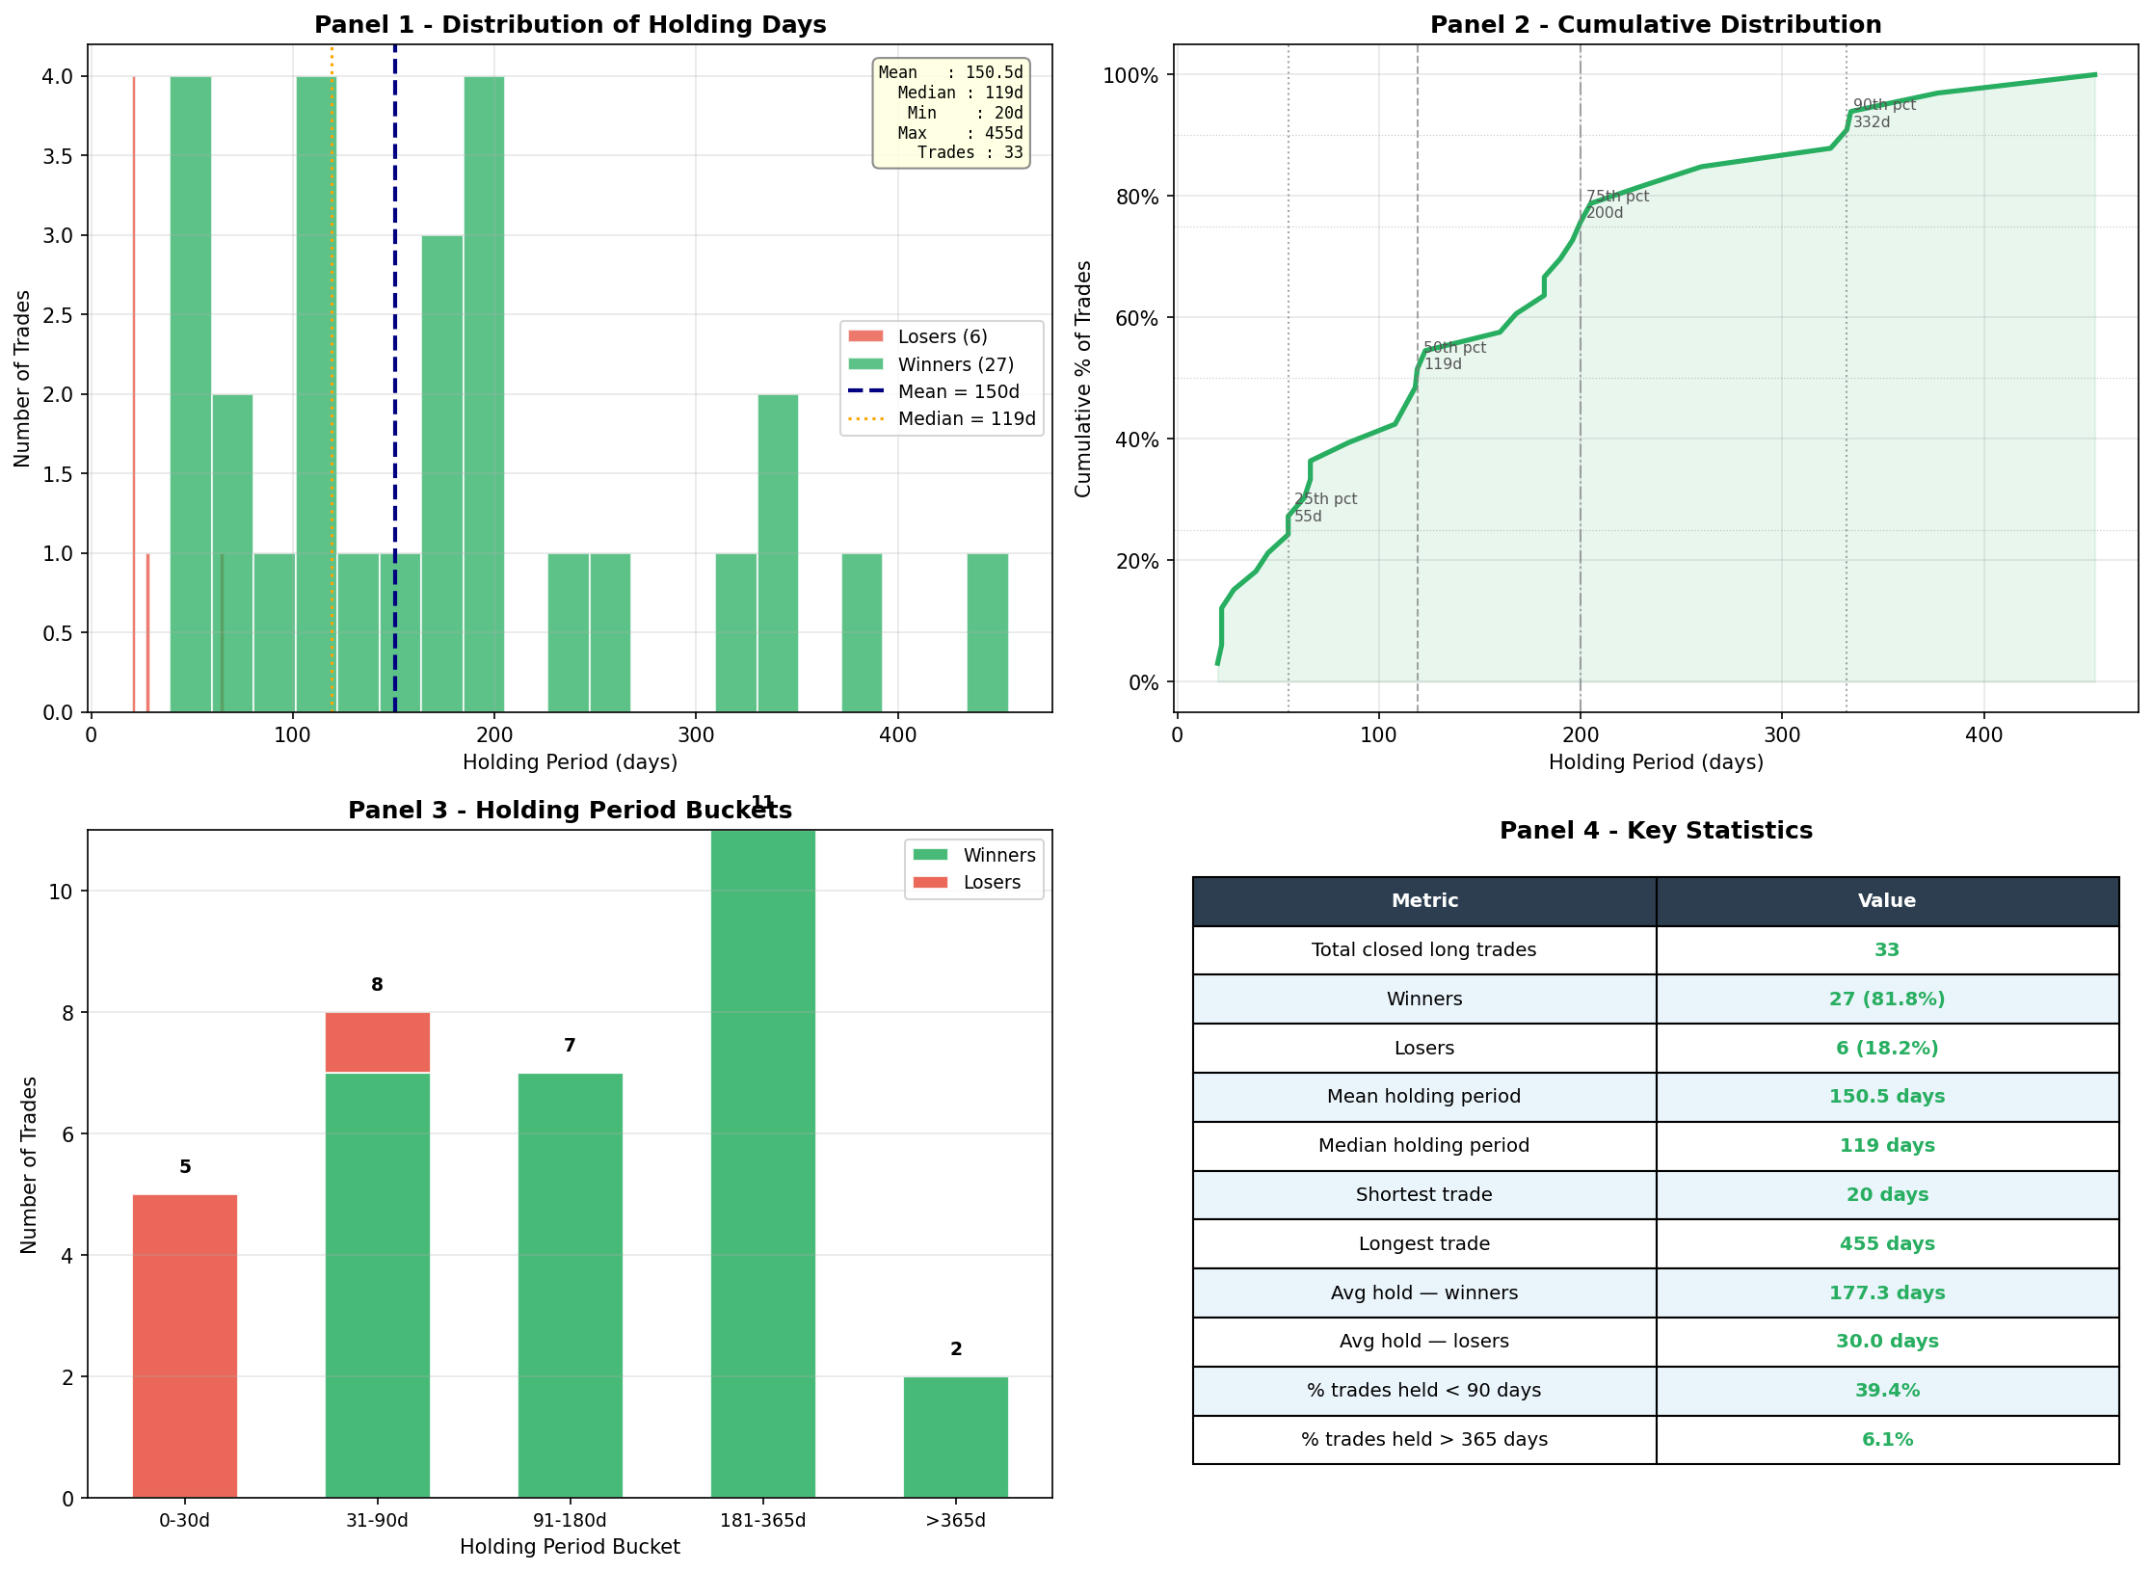
Figure 36: Holding Period Statistics for Phase 3

Short positions were the again were not able to pull good result during Phase 3, with only 9 of 25 closed short trades being profitable, only 36%-win rate. Figure is almost identical to the 36.6% short win rate recorded in Phase. Despite the COVID crash of early 2020(Feb 2020 – April 2020) providing good amount of opportunity for bearish positions, the market was mostly having rising condition in Phase 3 as a whole, making short selling genuinely difficult regardless of how sophisticated the signal generation was. The system was essentially swimming against the tide for much of the phase when it came to short positions, and the 36%-win rate honestly reflects that reality.
However, while doing in-depth analysis, by dividing the covid phase into 3 sections: Pre-COVID, during COVID, Post-COVID. In pre-COVID period of July to December 2019 the system opened 16 short positions and won only 4 of them, giving a win rate of just 25%. However, during the COVID crash period of January to June 2020 the short win rate more than doubled to 55.6%, with 5 of 9 short positions were in profitable position. From this insight we can confirm that analytical agents were correctly identifying genuine bearish opportunities during the crash rather than simply generating random short signals. System were particularly successful were the short positions in AMC which returned 51.78% and 22.79% respectively, and a META short which returned 15.97% over just 22 days. It is important to note that system placed no short trades after June 2020, which shows that Orchestrator correctly recognised the market had entered a sustained recovery and stopped betting against stocks entirely.

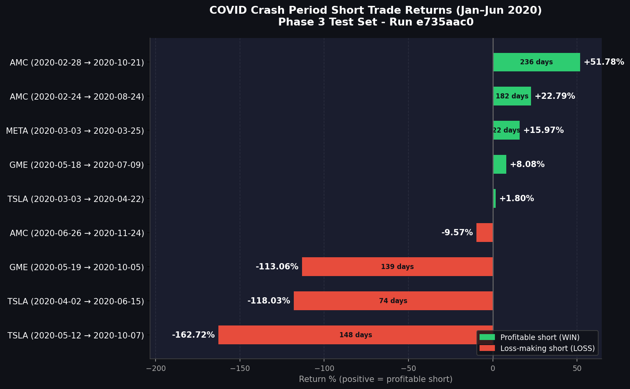
Figure 37: Short position deep analysis during covid

The biggest loses on short side came from TSLA position that were opened during that crash but hold too long that it got recovered after the crash. After the crash TSLA's share price more than doubled, rising by over 162%, which meant that both short positions ended up losing a significant amount of money despite looking like sensible trades when they were first opened.
IMP: Holding period is calculated by pairing buy and sell trade events sequentially (FIFO by event count). Partial position closures and quantity mismatches mean reported holding periods are approximate; true lot-level tracking was not implemented. One more important thing this is that fully closed trade means that we got the pair of buy-sold in sequence for any securities. But total number of buy and sold can be different.

4.2.3 Signal Analysis

Across the 370 trading days of Phase 3, the Stock Picker generated 4,810 signals in total. Out of these, 2,121 were buy signals representing 44.1%, 1,777 were hold signals representing 36.9%, and 909 were short signals representing 18.9%. Compared to Phase 1, where buy and short signals are very evenly spread. Phase 3 shows a clear lean towards buying rather than shorting, which makes sense given that the market was broadly rising for most of the phase outside of the COVID crash window. But by looking at the number of short signals, it cannot be wrong to say that agents were able to get a sense of the COVID-19 phase.

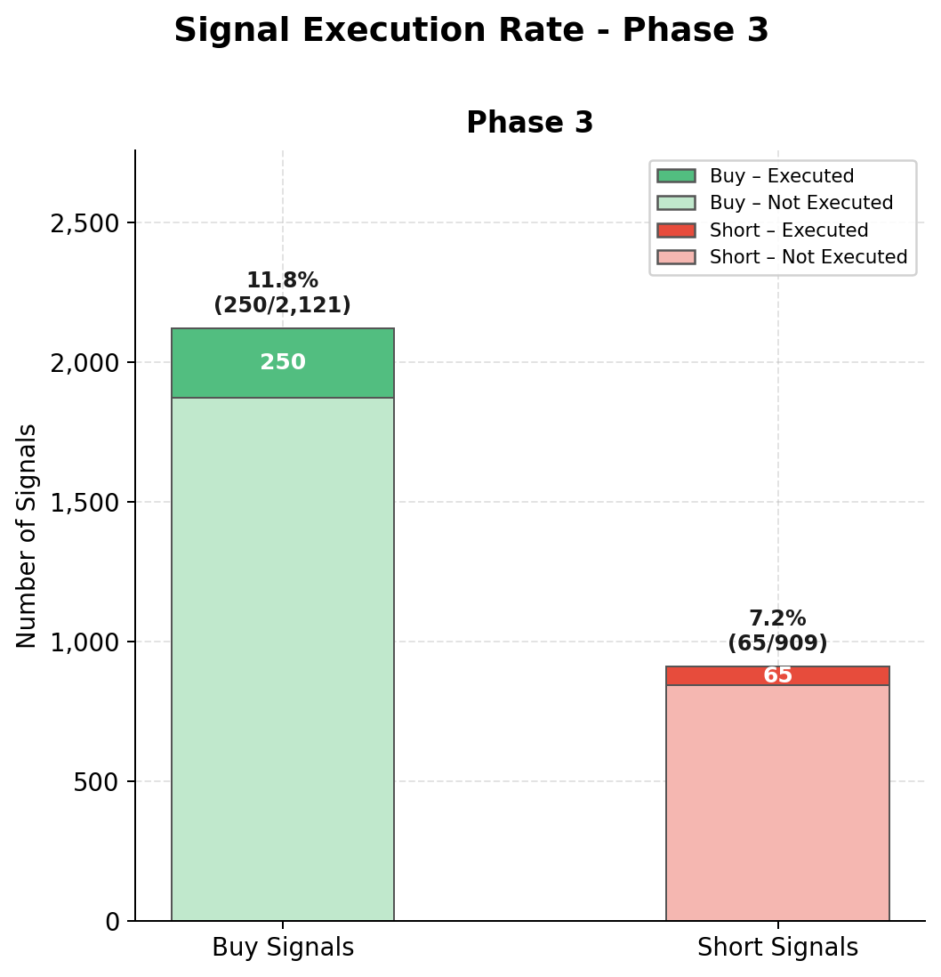
Figure 38: Signal execution rate for Phase 3

Not every signal was acted upon. Out of 2121 buy signals generated, the Orchestrator converted 227 into actual trades. It gives a buy execution rate of 10.7%. Out of 909 short signals, only 45 were executed, giving a short execution rate of 5.0%. As with Phase 1, these relatively low execution rates confirm that the Orchestrator was being highly selective, only placing trades when the broader portfolio picture gave it enough confidence to commit capital.
Looking at what each agent gives during Phase 3 gives a picture of it. The Technical Analyst was noticeably more bullish than in Phase 1; that’s the reason it is bullish signals 43.9% of the time compared to just 22.8% in Phase 1, which reflects the strong price momentum of the technology stocks in the portfolio during the COVID recovery. The Fundamental Analyst was fairly evenly split between bullish at 47.8% and bearish at 42.1%, suggesting it was finding clear directional views in the company's financial statements rather than sitting on the fence. The Sentiment Analyst was mostly giving positive overall, with 34.9% bullish and 26.0% mildly bullish signals, reflecting the broadly favourable news coverage of technology companies across the period.

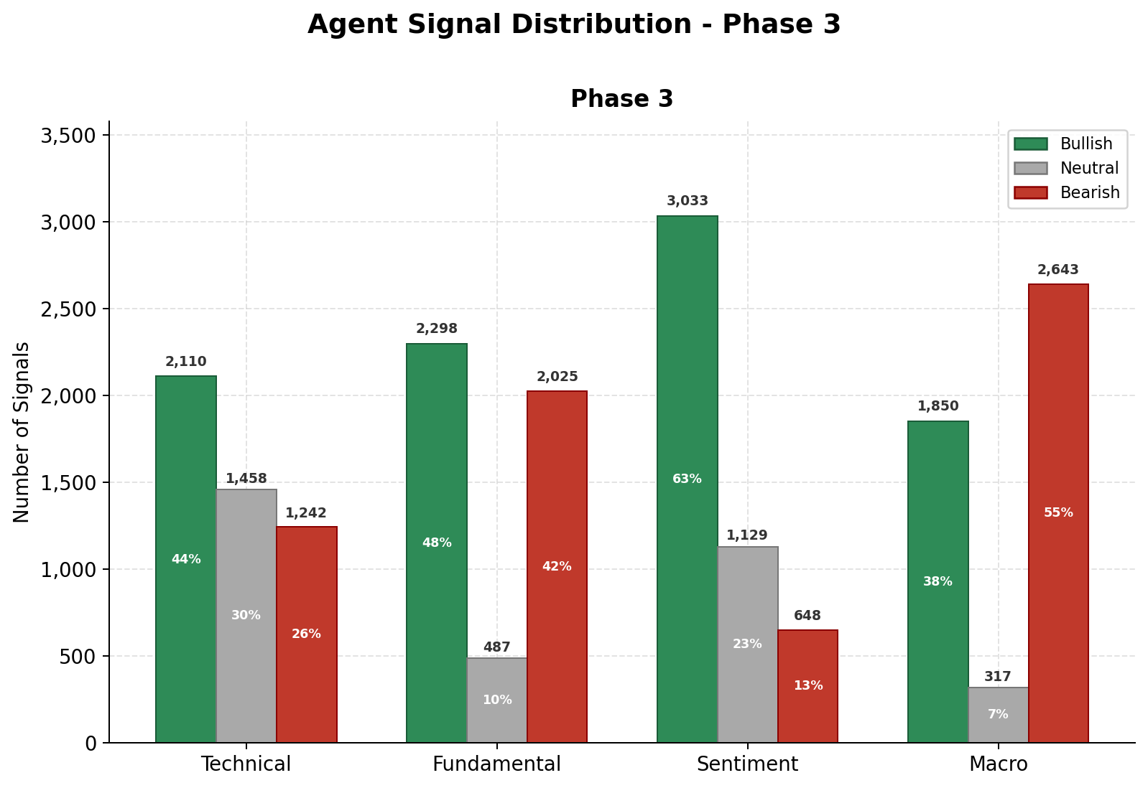
Figure 39: Agent signal distribution for phase3

The most interesting findings were from the Macro Analyst, which mostly gave bearish signals throughout Phase 3, producing bearish signals 54.9% of the time. This is entirely understandable given the COVID-era economic backdrop of rising unemployment, supply chain disruption, and deep uncertainty about the global economy. What makes this interesting is that despite the Macro Analyst showing a gloomy picture for much of the phase, the portfolio was still able to deliver a total return of 85.40%. From this, we can conclude that the Stock Picker and Fundamental Analyst were successfully identifying individual stocks with strong enough momentum and financial health to overcome the broader macroeconomic concerns, which is one of the genuine strengths of having multiple specialised agents rather than relying on a single view of the market.

IMP: Please note that some of the agent have variety of signal like Sentiment Analyst produces seven signal categories rather than three, ranging from strongly bullish through to strongly bearish. For simplicity these have been grouped into three broader categories in Figure 39, combining the bullish variants together and the bearish variants together.

4.2.4 Optimisation Trigger analysis

Phase 3 has called several times more optimisation mechanisms than it has in Phase 1. Reason being extreme market volatility of the COVID-19 pandemic. Across the 16 chunks of Phase 3, only 2 required no optimisation as the portfolio drawdown remained below the 2% threshold. While 11 triggered the Negative BootstrapFewShot procedure and 3 triggered Emergency MIPROv2, making Phase 3 the most difficult phase out of the two phases from an optimisation perspective. Please refer to Table 5.
The three Emergency MIPROv2 triggers are particularly noteworthy as they directly correspond to the most severe market dislocations of the evaluation period. The first trigger occurred at chunk 6, covering January to March 2020, when the portfolio recorded a drawdown of 12.04% as the COVID-19 pandemic triggered one of the fastest market crashes in history. The second trigger followed immediately at chunk 7, covering March to April 2020, with the drawdown remaining elevated at 9.47% as markets continued to fall before stabilising. The third trigger occurred at chunk 12 covering August to September 2020, when the portfolio recorded its largest single chunk drawdown of 15.92% during the sharp technology fell selloff September 2020. Important to note that the system triggered its most aggressive optimisation response three times across Phase 3, which shows that the feedback loop was functioning correctly; it adapts itself according to the market environment to tackle major market fluctuation.

Table 5: Optimisation Trigger: Before vs After Analysis for phase 3
Event details |  |  |  |  | Composite reward
# | Window before | Window after | Trigger type | Drawdown % | Before | After | Change | Improved?
1 | chunk_0 | chunk_1 | Neg BootstrapFewShot | 6.20% | 0.0000 | 0.2134 | +0.2134 | YES
2 | chunk_1 | chunk_2 | Neg BootstrapFewShot | 2.08% | 0.2134 | 0.3043 | +0.0909 | YES
3 | chunk_2 | chunk_3 | Neg BootstrapFewShot | 2.63% | 0.3043 | 0.1328 | -0.1715 | NO
4 | chunk_5 | chunk_6 | Neg BootstrapFewShot | 2.28% | 0.2537 | 0.0469 | -0.2068 | NO
5 | chunk_6 | chunk_7 | Emergency MIPROv2 | 12.04% | 0.0469 | 0.0000 | -0.0469 | NO
6 | chunk_7 | chunk_8 | Emergency MIPROv2 | 9.47% | 0.0000 | 0.2369 | +0.2369 | YES
7 | chunk_8 | chunk_9 | Neg BootstrapFewShot | 5.00% | 0.2369 | 0.3439 | +0.1070 | YES
8 | chunk_9 | chunk_10 | Neg BootstrapFewShot | 3.89% | 0.3439 | 0.3464 | +0.0025 | YES
9 | chunk_10 | chunk_11 | Neg BootstrapFewShot | 3.87% | 0.3464 | 0.0538 | -0.2926 | NO
10 | chunk_11 | chunk_12 | Neg BootstrapFewShot | 5.23% | 0.0538 | 0.0514 | -0.0024 | NO
11 | chunk_12 | chunk_13 | Emergency MIPROv2 | 15.92% | 0.0514 | 0.2276 | +0.1762 | YES
12 | chunk_13 | chunk_14 | Neg BootstrapFewShot | 5.54% | 0.2276 | 0.1676 | -0.0600 | NO
13 | chunk_14 | chunk_15 | Neg BootstrapFewShot | 6.07% | 0.1676 | 0.2917 | +0.1241 | YES
14 | chunk_15 | N/A | Neg BootstrapFewShot | 2.95% | 0.2917 |  | N/A | N/A

Of the 13 triggers with a measurable before and after comparison in Phase 3, performance improved in 7 out of 13 cases, representing an improvement rate of 53.8%. We can see that it is lower than the 77% improvement rate observed in Phase 1, it is important to consider the context. Phase 3 contained some of the most extreme and unpredictable market conditions in modern history, and the fact that the optimisation mechanism improved performance in more than half of all trigger events under those conditions is still a meaningful result.
Strong improvement has been seen in the chunk across the phase, rising from 0.0000 at chunk 0 to 0.2917 at the final chunk, with the best single chunk reward of 0.3464 recorded at chunk 10 during the strong market recovery of June and July 2020. All reward components improved between the first and last chunk of Phase 3, including accuracy, returns, Sharpe ratio, drawdown, and turnover, suggesting the system was genuinely learning and adapting throughout the phase rather than simply benefiting from favourable market conditions.

4.3 Comparative analysis

This section brings the two phases together to directly compare performance across all key dimensions in two unique market conditions.
Overall portfolio performance was consistent across both phases. System delivered a total return of 84.76% with a Sharpe ratio of 1.52 in Phase 1. While in Phase 3, it delivered a total return of 85.40% with an improved Sharpe ratio of 1.79. Almost similar returns across two very different market conditions. One of the most important findings of the entire study is framework's adaptive mechanisms were genuinely helping. It maintains consistent performance rather than simplifying a favourable market trend. Both phases also recorded a maximum drawdown of nearly 17%, which confirms that the risk management mechanism was operating consistently across both evaluation environments.
One of the important things to check is that the Sharpe ratios of 1.52 in Phase 1 to 1.79 in Phase 3 need to be given particular attention. A higher Sharpe ratio during a more volatile period shows that the framework was able to generate better risk-adjusted returns. When market conditions were harder, which is the opposite of what you would expect from a system that was simply benefiting from market momentum. The most reasonable explanation is that the dynamic prompt optimisation mechanism played a more active role during Phase 3. With three Emergency MIPROv2 triggers fired compared to just one in Phase 1. It helps the agents to adapt more aggressively to the rapidly changing conditions of the COVID crash and recovery.
Total return was almost identical at 84.76% in Phase 1 and 85.40% in Phase 3. Despite Phase 3, the global pandemic, and one of the fastest market crashes in history. Trade quality improved meaningfully between the phases, with the long win rate rising from 67.6% to 81.8% and the average loss shrinking from 15.58% to just 6.21%. It is giving a better profit-to-loss ratio of 6.3 to 1 in Phase 3 compared to 4.5 to 1 in Phase 1. The Sharpe ratio also improved from 1.52 to 1.79, confirming that Phase 3 returns were generated more efficiently relative to the risk taken. The optimisation mechanism was considerably more active during Phase 3. It got activated on 87.5% of all chunks compared to 28.75% in Phase 1. It shows that greater volatility of the COVID period, and shows the feedback loop was responding appropriately to more severe market conditions. Taken together, these findings suggest the framework was genuinely adapting to different market environments rather than simply benefiting from favourable

5. Discussion

The results ask an important question about how a system built on a relatively small 8 billion parameter language model, running sequentially on a minimal compute budget, managed to deliver such good performance across two drastically different market environments. The answer lies in the different analytical perspectives the multi-agent architecture provides. On any given day the four analytical agents frequently contradict each other, and it is the Stock Picker's role to weigh all views and arrive at a balanced recommendation. A purely technical system will not understand fundamental deterioration detected throughout Phase 1, while a purely sentiment-driven system would have been overwhelmed by the noise of the COVID crash. The combination of all four perspectives is what makes the system robust.
The feedback loop also proved to be more than a theoretical contribution. The optimisation mechanism triggered on 87.5% of all Phase 3 chunks and still delivered a 53.8% improvement rate under COVID-level volatility, suggesting genuine self-correction rather than a fixed strategy. The reward function is a composite of the Sharpe ratio at 30%. It tells the system to focus on steady risk-adjusted returns rather than chasing maximum gains. Because of that, the portfolio recovered quickly after periods of loss rather than making increasingly risky bets.
However, it is important to be honest about what these results do and do not prove. All findings are based on backtesting rather than live trading. Strategies that perform well historically do not always translate to real markets where price slippage, market impact, and changing dynamics come into play. There is also the question of temporal leakage, as Llama 3.1 8B was pretrained on internet data that may include financial information from the study period. However, if the model truly had precise knowledge of historical prices the results would look very different as the portfolio would have avoided every crash and generated far more returns than 85%. The fact that it experienced drawdowns, made losing trades, and struggled with short selling during rising markets suggests the model was genuinely reasoning from the data provided each day rather than drawing on memorised price outcomes.

6. Conclusion

In this research we have proposed fully autonomous multi-agent portfolio management framework that combines the reasoning capabilities of Large Language Models with dynamic prompt optimisation and a self-correcting feedback loop to manage investment portfolios without any human intervention. This framework makes investment decision-making process across seven specialised agents. Each agent is responsible for a distinct aspect of financial analysis. It uses the DSPy framework to automatically adjust agent instructions based on real portfolio performance rather than relying on fixed manually crafted prompts.
Backtesting has been done on two different phases of dataset. Results are strong and consistent returns across genuinely different market environments. In Phase 1 covering January 2015 to March 2018 the portfolio grew from £100,000 to £184,761, delivering a total return of 84.76% and an annualised Sharpe ratio of 1.52. Compared to an approximate 38% return for the SPY buy-and-hold benchmark over the same period. In Phase 3 covering July 2019 to December 2020 the portfolio grew from £100,000 to £185,399, delivering a total return of 85.40% and an improved Sharpe ratio of 1.79. Despite the phase-3 containing the COVID-19 market crash of early 2020 which represented one of the fastest and most severe market crash in modern history. The framework's ability to recover quickly from the COVID crash, surpassing its pre-crash peak by July 2020. It is reaching an all-time high of £187,376 by December 2020 which provide particularly strong evidence of the system's capability to adapt itself to the market environment.
Some of the highlighting performance of the framework is the combination of dynamic prompt optimisation mechanism with feedback loop triggering in 87.5% Phase 3 chunks. Out of those total trigger it was able to achieve 53.8% improvement rate in portfolio performance following those triggers under extreme market condition. The multi-agent architecture proved more robust than a single agent approach would have been. With different agent providing different capability and complimenting each other to produce overall best result. The dynamic trailing stop-loss mechanism successfully protected accumulated gains during periods of market stress while allowing winning positions to run for as long as momentum continued, contributing to a profit to loss ratio of 4.5 to 1 in Phase 1 and an improved 6.3 to 1 in Phase 3.
This research makes several contributions to the growing literature on LLM-based financial systems. It demonstrates that a small and cost-efficient language model can deliver competitive portfolio management performance when embedded within a well-designed multi-agent architecture with appropriate feedback and optimisation mechanisms. It introduces dynamic prompt optimisation as a practical alternative to static agent instructions in financial applications, and it provides empirical evidence that multi-agent collaboration across diverse analytical perspectives produces more robust trading decisions than single-agent approaches in volatile market conditions.

7. Reflection

This research has been both technically demanding and intellectually rewarding, it helped me for developing my understanding of how artificial intelligence can be applied to real-world financial problems.
Biggest practical challenge was the tension between the theoretical framework design and real-world infrastructure constraints. The decision to execute agents sequentially rather than in parallel was not part of the original design but became necessary due to Groq API rate limits. While this increased simulation time it ultimately simplified the data flow and did not compromise result quality, teaching me that building robust AI systems requires the ability to adapt designs pragmatically when real-world constraints arise.
The data collection process comes with its own challenge. Getting the sentiment data was one of the biggest hurdles because now most of social platform have close the door of free API service to collect data. Later on, I tried to collect data related to X then I was not able to collect the data for Reditt for the same span of time, so it was struggle to find dataset for both platform falling in the same span of year.
Several results genuinely surprised me. I expected the Sharpe ratio to be lower in Phase 3 given the COVID-19 crash, but the system delivered 1.79 compared to 1.52 in Phase 1. The finding that the Macro Analyst was predominantly bearish throughout Phase 3 yet the portfolio still returned 85.40% also highlighted the genuine strength of the multi-agent architecture in balancing contradictory signals.
From a technical perspective this project significantly developed my ability to work with LLM APIs, design multi-agent pipelines, manage large financial datasets, and apply DSPy for automatic prompt optimisation, skills I had little prior experience with and which I believe will be highly valuable in my future career.
If I were to continue this research the most important next step would be evaluating the framework in a live paper trading environment. I would also explore whether larger language models such as Llama 3.1 70B produce meaningfully better trading decisions and whether more comprehensive social media data improves performance during volatile periods.
Overall, this research has reinforced my belief that combining multi-agent collaboration with dynamic prompt optimisation and self-correcting feedback loops represents a genuinely promising direction for autonomous portfolio management.

8. Gantt Chart

Below chart shows the timeline of each component that I have been working during this

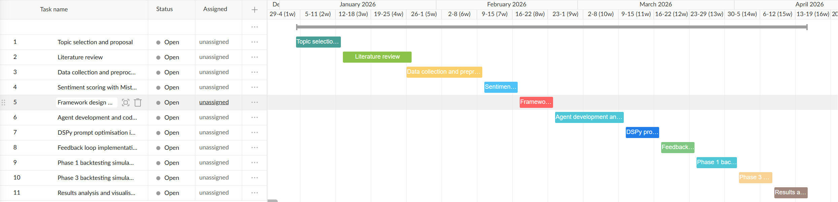

References

[1] shamik mehta, “(Part 2): AI-powered GRC in Banking and Financial Services - Hitachi Digital Services.” Accessed: Apr. 22, 2026. [Online]. Available: https://www.hitachids.com/insight/ai-powered-grc-in-banking-and-financial-services/
[2] A. Vaswani et al., “Attention Is All You Need,” Aug. 02, 2023, arXiv: arXiv:1706.03762. doi: 10.48550/arXiv.1706.03762.
[3] A. Grattafiori et al., “The Llama 3 Herd of Models,” Nov. 23, 2024, arXiv: arXiv:2407.21783. doi: 10.48550/arXiv.2407.21783.
[4] Y. Yu et al., “FinMem: A Performance-Enhanced LLM Trading Agent with Layered Memory and Character Design,” Dec. 03, 2023, arXiv: arXiv:2311.13743. doi: 10.48550/arXiv.2311.13743.
[5] Y. Xiao, E. Sun, D. Luo, and W. Wang, “TradingAgents: Multi-Agents LLM Financial Trading Framework,” Jun. 03, 2025, arXiv: arXiv:2412.20138. doi: 10.48550/arXiv.2412.20138.
[6] Y. Yu et al., “FinCon: A Synthesized LLM Multi-Agent System with Conceptual Verbal Reinforcement for Enhanced Financial Decision Making,” Nov. 07, 2024, arXiv: arXiv:2407.06567. doi: 10.48550/arXiv.2407.06567.
[7] H. Hong et al., “Multi-Agent Deep Research: Training Multi-Agent Systems with M-GRPO,” Nov. 18, 2025, arXiv: arXiv:2511.13288. doi: 10.48550/arXiv.2511.13288.
[8] T. Zhou, P. Wang, Y. Wu, and H. Yang, “FinRobot: AI Agent for Equity Research and Valuation with Large Language Models,” Nov. 13, 2024, arXiv: arXiv:2411.08804. doi: 10.48550/arXiv.2411.08804.
[9] S. Wang, H. Yuan, L. M. Ni, and J. Guo, “QuantAgent: Seeking Holy Grail in Trading by Self-Improving Large Language Model,” Feb. 06, 2024, arXiv: arXiv:2402.03755. doi: 10.48550/arXiv.2402.03755.
[10] A. Nair, A. Banerjee, L. Mombaerts, M. Hagen, and T. Borogovac, “Tournament of Prompts: Evolving LLM Instructions Through Structured Debates and Elo Ratings,” Jul. 22, 2025, arXiv: arXiv:2506.00178. doi: 10.48550/arXiv.2506.00178.
[11] O. Khattab et al., “DSPy: Compiling Declarative Language Model Calls into Self-Improving Pipelines,” Oct. 05, 2023, arXiv: arXiv:2310.03714. doi: 10.48550/arXiv.2310.03714.
[12] K. Opsahl-Ong et al., “Optimizing Instructions and Demonstrations for Multi-Stage Language Model Programs,” Oct. 06, 2024, arXiv: arXiv:2406.11695. doi: 10.48550/arXiv.2406.11695.
[13] J. Bergstra, R. Bardenet, Y. Bengio, and B. Kegl, “Algorithms for Hyper-Parameter Optimization,” 2011.
[14] A. Singhvi et al., “DSPy Assertions: Computational Constraints for Self-Refining Language Model Pipelines,” Feb. 02, 2024, arXiv: arXiv:2312.13382. doi: 10.48550/arXiv.2312.13382.
[15] R. Pryzant, D. Iter, J. Li, Y. T. Lee, C. Zhu, and M. Zeng, “Automatic Prompt Optimization with ‘Gradient Descent’ and Beam Search,” Oct. 19, 2023, arXiv: arXiv:2305.03495. doi: 10.48550/arXiv.2305.03495.
[16] L. A. Agrawal et al., “GEPA: Reflective Prompt Evolution Can Outperform Reinforcement Learning,” Feb. 14, 2026, arXiv: arXiv:2507.19457. doi: 10.48550/arXiv.2507.19457.
[17] L. Siyan, V. C. Raghuram, O. Khattab, J. Hirschberg, and Z. Yu, “PAPILLON: Privacy Preservation from Internet-based and Local Language Model Ensembles,” Mar. 25, 2025, arXiv: arXiv:2410.17127. doi: 10.48550/arXiv.2410.17127.
[18] D. Soylu, C. Potts, and O. Khattab, “Fine-Tuning and Prompt Optimization: Two Great Steps that Work Better Together,” Oct. 07, 2024, arXiv: arXiv:2407.10930. doi: 10.48550/arXiv.2407.10930.
[19] Z. Yang et al., “HotpotQA: A Dataset for Diverse, Explainable Multi-hop Question Answering,” in Proceedings of the 2018 Conference on Empirical Methods in Natural Language Processing, Brussels, Belgium: Association for Computational Linguistics, 2018, pp. 2369–2380. doi: 10.18653/v1/D18-1259.
[20] K. Cobbe et al., “Training Veriﬁers to Solve Math Word Problems”.
[21] G. Huang, X. Zhou, and Q. Song, “A Deep Reinforcement Learning Framework for Dynamic Portfolio Optimization: Evidence from China’s Stock Market”.
[22] F. Gu, Z. Jiang, Á. F. García-Fernández, A. Stefanidis, J. Su, and H. Li, “MTS: A Deep Reinforcement Learning Portfolio Management Framework with Time-Awareness and Short-Selling,” Mar. 06, 2025, arXiv: arXiv:2503.04143. doi: 10.48550/arXiv.2503.04143.
[23] X.-Y. Liu et al., “FinRL: A Deep Reinforcement Learning Library for Automated Stock Trading in Quantitative Finance,” Mar. 02, 2022, arXiv: arXiv:2011.09607. doi: 10.48550/arXiv.2011.09607.
[24] X.-Y. Liu, H. Yang, J. Gao, and C. D. Wang, “FinRL: Deep Reinforcement Learning Framework to Automate Trading in Quantitative Finance,” in Proceedings of the Second ACM International Conference on AI in Finance, Nov. 2021, pp. 1–9. doi: 10.1145/3490354.3494366.
[25] G. Xiong et al., “FLAG-Trader: Fusion LLM-Agent with Gradient-based Reinforcement Learning for Financial Trading,” Feb. 19, 2025, arXiv: arXiv:2502.11433. doi: 10.48550/arXiv.2502.11433.
[26] T. Deußer et al., “KPI-EDGAR: A Novel Dataset and Accompanying Metric for Relation Extraction from Financial Documents,” in 2022 21st IEEE International Conference on Machine Learning and Applications (ICMLA), Dec. 2022, pp. 1654–1659. doi: 10.1109/ICMLA55696.2022.00254.
[27] P. Ndikum and S. Ndikum, “Advancing Investment Frontiers: Industry-grade Deep Reinforcement Learning for Portfolio Optimization,” Feb. 27, 2024, arXiv: arXiv:2403.07916. doi: 10.48550/arXiv.2403.07916.
[28] B. Li, P. Zhao, S. C. H. Hoi, and V. Gopalkrishnan, “PAMR: Passive aggressive mean reversion strategy for portfolio selection,” Mach. Learn., vol. 87, no. 2, pp. 221–258, May 2012, doi: 10.1007/s10994-012-5281-z.
[29] B. Li and S. C. H. Hoi, “On-Line Portfolio Selection with Moving Average Reversion”.
[30] J. Schulman, F. Wolski, P. Dhariwal, A. Radford, and O. Klimov, “Proximal Policy Optimization Algorithms,” Aug. 28, 2017, arXiv: arXiv:1707.06347. doi: 10.48550/arXiv.1707.06347.
[31] K. Kirtac and G. Germano, “Sentiment trading with large language models,” Finance Res. Lett., vol. 62, p. 105227, Apr. 2024, doi: 10.1016/j.frl.2024.105227.
[32] T. Loughran and B. McDonald, “The Use of Word Lists in Textual Analysis”.
[33] D. Araci, “FinBERT: Financial Sentiment Analysis with Pre-trained Language Models,” Aug. 27, 2019, arXiv: arXiv:1908.10063. doi: 10.48550/arXiv.1908.10063.
[34] B. Zhang, H. Yang, and X.-Y. Liu, “Instruct-FinGPT: Financial Sentiment Analysis by Instruction Tuning of General-Purpose Large Language Models,” Jun. 22, 2023, arXiv: arXiv:2306.12659. doi: 10.48550/arXiv.2306.12659.
[35] T. Jiang and Q. Zeng, “Financial sentiment analysis using FinBERT with application in predicting stock movement,” Jun. 11, 2025, arXiv: arXiv:2306.02136. doi: 10.48550/arXiv.2306.02136.
[36] T. Guo and E. Hauptmann, “Fine-Tuning Large Language Models for Stock Return Prediction Using Newsflow,” Aug. 05, 2024, arXiv: arXiv:2407.18103. doi: 10.48550/arXiv.2407.18103.
[37] A. M. M. Rahman, A. Uddin, and G. “Grace” Wang, “Evaluating Financial Sentiment Analysis with Annotators Instruction Assisted Prompting: Enhancing Contextual Interpretation and Stock Prediction Accuracy,” May 09, 2025, arXiv: arXiv:2505.07871. doi: 10.48550/arXiv.2505.07871.
[38] Z. Dong, X. Fan, and Z. Peng, “FNSPID: A Comprehensive Financial News Dataset in Time Series,” Feb. 09, 2024, arXiv: arXiv:2402.06698. doi: 10.48550/arXiv.2402.06698.
[39] H. Liu, Z. Lin, and R. R. Rojas, “Enhancing Trading Performance Through Sentiment Analysis with Large Language Models: Evidence from the S&P 500,” Jul. 13, 2025, arXiv: arXiv:2507.09739. doi: 10.48550/arXiv.2507.09739.
[40] S. Hong et al., “MetaGPT: Meta Programming for A Multi-Agent Collaborative Framework,” Nov. 01, 2024, arXiv: arXiv:2308.00352. doi: 10.48550/arXiv.2308.00352.
[41] J. Wei et al., “Chain-of-Thought Prompting Elicits Reasoning in Large Language Models,” Jan. 10, 2023, arXiv: arXiv:2201.11903. doi: 10.48550/arXiv.2201.11903.
[42] S. Yao et al., “ReAct: Synergizing Reasoning and Acting in Language Models,” Mar. 10, 2023, arXiv: arXiv:2210.03629. doi: 10.48550/arXiv.2210.03629.
[43] S. Yao, H. Chen, J. Yang, and K. Narasimhan, “WebShop: Towards Scalable Real-World Web Interaction with Grounded Language Agents,” Feb. 08, 2023, arXiv: arXiv:2207.01206. doi: 10.48550/arXiv.2207.01206.
[44] M. Shridhar, X. Yuan, M.-A. Côté, Y. Bisk, A. Trischler, and M. Hausknecht, “ALFWorld: Aligning Text and Embodied Environments for Interactive Learning,” Mar. 14, 2021, arXiv: arXiv:2010.03768. doi: 10.48550/arXiv.2010.03768.
[45] N. Shinn, F. Cassano, E. Berman, A. Gopinath, K. Narasimhan, and S. Yao, “Reflexion: Language Agents with Verbal Reinforcement Learning,” Oct. 10, 2023, arXiv: arXiv:2303.11366. doi: 10.48550/arXiv.2303.11366.
[46] J. Austin et al., “Program Synthesis with Large Language Models,” Aug. 16, 2021, arXiv: arXiv:2108.07732. doi: 10.48550/arXiv.2108.07732.
[47] J. S. Park, J. C. O’Brien, C. J. Cai, M. R. Morris, P. Liang, and M. S. Bernstein, “Generative Agents: Interactive Simulacra of Human Behavior,” Aug. 06, 2023, arXiv: arXiv:2304.03442. doi: 10.48550/arXiv.2304.03442.
[48] T. Guo et al., “Large Language Model based Multi-Agents: A Survey of Progress and Challenges,” Apr. 19, 2024, arXiv: arXiv:2402.01680. doi: 10.48550/arXiv.2402.01680.
[49] H. Yang, X.-Y. Liu, and C. Dan Wang, “FinGPT: Open-Source Financial Large Language Models,” SSRN Electron. J., 2023, doi: 10.2139/ssrn.4489826.
[50] Q. Xie et al., “PIXIU: A Large Language Model, Instruction Data and Evaluation Benchmark for Finance”.
[51] M. Wang, K. Izumi, and H. Sakaji, “LLMFactor: Extracting Profitable Factors through Prompts for Explainable Stock Movement Prediction,” in Findings of the Association for Computational Linguistics ACL 2024, Bangkok, Thailand and virtual meeting: Association for Computational Linguistics, 2024, pp. 3120–3131. doi: 10.18653/v1/2024.findings-acl.185.
[52] K. J. L. Koa, Y. Ma, R. Ng, and T.-S. Chua, “Learning to Generate Explainable Stock Predictions using Self-Reflective Large Language Models,” in Proceedings of the ACM Web Conference 2024, Singapore Singapore: ACM, May 2024, pp. 4304–4315. doi: 10.1145/3589334.3645611.
[53] M. Grootendorst, “BERTopic: Neural topic modeling with a class-based TF-IDF procedure,” Mar. 11, 2022, arXiv: arXiv:2203.05794. doi: 10.48550/arXiv.2203.05794.
[54] J. Liu, “A Survey of Financial AI: Architectures, Advances and Open Challenges,” Nov. 01, 2024, arXiv: arXiv:2411.12747. doi: 10.48550/arXiv.2411.12747.
[55] G. Cohen, “Algorithmic setups for trading popular U.S. ETFs,” Cogent Econ. Finance, vol. 8, no. 1, p. 1720056, Jan. 2020, doi: 10.1080/23322039.2020.1720056.
[56] D. Fister, M. Perc, and T. Jagrič, “Two robust long short-term memory frameworks for trading stocks,” Appl. Intell., vol. 51, no. 10, pp. 7177–7195, Oct. 2021, doi: 10.1007/s10489-021-02249-x.

Appendix

Code link available in google drive. Please update directory path as well as your API token for groq API call and NVIDIA one too.
Dataset Link available in this google drive.

