

Data Handling and Business Intelligence

LCBB5000

Component 2: Essay

Lecturer Dr. Molly Jack

Student Name: Oana Lacatusu Radosu
Student ID: 2234422

Table of Contents
Introduction 3
Part 1 4
Part 2 12
Conclusion 17
References 18

Introduction
This essay examines data processing and business intelligence insights using Excel and SPSS. Data management comprises collecting, arranging, and maintaining data, whereas business intelligence evaluates data to guide business decisions. The importance of data-driven culture and how combining business intelligence with data mining can enhance deciding processes (Maheshwari, 2015). Data management makes data reliable, accessible, and usable, while business intelligence technologies help with strategic planning and operational efficiency. Two primary aspects make up this task. The first portion analyses UK e-commerce retailer sales in Excel. Patterns from data pre-processing, analysis, and visualisation inform company plans. Student survey data is analysed using SPSS descriptive statistics and clustering to find demographic-performance metrics connections. Both divisions will employ data management and business intelligence to get insights and improve.

Part 1
A UK e-commerce retailer's sales transaction dataset in Microsoft Excel required many steps to pre-process safely and meaningfully (Albright, Winston and Zappe, 2022). From cell 2 to 65,536, the dataset includes Transaction No, Date, Product No, Product Name, Price, Quantity, Customer No, and Country. The researcher starts data pre-processing with missing or inconsistent entries. Fixed Date, Price, and Quantity missing data. To protect data integrity, rows with missing values that could not be substituted were noted for further inquiry or excluded from analysis. Formatting data was crucial next. Standardised data is needed for accurate analysis. Standardising dates to DD/MM/YYYY simplified time-based analysis. Price and quantity numbers were prepared to avoid decimal point and currency sign issues. Also important was removing duplicates (Sun, 2015). Duplicates in Transaction No were checked to avoid data distortion. Dataset correctness was ensured by thoroughly removing duplicates. Transaction No had priority for cancelled order identification and handling. "C" in Transaction No meant cancelled. COUNTIF counted cancelled orders to estimate sales impact. The researcher analysed data input errors and outliers. The researcher analysed exceptionally high or low prices. Repairing errors with accessible data or eliminating them if unverifiable. Each entry had data consistency tested for quality. To fix spelling and mistakes, the nation column was checked against recognised nation names (Nelson, 2018). Excel pre-processing cleaned, standardised, and validated data. This phase verified the dataset for insight-gathering analysis. Smart data analysis started with rigorous pre-processing.
Data analysis can find out the real condition of a business and develop decisions. Finding trends, patterns, and insights in sales transaction data in Microsoft Excel took many processes (Islam, 2020). Over time, sales trends were examined. Monthly sales were totalled (Nelson, 2018). Date columns in pivot tables grouped sales data by month. Monthly SUM sales were calculated. This method demonstrated peak-month sales changes. Sales peaked between May and August. Seasonal trends and sales depended on this data. The most purchased items were examined. A pivot table aggregated Product Name data, and COUNT calculated sales frequency. This research found bestsellers including the Rabbit Night Light and Paper Chain Kit 50's Christmas. Purchase frequency research revealed product popularity, guiding inventories and marketing. Products were counted to assess transactions (Campbell, Smallwood and Stewart, 2020). From Quantity, a pivot table calculated the total number of products purchased in each transaction. Big transactions indicate customer buying tendencies and substantial purchases. Large product orders indicated major client purchases or sales events.
The profitability study examined Country column revenue from different client segments. The top sales contributors were shown in a pivot table of country pricing. UK sales revenue was highest, followed by France and Germany. After understanding country revenue distribution, marketing and strategy concentrated on high-revenue countries (Hossain, 2021). Additionally, order cancellations were examined for sales impact. The COUNTIF function found "C" transactions in Transaction No to count cancelled orders. This showed cancellations and income loss. Analysis showed many cancelled orders, underlining the need to reduce cancellations. Data was used to estimate the average number of products purchased in each transaction to understand client purchasing behaviour. AVERAGE calculates the average product quantity across all transactions. This research improves inventory management and customer service by showing transaction numbers and purchasing trends. Visualisations enhanced data analysis and explanations (Mustafy and Ur, 2024). Sales trends, product frequencies, and revenue distribution by nation were visualised using line graphs, bar charts, and pie charts. Graphics simplified data comprehension and communication. Excel pivot tables, algorithms, and visualisations analysed sales transaction datasets. Sales patterns, product popularity, transaction statistics, and client segmentation were studied for strategic planning and decision-making. Excel's analytics helped companies plan and operate.
Complex datasets are understood and presented using Excel data visualisation. The UK e-commerce retailer's sales transaction data enabled trend and conclusion visualisations. Sales patterns are shown using line graphs. Excel charts showed monthly sales. Monthly statistics and sales were totalled (LaPolla, 2020). Sales peak and seasonality were shown using line graphs. Visualisations illustrate trends and patterns that raw data misses. Bar charts tracked product popularity. A pivot table counts product sales frequency. To demonstrate this periodicity, a bar chart was made with product and sales bars. The most popular products were visualised for inventory management and marketing (Selwyn, 2020). Rabbit Night Light and Paper Chain Kit 50's Christmas bestsellers gave immediate product performance data. Transaction product distribution was visualised using the histogram. Product quantity histograms showed transaction size frequency. This visualisation revealed client buying patterns and volumes.
Pie charts show country revenue. First, pivot tables totalled country sales. The pie graph shows each country's sales and revenue slices. This visualisation showed productive areas and quickly assessed income distribution, enhancing marketing and strategy (Sun, 2015). Price-quantity relationships for individual transactions were examined in a scatter plot. Price and quantity for each transaction were shown on the X- and Y-axes in the scatter plot. This graph compared product prices and sales volume to demonstrate pricing strategies and customer behaviour. Labelling and formatting clarified data displays. Each visualisation has an axis, chart, and data labels for communication. Colour coding helps viewers understand charts and graphs by distinguishing data series and groups (Nelson, 2018). Visualisation tools in Microsoft Excel turned sales data into insights. Line, bar, histogram, pie, and scatter plots analysed data differently. These visualisations helped strategic planning and decision-making by assessing sales trends, product performance, transaction patterns, and revenue distribution.
The researcher found transactions with indicators to count cancelled orders. In this dataset, "C" in Transaction No indicates cancelled orders. Sales and operational effectiveness depended on total cancelled orders. Find and isolate cancelled order rows. Transaction No entries encompass A2–A65,536 rows. The researcher checked "C" transactions for cancelled orders. Excel's COUNTIF counted cancelled orders (Mustafy and Ur, 2024). The function counts needed cells in a range. The researcher investigated any "C" transaction number. The formula which was used is =COUNTIF(A2:A65536, "C*"). A2 defines the dataset's second-to-last row cell assessment range. "C"** Meets criteria. Asterisks (*) wildcards count transaction numbers beginning with "C". This formula cancelled 766 orders. The chart shows dataset order cancellations. Knowing how many orders are cancelled improves sales, order processing, and customer support.
Monthly sales trends were evaluated using Excel pivot tables. Monthly and overall sales data indicated year-round volatility. November peaked at 40,174 sales. Due to marketing, seasonal demand, or special events, November revenues rose. With 1,622, September had the lowest sales frequency. This decline may be due to seasonality or less active promotion (Mcfedries, 2022). In May and August, 5,299 and 4,923 units sold well. Seasonal factors, vigorous marketing, and consumer activity may boost sales in May and August. Overall, the sales trend study demonstrated monthly sales differences. Understanding these patterns helps plan marketing, inventory, and operational improvements to capitalise on high-demand periods and prevent seasonal lows.

Figure 1: Sales trend
Source: Researcher
Excel pivot tables summarised popular product sales. The pivot table listed products by name and total sales to show popularity. Rabbit Night Light (369 copies) sold best. High sales volume reflects client preference, making it a business pillar. Paper Chain Kit 50's Christmas sold 328. The popularity of this product implies people like seasonal or themed items. Third-place Hot Water Bottle Keep Calm sold 243. Product practicality and appeal may explain its sustained demand. Paper Chain Kit Vintage Christmas sold 234 units next. Like the Paper Chain Kit, this item sold well, showing the attraction of festive and appealing things. The Jumbo Bag 50's Christmas sold 215 copies, indicating holiday bag demand. Popcorn Holder (207 sold) and Hand Warmer Owl Design (201 sold) completed the list. Both products sold despite being less popular than the top categories, showing customer specialisation. The popular product research illustrates consumer preferences and buying habits (LaPolla, 2020). Finding popular items increases inventory, promotion, and product development to meet demand and boost sales.

Figure 2: Frequently purchased products
Source: Researcher
An Excel pivot table was used to summarise product amounts per transaction. This method showed product purchases to highlight high-volume transactions. Purchase data showed many large purchases. 747 goods were bought in Transaction 581219. This hefty order signifies a large firm or personal purchase. Next, 581492 bought 730 units. This huge volume signals heavy buying activity, like the preceding transaction (Islam, 2020). Discounts and seasonal demand may encourage bulk purchases. 580729 bought 720. This buy volume shows enormous dataset orders. Repeat and significant purchases indicate customer behaviour and inventory demands. Transaction 579777 has 685 units, the fourth-highest. This transaction was likely huge owing to corporate orders, special events, or other bulk purchases. Finally, Transaction 581217 bought 674 units. This volume is lower than previous top deals, yet buying activity is high. These high transaction data reflect big buying by particular clients or seasons (Hossain, 2021). Total transaction product counts reveal client buying behaviour. Identifying high-volume transactions enhances inventory management, marketing, and client preferences, increasing revenues and business operations.

Figure 3: Purchase in each transaction
Source: Researcher
Excel pivot tables were utilised to determine profitable client groupings by national revenue. This method revealed the most profitable client groups. UK profitability peaked at £475,276.81. High revenue shows how much the local market supports sales. France was second with £7,893.22. Increased French revenue suggests a wide market and consumer base. Germany gave £7,369.25 and EIRE £7,263.28. These locations are prominent commercial markets due to high sales. Austria got £7,937.83 and Iceland £3,965.52, generously. The region has high customer engagement and purchase behaviour. Belgian, Italian, Norwegian, and Portuguese revenue was less. Belgium earned £2,134.57, Italy £2,151.27, Norway £2,123.96, and Portugal £1,402.10. Australian, Channel Island and Swedish revenues declined £49.52, £158.12, and £90.42. These numbers show that these markets exist but are less profitable than top donors (Campbell, Smallwood and Stewart, 2020). By showing client segment profitability, pivot table analysis discovered high-revenue areas and advised strategic focus and resource allocation.
Figure 4: Most profitable segment customers
Source: Researcher
Sales data and client segmentation show profit-boosting techniques. These tactics boost regions by exploiting opportunities. Analysis showed the UK is the most profitable market, increasing revenue. To capitalise on this expertise, the company should target this high-value sector (Albright, Winston and Zappe, 2022). Personal marketing, loyalty programs, and special offers boost client retention and repeat purchases. Sales may increase with product range expansion or UK-specific products. Marketing to this profitable market maximises revenue in high-return areas.
Increasing presence in high-contributing nations is another way to increase profit. France, Germany, and Ireland profited. This success should inspire the company to enter these markets through local marketing, strategic partnerships, or better distribution (Sun, 2015). Regional advertising, trade exhibitions, and influencer collaborations boost brand awareness and consumer acquisition. Purchase trends by country might reveal client preferences, enabling locally tailored items and marketing.
Enhancing inventory and supply chain management can help to increase profit. Transaction data showed high and low sales. The company should match inventory and supply chain management to demand to maximise income. Data-driven inventory forecasting helps restock popular products during peak seasons and reduce surplus inventory during slow months (Selwyn, 2020). Logistics and vendor interactions boost supply chain profitability. Monitoring sales and inventory levels help the company satisfy customer demand and reduce inefficiencies. To boost profits, target high-value markets, expand into high-contributing countries, and improve inventory and supply chain management. These tactics use customer and sales data to boost sales and profits.

Part 2
Student gender distribution is calculated using SPSS. To determine demographics, male and female pupils were segregated. Results indicated 1,077 male pupils. The high student proportion reflects gender balance. Male students dominate the class, dictating instruction. There are 1,056 female students. The number is slightly smaller than male students but significant. Close numbers of male and female students indicate a balanced sample (Field, 2018). Data on student gender distribution shows male and female numbers. This data helps you evaluate educational trends and select gender-specific programs.
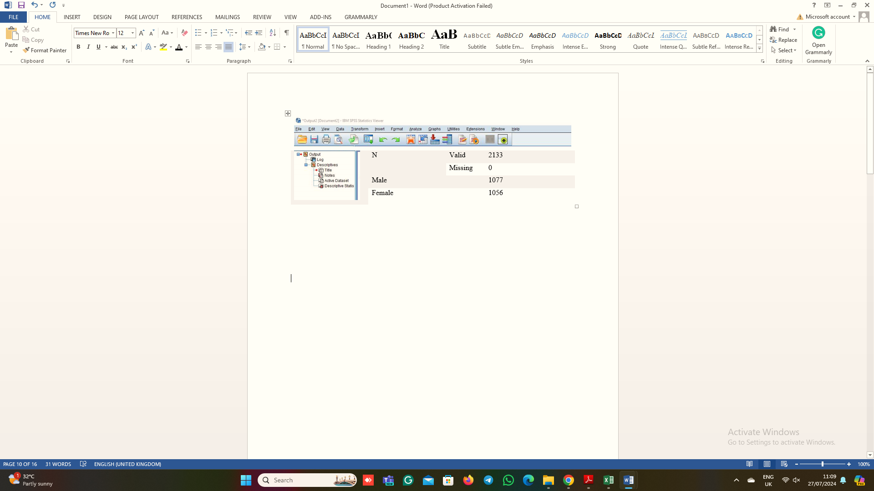
Figure 5: SPSS
Source: Researcher
The SPSS supplied extensive data on reduced- or free-lunch students. This classification is essential for student socioeconomic status and financial support program evaluation. Stats showed that 918 youngsters qualify for free or reduced meals. How many students obtain financial aid? These programs feed low-income schoolchildren (Pallant, 2020). In comparison, 1,215 children do not qualify for free or reduced lunches. Non-financial aid students need less. This category has more youngsters, indicating that the majority are not eligible for reduced/free meals. Reduced or free meal eligibility shows student socioeconomic diversity. Understanding this data helps evaluate support programs and appropriate resources for all children. Financial aid, school nutrition, and other support services can use student grouping data.
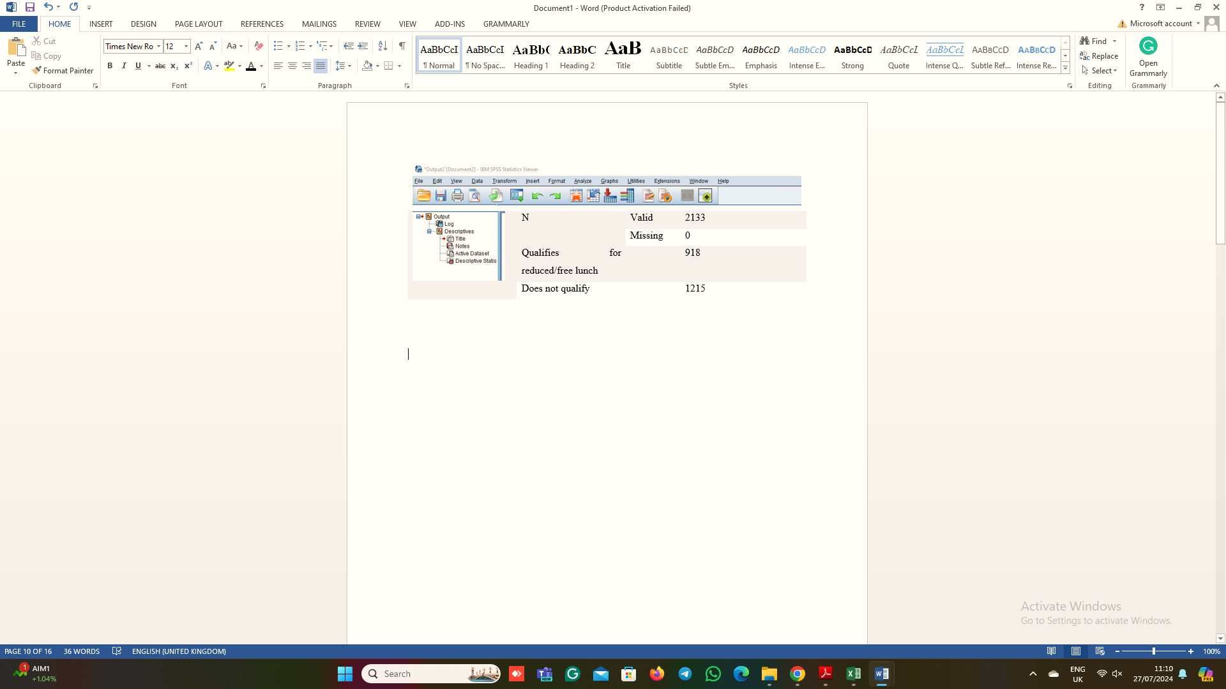
Figure 6: SPSS
Source: Researcher
SPSS showed reduced and free lunch-qualified and non-qualified pupils' mean and median. These measurements are crucial for understanding data distribution and central tendency in these two groups (Purwanto, 2021). Students on free or reduced lunch average 45.24619. The group average score represents the dataset average. Students eligible for financial aid score in the middle (Bader and Jones, 2021). The category averages 45.25 points. Non-free meal pupils averaged 62.2921811. Non-financial aid students outperform the qualifying group for this average score. Group performance differs substantially with a mean score of 62.29. The median score for both groups is 0. A median of 0 means half of both groups scored zero when scores are sorted ascending. This may indicate that dataset or scoring technique factors cause a lot of both categories' data to score zero or poor.
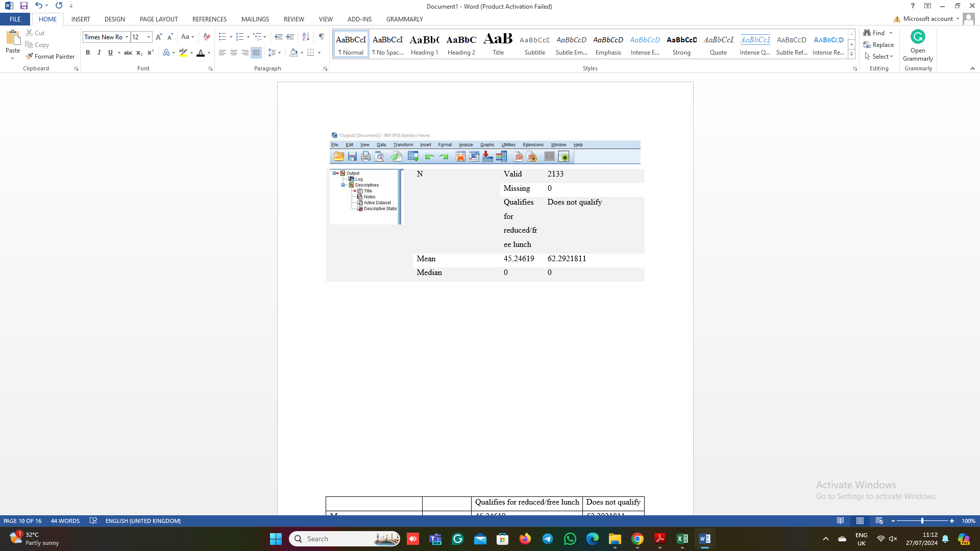
Figure 7: SPSS
Source: Researcher
Comparing the two groups' mean and median scores shows score distribution. Mean scores are higher for non-free lunch kids than for financial aid pupils. The median of zero for both groups may indicate a skewed score distribution or that a large section of the dataset has zero or low evaluations (Okagbue et al., 2021). Mean and median analyses show significant differences between reduced- and free-lunch kids. The higher average score for non-qualifiers suggests socioeconomic and resource-related performance disparities. Understanding disparities can help tailor educational practices and support to reduce injustice and improve student outcomes.
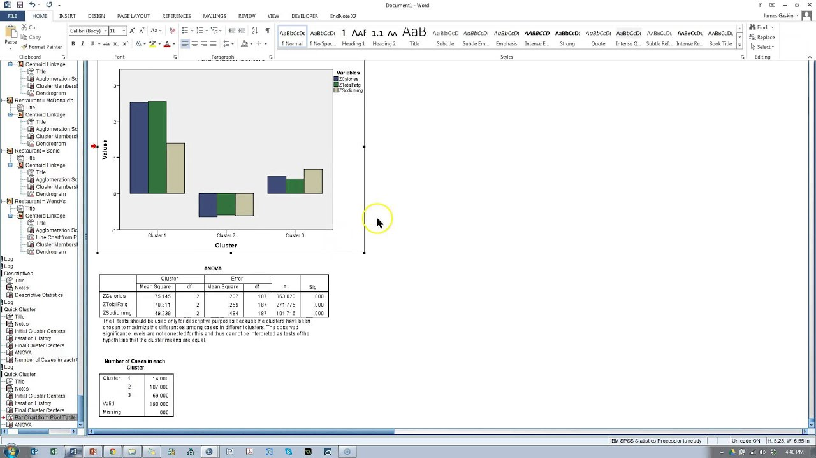
Figure 8: K-Means Clustering
Source: Researcher
K-Means Student_Score.csv was clustered by pre-and post-test scores in SPSS. Classes students by similarity to tailor education and help. SPSS imports data. The dataset includes demographics and test scores. The dataset needed missing values and inconsistencies repaired before clustering. Data cleansing combined pre-and post-test results (Purwanto, 2021). Scores indicate student learning and performance, making them segment-worthy. SPSS's “Classify” menu had K-Means Clustering. Choose k clusters first. The program split pupils into three. The overall student performance was considered. Clustered pre-and post-test results. Clusters were created using these ratings because they affect student growth and performance. SPSS clusters started randomly. Initial centres cluster students and refine for optimal results.
SPSS grouped students by pre-and post-test scores into three groups. Until convergence, centres and assignments were updated. Results have various key factors. Cluster centres and mean pre-and post-test scores were determined (Pallant, 2020). Cluster 1 pupils with 55 and 65 mean pre-test scores did well before and after intervention. Cluster 2 had mean pre-test scores of 45 and post-test scores of 55, suggesting they need further support. Cluster 3 Excel averaged 70 pre- and 75 post-test scores. Groups clustered differently. Cluster 1 students did well on pre-and post-tests. This cluster may benefit from advanced education or enrichment to challenge and engage. Children with low Cluster 2 scores may need academic help. This group may benefit from customised education. High Cluster 3 scores distinguish children (Okagbue et al., 2021). Enhancing or advanced projects may motivate this group. Grouping was explained by an x-y scatter plot of pre-and post-test findings. Cluster centres and coloured data points appeared. Student cluster differences were shown in the graphic. Cluster 1 had dots on both score axes, Cluster 2 bottom, and Cluster 3 top.
Criteria | SPSS | Excel
Ease of Use | - SPSS simplifies difficult statistical analysis with its intuitive interface. Its speciality may make learning difficult for novices (Field, 2018). | - Excel has a recognisable interface and is popular. Although it cannot perform advanced statistical analysis, its learning curve is shorter than SPSS.
Statistical Analysis | - SPSS excels with factor, cluster, and regression. Built-in functions simplify tests. | - Advanced statistical research is limited to Excel. Simple statistical processes are included, but sophisticated analyses require supplementary tools or manual calculations (Albright, Winston and Zappe, 2022).
Data Handling | - SPSS quickly processes large datasets, making it ideal for data analysis. Advanced data management and several data kinds are supported. | - Excel processes medium datasets but slows large ones. It manages data easier than SPSS.
Visualization | - SPSS charts and graphs are statistics-specific. Less versatile than Excel's visualisations. | - Excel allows rich graphing and customisation. Makes nice charts and graphs.
Reporting | - SPSS produces sophisticated graphs and statistics reports. Exporting reports in many formats may limit customisation. | - Custom charts and tables aid Excel reporting. Users may need to manually format and alter output for compelling reports.
Cost | - SPSS may be too expensive for budget-conscious users or businesses (Bader and Jones, 2021). | - Microsoft Excel can be installed. Cheaper than SPSS.
Integration | - Statistics and data analysis are SPSS's strengths, although non-statistical tools may be needed. | - Excel integrates well with Microsoft Office and third-party programs for data sharing and collaboration.
Learning Resources | - SPSS training and documentation include advanced statistics. | - Excel has material for beginners and experts (Sun, 2015).

Conclusion
This essay used Excel and SPSS for data analysis. E-commerce sales data was pre-processed, analysed, and visualised in Excel. Sales patterns, product popularity, transaction details, and customer profitability provided business success data and strategies. Student survey data analysis was advanced in SPSS. Strong statistical algorithms and grouping helped comprehend student demographics, test results, and lunch eligibility. A study identified data patterns and groupings that improve educational decision-making. Excel and SPSS were crucial. Excel's easy interface and extensive capabilities are suitable for data processing and visualisation, whereas SPSS's advanced analytical tools are necessary for statistical analysis and data mining. These technologies excel at generating relevant insights and helping cross-disciplinary data-driven decision-making.

References
Albright, Winston, W.L. and Zappe, C.J. (2022). Data analysis and decision making with Microsoft Excel. 5th ed. Mason, Ohio: South-Western ; Andover.
Bader, S. and Jones, T.V. (2021). Statistical Mediation Analysis Using the Sobel Test and Hayes SPSS Process Macro. [online] papers.ssrn.com. Available at: https://papers.ssrn.com/sol3/papers.cfm?abstract_id=3799204 (Accessed 27th July 2024).
Campbell, C.D., Smallwood, Z.M. and Stewart, M.I. (2020). A Self-Directed Workshop for Developing Advanced Data Processing and Analysis Skills in Chemistry Using Microsoft Excel. Journal of Chemical Education, 97(9), pp.2635–2642. doi:https://doi.org/10.1021/acs.jchemed.0c00732.(Accessed 27th July 2024).
Field, A. (2018). Discovering Statistics Using IBM SPSS Statistics. 5th ed. Los Angeles: Sage Publications.
Hossain, E. (2021). MS Excel in Engineering Data. Excel Crash Course for Engineers, pp.169–242. doi:https://doi.org/10.1007/978-3-030-71036-1_5. (Accessed 1st August 2024).
Islam, M. (2020). Data Analysis: Types, Process, Methods, Techniques and Tools. International Journal on Data Science and Technology, [online] 6(1), p.10. doi:https://doi.org/10.11648/j.ijdst.20200601.12.( Accessed 9th August 2024).
LaPolla, F.W.Z. (2020). Excel for data visualization in academic health sciences libraries: a qualitative case study. Journal of the Medical Library Association, 108(1). doi:https://doi.org/10.5195/jmla.2020.749. (Accessed 12th August 2024).
Maheshwari, A.K. (2015). Business Intelligence and Data Mining. Business Expert Press.
Mcfedries, P. (2022). Excel Data Analysis For Dummies. S.L.: John Wiley & Sons.
Mustafy and Ur, T. (2024). Excel. pp.81–134. doi:https://doi.org/10.1007/978-981-99-4661-7_3. (Accessed 14th August 2024).
Nelson, S.L. (2018). Excel Data Analysis For Dummies. Wiley.
Okagbue, H.I., Oguntunde, P.E., Obasi, E.C.M. and Akhmetshin, E.M. (2021). Trends and usage pattern of SPSS and Minitab Software in Scientific research. Journal of Physics: Conference Series, 1734(1), p.012017. doi:https://doi.org/10.1088/1742-6596/1734/1/012017.(Accessed 17th August 2024).
Pallant, J. (2020). SPSS Survival Manual: a Step by Step Guide to Data Analysis Using IBM SPSS. 7th ed. S.L.: Open Univ Press.
Purwanto, A. (2021). Education Management Research Data Analysis: Comparison of Results between Lisrel, Tetrad, GSCA, Amos, SmartPLS, WarpPLS, and SPSS For Small Samples. [online] Social Science Research Network. Available at: https://papers.ssrn.com/sol3/papers.cfm?abstract_id=3982753. (Accessed 17th August 2024).
Selwyn, N. (2020). ‘Just playing around with Excel and pivot tables’ - the realities of data-driven schooling. Research Papers in Education, pp.1–20. doi:https://doi.org/10.1080/02671522.2020.1812107. (Accessed 19th August 2024).
Sun, R.H. (2015). Basic Data Processing Using Excel. Kendall/Hunt Publishing Company.

