
Module Code: BMHP5014
Module Title: Changemakers: Creativity and Value Creation

Assignment Title: Component 2: Written Assignment /Poster and Pitch
Module Lecturer: Brian Mashumba

Student Name: MUSA BAMWINE
Student ID: 2425291

Title: CARE CONNECT AI - An AI powered digital platform for coordinated ,person-centred care across the NHS

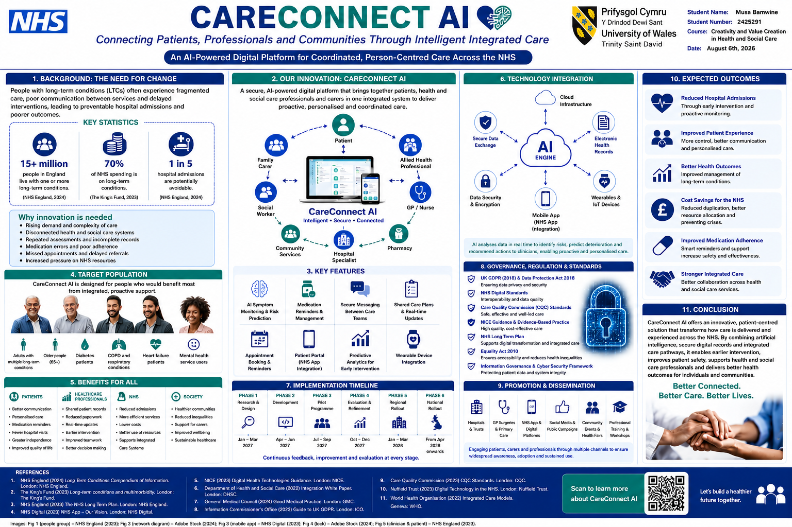

Introduction
Innovation: CareConnect AI – An AI-Powered Integrated Care Platform
CareConnect AI is an AI-powered digital platform designed to integrate health and social care information across NHS services. It connects patients, carers and multidisciplinary professionals through a secure mobile and web-based system. The innovation combines electronic health records, AI-assisted risk prediction, secure messaging, appointment management and wearable device integration to improve person-centred, coordinated care, particularly for people living with long-term conditions.

1. Introduction / Overview
CareConnect AI is an innovative digital service that supports integrated care by bringing together clinicians, social workers, pharmacists, carers and patients within one secure platform. Unlike fragmented systems, it enables real-time information sharing, personalized care plans and predictive analytics that support earlier intervention. The innovation aligns with NHS ambitions for digitally enabled, preventative and integrated care.

2. Problem Statement
Many people with long-term conditions experience fragmented services, repeated assessments, delayed referrals and poor communication between health and social care providers. NHS England reports that over 15 million people in England live with one or more long-term conditions, while these conditions account for around 70% of NHS spending. Fragmented care contributes to avoidable admissions, medication errors and poorer patient outcomes. The NHS Long Term Plan promotes integrated care, prevention and digital transformation, while the Care Act 2014 emphasizes person-centered wellbeing and coordinated support.

3. Target Audience and Impact
Primary beneficiaries include older adults, people with diabetes, COPD, heart failure, dementia and mental health conditions, together with carers and healthcare professionals. CareConnect AI improves communication, medication adherence, self-management and continuity of care. It supports the common good by improving equitable access, protecting dignity, reducing inequalities and helping vulnerable people remain independent.

4. Implementation
The platform would be commissioned by the NHS in partnership with Integrated Care Boards, local authorities and approved technology providers. It would be implemented through GP surgeries, hospitals, community services, pharmacies and care homes. Delivery would include staff training, pilot programmed, phased regional rollout and continuous evaluation.

5. Timeline
Phase 1: Research and design (3 months)
Phase 2: Platform development (3 months)
Phase 3: Pilot testing (3 months)
Phase 4: Evaluation and refinement (3 months)
Phase 5: Regional rollout (6 months)
Phase 6: National implementation and ongoing monitoring.

6. Regulations
Implementation must comply with the UK GDPR and Data Protection Act 2018 for confidentiality and information governance. Care quality should align with CQC standards, NICE guidance and professional codes including the NMC Code and HCPC Standards of Conduct, Performance and Ethics.

7. Technology Integration
Technology includes cloud computing, AI decision support, electronic health records, secure messaging, NHS App integration, wearable devices and predictive analytics. These technologies improve communication, identify patients at risk earlier, reduce duplication and support efficient resource allocation.

8. Dissemination
Awareness would be promoted through NHS websites, GP surgeries, hospitals, community pharmacies, social media campaigns, digital advertising, stakeholder briefings, conferences, patient groups and community outreach events. Educational materials and online demonstrations would encourage adoption.

Conclusion
CareConnect AI provides an innovative solution to fragmented care by integrating technology, person-centered practice and multidisciplinary collaboration. The platform has the potential to improve patient safety, efficiency, communication and health outcomes while supporting NHS digital transformation.

CareConnect AI: An Artificial Intelligence-Powered Platform for Integrated, Person-Centred Care Across the NHS
Introduction
The increasing complexity of health and social care within the United Kingdom has created a growing need for innovative solutions that improve communication, integration and person-centred care. Rising numbers of individuals living with multiple long-term conditions require coordinated support from a range of professionals; however, services frequently operate in isolation, leading to fragmented care, duplicated assessments and avoidable hospital admissions (NHS England, 2019). Digital innovation has therefore become a key priority within NHS transformation strategies.
CareConnect AI is an artificial intelligence (AI)-powered digital platform designed to connect patients, carers and multidisciplinary professionals through one secure integrated system. The platform combines electronic health records, predictive analytics, wearable technology, secure messaging and personalised care planning to support proactive, coordinated care. By enabling earlier intervention and improved communication between health and social care providers, CareConnect AI aims to improve patient outcomes, increase service efficiency and contribute to a more equitable healthcare system.

Background
Health and social care services in England are under increasing pressure due to demographic changes, rising life expectancy and the growing prevalence of long-term conditions. NHS England (2024) estimates that over 15 million people in England live with at least one long-term condition, while approximately 70% of NHS expenditure is associated with managing these conditions. Many of these individuals receive treatment from multiple healthcare professionals, including GPs, community nurses, hospital specialists, pharmacists and social workers. Unfortunately, poor communication between organisations often results in repeated assessments, inconsistent care plans, medication errors and unnecessary hospital admissions.
The NHS Long Term Plan identifies digital transformation and integrated care as essential priorities for improving patient outcomes while ensuring the long-term sustainability of NHS services (NHS England, 2019). Likewise, the Health and Care Act 2022 introduced Integrated Care Systems (ICSs) to strengthen collaboration between healthcare providers, local authorities and voluntary organisations through more coordinated service delivery.
Evidence from The King's Fund (2023) suggests that fragmented services particularly disadvantage older adults and people living with multiple long-term conditions because they frequently experience poor continuity of care. Similarly, the World Health Organization (2022) argues that digital health technologies can significantly improve healthcare quality by supporting integrated information sharing, early intervention and patient-centred decision-making. Consequently, innovative digital solutions are increasingly recognised as essential for improving efficiency, reducing inequalities and delivering safer, more personalised care.

Innovation Description
CareConnect AI is a secure cloud-based digital platform that integrates information from multiple health and social care providers into one intelligent system. Unlike conventional electronic patient record systems that primarily function as information repositories, CareConnect AI actively supports clinical decision-making through artificial intelligence, predictive analytics and real-time multidisciplinary communication.
Patients can securely access their personalised care plans, medication schedules, appointment reminders and educational resources through a mobile application linked with the NHS App. The platform also integrates wearable technologies capable of monitoring physiological indicators such as heart rate, blood pressure, glucose levels and physical activity. This information is analysed continuously using AI algorithms that identify individuals at increased risk of deterioration before symptoms become clinically significant.
When elevated risks are detected, automated alerts are sent securely to appropriate healthcare professionals, allowing earlier intervention and reducing the likelihood of emergency hospital admissions. Professionals from general practice, hospital services, community nursing, pharmacy, occupational therapy and social care can simultaneously access the same up-to-date information, reducing duplication and improving continuity of care.
This innovation reflects NHS ambitions to shift healthcare from reactive treatment towards preventative, personalised and digitally enabled services (NHS England, 2019). Furthermore, NICE (2023) recognises that appropriately evaluated digital health technologies have significant potential to improve clinical outcomes while increasing healthcare efficiency. Consequently, CareConnect AI represents a practical application of AI that complements rather than replaces professional judgement, enabling clinicians to deliver safer and more responsive care.

Impact on Health and Social Care
CareConnect AI offers substantial benefits for patients, healthcare professionals and the wider health and social care system. Primary beneficiaries include older adults, individuals with diabetes, chronic obstructive pulmonary disease (COPD), heart failure, dementia, mental health conditions and people living with multiple long-term conditions who often require coordinated support from several organisations.
Patients benefit through improved continuity of care, greater involvement in decision-making, better medication adherence and faster access to appropriate interventions. These improvements reflect the principles of person-centred care promoted within the Care Act 2014, which emphasises wellbeing, independence and active participation in decisions affecting an individual's care (Care Act, 2014).
Healthcare professionals also benefit from improved communication, reduced administrative duplication and quicker access to accurate patient information. This allows more time to be devoted to direct patient care while strengthening multidisciplinary collaboration. From an organisational perspective, earlier intervention may reduce emergency admissions, avoid unnecessary duplication of services and improve allocation of NHS resources.
Importantly, CareConnect AI contributes to the common good by promoting equitable access to coordinated healthcare regardless of age, disability, ethnicity or geographical location. The Equality Act 2010 requires healthcare providers to ensure services remain accessible and inclusive for all individuals (Equality Act, 2010). By integrating services and reducing barriers to care, CareConnect AI supports social justice, reduces health inequalities and enables vulnerable populations to receive timely, high-quality support while maintaining dignity and independence.

Public and Stakeholder Involvement
Meaningful stakeholder engagement will be fundamental throughout the design, implementation and evaluation of CareConnect AI. A co-production approach will ensure that patients, carers and healthcare professionals actively contribute to platform development, usability testing and continuous service improvement. This collaborative approach reflects NHS England's commitment to person-centred care and shared decision-making (NHS England, 2019).
Stakeholders will include Integrated Care Boards, NHS Trusts, GP practices, local authorities, community pharmacies, voluntary organisations and patient advocacy groups. Public engagement activities, including focus groups, community workshops and digital surveys, will ensure that diverse communities—including older adults, disabled individuals and minority ethnic populations—can influence future development. Healthcare professionals will receive structured training to support confident implementation, while targeted communication campaigns will encourage widespread adoption across health and social care services.

Policies, Services and Professional Links
CareConnect AI aligns closely with current UK legislation, professional guidance and national policy. The Care Act 2014 promotes wellbeing, prevention and integrated working between health and social care organisations, while the Health and Care Act 2022 strengthens collaboration through Integrated Care Systems. The Equality Act 2010 ensures that digital services remain accessible and non-discriminatory for all users.
Because the platform processes confidential health information, compliance with the UK General Data Protection Regulation (UK GDPR) and the Data Protection Act 2018 is essential to maintain information security and patient confidentiality. Service delivery should also comply with Care Quality Commission (2023) Fundamental Standards and NICE (2023) evidence standards for digital health technologies. Healthcare professionals using the platform will continue practising in accordance with the Nursing and Midwifery Council Code (NMC, 2018) and the Health and Care Professions Council Standards of Conduct, Performance and Ethics (HCPC, 2024), ensuring ethical, accountable and evidence-based care.

Conclusion
CareConnect AI provides an innovative and realistic solution to one of the NHS's most persistent challenges: fragmented health and social care. By combining artificial intelligence, integrated communication and person-centred practice, the platform supports earlier intervention, enhances multidisciplinary collaboration and improves patient experiences. The innovation aligns closely with current NHS policy, UK legislation and professional standards, demonstrating both feasibility and relevance within contemporary healthcare. If implemented effectively, CareConnect AI has the potential to improve health outcomes, reduce inequalities and contribute to a more efficient, sustainable and integrated health and social care system.

Harvard References
- Beauchamp, T.L. and Childress, J.F. (2019) Principles of Biomedical Ethics. 8th ed. Oxford: Oxford University Press.
- Care Act 2014 (c.23). London: The Stationery Office.
- Care Quality Commission (2023) Fundamental Standards. London: CQC.
- Data Protection Act 2018 (c.12). London: The Stationery Office.
- Equality Act 2010 (c.15). London: The Stationery Office.
- Health and Care Act 2022 (c.31). London: The Stationery Office.
- Health and Care Professions Council (2024) Standards of Conduct, Performance and Ethics. London: HCPC.
- NHS England (2019) The NHS Long Term Plan. London: NHS England.
- NHS England (2024) Long Term Conditions. London: NHS England.
- NICE (2023) Digital Health Technologies: Evidence Standards Framework. London: NICE.
- Nursing and Midwifery Council (2018) The Code: Professional Standards of Practice and Behaviour for Nurses, Midwives and Nursing Associates. London: NMC.
- The King's Fund (2023) Long-term Conditions and the NHS. London: The King's Fund.
- World Health Organization (2022) Global Strategy on Digital Health 2020–2025. Geneva: WHO

