Name: Sophie Pitcock
Student number: p150414
Course: Illustration
Title: An exploration of the progression of the female nude throughout history in regards to artistic practice
Word Count:
Tutor: Louise Burston

Within this proposal I will explore the progression of the female nude throughout history in regards to artistic practice focusing on eroticism, aesthetics and vulnerability as my three key words. The importance and relevance of the female nude within art will be discussed, specifically focusing on the difference between women used as muses and women as artists themselves. Feminism will be a main theme throughout this proposal, with emphasis on exploring how the female nude is viewed and painted throughout history. Art historian Kenneth Clark once stated when writing about the nude;
“To be naked is to be deprived of our clothes and the word implies some of the embarrassment which most of us feel in this condition. The word nude on the other hand, carries, in educated usage, no uncomfortable overtone.” (Clark, 1956)
By this Clark could be suggesting that there is a significant difference between the naked and the nude. Using the word ‘deprived’ gives connotations of something being taken away from the subject. Changing the vocabulary and making nudity into an art form reclaims some of the power for the subject and eliminates any implication of shame. This distinction between the two is a matter I plan to look into further within this writing.
When looking into the first key word of eroticism the topic of feminism arose frequently. Writer Lynda Nead stated
“art and pornography cannot be seen as isolated regimes of representation, but should be recognised as elements within a cultural continuum that distinguishes good and bad representations of the female body” (Nead, 1992)
By saying this Nead could be suggesting that eroticism within art could be a positive thing as it is showing good representations of the female body. It could also suggest that the difference between pornography and eroticism is that pornography gives a depersonalised version, whereas eroticism depicts the relation between humans. Nead went on to say that “the erotic represents aestheticized sexual representation; it marks out the limits of the sexual within legitimate culture.” (Nead 1992) By saying this she could be conjecting that by having erotica within a culture a sexual boundary is set. Representation is always important within a culture as it shows people that it is okay to be who they are, bringing people closer together. Art historian Peter Webb wrote that “Sexual freedom is synonymous with social freedom and sexual liberation is seen as the first step towards social revolution” (Peter Webb, 1983) Webb could be suggesting that to present one’s sexuality without guilt or embarrassment and without the judgement of others is the first step towards social change and acceptance. Eroticism in art is something that could be helping this along as there is a sexual theme surrounding the piece, often related to emotion instead of just actions, but are also excusable on aesthetically pleasing grounds. Writer and art critic Jon Berger once stated that
“Men act and women appear. Men look at women. Women watch themselves being looked at. This determines not only most relations between men and women but also the relation of women to themselves. The surveyor of woman in herself is male: the surveyed is female. Thus she turns herself into an object of vision: a sight.” (Berger 2008)
By saying this he could be suggesting that women make themselves aesthetically pleasing objects for the pleasure of the male gaze. This is something I feel is both questionable if not a little out dated. It doesn’t take into consideration the sexuality of both the male or female within the situation, not all men look at women and not all women care what men think. To conclude, eroticism within art isn’t just a gift from women as something for the male gaze, but an aesthetically pleasing means of representation in regards to female sexuality.
I have chosen an art piece to look at for the first key word of eroticism. Pictured below- Katsushika Hokusai’s “The Dream of the Fishermen’s Wife”
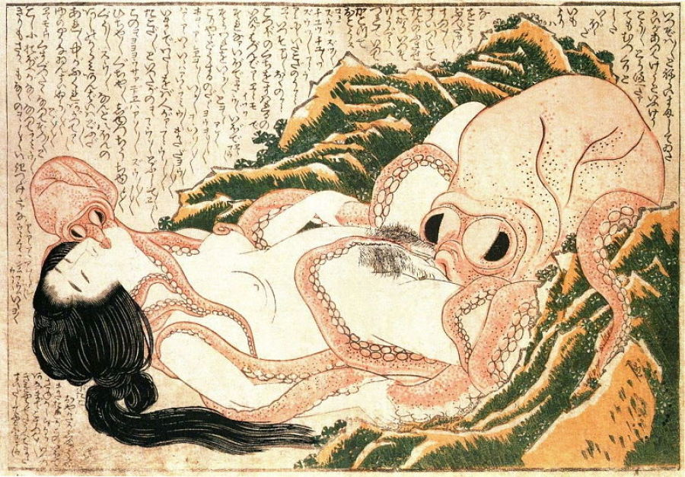
Hokusai, K. (1814). The Dream of the Fishermans Wife. [Woodblock print on paper].
This woodblock- printed Japanese print which is included in a three volume book of shunga erotica has become the most popular of all Hokousai’s shunga designs. It includes popular themes within Japanese art and has had a vivid influence on Japanese artists to follow. It could be argued that this piece could represent a symbol of female sexual power.
For the second key word the theme of aesthetics will be looked at. The word aesthetics suggests the appreciation and nature of beauty. For example, why do we find the naked female body so aesthetically pleasing? This must be a fact as it has been the most popular subject matter within art since the beginning. Clark once stated “It is widely supposed that the naked human body in itself is an object in which the eye dwells with pleasure and which we are glad to see depicted.” (Clark, 1956) Is this because of the physicality of the body being beautiful, or because of the connotations we could take from it. I think that naturally the human body is something that we would consider aesthetically beautiful because it is relatable directly to us. Writer and artist Jane Harris once said “The female nude has been freighted with everything human nature has symbolically displaced; what is dangerous and wild, sexual and other, unconscious and illogical.” (Harris, 2003) By saying this she could be suggesting that the female nude is responsible for representing the things within art that we as humans have displaced or lost. Aristotle once famously wrote “Art completes what nature cannot bring to finish. The artist gives us knowledge of natures unrealised ends.” (Aristotle 384-322BC) This quote would back up what Harris could have been suggesting earlier, explaining that the painted female nude is a perfect representation of everything the human nature has lost, “what is dangerous and wild, sexual and other, unconscious and illogical.”
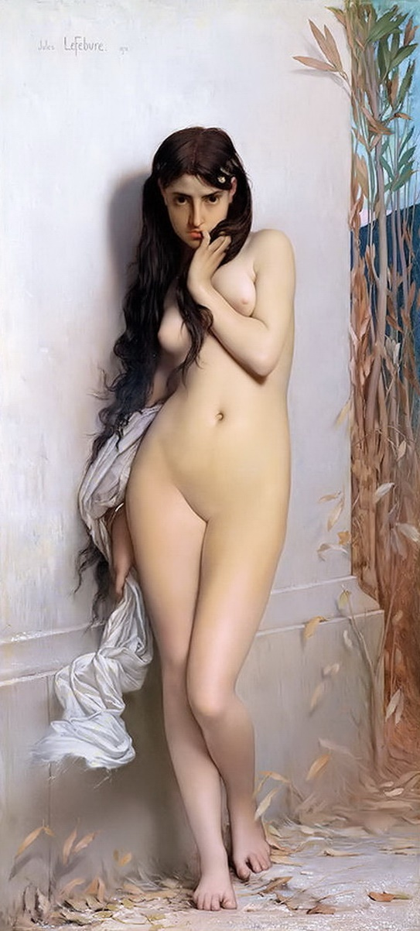
I have chosen an art piece to look at when looking into aestheticism in nude female art. This is Jules Joseph Lefebvre: La Cigale, 1872.
The subject stands on her own in the middle of the piece, your eye being immediately drawn to her. She is the whole focus. She is stood naked, outside in nature, leaves surrounding her feet. This could suggest that both the nature that surrounds her and the subject herself are one in the same thing. Both natural and from this world, and both having the same level of aesthetic beauty.
Lefebvre, J. (1982). La Cigale. [oil on panel].

For my third key word I will be discussing the topic of vulnerability within female nude art. Jon Berger once stated
“You painted a naked woman because you enjoyed looking at her, put a mirror in her hand and you called the painting “Vanity,” thus morally condemning the woman whose nakedness you had depicted for you own pleasure.” (Berger, 2008)
From this Berger could be suggesting that for a woman to pose naked she is endangering herself of being viewed negatively and wrongly by the viewer and in fact even the artist. This is both unfair and immoral towards the muse of the painting, showing how vulnerable women muses can be in this situation. The artist holds all of the power, deciding how to demonstrate them to the viewer.
Artist Yves Klein once held a performance art piece where women were used as ‘human paintbrushes’ to create a series of paintings he called the “Anthropometry paintings.” During this performance he would stand in a bow tie suit and conduct the women as they covered themselves in what he called “International Klein Blue” to make prints of their bodies. This has been arguably controversial within feminist arguments as the women are the muses, the women make the prints, the artist stands and just tells them what to do, but in turn receives all the credit, fame and money for the performance. It has been argued that Yves Klein put on a performance where he literally showed the audience that he was using women as objects to profit his own artistic career.
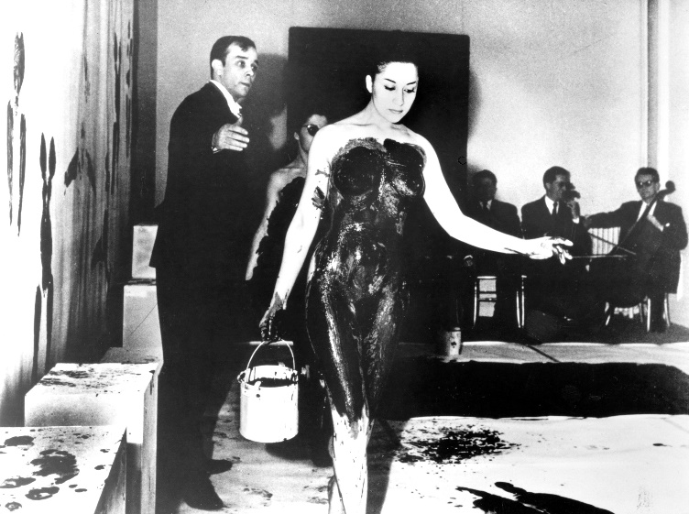

Conclusion

Bibliography
Books
Clark, K (1956) The Nude. Penguin books
Webb, P (1983) The Erotic Arts. Martin Secker & Warburg Ltd
Nead, L (1992) The Female Nude: Art Obscenity and Sexuality. Routledge Publishing
Berger, J (2008) Ways of Seeing. Penguin Books
Harris, J (2003) Curve: The Female Nude Now. Universe Publishing

Artwork
Hokusai, K. (1814). The Dream of the Fishermans Wife. [Woodblock print on paper].
Lefebvre, J. (1982). La Cigale. [Oil on panel] .

Websites
Tutorsglobe.com. (2018) Solved: To complete natures unrealised ends Aristotle believed that, Term Paper. [online] Available at: http://www.tutorsglobe.com/question/to-complete-natures-unrealized-ends-aristotle-believed-that-51497576.aspx [Accessed 10 May 2018].

