Module Title: Food & Beverage Operations
Module Code: BMIH4002
Assignment Title: Crafting a Memorable Dining Experience Menu in Keeping with the Concept
Student name: Ioana Neagu
Student Id:2245342

Concept of the Restaurant
Nomadian's Visit restaurant in the United Kingdom is going to be part of the Trinity Hotel chain. This restaurant will be an Italian restaurant with the aim and objective of gaining more customer base in the United Kingdom. Considering this, the restaurant will serve both the A la carte menu and the Table d Hote menu. Although they will focus on the A la carte menu specifically. The restaurant will provide fresh raw materials that are grown in the kitchen garden to give the customers freshly grown vegetables. This will eventually enhance the taste of the foods and stimulate the customer's satisfaction.

STP analysis
Segmentation
Segmentation is the first step of the STP analysis and the restaurant is going to cover a broad-spectrum customer base in the United Kingdom. Considering this, the restaurants will eventually attract the attention of students, individuals and families as well (Brow, 2013). The restaurant is all set to welcome the guests and serve them the desirable Italian flavors. In relation to this, the restaurant will eventually catch the attention of the customers as it going to be a part of the Trinity Hotel chain.
Target
Italian cuisine is one of the most delicious cuisines in the world and for this reason, the delicious food is the main attraction of the restaurants. This eventually gives them more attention to the teenage and adult age groups' attractions (Cousins et al., 2011). Despite this, people who love Italian foods are one of the most desirable target groups. Thus, people who are not that familiar with this cuisine are also a part of the target segment to spread the services to them and attract more customer bases.
Positioning
Numidian’s visit set to position their brand value in the community. People who love to try different Italian foods and recipes can get a detailed overview of the flavors as this will enhance their experiences in the restaurants. In relation to this, the ambience of the restaurant will soothe every customer enjoying the Ala carte menu as well as the Table d Hote. For this reason, the restaurant enhances its brand image and brand value in the community compared to the other ones.
Reasons behind the choice of menu
The restaurant has chosen to use the Italian menu for restaurant as in the United Kingdom 91 % of the British Population likes Italian cuisine. For this reason, the restaurant will gain more customer attention and make a good revenue collection. The Italian food market in the United Kingdom gained 3.6 billion pounds in exports which accounts for 8.3 % of the total import of the country (Specialityfoodmagazine, 2020). Thus, a restaurant speciality in Italian cuisine is more likely to get extra attention in the country.

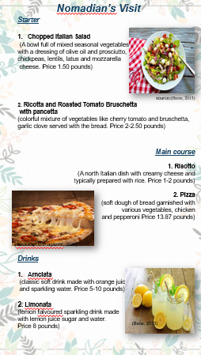

References
Brown, D. R., TotalBoox and TBX (2013) The Restaurant Manager's Handbook : How to Set Up, Operate,and Manage a Financially Successful Food Service Operation. 4th Edition. Atlantic Publishing Group*
Cousins et al. (2011) Food and beverage management: For the hospitality, tourism and event industries. 3rd edn. Oxford: Goodfellow.
Specialityfoodmagazine, (2020). Britain’s love affair with Italian cuisine explained. [Online] Available at: https://www.specialityfoodmagazine.com/food-and-drink/britains-love-affair-with-italian-cuisine-explained#:~:text=Indeed%2C%20a%20recent%20YouGov%20study,the%20UK's%20top%2010%20favourites.[Accessed 30 SEPTEMBER 2023].

