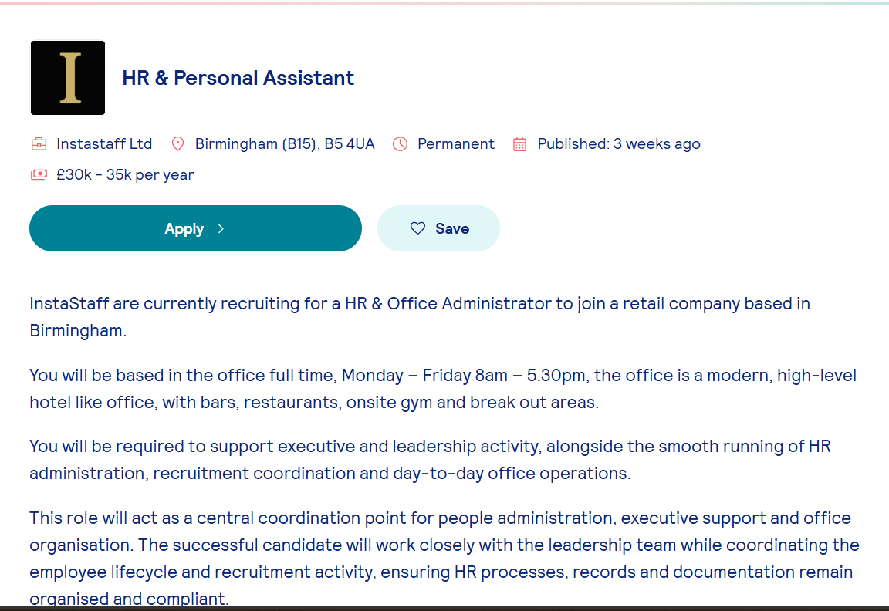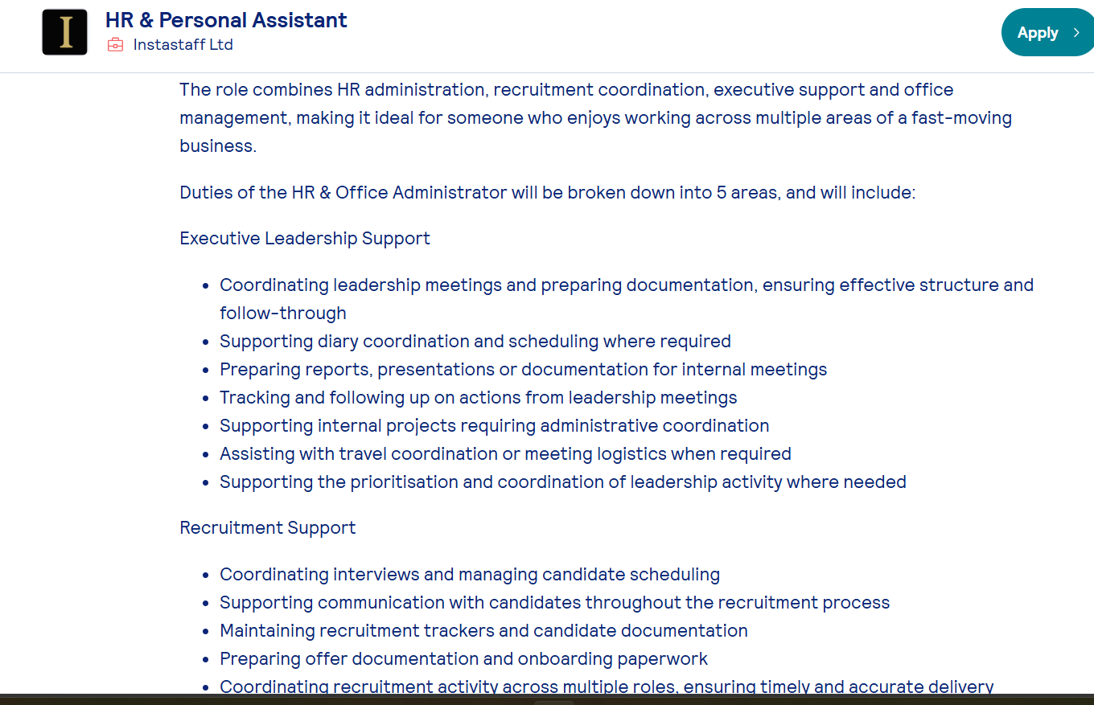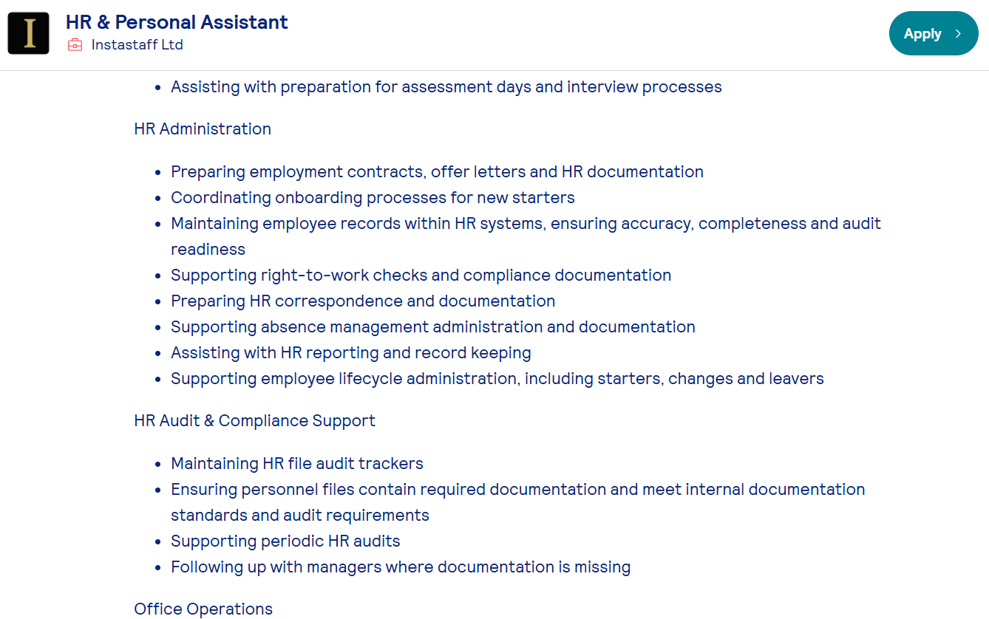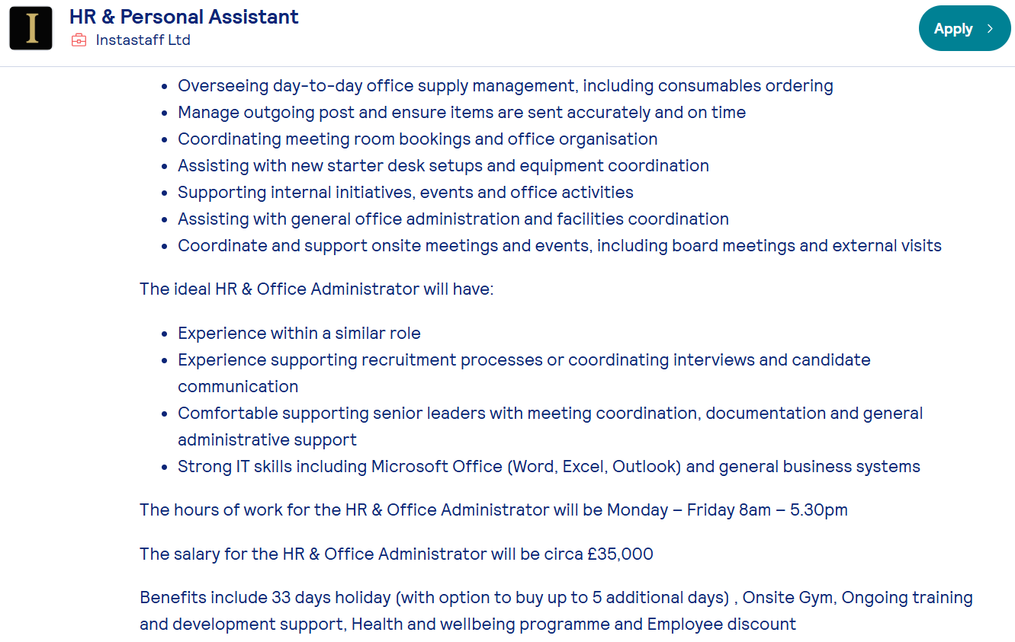z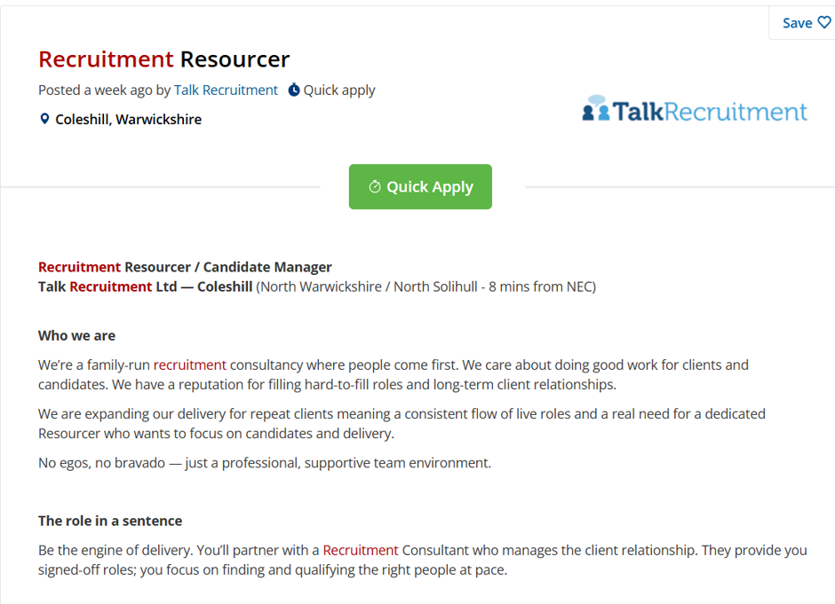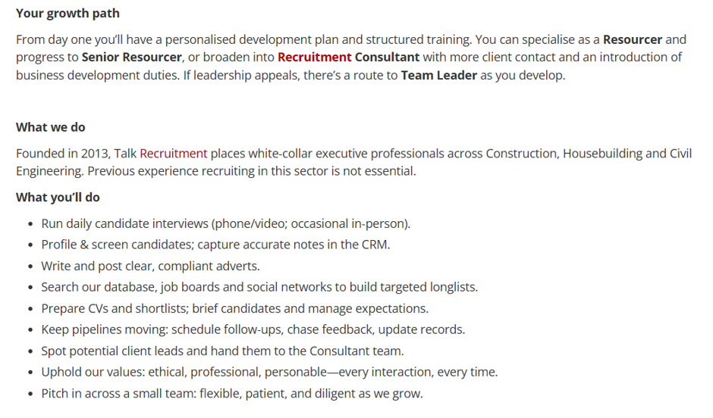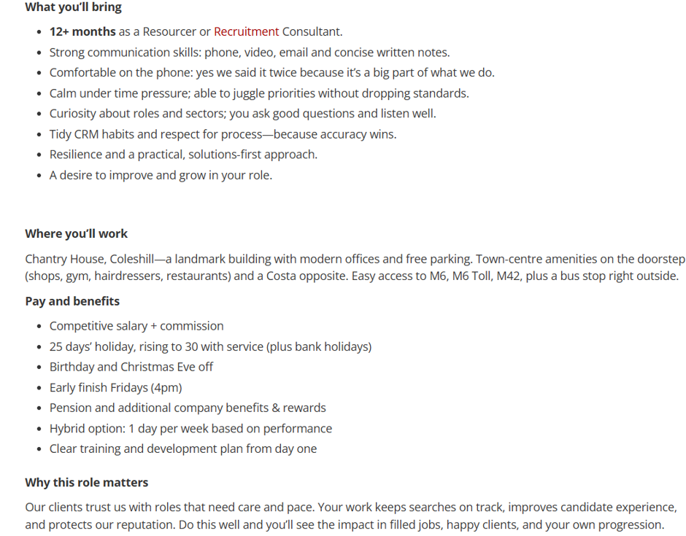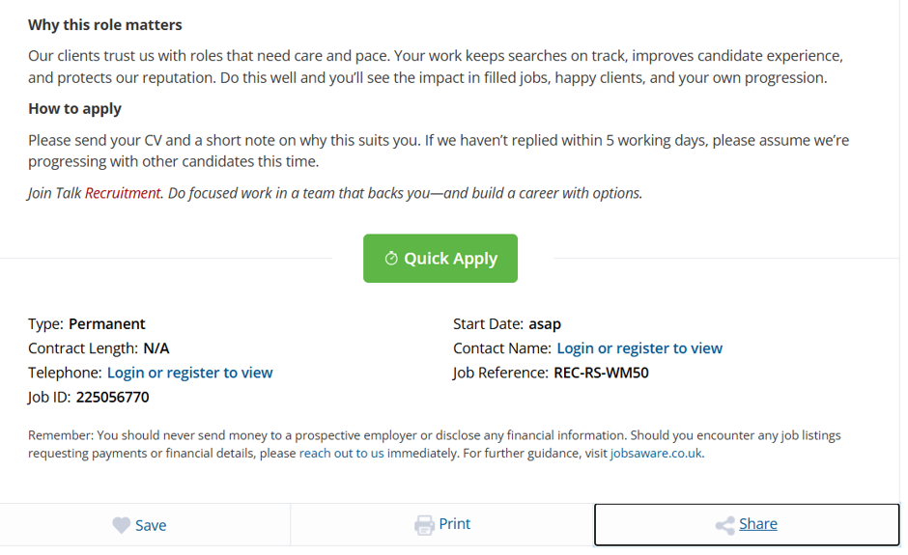

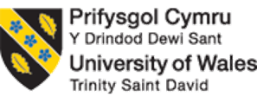

Programme: Cert HE Business Skills for the Workplace
Module: Employability and Career Development
Module code: LCLM4005
Lecturer: Trinh Nguyen Thi Ngoc (Jessie)
Task 2: Portfolio of written tasks
Name: Georgeta Cerasela Enache
Student ID: 2504652

Task A

Comparison of the Two Job Adverts
The two selected job advertisements are HR & Personal Assistant at InstaStaff Ltd and Recruitment Resourcer/Candidate Manager at Talk Recruitment Ltd. Both positions are within the human resources and recruitment profession, but they focus on different aspects of the employee recruitment and management process.
The HR & Personal Assistant role focuses on providing administrative and organisational support to senior managers while coordinating HR activities. Key responsibilities include maintaining employee records, supporting recruitment administration, coordinating the employee lifecycle, ensuring HR documentation remains accurate and compliant, and assisting with the day to day running of the office. The employer is looking for someone who is highly organised, able to work confidentially, manage multiple priorities, and communicate professionally with colleagues and managers.
In comparison, the Recruitment Resourcer/Candidate Manager role focuses on attracting, sourcing, and supporting candidates throughout the recruitment process. The successful candidate will work alongside Recruitment Consultants to identify suitable applicants, arrange interviews, maintain candidate relationships, and fill vacancies efficiently. This position places greater emphasis on customer service, relationship building, resilience, teamwork, and working effectively within a fast paced recruitment environment.

Common Skills and Areas of Knowledge
Although the two roles differ in their daily responsibilities, they require many of the same skills and areas of knowledge. Both employers emphasise the importance of excellent communication skills, strong organisational abilities, time management, teamwork, and professionalism. Candidates must also be capable of prioritising tasks, managing confidential information, and maintaining accurate records.
Both adverts require knowledge of recruitment procedures, administrative processes, customer service, and the use of computer software such as Microsoft Office. In addition, employers expect candidates to demonstrate problem solving skills, attention to detail, flexibility, and the ability to build positive relationships with candidates, clients, and colleagues. These shared requirements demonstrate that successful HR and recruitment professionals need both technical knowledge and strong interpersonal skills.

Assessment of One Key Skill
One of the most important skills identified in both job advertisements is communication. Communication is essential throughout the recruitment and HR process because professionals interact with candidates, managers, clients, and colleagues daily. Clear communication helps to build professional relationships, reduce misunderstandings, and ensure recruitment activities are completed efficiently.
I believe communication is one of my strongest skills because of my previous experience as a Recruitment Assistant. In that role, I regularly contacted candidates, arranged interviews, responded to enquiries, and worked closely with consultants to ensure recruitment activities ran smoothly. In my future career within HR, I will continue to develop this skill by communicating professionally with employees and managers, providing excellent customer service, and supporting recruitment activities. Strong communication will enable me to build trust, resolve issues effectively, and contribute to a positive working environment.

Task B

Self-Assessment (SWOT Analysis)

Strengths
One of my greatest strengths is my communication skills. During my previous role as a Recruitment Assistant, I communicated daily with candidates, clients, and colleagues by telephone, email, and face to face. I arranged interviews, answered enquiries, updated candidates on their application progress, and ensured they had a positive recruitment experience. These responsibilities improved my confidence and allowed me to develop professional communication skills that are essential within HR and recruitment.
Another strength is my organisational ability. Working in recruitment required me to manage several tasks at the same time, including updating candidate records, arranging interviews, maintaining confidential information, and meeting deadlines. In my current role as a Warehouse Operative, I continue to demonstrate good organisational skills by completing tasks efficiently while working in a busy environment. Being organised helps me manage my workload effectively and maintain a high standard of work.

Weaknesses
Although I have gained valuable experience, I recognise that there are areas where I need further development. One weakness is my limited knowledge of UK employment law and advanced HR policies. While I understand the basic recruitment process, I need to improve my knowledge of employment legislation, equality and diversity, employee relations, and HR compliance. Developing this knowledge will increase my confidence and allow me to perform more effectively in an HR role.
Another weakness is my confidence when speaking in formal meetings or delivering presentations. I am comfortable communicating with individuals and small groups, but I sometimes become nervous when presenting information to larger audiences. This lack of confidence could affect my ability to lead meetings or deliver training sessions in the future. I plan to improve this skill by taking every opportunity to practice presentations during my university studies and future employment.
I also believe I need to improve my advanced Microsoft Excel skills. HR professionals frequently use Excel to analyse recruitment data, prepare reports, and monitor employee information. Developing stronger Excel skills will improve my efficiency and prepare me for more advanced HR responsibilities.

Opportunities
There are several opportunities available that will support my career development. My Business Management degree provides knowledge of human resource management, leadership, organisational behaviour, and business operations. The knowledge gained from my studies complements my practical work experience and improves my understanding of how organisations operate.
There are also many professional development opportunities available through online courses, workshops, webinars, and professional organisations such as the Chartered Institute of Personnel and Development (CIPD). Completing additional HR training and eventually gaining a CIPD qualification will strengthen my professional knowledge and improve my employability within the HR sector.
My previous recruitment experience provides a strong foundation for future career progression. By applying for HR Assistant or Recruitment Resourcer roles, I can continue building practical experience while developing new skills. Networking through LinkedIn, attending recruitment events, and seeking advice from experienced HR professionals will also create valuable career opportunities.

Threats
There are several external factors that could influence my career progression. Competition for HR and recruitment positions is high, and many employers prefer candidates with professional qualifications and several years of experience. To remain competitive, I will need to continue developing my skills and gaining relevant qualifications.
Economic conditions may also affect employment opportunities. During periods of economic uncertainty, organisations often reduce recruitment activity, resulting in fewer vacancies. This means I must remain flexible and continue developing transferable skills that can be applied across different industries.
Another potential threat is the rapid development of technology within recruitment and HR. Many organisations now use Applicant Tracking Systems (ATS), artificial intelligence, and HR software to improve recruitment processes. To remain competitive, I will need to continue improving my digital skills and stay up to date with technological developments within the profession.

Evidence of Readiness for Employability and Personal Advancement
My work experience demonstrates that I am prepared for future employment within the HR and recruitment profession. As a Recruitment Assistant, I gained practical experience in candidate sourcing, recruitment administration, interview coordination, customer service, and maintaining confidential information. These responsibilities strengthened my communication, organisational, and relationship building skills while providing valuable insight into recruitment processes.
My current role as a Warehouse Operative has further developed my teamwork, reliability, time management, and ability to work effectively under pressure. Working in a busy warehouse has taught me the importance of accuracy, flexibility, and meeting deadlines. These transferable skills are valuable in any professional working environment, including HR.
My previous experience as a Security Officer also strengthened my professionalism, problem-solving ability, conflict management, and confidence when dealing with different people and challenging situations. These experiences have improved my ability to remain calm under pressure and communicate effectively with others.
Alongside my employment, studying Business Management has developed my academic knowledge of leadership, business management, human resource management, and organisational behaviour. Completing assignments, conducting research, and working on group activities have improved my critical thinking, time management, and written communication skills. Feedback from tutors has encouraged me to continue developing academically, while positive feedback from managers and colleagues has highlighted my reliability, willingness to learn, and positive attitude. These experiences provide strong evidence that I am ready to continue developing professionally and achieve my goal of building a successful career within human resources and recruitment.

Task 3

Employment Goals and Personal Development Plan

Employment Goals
Based on my SWOT analysis, I have identified several employment goals that will help me overcome my weaknesses and achieve my long-term career ambitions within the human resources and recruitment profession.
My short term goal is to secure a full time position as a Recruitment Resourcer or HR Assistant after completing my Business Management degree. This role will allow me to gain further practical experience in recruitment, employee administration, and candidate management. During this period, I also plan to improve my knowledge of UK employment law and HR policies by completing online training courses and attending professional development workshops. In addition, I aim to improve my confidence when speaking in meetings and delivering presentations by participating in group discussions and volunteering to present during university assignments.
My long term goal is to become an HR Advisor or Recruitment Consultant with increased responsibility for recruitment strategy, employee relations, and talent management. I also intend to complete a Chartered Institute of Personnel and Development (CIPD) qualification to strengthen my professional knowledge and improve my career progression. Achieving these goals will enable me to contribute more effectively to organisational success while supporting employees throughout the recruitment and employment lifecycle.
These goals are important because they align with my ambition to build a successful career within human resources. My previous experience as a Recruitment Assistant, together with my current work experience and university studies, has confirmed my interest in this profession. By continuing to develop my knowledge, communication skills, and confidence, I will become a more competent and effective HR professional who can adapt to changing workplace demands and provide a high standard of service to both employees and employers.

Personal Development Plan (PDP)


