MODULE TITLE: MANAGING PROJECTS IN THE ORGANIZATION
MODULE CODE: BMSK5004

Contents
1. Introduction 3
2. Critical Assessment of the Project Management Tools and Techniques 3
2.1: Critical assessment of project management methodologies 3
2.2: Project management methodology at Tesco Plc 8
2.3: Critical assessment of Project management Tools and Techniques used at Tesco Plc 10
3. Planning and communicating project implementation report and implementation the project 14
4. Project management ability and Self-development plan 22
References 23

1. Introduction
Application of the project management tools and techniques varies based on the type of project, project environment, and project management methodology chosen. The first section of the project includes the assessment of thee usefulness and appropriateness of the project management methodologies and techniques. The 2nd section involves the application and 3rd and last section includes self-skill assessment and development plan.

2. Critical Assessment of the Project Management Tools and Techniques
In this section, the pros, cons, and appropriateness of the project management methodologies, tools, and techniques are outlined. The section is ended with a discussion on the project management methodology, tools, and techniques used at Tesco Plc which have to undertake projects to open a new operational unit (i.e. super store, super market) and to digitalize its operations (i.e. introducing virtual store, direct sales, and grocery app etc).

2.1: Critical assessment of project management methodologies
Project management methodology can be defined as a set of principles of project management and processes to be followed in managing project. Some literatures showed that project management methodologies are agnostics. This means that a project management tool and techniques can be used under all methodologies. Other showed that, as project management methodologies are different in terms of underlying insight regarding project management, some project management tools & techniques are fit for best use under some project management methodologies and some are not. (Webster, 2012) Here, the pros, cons, and appropriateness of different project management methodologies are discussed.
2.1.1: Waterfall
The most sequential & oldest project management methodology is “Waterfall” which was designed by Dr. Winston in 1970 to deal with the complex process associated with the software development projects. As name suggest, Waterfall project management methodology is very sequential & each stage is self-contained. That is, one stage should be warp up before shifting resources to other. As the process is sequential and requirement focused & the stages of project management are self-contained, there is little scope of correction after the allocation of the resources to the project. That is, project manager should have crystal clear idea about the requirement of the project before starting; otherwise the project will fail to generate desired outcome as correction is not possible.
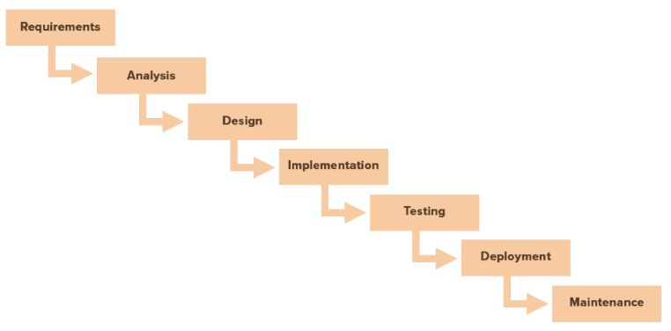
Figure 1: Project management process under Waterfall methodology (Toney & Powers, 2017)
Pros: According to Adams and Caldentey, (2017), Waterfall project management methodologies require investment of time during the initial stage of the project management for the identification & collection of all requirements, but it saves the time require to correct things throughout the project. Huge documentation of resource requirement is required which makes the process of resource allocation (i.e. in and out) throughout the project easy. On the other hand, as the demarcation between the stages is clear, the process is easy to understand and implement.
Cons: High project failure risk is associated with the project as there is less scope of correction during the project life period. Correction requires starting again from the inception. In addition, it is a front-heavy less flexible method where success highly depends on the ability to address all the project requirements at the inception and there is no flexibility to adopt changes in the requirements during the project life.
Appropriateness: Waterfall is appropriate for the simple projects with short life and projects whose requirements are fixed and determinable at the inception.
2.1.2: Agile
Agile is another complex software development project management focused methodology which is iterative, fast, and flexible approach that allows incremental changes during the project life and allows the addressing of the changing project requirement over the time. This doesn’t involve front-heavy project requirement gathering.
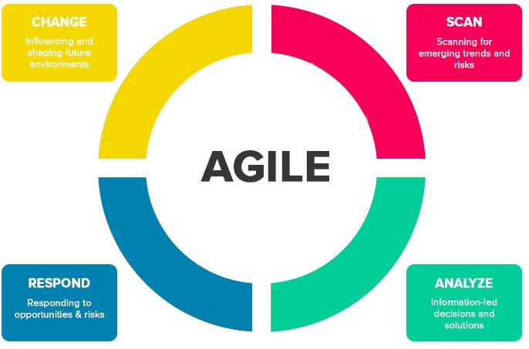
Figure 2: Agile Project Management Methodology (Bu-Bushait, 2014)
Pros: Agile project management method demands frequent involvement of the stakeholders and addressing of the feedback from them. That is, this is not based on heavy requirements and collection incremental changes over the project life. Thus, the risk of project failure reduces drastically.
Cons: as there is no fixed plan under this method and focuses on the addressing on the changes as they occur, the process of resource management and task scheduling become complex and harder. This affects resource utilization efficiency. In addition, lack of fixed plan increased the correlation of the project success with the stakeholders willing to involve with the project (Davidson Frame, 2014).
Appropriateness: When collaboration among the project stakeholders is strong and project may require frequents changes or project end is not determined/ clear at the inception, agile project management method is effective.
2.1.3: Scrum
Scrum project management approach usages the agile philosophy but it promote the involvement of the self-motivated and self-managed skilled team which may not require a project manager. Goals breakdown, daily stand-up meetings, and rapid iteration & development are promoted throughout the project life under this project management methodology.

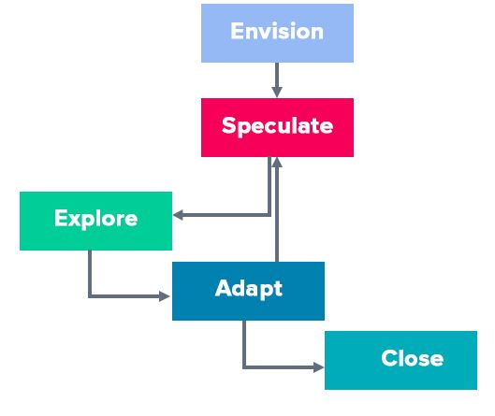
Figure 3: Scrum project management method (Mir and Pinnington, 2014)
Pros: Flexibility is ensured as goals are set and tasks are breakdown on the basis of the team’s assessment about the priority of an issue. Rapid iteration and development is ensured due to the daily stand-up meeting and “scrum sprint” (30 day limit) philosophy. Agile benefit, i.e. high stakeholder involvement, is also ensured there.
Cons: There is high exposure to scope creep risk as the trend of formal scheduling and budgeting is absent. In addition, if team size is large and/or team members are not skilled and dedicated, scrum may lead to project failure.
Appropriateness: Scrum is appropriate for complex and large project only if there is highly skilled and self-motivated team to execute the implementation of the project.
2.1.4: PRiSM
PRiSM is a project management method that is focused of sustainability & reduction of the adverse impact of the project on the environment and society. Prism is methodology which does not end with the delivery of the project outcome rather it extends beyond the project life and deal with the post-deliver factors to maximize the sustainability.
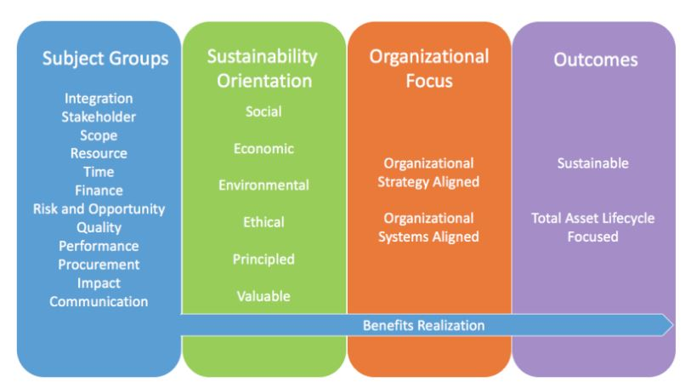
Figure 4: Project management focus under Prism (Cleland, 2018)
Pros, cons, and appropriateness: PRiSM is beneficial for the projects where energy consumption, CO₂ emission, water usages, and waste disposal (i.e. real estate and industrial project) is critical as this helps to reduce the accountability for pollution. In addition, when the external parties engaged with the project is not encouraged by same principle and where sustainability issues are not involved, PRiSM is not appropriate.
2.1.5: PRINCE 2
PRINCE stands for project in controlled environment. PRINCE 2 is an official methodology which is used in managing UK govt. projects. The methodology is based on 7 principle, 7 theme, 7 processes (i.e. stages) and 41 activities. PRICNE 2 referenced 42 project management tools and techniques. The method is focused on high control but also allows tailoring of the project management approach based on the project requirement and environment.
7 principle of the PRINCE includes business case justification on continual basis, stage management, clear definition of tasks and roles, exception based management, product/outcome focused management, learning from the experience, and tailoring of the project management approach based on the requirement and environment.7 themes of project management under the PRINCE approach includes business case justification, quality of deliverable, planning, risk management, change management, project organization, and progress tracking. There are 7 stages/ process under PRINCE 2 philosophy which are starting up, initiation, direction, controlling, stage boundary (i.e. scope) management, product delivery management, and closing.
Pros: PRINCE 2 is focused on documentation and past experience which helps in addressing the risks associated with the projects. In addition, focused management (i.e. planning, stage management, delivery management, control) helps to reduce the exposure to the scope creep. In addition, tailoring of approach makes PRINCE2 appropriate under many project environments (Heerkens, 2015). Business case justification helps to ensure feasibility and profitability of the project.
Cons: Extensive documentation and control is required which narrows down the application area considering the budget and resource require to manage project using the PRINCE2 methodology.
Application: PRINCE 2 appropriate for large and complex project and projects which have fixed requirements. But it can also be appropriate for the small projects as tailoring of the approach is allowed and motivated.
2.1.6: PMBOK guideline: Project life cycle management
PMBOK outlined 10 areas of knowledge of project managements, 5 stages of project life, and 119 tools and techniques to manage the projects. This is designed and updated by the Project Management Institution (PMI) which promotes project life cycle management based project management methodologies where the focus changes as the project progress through 1 stage to another. The project management process and philosophy outlined in the PMBOK can best be described as the guideline rather than a methodology. 10 areas of knowledge include scope management, scheduling, budgeting, business case justification, communication planning, risk management, resource management, responsibility defining and allocation, and progress tracking.
Pros and Cons: Life-cycle based management helps to avoid scope creep risk and helps to identify and address the variances on time. As the management focus is changes over time based on the status and requirement of the project, high flexibility and resources utilization is ensured. The problems with the project life cycle management are that type of project many make it ineffective and the scope statement is generalized. In addition, the roles are not as defined as under PRINCE2.

2.2: Project management methodology at Tesco Plc
Considering the pros and cons of the project management methodologies and the types of the project undertaken, Tesco management usages PMBOK guide laid project life cycle management based project management philosophy and PRINCE 2 principles, themes, processes, and techniques. That is, the project management approach followed at Tesco Plc can be stated as hybrid approach which is the combination of PMBOK guide laid project life cycle management strategy and PRINCE2 project management methodology.
Projects undertaken at Tesco Plc are not routine in nature as it is not project based organization. Rather these projects are unique projects which are administrative or technical. Administrative projects undertaken by Tesco Plc includes the acquisition of Booker, largest grocery whole-seller in the UK, and opening of new superstores, super markets, convenience store, and hypermarkets etc. On the other hand, technical projects undertaken by the Tesco Plc includes the introduction of virtual store platform, grocery app platform, online click & collect platform, and direct sales facilities etc to strengthen its position in the online retailing segment of the market based on the expectation that online retailing will dominate the industry in near future given the changes in the customer buying behaviour.
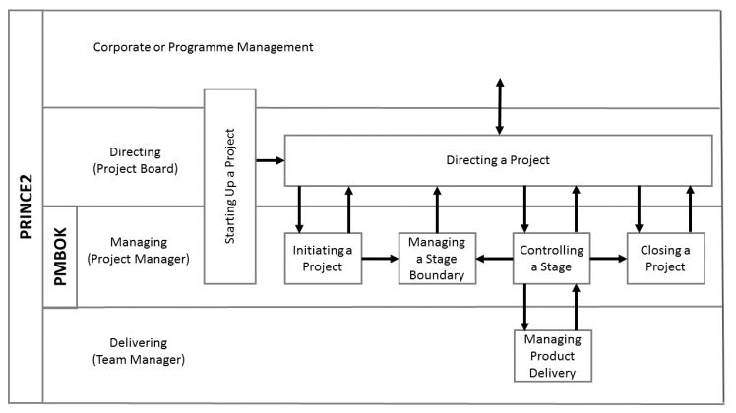
Figure 5: Prince 2 methodology and PMBOK guide (Heerkens, 2015)
Life cycle management technique is used but by using the PRINCE2 processes rather than by using the processes (i.e. project life cycle stages outlined at PMBOK). According to PMBOK guide, a project has 5 stages throughout its life, namely, project initiation, planning, execution & controlling, and closure. These are expected to happen one after one. But according to PRINCE 2 project management methodology; there are 7 stages but planning and directing are expected to be ongoing stages throughout the project life time. Project steering board (i.e. project board; consists of members from related departments and internal & external specialists) direct the project throughout the project life and reports to the corporate management about the progress and issues related with the project.
Project manager deals with the core project management issues (i.e. planning, business case justification, scope management, execution controlling, and project closing). The project manager reports to the project board and helps implementing the direction from the steering group. Every team leader is responsible for the completion of the specific deliverable within the specified time period and on budget. Thus, the pressure on project manager reduces and the focus on core project management activities can be increased while helps to maintain the quality project deliverable.

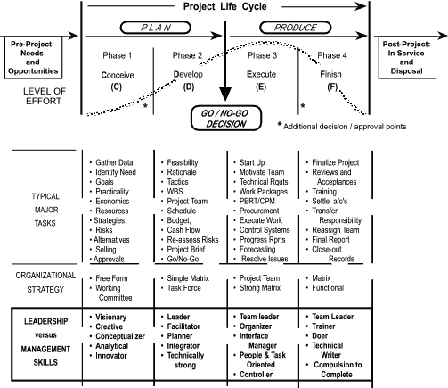
Figure 6: Project life cycle management (PROJECT MANAGEMENT INSTITUTE, 2016)
Project management focus, from the perspective of leadership strategy, organizational strategy, tools and techniques application, varies from project life cycle stages to stages. This is so as the required level of effort and potential exposure to the risks are different at different stages of the project life cycle. Such approach at Tesco Plc helps to implement the PRINCE 2 principles like managing stage boundary which helps to ensure the project quality and to avoid the exposure to the scope creep and other project management risks.

2.3: Critical assessment of Project management Tools and Techniques used at Tesco Plc
The choice and application of project management tools and techniques at Tesco Plc is different based on the types of the project. Projects undertaken at Tesco Plc are unique projects which are administrative or technical. Administrative projects undertaken by Tesco Plc includes the acquisition of Booker, largest grocery whole-seller in the UK, and opening of new superstores, super markets, convenience store, and hypermarkets etc and technical projects undertaken by the Tesco Plc includes the introduction of virtual store platform, grocery app platform, online click & collect platform, and direct sales facilities etc to strengthen its position in the online retailing segment.
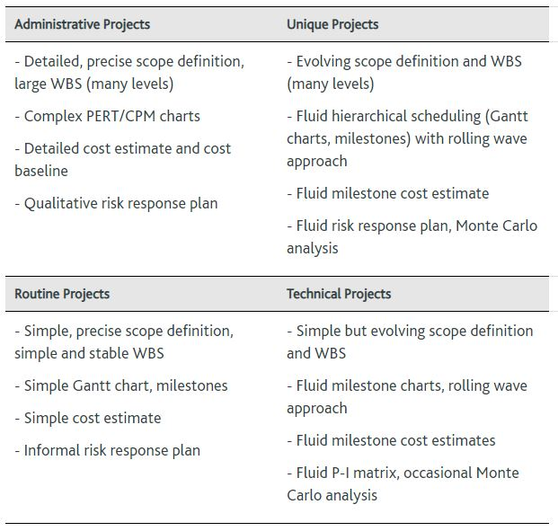
Figure 7: Types of projects (Davidson Frame, 2014)
Administrative projects like acquisition of Booker or opening of new specialty is complexity but the technological uncertainty is low. That is, the requirement is fixed though the process is complex. For such projects, tools and techniques that facilitate clear and efficient scheduling, budgeting, and risk management planning are appropriate. On the other hand, technical projects like the introduction of virtual stores, grocery apps, and direct sales facilities etc have least amount of complexity but are exposed to the uncertainty of technology (i.e. more than 50% new technology are used). Flexibility is allowed to highest extent during the implementation of such projects to ensure the addressing of the scope change requirements.
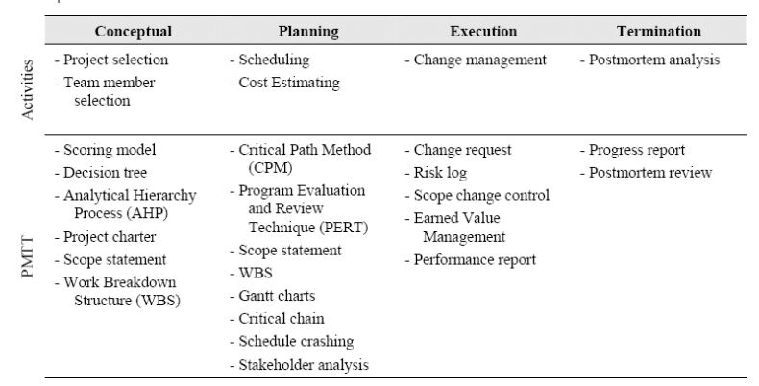
Figure 8: Project life cycle and Project management tools and techniques (Webster, 2012)
As Tesco follows project life cycle management philosophy, the project management tools and techniques used at different stages of project life is different and specific. This is so as the management focus and related activities as different stage throughout the project life is different. For example, during the planning stage, to support scheduling of the required tasks identified through the WBS developed during the project initiation stage, CPM technique and PERT is used.
2.3.1: Usefulness of project selection tools and techniques
Decision tree, scoring model, and analytical hierarchy process are the tools that facilitate decision making through providing the platform to evaluate the risk and reward associated with the alternative options and courses of actions. Thus, business development team can choose the best alternative action/ project to solve a problem or to attain the benefit by recognizing an opportunity. Beside these, net present value, internal rate of return, and discounted payback period etc quantitative investment appraisal techniques are used in assessing the feasibility and business case of the project (Mir and Pinnington, 2014). In addition, Tesco also addresses the qualitative factors like cannibalization effect and synergistic benefit while choosing a project.
2.3.2: Usefulness of project charter, scope statement, and WBS
Scope statement outlines what tasks, goals, and deliverables will be approached and what will not be approached under the project. This, thus, facilitates later stage activities like resources planning, WBS, scheduling, and budgeting etc by providing insight about the boundary of the project. Project charter, on the other hand, includes the business case justification, feasibility, scope, objectives, deliverables, acceptance criteria, constraints, and resource requirements etc. Project charter is a summary report on the basis of what company management approves the allocation of the resources to the project.
2.3.3: Usefulness of Critical Path Method (CPM), PERT, and Critical Chain Tools
PERT technique involves the identification of the tasks, determination of duration and interdependencies, scheduling, Gantt chart development, and critical path identification. The benefits of the use of PERT technique are that this makes the planning easy and efficient (i.e. resource planning, budgeting) by improving the quality of scheduling, helps to identify works with requiring more attention (i.e. activities in the critical path; works that allows slack or float can lend resource to the works at the critical path which helps to ensure efficient resource utilization), and provides insight about the expected project completion period. Critical chain method is another scheduling technique that is based on backward calculation and is focused more on improved resource utilization, wipe out of multi tasks, and avoiding of multitasking (Cleland, 2018). Critical chain technique to schedule tasks is a must for project’s success when project teams are resource-strapped.
2.3.4: Usefulness of the stakeholders’ analysis, communication plan, budget, resource plan, RACI framework, quality control plan, and risk log
Stakeholder analysis helps to assess the communication need based on the interest and involvement of the specific stakeholder to a project. Based on the analysis, communication plan defining the time, subject, frequency, and medium of the communication is developed. This helps to increase the shareholders involvement and in motivating them. Budget helps to identify the financing need (i.e. time and amount) and works as the framework to assess the quality of the project management during project execution period. Resource plan specifies the time of resource requirement and facilitates the timely flow of the resource so that the project may not delay. RACI framework helps to increase the accountability by specifying responsible, accountable, consult, and inform roles for each task. Quality control plan specifies the standard of the deliverable that should be maintained, the person responsible for assessing the quality, and the frequency with which the quality will be tested. This thus helps to achieve the acceptance criteria (Bu-Bushait, 2014). Risk log helps to identify the priority of potential adverse issues, based on the probability of happening and severity, that may have impact on the outcome (i.e. quality, schedule, budget) of the project and to plan for the pre-requisite that will help to reduce exposure to the risks. Risk log and current issue log also helps to make the stakeholders informed about the abnormal issues so that they can deal these with efficiency when they arise.
2.3.4: Usefulness of the progress reporting techniques (i.e. EVA), change management tools (i.e. cause and effect diagram), and project closure report (i.e. performance review report)
Earned value analysis tool helps to assess the deviation from the projected schedule and budget based on the level of work done and amount of time elapsed. This helps to address the time to complete the project at any point and cost to complete the project at any point of time. Thus, beside progress reporting, earned value analysis helps to assess whether any change to the scope (i.e. quality, time, budget) is required at any point (Toney & Powers, 2017). Cause and effect diagram helps to assess the reason behind any deviation and helps to determine the tasks required to address the deviation. Project closure report helps to review the performance (i.e. performance acceptance criteria achieved or not, schedule deviation, budget variance, financing deviation), works as a document of learning, and facilitates a framework for post-project appraisal (i.e. time, criteria, and responsible person).

3. Planning and communicating project implementation report and implementation the project
In this section, the project plan regarding the one of the technical project undertaken by Tesco Plc is outlined.
Project Title: Strengthening position in the online retailing segment.
Project rationale or background summary: Currently, 15% of the grocery retailing at UK is done through online and which is expected to be 25% by 2024. And so, market leaders like TESCO Plc, Sainsbury’s Plc, and ASDA stores limited are facing huge competition from the online catalogue sellers and online retailers like Argos. Some industry peers’ like Sainsbury’s plc and Asda stores limited are acquiring online retailers to keep their market share secure. On the other hand, the market leaders are also losing market share to the discount retailers like Aldi and Lidl. Tesco Plc, thus, was planning to strengthen its position in the market by introducing new platforms that will help to attract customers in the online segment and to offer goods and services at more competitive price.
Objectives: The main objective of the project is to increase the revenue generation through the online segment by 5% over the next 5 years through introducing new comfortable platforms to the clients i.e. virtual store and direct sales opportunity.
- Delivering virtual store platform and direct sales platform within 3 months by incurring not more than 500,00 GBP.
- Increasing the traffic to the online retailing segment by 15% by the end of the project.
Scope:
- Designing, development, and commissioning of virtual store
- Designing, development, and commissioning of direct sales facility
The project will not involve with the marketing of the newly introduced online retailing facilities to the customers.
Constraints:
- 3 month of window of opportunity
- Budget: £500000
Deliverables, acceptance criteria, and quality control plan:
 | Date of delivery | Criteria | Quality Inspector | Time of inspection
Virtual store | Thursday, May 4, 2017 | Easy order by clicking on the electronic screen | Project steering committee, IT & technical team head, project manager, customers. | Wednesday, May 31, 2017
Direct sales facility | Thursday, April 25, 2017 | Facility to purchase directly from the local producers | Project steering committee, IT & technical team head, project manager, customers. | Friday, June 2, 2017

Business case justification:
 | Year 0 | Year 1 | Year 2 | Year 3 | Year 4 | Year 5
Initial Cost | £488,250
**Breakdown is in the budget section
Incremental cash flow (i.e. Revenue) |  | £4,050,000 | £4,252,500 | £4,465,125 | £4,688,381 | £4,922,800
Incremental yearly cash outflow to maintain the project |  | £5,500,000 | £5,665,000 | £5,834,950 | £6,009,999 | £6,190,298
Incremental net cash flow
Cost of capital | 12.35%
Discounted Cash flow |  | £4,895,416 | £5,665,000 | £5,834,950 | £6,009,999 | £6,190,298
NPV | £28,107,413

Schedule:
 | Tasks | Duration | Start | End | Predecessors | Resource
1 | Collaboration with TEC firms | 3 days | Monday, March 13, 2017 | Wednesday, March 15, 2017 |  | PR & sourcing team
2 | Designing the Virtual store platform | 14 days | Thursday, March 16, 2017 | Tuesday, April 4, 2017 | 1 | IT team and external TEC firm
3 | Designing the direct sales platform | 14 days | Thursday, March 16, 2017 | Tuesday, April 4, 2017 | 1 | IT team and external TEC firm
4 | Collaboration with the local suppliers to facilitate the direct sales | 5 days | Monday, March 13, 2017 | Friday, March 17, 2017 |  | PR & sourcing team
5 | Development of the virtual store platform | 21 days | Wednesday, April 5, 2017 | Wednesday, May 3, 2017 | 2 | IT team and external TEC firm
 | Development of the direct sales platform | 14 days | Wednesday, April 5, 2017 | Monday, April 24, 2017 | 3 | IT team and external TEC firm
6 | Complete the negotiation with the space owners at busy street and with the regulatory authority to place the virtual stores | 7 days | Monday, March 13, 2017 | Tuesday, March 21, 2017 |  | PR & sourcing team
7 | Place the virtual stores | 14 days | Thursday, May 4, 2017 | Tuesday, May 23, 2017 | 5,7 | Technical team
8 | Commission the direct sales facility in the existing grocery app platform | 10 days | Tuesday, April 25, 2017 | Monday, May 8, 2017 | 6,4 | IT team and external TEC firm
9 | Integrate the whole system | 5 days | Wednesday, May 24, 2017 | Tuesday, May 30, 2017 | 8,9 | IT team and external TEC firm
10 | Test the functioning | 3 days | Wednesday, May 31, 2017 | Friday, June 2, 2017 | 10 | IT team and external TEC firm
11 | handover to the management for the commercial usages | 1 day | Monday, June 5, 2017 | Monday, June 5, 2017 | 11 | Project managers and team leaders

Gnat Chart
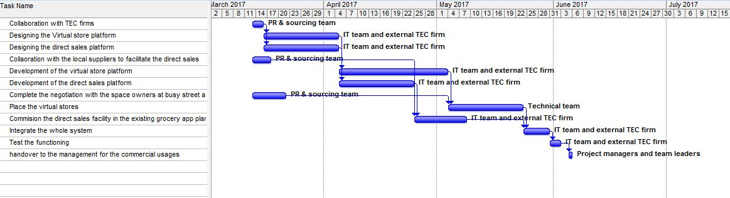
Network Diagram
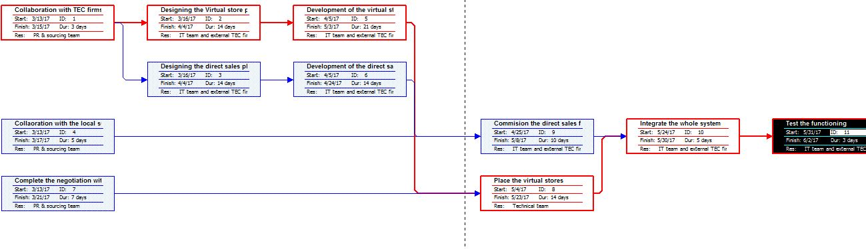

Budget:
Task based budget
Collaboration with TEC firms | £25,000.00
Designing the Virtual store platform | £35,000.00
Designing the direct sales platform | £27,500.00
Collaboration with the local suppliers to facilitate the direct sales | £22,300.00
Development of the virtual store platform | £178,500.00
Development of the direct sales platform | £109,600.00
Complete the negotiation with the space owners at busy street and with the regulatory authority to place the virtual stores | £37,000.00
Place the virtual stores | £14,800.00
Commission the direct sales facility in the existing grocery app platform | £12,500.00
Integrate the whole system | £17,500.00
Test the functioning | £7,500.00
handover to the management for the commercial usages | £1,050.00
Total | £488,250.00

RACI Framework:
 | Responsibility | Accountability | Consult | Inform
Collaboration with TEC firms | PR & sourcing team | Team head and PM | Internal specialist | Project steering committee
Designing the Virtual store platform | IT team and external TEC firm | Team head and PM | External TEC consult firm | Project steering committee
Designing the direct sales platform | IT team and external TEC firm | Team head and PM | External TEC consult firm | Project steering committee
Collaboration with the local suppliers to facilitate the direct sales | PR & sourcing team | Team head and PM | Corporate Lawyer | Project steering committee
Development of the virtual store platform | IT team and external TEC firm | Team head and PM | External TEC consult firm | Project steering committee
Development of the direct sales platform | IT team and external TEC firm | Team head and PM | External TEC consult firm | Project steering committee
Complete the negotiation with the space owners at busy street and with the regulatory authority to place the virtual stores | PR & sourcing team | Team head and PM | Corporate Lawyer | Project steering committee
Place the virtual stores | Technical team | Team head and PM | External TEC consult firm | Project steering committee
Commission the direct sales facility in the existing grocery app platform | IT team and external TEC firm | Team head and PM | External TEC consult firm | Project steering committee
Integrate the whole system | IT team and external TEC firm | Team head and PM | External TEC consult firm | Project steering committee
Test the functioning | IT team and external TEC firm | Team head and PM | External TEC consult firm | Project steering committee
handover to the management for the commercial usages | Project managers and team leaders | Team head and PM |  | Project steering committee

Stakeholder analysis:
(Low) Influence (high) | Keep Satisfied  - Approaching to increase their motivation as they are involved with the project  - I.e. External TEC firm (contractor) an external TEC firm | Involve closely in the project  - Technical team  - PR & sourcing team  - Technical team
(Low) Influence (high) | Monitor  - Approaching to increase their interest and get important consultation from them  - Regulatory body | Keep Informed  - Consultation on the respective areas of interest to increase their involvement  - I.e. customers, project steering board, suppliers, other employees who do not relate with the project directly
 | (Low) Interest (High)

Communication Plan:
What | To whom | By whom | Time and how often | Way
MoU signing | Local suppliers | PR & sourcing team | Friday, March 17, 2017 | Face to face meeting
Contract for space | Space owner or bill board lender | PR & sourcing team | Tuesday, March 21, 2017 | Face to face meeting
Project contract | TEC firm and consult | PR & sourcing team | Wednesday, March 15, 2017 | Face to face meeting
Risk & issue update | All executive project team members | Project manager | Bi-Weekly | Dashboard
Progress reporting | Project steering group | Project manager and loam leader | Weekly | Face to face meeting or mailing

Initial Risk Log:
Risks | Probability | Severity | Rating | Risk action
Lack of internal expertise in handling issues related with the TECH projects may cause the extension of deadline and budget | 5 | 5 | 25 | Risk transfer  Contracting award to specialized third party
Potential data security disputes | 5 | 4 | 20 | Risk mitigation  Expert team employing and collaboration with the regulatory authority.

Earned value analysis framework:
The following framework is used tracking the progress of the project and in assessing the required changes in the scope i.e. time, budget, quality. The later on is done by calculating the estimated budget at completion [Actual cost incurred + (Actual budget to complete – earned value] and Estimate to complete [estimated budget at completion- actual cost incurred]
1 | 2 | 3 | 4 | 5 | 6 | 7 | 8 | 9 | 10 | 11
Tasks | Budget | Duration | Planned completion date | % of work performed | Actual cost incurred | EV= 5*2 | CV=7-6 | % of work planned to be performed | PV=2*9 | SV=7-10
Collaboration with TEC firms | £25,000 | 3 days | 3/15/2017
Designing the Virtual store platform | £35,000 | 14 days | 4/4/2017
Designing the direct sales platform | £27,500 | 14 days | 4/4/2017
Collaboration with the local suppliers to facilitate the direct sales | £22,300 | 5 days | 3/17/2017
Development of the virtual store platform | £178,500 | 21 days | 5/3/2017
Development of the direct sales platform | £109,600 | 14 days | 4/24/2017
Complete the negotiation with the space owners at busy street and with the regulatory authority to place the virtual stores | £37,000 | 7 days | 3/21/2017
Place the virtual stores | £14,800 | 14 days | 5/23/2017
Commission the direct sales facility in the existing grocery app platform | £12,500 | 10 days | 5/8/2017
Integrate the whole system | £17,500 | 5 days | 5/30/2017
Test the functioning | £7,500 | 3 days | 6/2/2017
handover to the management for the commercial usages | £1,050 | 1 day | 6/5/2017
***Here, EV= earned value, CV= cost variance, PV= planned value, SV = schedule variance.

4. Project management ability and Self-development plan
Peers Feedback: after identifying the 7 best project management qualities, the peers were asked to rate on three criteria for different skills as they realized while working in a team. Following is the result of the peer review.
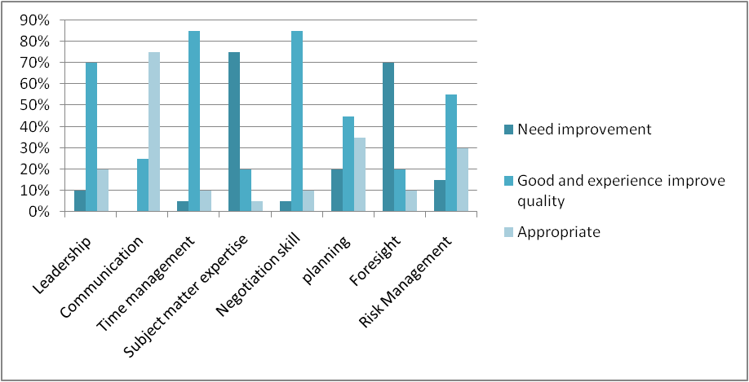
Most of the peers showed concern about my subject matter knowledge and the ability to forecasts the critical issues. Following the plan I have planned to increase my ability of project management.
Particular | Timeline | Way
Improving project management knowledge | 1 month | Reviewing the real life project management cases, PMBOK guide, PRINCE2 techniques, and literatures
Getting insight from the experienced project managers | 2 months | Interviewing the real life successful project managers. Approaching working under supervision of a experienced project managers.

Conclusion
To complete a project, it is important that each of the stage of project management be complete following a sequence. However, 3 pillars of constraint namely cost, quality and time is also an important consideration while completing a project. Different project management tools used in real life normally ease the overall project work. However, proper scrutiny and observation is necessary to complete the project successfully.

References
Adams, J. R., & Caldentey, M. E. (2017). A Project-Management Model. In D. I. Cleland (Ed.), Field Guide to Project Management (pp. 48-60). USA: International Thomson Publishing Company.
Bu-Bushait, K. A. (2014). A Descriptive Examination of the Relationships Between the Application of Project Management Techniques and Project Characteristics. Unpublished Dissertation, Georgia State University.
Cleland, D. I. (2018). Strategic Project Management. In J. K. Pinto (Ed.), The Project Management Institute Project Management Handbook (pp. 27-54). San Francisco, CA: Jossey-Bass.
Davidson Frame, J. (2014). Reconstructing Project Management. Project Management Journal, 45(1), pp.123-128.
Heerkens, G. (2015). Project management. [London, UK]: Mcgraw-Hill Education.
Mir, F. and Pinnington, A. (2014). Exploring the value of project management: Linking Project Management Performance and Project Success. International Journal of Project Management, 32(2), pp.202-217.
PROJECT MANAGEMENT INSTITUTE (2016). GUIDE TO THE PROJECT MANAGEMENT BODY OF KNOWLEDGE.
Toney, F., & Powers, R. (2017). Best Practice of Project Management Groups in Large Functional Organizations: Project Management Institute.
Webster, F. M. (2012). Tools for Managing Projects. Project Management Quarterly (June), 46.

