
What makes tim cook a great leader?
Emergent Leadership Skills BMSW6101

April 2, 2021
Samantha davis
1812476

Contents
1.0 Introduction 2
1.1 3
2.0 Main Findings 5
2.1 5
2.2 7
2.3 12
2.4 14
2.5 17
3.0 Conclusion 18
4.0 References 19

1.0 Introduction
Our lecture Brynach Heffernan as assigned us the task of compiling an essay and a professional discussion on What makes a great leader? The professional discussion will be had on Monday March 22nd and the essay will be submitted on April 2nd. The following essay is going to be split into various tasks identifying and answering the question What makes a great Leader? And will be focusing on my own personal skills within a leadership role.
What is Leadership?
Leadership is defined simply as ‘the action of leading a group of people or organisations, or having the ability to do this’
‘Leadership is a combination of strategy and character’ (Simpson, 2012)
Mullins (2008:806) defines leadership as: ‘A relationship through which one person influences the behaviour or actions of others.’
The essay will be highlighting what makes Tim Cook Apple CEO a great leader and by using various leadership theorists and models I will be able to identify the type of leader he is and his impact on others.

1.1
Who is Tim Cook?
Tim Cook is an American businessman who has been the acting CEO of Apple Inc since the death of its co-founder Steve Jobs. Prior to this role Tim was the company’s chief operating officer under the guidance of Steve.
Early Life
Tim Cook was born Timothy Donald Cook on November 1st, 1960 in Mobile Alabama. Tim spent his childhood growing up with his 2 brothers in Robertsdale Alabama, where he would remain until graduating high school in 1978. Tim was raised by working parents Donald who worked in the local shipyard and Geraldine who was employed in the local pharmacy. Tim was the middle child, and all 3 boys had a happy childhood. (Apple Leadership - Tim Cook, 2021)
Education
After graduating second in his class from Robertson High School. In 1982 Tim went on to graduate from Auburn University in Alabama, with a bachelor's degree in industrial engineering, and went on to earn a Master of Business Administration degree from Duke University's Fuqua School of Business in 1988. Whilst studying at Duke Tim was also awarded the title of Fuqua Scholar—an honour given only to students at the business school who graduate in the top 10 percent of their class. (Tim Cook, 2021)
Career
Tim started his career by investing 12 years working for International Business Machines (IBM) as director of North America Fulfilment before relocating to Compaq Computers as Vice President for Corporate Materials. Tim finally started his career with Apple Inc as Senior Vice President of worldwide operations working alongside Steve Jobs. (Mapping Tim Cook's Career Path (AAPL), 2021)
Awards and Achievements
He was named one of ‘Forbes’ magazine's ‘World's Most Powerful People’ in 2011. (Forbes, 2021)
In 2015, Cook was inducted into the ‘Alabama Academy of Honour,’ the highest honour given by Alabama to its citizens.
He received an honorary doctorate from ‘George Washington University’ in 2015.
In 2017, he received an honorary Doctor of Science from the ‘University of Glasgow.’
Private Life
Not much is known about Tims private life as he is a very private person who likes to keep his personal and professional lives separate however in October 2014 Tim openly admitted on live T.V that he was proud to be gay. This announcement made him the first openly gay CEO of the Fortune 500 companies.
He is a very private person and does not like to be seen in the public eye although he does enjoy cycling and working out at the gym.
Charity Work
Tim Cook donated $50 million to ‘Stanford’ hospitals, including $25 million to a new children’s hospital in 2012. He also made a $50 million donation to the charity ‘Product Red,’ which works towards combating issues like AIDS, tuberculosis, and malaria.
In March 2015, he announced that he has plans to donate his entire fortune to charity. He also stated that he would develop a systematic approach to philanthropy.
Net Worth
As of 2020, Tim Cook has a net worth of $1 billion. (Who is Tim Cook? Everything You Need to Know, 2021)

2.0 Main Findings

2.1
“Thanks to his excellent management strategy, Apple was able to rose rapidly. Cook helped the company to grow and gain big profits.
He eventually became Apple's CEO in 2011 and was able to make Apple a $2 trillion company in 2020. This allowed him to reach billionaire status for the first time.
According to Bloomberg, the CEO promised to give away most of his wealth to Apple.” (Leon, 2021)
"My own personal philosophy on giving is best stated in a [John F.] Kennedy quote, 'To whom much is given, much is expected.' I have always believed this."
Tim Cook says that when Steve Jobs picked him to be CEO, Jobs said, “I never want you to ask what I would have done. Just do what’s right.” Cook has indeed followed Jobs' advice, and he has changed the company to fit his idea of what is right.
Some of the biggest changes/ achievements Cook has made since becoming Apple CEO are
- Apple is now more charitable- Cook has pledged that Apple will be matching employees’ charitable donations by up to $10,000. To date this money has helped hospitals, Project Red, and anti-poverty initiatives.
- Got rid of Google Maps- Cook launched Apple Maps after ending Apple’s contract with Google Maps earlier than scheduled. Initially this was not a great move as Apple Maps was not fully developed and resulted in upset customers. These problems were so upsetting to Cook that he publicly apologised and even recommended competitors’ applications that were better.
- Introduced Apple Mini- Along with the first Apple mini product Cook also made bigger screens, handsets all with state-of-the-art cameras and technology leading the way in Creativity and Innovation.
- Gave Jony Ive control over the look and feel of iPhone after forcing the lead engineer Scott Forstall out. Cook soon seen the rewards of this decision with a sleeker and more competitive look and feel around its software.
- Shared the limelight- Invited Jony Ivey and lead software engineer Craig Federighi to join him on the cover of Bloomberg Businessweek and encouraged them to interact more with the media and give the necessary interviews and public appearances.
- Acquired acquisitions- Helped Apple have more than one brand by acquiring Beats Audio Acquisitions and purchasing 24 other small businesses.
- Created manufacturing jobs- Started making their Mac computers in the United States thus creating thousands of jobs for the American population.
- Returned money to its shareholders-Jobs took care of shareholders by making Apple’s stock fly to the moon. Cook has overseen an appreciation in Apple’s share price, too, but he has done more than that for shareholders. He has approved an unprecedented $130 billion share buyback and implemented a dividend. (How Tim Cook Has Changed Apple, 2021)

2.2
Over the last 20 years Apple has grown under the leadership of two very powerful and great leaders. From 19997-2011 Apple was under the leadership of CEO Steve Jobs who many described as an Autocratic Leader who micro- managed most of Apples business endeavours. Employees have been quoted as saying that when Jobs was in charge “everything flowed through him.” Whilst others have said Tim Cook is a Transformational Leader.
Since Jobs resignation as CEO in August 2011 followed swiftly by his death in October 2011 resulted in Apple’s stock price dropping by 6%. The loss of Jobs affected not only the company’s share price but also the company’s leadership leaving ‘big boots for Cook to fill’. (MarketLine, 2012).
“All eyes were on Apple CEO Tim Cook after he took over from the iconic and masterful Steve Jobs. People did not believe he possessed the necessary leadership qualities required to help Apple continue as a tech powerhouse. We have quickly realized that this is not the case and Tim Cook is more than capable of taking Apple to the next level” (11 Leadership Lessons We Can Learn from Tim Cook, 2021)
Leadership requires many skills that leaders must continue to possess and develop to have a successful career, many believe that Cook possesses the following skills and that others can learn a lot from him:
- Take Risks
- Focus
- Trust others
- Diversity is important
- Be humble
- Admit when your wrong
- Do what you do and do it well
- Believe in what you are doing
- Be yourself
- Write your own rules
- Be transparent (11 Leadership Lessons We Can Learn from Tim Cook, 2021)

What makes Cook exceptional is his use of the transformational leadership principles to not only influence and guide Apple, but to affect change in the IT security industry worldwide by becoming a role model for advocating privacy and encryption. Cook’s stance on privacy and encryption came to the public’s attention after he stated Apple would not unlock an iPhone of a suspect in a domestic terrorist attack, even under enormous legal and political pressure
Transformational leadership “is the ability to get people to want to change, to improve, and to be led” (Hall et al. 2015).
Cook's willingness to take on the tough battles, such as the fight for privacy, makes him a role model and inspiration to his employees. In a commencement speech at George Washington University in 2015, Cook emphasized his point when he stated, “The side-lines are not where you want to live your life. The world needs you in the arena” (Eadicicco, 2015).
There are many different Leadership Models that we can be looking at but for this Essay we are mainly going to be focusing on John Adair, Douglas McGregor and Kurt Lewins who all have different theories on Leadership.

It is easy to align Cook’s traits and styles with the John Adair Action Centred Leadership Model as this theory centres around the task team and individual.
“Good managers and leaders should have full command of the three main areas of the Action Centred Leadership model and should be able to use each of the elements according to the situation. Being able to do all of these things, and keep the right balance, gets results, builds morale, improves quality, develops teams and productivity and is the mark of a successful manager and leader.”
John Adair's Action-Centred Leadership model is represented by Adair's 'three circles' diagram, which illustrates Adair's three core management responsibilities:
- Achieving the task
- Managing the team or group
- Managing individuals
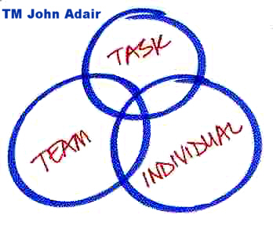
(Action-Centred Leadership - John Adair, 2021)
For a leader to benefit from the John Adair model and see the success Adair also believes there are 9 core functions that play a vital part
- Planning – Cook enjoys 2-way communication and also likes to sit back and listen so that he gains information before commencing a plan.
- Initiating - briefing, task allocation, setting standards
- Controlling - maintaining standards, ensuring progress, ongoing decision-making
- Supporting – Cook is highly respected for letting people take the lead and boosting morale
- Informing - clarifying tasks and plans, updating, receiving feedback and interpreting
- Evaluating - feasibility of ideas, performance, enabling self-assessment
McGregor believes that the managers style was determined by how the manager understood his employee’s human nature. He identified two sets theory X and theory Y. Whilst Cook assumptions would put him within theory Y his predecessor Job would identify as theory X. This is evident as Job was an Autocratic leader who liked every aspect of decision making and leadership go via him and in some opinions he was thought of as a controller, all these traits and assumptions are not evident in Cook’s calm and passive demeanour. Cook is a much more passive leader who believes that employees gain a sense of satisfaction from going to work, and that it is possible to motivate the staff to give him the respect and recognition that so many give him. By working within the theory Y grid Cook will see the results of this via high levels of motivation and performance. This participative style also aligns with the Lewins Model (Management and Leadership Styles - CMI, 2021)

McGregor theory X theory Y
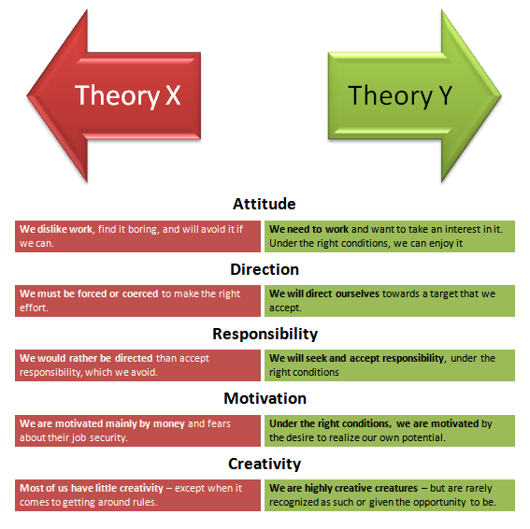 (theory x and y - Bing, 2021)

Although Cook is seen as a Democratic Leader, by identifying his styles and traits it easy to see that he possesses various skills and attributes from all three leadership styles of Kurt Lewins theory which is helping to make him one of the world’s greatest Leaders.
KURT Lewins theory highlights the 3 main Leaderships Styles
- Authoritarian (Autocratic)
- Participative (Democratic)
- Delegative (Laissez-faire)
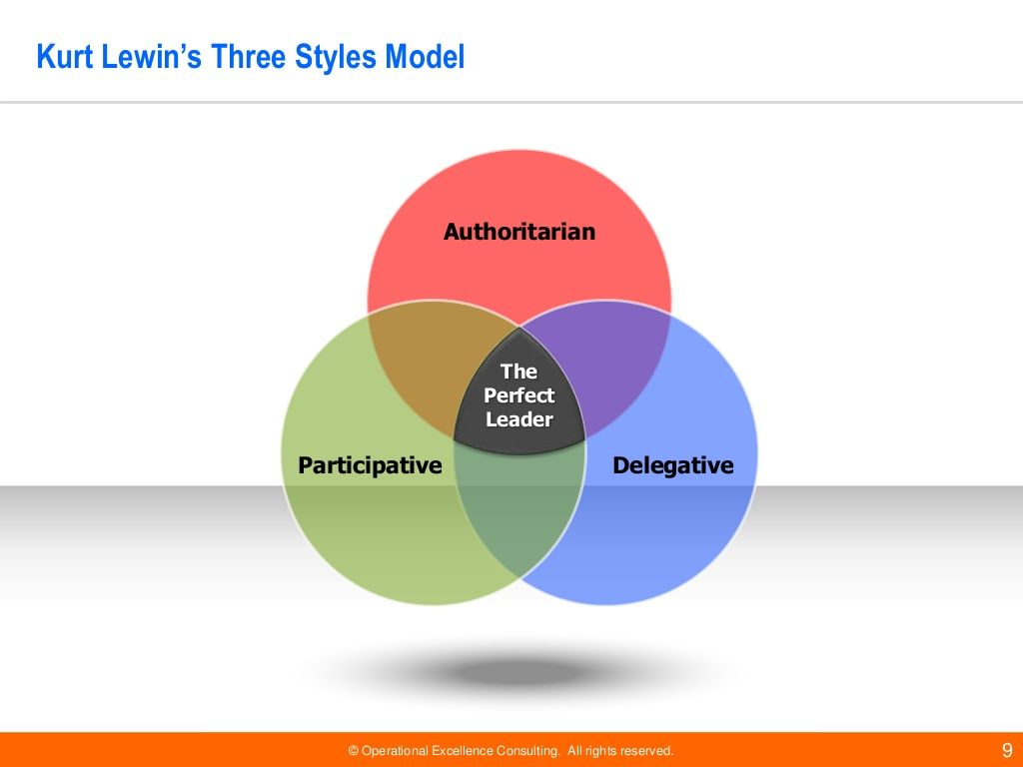
Kurt Lewins (Bing,2021)
By understanding Lewins Model and aligning Cooks various skills and traits if the model is to be believed then many would see Cook as the ‘Perfect Leader’. (Lewin's Leadership Theory Explained - Leadership and Performance, 2021)

2.3
It is coming up to the ten-year anniversary of Cook becoming Apples CEO and what a decade it has been. Cook has not only changed Apple for the best but has positively changed the lives of those he is leading. He has remained true to himself and his beliefs throughout his career and at times has gained the respect of his competitors and employees by his need to remain honest and moralistic throughout. He is well known for praising his staff and constantly trying to motivate them to make them better individuals. He is positively practicing the strategies of the Vrooms Expectancy Theory of Effort, Performance Reward. Whilst majority of employees appreciate the rewards and financial bonuses it is important that Cook understands that individuals will have a different level of expectancy when it comes to this gratitude. Cook is aware that without well motivated and happy staff his success as a leader would be come under fire.

Vrooms Expectancy Theory
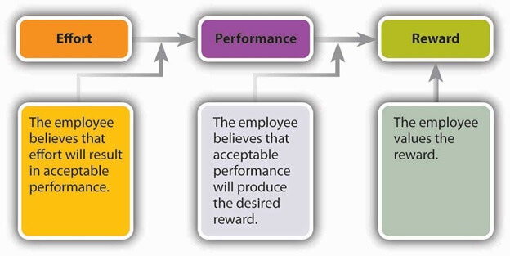(vrooms expectancy theory - Bing, 2021)

But as Cook nears his 10-year anniversary as CEO, he has arguably bested his mentor. He is made Apple ubiquitous in our lives, introducing a 5G iPhone, Apple Watch, Air Pods Max, I Home and more. (The company was also the first ever to reach a $2 trillion valuation.) And Cook has tried to position himself as one of the good guys in Silicon Valley, speaking up in support of a "fundamental right to privacy" in tech and pushing for changes in areas like racial justice (Apple pledged $100 million to support historic Black colleges and other initiatives) and climate change (the company has committed to being carbon neutral by 2030). (A Decade After Becoming Apple's CEO, Tim Cook Says He Never Felt He Had to Fill Steve Jobs’ Shoes, 2021)
Cook also motivates others with his desires to do right for the greater good.
"I don't consider myself an activist, but I realize how much I've benefited from the sacrifice of others" after making this statement in 2014 Cook continued to speak out and publicly announce he was proud to be Gay. He believes his sexuality has given him a greater understanding of being a part of a minority group. He believes this has made him more empathetic and it has provided him with an insight of how people in other minority groups deal with every day. (Tim Cook Speaks Up, 2021)
This public announcement only helped to gain him more respect and admiration from others.
Cooks high ethical and moral standards have also helped change the lives of others.
Tim Cook’s leadership on how to deal with personal privacy on protection delivers great example for high ethical and moral standards. Tim Cook’s transformational leadership significantly focused on this factor during Apple vs. FBI privacy confliction era. How to lead its organization for morally standardized and ethically correct goal is not easy to pursue. As a CEO of Apple, Tim Cook had faced with political power which is one of US Federal government official. His achievement to deal with it would be highly applauded (Perry, 2016).
Cook also believes in communicating honestly with its customers and decided to write to them when Apple were objecting to the unlocking of a murder suspects phone. “Privacy to us is a human right. It’s a civil liberty,” he said. [I]n something that is unique to America, you know, this is like freedom of speech and freedom of the press, and privacy is right up there for us.”
Cook said Apple has always protected the data of its customers: “This is not something that we just started last week, when we saw something happening. We’ve been doing this for years.” (CNBC, 2021)
This need to be open and honest whilst protecting everyone’s human rights is another example of how Cook is changing peoples lives.

2.4
To help me better understand and identify how I view leadership I took part in a Conceptualizing Leadership Questionnaire. The questionnaire consisted of 24 questions based on my experiences within leadership and the results would help me define how I view leadership. There are 6 different emphasis that define a leader’s style which include
1. Trait Emphasis-scored 17
2. Ability Emphasis-scored 16
3. Skill Emphasis-scored 18
4. Behaviour Emphasis-scored 19
5. Relationship Emphasis-scored 15
6. Process Emphasis- scored 17
I also took part in a Leadership Style Questionnaire to help identify my personal style of Leadership. These 18 questions would help identify which of the three most common styles
1. Authoritarian Leadership- scored 23
2. Democratic Leadership- scored 26
3. Laissez- Faire Leadership- scored 15

The results did not surprise me as they showed I am a Democratic Leader.
"Democratic leadership, also known as participative leadership or shared leadership, is a type of leadership style in which members of the group take a more participative role in the decision-making process.
Researchers have found that the democratic leadership style is one of the most effective types and leads to higher productivity, better contributions from group members, and increased group morale.” (Amanchukwu, 2015)
Democratic leaders encourage two-way communication and encourage their employees to share ideas and opinions although they will have the final say. All employees are made to feel engaged in their roles and are often rewarded for reaching their goals and are constantly being encouraged to be more creative.
A good democratic leader will also have specific traits which include honesty, intelligence, courage, creativity, competence, and fairness. Democratic leaders will work hard to gain their peers respect and trust. They are sincere individuals and are always trying to base their decisions on their belief’s attitudes and values. The positives to being a democratic leader are that communication is encouraged and employees are more likely to share their thoughts resulting in more creativity, this communication can also help solve any queries or problems that may arise. There is a sense of family throughout the team and the commitment is evident throughout as everyone feels invested in the result. A democratic leader is likely to see higher productivity among their employees.
While democratic leadership has been described as the most effective leadership style, it does have some potential downsides. In situations where roles are unclear or time is of the essence, democratic leadership can lead to communication failures and uncompleted projects.
In some cases, group members may not have the necessary knowledge or expertise to make quality contributions to the decision-making process. Democratic leadership can also result in team members feeling like their opinions and ideas are not considered, which may lower employee satisfaction and morale.” (Is Democratic Leadership the Best Style of Leadership?, 2021)
I believe I possess many of these traits as within my role as a Commercial Manager I operated an open-door policy and was always keen to listen to my employees’ ideas and if necessary take them on board to help complete a job. My staff always felt part of a team and I was always keen to praise and reward their good work. One of my downsides however could be that as I am so friendly and interactive with my staff that if ever there was a need for disciplinary action or to reach a deadline the line between colleague/ manager would become blurred. I also find that I have a tendency to speak before considering others feelings and sometimes the message I was trying to get out becomes difficult to understand.
I believe in treating staff fairly and would never demand too much from them or ask them to do something I did not wholly believe would better their roles.
Although I enjoy the open communication I do make it clear that the final decision lies with myself even though any successes or failures are on my head.
I enjoy working with a team of qualified individuals who know their roles and can give me credible information of their expertise to help reach a decision.
I was quite surprised that the questionnaire showed that I also had quite a high dominant of Authoritarian as I do not feel I possess any of the qualities, I definitely do not put more emphasis on quantity than quality as I believe everyone deserves the highest standard experience under my leadership, there is no way anybody could class me as detached as I believe I am a very loud friendly outspoken person who also believes in listening to others. I also do not like to rush any decisions as I would much rather take my time and get it correct the first time than rushing and having to redo it again this not only is time consuming but can have financial implications and will create a negative unhappy and unmotivated work team. From this perspective like Cook I too believe that I also align well with McGregor’s theory Y.
The laissez-faire style is understandably my lowest as I do not feel I can relate to any of these traits. “Laissez-faire (also called free reign) leadership style refers to a hands-off approach in which the supervisor actually does as little leading as possible. In effect, the laissez-faire supervisor delegates all authority and power to the employees. The supervisor relies on the employees to establish goals, make decisions, and solve problems.” (Stanley, 2021)
The questionnaire also identified that I viewed leadership the best as approaching the process as Skills, Behaviour, Trait and Processes which again I can fully relate to as I believe these qualities make an excellent leader and that the skills and behaviours of individuals are very important. I also agree with the process emphasis as I enjoy teaching others and offering my support and ideas to all. I enjoy making all staff feel equally important and making them invested in what they do.

2.5
Due to the current global pandemic covid 19 there has been a lot of worries and uncertainty within the workplace. This has highlighted to me that sometimes leaders will need to change their leadership style to fit with the needs of the business. At these difficult times I have been less inclined to get feedback and include all staff but have shown a style of Autocratic as I have needed to make fast and quick decisions as the business environment is constantly changing. I also have had to adapt to change as the government has put so many restrictions and guidelines in place.
This has been a difficult process as I need to be seen as positive and in control for the staff as now staff morale is very low. Covid has caught so many of us off guard as there was no time to predict or plan for these changes. Due to my knowledge and easiness to adapt to change I have managed to mostly take it in my stride and continue to keep the staff informed of all decisions and to the best of my knowledge explain why the changes are happening. Covid has also brought a sense of uncertainty for all businesses as customer needs are changing we need to be creative with how we operate to not only make the business sustainable but to also put the staff at ease that their jobs, income etc are secure.

3.0 Conclusion
Many believe that Cook is the best leader that Apple has ever had and that is down to his personality and leadership styles. On numerous occasions Cook has remained true to him beliefs and has come under scrutiny for being a moralistic and honest man. Whilst he differs from Jobs outgoing personality and traits Cook has proved his critics wrong by bringing Apple into the 21st century and making them the most successful tech company in the world.
Successes such as the iWatch, Apple Pay, and the recent versions of the iPhone have proven his leadership style as effective.
Cook has also improved how competitors and customers perceive the brand with all the changes he has made. Throughout his Leadership he has been keen to give back and is not afraid to speak out for a cause he believes in.

“He also got an important issue very right, when he made preserving user privacy a principle at Apple, and a reason to choose Apple products over its competitors'. As Kahney put it, "I think with Tim Cook, the Apple brand is one you can trust. We are not going to spy on you. We're not going to sell your data." An ordinary mobile phone can become a mobile spying device, but "You can trust your iPhone. It's not going to betray you, and it's not going to spy on you."
That is a powerful value proposition, and it came about under Cook. He may not be as charismatic as Jobs was or as quotable. But he is absolutely the leader that Apple needs, and quite possibly the best it's ever had.” (Tim Cook Is a Better CEO Than Steve Jobs Was, Says Biography Author, 2021)
I believe that Cook will remain as one of the greatest Leaders of our times and that many of his competitors can learn a lot from observing his methods and styles.

4.0 References

Amanchukwu RN, Nwachukwu OP, Stanley GJ. A review of leadership theories, principles and styles and their relevance to educational management. Management. 2015;5(1):6-14.
Apple (United Kingdom). 2021. Apple Leadership - Tim Cook. [online] Available at: <https://www.apple.com/uk/leadership/tim-cook/> [Accessed 10 March 2021].
Bing.com. 2021. theory x and y - Bing. [online] Available at: <https://www.bing.com/images/search?view=detailV2&ccid=PRginTX3&id=B9321452326B469A216896D609D16E4FA4E5FE21&thid=OIP.PRginTX30oovlVEwd3746QHaHZ&mediaurl=https%3a%2f%2fth.bing.com%2fth%2fid%2fR3d18229d35f7d28a2f955130777ef8e9%3frik%3dIf7lpE9u0QnWlg%26riu%3dhttp%253a%252f%252f4.bp.blogspot.com%252f-UhditA3kxYo%252fUC1n1FXEZbI%252fAAAAAAAAATA%252fWThKKSRVuCg%252fs1600%252ftheoryxy.png%26ehk%3dvh8Et4ySX7QLod%252bmOo0NV5sONoSjYXPsVI2%252fvVwmMxg%253d%26risl%3d%26pid%3dImgRaw&exph=566&expw=567&q=theory+x+and+y&simid=607995965634188735&ck=C4913030CD240AF222365832A9A9645D&selectedIndex=0&FORM=IRPRST&ajaxhist=0> [Accessed 1 April 2021].
Bing.com. 2021. vrooms expectancy theory - Bing. [online] Available at: <https://www.bing.com/images/search?view=detailV2&ccid=ksWNqQIz&id=FB98B88A116D388438D2700E718C64932760683F&thid=OIP.ksWNqQIzuGX7kgLYCaMdHAHaDt&mediaurl=https%3a%2f%2fwww.myassignmenthelp.net%2fimages%2fvroom-expectancy-theory.jpg&exph=313&expw=624&q=vrooms+expectancy+theory&simid=608010534164257037&ck=C5659D71DF45E76AB70C523707DD17D6&https://www.bing.com/images/search?view=detailV2&ccid=ksWNqQIz&id=FB98B88A116D388438D2700E718C64932760683F&thid=OIP.ksWNqQIzuGX7kgLYCaMdHAHaDt&mediaurl=https%3a%2f%2fwww.myassignmenthelp.net%2fimages%2fvroom-expectancy-theory.jpg&exph=313&expw=624&q=vrooms+expectancy+theory&simid=608010534164257037&ck=C5659D71DF45E76AB70C523707DD17D6&selectedIndex=1&FORM=IRPRST&ajaxhist=0&ajaxhist=0> [Accessed 1 April 2021].
Biography. 2021. Tim Cook. [online] Available at: <https://www.biography.com/business-figure/tim-cook> [Accessed 10 March 2021].
Bloomberg.com. 2021. Tim Cook Speaks Up. [online] Available at: <https://www.bloomberg.com/news/articles/2014-10-30/tim-cook-speaks-up> [Accessed 1 April 2021].
Business Insider. 2021. How Tim Cook Has Changed Apple. [online] Available at: <https://www.businessinsider.com/how-tim-cook-has-changed-apple-2014-5?r=US&IR=T> [Accessed 1 April 2021].
Businessballs.com. 2021. Action-Centred Leadership - John Adair. [online] Available at: <https://www.businessballs.com/leadership-models/action-centred-leadership-john-adair/#:~:text=John%20Adair%2C%20born%201934%2C%20British%2C%20developed%20his%20Action,of%20management%20theories%2C%20Adair%27s%20work%20is%20relatively%20recent.> [Accessed 1 April 2021].
CMI. 2021. Management and Leadership Styles - CMI. [online] Available at: <https://www.managers.org.uk/knowledge-and-insights/resource/management-and-leadership-styles/> [Accessed 1 April 2021].
cnbc.com. 2021. [online] Available at: <https://www.cnbc.com/2018/04/10/apple-ceo-tim-cook-on-the-importance-of-consumer-privacy.html> [Accessed 1 April 2021].
Eadicicco, L. (2015, October 15). Best quotes from Apple CEO Tim Cook - Business Insider. Available from http://www.businessinsider.com/apple-ceo-tim-cook-best-quotes-2015-10/#thesidelines-are-not-where-you-want-to-live-your-life-the-world-needs-you-in-thearena-1 [Accessed April 01, 2021].
Forbes. 2021. Forbes. [online] Available at: <https://www.forbes.com/?sh=45a09bb02254> [Accessed 10 March 2021].
Free-management-ebooks.com. 2021. [online] Available at: <http://www.free-management-ebooks.com/images/ldth0801.jpg> [Accessed 1 April 2021].
Hall, J., Johnson, S., Wysocki, A., Kepner, K., Farnsworth, D., & Clark, J. L. (2015, October). Transformational Leadership: The Transformation of Managers and Associates. Available from http://edis.ifas.ufl.edu/pdffiles/HR/HR02000.pdf [Accessed April 01, 2021.]
Hofstede. (2017). Cultural Dimension, s.l. Retrieved from https://www.hofstede-insights.com [Accessed 31 March 2021].
Inc.com. 2021. Tim Cook Is a Better CEO Than Steve Jobs Was, Says Biography Author. [online] Available at: <https://www.inc.com/minda-zetlin/tim-cook-apple-better-ceo-than-jobs.html#:~:text=But%20current%20Apple%20CEO%20Tim%20Cook%20is%20actually,industry%20observers%20predicted%20dire%20things%20for%20the%20company.> [Accessed 1 April 2021].
Investopedia. 2021. Mapping Tim Cook's Career Path (AAPL). [online] Available at: <https://www.investopedia.com/ask/answers/032415/what-tim-cooks-career-and-educational-background.asp> [Accessed 10 March 2021].
Investopedia. 2021. What Is Tim Cook's Managerial Style?. [online] Available at: <https://www.investopedia.com/ask/answers/032515/what-tim-cooks-managerial-style.asp> [Accessed 31 March 2021].
Kim, H., 2020. Comparison of Strategic Leadership: Steve Jobs and Tim Cook. Business and Management Studies, 6(3), p.17.
Leadership and Performance. 2021. Lewin's Leadership Theory Explained - Leadership and Performance. [online] Available at: <https://leadershipandperformance.com.au/leadership-development/lewins-leadership-theory-explained/> [Accessed 1 April 2021].
Leon, G., 2021. Here's How Tim Cook Builds Apple as World's Most Valuable Company. [online] Tech Times. Available at: <https://www.techtimes.com/articles/252945/20200929/how-tim-cook-makes-apple-into-worlds-first-2-trillion-company-heres-his-story.htm> [Accessed 1 April 2021].
Lifehack. 2021. 11 Leadership Lessons We Can Learn from Tim Cook. [online] Available at: <https://www.lifehack.org/articles/productivity/11-leadership-lessons-can-learn-from-tim-cook.html> [Accessed 1 April 2021].
Managers.org.uk. 2021. [online] Available at: <https://www.managers.org.uk/wp-content/uploads/2020/03/CHK-256-Understanding_Management_and_Leadership_Styles.pdf> [Accessed 2 April 2021].
MarketLine, (2012). Apple Inc. The Steve Jobs Effect - MarketLine Case Study, s.l.: MarketLine.
PEOPLE.com. 2021. A Decade After Becoming Apple's CEO, Tim Cook Says He Never Felt He Had to Fill Steve Jobs’ Shoes. [online] Available at: <https://people.com/human-interest/tim-cook-reflects-on-10-years-leading-apple-after-steve-jobs/> [Accessed 1 April 2021].
Perry, S. (2016). Tim Cook, a Case Study on the Effects of. s.l., The SANS Institute.
Simpson, s., 2012. UWTSD Moodle 2020/21: Log in. [online] Moodle.uwtsd.ac.uk. Available at: <https://moodle.uwtsd.ac.uk/pluginfile.php/425698/mod_resource/content/1/the-styles-models-philosophy-of-leadership.pdf> [Accessed 10 March 2021].
Stanley, K., 2021. LEADERSHIP. [online] Slide Serve. Available at: <https://www.slideserve.com/karyn-stanley/leadership-powerpoint-ppt-presentation> [Accessed 1 April 2021].
The Strategy Watch. 2021. Leadership Qualities, Skills and Style of Tim Cook. [online] Available at: <https://www.thestrategywatch.com/leadership-qualities-skills-style-tim-cook/#:~:text=Leadership%20Skills%20of%20Tim%20Cook.%20A%20Man%20with,new%20level%20with%20his%20passion%2C%20integrity%2C%20and%20accountability.> [Accessed 1 April 2021].
The Strategy Watch. 2021. Leadership Qualities, Skills and Style of Tim Cook. [online] Available at: <https://www.thestrategywatch.com/leadership-qualities-skills-style-tim-cook/#:~:text=Leadership%20Skills%20of%20Tim%20Cook.%20A%20Man%20with,new%20level%20with%20his%20passion%2C%20integrity%2C%20and%20accountability.> [Accessed 1 April 2021].
Thefamouspeople.com. 2021. Who is Tim Cook? Everything You Need to Know. [online] Available at: <https://www.thefamouspeople.com/profiles/tim-cook-6713.php> [Accessed 10 March 2021].
Toolshero. 2021. What are the Kurt Lewin's leadership styles? Framework & tips | Toolshero. [online] Available at: <https://www.toolshero.com/leadership/lewin-leadership-styles/> [Accessed 1 April 2021].
Verywell Mind. 2021. Is Democratic Leadership the Best Style of Leadership?. [online] Available at: <https://www.verywellmind.com/what-is-democratic-leadership-2795315> [Accessed 1 April 2021].

