

University of Wales Trinity Saint David
School of Engineering

Simulation and Modelling
M7X01380
Optimisation in the Design Process

Jake Mowbray
1603023
May 2019

Abstract
With the current economic climate driving the need for continual development in manufacturing, it is seemly appropriate to consider structural optimisation as a means of increasing efficiency and improving design characteristics. This report explores the application of optimisation techniques, the surrounding knowledge and best practice.

Contents

Abstract i
Contents ii
List of Figures iii
1. Introduction 1
2. Justification 2
2.1 Component 2
2.2 Assumptions 4
2.3 Advantages 4
3. Load Case 5
3.1 CAD Model 5
3.2 Fixtures 5
3.3 Applied Load 6
3.4 Material 7
3.5 Meshing 8
3.6 Comparative Case Study 9
4. Parameters 10
4.1 Objective 10
4.2 Constraint 10
4.3 Variable 10
5. Method 11
5.1 Topology Optimisation 11
5.2 Comparative Case Study 11
5.3 Further Methods 12
5.3.1 Free-Size Optimisation 12
5.3.2 Topography Optimisation 12
5.3.3 Free-Shape Optimisation 13
5.3.4 Composite Laminates Optimisation 13
Conclusion 14
References 15
Bibliography 17

List of Figures
Figure 1 - Support Gusset (QinetiQ, 2019). 2
Figure 2 - Modular Frame (QinetiQ, 2019). 3
Figure 3 - Modular Stacking Section (QinetiQ, 2019). 3
Figure 4 - Threaded Boss (QinetiQ, 2019). 5
Figure 5 - Fixture Setup (Martin, 2013). 6
Figure 6 - Fixtures and Loads (QinetiQ, 2019). 6
Figure 7 - Material Properties Comparison (Aalco, 2018). 7
Figure 8 - First and Second Order Mesh (SimScale, 2016) 9
Figure 9 - Case Study Loading (Revit Structure, 2016). 9
Figure 10 - Topology Result of a Simple Plate (Altair, 2018). 11
Figure 11 - Results and Design Amendments (Revit Structure, 2016). 12
Figure 12 - Topology & Free-Size Comparison (Altair, 2018). 12

1. Introduction
Structural optimisation techniques are employed for the purpose of realising and developing optimum designs in regards to fulfilling user defined objectives. The purpose of this report is to identify the current methods of applying optimisation to classically designed structures. By way of example, it is proposed that an existing design will be assessed for potential improvements and the results will be discussed.

2. Justification

2.1 Component
Design optimisation may be applied to the support gusset shown in Figure 1; the component is a structural member of a transportation frame for a particular type of marine craft utilised by the Aberporth Range. The component is made from aluminium plate of 6mm thickness, the features include: attachment holes, radii, cut-outs, bends, a fine blast finish and an identification label. The overall frame is modular for the purposes of stacking, evidently there are large clearance values between the sliding sections; the purpose of the gusset when fitted is to limit any unintended movement of the modular frame. The gusset provides a critical hole centre dimension which enables the modular upright to be squared with the frame base carriage, some degree of rigidity would also be conveyed to the frame by the incorporation of the gusset, shown in Figure 2. An additional stacking section which would be secured by four support brackets is shown in Figure 3.
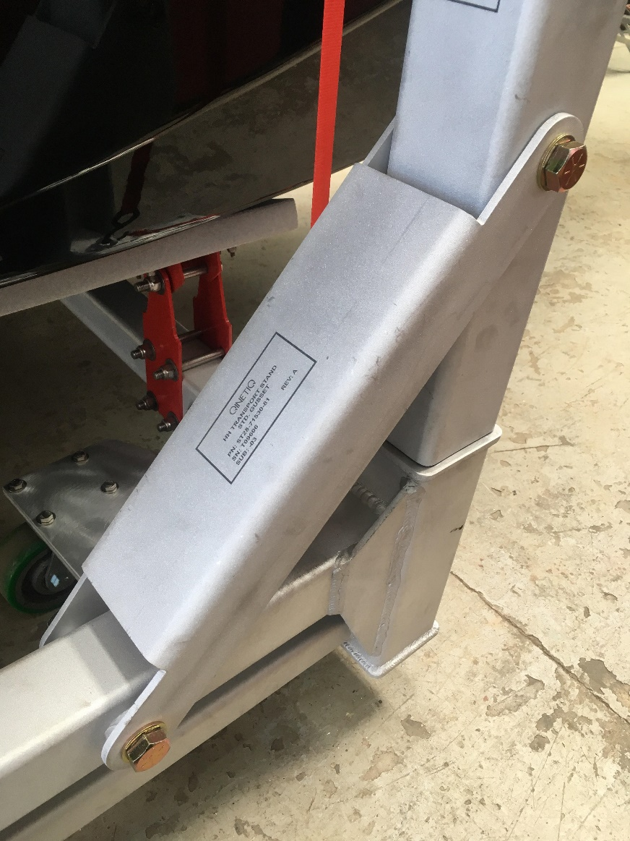
Figure 1 - Support Gusset (QinetiQ, 2019).
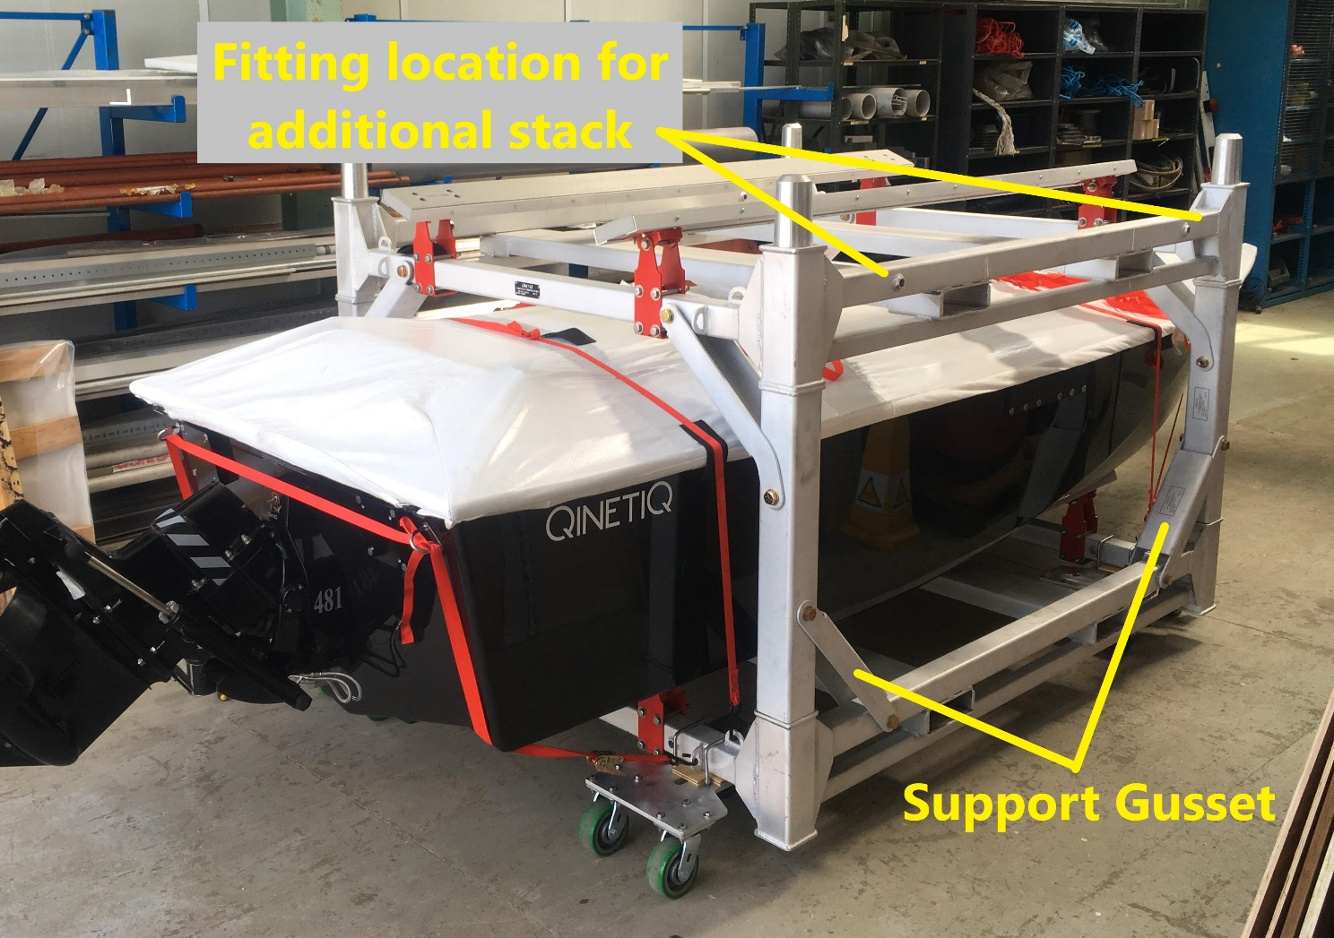
Figure 2 - Modular Frame (QinetiQ, 2019).

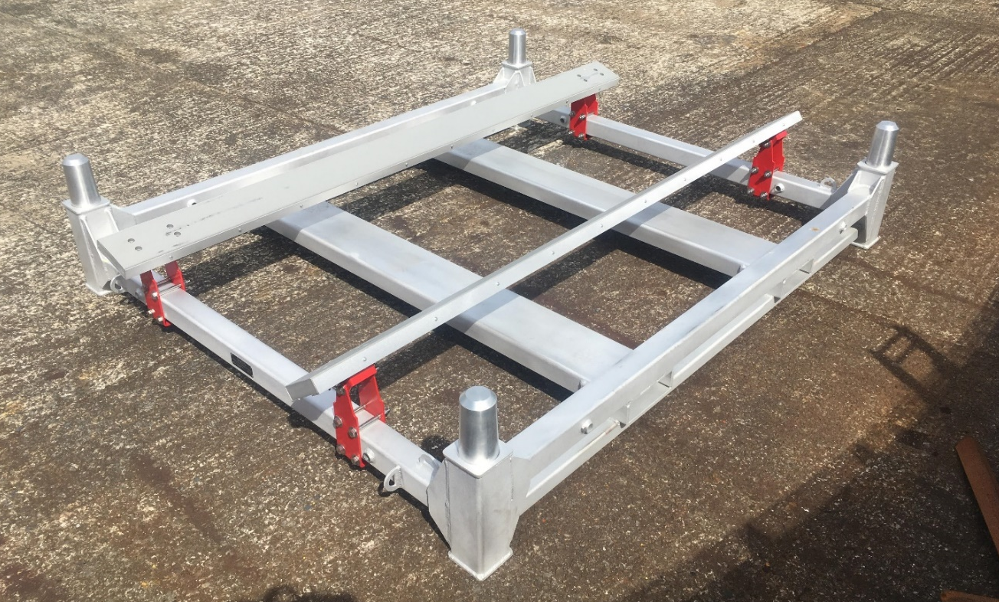
Figure 3 - Modular Stacking Section (QinetiQ, 2019).

2.2 Assumptions
From studying both the frame and the gusset it is clear from the level of detail among the components that a significant amount static load analysis has been considered during the design stage. However, there is no clear evidence of design optimisation; this assumption is based upon the classic, overdesigned and bulky look of the final product. It may be argued that optimisation is not appropriate for areas of the frame such as, the fork-holes and the corner-post uprights; as they are considered likely areas to experience handling damage. The support gussets are noticeably enclosed within the structure and less likely to be struck by handling equipment. For the reasons stated, an attempt to benefit from the application of optimisation techniques in regards to the support gusset design is considered logical.

2.3 Advantages
Ultimately, a reduction in overall manufacture cost is the desired outcome of applying optimisation techniques to the support gusset. It is proposed, that this will be achieved through the use of less material initially; a thinner plate for example, or the removal of excessive material, or the addition of lightening holes. An overall reduction in material will certainly benefit cost and sustainability as long as the impact of the manufacture process to create the optimised component is not costlier or more environmentally damaging overall.

3. Load Case

3.1 CAD Model
The development of a complete and accurate parametric model is required that fully represents the gusset design; if an imported model of the original design is used it would be prudent to confirm the geometry. It would also be of benefit to not only set the correct material but confirm that the material properties for the particular grade concur with those of the material supplier. A representation of the component’s attachment to the frame alongside the potential loading should be defined appropriately (Close, 2019).

3.2 Fixtures
The four holes are required for attachment to the frame, and the gusset must mate against the protruding bosses in a lapped fashion. The presence of weld-in threaded bosses enables the gusset material to maintain a small area of contact, shown in Figure 4. This feature is beneficial in the sense that only a small area will require constraining; allowing the software to move material reasonably close to the hole edge. The zone surrounding each hole is effectively clamped between the boss and the washer through the pressure delivered by the bolt. For the purpose of practicality, it is more reasonable to provide a fixture about the inside circumferential area of the hole than attempting to replicate the clamping scenario (Kalin, 2019). The defined surface is to be locked in 6 degrees of freedom, Figure 5 illustrates the workings of the described fixed feature.

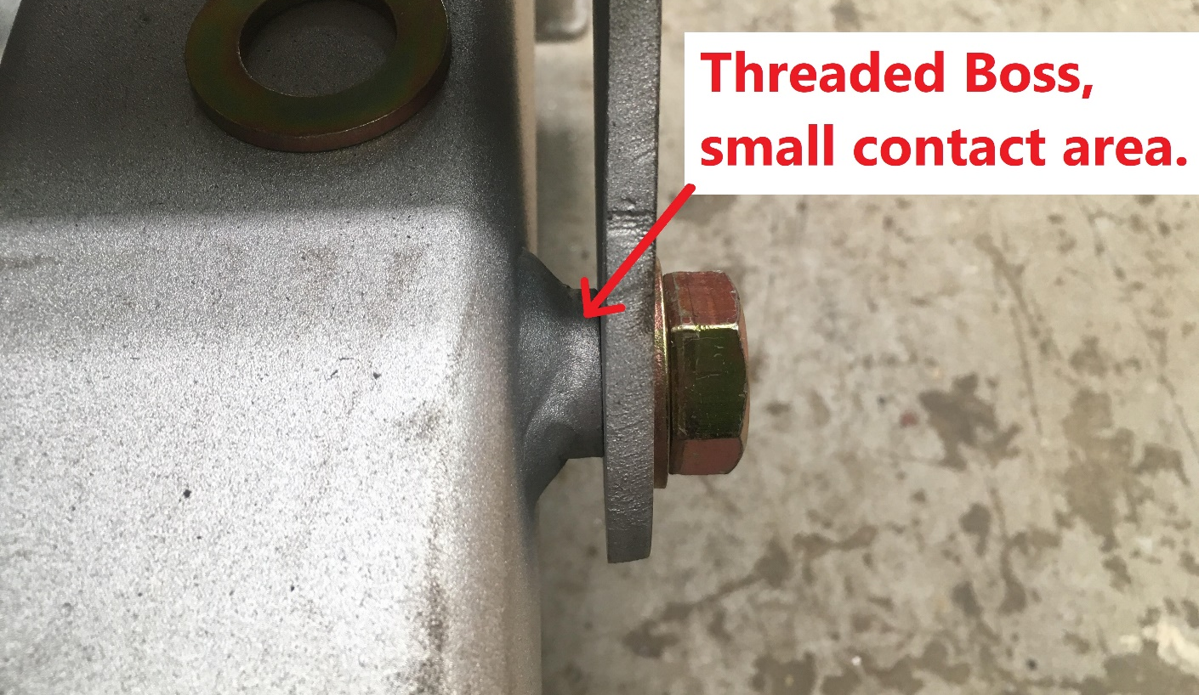
Figure 4 - Threaded Boss (QinetiQ, 2019).
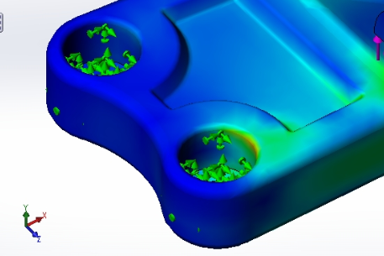
Figure 5 - Fixture Setup (Martin, 2013).

3.3 Applied Load
The flexibility between the corner-post upright and the carriage will impart a loading upon the support gusset via the bolts. However, it is not possible to simulate movable fixtures with only a single component. For true accuracy the gusset should be connected to the frame and movement should be imposed on the frame as a reflection of the equipment operation (Akin, 2009). For simplicity, providing fixtures on one set of bolt holes and a loading on the other set is ample in terms of representing the movement scenario, shown in Figure 6.
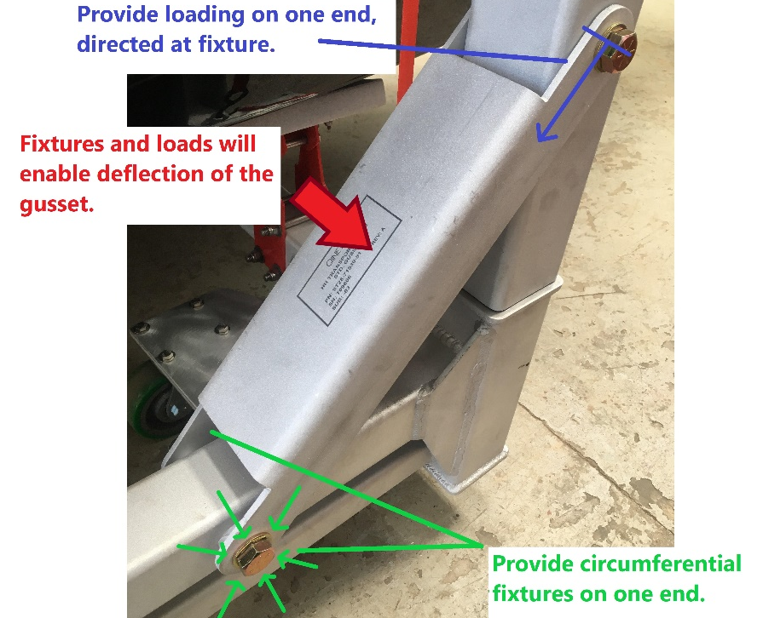
Figure 6 - Fixtures and Loads (QinetiQ, 2019).

3.4 Material
The support gusset is currently fabricated from 6063-T6 grade aluminium alloy, the 6000 series contains silicon and magnesium alloying additions which improve strength and corrosion resistance. The heat treatment is defined as solution heat treated followed by artificial aging which further improves the material strength (Aalco, 2018). Rödiger et al. (2018) propose that any discrepancies between the CAD properties and the actual values of the material will have untold effects on any obtained results, they suggest that the material is specific to every situation and should be assessed accordingly.
The particular properties for this grade of material must be specified when initialising the model for analysis due to the considerable differences observed in Figure 7. Material grade and heat treatment specification can be further optimised to suit the particular demands of the operating environment. However, it is likely that cost implications have already limited the material selection to the optimum choice in terms of desired values versus cost (Ashby, 2010). This view is expanded further and the critical link between quality and cost is recognised:
It’s very likely a car designer would simultaneously want excellent safety and low cost. Unfortunately, in many cases, the objectives are contradictory, making it increasingly difficult for the designer to reach the best compromise (Altair, 2018, p. 25).
Note, if the gusset optimisation results yield the use of significantly less material; the value of material saving may be spent on an improved grade. This scenario in itself is an iterative process which could be solved through the use of optimisation software providing currently available material data is available.
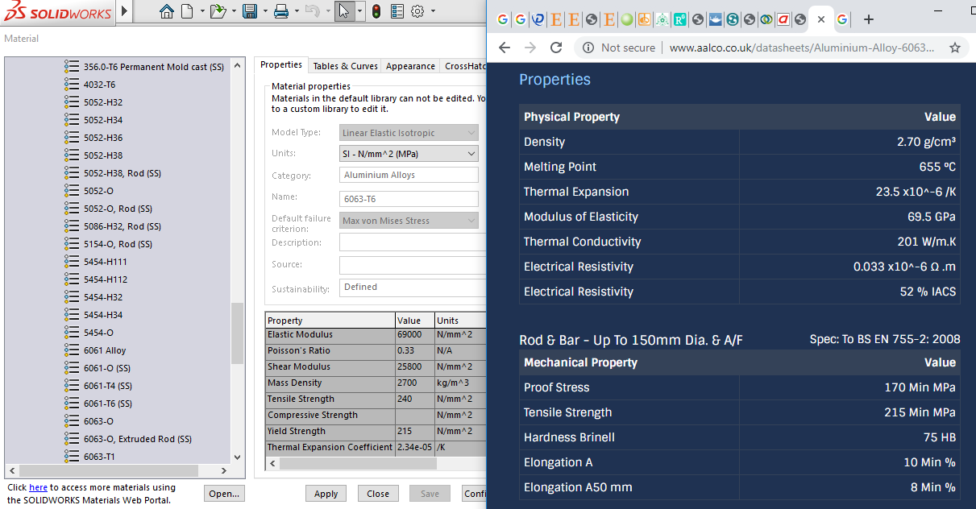
Figure 7 - Material Properties Comparison (Aalco, 2018).

3.5 Meshing
Witowski et al. (2014) highlight the need to investigate mesh density before commencing optimisation; it is instructed that mesh elements should be fine enough to enable analysis results of appropriate precision. Fortunately, the support gusset is of a relatively simple design which enables the application of a moderate to fine mesh which will not demand excessive computational power; this will allow several runs in a relatively short amount of time (Skonty, 2017). The current design comprises four sharp corners as a result of the cut-outs at each end; it is widely recognised that these points are problematic in an operational sense, sustaining the potential for the propagation of stress induced cracks. Furthermore, Hale (2015) proposed that the problematic nature of these points is not always fully considered in the design stage, the work explains that sharp corners and point loads require special consideration due to incredibly high stress values obtained from infinite points. Mitigation is offered through modification of the original design or acceptance of an amount of uncertainty within the results:
Leaving these features in your model is certainly an option, but only if they are located away from all critical regions where accurate results are required. Even if they are left in a model, you need to be aware that these singularities exist and will adversely affect your results in these locations (Hale, 2015).
With regards to mesh quality, it is necessary to monitor values for skew, aspect ratio, orthogonal quality etc. The overall quality can have a large influence upon the accuracy of the results and adjustments are to be made to ensure a proper replication of the load paths within the analysis software (Knupp, 2007).
The type of mesh constructed, where from first order elements or second order elements is largely governed by the specific situation and what is trying to be achieved. Analysis of the support gusset is a reasonably simplistic scenario where only the maximum deflection is of interest: first order elements are well suited to this situation and can provide quicker convergence on the solution. Second order elements are considerably better at capturing curved surfaces but far more demanding on computational power; the difference is shown in Figure 8, note the slight shading within the second order elements which represent the additional nodes (SimScale, 2016). It is assumed that first order elements will provide the required detail to effectively identify load paths and stress concentrations within the gusset, however a comparison of both in conjunction with increasing mesh refinement would be necessary to be fully confident in the results delivered by the software.
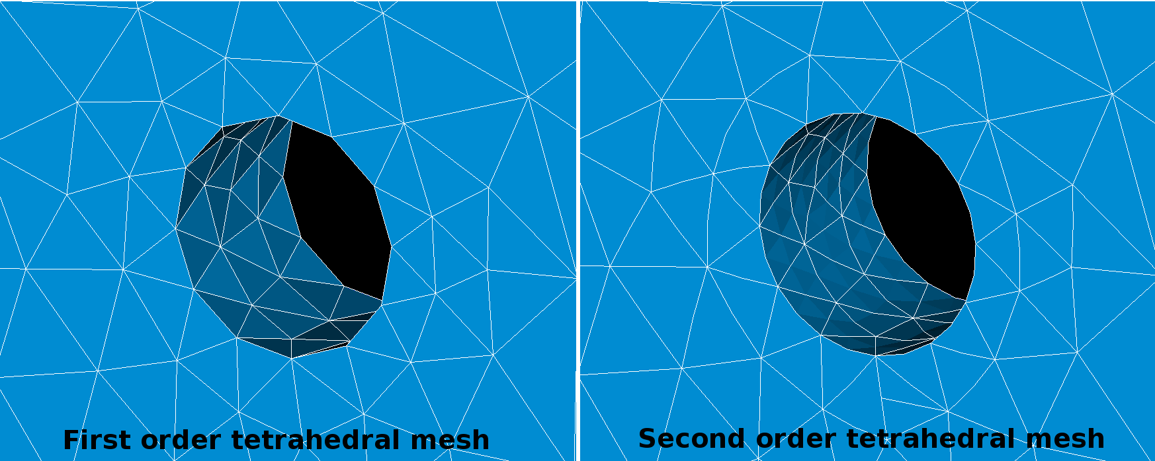
Figure 8 - First and Second Order Mesh (SimScale, 2016)

3.6 Comparative Case Study
The work published by Revit Structure (2016) provides a comparative optimisation study of a gusset bracket which is based around a similar CAD model setup. It is stated that manufacturers of mass produced fabricated structures stand to benefit from the optimisation of traditional designs. This view is also supported by Altair (2016), whom further the theory by associating mass savings with fuel efficiency and overall carbon footprint. The study discusses loading and fixtures, and confirms the proposed approach of initialising the CAD model, shown in Figure 9.
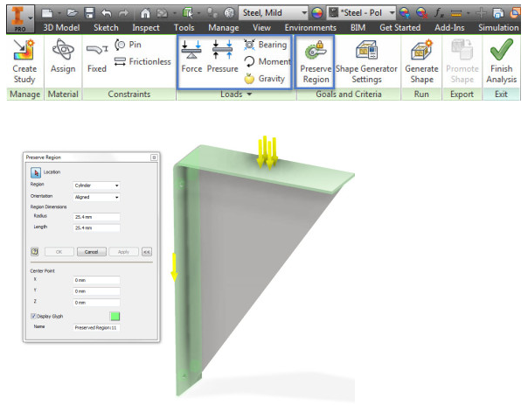
Figure 9 - Case Study Loading (Revit Structure, 2016).

4. Parameters
The following objective, constraint and variable parameters are set to achieve the optimisation of the support gusset design. For practicality, it is proposed that improvements shall be made to the current design as oppose to conjuring an entirely new solution. It is expected that the software will deliver a solution within the bounds of the original design; in other words, a lightened structure informed by the identification of load paths (Altair, 2016). Note, if the whole available design space were to be used to create an envelope where the solution could exist; the mapping of said space would draw substantially more computing power and time. It is also recognised that the potential exists for development of an infinite number of solutions. Yadav (2016) suggests the more logical approach is to improve a present, working design to ascertain practical results rather than exploring potentially awkward designs.

4.1 Objective
Minimal Strain Energy
The optimisation objective is to reduce any deflection observed in the support gusset when under load, as far as reasonably practicable. The deflection is defined in terms of the strain value, which is a ratio of material extension. If an objective is set to reduce the strain within the elements; the solution will converge on the solution which provides the lowest value.

4.2 Constraint
Upper Mass Bound 0.3 of Original
The objective must meet its criteria in conjunction with obeying a 70% material saving. The utilisation of 30% of the original material ensures that unstressed elements are removed and the critical load paths have sufficient densities to ensure stiffness. The requirement of manufacturing constrains may be considered after an initial optimisation run. No issues are anticipated as the component is already manufacturable; however, if a highly organic structure is developed a machining tool or plasma cutter minimum radius may be needed.

4.3 Variable
All Material Elements
Minimum Member Size of 6mm
Elements are filled within the geometrical boundaries of the current CAD model; noting, the CAD model is an interpretation of the external faces of the real life support gusset. Said elements are all variable in the sense that they may remain in their current location or be removed to satisfy the constraint of reducing mass. The minimum member value is included to stop the formation of strands which are narrower than the stock material thickness, mitigating design fragility by considering the polar second moment of area.

5. Method

5.1 Topology Optimisation
To reduce the mass of the support gusset combined with maintaining stiffness, the topology optimisation method is applied. The process aims to identify the load paths and retain material in support of the stressed areas. The identification of un-stressed areas is inevitable in a traditional design and this is the opportunity to remove material in that area. This process is illustrated in Figure 10 where material has been retained in the plate to accommodate the critical load paths. Once a workable optimisation model has been obtained, engineering judgement is required to interpret the results and deliver informed modifications to the original model. The expectation is that the support gusset would present several vacant zones which would require interpretation in regards to enabling production. The ideal design would allow for quick and efficient laser or plasma cutting of the stock material; followed by fettling, drilling and folding.

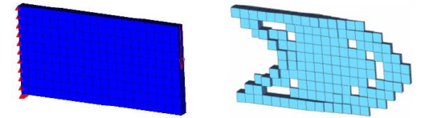
Figure 10 - Topology Result of a Simple Plate (Altair, 2018).

5.2 Comparative Case Study
The work of Revit Structure (2016) presents an optimised bracket with a 30% reduction in mass within the web section when compared with the original. The typical standard of detail required for manufacture is illustrated alongside the final optimisation in Figure 11. The overlaying of optimisation results has become a common practice due to recent developments in CAD software.

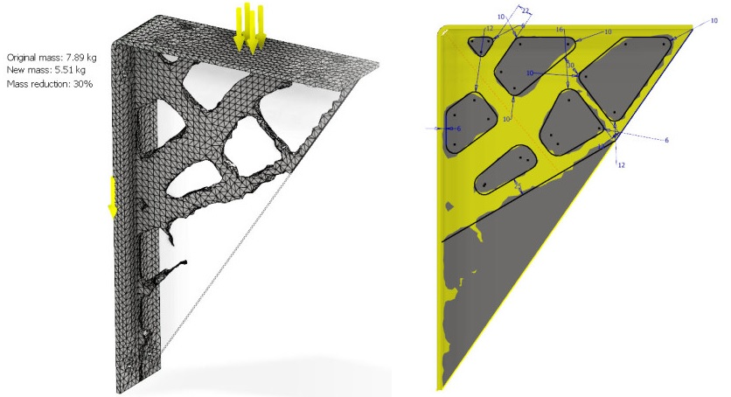
Figure 11 - Results and Design Amendments (Revit Structure, 2016).

5.3 Further Methods

5.3.1 Free-Size Optimisation
Free-size, or topometry optimisation is suggested as an improvement on topology providing that the manufacturing process is capable of delivering a panel of variable thickness. A comparison between the two methods is illustrated in Figure 12. In this situation, free-size design outperforms the topology design in terms of compliance with the objective due to better stress distribution across the central plate (Altair, 2018).
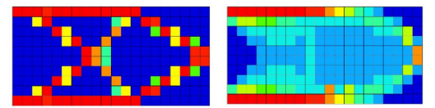
Figure 12 - Topology & Free-Size Comparison (Altair, 2018).

5.3.2 Topography Optimisation
If the desired result is not to be delivered by the removal of material it may be possible to press a sheet metal form to suit the requirements of the support gusset. The use of pressed material that includes stamped sections stands to strengthen the component (ESI, 2019). The optimisation variables are adjusted to allow for elements to be offset perpendicularly to the material plane, which enables material elements to migrate above the plane to a defined limit to provide strength (Cabanettes, et al., 2018). Potential exists to combine topology and topography to deliver a component which encapsulates the benefit of: a lightened structure though material removal and the use of thinner material due to the additional strength added through pressing.

5.3.3 Free-Shape Optimisation
In a parameter-free optimisation, where the CAD model boundary locations are used as an optimisation variable, a vast range of solutions can be unearthed which may, or indeed may not benefit the design process (Schmitt & Steinmann, 2017). The work by Altair Enlighten (2016) explain how the outer boundary is altered to meet pre-defined objectives and constraints, the study promotes the self-forming features as a benefit to designers where infinitely loaded elements are automatically avoided.

5.3.4 Composite Laminates Optimisation
The application of layer based modelling holds the potential of simplifying the composite configuration selection by enabling optimisation of layer thickness, layer offset angle and stacking arrangements. It is not suggested that a shift to composites would provide an appropriate solution, however their value is recognised. The marine craft held by the transportation frame and support gusset are constructed from composite materials for the purpose of exploiting the healthy strength to weight ratio when configured correctly (Altair, 2019).

Conclusion
This report has successfully identified and presented the current design practices applicable to structural optimisation. To develop a practical understanding; a potential optimisation example has been explored in terms of the steps which are required to achieve accurate results. With assumed results, derived from multiple reports and the case study and it is certainly possible to stabilise a component’s strength whilst tremendously reducing its mass.
The following conclusions are drawn from the report:
- A thorough understanding of optimisation parameters is integral if appropriate design modifications are to be informed by the delivery of results, the accuracy of result is dependent on said parameters.
- The process is iterative: not only in the sense of running the optimisation study but in terms of repeating the study after altering the user defined parameters to explore the potential of better results.
- The consideration toward cost of implementation is paramount. Understandably, for the aerospace and automotive industry where weight reduction equals colossal gains, any process cost for material reduction would be immediately justified. However, where the mass reduction is only a target for reducing the cost of utilised materials it is crucial to vindicate the process cost against the potential saving.
- With regards to the support gusset, the gains in material reduction would certainly not outweigh the additional cost of manufacture to implement a non-classic fabrication.
- The application of a multi-method approach is prospective in order to harness the maximum obtainable gains from structural optimisation.
The integration of optimisation techniques is within conventional design sector is becoming more prevalent with the development of in-CAD optimisation software. Hence, the primary consideration for the future is to incorporate optimisation from the beginning of a design project to enable the most informed design choices.
Optimisation is only one element in the designer’s toolbox for the reduction of product cost. Additional aspect such as; lean, standardisation and supply chain management are to be explored in conjunction with optimisation to experience sustainable improvements over time.

References

Aalco, 2018. Aluminium Alloy. [Online]
Available at: http://www.aalco.co.uk/datasheets/Aluminium-Alloy-6063-T6-Extrusions_158.ashx
[Accessed 30 May 2019].
Akin, J. E., 2009. Finite Element Analysis Concepts. [Online]
Available at: https://www.clear.rice.edu/mech403/HelpFiles/FEAC_final.pdf
[Accessed 30 May 2019].
Altair Enlighten, 2016. Shape Optimisation. [Online]
Available at: https://altairenlighten.com/in-depth/shape-optimization/
[Accessed 1 June 2019].
Altair, 2016. Mass Reduction of a Motorsport Component by. [Online]
Available at: https://altairuniversity.com/wp-content/uploads/2016/11/CS_Warwick_A4_print_fin.pdf
[Accessed 31 May 2019].
Altair, 2018. Practical Aspects of Structural Optimization. 3rd ed. s.l.:Altair University.
Altair, 2019. Optimization. [Online]
Available at: https://altairhyperworks.com/solution/Optimization
[Accessed 1 June 2019].
Ashby, M., 2010. Materials: engineering, science, processing and design. [Online]
Available at: https://downloadfiles.grantadesign.com/pdf/teaching_resource_books/Sol_Mat2e_part1.pdf
[Accessed 30 May 2019].
Cabanettes, F., Joubert, A., Chardon, G. & Dumas, V., 2018. Topography of as built surfaces generated in metal additive manufacturing: A multi scale analysis from form to roughness. [Online]
Available at: https://www.researchgate.net/publication/322547034_Topography_of_as_built_surfaces_generated_in_metal_additive_manufacturing_A_multi_scale_analysis_from_form_to_roughness
[Accessed 1 June 2019].
Close, R., 2019. Finite Element Analysis: How to create a great model. [Online]
Available at: https://coventivecomposites.com/explainers/finite-element-analysis-how-to-create-a-great-model/
[Accessed 30 May 2019].
ESI, 2019. WHAT IS METAL STAMPING?. [Online]
Available at: https://www.esict.com/what-is-metal-stamping/
[Accessed 1 June 2019].
Hale, S., 2015. Why Worry About Sharp Corners and Point Loads?. [Online]
Available at: https://caeai.com/blog/why-worry-about-sharp-corners-and-point-loads
[Accessed 30 May 2019].
Kalin, M., 2019. How to Think Like a Simulation Engineer. [Online]
Available at: https://www.engineersrule.com/think-like-simulation-engineer/
[Accessed 30 May 2019].
Knupp, P. M., 2007. Remarks on Mesh Quality. Reno, AIAA Aerospace Sciences Meeting and Exhibit.
Martin, T., 2013. Tutorial - How to create a static stress analysis simulation in Solidworks?. [Online]
Available at: https://grabcad.com/questions/tutorial-how-to-create-a-static-stress-analysis-simulation-in-solidworks
[Accessed 30 May 2019].
QinetiQ, 2019. Photography for Optimisation Project. [Online]
[Accessed 28 May 2019].
Revit Structure, 2016. Autodesk Inventor 2016 R2- Shape Optimisation for Structural Connections. [Online]
Available at: https://revitstructureblog.wordpress.com/2016/04/17/autodesk-inventor-2016-r3-shape-optimisation-for-structural-connections/
[Accessed 31 May 2019].
Rödiger, M., Schneider, L. & Rinke, S., 2018. Influence of Material Selection on the Marginal Accuracy of CAD/CAM-Fabricated Metal- and All-Ceramic Single Crown Copings. BioMed Research International, Volume 2018, pp. 1-8.
Schmitt, O. & Steinmann, P., 2017. Control of minimum member size in parameter-free structural shape optimization by a medial axis approximation. Computational Mechanics, 61(6), p. 717–727.
SimScale, 2016. When should I use a second order mesh?. [Online]
Available at: https://www.simscale.com/forum/t/when-should-i-use-a-second-order-mesh/25899
[Accessed 30 May 2019].
Skonty, L., 2017. Correct mesh size – a quick guide!. [Online]
Available at: https://enterfea.com/correct-mesh-size-quick-guide/
[Accessed 30 May 2019].
Witowski, K. et al., 2014. Topology and Topometry Optimization of Crash Applications with the Equivalent Static Load Method. Stuttgrat, DYNAmore GmbH.
Yavad, P., 2016. How to Add Topology Optimization to SOLIDWORKS?. [Online]
Available at: https://www.engineersrule.com/topology-optimization-add-solidworks/
[Accessed 30 May 2019].

Bibliography
Altair, 2018. Practical Aspects of Structural Optimization. 3rd ed. s.l.:Altair University.
Anderson, D. M., 2019. How to Design Half-Cost Products. [Online]
Available at: http://www.halfcostproducts.com/
[Accessed 27 May 2019].
MathWorks, 2019. Evaluate design trade-offs and find optimal designs. [Online]
Available at: https://uk.mathworks.com/discovery/design-optimization.html
[Accessed 29 May 2019].

The marine craft are typically used by customers to represent threats to commercial shipping and naval vessels, and can be used to test the effectiveness and operational readiness of weapon systems.

