

MSc Software Engineering
Database Systems
University of Wales Trinity St David
Lecturer: Dr Stephen Hole

By Lewis Wells
1503245

Table of Contents
Abstract 3
Database Scenario 4
Assumptions 4
Depot 4
Driver 5
Salary 6
Route 7
Entity Relationship Model 7
Primary Key 7
Foreign Key 7
Normalisation 7
1st Normal form 8
2nd Normal form 8
3rd Normal form 8
Check constraints 9
Multi-user databases 9
Transactions 10
Mongo DB and NoSQL 12
Examples from bus scenario 13
SQL or NoSQL? 14
Conclusion 15
References 15
Appendices 16
Tables 16
Triggers 24
Evidence of transactions 28
Table insert results 31

Table 1 - Parking bay example. 5
Table 2 - Bus type example. 5
Table 3 - Salary Concept assumption. 7
Table 4 - 3rd normal form example 1. 8
Table 5 - 3rd normal form example 2. 8
Table 6 - Single user vs Multi user [6]. 10
Table 7 - Entity Example. 12
Table 8 - Compliant Data. 12
Table 9 - NoSQL Example. 13

Figure 1 - Cardinality & Ordinality example. 9
Figure 2 - Entity Relationship Model. 11
Figure 3 - Route SQL Example. 13
Figure 4 - Insert route. 13
Figure 5 - Creating collection in MongoDB. 14
Figure 6 - result of MongoDB. 14
Figure 7 - checking the salary constraint. 16
Figure 8 - Employee with invalid salary scale No. 16
Figure 9 - Transaction aborted. 29
Figure 10 - Rollback Transaction. 29
Figure 11 - Serializable. 30

Abstract

This document will discuss the Authors assumptions regarding the database scenario. An entity relationship model will be designed based on these assumptions. Research into multiuser databases, triggers, transactions and normalisation will all be key principles in the implementation of the database.
The document will aim to produce a working database which adheres to the standard of 3rd normal form, in addition to this a NoSQL version will be created using MongoDB. An evaluation of the differences between the two concepts will be discussed with the document closing by concluding the findings from the report.

Database Scenario

A scenario has been constructed to allow the Author to make assumptions and apply database analysis techniques to the scenario to produce an entity relationship model, the entity relationship model will represent the logical structure of the relationships between the entities in the database system.

Assumptions

The following assumptions have been concluded by examining the scenario, the assumptions relate to how the design for the database should be constructed, and any tables which have been deemed relevant to construct a relational database.

Depot

- The bus company has depots distributed in different regions over wales with each of the depots having a pool of drivers whom drive for that depot. It can be assumed from the scenario brief that the drivers drive for that depot and that depot only due to the locality difference from each of the depots. Based in this statement a one-to-many relationship can be assigned from the depot table to the employee table.
- Each depot has at least two bus types, assuming a table is created which holds the bus/vehicle data, the relationship will consist of a one-to-many relationship from the depot to bus table.
- Some routes the buses must take on their daily routines are prevented from accessing certain areas due to restrictions regarding the height and road conditions, it can be assumed that any vehicle which seats 60 or over would be deemed to high risk to contemplate attempting this journey. A table would need to be constructed to contain which routes indicate any restrictions, this would need to be linked to the depot table with a one-to-many relationship from depot to the route entity.
- The depot has its own pool of cleaners whom may be assigned multiple buses to clean by multiple staff, this would indicate a many-to-many relationship which a relationship database attempts to avoid. An entity will be created as an intermediary table to prevent this from occurring. Both the employee table and depot tables will have one-to-many relationships with the intermediary with the primary key from both tables being used in the central entity. Could be worth considering a staff rota for driving and cleaning.
- Each bus is parked in a parking bay in the depot and must be cleaned daily before commencing work, the scenario does not provide an indication of how many of a specific type each depot has so we can assume they have no more than 2 per type (max 10 buses). Using this assumption, we can use this table as a guide for bay parking.

Bus ID | Bay | Bus Type ID | Bus Name
1 | 1 | 1 | Double Decker
2 | 2 | 2 | Large Coach
3 | 3 | 1 | Double Decker
Table 1 - Parking bay example.
Each bus can be assigned to a bay by matching the bus ID to bay value, the bus type ID will define what type of vehicle it is such as:
Bus Type ID | Bus Name
1 | Double Decker
2 | Large Coach
3 | Single Decker
4 | Small Coach
5 | Mini Bus
Table 2 - Bus type example.
If a record would show that a Bus type with the value 3 was in service, then it can be acknowledged that the bus is a Single Decker.

Driver

- Any driver employed by the company must hold a valid driving licence.
- Drivers must have obtained a Certificate of Professional Competence (CPC), if the driver does not have one the company provides training for them. The training consists of 4 different CPC tests and the driver must pass all to be compliant with the driving regulations.
- Any driver whom holds a CPC must accumulate 35 hours of training within the 5 years of obtaining the CPC or it is removed. If the driver already devises a CPC qualification, they do not have to sit exam 1 -4; in contrast to this, provisional drivers must take all exams and pass the bus-type and bus route tests.
- The company has various bus types, a driver whom wishes to drive a specific type must pass training on that vehicle to attain a bus-type pass, only then can they proceed to drive that type of vehicle. In addition to this ALL drivers must hold at least one buss-type pass to allow them to drive with the company (think of a trigger or check constraint).
- A training table must be constructed to document was qualifications are held by the drivers, maybe one table for provisional and one for CPC holders. The CPC holders table will consist of a field which increments by each hour of training they do to comply with the CPC regulations. The company is not concerned where the exams are located, they only require a record to be kept regarding the results of the examinations and the date they were passed/failed.
- A driver can have many training sessions or attempts at an exam and training will involve many drivers, this many-to-many relationship will need an intermediary entity (Employee-Training). A driver can have many logs of hours accumulated and the log can contain multiple instances of a driver record. This many-to-many relationship would require an intermediary table which is allocated the primary key from each of the linked tables. The table below demonstrates the assumption of the test type:

Salary

- A provisional driver has a starting salary which is representative of scale 5 (£20,000), when the driver obtains bus-type passes the salary has the potential to increase depending on experience. A structure has been considered to inform the drivers of how they can achieve a higher pay salary, for every bus-type pass and years’ experience that they amass they proceed to rise to the next salary grade.
- Cleaners start on salary scale one, they can increase their pay grade by each years’ experience gained at the company. A salary cap will be implemented on the scale they can achieve; it would be assumed that the company would not want to pay a cleaner scale 11 (50,000) so the highest scale achievable will be limited to scale 5 (20,000).
- An employee can only have one salary at one time, but a salary can be received my multiple employees, based on this a one-to-many relationship will be created from the salary table to the employee table.

The new salary table can be seen below:

Scale Number | Salary Drivers Cleaners
1 | £10,000 --------------------------- 0 – 1 years exp
2 | £12,000 --------------------------- 1 – 2 years exp
3 | £15,000 --------------------------- 2 – 3 years exp
4 | £18,000 --------------------------- 3 – 4 years exp
5 | £20,000 0 – 1 years exp 4 – 5 years exp
6 | £23,000 1 pass + 1 years exp
7 | £28,000 2 passes + 2 years exp
8 | £32,000 3 passes + 3 years exp
9 | £36,000 4 passes + 4 years exp
10 | £40,000 5 passes + 5 years exp
11 | £50,000 5 passes + 6 years exp
Table 3 - Salary Concept assumption.

Route

- Drivers must train on a bus route and demonstrate competence to drive that route, only then can they be eligible to be assigned that route.
- Would assume that a bus type will be allocated to a route as the driver must obtain a bus type training pass for a specific route.
- The route table will have a relation with the depot table because the routes are based on the depot location. A depot has many routes, but a route only has one depot. A one-to-many relationship from the depot table to the route table is required.
- A route can be completed by many buses and a bus can have multiple routes, this many-to-many relationship will require an intermediary entity (Bus-Route). This central entity will have the

An entity relationship diagram must now be constructed based on the information gathered, the diagram will illustrate the tables formed (entities), attributes, primary keys, foreign keys and any check constraints for the tables.

Entity Relationship Model

An entity relationship model is a visual representation of the relationships what exists between tables or entities in a system and provides an overview of the structured data contained within, the visual representation provides an illustration of the logical structure in the system and delineates the attributes associated with the entity. It is imperative that the database correctly normalised to prevent the possibility of duplicating data and minimising the redundancy in the database [1].

Primary Key
A primary key is an attribute contained in a relational database which uniquely identifies each of the records contained in a table, they also have functionality to create relationships between tables by being expended as a foreign key in a table which has a relation [1].
It is considered good practice to ensure a primary key is a number because numbers are generally processed quicker in a database than characters, this applies to databases which hold significant levels of data and have extensively large amounts of tables.

Foreign Key
In relational databases a foreign key references a primary key allocated in a different table, it is used to uniquely identify a row or field in another table [1].

Normalisation
Database normalisation is the practice used when assembling a relational database, normalisation comprises of several “normal forms” with the intention to reduce data redundancy and improve data integrity [2]. The tables and attributes of a relational database require some arrangement to correctly impose database integrity constraints.
The main 3 types of normalisation commonly used are:

1st Normal form
- A database to meet the requirements for 1st normal form each of the cells contained in the database must be single valued. For example, if the column name is colour; the cell cannot contain “Red, Blue”. This would violate one of the key principles of 1st normal form [2].
- Entries into each column must contain the same type. For example, if the column name remains colour; the cell should not contain anything which is not regarded as a colour [2].
- The rows should be uniquely identified; this signifies that careful consideration should go into the naming of this unique ID. It would be bad practice to allocate “Name” as a primary key because multiple people can have the same name. It would be more efficient to have the primary key as their national insurance number or employee ID if building a database which is based on a work concept [2].

2nd Normal form
- All attributes in an entity are dependent on the primary key [2]. For example, a primary key “customer ID” could have a dependant attribute “Customer name”.

3rd Normal form
- Each of the column contained within the entity are defined by only the primary key. For example:
Customer ID | Customer Name | Shipping Address
Table 4 - 3rd normal form example 1.
Both customer name and shipping address are determined by only the primary key, it would be common to think that the customer name would define a customers’ address but that is incorrect. The illustration below demonstrates this.
Customer ID | Customer Name | Shipping Address
Cust1 | Alan Davies | 25 new street
Cust2 | Alan Davies | 44 old church road
Table 5 - 3rd normal form example 2.
The database can have multiple people with the same name, applying 3rd normal formal would eradicate the possibility of repeating groups or data and will maintain data integrity.
The cardinality of the relationship between tables indicates the quantity of instances between two entities; whilst the ordinality defines if the relationship is compulsory or elective [3]. This can be seen from the figure 1 below:

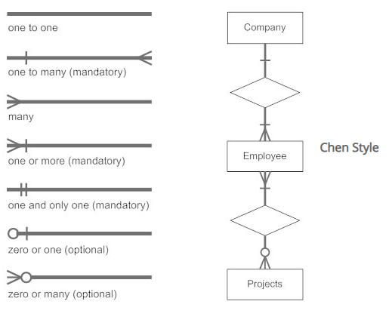
Figure 1 - Cardinality & Ordinality example.

Check constraints
A check constraint is a method used in SQL to maintain the integrity of a column or multiple columns in a table. The constraint will specify a condition which must be satisfied before the update on insertion to a table can occur. Constraints are commonly implemented to ensure that “none valid” data does not integrate into the database, an example of this could be negative values; an alternative to this is to indicate a “not null” when declaring the attribute and type [4].

Multi-user databases

A multiuser database is a database which is accessible by multiple users whom all have the admission to the information which exists in it. Depending on access rights and read/write permissions users can modify the data which is contained in the environment, careful consideration must be undertaken when assigning privileges to multiple users to ensure the protection of the sensitive data inside. In addition to this, redundancy measures must be implemented in the multi user environment to safeguard against the possibility of conflicting changes [5].
For the bus company scenario, it would be suggested that the only individuals whom have access to write permissions should be admin or managers. The admin or managers have access to all the staff members who are located there so can organise a rota based on the information, they also have access to information regarding the bus-type passes to ensure they don’t rota an individual on a route or bus whom hasn’t passed the required bus-type pass.
The admin would be assigned full privileges to provide them with the ability to change the pay grade if needed, remove employees whom have left, add new employees, supply managers or stakeholders with information regarding the business and anything else deemed necessary.
Sufficient triggers should be implemented to provide information regarding any changes in the system, it is important that any changes made in a database are logged for piers to have reference should they have any queries regarding modifications.
In contrast to what a multiuser database is designed to supply, a single-user database can only support one user at a time. A database which has been configured to only support a single-user should be optimised to achieve maximum capabilities for the single-user experience [5].
Below demonstrates a comparison table which explains several key differences between the two styles:
Single-User Database | Multi-user Database
Only one user permitted at any given time. | Facilitates multiple users to access concurrently
The structure of the database is reasonably simple. | Increased structure complexity due to multi-user access, the scale of the database significantly impacts the complexity.
Assigning changes is a relatively risk free process. Minimal chance of causing deadlock. | Due to the shared access, if sufficient measures are not taken to ensure the consistent state of the database it will inevitably cause a deadlock.
The cost of the infrastructure is minimal as only one user is permitted access. | Requires significantly more infrastructure to support multiple users, the cost of the additional hardware and network costs make multi-user significantly more expensive than single-user.
Table 6 - Single user vs Multi user [6].

Transactions

A transaction is a change made to a database system, as previously mentioned it is crucial that measures are implemented to ensure the database transitions from one consistent state to another efficiently. Transactions should remain isolated from each-other to prevent such occurrences, adhering to the four principles of ACID (Atomicity, Consistency, Isolation and Durability) will ensure validity with the database system. [7]
Atomicity
Transactions are commonly comprised of numerous amounts of statements. Atomicity certifies that each transaction is treated as an individual unit which either entirely succeeds, or entirely fails. If any of the numerous statements contained within the transaction fail, the whole transaction is aborted and the system will remain unchanged.
Consistency
Consistency enforces the principle that the system must transition from one consistent state to another maintaining the data inside. Any constraints or triggers configured in the database are adhered to, only data which satisfies these functions will be written to the database. This provides assurance to the database user and guarantees the prevention of corruption via the process of an illegal transaction; however, does not guarantee that the transaction committed is accurate.
Isolation
Isolation is a key principle in providing concurrency control, the reading and writing to various tables concurrently in a database is very common. isolation ensures that the simultaneous executions return the database to a state which would be representative if the executions had been accomplished sequentially [6].
Durability
The final principle ensures that a committed transaction remains committed, even in the event of a system failure. The committed transactions would invariably be stored in a segment of non-volatile memory to ensure that if there is a power outage, the transaction remains committed.
The database should be constructed efficiently to ensure it adheres to the principles outlined, minimising the risk of any transaction errors occurring will definitely improve the operations performed.
Based on the information gathered regarding normalisation, transactions and assumptions, an entity relationship model will be constructed which represents 3rd normal form.
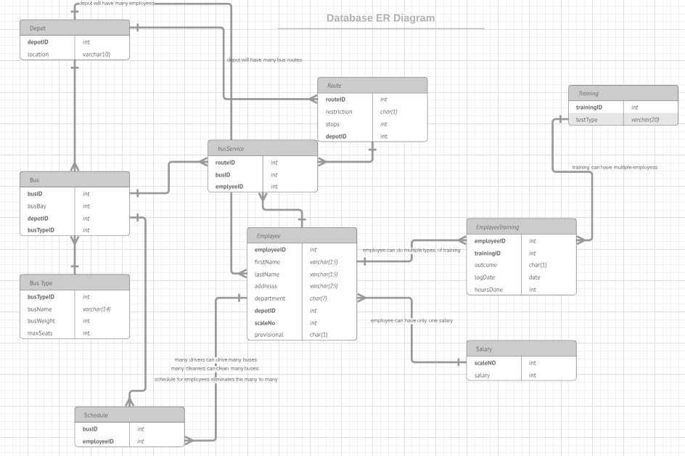
Figure 2 - Entity Relationship Model.

The entity relationship model illustrates the relationships between the tables in the database, it also provides an indication of the data types which have been allocated to each attribute. The entity relationship model meets the requirements for 3rd normal for because each of the attributes are independently dependent on the primary key and not on each-other. The choice to be representative of a 3rd normal form database had been made assuming the bus company would not want a system which has duplications of data, also any modifications enable the system to update itself correctly.

Mongo DB and NoSQL

MongoDB is a document-oriented program which allows users to construct databases in a non-relational style, MongoDB is considered to be extremely flexible in regard to how it stores the data. The design allows for data to be stored in documents which allows an increased manipulability of the fields and structure which can be modified over time. The system is regarded as having greater efficiency over a relational model such as MySQL when managing large unstructured data [4].
When using a relational model, it is imperative that extensive consideration concerning the structure and data which binds the database is thought of. Careful planning must be undertaken to identify the Entities in the database and the attributes and primary keys which are responsible for maintaining a relationship with other tables [4].
When constructing a large database which contains colossal quantities of data it becomes incredibly difficult to make changes to the structure because of the magnitude of the data and the schema of the tables contained internally. The schema determines what data can be used in the tables and the user must comply with this standard outlined [4]. An example of the schema based around an entity relational model is illustrated below:

Depot
Depot ID - integer
Location - varchar (15)
Table 7 - Entity Example.
The depot entity had a primary key (depot ID) of the type integer and an attribute called “location” which has the type varchar (15). When inserting data into this table, to comply with the format of the table it must be compliant with the type.
Depot ID | Location
1 | Swansea
Table 8 - Compliant Data.
The schema delineates the types of data which are required and unless stated “not null” will require both fields to have data input.
A NoSQL database will contain collections which comprise of documents of data; unlike SQL, this style does not require a specific schema to be satisfied.
Depot ID: 1 | Location: ‘London’ | Staff members: 20
Depot ID: 2 | Location: ‘Swansea’
Depot ID: 3 |  | Staff Members: 43
Table 9 - NoSQL Example.
This would be an acceptable input for a NoSQL based database, it allows for huge flexibility and demonstrates an unstructured method of creating a database.

Examples from bus scenario

Examples of implementing an SQL and NoSQL based around the information from the scenario can be seen below:
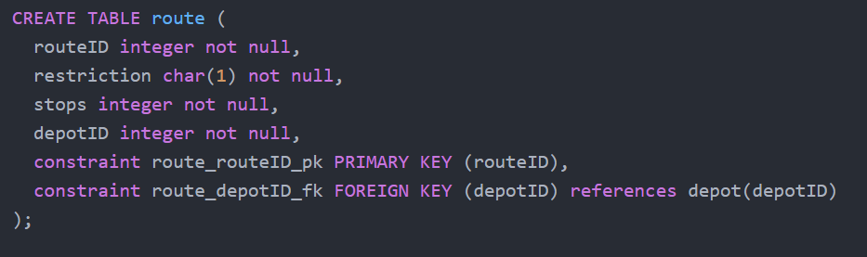
Figure 3 - Route SQL Example.
Figure 3 illustrates an example of how a table is constructed using SQL, the type of data must be declared with constraints for any primary and foreign keys utilised in the table. The table references the depot table and illustrates the use of the depot primary key.
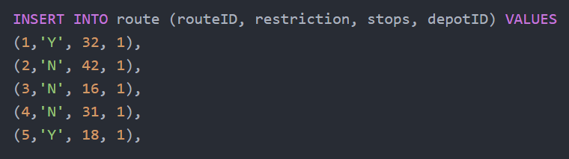
Figure 4 - Insert route.
Figure 4 illustrates an example of SQL being inputted into the route table, it specifies 4 fields which the inputted data must satisfy for the software to actively execute the query with no errors.

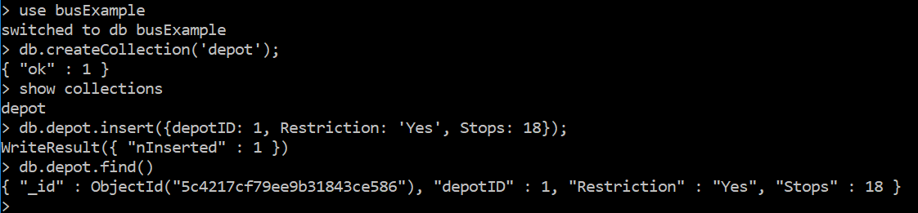
Figure 5 - Creating collection in MongoDB.

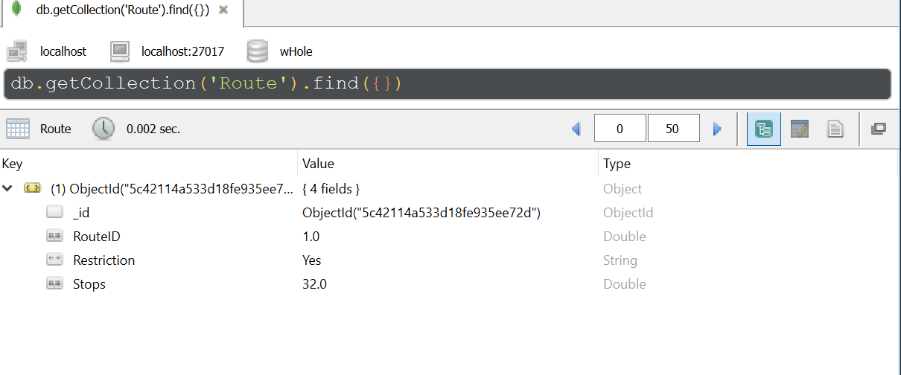
Figure 6 - result of MongoDB.
When viewing the illustrations above it is noticeable the different styles of implementing the same table or collection. The primary and foreign keys are removed from the tables in MongoDB as the software uses non-relational standards. Figure 6 demonstrates viewing the Database/Collection/Document in Robo 3t, the type is automatically detected by MongoDB; Using a relational model would require the declaration of the type which intended on being inputted, this implies that consideration surrounding the structure and relations must occur.

SQL or NoSQL?
SQL uses schemas which can be advantageous if the data requires a predictable layout but a disadvantage if flexibility is desired surrounding the data. The structured SQL approach utilises a relational model, this can be beneficial when changing for example, a username in a database. The username can simply be changed in the parent entity and any new query which is associated with the primary key of the username will now return the updates version; The NoSQL approach makes this significantly more difficult, due to the structure it will require each instance of the username to be updated in each collection and document [5].
Scaling a SQL database can be problematic, horizontal scaling is regarded as being extremely challenging because the data often cannot be split over multiple servers. Vertical scaling could be a solution but it presents the issue that a service can only have its capacity increased to a certain level before the CPU power becomes incapable of supplying adequate functionality. It can be incredibly expensive to implement the desired hardware which is associated with such large data storage, this could be a defining choice in using a NoSQL approach but is exclusively decided by the situation. Software such as MongoDB has the capability to efficiently scale horizontally due to the approach it utilises when storing data [6].

Conclusion

The majority of the assumptions initially declared were achieved, the implementation of the tables and attributes gave a greater indication to any discrepancies between the assumptions. The database represents 3rd normal for which was the objective; There could be arguments for some attributes to be consumed by a different entity but the system works to an extent as it is. To enable multi user functionality a log on portal would be advisable with privileges assigned based on the requirement and authorisation, this would enable any managers or administrators (not declared in the scenario) to have access to information and apply crud functionality operations to the database.
Given more time, the training table would be amended to allow the input of the test undertaken rather than using an ID in reference to a specific test type, also adding more triggers and check constraints would be beneficial.
The research into the differences between SQL and NoSQL concluded to indicate that it is not a choice of which is the better; it is a choice of which is most suitable for the database which is to be constructed. The research would suggest that a combination of both may be advantageous or using NoSQL in large datasets because of the scalability options available.
To conclude, if the database requirements suggest a relational model would favourable, utilise software which incorporates this vision; if not, investigate if the NoSQL model is useful.

References

[1] | L. S. H. Regina Obe, PostgreSQL: Up and Running, O'Reilly Media, Inc., 2012.
[2] | C. Date, Relational Theory for Computer Professionals: What Relational Databases Are Really All About, O'Reilly Media, Inc., 2013.
[3] | M. Mandler, “Cardinality versus Ordinality: A Suggested Compromise,” American Economic Review, vol. 96, no. 4, pp. 1114 - 1136, 2006.
[4] | E. R. J. W. Luc Perkins, Seven Databases in Seven Weeks: A Guide to Modern Databases and the NoSQL Movement, Pragmatic Bookshelf, 2018.
[5] | P. J. S. Martin Fowler, NoSQL Distilled: A Brief Guide to the Emerging World of Polyglot Persistence, Addison-Wesley, 2012.
[6] | R. Cattell, “Scalable SQL and NoSQL data stores,” ACM Sigmod record, vol. 39, no. 4, pp. 12 - 27, 2010.

Appendices

The following tables have been created in PostgreSQL using the accompanied SQL.

Tables

Salary Table
CREATE TABLE salary (
scaleNo integer not null,
salary integer not null,
constraint salary_scaleNo_pk PRIMARY KEY (scaleNo),
constraint check_range_scaleNo CHECK (scaleNo > 0 and scaleNo < 12),
constraint check_range_salary CHECK (salary > 9999 and salary < 50001)
);

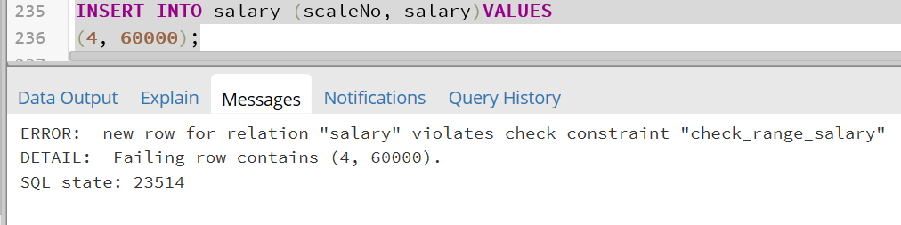
Figure 7 - checking the salary constraint.
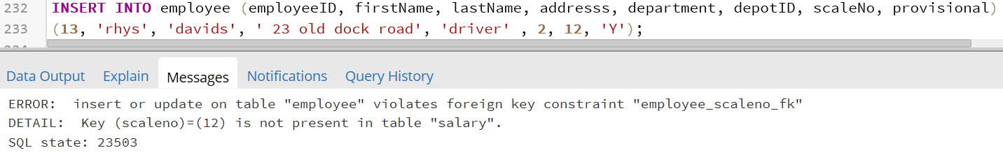
Figure 8 - Employee with invalid salary scale No.
Depot Table
CREATE TABLE depot (
depotID integer not null,
location varchar(20) not null,
constraint depot_depotID_pk PRIMARY KEY (depotID)
);

Bus Type Table

CREATE TABLE busType (
busTypeID integer not null,
busName varchar(14) not null,
busWeight integer not null,
maxSeats integer not null,
constraint busType_busTypeID_pk PRIMARY KEY (busTypeID)
);

Training Table

CREATE TABLE training (
trainingID integer not null,
testType varchar(15) not null,
constraint training_trainingID_pk PRIMARY KEY (trainingID)
);

Bus Table

CREATE TABLE bus (
busID integer not null,
busBay int not null,
depotID integer not null,
busTypeID integer not null,
constraint bus_busId_pk PRIMARY KEY (busID),
constraint bus_depotID_fk FOREIGN KEY (depotID) references depot(depotID),
constraint bus_busTypeID_fk FOREIGN KEY (busTypeID) references busType(busTypeID)
);

Employee Table

CREATE TABLE employee (
employeeID integer not null,
firstName varchar(15) not null,
lastName varchar(15) not null,
addresss varchar(25) not null,
department varchar(15) not null,
depotID integer not null,
scaleNo integer not null,
provisional char(1) not null,
constraint employee_employeeID_pk PRIMARY KEY (employeeID),
constraint employee_depotID_fk FOREIGN KEY (depotID) references depot(depotID),
constraint employee_scaleNo_fk FOREIGN KEY (scaleNo) references salary(scaleNo)
);
Route Table

CREATE TABLE route (
routeID integer not null,
restriction char(1) not null,
stops integer not null,
depotID integer not null,
constraint route_routeID_pk PRIMARY KEY (routeID),
constraint route_depotID_fk FOREIGN KEY (depotID) references depot(depotID)
);

Bus Service Table

CREATE TABLE busService (
routeID integer not null,
busID integer not null,
employeeID integer not null,
constraint busService_pk PRIMARY KEY (routeID, busID, employeeID),
constraint busService_routeId_fk FOREIGN KEY (routeID) references route(routeID),
constraint busService_busID_fk FOREIGN KEY (busID) references bus(busID),
constraint busService_employeeID_fk FOREIGN KEY (employeeID) references employee(employeeID)
);
Employee Training Table

CREATE TABLE employeetraining (
employeeID integer not null,
trainingID integer not null,
logDate date not null,
outcome char(1),
hoursDone integer,
constraint employeetraining_pk PRIMARY KEY (employeeID, trainingID),
constraint employeetraining_employeeID_fk FOREIGN KEY (employeeID) references employee(employeeID),
constraint employeetraining_trainingID_fk FOREIGN KEY (trainingID) references training(trainingID)
);

Schedule Table

CREATE TABLE schedule (
busID integer not null,
employeeID integer not null,
constraint schedule_pk PRIMARY KEY (busID, employeeID),
constraint schedule_busId_fk FOREIGN KEY (busID) references bus(busID),
constraint schedule_employeeID_fk FOREIGN KEY (employeeID) references employee(employeeID)
);

Inputted Data
INSERT INTO salary (scaleNo, salary) VALUES
(1, 10000),
(2, 12000),
(3, 15000),
(4, 18000),
(5, 20000),
(6, 23000),
(7, 28000),
(8, 32000),
(9, 40000),
(10,50000);

INSERT INTO depot (depotID, location) VALUES
(1, 'Swansea'),
(2, 'Cardiff'),
(3, 'Newport'),
(4, 'Brecon'),
(5, 'Aberystwyth');

INSERT INTO busType (busTypeID, busName, busWeight, maxSeats) VALUES
(1, 'Double-Decker', 7, 80),
(2, 'Single Decker', 5, 60),
(3, 'Large Coach', 6, 60),
(4, 'Small Coach', 4, 40),
(5, 'Mini-Bus', 2, 25);

INSERT INTO training (trainingID, testType) VALUES
(1, 'CPC-1'),
(2, 'CPC-2'),
(3, 'CPC-3'),
(4, 'CPC-4'),
(5, 'Bus-type pass 1'),
(6, 'Bus-type pass 2'),
(7, 'Bus-type pass 3'),
(8, 'Bus-type pass 4'),
(9, 'Bus-type pass 5');

INSERT INTO bus (busID, busBay, depotID, busTypeID) VALUES
(1, 1, 1, 1),
(2, 1, 1, 1),
(3, 1, 2, 1),
(4, 1, 2, 1),
(5, 1, 3, 1),
(6, 1, 3, 1),
(7, 1, 4, 1),
(8, 1, 5, 1),
(9, 2, 1, 2),
(10, 2, 2, 2),
(11, 2, 3, 2),
(12, 2, 4, 2),
(13, 3, 1, 3),
(14, 3, 2, 3),
(15, 3, 3, 3),
(16, 3, 4, 3),
(17, 3, 5, 3),
(18, 4, 1, 4),
(19, 4, 2, 4),
(20, 4, 3, 4),
(21, 4, 4, 4),
(22, 4, 5, 4),
(23, 5, 1, 5),
(24, 5, 2, 5),
(25, 5, 3, 5),
(26, 5, 4, 5),
(27, 5, 5, 5);

INSERT INTO route (routeID, restriction, stops, depotID) VALUES
(1,'Y', 32, 1),
(2,'N', 42, 1),
(3,'N', 16, 1),
(4,'N', 31, 1),
(5,'Y', 18, 1),

(6,'Y', 20, 2),
(7,'N', 22, 2),
(8,'N', 33, 2),
(9,'N', 19, 2),
(10,'N', 28, 2),

(11,'N', 23, 3),
(12,'N', 27, 3),
(13,'N', 12, 3),
(14,'N', 43, 3),
(15,'Y', 17, 3),

(16,'Y', 32, 4),
(17,'Y', 45, 4),
(18,'N', 43, 4),
(19,'N', 23, 4),
(20,'N', 16, 4),

(21,'N', 32, 5),
(22,'N', 42, 5),
(23,'N', 12, 5),
(24,'N', 31, 5),
(25,'N', 25, 5);

INSERT INTO employee (employeeID, firstName, lastName, addresss, department, depotID, scaleNo, provisional) VALUES

(1, 'Bob', 'Davies', '58 old kent road', 'Driver', 1, 5, 'Y' ),
(2, 'Dave', 'Davies', '23 new dock', 'Driver', 1, 5, 'Y' ),
(3, 'Ian', 'Evans', '18 pall mall', 'Cleaner', 2, 2, 'N' ),
(4, 'Carl', 'Donelly', '13 northumberland avenue', 'Driver', 2, 5, 'N' ),
(5, 'Declan', 'Jones', '1 park lane', 'Driver', 3, 5, 'Y' ),
(6, 'Victoria', 'harding', '2 Strand street', 'Cleaner', 3, 3, 'N' ),
(7, 'Ainsley', 'Jones', '43 siccamore way', 'Driver', 4, 7, 'Y' ),
(8, 'Lewis', 'Bartley', '13 bond street', 'Driver', 4, 6, 'Y' ),
(9, 'Albus', 'James', '4 mayfair road', 'Driver', 5, 6, 'Y' ),
(10, 'Kelly', 'Davies', '6 euston street', 'Driver', 5, 6, 'Y' );

INSERT INTO busService (routeID, busID, employeeID) VALUES
(1, 1, 1),
(2, 1, 2),
(3, 2, 3),
(4, 3, 4),
(5, 4, 5);

INSERT INTO employeetraining (employeeID, trainingID, logDate, outcome, hoursDone) VALUES
(1,5,'17-01-2018','P', 23),
(2,5,'14-01-2018', 'P', 21),
(4,2,'17-01-2018', 'F', 0);

INSERT INTO schedule (busID, employeeID) VALUES
(1,1),
(2,2);

Triggers

CREATE TABLE employee_audit(
operation char(1) not null,
stamp timestamp not null,
userid text not null,
firstName varchar(15) not null,
lastName varchar(15) not null,
department varchar(15) not null,
provisional char(1) not null

);

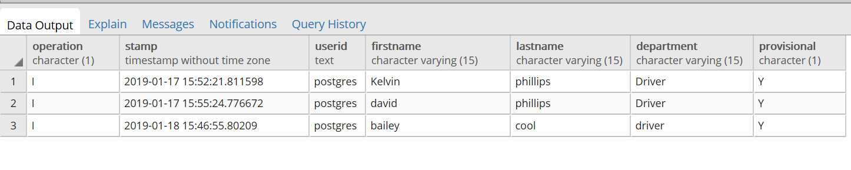

CREATE OR REPLACE FUNCTION process_employee_audit() RETURNS TRIGGER AS $employee_audit$
BEGIN

IF (TG_OP = 'DELETE') THEN
INSERT INTO employee_audit
VALUES ('D', now(), user, old.firstName, old.lastName, old.department, old.provisional);
return old;
ELSIF (TG_OP = 'UPDATE') THEN
INSERT INTO employee_audit
VALUES ('U', now(), user, new.firstName, new.lastName, new.department, new.provisional);
RETURN NEW;
ELSIF (TG_OP = 'INSERT') THEN
INSERT INTO employee_audit
VALUES ('I', now(), user, new.firstName, new.lastName, new.department, new.provisional);
RETURN NEW;

END IF;
RETURN NULL;
END;
$employee_audit$ LANGUAGE plpgsql;

CREATE TRIGGER employee_audit
AFTER INSERT OR UPDATE OR DELETE ON employee
FOR EACH ROW EXECUTE PROCEDURE process_employee_audit();

CREATE TABLE salary_audit (
operation char(1) not null,
stamp timestamp not null,
userid text not null,
scaleNo integer not null,
salary integer not null

);

CREATE OR REPLACE FUNCTION process_salary_audit() RETURNS TRIGGER AS $salary_audit$
BEGIN

IF (TG_OP = 'DELETE') THEN
INSERT INTO salary_audit
VALUES ('D', now(), user, old.scaleNo, old.salary);
return old;
ELSIF (TG_OP = 'UPDATE') THEN
INSERT INTO salary_audit
VALUES ('U', now(), user, new.scaleNo, new.salary);
RETURN NEW;
ELSIF (TG_OP = 'INSERT') THEN
INSERT INTO salary_audit
VALUES ('I', now(), user, new.scaleNo, new.salary);
RETURN NEW;

END IF;
RETURN NULL;
END;
$salary_audit$ LANGUAGE plpgsql;

CREATE TRIGGER salary_audit
AFTER INSERT OR UPDATE OR DELETE ON salary
FOR EACH ROW EXECUTE PROCEDURE process_salary_audit();

CREATE TABLE bus_audit(
operation char(1) not null,
stamp timestamp not null,
userid text not null,
busID integer not null,
busBay integer not null,
depotID integer not null,
busTypeID integer not null

);

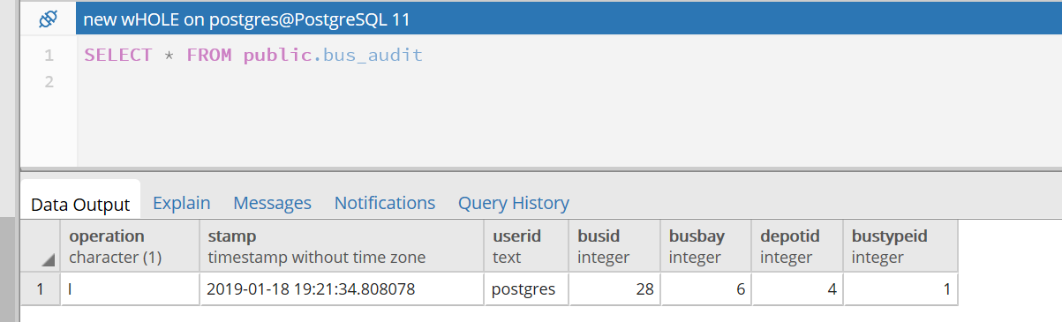

CREATE OR REPLACE FUNCTION process_bus_audit() RETURNS TRIGGER AS $bus_audit$
BEGIN

IF (TG_OP = 'DELETE') THEN
INSERT INTO bus_audit
VALUES ('D', now(), user, old.busID, old.busBay, old.depotID, old.busTypeID);
return old;
ELSIF (TG_OP = 'UPDATE') THEN
INSERT INTO bus_audit
VALUES ('U', now(), user, new.busID, new.busBay, new.depotID, new.busTypeID);
RETURN NEW;
ELSIF (TG_OP = 'INSERT') THEN
INSERT INTO bus_audit
VALUES ('I', now(), user, new.busID, new.busBay, new.depotID, new.busTypeID);
RETURN NEW;

END IF;
RETURN NULL;
END;
$bus_audit$ LANGUAGE plpgsql;

CREATE TRIGGER bus_audit
AFTER INSERT OR UPDATE OR DELETE ON bus
FOR EACH ROW EXECUTE PROCEDURE process_bus_audit();

Evidence of transactions

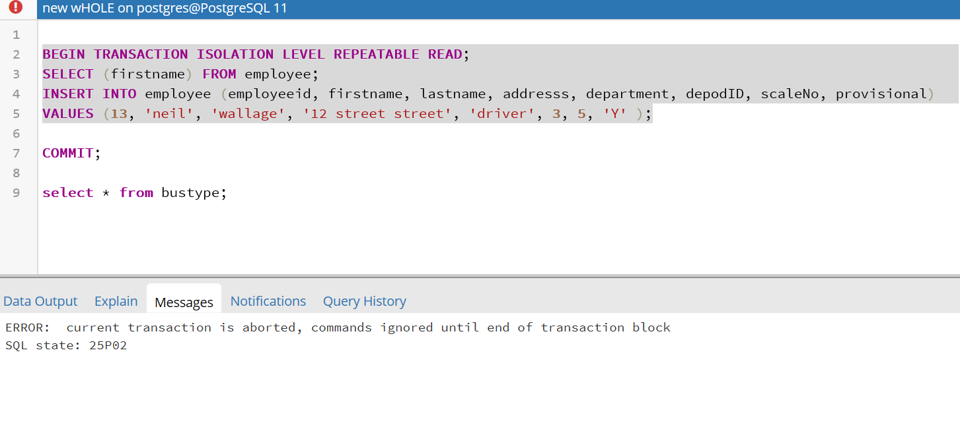
Figure 9 - Transaction aborted.

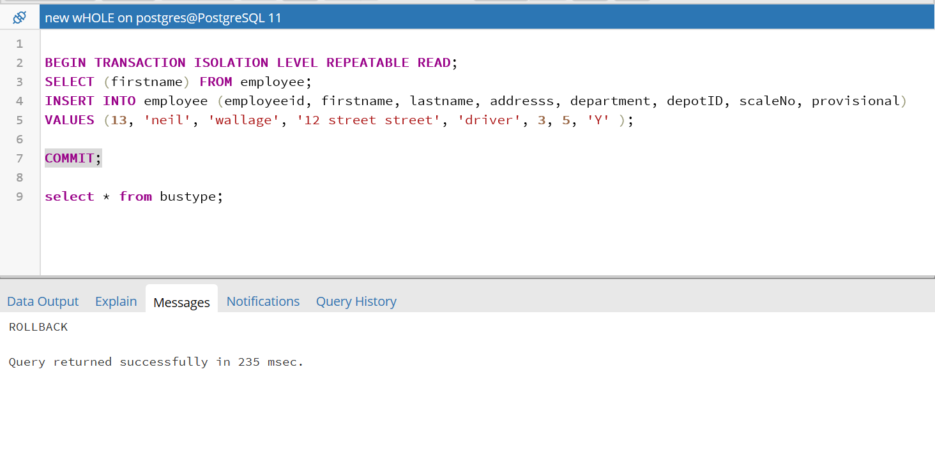
Figure 10 - Rollback Transaction.
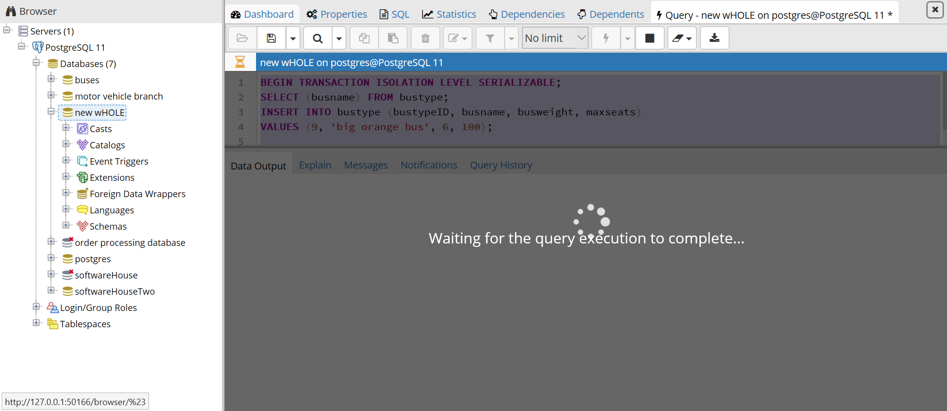
Figure 11 - Serializable.

Table insert results
Bus
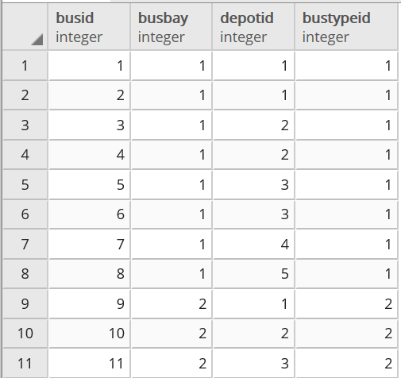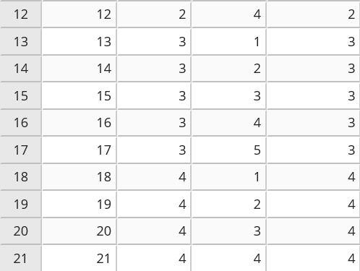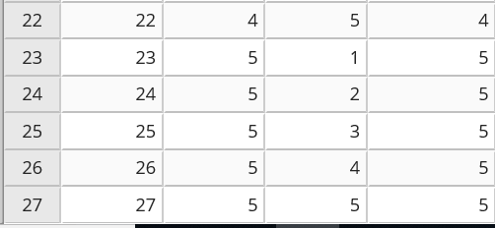

Bus Type
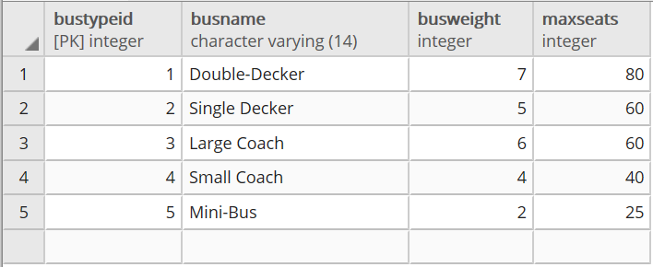
Depot
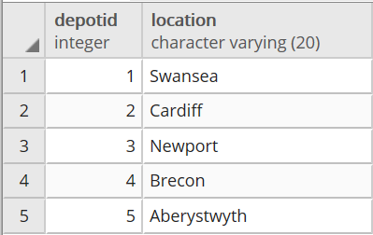
Employee
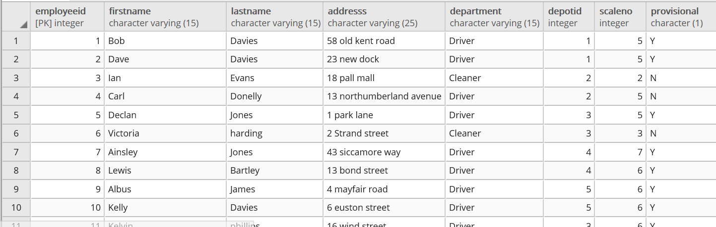
Employee Training

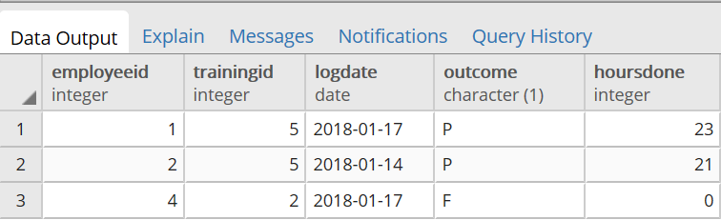
Route
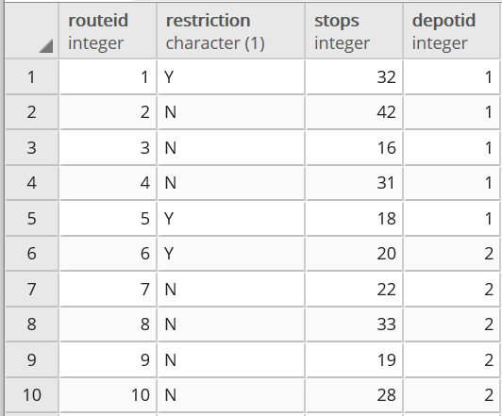
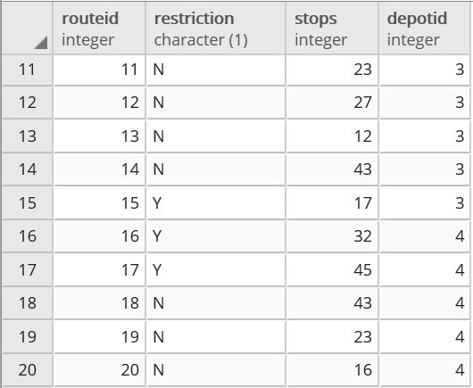
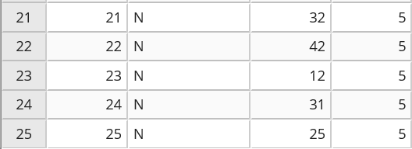

Salary
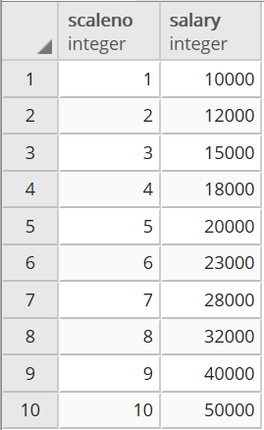
schedule

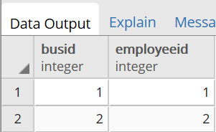
Training

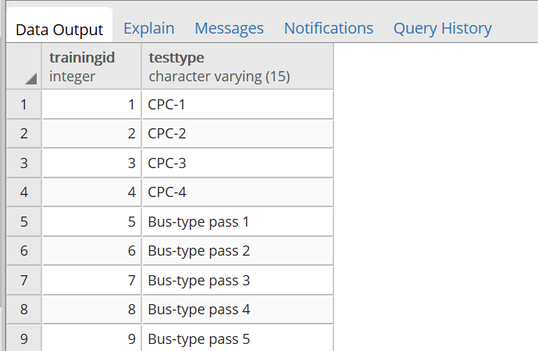
MongoDB example
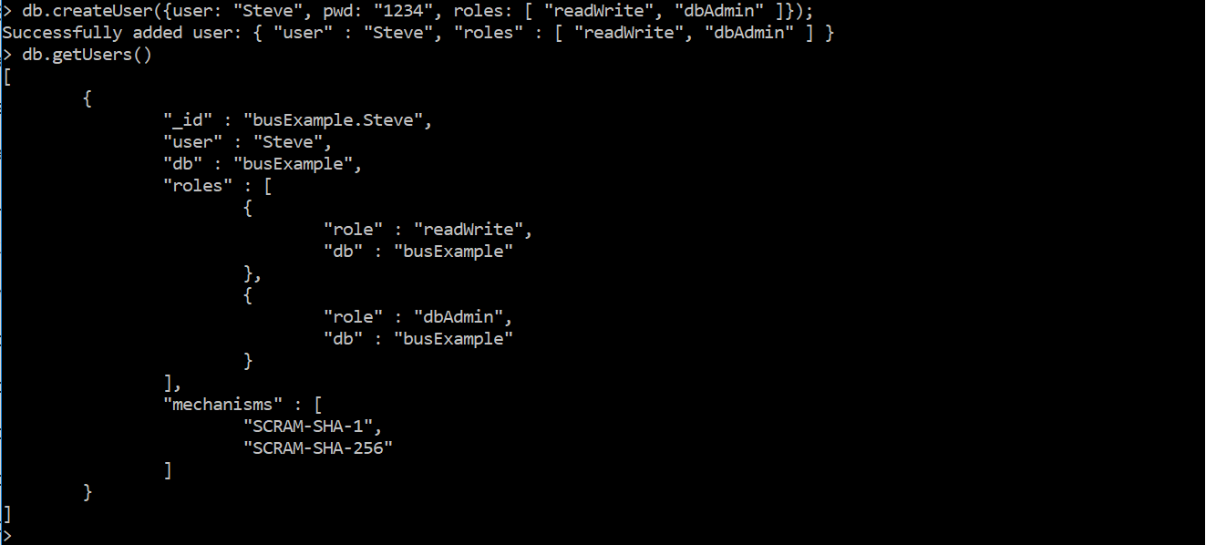
Assigning privileges to Admin, this could be something the bus scenario could implement.

