
Name Matthew David Norman
Student Number 2031011
Date 01/05/2023
Lecturer Andrew Noble
University of Wales Trinity Saint David
BEng Ordnance, Munitions & Explosives

Computer aided Engineering (ACDB5007)
Application of Computer Aided Engineering Processes
Table of Contents
Introduction 2
Aims & Objectives 2
Background Information 3
What is CAE? 3
Advantages 4
Disadvantages 4
CAE in the Ordnance, Munitions and Explosives Industry 5
Design 5
Material Properties 5
Blast Modelling 5
Safety Analysis 5
Optimization 5
Methodology 6
Validation 8
What is a validation study? 8
Results & Analysis 12
Conclusion 13
References 14
Bibliography 15

Introduction

The purpose of this report is to examine the computer aided processes and limitations using Solidworks to make the components and assembly and Anysis to critically analyse these.
In Anysis both a structural and thermal case study will take place using loading and applying temperature to the assembly to show if it can withstand normal real world operating parameters.
This study will highlight how computer aided engineering tools can be used in an engineering design process but also highlighting the limitations of this type of simulation and why this type of analyse study won’t always be 100% accurate.

Aims & Objectives

This report aims to show how computer aided engineering can be used to design and test components and assembly’s using these tools to give accurate and efficient results to provide data and visual representations of how they behave under realistic operating conditions.
This report will focus on the static structural and thermal studies of the completed assembly to under real world conditions in order to generate data that will show the maximum stress load than can be applied to the shell before significant deformation, The thermal study will look at the maximum and minimum temperature extremes to generate data on the behaviour of the 155mm shell during these simulations to interpret whether they meet the required specifications when out in the field.
Objectives include:
- Background information
This will include some research into accreted sources to find values for the study’s materials and looking into how reliable and accurate computer aided engineering is, and whether it’s a viable, cheaper, and faster alternative to physical testing.
- Methodology
This section will highlight the methods used in both Anysis and Solidworks in order to convey understanding of the steps involved to gain the data from the study.
- Validation
This will show how validation should be used when undertaking computational testing that shows the methodology that is being applied to fit for this study.

- Results and Analysis
This section will show the data gathered during the methodology for this study, then it will be analysed and compared to other published works to find the accuracy of computational problem solving for both structural and thermal tasks.
- Conclusion
This will highlight what the findings are from the study and how they relate to other publications and whether they match the expected trend.

Background Information

What is CAE?
Computer Aided Engineering is the utilization of specialist computer software to simulate real world scenarios for products and assemblies within the application without the need to physically make the product. [1]
This revolves around the software being able to pre-process in which the geometry, physical properties and then environment of the design are defined. [1] The next step is solving using the software to do the work for you depending on which mathematical formula you choose it to use based on the study involved. [1] The final step is post-processing in which the software generates the data from the information you have inputted which is shown in both graphical and numerical values to show the engineer how successful their design was against the type of study you were conducting which could be a static structural for example with a set load.
Some application for CAE are as follows:
- Design candidates use this to evaluate and refine making use of computer simulation rather than making protypes which will save money and time.[2] This is often used in the construction industry for the structures such as bridges and houses.

- Computer Aided Engineering can be used to help engineering development teams understand the performance implications of designs. [2] This is especially useful in the automotive industry for finite element analysis of thermal cycling for engine components.

- Warranty Exposure is reduced for product manufacturers by identifying and eliminating any problems [2] by conducting extensive analysis for static structural loading to evaluate the force required to achieve product failure, this can they be analysed to identify if the material properties or design needs to change to meet the customer requirements.

Advantages
There are several advantages of using computer-aided engineering (CAE) in the design, analysis, and optimization of engineering systems and products. Some of the key advantages include:
- Improved accuracy: CAE allows engineers to simulate and analyse the behaviour of products and systems with a high degree of accuracy, without the need for physical prototypes. This can reduce the risk of errors and optimize product performance. [3]

- Faster time to market: CAE can help reduce the time required to design and develop products, as well as the time required to evaluate their performance. This can lead to faster time to market and improved competitiveness. [3]

- Cost savings: CAE can reduce the cost of physical prototyping and testing by allowing engineers to simulate and analyse the behaviour of products and systems virtually. This can also reduce the cost of material and manufacturing processes by optimizing design parameters and reducing waste. [3]
- Increased innovation: CAE can enable engineers to explore new design concepts and ideas that may not be feasible using traditional design methods. This can lead to increased innovation and improved product performance.

- Improved collaboration: CAE allows engineers to share digital models and simulations with team members and stakeholders, enabling better collaboration and communication throughout the design and development process.
Overall, CAE can improve the efficiency, effectiveness, and competitiveness of engineering design and development processes, leading to better products and systems.

Disadvantages
While there are many advantages of using computer-aided engineering (CAE), there are also some potential disadvantages that should be considered. Here are a few:
- Cost: CAE software and hardware can be expensive, particularly for small businesses or individual designers. Additionally, the cost of training staff to use the software can be significant. [3]

- Complexity: CAE software can be complex and require significant technical knowledge to operate effectively. This can make it difficult for some designers to use, and can require the hiring of specialized staff. [3]

- Limited accuracy: While CAE can be highly accurate, it is still a simulation and may not always accurately reflect real-world conditions. As such, it is important to validate the simulation results with physical testing.

- Computer hardware limitations: CAE simulations can require significant computational resources and may require specialized hardware. This can limit the ability of some organizations to perform complex simulations.

- Over-reliance on simulation: In some cases, designers may rely too heavily on CAE simulations and may not perform adequate physical testing. This can lead to unexpected failures or issues in the final product. [3]

Overall, while the advantages of CAE can be significant, it is important to weigh these against the potential disadvantages and consider the unique needs of each design project.

CAE in the Ordnance, Munitions and Explosives Industry
Computer-aided engineering (CAE) can be a valuable tool in the design, analysis, and optimization of ordnance, munitions, and explosives. Here are some specific ways in which CAE can be used in this field:

Design
CAE software can be used to create 3D models of ordnance, munitions, and explosives and simulate their performance under various conditions, such as impact, thermal, and chemical loading. This can help engineers optimize the design for maximum efficiency, reliability, and safety.

Material Properties
CAE can be used to determine the material properties of explosives and other materials used in ordnance and munitions. This can include properties such as density, thermal conductivity, and mechanical properties.

Blast Modelling
CAE software can simulate the blast effects of explosives, including the blast wave, fragmentation, and shock loading. This can help engineers optimize the design of protective structures and minimize collateral damage.

Safety Analysis
CAE can be used to perform safety analyses on explosive devices, including the prediction of blast overpressure, shrapnel hazards, and potential collateral damage. This can help identify potential safety hazards and mitigate risks.

Optimization
CAE can be used to optimize the performance of ordnance, munitions, and explosives, including the optimization of design parameters, such as shape, size, and composition, as well as manufacturing processes.
Overall, CAE can help engineers and scientists in the ordnance, munitions, and explosives field improve the performance, reliability, and safety of their products while minimizing risks and costs. However, it is important to validate the results of the simulations through experimental testing and to adhere to strict safety protocols and regulations.

Methodology

These are the steps taken for the methodology of this study utilizing the SolidWorks and Ansys software:
Here is the methodology for the SolidWorks software before importing the file into Ansys:
1. Define the assembly: Clearly define the assembly you want to create and identify the components that will be included. Determine the required input parameters and assumptions.
2. Create a new assembly: Open a new assembly document in SolidWorks.
3. Insert components: Insert the individual components into the assembly using the "Insert Components" command. Position the various components as required.
4. Define relationships: Define the relationships between the components using the "Mate" command. These relationships can include concentric, coincident, parallel, perpendicular, and other types of constraints.
5. Add fasteners and other hardware: Add fasteners and other hardware to the assembly using the "Fasteners" or "Hole Wizard" commands. This step is primarily used for bolts however the 155mm shell didn’t have any requirements for this, so this step wasn’t used for this design model.
6. Apply materials: Apply the appropriate materials to the components using the "Appearance" or "Edit Material" commands. This step can help to identify potential issues with the assembly, such as interference or excessive stress.
7. Test for interferences: Test the assembly for interferences using the "Interference Detection" command. Resolve any interferences by adjusting the position or orientation of the components or by modifying the relationships between them.
8. Add motion: Add motion to the assembly using the "Motion Study" command. This can help to verify that the components are properly constrained and that the assembly will function as intended.
9. Check for errors: Check the assembly for errors using the "Check" command. This can help to identify any issues with the assembly, such as missing components or incorrect relationships.
10. Save and Export to Ansys: Save the assembly and import the file into the Ansys program to continue with the study to further the simulation analysis.

These are the steps to conduct the ANSYS finite element analysis (FEA) study:
- Define the problem: Clearly define the problem you want to solve and identify the objective of your analysis. Determine the required input parameters and assumptions.

- Create a geometry: This is where the SolidWorks steps come back in to create a 3D geometry of the system to be analysed. This may involve simplifying or idealizing the geometry to make the analysis more tractable.

- Mesh the model: Generate a mesh of the geometry using ANSYS Meshing software. The mesh should be fine enough to accurately capture the behaviour of the system, but not so fine that the simulation becomes computationally infeasible.

- Assign material properties: Specify the material properties of the various components in the system, including density, elasticity, and thermal conductivity. These properties can be obtained from published data or through experimental testing. This study made use of Ganta EduPack to get information on the material properties of the 155mm Shell.

- Define boundary conditions: Specify the boundary conditions for the system, including external loads, constraints, and thermal conditions. These boundary conditions should be based on the real-world conditions that the system will experience.

- Set up the analysis: Choose the appropriate analysis type in ANSYS based on the type of problem you are solving. For example, if you are analysing stress in a mechanical component, you may choose a static structural analysis. For this study both a static structural & thermal study were conducted.

- Solve the problem: Run the analysis in ANSYS to solve for the unknowns in the system, such as stress or temperature. This may take some time, depending on the complexity of the problem and the computational resources available.

- Post-process the results: Examine the results of the analysis using ANSYS Postprocessing tools, including visualizations of stress, strain, displacement, or other outputs of interest. Compare the results to the objectives of the study and the real-world requirements of the system.

- Validate and refine the model: Validate the model by comparing the results with experimental data or other established models. Refine the model as necessary to improve accuracy or address any discrepancies.

- Report the findings: Document the results of the analysis in a report or presentation, including the methodology used, the assumptions made, the results obtained, and any recommendations or conclusions.

Validation

What is a validation study?

A validation study of ANSYS involves assessing the accuracy and reliability of the simulation software for a specific problem by comparing the simulation results with experimental data or analytical solutions. The goal is to determine whether ANSYS is an appropriate tool for simulating the physics and behaviour of the system being studied.
The following steps are involved in a typical validation study of ANSYS:
- Define the problem: Identify the problem you want to solve using ANSYS. This could be a specific simulation task or a more general area of interest.
- Gather experimental data or analytical solutions: Collect experimental data or analytical solutions that relate to the problem being studied. This data will be used to validate the simulation results generated by ANSYS.
- Set up the simulation: Set up the simulation in ANSYS using the parameters that are relevant to the problem being studied. This includes defining the geometry, material properties, boundary conditions, and other relevant parameters.
- Run the simulation: Run the simulation in ANSYS using the defined parameters. Ensure that the simulation is run for an appropriate amount of time to obtain stable and accurate results.
- Analyse the results: Analyse the simulation results generated by ANSYS and compare them with the experimental data or analytical solutions. This involves comparing key metrics such as temperature, pressure, velocity, and stress.
- Assess the accuracy of the results: Assess the accuracy of the simulation results by comparing them with the experimental data or analytical solutions. If the results match, then ANSYS is validated for the specific problem.
- Document the validation study: Document the entire validation study, including the problem definition, simulation setup, experimental data or analytical solutions, simulation results, and analysis of the accuracy of the results.
- Repeat for other problems: Repeat the validation study process for other problems of interest to ensure that ANSYS is validated for a broad range of applications.

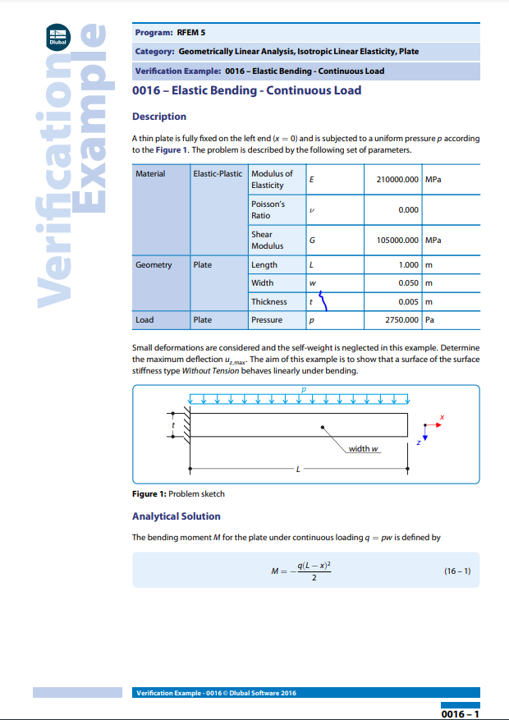
The following information is taken from Dlubal validation studies website [4] which shows specific validation cases which you can compare against the Ansys results. This information highlights a plate of material with a uniformly distributed load applied to indicate the surface stiffness. We can use this information to compare it to the Ansys study to see how accurate the data is.
Figure 1 - Validation Study [4]

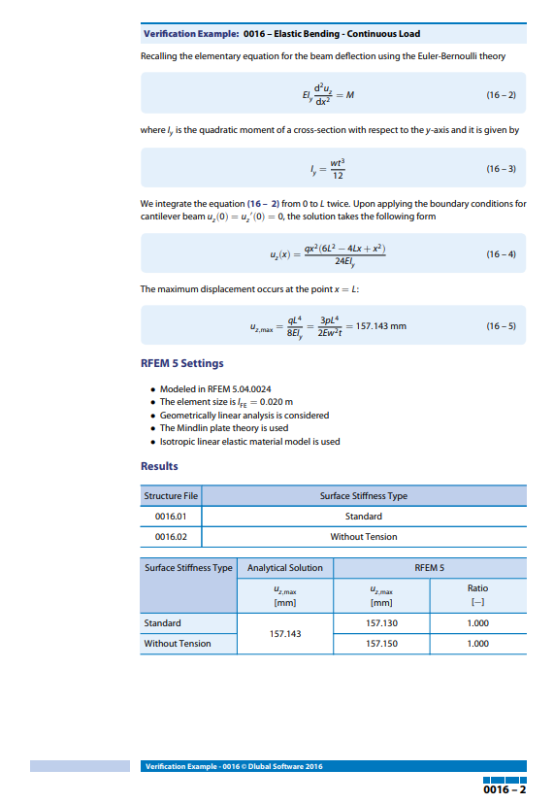
Figure 2 - Validation Study [4]

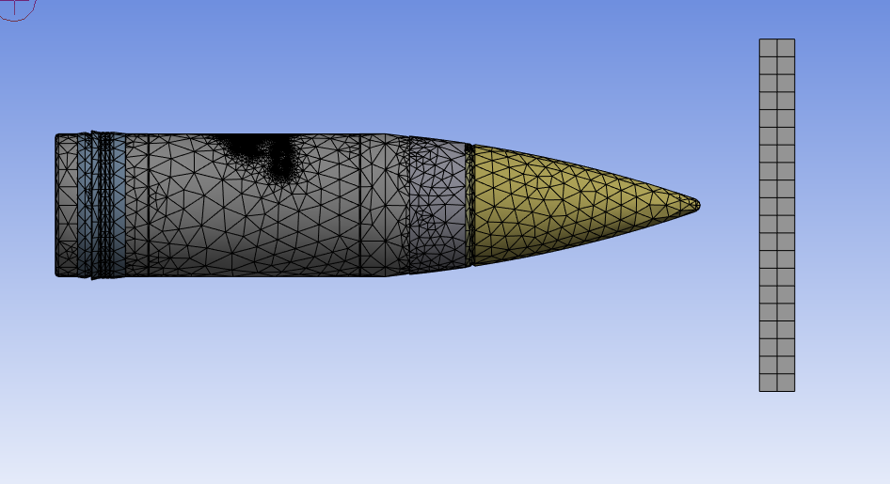
Figure 3 shows mesh sizing used for the Ansys simulations which comprises of a fine enough mesh to give detailed results of the static structural and thermal studies without taking a very long time to process the simulation on the computer.
Figure 3 - Mesh Example of 155mm Shell & Target

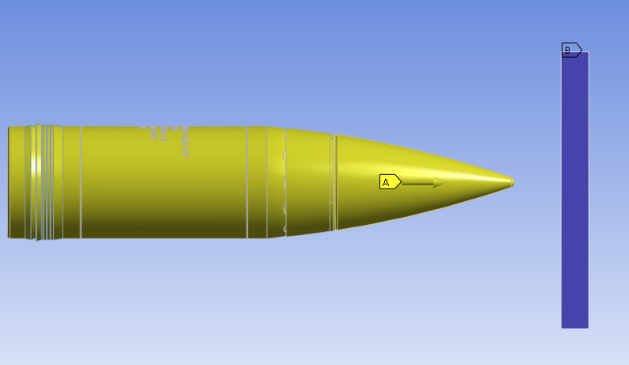
Figure 4 shows the loads and direction applied for the 155mm shell to impact the target.
Figure 4 - Load & Direction of 155mm Shell & Target

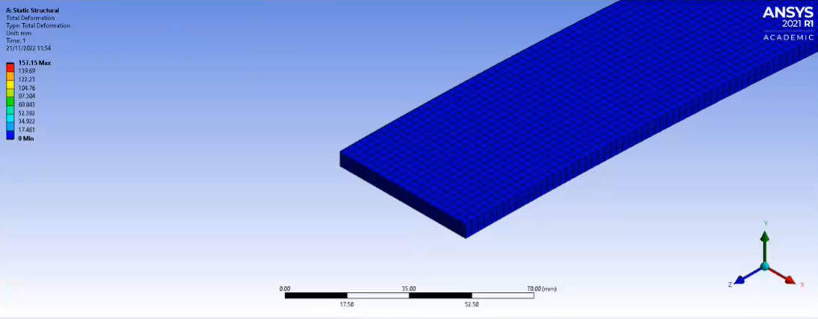
Figure 5 shows the total deformation of the material using a uniformly distributed load with the data on the left-hand side which is colour coded.
Figure 5 - Static Structural Total Deformation Example [5]

Results & Analysis

The results from figure 5 show that the maximum total deformation of the static structural analysis is 157.15 mm, if you compare this with the results presented in the validation case study you can see that the study shows the maximum total deformation is 157.143 mm.
This then shows the static structural case study in Ansys in figure 5 is very accurate.
Factors that will affect these type of results and impact the accuracy compared to real world examples are:
- Mesh quality: The quality of the mesh used in the simulation can have a significant impact on the accuracy of the results. A poorly constructed mesh can lead to inaccurate results and convergence issues.
- Material properties: The accuracy of the material properties used in the simulation can affect the accuracy of the results. The material properties must be properly characterized and validated to ensure that they accurately represent the real-world behaviour of the materials being modelled.
- Solver settings: The solver settings used in the simulation can affect the accuracy and speed of the solution. The solver settings must be appropriately set to balance accuracy and computational efficiency.
- User error: User error, such as incorrect input data or improper use of the software, can also affect the accuracy of the results.

Conclusion

In Conclusion it is possible to see that there are clear advantages to using SolidWorks and Ansys for finite element analysis compared with making prototypes for time and cost saving benefits.
However as mentioned in the previous section there can be draw backs to this as lots of things can go wrong and present inaccurate data from things such as mesh quality, user error and selecting the correct material properties and solver settings.
This shows that if a proficient person is undertaking the analysis and making use of validation studies as shown in figure 5 to compare back to then simulation using Ansys is a fantastic way to save companies money and time when producing components and assemblies which can be applied to a great deal of fields including aerospace, automotive, civil, mechanical, and biomedical engineering, to name a few.
It provides engineers and scientists with a powerful tool to optimize designs, evaluate performance, and predict the behaviour of a system under different conditions. By using FEA, it is possible to reduce development time, cost, and risks associated with the design, manufacturing, and testing of prototypes.
In addition, FEA provides a way to evaluate the effects of different materials, manufacturing processes, and environmental conditions on the behaviour of a system. This information can be used to optimize the design of a system, reduce material waste, and minimize environmental impact.
Overall, finite element analysis is an essential tool for engineers and scientists working on complex systems and structures. Its ability to accurately simulate the behaviour of a system under different conditions provides valuable insight into the design and performance of a system and helps to improve its reliability, safety, and efficiency.

References

[1] “Computer-Aided Engineering (CAE),” Siemens PLM Software, 2019. https://www.plm.automation.siemens.com/global/en/our-story/glossary/computer-aided-engineering-cae/13112 (accessed Apr. 10, 2023).
[2] Z. Bi, Finite Element Analysis Applications: A Systematic and Practical Approach. Saint Louis: Elsevier Science & Technology, 2017.
[3] “What is Computer Aided Engineering (CAE)?” www.twi-global.com. https://www.twi-global.com/technical-knowledge/faqs/what-is-computer-aided-engineering#Advantages (accessed Apr. 10, 2023).
[4] “Verification Example 0016 -Elastic Bending -Continuous Load Description,” 2016. Accessed: Apr. 15, 2023. [Online]. Available: https://www.dlubal.com/-/media/769CFB1370D742D9BEE0D37876B3E637.ashx
[5] A. Noble, “Static Structural Study,” Microsoft Teams. 2023. Accessed: Apr. 15, 2023. [Online]. Available: https://web.microsoftstream.com/embed/channel/0473ddb1-c257-4584-b3c1-10a50abf2a37?app=microsoftteams&sort=undefined&l=en-us#

Bibliography

Bird, J.O. and Ross, C. (2014) Mechanical Engineering Principles – 3rd ed, Abingdon-on-Thames: Routledge
MacDonald, B.J. (2020) Practical Stress Analysis with Finite Elements – 3rd ed, Dublin: MacDonald
Beer, F., Johnson, E. et al (2015) Mechanics of Materials, New York: McGraw-Hill
Benham, P.P., Crawford, R.J. and Armstrong, C.G.
(2006) Mechanics of Engineering Materials, New Jersey: Prentice Hall
Bacon, D.H. and Bennet, K. (1998) Mechanical Technology, Oxford : Butterworth-Heinemann

