Leading and Implementing Workplace Change.

Module code: BMSW6103.
Student Name : LOUAY ALSAYED-OMAR
Student Number: 1922056
Level 6 Term 2. Group 1.
Module lecturer: Dr. Dudley Ofori
Assignment title: individual report.

1

Executive summary:

This report demonstrates the importance of leading and implementing change in the workplace as a factor of successes achievement in any organisation when it applied with an appropriate approach , the importance of change concept in this report had been closely applied through Both Boots pharmacy and Walgreens Boots Alliance Inc. as a global organisation how it faced the challenges of uncertainty situation during and post COVID-19 pandemic global situation, this organisation had scanned global market successfully to provide a modern change in its international business operations, the decision making was to provide a new change in pharmacy functions by implementing a medical laboratory services which is unpredicted change for a usual function in any pharmacy services till this moment, this change had been created not only face COVID-19 pandemic global situation but in reality it is a new pharmacy platform that have the ability to face other any epidemics and pandemics natural phenomenon’s, this change was supported completely by governate legalisation’s especially in travel testing PCR analyses to issue a legal traveling certificate, this report provide the proof of how this organisation succeed to implement this change in three levels of business environments and why it had adopted this significant change also where are the academic methods, modules, theories that had been applied to support this change the evidence included in a strategical stages which start with analysis of recent organisation history and changes impact including COVID-19 clarified within BESTEL model analysis for external factors during and post Covid-19 then a critical evaluation of different change management models and evaluating the impact of organisational culture the next important stage is evaluating the impact on change management programme and applying Pettigrew Model for developing a suitable change management plan in the future as an evidence that this module dimensions which include vital process can explain as a suitable change management plan in future, conclusion and recommendation provide a clear steps of leading change as a real factor to achieve business successes. the report evaluates and support the module aims in developing a comprehensive concept of leadership and management of change.

2

Table of contents:

1. introduction..................................................................................................................4.
2. Reviewing current state of Boots Pharmacy................................................................5.
2.1. Personal involvement with Boots Pharmacy........................................................6.
2.2. Outlining recent change initiative in this report…………………………………..…6.
3. Analysis of recent organisation history and changes impact including COVID-19.
3.1. BESTEL model analysis for external factors during and post Covid-19…..7.8.9.10.
3.2. Explanation of contemporary issues that impacted the organisation………..…..10.
4. Critical evaluation of different change management models.
4.1. Lewin’s three-step Model……………………………………………………...….11.12.
4.2. Kotter’s Eight-Step Model…………………………………………………………….13.
4.3. Pettigrew Model………………………………………………………………….....…14.
5. Evaluating the impact of organisational culture.
5.1. Evaluating the impact on change management programme…………………....15.
5.2. Pettigrew Model developing a suitable change management plan………....16.17.
6. Conclusion and recommendation……………………………………………………......18.
7. References.

3

1. introduction:
Leading and implementing workplace change is a challenging task, but with the right approach it could be positive for both organisations and employees, change generally encounter with needs or forecasting a new thought this can explain the reason of why change should happens, according to Cambridge dictionary it providing change definition as an interchange of one thing to another accurately if they are from the same type to make it possibly or different (Cambridge dictionary n. d.). rationally this change need a successful implementing to achieve its goals and objectives by implementing a new ideas and implementing plans (Kenny chapman , 2020). According to John Kotter’s provide change management definition as a set of requested tools or structures intended to hold any change effort under its control (Change walk me, 2021). change is a necessity it often confront with barriers and difficulties to be immediately accepted from all organisation employees perspectives for some reasons related to their various intellectual or educational levels and different cultural structures that have an impact of organisational culture and change processes, it caused by the event of resistance as an organisational response change could be so difficult for some employees and result difficulties of implementing in organisation environmental change, in this stage managers as a change agent can release strategy of contemporary leadership in leading and implementing workplace because change is a continuing process that need flexibility and open to feedbacks in its nature of change and change management process.

4

2. Reviewing current state of Boots Pharmacy:


Figure 1. Free Boots Pharmacy Logo UK (Boots-rebrand, 2019).
Boots Pharmacy is well-established retail chain with a long history in the UK dated to 1849 when John Boot opened the first herbalist store in Nottingham (Nottingham shire , 2011). the most significant change when Jesse and Florence Boot donated over 70 acres for public a small part of it had been used as a new home for university college of Nottingham at that time, this means that Boots pharmacy is aware of moral and ethical considerations, the current company state in present is related with the statistics from 2015 till 2022 with number of 2,573 retail stores in the UK (Statista, 2023). Boots Pharmacy offers wide range of health services and vast beauty products with strong online marketing , the company revenue in 2022 is £ 5,812 million (Information service gov.uk, 2022). the main factor of increasing company incomes of 5% was the impact of COVID-19 vaccinations profit (Covid-19-vaccination-programme, 2020). Covid-19 will remain in a long term according to China pandemic situation and international statistics of WHO World Health Organisation (COVID-19. who.int, 2023). Boots pharmacy stakeholders predicting unexpected new epidemics and pandemics natural phenomenon such as HIV, Ebola, Avian influenza and other diseases that can be contagious from animals to humans according to UK government report (UK pandemic preparedness , 2022). The organisation current situation corresponding with Milton Friedman theory that emphases on the social responsibility in business which lead to increases organisation revenue profits when the shareholders spend them own money separately for their personal action (Link springer, 2007). in the same concept of stakeholder theory that have an impact on organization Dr. F. Edward Freeman approach stakeholder theory in a strategic management level and proposes that also shareholders are also simply one of the a considerable stakeholders in the company also emphasising on the concept of real success within satisfying all stakeholders and not only those who might profit from the stock but it involve anyone investing or any one that have a moral claim and affected in commercial company business process for example employees, sellers, government agencies, global economists (Smart sheet, 2022). In current organisation state it merge with Walgreens as a global business leaders in retail pharmacy (Walgreens boots alliance , 2021). these business factors possess a complex concept related with current state in change management on Boots pharmacy.

5

2.1.Personal involvement with Boots Pharmacy:
Since 2019 till present I am working with Boots pharmacy west Thurrock lakeside shopping centre near by Grays town, my personal involvement with the company include multi-tasking as a top security officer I am responsible for health and safety for staff members and customer advising on Boots pharmacy shop floor with full time job hours, this type of job needs diverse set of skills following are some of key responsibilities and skills required for this role such as regular patrolling on premises to prevent theft and medical items vandalism, CCTV monitoring technology, customer service and assistance, collaborating with staff members as a team to maintain a secure environment , strong communication skills to interact with customers, visitors, and colleagues, attendance managers daily short meetings to execute new management plans. Overall, my personal involvement needs a strong sense of responsibility, ability to adapt any changing situations also understanding security protocols to carry out all these duties.
2.2. Outlining recent change initiative in this report:
Exploring contemporary change with successful change management that Boots pharmacy implementing and how this organisation made changes by scanning the external environment and implementing in the workplace a new change that can face not only the Covid-19 pandemic situation but further predicting unexpected epidemics and pandemics natural phenomenon by establishing travel testing PCR analyses to issue a legal traveling certificate this is a change process that will be applied not only for covid-19 but also for any unexpected urgent pandemic and epidemics situation’s, it is a medical healthcare science achievement that assist NHS England (NHS England, n.d.).also in this report analysis of the current situation and how Boots pharmacy identifying and mange other unexpected situations for better change management in future, it developed already a change management plan that outlines the goals, strategies, and implementing the necessary changes, the plan include generating a clear communication strategy also tolerances and staff training to avoid any possible workplace resistances based on the journey through change module for resilience and adaptability to achieve both stakeholders and shareholders groups their own objectives and goals to lead this change effectively,
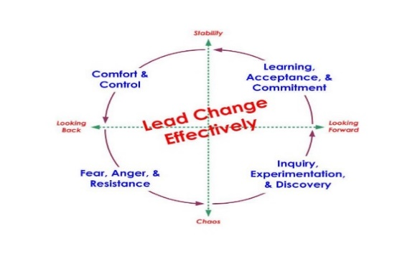
Figure 2. (Russell Consulting , 2013).

6

3. Analysis of recent organisation history and changes impact including COVID-19:
Analysing the recent history of Boots Pharmacy retailer and the unpredicted external environment factors and a powerful challenge due post Covid-19 which resulted in 2022 it provides a huge sale declining impact and changing in consumer behaviours it proclaims closing numbers of 60 branches and operating with reduced hours across several stores with reduced staff working hours (Pharmacy magazine, 2022). focusing on running a large wide list of productions reflect on a milestones of a successful business but due post Covid-19 factors and merger Boots Pharmacy with Walgreens organisation in 2022 stockholders in consolidation had confronted with forces for change process as the biggest association alliance they declared that Walgreens alliance might sell Boots pharmacy in the UK for private equities, this gives a clear explanation of how changes in the external environment including post COVID-19 had a negative impact on global Boots Pharmacy business according to ACG UK. the association for corporate growth in UK (ACG UK , 2022).
3.1. BESTEL model analysis for external factors during and post Covid-19:
For identification and assessing these external environmental factors BESTEL model analysis will be applied as a useful tool to explain the impact of external factors on the organisation during and post Covid-19 and what are the contextualise of these factors in marketing before any strategic implementation plan (Oxford college of marketing, 2016). it can be applied periodically in around of six months because it monitor also help organisation and mangers successfully in decision making also competitively establishing a contemporary marketing strategies as an effective answer for any new changes in macro-environment PESTEL analysis is an efficient environmental scanning tools for the recent forces and changes that gives at the end results of organisation differentiate by possessing a competitive advantage over other organisations in business, the following are PESTEL model factors analysis:
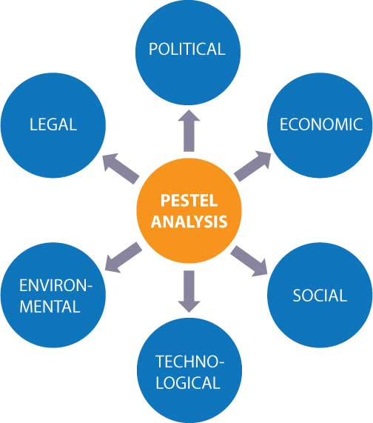
Figure 3. ( Scanning the environment, n. d. ).

7

BESTEL analysis:
Political factors:
During Coronavirus COVID-19 pandemic global situation the political factors considered by a variation of political external factors that affected the political and economic outcomes , According to Cambridge University The United Kingdom's response had included in factors of political pandemic crisis concept and related to epidemiologists medical science (Cambridge , 2020). Government issued different guidance related to this pandemic situation with limitations in external global macro environment contacts and restrictions included checklist legislation’s for traveling abroad (Gov.uk COVID-19 rules, 2021). Boots pharmacy implemented in lockdowns its own examination PCR travelling testing laboratory in stores (Travelling safely, 2021). The UK government policy had involved in global environments with big efforts to combat COVID-19 including contributing to development of vaccines and providing aid to other countries also applied drastic measures to tackle COVID-19 (UK tackle COVID-19 gov.uk, 2020). In recent organisation history there are different external political factors in international trading policy, and they are with high importance factors that affect Boots pharmacy industry by merging with Walgreens Boots alliance it will provide a wide competition for both organisations to lowers prices and open their stores for long hours , these are the essential political factors that affect Boots pharmacy.
Economic factors:
Global economic growth in 2021 predicted a lowest records number in the UK with small recovery ranged between 2.2% and 4.8% in annual GDP growth (PWC, 2021). It dramatic declining possibility of inflation and effect economic interest rates resulted from the economic factors of COVID-19 impact, market exchange rates in the global economy should expanding at least to 5% to partly solve this economic crisis, global green issues typically appear as a daily contemporary topic issue caused by increasing the cost of living for example today one of eight cars are electrical, according to national news (Matthew Davies,2022). this economy recession will continue so far till 2023 in the UK, post pandemic causes a permanent exporter factor of decline inflation and interest rates , labor market costs factor affects economy productivity these economic factors affect directly Boots pharmacy when the UK had left EU in its macro environment trade restrictions resulted uncertainty in organisation business Walgreens Boots Alliance confirmed closing about 200 stores pharmacies in earmarked (Pharmaceutical , 2022). These economic factors impact is in a high importance that strongly affect Boots pharmacy.

8

Social factors:
The most vital external social factors can be considered in social norms starting from merging Boots pharmacy UK with Walgreens Boots alliance this had impacted predominant buyers behavior in society some groups decided that Boots pharmacy doesn’t have the capability to NHS social services for example some customers complained in medical prescriptions services particularly in the official of NHS reporting Boots pharmacy ratings on some customers reviews (NHS.UK , 2022). These small compliance have the possibility to change cultural values also impact beliefs and attitudes in the society and influence the opportunities in shar market in the external environments of organisation business both genders are not happy to apply jobs in Boots pharmacy if the organisation continue to cut shifts hours, Walgreens Boots Alliance Inc. should take part of this responsibility with more research demanded to amend these social factors on different demographic concerns in the contemporary society it is with a high important implication in the organisation business future.
Technology factors:
The organisation possesses an advanced technological factors level that provide an effective communication technologies and automation which reduced labor costs in healthcare by applying cloud computing system and establishing a wide range of services in the organisation website with an advanced cybersecurity for each customers private data individually this includes contacting customers within external organisation macro environment as a external technology factors by E-business platform related with customers phones and email marketing (Boots customer services, n. d.). this technology of IT services related also with customer’s Boots advanced buying cards it is an advanced IT digital buying process with products discounts and advertisements (Boots Digital Advantage Card n. d.). the importance of this technological factors that it has a low level of compliance with GDPR regulations.
Legal factors:
Both Boots pharmacy and Walgreens Boots Alliance Inc. had considered and respect the external factors of employment law but in minimum wages under government law with unsatisfied local labour law organisation and employees highly affected due the economic crisis by high taxation law in salaries payslips deduction , monthly pensions and insurance taxes, these legal factors have a high importance impact on the organisation business this new legal factors can affect organisation revenue and financial grow al
so organisation ability, productivity, business operation systems in global an national market share in this context the organisation should strive to comply within an effective solutions relevant laws and legislations Legal factors can have a significant impact on businesses, as they can affect their ability to operate, compete, and grow. It is important for any businesses to stay informed about new annual legal factors laws and government legislations to develop organisation policies as an effective solution relevant to laws and regulations.

9

Environmental factors:
The organisation policy includes high external conditions and restrictions standards for environmental protection factors it obey the UK governments law also apply the main concept of CSR business model in corporate social responsibility surroundings its global and national ethical responsibilities for example pharmacy products are recyclable and biodegradable this include medical products, beauty products recycling with advantages points and gifts when customers use scanning old products barcodes inside the pharmacy branches, sales badges that customers use at buying process are 100 % are recyclable, this ethical sourcing add a small raising prices yet customers understand and support this opportunity environmentally products factors, pharmacy customers interact dynamically with ecosystems and the development of a new sustainable system that face part of challenges in national and global environmental factors .

3.2. Explanation of contemporary issues that impacted the organisation:
There are unlimited contemporary issues and factors that still have a powerful impact on the organisation with different dimensions, these factors continue and still affects the organisation for instance post COVID-19 persist to impact Boots pharmacy in finances income (Chemist and druggist 2021). also geopolitical uncertainty created a complexity in organisation global and national business environments, adding the fact of recent economy recession factor which have an extensive impact on the organisation to change its strategical object’s in the external and internal environments because it affected the three levels of business environments according to the above BESTEL framework analysis it provides a justification why Boots pharmacy as an organisation had applied and leading a new workplace changes and how it was forced to change management function in organisation structurers specifically in pharmaceutical public health services when it had implemented unexpected medical analysis platform that can face further global challenges and not only the test of PCR for Coronavirus diseases, this change in the workplace facing a huge challenges in implementing because it requested from Boots pharmacy to merge with a new business alliance as an appropriate strategic change option and to adapt the consequences of contemporary global challenges in macro and micro environments and lead another changes in marketing strategies that include suppliers, customers, and marketing competitions, it is a business response through global crisis.

10

4. Critical evaluation of different change management models:
The purpose of different change management models is planning and introducing a new process, methods , models , in the organization activities these processes utilized to move an organization from one situation to another (Oxford Reference , 2019). this process includes how much individuals are informed , what are their incentives , the effectiveness of their contribution’s and their major support in the change process, the process applications are for planning the change and change implementation, organisational change is continuous in successful organisations the following is a critical evaluation of different change management models:
4.1. Lewin’s three-step Model:

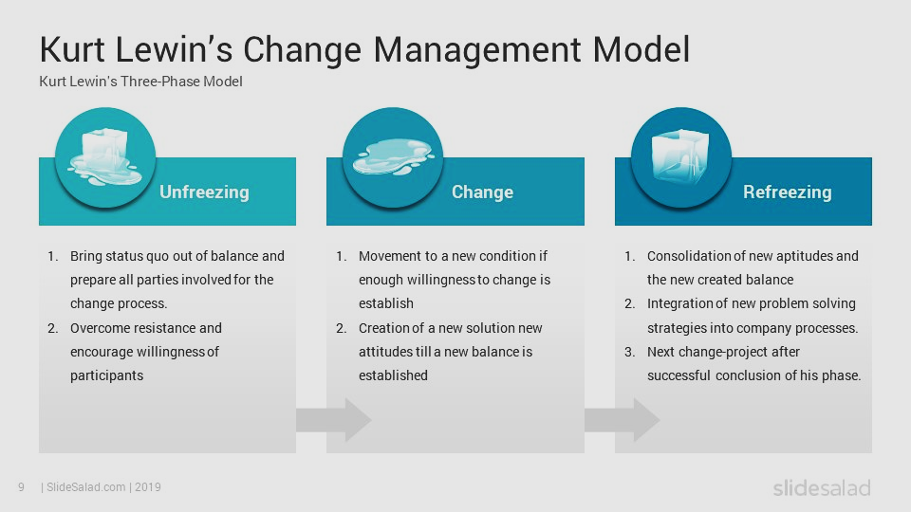
Figure 4. Free images (Slide share tips, 2020).

Dr. Kurt Lewin's three-step model is a framework of managing change in organizations it was developed by Kurt Lewin in the 1940s. (Science direct, 2018). an ancestor in social psychology sciences, Lewin's three-step model contain three stages: unfreezing, changing, and refreezing, first stage it involves in setting up the organization to accept the change and encourage all participations to come over resistances also encouraging them to change the existing behaviour mindset and habits before operating in any new change, the second stage involves in moving towards change implementing period to make it more sustainable, third stage is refreeze it involves in post change team consolidation and all participations support are available to work with the new method of change.

11

The critical evaluation agrees with the context of simplicity in Kurt Lewin model stages and the strengths extinction in change activities approach of participative within the organization, whoever the main disagreement argument emphasis on the time interval period when Kurt Lewin model was developed in 1947 (technology changed , 2020). that period was out of data since technology and weakness of implementation details in model stages the examination provides lack of practical empirical transition support in the three stages structures comparing with the five stages dimensions of ADKAR change model that accurately describe the implement in organizational changes without individuals resistance (CMI 2019).The advantages of Kurt Lewin model are in a regular transitional stages and support changes, it analyses individuals behaviours by the means of psychology, the disadvantages are simplicity and missing of effectiveness in every stage structure, the approach limitation can provide unexpected conflict in organisation top-down management and bottom-up management styles (Change management insight, 2019). In conclusion this model presumes a stable organisation environment and doesn’t considers time implementation stage and the organisation cultural differentiations so it cannot be applied in a global organisation such as Boots pharmacy.

12

4.2. Kotter’s Eight-Step Model:

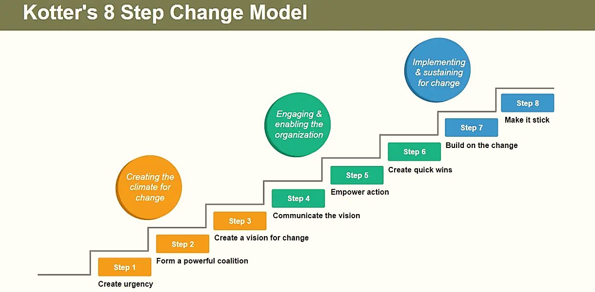
Figure 5. Free image (Kotter's 8-Step Change Model, 2022).
Harvard business school professor Dr. Kotter's encompass eight steps Model in change management which outlines how to implement changes process successfully in the organizations (User Guiding, 2023). Kotter's eight steps Model include creating a sense of urgency, building a coalition, development of a clear vision, sharing this vision , empowering people to clear obstacles , obtain a secure short-term win , consolidation and keep moving, also how to implement the change. The critical evaluation assessment agrees with the core concept of planning an emergent approach and the argument relay on the methodological approaches of a clarified eight stages system that can be successfully implemented during a practical applications in each stage with an active communication analyses examination provide that the adventive’s of this Model are in clarity of eight stages structure and outlines specific steps, it emphasizes on the importance of communication throughout the change process, highlighting the importance of leadership in driving change and focussing to empower employees in the change process, the disadvantages are not all organizations need to apply the eight steps for all types of changes, every organization it may have a different changes with a specific needs and different situations that can be applied from leadership to drive changes, also in implementing change process there are lack of attention in cultural impact and its contextual factors it should be considered when it arrives in implementing stage , this Model have limitations in eight steps process by focusing on a temporary change within a short-term winning goal (Rose 2002). rather than a long-term transformation to maintain a support for leading change, also there are some of limited flexibility in the eight steps comparing with McKinsey 7S Model elements that focus in the efficiency of strategic planning and sharing values (McKinsey 7S Model, 2022).In conclusion Kotter's Eight-Step Model provides unclear specific change management operations it can be applied in a global organisation such as Boots pharmacy but it does not contain external environmental scanning of change implementation.

13

4.3. Pettigrew Model

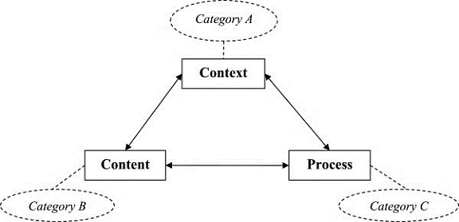
Figure 6. Pettigrew’s framework (Research gate, 2014)
Ph.D. professor in business school at the university of Oxford Andrew Marshall Pettigrew born on 1944 (E N - academic, 2023). Pettigrew’s framework concept based on the dimensions of strategical change for a successful change management by distinguishing this change in three comprehensive fundamental dimensions (Andrew M. Pettigrew,1987). these dimensions firstly it includes the content of change that achieve organisations strategical goals, purposes, and objectives, secondly it includes process of change and how organisation strategy can be implemented, thirdly the context of change it extensively includes where are the organisations operates systematically in internal and external environments. the critical evaluation agrees with continuous planning for an emergent approach, the argument of this evaluation is demonstrating that this model can be successfully execute in contemporary organisations for leading change and implementing it in the workplace, though there are some conceptions that adopting change Models process is difficult, Pettigrew’s framework concept with its three dimensions gives an efficient clarity for implementing change in organisations to undergoing with a significant need of leading change, the evidences acquired from recent research’s as a proof in health sector this model had been applied in NHS change programmes analyse and the three dimensions were considered effectively also interrelated in many NHS studies (Research gate, 1994) adding it developed a new change Model for different change needs (England NHS n. d.) .advantages of Pettigrew Model it shapes a new transformation leadership and create an effective active communication by involving employees in the change process which leads to mitigate resistance then managing it, the main disadvantages are that this Model may not fully grasp the complexity and predict all organisations change barriers, risk of change failure are not included when change agents have their responsibilities in managing change, the Model limitation can be described firstly in modern organizations which facing today a disruptive change that is beyond their control, secondly external factors not accounted it significantly impact the change initiatives, in conclusion Pettigrew Model is a useful framework in managing organizational change if organisation’s made the effort to redesign some techniques modifications for integrating with this useful Model, Pettigrew Model can be applied successfully in an international organisation such as Boots pharmacy because it is valuable tool for undergoing a significant change and supporting transformational leadership style, change agents tasks including their skills and modern styles to achieve the organisation goals and objectives.
14

5. Evaluating the impact of organisational culture:

5.1. Evaluating the impact of organisational culture on change management programme:
Boots pharmacy and Walgreens Boots Alliance Inc. are a global organisation for this reason it have a powerful organisational culture impact on change management programs which focus on organisational psychological assets members reactions in change process on different powerful impact across the three levels of the organisation environments, because this organisational cultural impacts can contribute to organisation success or failure, there are different researches to identify an academic definitions for organisation culture and its impact on change management programs according to Harvard business review (hbr.org , 2013). Rolf Winkler provides the definition of organisational culture as it over simplifying the situation in large organizations to assume that there is only one culture and it’s so risky for a new leader to eliminate the subcultures existence, a global organisation as Boots pharmacy made a significant change during and post COVID-19 it introduced a medical laboratory in pharmacy management programme as a modern pharmacy function which have the a vision and purpose to introduce a new change of laboratories’ analyses for uncertain health care situation’s in the future, this statement is mentioned in organisation website about Boots pharmacy and Walgreens Boots Alliance Inc. in its vision also in its purpose and values (Boots UK n.d.). it has the impact of a challenging mission when a pharmacy's declares a new change in its systematic global business operations it transfers and implement a new unique value proposition, there is un expected statement about this organization addressing that it is ready for any direct conflict impact or resistance challenging in status-quo it also insets that the organisation values had already take this change risk responsibilities in consideration’s, there is a negative hidden impact related to the professional employees beliefs they have a resistance about their patients health care services and their interactions with patients within stakeholders business policies quality in the way that they care and provides their heath care services they retain it in their ethical career standards and they cannot disclosed, this cultural employees attitudes approach can impact the organisation in tow levels the first level is a positive attitude impact that support and collaborate with the workplace environment, the second is the negative attitude impact level that can frustration and morale resistance conflict.
Finally, the impact of organisational culture on change management programme can be improved with more opportunities when it is related with a contemporary organizational transformational leadership style that can close the gap theoretical methodology contextualizing and successfully implement change in organisational culture and create a sustaining culture change.

15

5.2. Pettigrew Model developing a suitable change management plan:
Boots pharmacy and Walgreens Boots Alliance Inc. implemented a change as an urgent medical service, the organisation introduced a new change of laboratories’ analyses platform during COVID 19 and sustained this change in post COVID 19, during COVID 19 this change introduced un a short-term process for problem-solving solution but this global organisation vision and its business strategy plan is beyond what actually public community can see in this medical services, in the reality within change management principles it leads a significant contemporary change by adding pharmaceutical public health laboratories platform that includes divers lists of medical laboratories testing preparing and creating a new change for unlimited medical disease diagnostics with different types of laboratories analysis specialisations procedures (Britannica n.d.) for example cellular and chemical analysis, genetic testing different measurement such as electrocardiography ,physical visual examination, this post-pandemic change needs a development of a suitable change management plan to lead this change also for implementing it in the organisation making it different with sustainability to face and forecasting any post-pandemic uncertainty situations in the future, the suitable change management plan can be presented by Pettigrew Model as the following:
Pettigrew Model:
Content of change:
Boots pharmacy and Walgreens Boots Alliance Inc. they can successfully implement changes in the organization within a strategic plan that contain the objectives of a contemporary health change service’s that is already identified during COVID-19 by a new laboratory function in the organisation with purpose of introducing a large wide laboratory sciences analyses platform in post COVID 19 , still there are several tools , skills and techniques requested which enable the organisation to achieve these goals with a strategical plan helped by change agent this include organisation stakeholders responsibilities and involved all individuals that are actually have their workplace responsibility in the organisation, mangers have their part with charismatic leaders of transformational leadership style that should present a positive impact on change management programme with requirement of providing a new technology of medical analysis devices utilisations inside the organisation to accelerate their change processes in organizational, this will strongly help to lead change in emerge post-pandemic challenge’s and simplified it for more resilient in staff members and employees they should professionally deal with a new operational organisation website booking system in customers services also medical samples suppliers must be prepared to supply all laboratories materials needs without any interruptions, global organisation cultural structure provide a critical risk and challenges so to mitigate this risk a clear delay meeting structured plan is highly requested with employees it can create a facility advantage for adopting a successful change programme process moving it as much as possible from any possible failure risk in change programme.

16

Process of change:
Change management plan implementations consider timelines and milestones factors in the organisation to successfully achieve the expected outcomes changes implementing within a clear step as the following:
A- Staff training: Skills and knowledge of software training must be examined, health and safety instructions should be clarified in staff training, providing a training of general medical analysis laboratories test list.
B- Communication plan: high standards of change agent skills must apply effective communication with active listening skills in internal and external organisational environments in effective networking plan this involve all individual’s and employees to interact in change leading with problem solving and their part decision making.
C- Implement the plan: after change management development plan had considered in the previous steps actions what attributes are needed for and change agents and the employees training had been executed the plan can be implemented and can be evaluated by employees performance indicator it will be measured through mangers monitoring system, when changes face any resistance in implementation only an urgent partial modification procedure’s will be applied that include effectively enhancing change frequency activities.

Context of change: the organisation operates systematically in an internal and external environment the context of change can attract customers for their needs with a vital modification in global pharmacy function, organisation goals and objects can be accomplished when staff members can operate comprehensively in the three levels of the organisation environments.

17

6. Conclusion and recommendation:
Organisations developments OD can not be achieved without leading and implementing workplace change though it is very complex to accept and adopt any change especially in a global organisation such as Boots pharmacy that possess a huge employees number, but uncertain global situation impose change as an urgent necessity for any organisation to remain innovative and competitive with recent market changing conditions, organisation success relay on the efficiency of stakeholders and managers in implementing and leading this change in the workplace with less resistance , effective change management involves in needs and nature of change so managers should have resilience and perseverance to accomplish change by creating a clear vision and a suitable plan in change management process to insure a successful implementation in the workplace , the recommendations are creating change with a clear vision to be understand and to deal with so it can achieve objectives and outcomes with a positive expected, effective communication is highly recommended with strong leadership skills also adjustments any necessary change to mitigate and control any resistance cause by different culture believes following the above recommendations organization can successfully leads the challenges of change to make it more adaptable in the workplace and more competitive in the market , recognising change in continuous improve organisation opportunities’ to lead change as a real factor to achieve business successes.

18

References:
Cambridge Dictionary (n.d.)CHANGE | English meaning - Cambridge Dictionary [online] available at: https://dictionary.cambridge.org/dictionary/english/change (Accessed: 2 MAR. 2023).
kenny chapman (2020). Leading Change: How To Lead Change In The Workplace - Kenn…[online] available at: www.kennychapman.com/leading-change/ (Accessed: 2 MAR. 2023).
Change walk me 2021 Organizational Change Definition by Authors & Authorities [online] available at: change.walkme.com/organizational-change-definition-by-authors/ (Accessed: 2 MAR. 2023).
Boots-rebrand (2019). Boots reveals biggest logo redesign in 170 years [online] available at: https://www.creativebloq.com/news/boots-rebrand (Accessed: 2 MAR. 2023).
Nottingham shire (2011). The Nottinghamshire Heritage Gateway > Themes > … [online] available at: http://www.nottsheritagegateway.org.uk/themes/boots.htm (Accessed: 3 MAR. 2023).
Statista (2023). Boots: UK store numbers 2022 | Statista [online] available at: https://www.statista.com/statistics/882967/boots-store-numbers-united-kingdom-uk/(Accessed: 3 MAR. 2023).
Information service gov.uk (2022). BOOTS UK LIMITED - Find and update company information [online] available at: https://find-and-update.company-information.service.gov.uk/company/00928555/filing-history (Accessed: 4 MAR. 2023).
Covid-19-vaccination-programme (2020). COVID-19 vaccination programme - GOV.UK [online] available at: https://www.gov.uk/government/collections/covid-19-vaccination-programme (Accessed: 4 MAR. 2023).
COVID-19. who.int (2023). China: WHO Coronavirus Disease (COVID-19) Dashboard With …[online] available at: https://covid19.who.int/region/wpro/country/cn (Accessed: 5 MAR. 2023).
UK pandemic preparedness (2022). UK pandemic preparedness - GOV.UK [online] available at: https://www.gov.uk/government/publications/uk-pandemic-preparedness/uk... (Accessed: 5 MAR. 2023).
Link springer (2007). The Social Responsibility of Business [online] available at: https://link.springer.com/chapter/10.1007/978-3-540-70818-6_14(Accessed: 6 MAR. 2023).
Smart sheet (2022). What Is Stakeholder Theory? | Smartsheet [online] available at: www.smartsheet.com/what-stakeholder-theory-and-how-does-it-impact-organiz…(Accessed: 6 MAR. 2023).

Walgreens Boots Alliance (2021). [online] available at: https://www.boots-uk.com/about-boots-uk/company-information/walgreens-boots-alliance/ (Accessed: 7 MAR. 2023).
NHS England (n.d.). NHS England » What is healthcare science? [online] available at:
https://www.england.nhs.uk/healthcare-science/what(Accessed: 7 MAR. 2023).
Russell Consulting (2013). Change model – Russell Consulting, Inc. [online] available at: https://www.russellconsultinginc.com/change_model/ (Accessed: 7 MAR. 2023).
Pharmacy magazine (2022). Boots to cut up to 6pc of trading hours across pharmacy …[online] available at: https://www.pharmacymagazine.co.uk/news/boots-to-cut-trading-hours...(Accessed: 8 MAR. 2023).
ACG UK (2022). Private equity firms set for tilt at Boots after approach by …[online] available at:https://www.acg.org/uk/news-trends/news/private-equity-firms-set-tilt...(Accessed: 8 MAR. 2023).
Oxford College of Marketing (2016). What is a PESTEL analysis? - Oxford College of Marketing Blog blog.oxfordcollegeofmarketing.com/2016/0 [online] available at: https://blog.oxfordcollegeofmarketing.com/2016/06/30/pestel-analysis/(Accessed: 9 MAR. 2023).
Scanning the Environment (n.d.) Scanning the Environment: PESTEL Analysis – Planium Pro [online] available at: https://www.planiumpro.com/blog/scanning-the-environment-pestel-analysis (Accessed: 10 MAR. 2023).
Cambridge (2020). Cambridge University COVID-19 and the Politics of Crisis - Cambridge Core [online] available at: https://www.cambridge.org/core/journals/international-organization/...(Accessed: 10 MAR. 2023).
Gov.uk COVID-19 rules (2021). Travel abroad from England during coronavirus (COVID-19) [online] available at: https://www.gov.uk/guidance/travel-abroad-from-england-during-corona... (Accessed: 10 MAR. 2023).
Travelling safely (2021). How to travel safely during COVID-19 - Boots [online] available at:
https://www.boots.com/health/covid-19/preventing-covid/travelling-safely(Accessed: 10 MAR. 2023).
UK tackle COVID-19 gov.uk (2020). UK takes drastic measures to tackle COVID-19[online] available at: https://www.gov.uk/.../news/uk-takes-drastic-meas…(Accessed: 11 MAR. 2023).
PWC (2021). 2021 UK and Global economic outlook - PwC [online] available at: https://www.pwc.co.uk/.../2021-uk-and-global-economic-outlook (Accessed: 11 MAR. 2023).
Matthew Davies (2022). UK economy to be in recession for all of 2023, KPMG says[online] available at: www.thenationalnews.com/world/uk-news/2022/12/19/uk-economy-to-be-in-rece (Accessed: 11 MAR. 2023).

Pharmaceutical (2022). Boots shuts nearly all 200 pharmacies earmarked for …[online] available at: https://pharmaceutical-journal.com/article/news/boots-shuts-nearly-all-200-pharmacies-earmarked-for-closure (Accessed: 11 MAR. 2023).
NHS.UK (2022). Ratings and reviews - Boots - NHS [online] available at : https://www.nhs.uk/services/pharmacy/boots/X11864/ratings-and-reviews (Accessed: 12 MAR. 2023).
Boots customer services (n.d.).contact us | customer services - Boots [online] available at:
https://www.boots.com/floating-editorial/customer-services/contact-us- (Accessed: 13 MAR. 2023).
Boots Digital Advantage Card (n. d.). Digital Advantage Card Set Up - Boots[online] available at: https://www.boots.com/digital-advantage-card-set-up(Accessed: 14 MAR. 2023).
Chemist and druggist (2021). COVID-19 continues to impact Boots finances, with 13.4% profit …[online] available at: https://www.chemistanddruggist.co.uk/CD007099/COVID19-continues-to... (Accessed: 14 MAR. 2023).
Oxford Reference (2019). Change management - Oxford Reference [online] available at: https://www.oxfordreference.com/view/10.1093/acref/9780191843273.001 (Accessed: 15 MAR. 2023).
Free images Slide share tips (2020). [online] available at: https://slidesharetips.blogspot.com/2020/02/lewin-s-model-of-change.html (Accessed: 15 MAR. 2023).
Science direct (2018). Kurt Lewin's change model: A critical review of the role of [online] available at: https: www.sciencedirect.com/science/article/ (Accessed: 16 MAR. 2023).
Technology changed (2020). Here’s how technology has changed the world since 2000 [online] available at: https://www.weforum.org/agenda/2020/11/heres-how-technology-has (Accessed: 16 MAR. 2023).
CMI (2019). ADKAR Model of Change Management | CMI [online] available at: https://changemanagementinsight.com/adkar-model-of-change-management (Accessed: 17 MAR.2023).
Change management insight (2019). Lewin model of change management - CMI[online] available at: https://changemanagementinsight.com/lewins-model-of-change-management (Accessed:17MAR.2023).
Kotter's 8-Step Change Model, 2022 [online] available at: https://cio-wiki.org/wiki/Kotter's_8-Step_Change_Model(Accessed:18 MAR.2023).
User Guiding (2023). What is Kotter’s 8 Step Change Management Model [online] available at: https://userguiding.com/blog/kotters-8-step-chang…(Accessed:18 MAR.2023).

McKinsey 7S Model (2022). The 7S Framework Explained - SM …[online] available at: https://strategicmanagementinsight.com/tools/mckinsey-(Accessed:18MAR.2023).
Research gate (2014).Pettigrew’s framework [13]] and the corresponding …[online] available at: https://www.researchgate.net/figure/Pettigrews-frame…(Accessed:19 MAR.2023).
E N – academic (2023). Andrew Pettigrew - en-academic.com [online] available at: https://en-academic.com/dic.nsf/enwiki/6173777 (Accessed:19 MAR.2023).
Research gate (1994). Pettigrew and Whipp’s (1991) Context-Content- Process framework [online] available at: www.researchgate.net/figure/Pettigrew-and-Whipps-1991-Context-Content-Proc…(Accessed: 20 MAR.2023).
England NHS (n.d.) NHS England Change Model [online] available at: https://www.england.nhs.uk/sustainableimprovement/change-model (Accessed:21 MAR.2023).
Rolf Winkler (HBR , 2013). What Is Organizational Culture? And Why Should We …[online] available at: https://hbr.org/2013/05/what-is-organizational-culture(Accessed:22 MAR.2023).
Boots UK (n.d.). Vision purpose and values [online] available at:https://www.boots-uk.com/about-boots-uk/company-information/walgreens-boots-alliance/vision-purpose-and-values (Accessed:23 MAR.2023).
Britannica (n.d.) List of medical tests and diagnostic procedures | Britannica[online] available at:https://www.britannica.com/topic/list-of-medical-tests-and-diagnostic(Accessed:24 MAR.2023).

