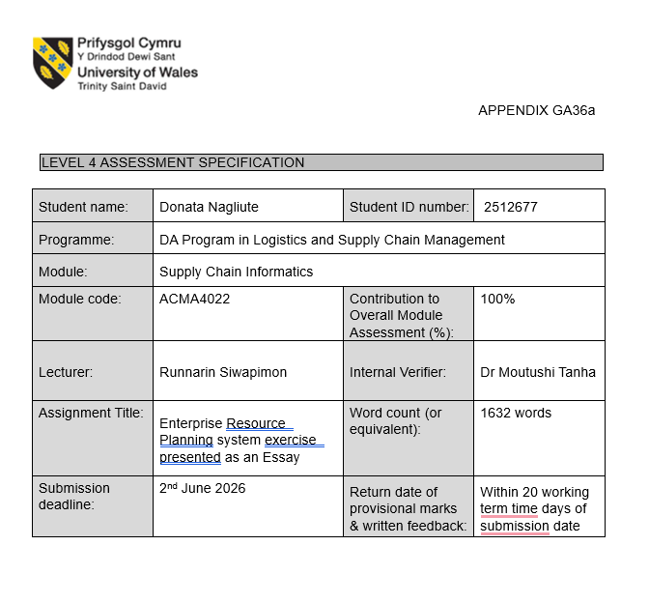
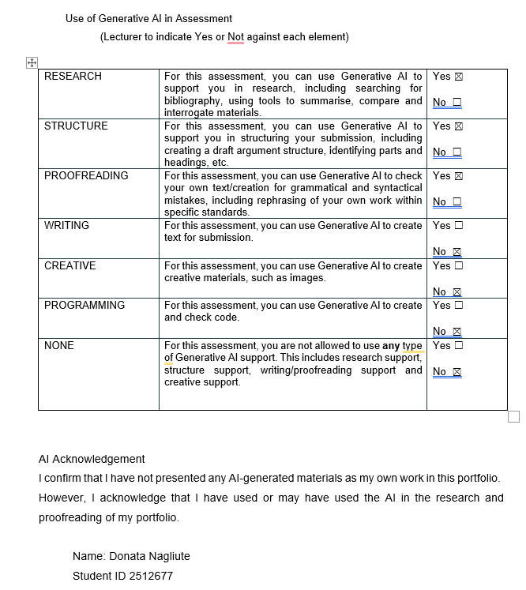
Table of Contents
Introduction 1
Literature review 1
Organisation Background: Coloplast 2
ERP Environment Used Within Coloplast 2
ERP Integration Within the Coloplast Digital Environment 3
Challenges Associated with the ERP Environment 4
Warehouse automation and operational control 4
User capability and training 4
Integration Complexity 4
Recommendations for Future Improvement 5
Conclusion 6
References 7

Introduction

Enterprise Resource Planning (ERP) systems play an important role in the organisational coordination and decision-making within the supply chain. ERP environments are implemented within organisations to facilitate the integration of different business processes and to support the movement of information between different areas of those organisations. The ERP system used by Coloplast is Oracle JD Edwards EnterpriseOne (JDE). This essay explores the use of this system in the company to determine how it supports supply chain and logistics processes, how it integrates with other digital platforms, the challenges associated with the use and potential opportunities for future improvement.

Literature review

Enterprise Resource Planning (ERP) systems are generally recognised as integrated information systems that support the coordination of organisational processes. According to Klaus, Rosemann and Gable (2000, pp. 141 – 151a), ERP systems allow for various business functions of an organisation to be integrated into a single system. These functions include procurement, manufacturing, finance, inventory management and logistics. Davenport (1998, pp. 121 – 123) notes that ERP systems also extend beyond the software applications that are common in businesses. This integration also allows the coordination and standardisation of the processes within the businesses. Therefore, the system acts as a single source of truth for the organisation, allowing for improved decision-making within the organisation.
Within supply chain and logistics environments, ERP systems support the flow of information that underpins material and financial flows across the supply chain (Mangan, Lalwani and Calatayud, 2021, p. 10). ERP systems improve the management of inventory, warehousing, production and order processes, contributing to greater organisational visibility and coordination across operations (Pagano and Liotine, 2020, p. 27).
However, literature also shows that the implementation of ERP does not automatically ensure an increased performance of the organisation and the system is linked with various changes to the organisation and processes. Training of the users of the ERP system is one of the changes (Umble, Haft and Umble, 2003, pp. 243 – 247a). Additionally, Singh, Singh and Misra (2023, pp. 904 – 908) state that many challenges often emerge after the implementation of an ERP, including complexity in the system, user resistance to change and the need for accurate data. Furthermore, other research suggests that the performance of a company using an ERP depends on the capabilities and skills, as well as the efficiency of the supply chain processes (Bhattacharya, Ramakrishnan and Fosso Wamba, 2023). Therefore, ERP success should be understood as both a technological and organisational issue.

Organisation Background: Coloplast

Coloplast is a healthcare company that develops products and services for individuals with medical conditions and needs in relation to their personal healthcare. Coloplast operates globally, with manufacturing and distribution facilities and operations in various regions of the world (Coloplast, 2025).
To support the global operations, Coloplast relies on integrated digital systems to manage information, processes and supply chain activities. These systems enable coordination across manufacturing sites, distribution centres, and customer-facing operations (Coloplast, 2025a).
The company has established Digital, Data and IT capabilities to support the digital technologies and systems in place across the company. The various enterprise systems and digital technologies used by the company indicate the importance of information systems within the organisation (Coloplast, 2026).

ERP Environment Used Within Coloplast

Coloplast uses Oracle JD Edwards EnterpriseOne (JDE) as part of its ERP environment. Internal documentation of the company indicates that this ERP system is used within processes related to the company's product and customer master data, indicating the importance of managing operational and supporting business coordination. While no details are publicly available regarding the deployment architecture of this system, it is understood to be applied to operational data and processes within the company.
JDE supports Coloplast in a range of logistics and supply chain processes, including those related to product master data, inventory control and order management (Coloplast, 2026). Furthermore, internal company materials indicate that the system contributes to product lifecycle activities such as the creation, modification and discontinuation of products, while also supporting production sites and distribution centres. This suggests that the ERP environment extends beyond transactional processing and across supply chain. This reflects the literature which describes ERP as an integrated system supporting organisational coordination and information sharing across business functions (Klaus, Rosemann and Gable, 2000, pp. 141 – 151b).
JDE is also used to support inventory and warehouse processes, enabling stock visibility and supporting booking and picking activities. This suggests that JDE is effective in supporting core supply chain coordination and operational visibility. Also, the capabilities appear more focused on transactional control rather than advanced warehouse execution and automation.

ERP Integration Within the Coloplast Digital Environment

Within the digital environment in which Oracle JD Edwards EnterpriseOne (JDE) operates, Coloplast is not only the ERP software itself, but also a range of other systems that support supply chain, operational and customer-related processes and activities. The integration of these various technologies enables information to move across operational processes and contributes to greater visibility and coordination across the organisation (Pagano and Liotine, 2020, p. 18).
The system that integrates with JDE interacts with platforms including STEP, Power BI, Supply Chain Toolbox and Salesforce:
Salesforce is implemented to support the processes linked to the company’s customers. The integration between Salesforce and JDE allows for the sharing of customer-related information across operational processes in the company. This integration allows for improved visibility into customer orders and better coordination between operational and customer-facing processes (Coloplast, 2023).
STEP contributes to the management of information relating to the company’s products. Through the integration with JDE, information regarding the company's products can be shared between the different business functions, supporting consistency of those processes (Coloplast, 2025).
Power BI is used to create reports and dashboards for monitoring organisational KPIs and analysing operational information within Coloplast. The integration of Power BI with operational systems enables data to be transformed into information that can be used to monitor and manage its operations. This improves the company's visibility into the operations and enables more informed decision-making (Coloplast, 2026).
Supply Chain Toolbox is implemented to support operational activities in the supply chain, including logistics and forecasting. Internal company analysis further indicates that Warehouse Management System (WMS) capabilities are under consideration to address limitations associated with warehouse automation and real-time operational functionality. This indicates that Coloplast manages supply chain operations through specialised systems, while ongoing consideration of WMS functionality highlights current limitations in warehouse automation (Coloplast, 2025b).

Challenges Associated with the ERP Environment

To implement and operate an ERP environment effectively, an organisation needs to adapt to different aspects of implementing the system (Umble, Haft and Umble, 2003, pp. 243 – 247b). The effectiveness of an ERP environment also depends on organisational capabilities, processes and data management practices (Muketha and Micheni, 2020, pp. 119 – 123). Within Coloplast's current ERP environment, several challenges are linked with supply chain processes.

Warehouse automation and operational control

Internal analysis suggests that the current ERP environment has limitations in warehouse automation and real-time operational control, which can increase reliance on manual processes and reduce efficiency in operations. This may result in slower picking processes, increased dependence on manual activities and reduced operational flexibility within warehouse operations.

User capability and training

ERP effectiveness also depends on user capability. The internal documents show that training is managed locally, which may lead to inconsistency in system usage and reduce overall efficiency. As ERP systems become increasingly integrated into operational processes, differences in user knowledge and understanding may influence the effectiveness of supply chain activities and decision-making.

Integration Complexity

The use of multiple integrated systems increases system complexity and may create challenges in maintaining data consistency and coordination across functions (Morawiec and Sołtysik-Piorunkiewicz, 2023). As supply chains depend on the integration of materials, information and financial flows, any limitations to integration can have a negative influence on the supply chain's ability to respond to demands or make decisions (Mangan, Lalwani and Calatayud, 2021, pp. 218 – 220). Therefore, the effectiveness of the ERP systems should be understood as both technological and organisational, depending on how well the organisation can operate the system, integrate and manage the data flows.

Recommendations for Future Improvement

Based on the challenges identified within the current ERP platform, several opportunities for improvement can be made.
To address the identified limitations in warehouse automation, Coloplast could further enhance warehouse operations through the implementation of advanced warehouse automation solutions integrated with WMS functionality. Providers such as Swisslog offer automated storage and retrieval systems, robotics and data-driven warehouse technologies that can improve material handling efficiency, warehouse task execution and real-time operational visibility (Swisslog, no data). Such improvements could reduce reliance on manual activities, increase operational control and support higher levels of warehouse efficiency. Furthermore, enhanced automation and warehouse visibility may contribute to improved inventory accuracy, faster order processing and stronger overall supply chain performance.
To improve planning and decision-making within a complex data environment, AI-supported tools could enhance forecasting accuracy and supply chain optimisation (Riad, Naimi and Okar, 2024, p. 6). Experiences shared by other companies indicate that the use of IT for planning purposes may increase forecasting and stock management performance (Slimstock, no data). However, such tools could help Coloplast improve planning effectiveness and manage supply chain complexity associated with a large product portfolio.
Training programs would enhance user capabilities and make the utilisation of ERP more efficient (Umble, Haft and Umble, 2003). Advancements in technology will also need to go hand-in-hand with effective data management practices because the capabilities of users, organisational adjustments and information quality still play an important role in determining the success of the ERP system.

Conclusion

Throughout this essay, JDE has been investigated in terms of its use by Coloplast and its contribution to logistics and supply chain operations through information management and integration. Inventory control and order management is where JDE makes its biggest contributions, but integration with STEP, Power BI, Supply Chain Toolbox, and Salesforce ensures that information flows more freely within the organisation.
Challenges associated with warehousing, ERP integration and user capabilities have been revealed during research conducted for this paper. Despite successful functioning of ERP in terms of support of Coloplast's logistics and supply chain operations, there are still some weaknesses related to real-time warehouse control, automation in general, as well as increasing complexity of digital environment.
Therefore, the results of the analysis show that improving the performance of warehouses and providing better user training can be regarded as essential steps that should be taken by the organisation to make more out of the current ERP solution. Moreover, despite the importance of implementing such solutions as WMS, as well as introducing planning based on AI, their success will be possible only due to good data management and proper integration into ERP environment.
This demonstrates that ERP effectiveness depends not only on technological capability but also on organisational readiness and integrated information management.

References

Bhattacharya, M., Ramakrishnan, T. and Fosso Wamba, S. (2023) “Leveraging ERP systems for improving ERP effectiveness in emergency service organizations: an empirical study,” Business process management journal, 29(3), pp. 710–736. Available at: https://doi.org/10.1108/BPMJ-06-2022-0303 (Accessed: 20 May 2026).

Coloplast (2023) Salesforce. Available at: https://coloplastmigration.sharepoint.com/sites/Atos/SitePages/Salesforce.aspx (Accessed: 26 May 2026).

Coloplast (2025) Annual Report. Available at: https://www.coloplast.com/siteassets/sustainability/targets--reporting/11_2025_annual_report_2024-25.pdf (Accessed: 26 May 2026).

Coloplast (2025) Supply Chain Toolbox. Available at: https://coloplastmigration.sharepoint.com/sites/globalsupplychain/SitePages/Supply-Chain-Toolbox.aspx (Accessed: 26 May 2026).

Coloplast (2025) Unlocking next-level efficiency in product catalogue integration. Available at: https://coloplastmigration.sharepoint.com/sites/Newsroom/SitePages/Unlocking%20next-level%20efficiency%20in%20product%20catalogue%20integration.aspx (Accessed: 26 May 2026).

Coloplast (2026) Digital, Data & IT part of Global Business Support. Available at: https://coloplastmigration.sharepoint.com/sites/Digital-Data-IT/SitePages/DigitalDataIT-hub.aspx (Accessed: 26 May 2026).

Coloplast (2026) E1 Documentation and training. Available at: https://coloplastmigration.sharepoint.com/sites/e1toolbox/SitePages/E1-Documentation.aspx (Accessed: 26 May 2026).

Coloplast (2026) Power BI Developers. Available at: https://coloplastmigration.sharepoint.com/sites/coloplastreportingtoolbox/SitePages/Power-BI-Developers.aspx (Accessed: 26 May 2026).

Davenport, T.H. (1998) “Putting the enterprise into the enterprise system,” Harvard business review, 1 July, p. 121 (Accessed: 30 May 2026).

Klaus, H., Rosemann, M. and Gable, G.G. (2000) “What is ERP?,” Information systems frontiers, 2(2), pp. 141–162. Available at: https://doi.org/10.1023/A:1026543906354 (Accessed: 30 May 2026).

Mangan J., Lalwani C. and Calatayud A. (2021) Global logistics and supply chain management. Fourth edition. Hoboken, NJ: John Wiley & Sons, Inc. Available at: https://search.ebscohost.com/login.aspx?direct=true&scope=site&db=nlebk&db=nlabk&AN=3756161 (Accessed: 20 May 2026).

Morawiec, P. and Sołtysik-Piorunkiewicz, A. (2023) “ERP System Development for Business Agility in Industry 4.0—A Literature Review Based on the TOE Framework,” Sustainability, 15(5), p. 4646. Available at: https://doi.org/10.3390/su15054646 (Accessed: 03 June 2026).

Muketha, G.M. and Micheni E.M. (2020) Metrics and models for evaluating the quality and effectiveness of ERP software. Edited by G.M. Muketha and E.M. Micheni. Hershey, Pennsylvania: IGI Global. Available at: https://doi.org/10.4018/978-1-5225-7678-5 (Accessed: 02 June 2026).
Pagano, A.M. and Liotine, M. (2020) Technology in supply chain management and logistics : current practice and future applications. 1st edition. Amsterdam, Netherlands: Elsevier. (Accessed: 30 May 2026).

Riad, M., Naimi, M. and Okar, C. (2024) “Enhancing Supply Chain Resilience Through Artificial Intelligence: Developing a Comprehensive Conceptual Framework for AI Implementation and Supply Chain Optimization,” Logistics, 8(4), p. 111. Available at: https://doi.org/10.3390/logistics8040111 (Accessed: 03 June 2026).

Singh, Shikha, Singh, Smriti and Misra, S.C. (2023) “Post-implementation challenges of ERP system in pharmaceutical companies,” The International journal of quality & reliability management, 40(4), pp. 889–921. Available at: https://doi.org/10.1108/IJQRM-10-2020-0333 (Accessed: 20 May 2026).

Slimstock (no data) Hydrogarden flourishes following supply chain success. Available at: https://www.slimstock.com/customers/hydrogarden/ (Accessed: 03 June 2026).

Swisslog (no data) Building relationships that maximize the value of automation. Available at: https://www.swisslog.com/ (Accessed: 08 June 2026).

Umble, E.J., Haft, R.R. and Umble, M.M. (2003) “Enterprise resource planning: Implementation procedures and critical success factors,” European journal of operational research, 146(2), pp. 241–257. Available at: https://doi.org/10.1016/S0377-2217(02)00547-7 (Accessed: 20 May 2026).

